Supplementary Material

# Supplementary Figures and Tables

## Supplementary Figures

**Supplementary Figure 1.** May average 2-m air temperature relative to the 41-year monthly mean. Red markers represent a gridpoint temperature greater than the 41-year 90th percentile.

**Supplementary Figure 2.** Same as Supplementary Figure 1, except for June.

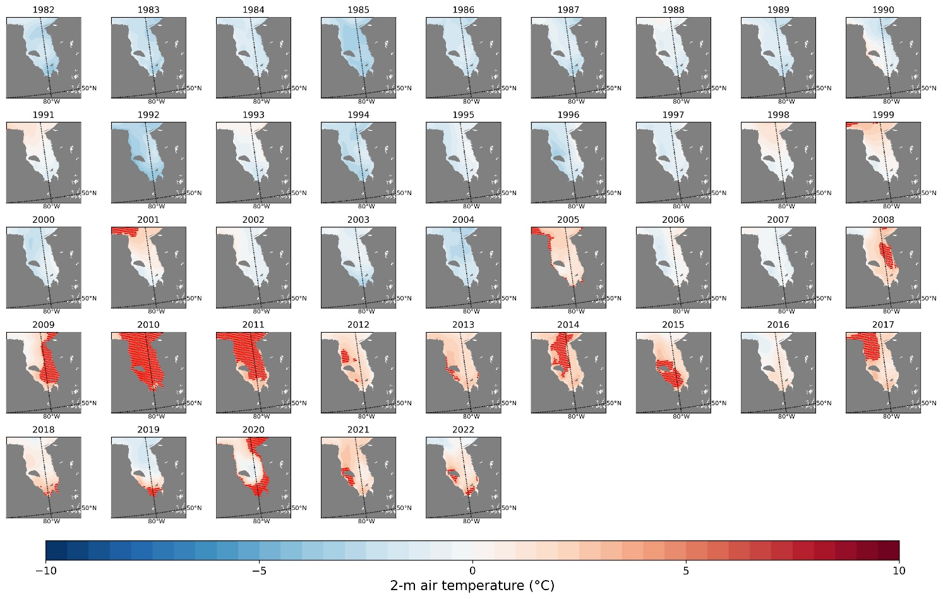

**Supplementary Figure 3.** Same as Supplementary Figure 1, except for July.

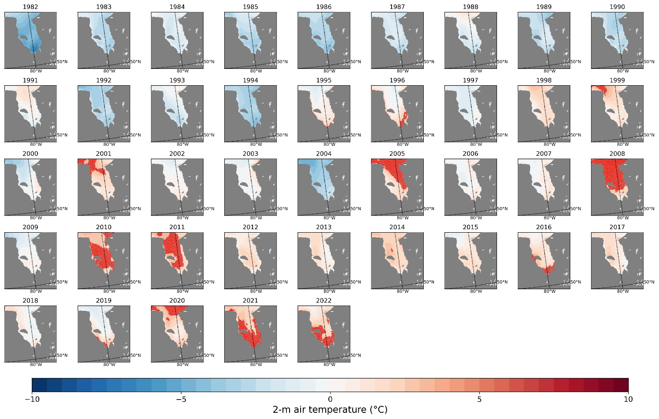

**Supplementary Figure 4.** Same as Supplementary Figure 1, except for August.

**Supplementary Figure 5.** Same as Supplementary Figure 1, except for September.

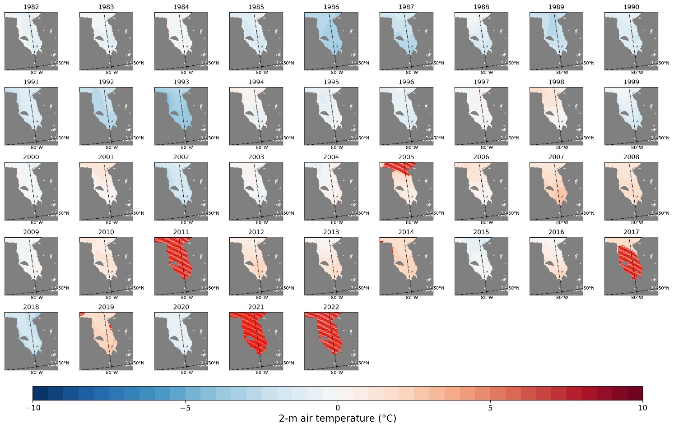

**Supplementary Figure 6.** Same as Supplementary Figure 1, except for October.

**Supplementary Figure 7.** OSTIA sea surface temperature correlated with AMO using Spearman rho test.

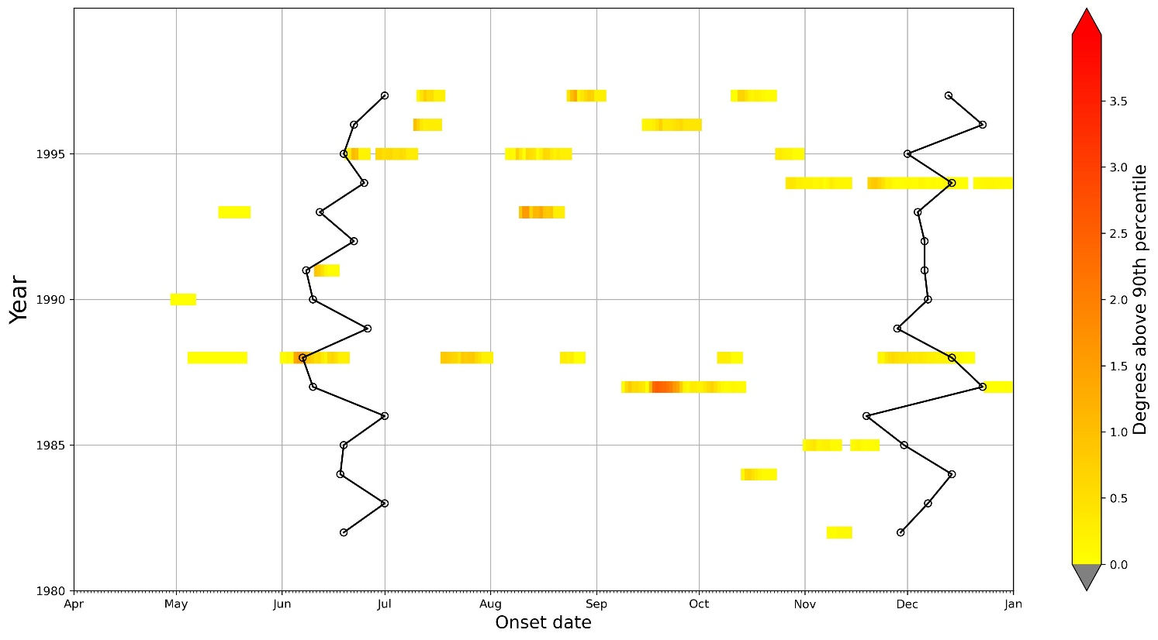

**Supplementary Figure 8.** Same as Figure 2, but for 1982 to 1997.

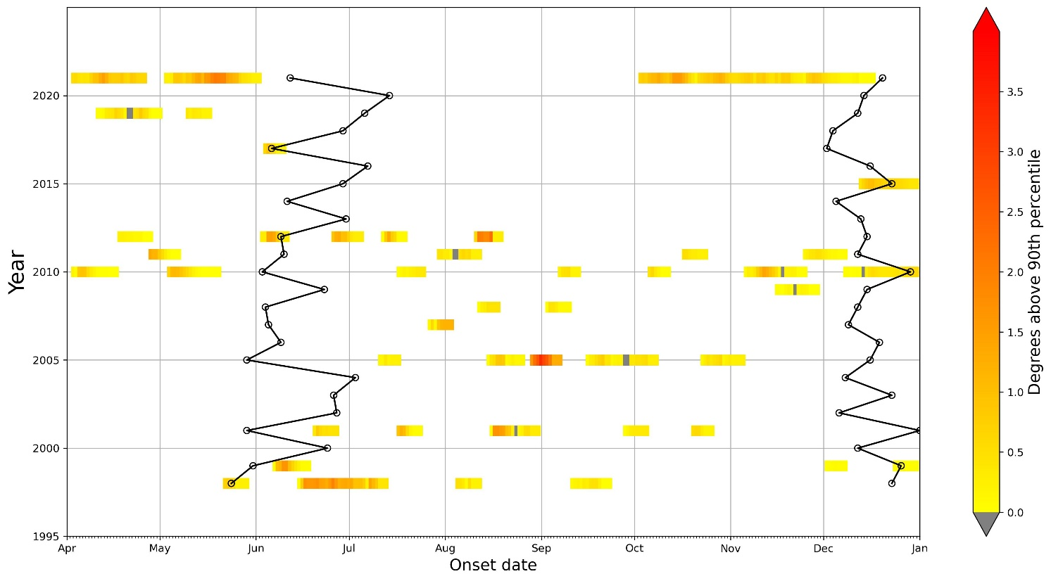

**Supplementary Figure 9.** Same as Figure 2, but for 1998 to 2021.

## Supplementary Tables

**Supplementary Table 1.** Monthly and annual cumulative marine heat wave days.

|  |  |  |  |  |  |  |  |
| --- | --- | --- | --- | --- | --- | --- | --- |
|  | May | June | July | August | September | October | MHW days |
| 1982 | 0 | 0 | 0 | 0 | 0 | 0 | 0 |
| 1983 | 0 | 0 | 0 | 0 | 0 | 0 | 0 |
| 1984 | 0 | 0 | 0 | 0 | 0 | 0 | 0 |
| 1985 | 0 | 0 | 0 | 0 | 0 | 0 | 0 |
| 1986 | 0 | 0 | 0 | 0 | 0 | 0 | 0 |
| 1987 | 0 | 0 | 0 | 0 | 8 | 0 | 8 |
| 1988 | 0 | 0 | 0 | 0 | 0 | 0 | 0 |
| 1989 | 0 | 0 | 0 | 0 | 0 | 0 | 0 |
| 1990 | 0 | 0 | 0 | 0 | 0 | 0 | 0 |
| 1991 | 0 | 0 | 0 | 0 | 0 | 0 | 0 |
| 1992 | 0 | 0 | 0 | 0 | 0 | 0 | 0 |
| 1993 | 0 | 0 | 0 | 6 | 0 | 0 | 6 |
| 1994 | 0 | 0 | 0 | 0 | 0 | 0 | 0 |
| 1995 | 0 | 0 | 0 | 0 | 0 | 0 | 0 |
| 1996 | 0 | 0 | 0 | 0 | 0 | 0 | 0 |
| 1997 | 0 | 0 | 0 | 0 | 0 | 0 | 0 |
| 1998 | 10 | 20 | 19 | 7 | 16 | 6 | 78 |
| 1999 | 0 | 10 | 0 | 0 | 7 | 2 | 19 |
| 2000 | 0 | 0 | 0 | 0 | 0 | 0 | 0 |
| 2001 | 0 | 23 | 7 | 17 | 6 | 22 | 75 |
| 2002 | 0 | 0 | 0 | 0 | 0 | 0 | 0 |
| 2003 | 0 | 0 | 0 | 0 | 0 | 0 | 0 |
| 2004 | 0 | 0 | 0 | 0 | 0 | 0 | 0 |
| 2005 | 0 | 2 | 11 | 23 | 29 | 21 | 86 |
| 2006 | 0 | 0 | 0 | 0 | 0 | 0 | 0 |
| 2007 | 0 | 0 | 5 | 2 | 0 | 0 | 7 |
| 2008 | 0 | 0 | 0 | 5 | 13 | 0 | 18 |
| 2009 | 0 | 0 | 0 | 0 | 0 | 0 | 0 |
| 2010 | 20 | 8 | 20 | 6 | 13 | 8 | 75 |
| 2011 | 18 | 0 | 13 | 9 | 0 | 14 | 54 |
| 2012 | 0 | 12 | 9 | 17 | 8 | 0 | 46 |
| 2013 | 0 | 0 | 0 | 0 | 0 | 0 | 0 |
| 2014 | 0 | 0 | 0 | 5 | 0 | 0 | 5 |
| 2015 | 0 | 0 | 0 | 0 | 0 | 0 | 0 |
| 2016 | 0 | 0 | 0 | 0 | 0 | 0 | 0 |
| 2017 | 0 | 11 | 0 | 0 | 0 | 14 | 25 |
| 2018 | 0 | 0 | 0 | 0 | 0 | 0 | 0 |
| 2019 | 25 | 0 | 0 | 0 | 0 | 0 | 25 |
| 2020 | 10 | 0 | 0 | 0 | 0 | 0 | 10 |
| 2021 | 31 | 1 | 0 | 0 | 0 | 30 | 62 |