## ****Appendix 1****

## ****Bibliometric analysis software operation process****

# ****CiteSpace****

## ****1 Installation Configuration****

****System support: Windows/macOS/Linux.****

****Java dependency: Java 8 or higher version is required.****

****Download:** <https://citespace.podia.com/>**

## ****2 Data Import Process****

****2.1 Data source****

Support data exported from Web of Science, Scopus, CNKI and other databases.

****2.2 File format****

WWeb of Science .txt file or .csv file.

## ****3 Operation Steps****

****3.1 reate four folders****

Name them as data, input, output and project.

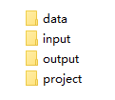

****3.2 Obtaining and organizing data****

(1) Download txt data from various databases.

(2) After backing up, change the file name to “download\_\*” (\* is a customized logo, usually a serial number), and then put it into the input folder.

IMG_256

(3) In the citespace data tool to select the corresponding database, and then in the “input directory” browse “input” folder, in the “output directory” browse “input” folder. output directory” browse ‘output’ folder.

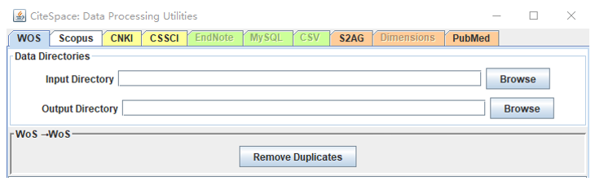

(4) After selecting the conversion, there will be converted files in the “output” folder. Copy them to the “data” folder.

****3.3 Linking Project and Data Folders****

Create a new project, then bind “project home” to the “project” folder and “data directory” to the “data” folder.

****3.4 Measurement Analysis****

Adjust “time slicing”. Other more advanced options can be set as needed. Select “Co-citation”, “Keyword Co-occurrence” and so on.

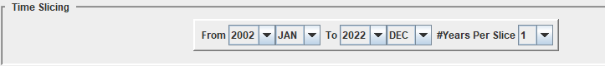

Adjustments can be visualized on the control panel.

Layout algorithms: Force-Atlas2, etc.

Time Dimension: Use “Time Zone View” to show research evolution trends.

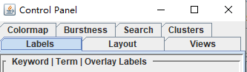

## ****4 Export of results****

Right-click on the plot → Save as .png or .svg format. Analysis results can be exported to Excel or a text file.

# ****Bibliometrix R****

## ****1 Installation Configuration****

****1.1 Installing R with RStudio****

R：[https://cran.r-project.org/](https://cran.r-project.org/" \t "https://www.doubao.com/chat/_blank)

RStudio：[https://posit.co/download/rstudio-desktop/](https://posit.co/download/rstudio-desktop/" \t "https://www.doubao.com/chat/_blank)

****1.2 Install the Bibliometrix package****

Enter the code:

install.packages("bibliometrix", dependencies=TRUE)

library(bibliometrix)

biblioshiny()

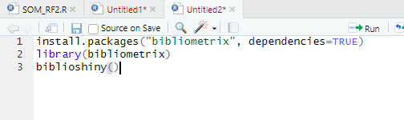

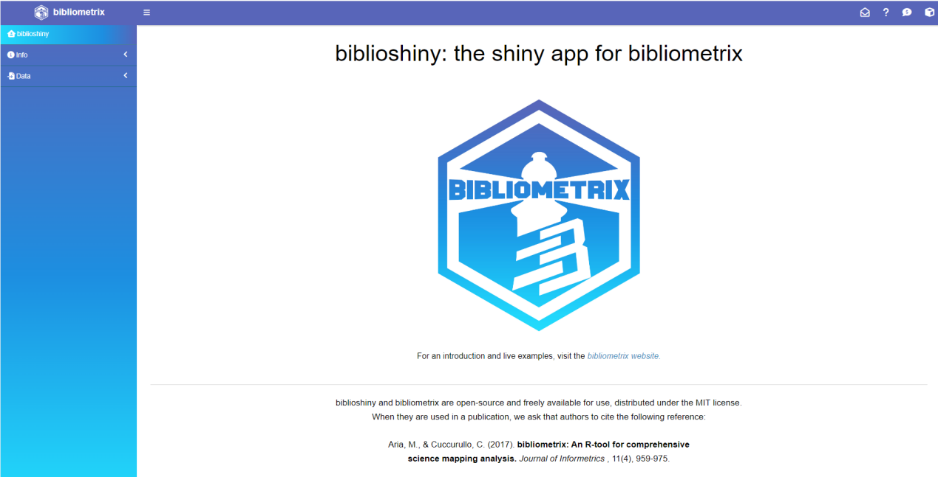

## ****2 Data Import Process****

****2.1 Data source****

Support .bib/.ris/.csv files of Web of Science, Scopus, etc.

****2.2 File format****

Saves the downloaded file in .zip format.

## ****3 Operation Steps****

****3.1 Data import****

Select Data-Import or Load files to upload the downloaded wos data, with the option to save the bibliometrix file as an alternative in excel/R Data Format format.

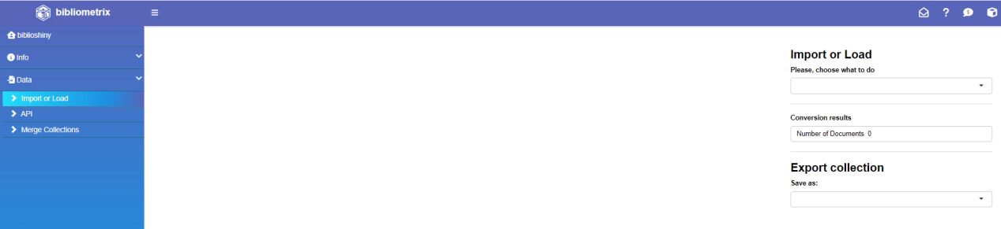

The data can be filtered based on the type of literature, year of publication, number of citations, and source. The final result is detailed information about the dataset, such as Main Information, Average Citations per Yea and Three-Fields Plot.

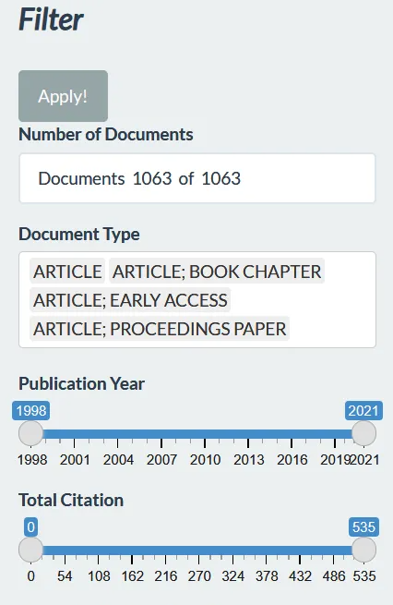

****3.2 Data analysis****

After data cleaning, follow the operation column on the left side to select the appropriate method for econometric analysis. The analysis and visualization can be done through the graphical interface.

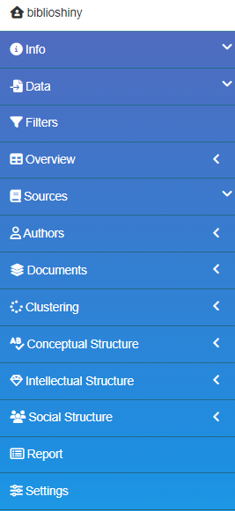

## ****4 Export of results****

Use write.csv() to save analysis results as a CSV file; visualization charts can be exported as .csv, .png, or .pdf.

# ****VOSviewer****

## ****1 Installation Configuration****

System Support: Windows/macOS/Linux

Java dependency: Java 8 or higher required

Download: <https://www.vosviewer.com/>

## ****2 Data Import Process****

****2.1 Data source and file format****

Supports .csv/.txt/.ris files for Web of Science, Scopus, etc.

****2.2 Data import****

Choose type of data：After clicking “Create”, select “Create a map based on bibliographic data” . Select “Read data from bibliographic database files”.

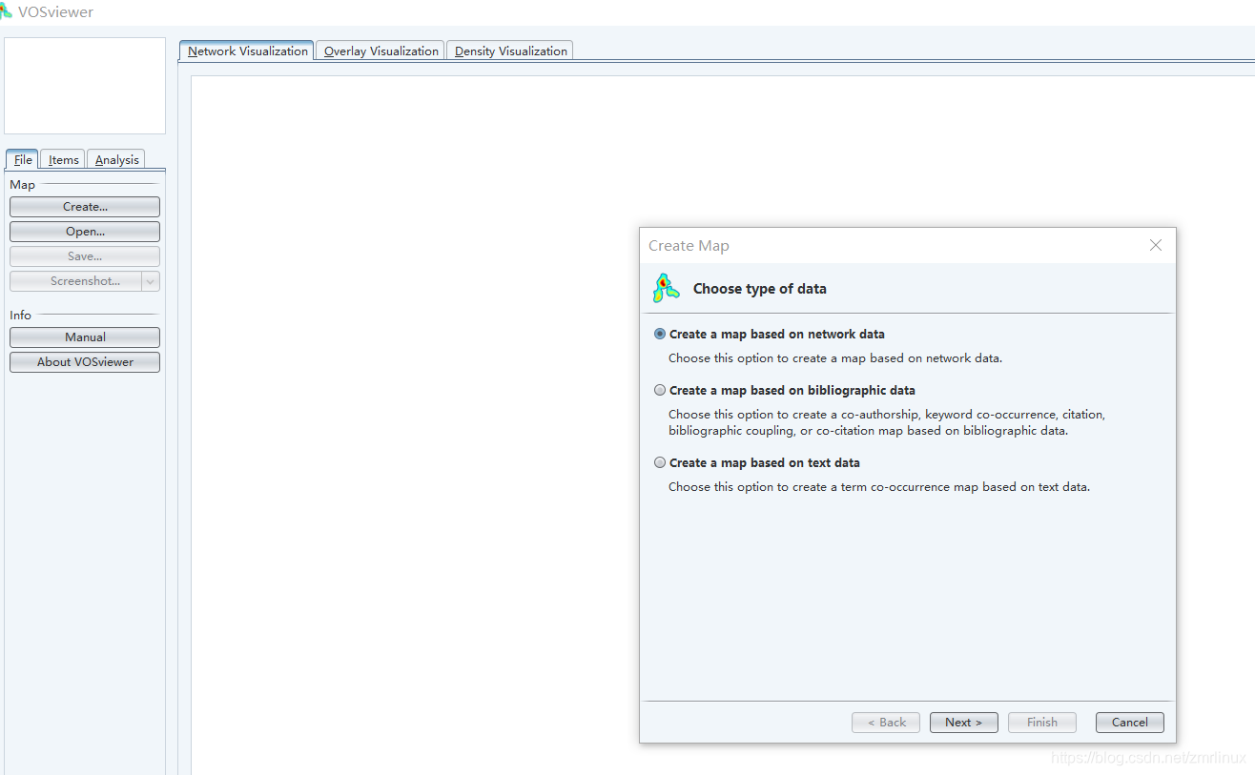

## ****3 Measurement analysis****

(1) Network view: the size of each circle represents the weight of this keyword, and the distance between two circles indicates the affinity between the two circles, if the affinity is stronger then the distance is shorter, and if the affinity is weaker then the distance is farther. The colors of the circles represent the respective cluster classes.

(2) Coverage view: the structure of the graph of the coverage view and the network view is the same, with a difference in color, and all keywords are colored according to their weights, and participants are given their own coloring method. The overlay view is only useful if the attributes and keywords associated with the entries are set.

(3) Density view: shows the density of the items. The larger the number of keywords around the keyword, the brighter the color.

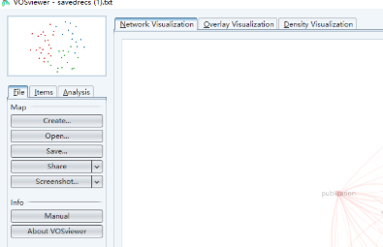

## ****4 Export of results****

Click “File” → “Export” → “Save as image” → select .png or .svg format.

# ****Core Features Comparison****

| ****Function**** | ****CiteSpace**** | ****Bibliometrix R**** | ****VOSviewer**** |
| --- | --- | --- | --- |
| **Learning Difficulty** | Medium | Medium | Low, user-friendly interface |
| **Scale of data processing** | Small to medium sized datasets | Large-scale data sets | Full-scale data sets |
| **Visualization Focus** | Time-series dynamic analysis | Statistical Chart Diversity | Network relationship visualization |
| **Featured Functions** | Emergent word detection (frontier tracking) | Calculation of advanced metrics | Efficient layout algorithm |