Unveiling the mechanism of phenylpropanoid-rich the peel of *Zea mays L.* in ameliorating metabolic disorders in diabetic mice via gut microbiome and metabolomics

Xiaotian Cheng a,b,#, Jinyan He a,#, Yuru Yang a, Yaonan He a, Guangtong Chen a, Bai Ling a,b,*, Andong Wang a,*

a School of Pharmacy, Nantong University, Nantong, Jiangsu 226001, P. R. China

b Department of Pharmacy, The Yancheng Clinical College of Xuzhou Medical University & The First people’s Hospital of Yancheng, Yancheng, Jiangsu 224001, P. R. China

# These authors contributed equally to this work and shared first authorship.

* Corresponding author: Andong Wang ([wangandong19891220@163.com](mailto:wangandong19891220@163.com)), Bai Ling (lingbai@ntu.edu.cn)

**Figure details**

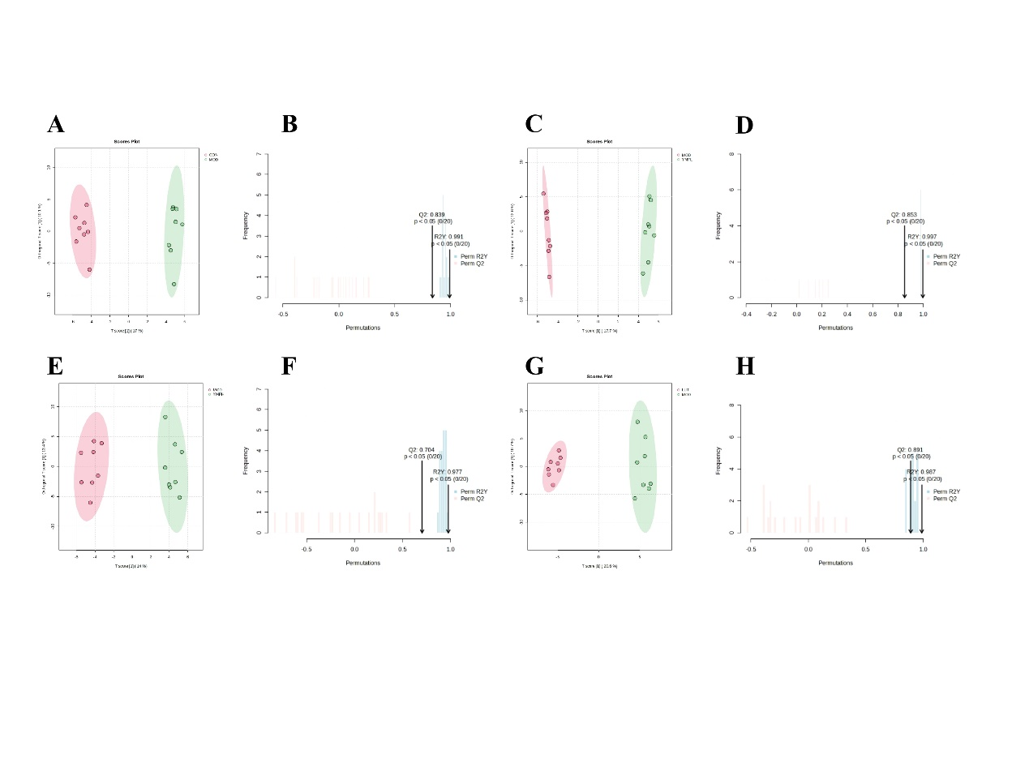

Figure S1 OPLS-DA (CON vs MOD) (A), R2Y and Q2 (CON vs MOD) (B), OPLS-DA (MOD vs YMPL) (C), R2Y and Q2 (MOD vs YMPL) (D), OPLS-DA (MOD vs YMPH) (E), R2Y and Q2 R2Y and Q2 (F), OPLS-DA (MOD vs LUT) (G), R2Y and Q2 (MOD vs LUT) (H). (n=8)

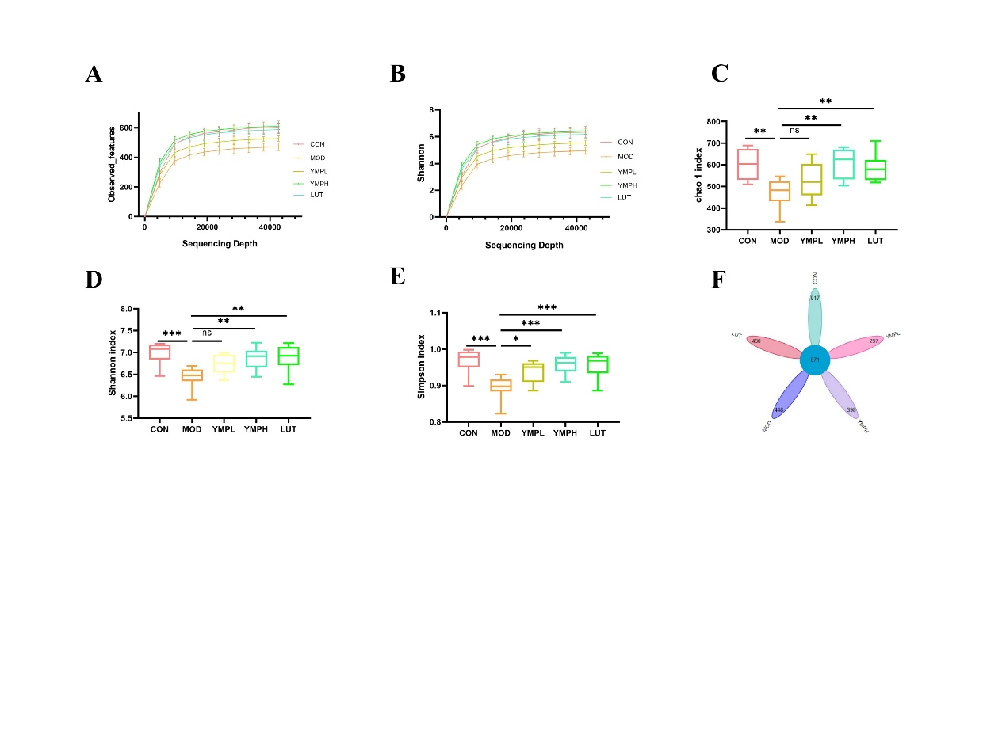

Figure S2 Rarefaction curve (A), Shannon curve (B), Chao1 index (C), Simpson index (D), Shannon index (E), flower diagram of OTUs (F). Note: * represents for vs MOD group (*p* < 0.05), ** represents for vs MOD group (*p* < 0.01), *** represents for vs MOD group (*p* < 0.001), respectively. n=4