**Figure S1. Overall Architecture of Yolov8 and combine attention mechanism of model.**

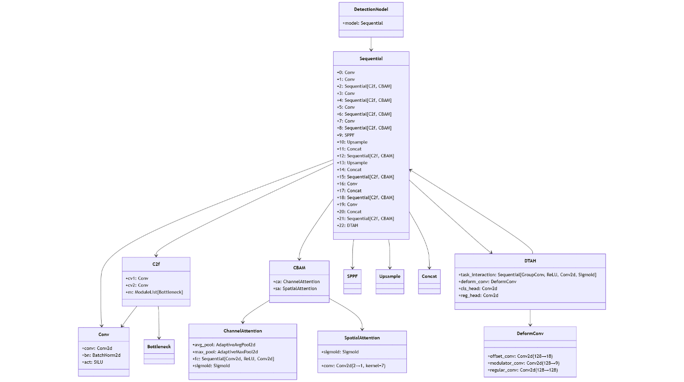

**Figure S2 Correlogram of custom dataset**

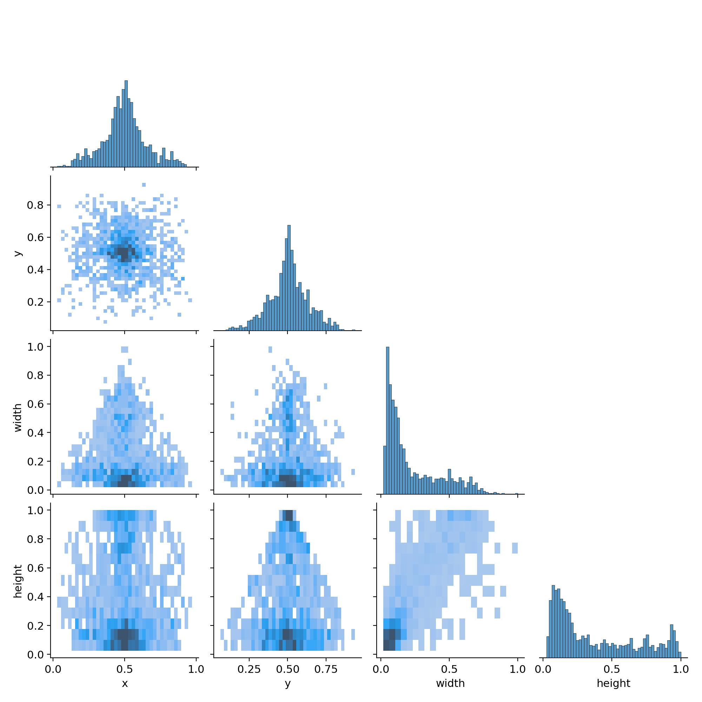

Figure S3. Precision-Recall Curve comparison across model.

