**Supplementary materials**

**Figure S1.** Relationships between *E*c and soil temperature (a-h), air temperature (i-l), and relative humidity (m-p). E*TP*, *E*c in the tapped panel of the tapped rubber trees; E*CK*, *E*c in the untapped panel of the tapped rubber trees; E*NP*, *E*c in the non-tapped rubber trees; *T10*, soil temperature at 10 cm soil depth; *T50*, soil temperature at 50 cm soil depth; *Ta*, air temperature; RH, relative humidity. R2 and *p*-values for the relationships were calculated using a linear regression model. R² and p values for the relationships were derived from linear regression analysis. A solid line denotes a statistically significant linear relationship between factors (*p* < 0.05), whereas a dotted line indicates no significant relationship. The same below.

**Figure S2.** Relationships between *E*c and vapor pressure deficit (a-d), leaf area index (e-h), and sap flux density (i-l). VPD, vapor pressure deficit; LAI, leaf area index; F*d*, sap flow flux density; RH, relative humidity.

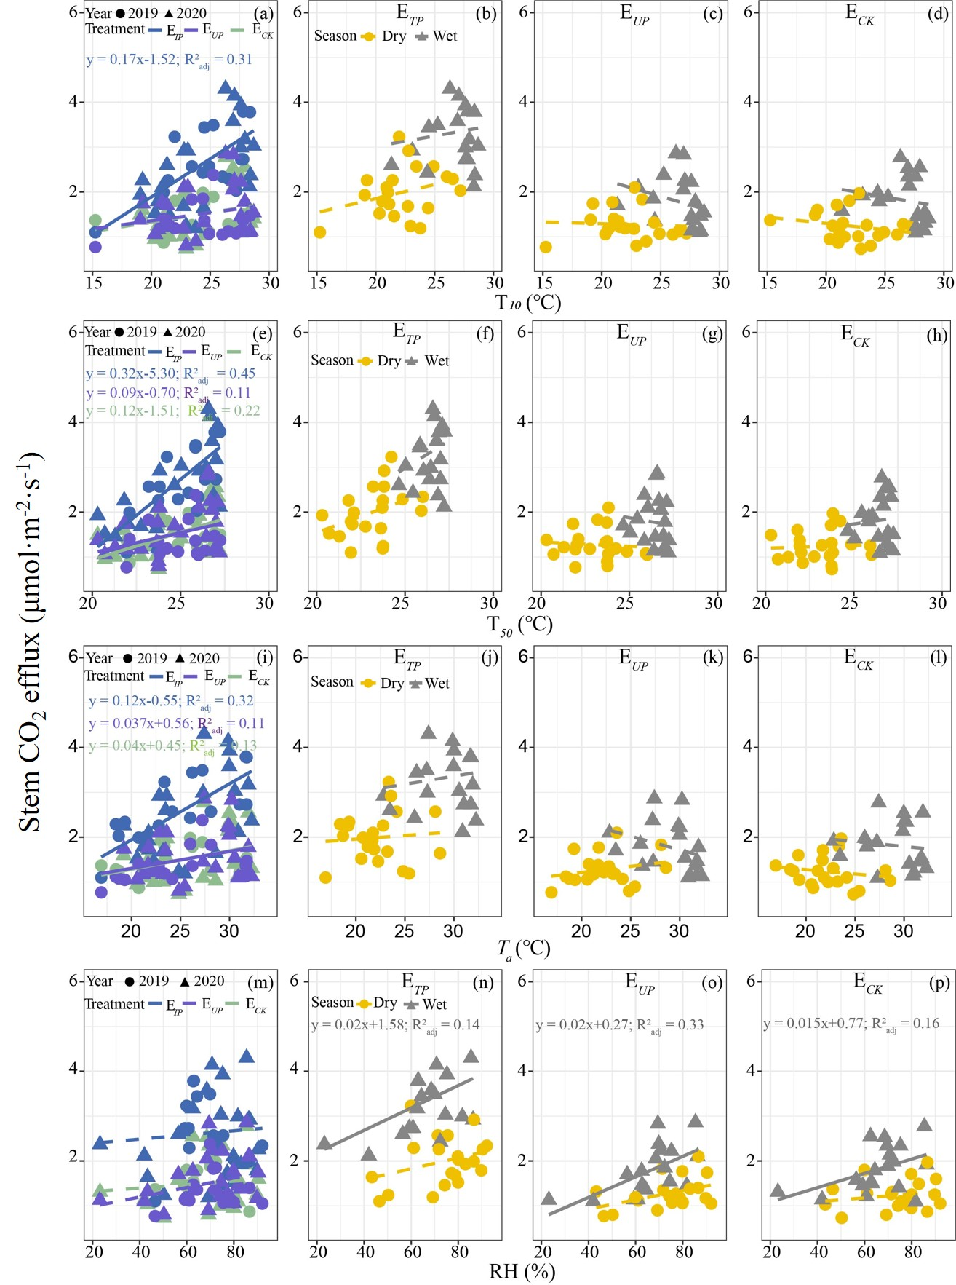

**Figure S1.** Relationships between *E*c and soil temperature, *Ta*, and RH.

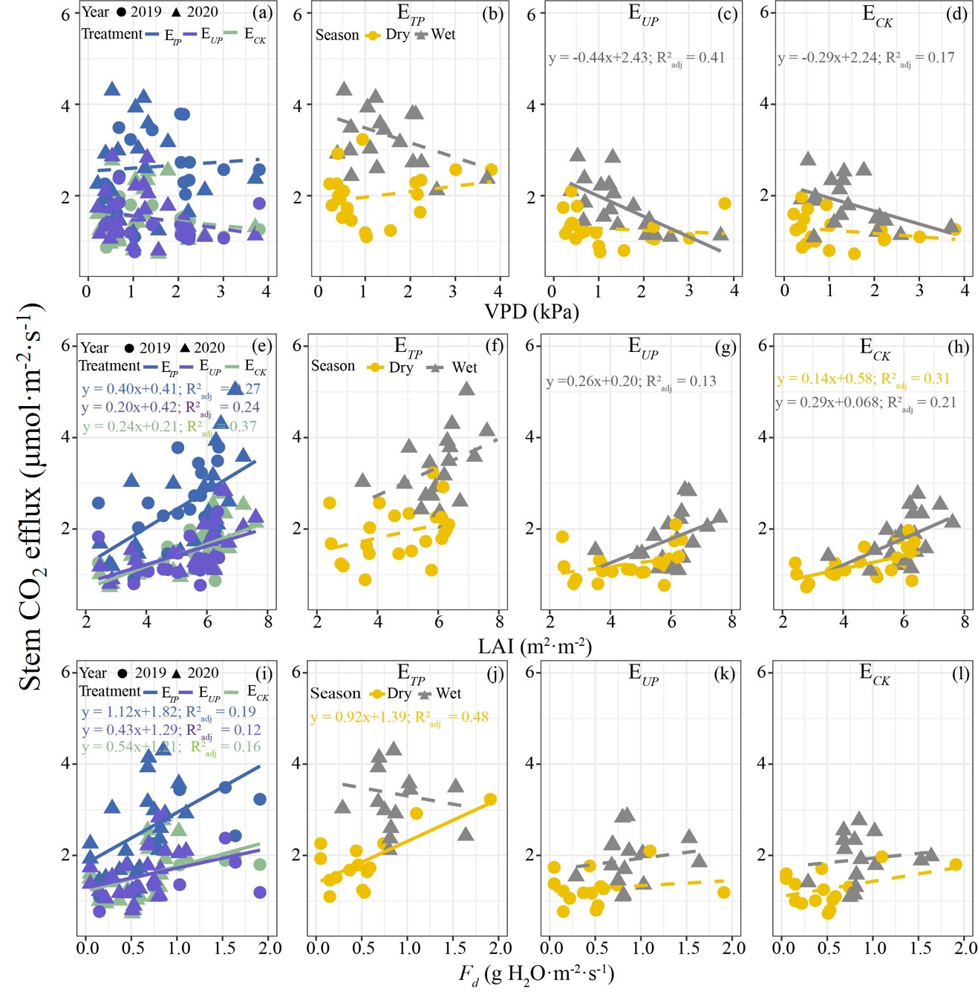

**Figure S2.** Relationships between *E*c and VPD, LAI, and *Fd*.