Original Western blots
Figure. 3
CD36 88 kDa | 88 kDa | 88 kDa | 88 kDa
VLDLR 96 kDa | 96 kDa | 96 kDa | 96 kDa
FATP5 75kDa | 75 kDa | 75 kDa | 75 kDa
SREBP1c 125 kDa | 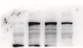  125 kDa | 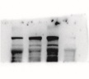  125 kDa | 125 kDa
FASN 273 kDa | 273 kDa | 273 kDa | 273 kDa
SCD1  37 kDa | 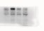  37 kDa | 37 kDa | 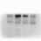  37 kDa
p-AMPK 62 kDa | 62 kDa | 62 kDa | 62 kDa
AMPK 62 kDa | 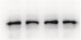  62 kDa | 62 kDa | 62 kDa
CPT1α  88 kDa | 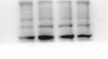  88 kDa | 88 kDa | 88 kDa
PPARα  55 kDa | 55 kDa | 55 kDa | 55 kDa
β-actin  42 kDa | 42 kDa | 42 kDa | 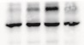  42 kDa

Figure. 4
4-HNE | 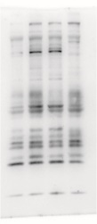 | 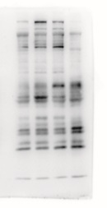 | 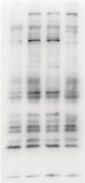
β-actin  42 kDa | 42 kDa | 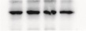  42 kDa | 42 kDa
GPX4  17 kDa | 17 kDa | 17 kDa | 17 kDa
SLC7A11  63 kDa | 63kDa | 63 kDa | 63 kDa
β-actin  42 kDa | 42 kDa | 42 kDa | 42 kDa

Figure. 5
44/42 kDa
p-ASK1  155 kDa | 155 kDa
ASK1  155 kDa | 155 kDa | 155 kDa  155 kDa | 155 kDa  155 kDa
p-ERK  44/42 kDa | 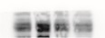  44/42 kDa |  | 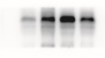  44/42 kDa
ERK  44/42 kDa | 44/42 kDa | 44/42 kDa | 44/42 kDa
p-JNK  54/46 kDa | 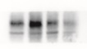  54/46 kDa | 54/46 kDa | 54/46 kDa
JNK  54/46 kDa | 54/46 kDa | 54/46 kDa | 54/46 kDa
p-P38  38 kDa |  | 38 kDa | 38 kDa  38 kDa
P38  38 kDa | 38 kDa | 38 kDa | 38 kDa
β-actin  42 kDa | 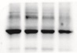  42 kDa | 42 kDa | 42 kDa

Figure. 7
CD36 88 kDa | 88 kDa | 88 kDa | 88 kDa
VLDLR 96 kDa | 96 kDa | 96 kDa | 96 kDa
FATP5 75kDa | 75 kDa | 75 kDa | 75 kDa
SREBP1c 125 kDa | 125 kDa | 125 kDa | 125 kDa
FASN 273 kDa | 273 kDa | 273 kDa  37 kDa | 273 kDa
SCD1  37 kDa | 37 kDa |  | 37 kDa
p-AMPK 62 kDa | 62 kDa | 62 kDa | 62 kDa
AMPK 62 kDa | 62 kDa | 62 kDa | 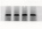  62 kDa
CPT1α  88 kDa | 88 kDa | 88 kDa | 88 kDa
PPARα  55 kDa | 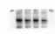  55 kDa | 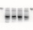  55 kDa | 55 kDa
β-actin  42 kDa | 42 kDa | 42 kDa | 42 kDa

Figure. 8
4-HNE |  |  | 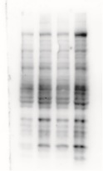
β-actin  42 kDa | 42 kDa | 42 kDa | 42 kDa
GPX4  17 kDa | 17 kDa | 17 kDa | 17 kDa
SLC7A11  63 kDa | 63kDa | 63 kDa | 63 kDa
β-actin  42 kDa | 42 kDa | 42 kDa | 42 kDa

Figure. 9
38 kDa
54/46 kDa
54/46 kDa
44/42 kDa
p-ASK1  155 kDa | 155 kDa |  | 155 kDa  155 kDa
ASK  155 kDa | 44/42 kDa  155 kDa | 155 kDa | 155 kDa
p-ERK  44/42 kDa |  | 44/42 kDa
ERK  44/42 kDa | 44/42 kDa |  | 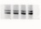  44/42 kDa  44/42 kDa
p-JNK  54/46 kDa | 54/46 kDa | 54/46 kDa
JNK  54/46 kDa | 54/46 kDa |  | 54/46 kDa
p-P38  38 kDa | 38 kDa |  | 38 kDa  38 kDa
P38  38 kDa | 38 kDa |  | 38 kDa
β-actin  42 kDa | 42 kDa | 42 kDa | 42 kDa

