Supplementary Material
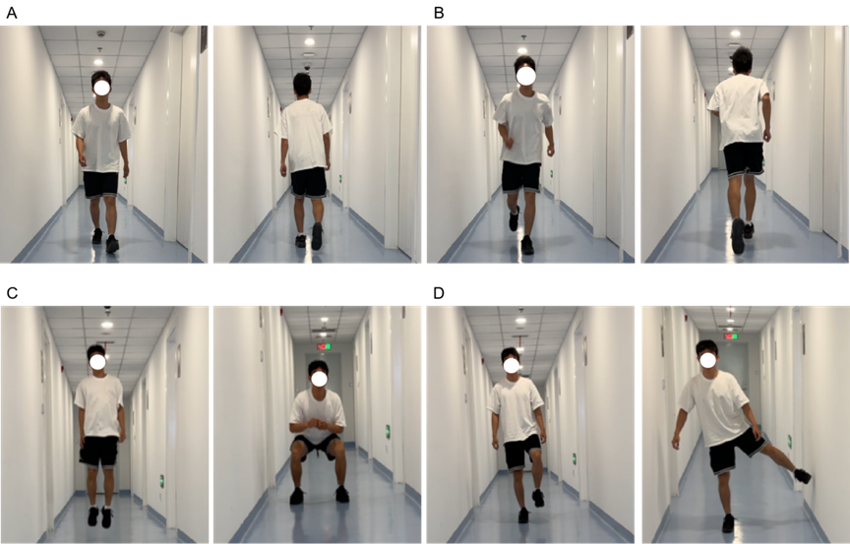
Figure S1. Case presentation of an 18-year-old patient: Right ankle function at 24 months postoperatively. (A) Walking test in a weight-bearing state. (B) Running test in a weight-bearing state. (C) Jumping and squatting test. (D) Single-leg standing test.

Table S1. A literature review of current options of autologous graft for treating OLT.
Author and year | Participants | Study type | Follow-up | Graft | Characteristics of lesions | Outcomes
Kwak 2014 ^{[7]} | 29 | Case series | 2-10 years | Autologous chondrocyte from knee, combined periosteal graft from the proximal or distal tibia | 1.98 cm² in area | AOFAS, Tegner, Finsen, Imaging evaluations
Giannini 2014 ^{[21]} | 46 | Case series | 1.2 years | Autologous chondrocyte from knee, combined hyaluronan scaffold | 1.6 cm² in area | AOFAS, Histological analysis
Baums 2006 ^{[22]} | 12 | Case series | 5 years | Autologous chondrocyte from anterior part of the talus, combined a periosteal flap from the distal tibia | 2.3 cm2 in area | AOFAS, Hannover ankle score
Anders 2012 ^{[23]} | 22 | Case series | 5 years | Autologous chondrocyte from lesion site of the talus, combined a collagen type I/III scaffold | 1.94 cm2 in area | AOFAS, VAS, Tegner, MOCART
Gautier 2002 ^{[27]} | 11 | Case series | 2 years | Osteochondral autograft from non-weight-bearing trochlear border of the ipsilateral knee | 18 mm*10mm in area | AOFAS, Hannover ankle score
Scranton 2006 ^{[9]} | 50 | Case series | 3 years | Osteochondral autograft from knee | 8 mm to 20 mm in diameter | Karlsson-Peterson Ankle Score
Wei 2023 ^{[30]} | 5 | Case series | 1 year | Osteochondral autograft from ribs | 10.40±1.86mm in depth; 10.66±1.84mm in diameter | AOFAS, FAAM, MOCART, ICRS
Suh 2024 ^{[28]} | 11 | Case series | 5 years | Osteochondral autograft from the lateral talar articular facet | 7.3 mm in depth;  8 to 10 mm in diameter | AOFAS, VAS, MOCART
Shi 2022 ^{[8]} | 46 | Retrospective cohort study | 4 years | Osteochondral autograft from knee vs Autologous osteoperiosteal from iliac | 2.17 cm³ or 2.55 cm³ in volume | AOFAS, VAS, Tegner, MOCART, ICRS
Cao 2024 ^{[25]} | 31 | Case series | 2.5 years | Autologous osteoperiosteal and cancellous bone from iliac or distal tibia | 8.5±1.8mm in depth; 81.1±37.4mm² in area | AOFAS, VAS, SF‐36
Guo 2022 ^{[24]} | 26 | Case series | 2.5 years | Autologous osteoperiosteal from iliac, combined recombinant human bone morphogenetic protein 2 | 10.7±3.5mm in depth;  13.6±4.0mm in diameter | FFI, AOFAS, VAS, Tegner, MOCART
Yang 2024 ^{[26]} | 55 | Retrospective cohort study | 5 years | Autologous osteoperiosteal from iliac vs bone marrow stimulation | AOPT group: 11.7 ± 2.8 mm in depth; 126.5±18mm2 in area | AOFAS, VAS, FAAM
Abbreviations: AOFAS, American Orthopaedic Foot and Ankle Society score; FAAM, Foot and Ankle Activity Measure; ICRS, International Cartilage Repair Society score; MOCART, Magnetic Resonance Observation of Cartilage Repair Tissue score; VAS, Visual Analogue Scale; SF‐36, 36 item Short‐Form Health Survey; FFI, Foot Function Index; OLT, osteochondral lesions of the talus; AOPT, autologous osteoperiosteal transplantation.

Table S2. Baseline characteristics of NO.4 patient.
Patient No. | Gender | Age | Follow-up Duration (years) | Lesion site | Lesion area (cm^2) | Depth (cm)
④ | Male | 31 | 1 | Left (Medial) | 1.6*1.5 | 1.3

Table S3. Functional and Radiographic Outcomes of NO.4 patient
Patient No. | AOFAS |  |  | NRS |  |  | FAAM/ADL |  |  | FAAM/Sports |  |  | Tegner
 | Pre | 1 year |  | Pre | 1 year |  | Pre | 1 year |  | Pre | 1 year |  | Pre | 1 year
4 | 50 | 85 |  | 5 | 2 |  | 54.8 | 96.4 |  | 42.9 | 75 |  | 4 | 7
AOFAS, American Orthopaedic Foot and Ankle Society score; FAAM/ADL, Foot and Ankle Activity Measure/Activities of Daily Living score; FAAM/ Sports, Foot and Ankle Activity Measure/Sports score.

Figure S2. Evaluations of preoperative and 1-year postoperative imaging outcomes.

Figure S3. The surgical procedure of autologous costal cartilage transplantation for the treatment of giant cell tumor of tendon sheath (GCTTS) of talus.

Figure S4. Postoperative ankle function of NO.4 patient.

