Myonectin and Metabolic Health: A Systematic Review

Jorge L. Petro1,2*, Jaime Gallo-Villegas3,4, Juan C. Calderón1*

1 Physiology and Biochemistry Research Group-PHYSIS, Faculty of Medicine, University of Antioquia, Medellín, Colombia.

2 Research Group in Physical Activity, Sports and Health Sciences (GICAFS), Universidad de Córdoba, Montería, Colombia.

3 Sports Medicine Postgraduate Program, and GRINMADE Research Group, Faculty of Medicine, University of Antioquia, Medellín, Colombia.

4 SICOR center, Medellín, Colombia.

**\* Correspondence:**

[jorgelpetro@correo.unicordoba.edu.co](mailto:jorgelpetro@correo.unicordoba.edu.co) (J.L. Petro.); [jcalderonv00@yahoo.com](mailto:jcalderonv00@yahoo.com) (J.C. Calderón).

Supplementary Material



**Supplementary Figure 1.** The human myonectin structure predicted by AlphaFold (magenta) and I-TASSER (blue) was compared, yielding a root mean square deviation (RMSD) of 0.821 Å across 70 pruned atom pairs. However, when considering all 354 atom pairs, the RMSD increased significantly to 37.758 Å. The overlay highlights both the similarities and differences between the models. The structural comparison was conducted using ChimeraX, employing the Needleman-Wunsch alignment algorithm with the BLOSUM-62 similarity matrix and specific gap penalties for alignment.

|  |  |
| --- | --- |
| **miRNA** | **Score** |
| hsa-miR-4251 | 93 |
| hsa-miR-450a-2-3p | 91 |
| hsa-miR-3619-5p | 91 |
| hsa-miR-214-3p | 85 |
| hsa-miR-7854-3p | 85 |
| hsa-miR-210-5p | 85 |
| hsa-miR-761 | 85 |
| hsa-miR-148a-5p | 85 |
| hsa-miR-2467-3p | 83 |
| hsa-miR-486-5p | 82 |

**Supplementary Table 1. Human miRNA predicted to target human *ERFE* in miRDB.** amiRNA, micro ribonucleic acid; *ERFE*, erythroferrone gene; miRDB, miRNA database. Accessed on May 29th, 2025.

**Supplementary Figure 2. Risk of bias in individual animal studies assessed using the SYRCLE tool.**

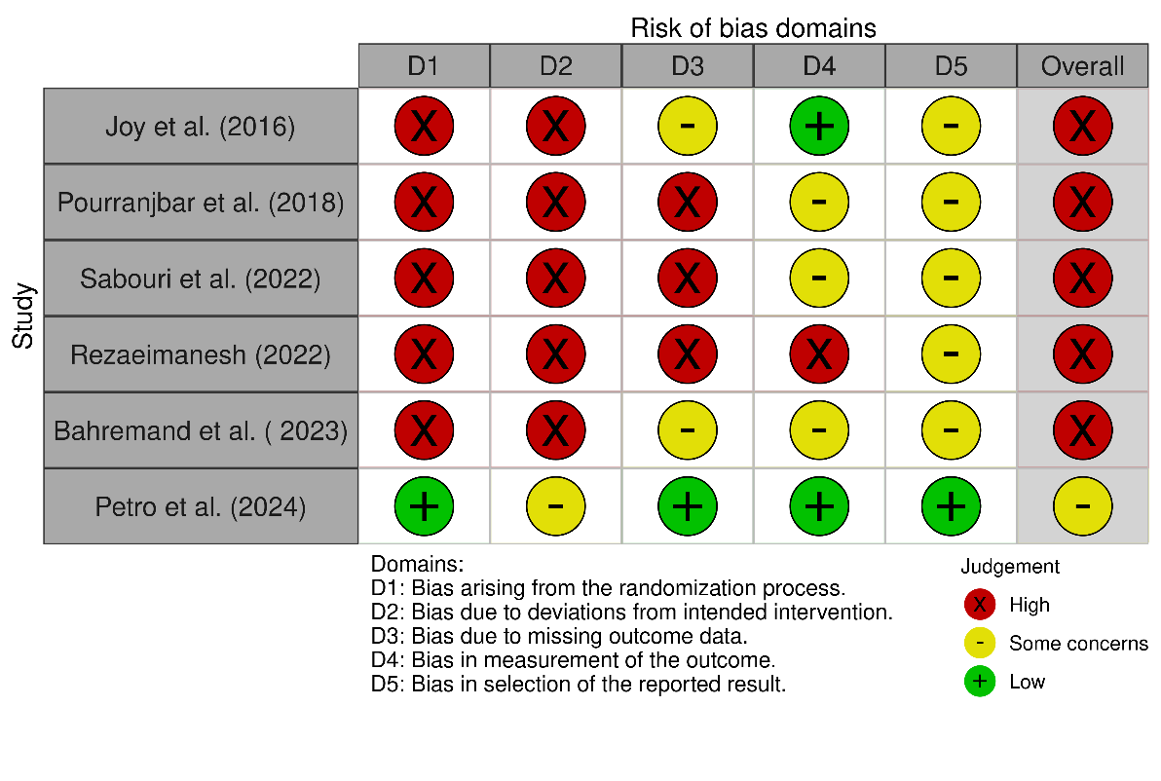

**Supplementary Figure 3. Risk of bias in individual randomized controlled trials assessed using the RoB 2 tool.**