# Supplementary electronic material for:

# Mercury interaction with S-containing molecules: Implications for Potential methylation and Demethylation Regulation in a sulfate reducing bacteria Ikram Bakour1, Marie-Pierre Isaure2, Sophie Barrouilhet2, Marisol Goñi-Urriza2. Mathilde Monperrus1*

1Universite de Pau et des Pays de l’Adour, E2S UPPA, CNRS, IPREM UMR 5254, Anglet, France.

2Universite de Pau et des Pays de l’Adour, E2S UPPA, CNRS, IPREM UMR 5254, Pau, France.

*Correspondence

Mathilde Monperrus

[mathilde.monperrus@univ-pau.fr](mailto:mathilde.monperrus@univ-pau.fr)

**Text S1: Chemicals and Reagents**

For LMW thiol standards, stock solutions (10 mM) of 14 LMW thiols were prepared in deoxygenated Milli-Q water (>18 MΩ.cm) inside a glove box amended with N2. They included L-cysteine (Cys; ≥99%), 2-Mercaptoethanesulfonic acid (SULF, 98%), N-acetyl-D-penicillamine (PEN, 97%) from Acros Organics, N-acetyl-L-cysteine (NacCys, 98%), mercaptosuccinic acid (SUC, 98%), 2-Mercaptopropionic acid (2-MPA, 97%) from Alfa Aesar, L-glutathione (GSH ≥98%), cysteamine (Cyst≥ 98%),1-Thiolglycerol (GLYC, 97%), mercaptoacetic acid (MAC, 98%), N-acetyl-D-penicillamine (NacPen> 99%), L-homocysteine (HCys ≥ 98%), γ-L-glutamyl-L-cysteine (γ-Glu-Cys, ≥80%), and cysteine-glycine (Cys-Gly ≥85%) from Sigma-Aldrich. Sulfide standards (10 mM) was prepared from Na2S, 9H2O (98%, Alfa Aesar) dissolved in deoxygenated Milli-Q water (>18 MΩ.cm) inside a glove box amended with N2.

**Text S2: Growth medium composition**

Multipurpose Medium containing (per liter):10 g NaCl, 1.2 g MgCl2∙6H2O, 0.1 g CaCl2∙2H2O, 0.25 g NH4Cl, 0.5 g KCl, 1 mL trace metal elements SL12B, 1 mL Sélénite-Tungstate, 2.38 g HEPES, 1 mL V7 vitamins solution and 0.2 g KH2PO4. Sélénite-Tungstate is composed of 0.5 g NaOH, 2 mg Na2SeO3, and 4 mg Na2WO4·2H2O per liter. The SL12B solution was composed of 300 mg H3BO3, 190 mg CoCl2.6H2O; 50 mg MnCl2.2H2O; 42 mg ZnCl2, 24 mg NiCl2.6H2O, 18 mg Na2MoO4.2H2O, 2 mg CuCl2.2H2O per liter. Pre-cultures were performed under non-sulfidogenic growth conditions with 40 mM pyruvate as electron donor and 40 mM fumarate as electron acceptor.

**Table S1:** General Operating parameters for the LC-MS\MS instrument

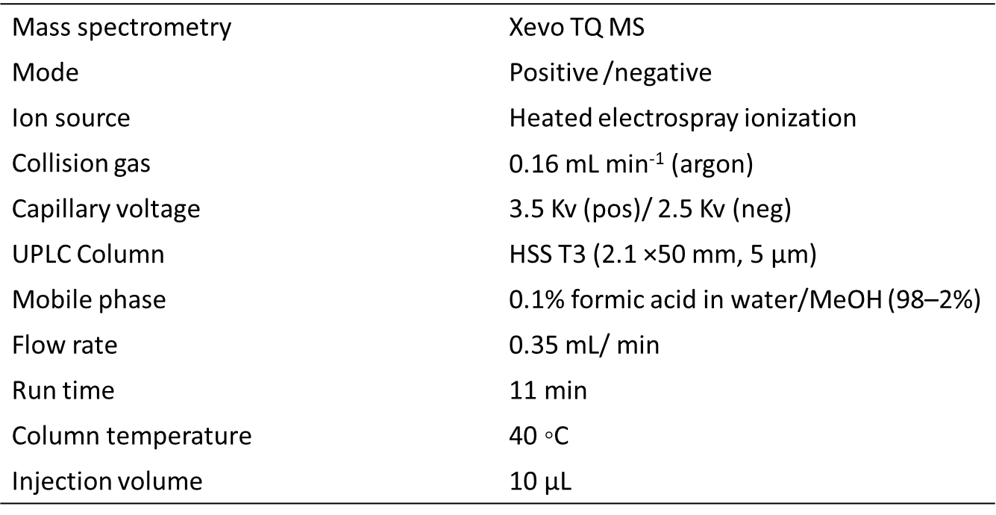

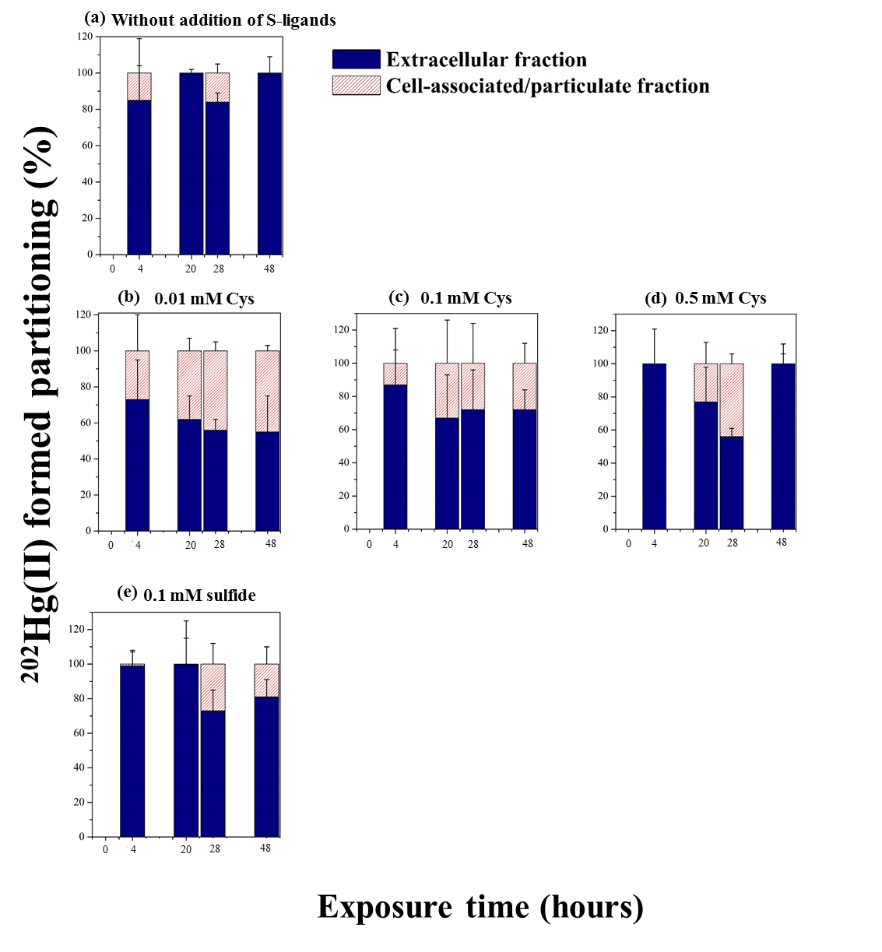

**Figure S1.** Partitioning (%) of formed 202Hg(II) between extracellular (blue), and cell associated/ particulate (red) fractions at the time = 0, 4, 20, 28 and 48 hours during exposure to 0.5 µM of 199Hg(II) and 0.05 µM of 202Hg(II). **(a)** Experimental without addition of external S-ligands **(b)** with the addition of 0.01 mM of Cys **(c)** 0.1 mM Cys **(d)** 0.5 mM Cys **(e)** 0.1 mM of sulfide. The percentage was calculated by considering the Hg concentration in the two studied fractions. Error bars represent the averages from three independent experiments, and the error bars are ± 1 S.D.

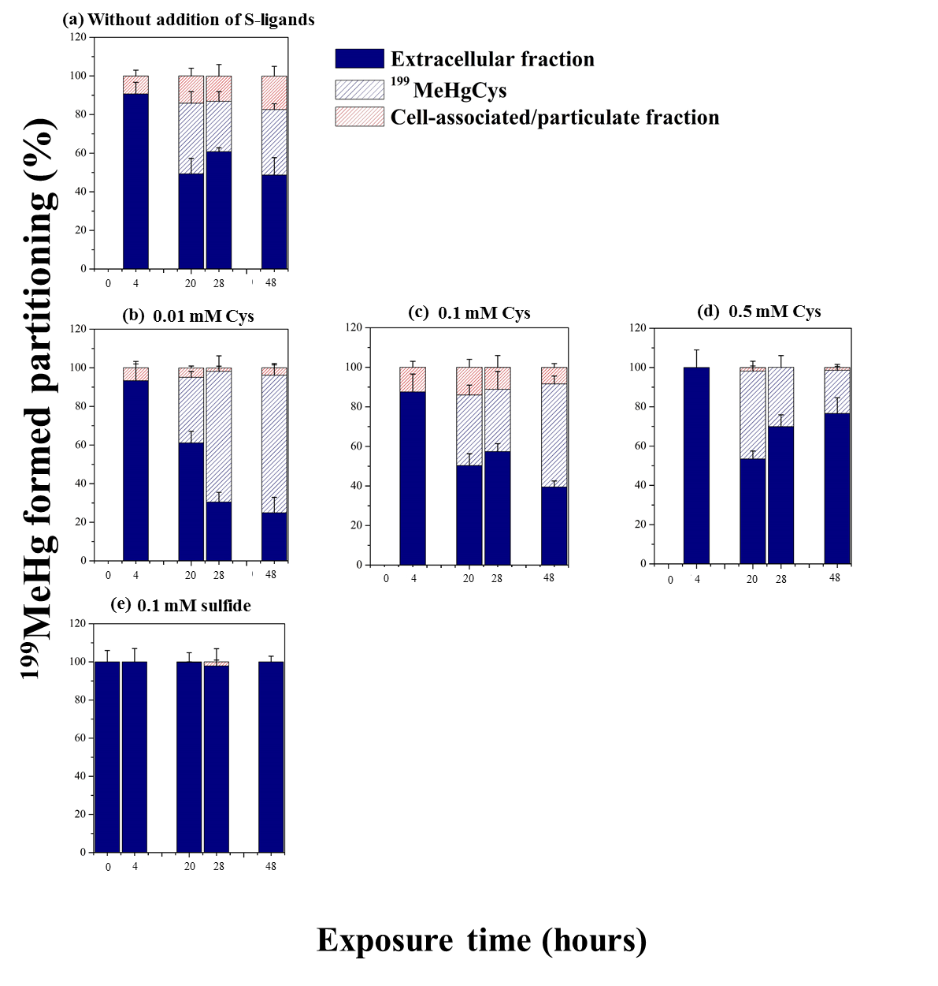

**Figure S2.** Partitioning (%) of formed Me199Hg between extracellular (blue), the % of Hg(Cys)2 complex detected in the extracellular fraction (blue dash) and cell associated/ particulate (red) fractions at the time = 0, 4, 20, 28 and 48 hours during exposure to 0.5 µM of 199Hg(II) and 0.05 µM of Me199Hg. **(a)** Experimental without addition of external S-ligands **(b)** with the addition of 0.01 mM of Cys **(c)** 0.1 mM Cys **(d)** 0.5 mM Cys **(e)** 0.1 mM of sulfide. The percentage was calculated by considering the Hg concentration in the three studied fractions. The same culture batches were used to determine the Hg species in the bulk and extracellular fractions for each kinetics. After sampling for Hg species determination using GCICPMS (bulk+supernatant), cultures were filtered (0.2µm), and the molecular speciation of Hg(II) was measured in the extracellular fraction using LCMSMS. Error bars represent the averages from three independent experiments, and the error bars are ± 1 S.D.

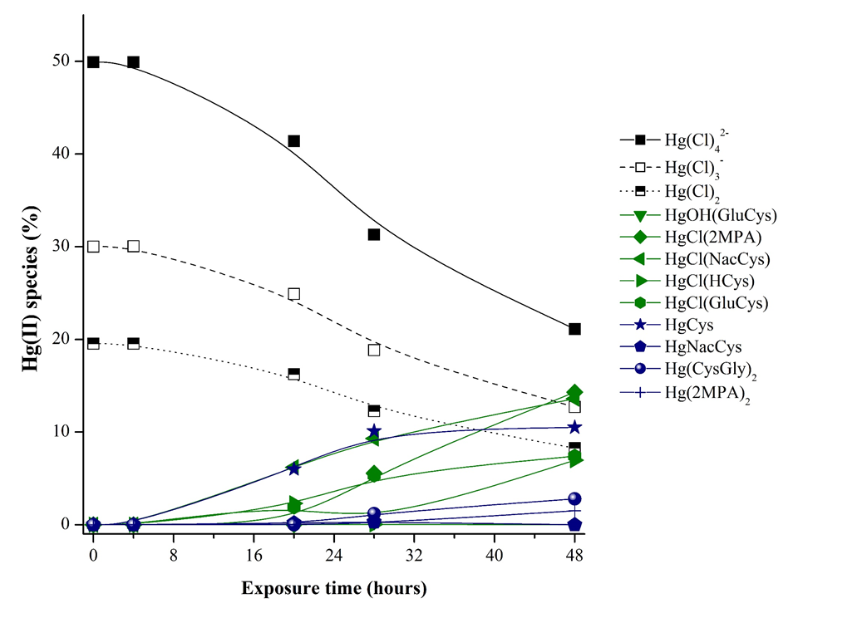

**Figure S3.** Chemical modeling using Minteq software for major Hg(II) species in the assay medium without externally added S-ligands plotted against exposure time.

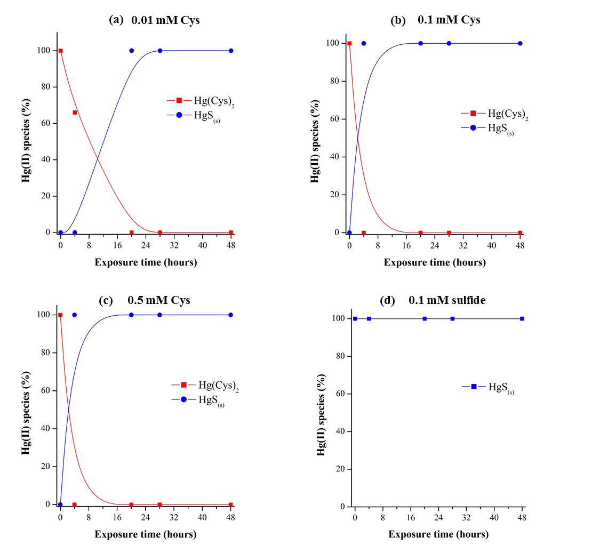

**Figure S4.**Chemical modeling using Minteq software for major Hg(II) species in the assay medium with externally added S-ligands plotted against exposure time.

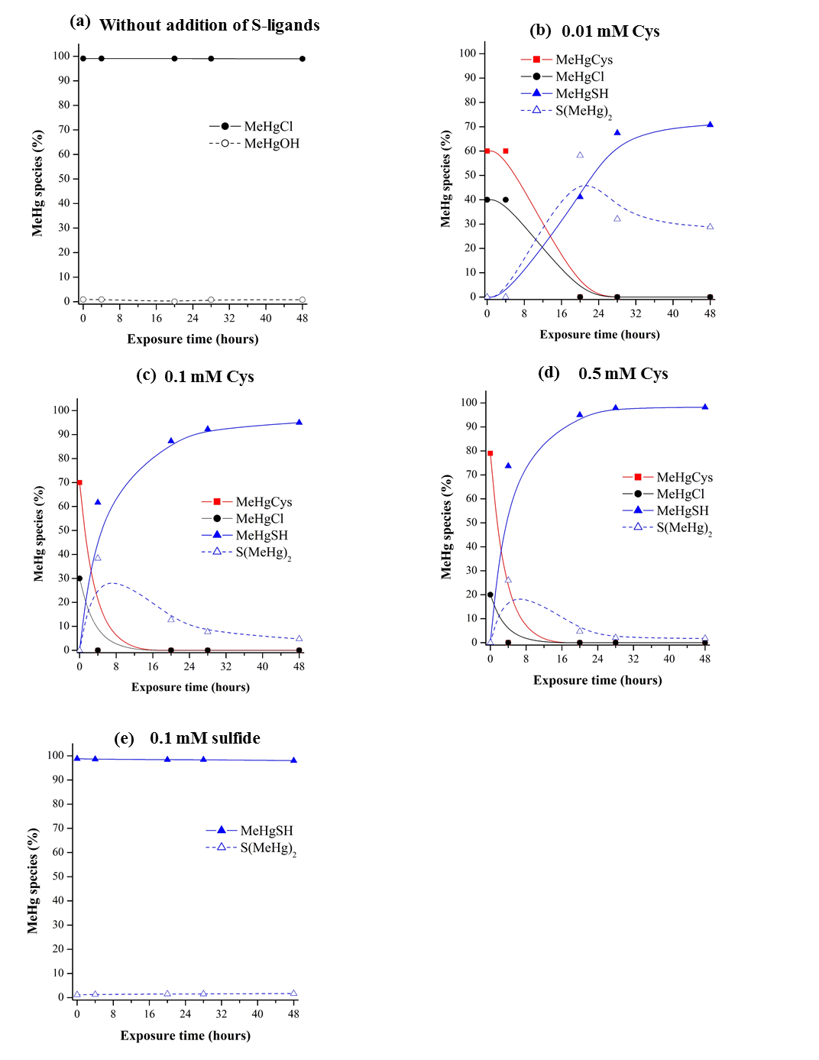

**Figure S5.** Chemical modeling using Minteq software for major MeHg species in the assay medium without externally added S-ligands (a), increasing Cyst concentrations (b, c and d) and with 0.1 mM of sulfide (e) plotted against exposure time.

**Table S2**. Species, reactions and stability constants for the speciation model of Hg(II) and MeHg in assay medium.

|  |  |  |  |  |  |  |  |  |  |  |  |  |  |  |  |  |  |  |  |
| --- | --- | --- | --- | --- | --- | --- | --- | --- | --- | --- | --- | --- | --- | --- | --- | --- | --- | --- | --- |
| Ref | Species | Compounds | | | | | | | | | | | | | | | | | |
| **log K** | **Cl-1** | **CystN-1** | **Cys-1** | **GluCys-1** | **Glyc-1** | **H+1** | **H2O** | **H2S** | **HCys-1** | **Hg+2** | **MAC-1** | **MeHg+1** | **NACCYS-1** | **Pen-1** | **2MPA-1** | **CysGly-1** | **R-COO-1** |
| 1 | **CystN-H** | 10.3 | 0 | 1 | 0 | 0 | 0 | 1 | 0 | 0 | 0 | 0 | 0 | 0 | 0 | 0 | 0 | 0 | 0 |
| 1 | **GluCys-H** | 9.9 | 0 | 0 | 0 | 1 | 0 | 1 | 0 | 0 | 0 | 0 | 0 | 0 | 0 | 0 | 0 | 0 | 0 |
| 1 | **Pen-H** | 8.3 | 0 | 0 | 0 | 0 | 0 | 1 | 0 | 0 | 0 | 0 | 0 | 0 | 0 | 1 | 0 | 0 | 0 |
| 1 | **NACCYS-H** | 9.79 | 0 | 0 | 0 | 0 | 0 | 1 | 0 | 0 | 0 | 0 | 0 | 0 | 1 | 0 | 0 | 0 | 0 |
| 1 | **MAC-H** | 10.16 | 0 | 0 | 0 | 0 | 0 | 1 | 0 | 0 | 0 | 0 | 1 | 0 | 0 | 0 | 0 | 0 | 0 |
| 1 | **Glyc-H** | 9.42 | 0 | 0 | 0 | 0 | 1 | 1 | 0 | 0 | 0 | 0 | 0 | 0 | 0 | 0 | 0 | 0 | 0 |
| 1 | **HCys-H** | 9.87 | 0 | 0 | 0 | 0 | 0 | 1 | 0 | 0 | 1 | 0 | 0 | 0 | 0 | 0 | 0 | 0 | 0 |
| 1 | **HCysteine-** | 10.8 | 0 | 0 | 1 | 0 | 0 | 1 | 0 | 0 | 0 | 0 | 0 | 0 | 0 | 0 | 0 | 0 | 0 |
| 2 | **HgCl+** | 7.1 | 1 | 0 | 0 | 0 | 0 | 0 | 0 | 0 | 0 | 1 | 0 | 0 | 0 | 0 | 0 | 0 | 0 |
| 2 | **Hg(Cl)2** | 13.8 | 2 | 0 | 0 | 0 | 0 | 0 | 0 | 0 | 0 | 1 | 0 | 0 | 0 | 0 | 0 | 0 | 0 |
| 2 | **Hg(Cl)3 -** | 14.7 | 3 | 0 | 0 | 0 | 0 | 0 | 0 | 0 | 0 | 1 | 0 | 0 | 0 | 0 | 0 | 0 | 0 |
| 2 | **Hg(Cl)4 2-** | 15.4 | 4 | 0 | 0 | 0 | 0 | 0 | 0 | 0 | 0 | 1 | 0 | 0 | 0 | 0 | 0 | 0 | 0 |
| 2 | **HgOH+** | -3.4 | 0 | 0 | 0 | 0 | 0 | -1 | 1 | 0 | 0 | 1 | 0 | 0 | 0 | 0 | 0 | 0 | 0 |
| 2 | **Hg(OH)2** | -6.2 | 0 | 0 | 0 | 0 | 0 | -2 | 2 | 0 | 0 | 1 | 0 | 0 | 0 | 0 | 0 | 0 | 0 |
| 2 | **HgOHCl** | 4.3 | 1 | 0 | 0 | 0 | 0 | -1 | 1 | 0 | 0 | 1 | 0 | 0 | 0 | 0 | 0 | 0 | 0 |
| 3 | **HgCl(Cys)** | 28.5 | 1 | 0 | 1 | 0 | 0 | 0 | 0 | 0 | 0 | 1 | 0 | 0 | 0 | 0 | 0 | 0 | 0 |
| 3 | **HgCl(CystN)** | 28.5 | 1 | 1 | 0 | 0 | 0 | 0 | 0 | 0 | 0 | 1 | 0 | 0 | 0 | 0 | 0 | 0 | 0 |
| 3 | **HgCl(GluCys)** | 28.5 | 1 | 0 | 0 | 1 | 0 | 0 | 0 | 0 | 0 | 1 | 0 | 0 | 0 | 0 | 0 | 0 | 0 |
| 3 | **HgCl(Glyc)** | 28.5 | 1 | 0 | 0 | 0 | 1 | 0 | 0 | 0 | 0 | 1 | 0 | 0 | 0 | 0 | 0 | 0 | 0 |
| 3 | **HgCl(HCys)** | 28.5 | 1 | 0 | 0 | 0 | 0 | 0 | 0 | 0 | 1 | 1 | 0 | 0 | 0 | 0 | 0 | 0 | 0 |
| 3 | **HgCl(MAC)** | 28.5 | 1 | 0 | 0 | 0 | 0 | 0 | 0 | 0 | 0 | 1 | 1 | 0 | 0 | 0 | 0 | 0 | 0 |
| 3 | **HgCl(Pen)** | 28.5 | 1 | 0 | 0 | 0 | 0 | 0 | 0 | 0 | 0 | 1 | 0 | 0 | 0 | 1 | 0 | 0 | 0 |
| 3 | **HgCl(NACCYS)** | 28.5 | 1 | 0 | 0 | 0 | 0 | 0 | 0 | 0 | 0 | 1 | 0 | 0 | 1 | 0 | 0 | 0 | 0 |
| 3 | **HgOH(CystN)** | 18.5 | 0 | 1 | 0 | 0 | 0 | -1 | 1 | 0 | 0 | 1 | 0 | 0 | 0 | 0 | 0 | 0 | 0 |
| 3 | **HgOH(GluCys)** | 18.5 | 0 | 0 | 0 | 1 | 0 | -1 | 1 | 0 | 0 | 1 | 0 | 0 | 0 | 0 | 0 | 0 | 0 |
| 3 | **HgOH(Glyc)** | 18.5 | 0 | 0 | 0 | 0 | 1 | -1 | 1 | 0 | 0 | 1 | 0 | 0 | 0 | 0 | 0 | 0 | 0 |
| 3 | **HgOH(HCys)** | 18.5 | 0 | 0 | 0 | 0 | 0 | -1 | 1 | 0 | 1 | 1 | 0 | 0 | 0 | 0 | 0 | 0 | 0 |
| 3 | **HgOH(MAC)** | 18.5 | 0 | 0 | 0 | 0 | 0 | -1 | 1 | 0 | 0 | 0 | 1 | 0 | 0 | 0 | 0 | 0 | 0 |
| 3 | **HgOH(NACCYS)** | 18.5 | 0 | 0 | 0 | 0 | 0 | -1 | 1 | 0 | 0 | 1 | 0 | 0 | 1 | 0 | 0 | 0 | 0 |
| 3 | **HgOH(Pen)** | 18.5 | 0 | 0 | 0 | 0 | 0 | -1 | 1 | 0 | 0 | 1 | 0 | 0 | 0 | 1 | 0 | 0 | 0 |
| 1,4,5 | **HgCys+** | 25 | 0 | 0 | 1 | 0 | 0 | 0 | 0 | 0 | 0 | 1 | 0 | 0 | 0 | 0 | 0 | 0 | 0 |
| 1,4,5 | **HgGluCys+** | 25.7 | 0 | 0 | 0 | 1 | 0 | 0 | 0 | 0 | 0 | 1 | 0 | 0 | 0 | 0 | 0 | 0 | 0 |
| 1,4,5 | **HgGlyc+** | 26 | 0 | 0 | 0 | 0 | 1 | 0 | 0 | 0 | 0 | 1 | 0 | 0 | 0 | 0 | 0 | 0 | 0 |
| 1,4,5 | **HgPen+** | 25.7 | 0 | 0 | 0 | 0 | 0 | 0 | 0 | 0 | 0 | 1 | 0 | 0 | 0 | 1 | 0 | 0 | 0 |
| 1,4,5 | **HgHCys+** | 25.5 | 0 | 0 | 0 | 0 | 0 | 0 | 0 | 0 | 1 | 1 | 0 | 0 | 0 | 0 | 0 | 0 | 0 |
| 1,4,5 | **HgMAC+** | 26.5 | 0 | 0 | 0 | 0 | 0 | 0 | 0 | 0 | 0 | 1 | 1 | 0 | 0 | 0 | 0 | 0 | 0 |
| 1,4,5 | **HgNACCYS+** | 26 | 0 | 0 | 0 | 0 | 0 | 0 | 0 | 0 | 0 | 1 | 0 | 0 | 1 | 0 | 0 | 0 | 0 |
| 1 | **Hg(Cys)2** | 37.5 | 0 | 0 | 2 | 0 | 0 | 0 | 0 | 0 | 0 | 1 | 0 | 0 | 0 | 0 | 0 | 0 | 0 |
| 6 | **Hg(Cys)3-** | 40.45 | 0 | 0 | 3 | 0 | 0 | 0 | 0 | 0 | 0 | 1 | 0 | 0 | 0 | 0 | 0 | 0 | 0 |
| 6 | **Hg(Cys)4 2-** | 42.6 | 0 | 0 | 4 | 0 | 0 | 0 | 0 | 0 | 0 | 1 | 0 | 0 | 0 | 0 | 0 | 0 | 0 |
| 1 | **Hg(CystN)2** | 40.3 | 0 | 2 | 0 | 0 | 0 | 0 | 0 | 0 | 0 | 1 | 0 | 0 | 0 | 0 | 0 | 0 | 0 |
| 1 | **Hg(GluCys)2** | 40.3 | 0 | 0 | 0 | 2 | 0 | 0 | 0 | 0 | 0 | 1 | 0 | 0 | 0 | 0 | 0 | 0 | 0 |
| 1 | **Hg(Glyc)2** | 39.4 | 0 | 0 | 0 | 0 | 2 | 0 | 0 | 0 | 0 | 1 | 0 | 0 | 0 | 0 | 0 | 0 | 0 |
| 1 | **Hg(Hcys)2** | 39.4 | 0 | 0 | 0 | 0 | 0 | 0 | 0 | 0 | 2 | 1 | 0 | 0 | 0 | 0 | 0 | 0 | 0 |
| 1 | **Hg(2MPA)2** | 41.5 | 0 | 0 | 0 | 0 | 0 | 0 | 0 | 0 | 0 | 0 | 0 | 0 | 0 | 0 | 2 | 0 | 0 |
| 1 | **Hg(CysGly)2** | 34.6 | 0 | 0 | 0 | 0 | 0 | 0 | 0 | 0 | 0 | 0 | 0 | 0 | 0 | 0 | 0 | 2 | 0 |
| 1 | **Hg(MAC)2** | 40.9 | 0 | 0 | 0 | 0 | 0 | 0 | 0 | 0 | 0 | 1 | 2 | 0 | 0 | 0 | 0 | 0 | 0 |
| 1 | **Hg(NACCYS)2** | 40.2 | 0 | 0 | 0 | 0 | 0 | 0 | 0 | 0 | 0 | 1 | 0 | 0 | 2 | 0 | 0 | 0 | 0 |
| 1 | **Hg(Pen)2** | 36.3 | 0 | 0 | 0 | 0 | 0 | 0 | 0 | 0 | 0 | 1 | 0 | 0 | 0 | 2 | 0 | 0 | 0 |
| 3 | **Hg(SH)2 0** | 24.6 | 0 | 0 | 0 | 0 | 0 | -2 | 0 | 2 | 0 | 1 | 0 | 0 | 0 | 0 | 0 | 0 | 0 |
| 3 | **HgClSH** | 18.9 | 1 | 0 | 0 | 0 | 0 | -1 | 0 | 1 | 0 | 1 | 0 | 0 | 0 | 0 | 0 | 0 | 0 |
| 3 | **HgOHSH** | 9.4 | 0 | 0 | 0 | 0 | 0 | -2 | 1 | 1 | 0 | 1 | 0 | 0 | 0 | 0 | 0 | 0 | 0 |
| 3 | **HgS2 2-** | 8.9 | 0 | 0 | 0 | 0 | 0 | -4 | 0 | 2 | 0 | 1 | 0 | 0 | 0 | 0 | 0 | 0 | 0 |
| 7 | **HgS(s)** | 29.8 | 0 | 0 | 0 | 0 | 0 | -2 | 0 | 1 | 0 | 1 | 0 | 0 | 0 | 0 | 0 | 0 | 0 |
| 3 | **HgS2H-** | 18.2 | 0 | 0 | 0 | 0 | 0 | -3 | 0 | 2 | 0 | 1 | 0 | 0 | 0 | 0 | 0 | 0 | 0 |
| 3 | **HgSH+** | 13 | 0 | 0 | 0 | 0 | 0 | -1 | 0 | 1 | 0 | 1 | 0 | 0 | 0 | 0 | 0 | 0 | 0 |
| 4 | **Hg(COO)2** | 8.4 | 0 | 0 | 0 | 0 | 0 | 0 | 0 | 0 | 0 | 1 | 0 | 0 | 0 | 0 | 0 | 0 | 2 |
| 4 | **Hg(RCOO)+** | 3.7 | 0 | 0 | 0 | 0 | 0 | 0 | 0 | 0 | 0 | 1 | 0 | 0 | 0 | 0 | 0 | 0 | 1 |
| 8 | **MeHgOH** | -4.5 | 0 | 0 | 0 | 0 | 0 | -1 | 1 | 0 | 0 | 0 | 0 | 1 | 0 | 0 | 0 | 0 | 0 |
| 8 | **MeHgCl** | 5.4 | 1 | 0 | 0 | 0 | 0 | 0 | 0 | 0 | 0 | 0 | 0 | 1 | 0 | 0 | 0 | 0 | 0 |
| 9 | **MeHgCys** | 16.7 | 0 | 0 | 1 | 0 | 0 | 0 | 0 | 0 | 0 | 0 | 0 | 1 | 0 | 0 | 0 | 0 | 0 |
| 9 | **MeHgCystN** | 16.7 | 0 | 1 | 0 | 0 | 0 | 0 | 0 | 0 | 0 | 0 | 0 | 1 | 0 | 0 | 0 | 0 | 0 |
| 9 | **MeHgGluCys** | 16.7 | 0 | 0 | 0 | 1 | 0 | 0 | 0 | 0 | 0 | 0 | 0 | 1 | 0 | 0 | 0 | 0 | 0 |
| 9 | **MeHgGlyc** | 16.7 | 0 | 0 | 0 | 0 | 1 | 0 | 0 | 0 | 0 | 0 | 0 | 1 | 0 | 0 | 0 | 0 | 0 |
| 9 | **MeHgHCys** | 16.5 | 0 | 0 | 0 | 0 | 0 | 0 | 0 | 0 | 1 | 0 | 0 | 1 | 0 | 0 | 0 | 0 | 0 |
| 9 | **MeHgMAC** | 16.7 | 0 | 0 | 0 | 0 | 0 | 0 | 0 | 0 | 0 | 0 | 1 | 1 | 0 | 0 | 0 | 0 | 0 |
| 9 | **MeHgNACCYS** | 16.7 | 0 | 0 | 0 | 0 | 0 | 0 | 0 | 0 | 0 | 0 | 0 | 1 | 1 | 0 | 0 | 0 | 0 |
| 8 | **MeHgOOCR** | 2.95 | 0 | 0 | 0 | 0 | 0 | 0 | 0 | 0 | 0 | 0 | 0 | 1 | 0 | 0 | 0 | 0 | 1 |
| 9 | **MeHgPen** | 17 | 0 | 0 | 0 | 0 | 0 | 0 | 0 | 0 | 0 | 0 | 0 | 1 | 0 | 1 | 0 | 0 | 0 |
| 8 | **MeHgS-** | 0.12 | 0 | 0 | 0 | 0 | 0 | -2 | 0 | 1 | 0 | 0 | 0 | 1 | 0 | 0 | 0 | 0 | 0 |
| 8 | **MeHgSH** | 7.5 | 0 | 0 | 0 | 0 | 0 | -1 | 0 | 1 | 0 | 0 | 0 | 1 | 0 | 0 | 0 | 0 | 0 |
| 8 | **S(MeHg)2** | 16.4 | 0 | 0 | 0 | 0 | 0 | -2 | 0 | 1 | 0 | 0 | 0 | 2 | 0 | 0 | 0 | 0 | 0 |

**References**

(1) Liem-Nguyen, V.; Skyllberg, U.; Nam, K.; Björn, E.; Liem-Nguyen, V.; Skyllberg, U.; Nam, K.; Björn, E. Thermodynamic Stability of Mercury(II) Complexes Formed with Environmentally Relevant Low-Molecular-Mass Thiols Studied by Competing Ligand Exchange and Density Functional Theory. *Environ. Chem.* **2017**, *14* (4), 243–253. https://doi.org/10.1071/EN17062.

(2) Smith, R. M.; Martell, A.; Motekaitis, R.; Smith, R.; Motekaitis, R. NIST Critically Selected Stability Constants of Metal Complexes Database; 2004.

(3) Dyrssen, D.; Wedborg, M. The Sulphur-Mercury(II) System in Natural Waters. *Water, Air, and Soil Pollution* **1991**, *56* (1), 507–519. https://doi.org/10.1007/BF00342295.

(4) Ravichandran, M. Interactions between Mercury and Dissolved Organic Matter––a Review. *Chemosphere* **2004**, *55* (3), 319–331. https://doi.org/10.1016/j.chemosphere.2003.11.011.

(5) Cardiano, P.; Falcone, G.; Foti, C.; Sammartano, S. Sequestration of Hg2+ by Some Biologically Important Thiols. *Journal of Chemical & Engineering Data* **2011**, *56*. https://doi.org/10.1021/je200735r.

(6) Warner, T.; Jalilehvand, F. Formation of Hg(II) Tetrathiolate Complexes with Cysteine at Neutral PH. *Can J Chem* **2016**, *94* (4), 373–379. https://doi.org/10.1139/cjc-2015-0375.

(7) Drott, A.; Björn, E.; Bouchet, S.; Skyllberg, U. Refining Thermodynamic Constants for Mercury(II)-Sulfides in Equilibrium with Metacinnabar at Sub-Micromolar Aqueous Sulfide Concentrations. *Environ. Sci. Technol.* **2013**, *47* (9), 4197–4203. https://doi.org/10.1021/es304824n.

(8) Loux, N. T. An Assessment of Thermodynamic Reaction Constants for Simulating Aqueous Environmental Monomethylmercury Speciation. *Chemical Speciation & Bioavailability* **2007**, *19* (4), 183–196. https://doi.org/10.3184/095422907X255947.

(9) Rabenstein, D. L.; Reid, R. S. Nuclear Magnetic Resonance Studies of the Solution Chemistry of Metal Complexes. 20. Ligand-Exchange Kinetics of Methylmercury(II)-Thiol Complexes. *Inorg. Chem.* **1984**, *23* (9), 1246–1250. https://doi.org/10.1021/ic00177a016.