Supplementary Material

## Supplementary Figure

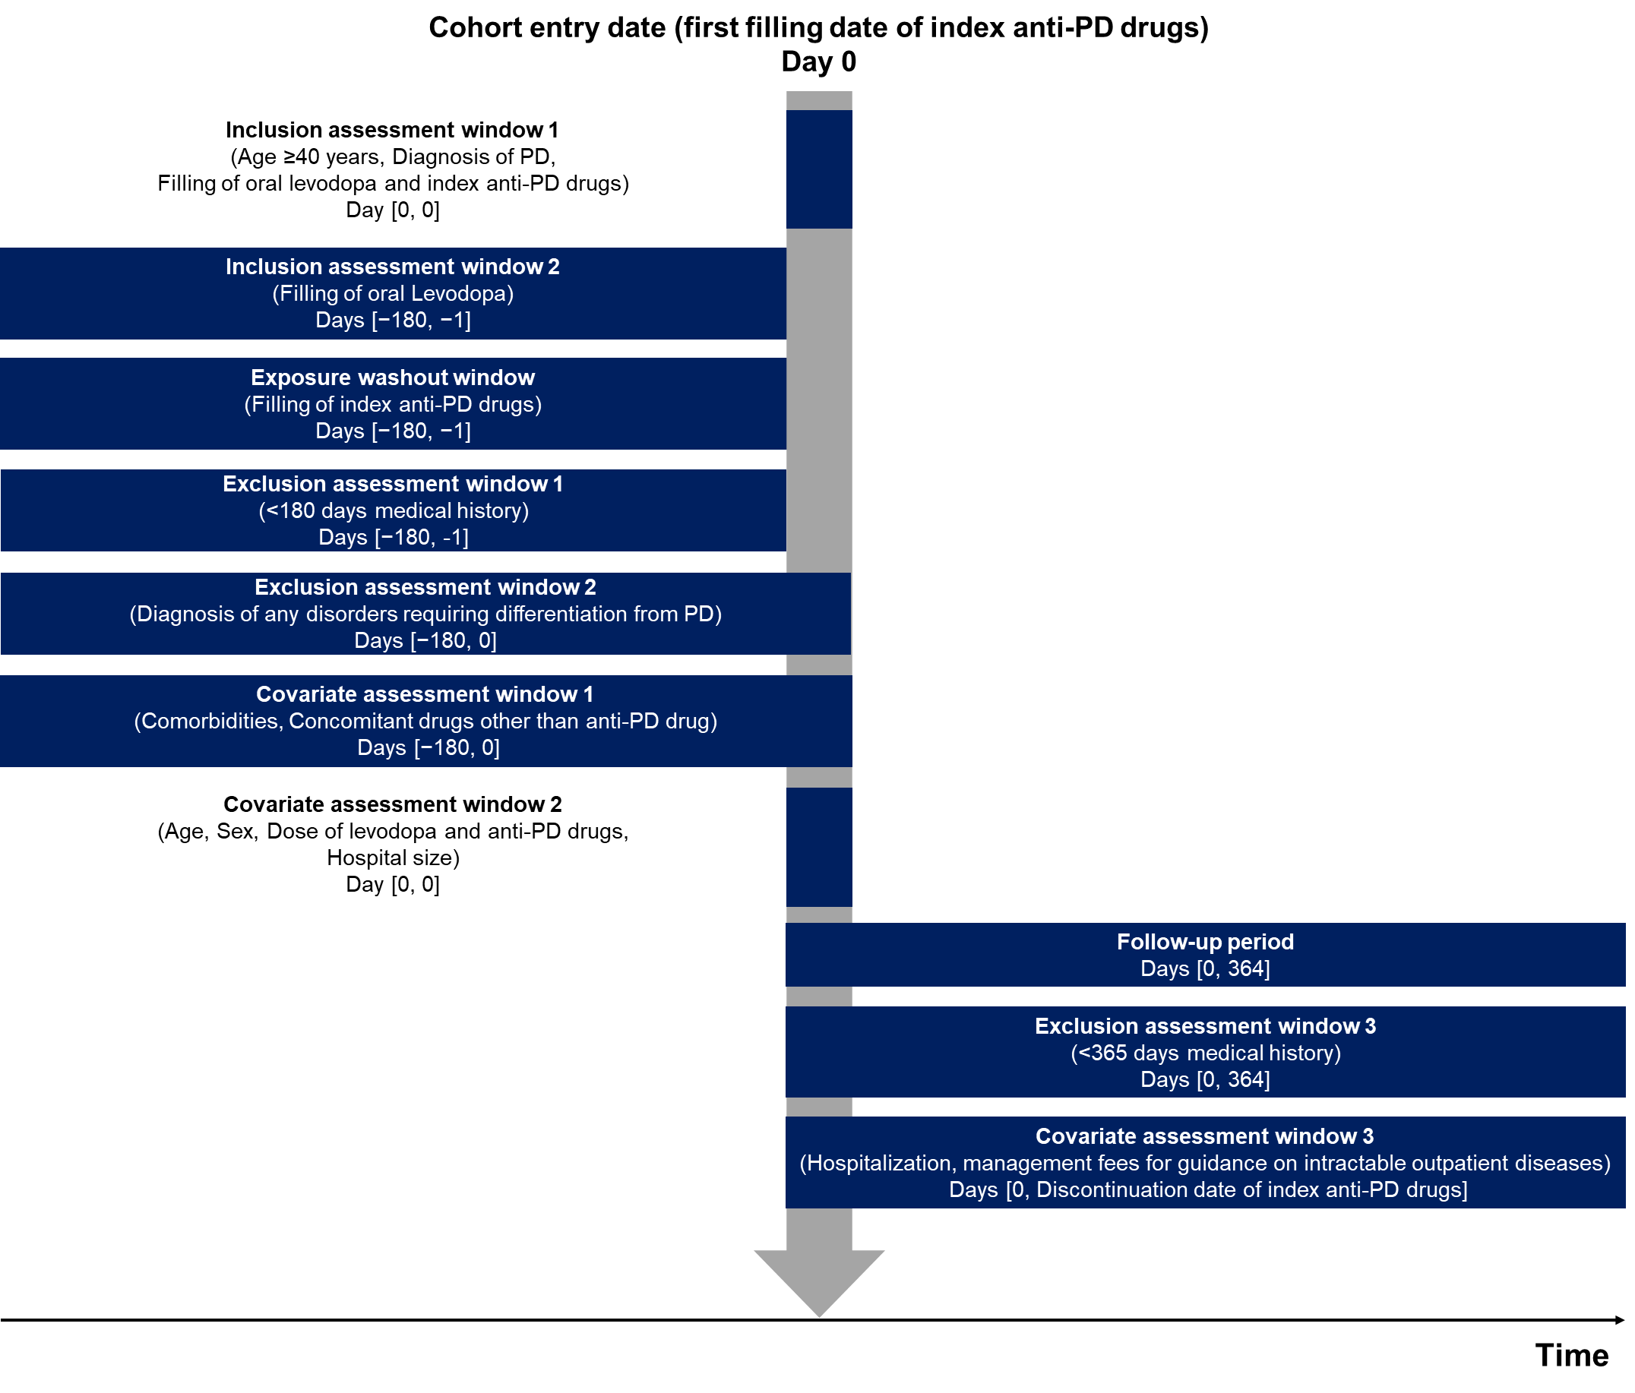

**Supplementary Figure 1.** Study design

Abbreviation: PD, Parkinson’s disease.

**Supplementary Tables**

**Supplementary Table 1.** Drug codes

**Supplementary Table 2.** Disease codes

**Supplementary Table 3.** Background characteristics of the study population by individual drug

**Supplementary Table 4.** Study population in each cohort

**Supplementary Table 5.** Subgroup analysis of persistence of anti-PD drug treatment

**Supplementary Table 6.** Subgroup analysis of adherence to anti- PD drugs

**Supplementary Table 7.** Sensitivity analysis of persistence of anti-PD drug treatment

**Supplementary Table 8.** Sensitivity analysis of PDC of anti-PD drug treatment

**Supplementary Table 9.** PDC of anti-PD drug treatment to the last fill date in the follow-up period

**Supplementary Table 10.** MPR of anti-PD drug treatment to the last fill date in the follow-up period