Appendix A
Due to the extensive volume of bibliometric data and supplementary materials, detailed appendices including the complete dataset, R code for analysis, and additional visualizations are made available through a cloud storage repository. These materials can be accessed via insert link as below or by contacting the corresponding author. The comprehensive appendices include:

Complete list of included studies
- R code for bibliometric analysis and visualization
- Supplementary figures and detailed network metrics
- Extended data tables and analysis results

The authors will maintain this data repository for at least five years following publication. For any inquiries regarding access to these materials, please contact the corresponding author at [email address open after proof due to the anonymous review requires].

- List of Included Studies
- https://hunnueducn-my.sharepoint.com/:x:/g/personal/201930175079_hunnu_edu_cn/EYS2FWogGQNPn_vmQtE7j30Bm-TOpUpzkMKXYYHQ5wcBZw?e=3jHozs
- Code for Bibliometric Analysis
https://hunnueducn-my.sharepoint.com/:f:/g/personal/201930175079_hunnu_edu_cn/Ev-lYN3kt3lNukyLrWq7aw8Bi08KmzrKkUtblDFu-AHtCg?e=wDLLA5
- Additional Network Analyses & Supplementary Tables
https://hunnueducn-my.sharepoint.com/:f:/g/personal/201930175079_hunnu_edu_cn/Eg6TKN2tKExGlzWl9qu_hLAB7d-tvAC1g7rvbaLXdKMjAQ?e=WfTnyA

Appendix Tables
Supplementary Table S1: Complete Author Information for Top 10 Highly Cited Papers
Rank | Complete Author List | Corresponding Author(s)
1 | Juslin PN, Västfjäll D | Juslin PN
2 | Menon V, Levitin DJ | Menon V
3 | Naseer N, Hong KS | Hong KS
4 | Zentner M, Eerola T | Zentner M
5 | Chanda ML, Levitin DJ | Chanda ML
6 | Särkämö T, Tervaniemi M, Laitinen S, Forsblom A, Soinila S, Mikkonen M, Autti T, Silvennoinen HM, Erkkilä J, Laine M, Peretz I, Hietanen M | Särkämö T
7 | Greenlee H, Dupont-Reyes MJ, Balneaves LG, Carlson LG, Cohen LE, Deng G, Johnson JA, Mumber M, Seely D, Zick SM | Carlson LG
8 | Boyce SM, Tripathy D, Koelsch S | Koelsch S
9 | Barrett FS, Grimm KJ, Robins RW, Wildschut T, Sedikides C, Janata P | Robins KJ
10 | Lehrner J, Marwinski G, Lehr S, Johren P, Deecke L | Lehrner J
Note: Author names are listed as they appear in the original publications. Corresponding authors are identified based on the original paper's contact information.

Supplementary Table S2: Complete Journal Information and Impact Metrics
Rank | Complete Journal Name | Journal Abbreviation | Impact Factor* | Publisher | Category
1 | Behavioral and Brain Sciences | Behav Brain Sci | 20.6 | Cambridge University Press | Psychology/Neuroscience
2 | NeuroImage | NeuroImage | 5.9 | Elsevier | Neuroimaging
3 | Frontiers in Human Neuroscience | Front Hum Neurosci | 2.9 | Frontiers Media | Neuroscience
4 | Proceedings of the National Academy of Sciences | PNAS | 12.8 | National Academy of Sciences | Multidisciplinary
5 | Trends in Cognitive Sciences | Trends Cogn Sci | 21.2 | Elsevier | Cognitive Science
6 | Brain | Brain | 14.5 | Oxford University Press | Neurology
7 | CA: A Cancer Journal for Clinicians | CA Cancer J Clin | 286.1 | American Cancer Society | Oncology
8 | Trends in Cognitive Sciences | Trends Cogn Sci | 21.2 | Elsevier | Cognitive Science
9 | Emotion | Emotion | 3.4 | American Psychological Association | Psychology
10 | Physiology & Behavior | Physiol Behav | 3.0 | Elsevier | Behavioral Sciences

Appendix B
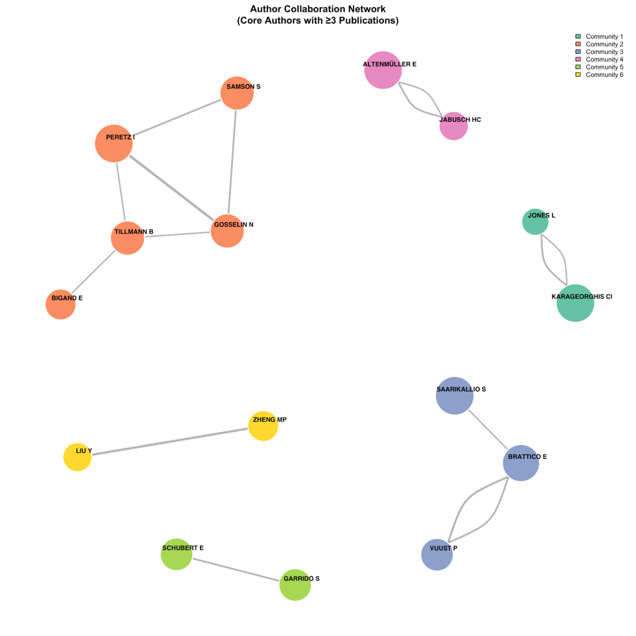
B1. Author Collaboration

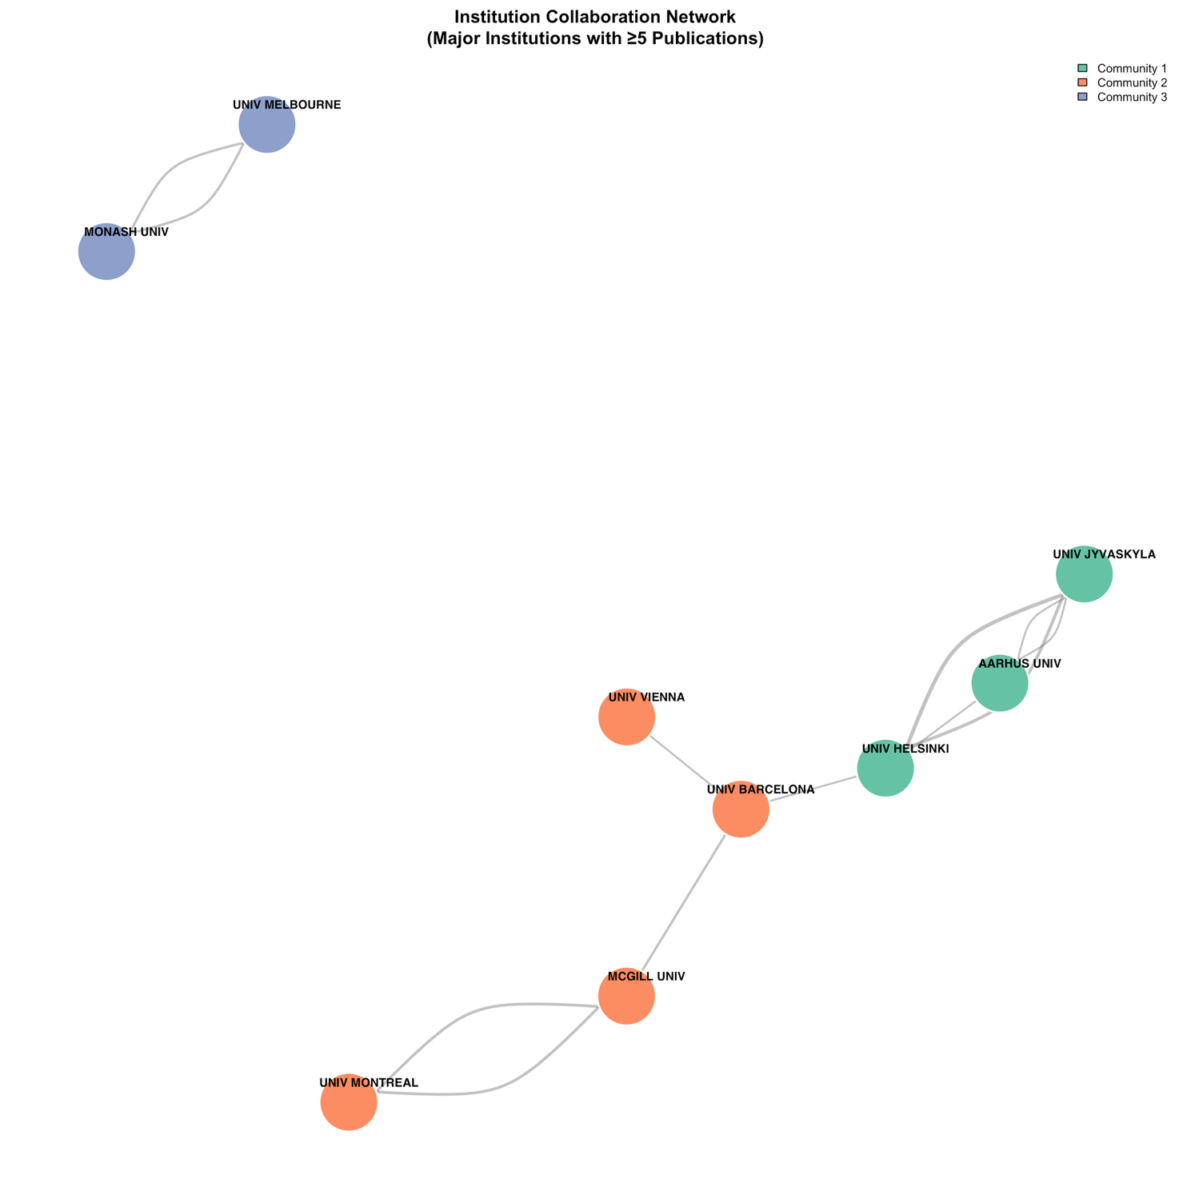
B2. Institutional Collaboration Network

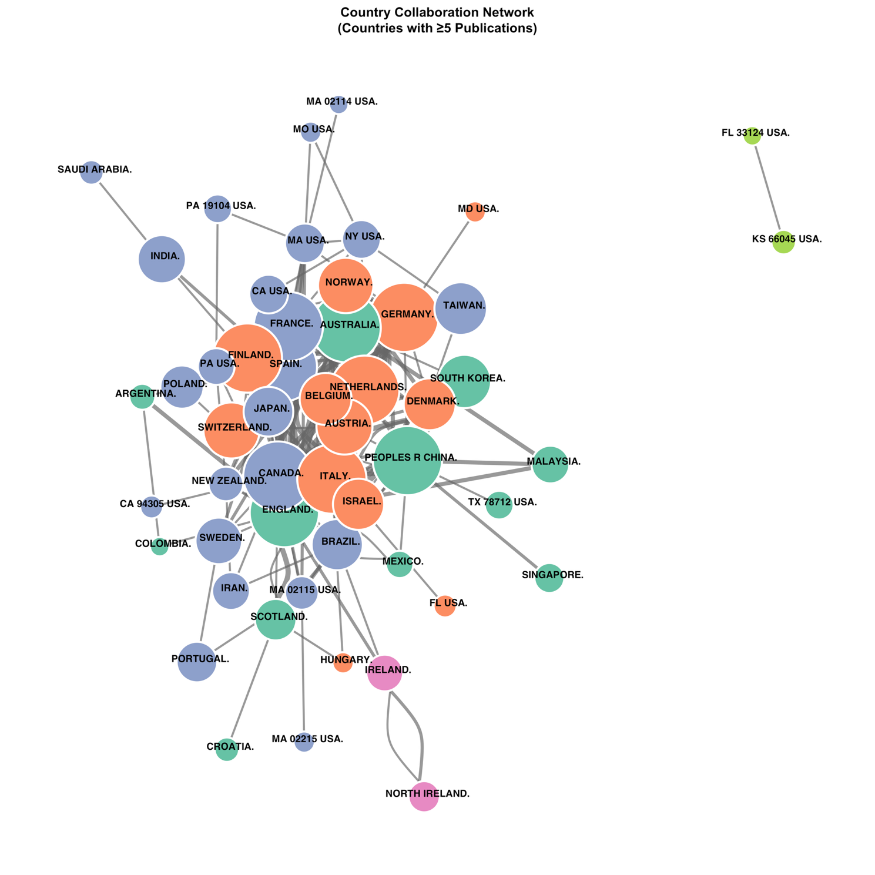
B3. Country-level Collaboration Network

