Supplementary Material

Supplementary Figures
Supplementary Figure 1. Analysis of the effect of the intervention by Training Center on the parameters of subjective happiness
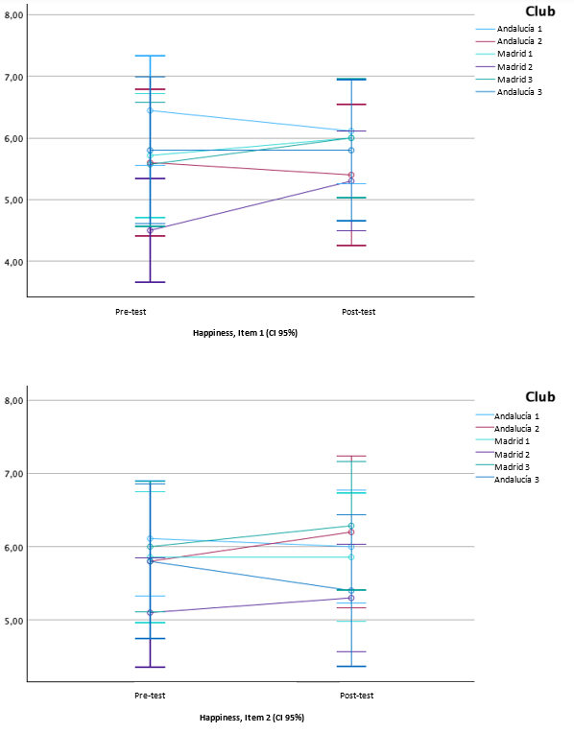
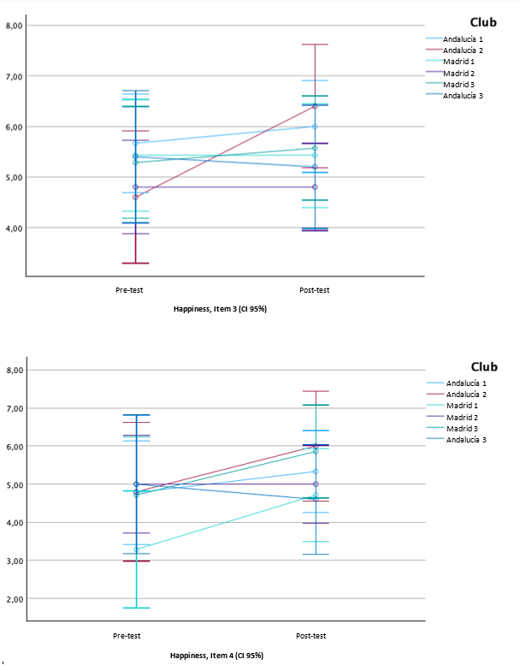

Supplementary Figure 2. Analysis of the effect of the intervention according to the Sports Center on self-perceived health parameters
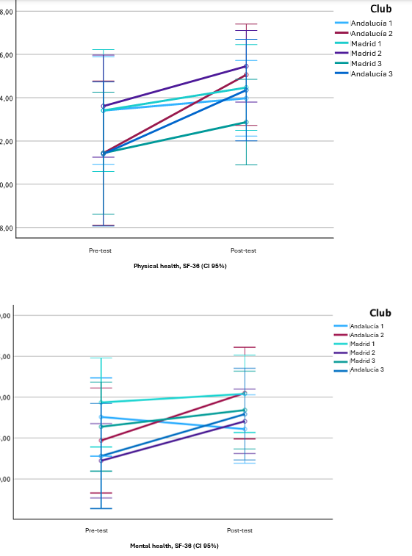
Supplementary Figure 3. Analysis of the effect of the intervention according to sex on the parameters of subjective happiness levels

Supplementary Figure 4. Analysis of the effect of the intervention according to sex on self-perceived health parameters
