Supplementary Material

Table S1. Strains used in this study.
Strain | Genotype | Pathway(s) affected |  | Mechanism of quinolone resistance^{c} |  |  |  | Source
 |  |  |  | gyrA | gyrB | parC | parE
E. coli BW25113ª | wild-type E. coli strain BW25113 | - |  | - | - | - | - | (Baba et al., 2006)
E. coli BW25113 ∆fumAª | fumA knock-out | TCA cycle and DNA repair signalling |  | - | - | - | - | (Baba et al., 2006)
E. coli BW25113 ∆fumBª | fumB knock-out |  |  | - | - | - | - | (Baba et al., 2006)
E. coli BW25113 ∆fumCª | fumC knock-out |  |  | - | - | - | - | (Baba et al., 2006)
E. coli BW25113 ∆alkAª | alkA knock-out | Adaptive response |  | - | - | - | - | (Baba et al., 2006)
E. coli BW25113 ∆alkBª | alkB knock-out |  |  | - | - | - | - | (Baba et al., 2006)
E. coli BW25113 ∆aidBª | aidB knock-out |  |  | - | - | - | - | (Baba et al., 2006)
E. coli BW25113 ∆recAª | recA knock-out | SOS response |  | - | - | - | - | (Baba et al., 2006)
E. coli BW25113 ∆fumC/∆recAª | fumC / recA double knock-out | TCA cycle and DNA repair signalling, SOS response |  | - | - | - | - | This study
E. coli BW25113 ∆aidB/∆recAª | aidB / recA double knock-out | Adaptive and SOS responses |  | - | - | - | - | This study
E. coli FI20^{b} | E. coli clinical strain FI20 | - |  | S83L | - | S80R | I529L | (Machuca et al., 2021)
E. coli FI20 ∆fumC^{b} | fumC knock-out | TCA cycle and DNA repair signalling |  | S83L | - | S80R | I529L | This study
E. coli FI20 ∆recA^{b} | recA knock-out | SOS response |  | S83L | - | S80R | I529L | (Machuca et al., 2021)
E. coli FI20 ∆fumC/∆recA^{b} | fumC / recA double knock-out | TCA cycle and DNA repair signalling, SOS response |  | S83L | - | S80R | I529L | This study
ª Isogenic strains of BW25113 carrying only the inactivated gene(s) indicated.
^{b} Isogenic strains of clinical isolate F120 carrying only the inactivated gene(s) indicated. FI20 is an ST131 clone according to the University of Warwick MLST scheme (https://enterobase.warwick.ac.uk
^{c} Resistance-associated mutations in gyr and par genes have been identified as quinolone-resistance determinants. Aminoacid changes are shown.

Table S2. Oligonucleotides, phages and plasmids used in this study for genetic manipulation.
Oligonucleotides
Oligonucleotides for gene inactivation testing
Name | Sequence (5' -> 3') | Description and annealing location | Reference
pre-fumA | TGGAGCCGCAAAAAGTCGTA | fumA locus-specific, forward and external | This study
post-fumA | ATCTGCCGGGACATCAATCG | fumA locus-specific, reverse and external | This study
pre-fumB | CCGCGATGTACGGGTTCTTA | fumB locus-specific, forward and external | This study
post-fumB | TGAGTTTGTCATGGGCCGAA | fumB locus-specific, reverse and external | This study
pre-fumC | TGCACCCGCTGTGTGAAATA | fumC locus-specific, forward and external | This study
post-fumC | TGCCCTACACCACTGATTGC | fumC locus-specific, reverse and external | This study
pre-alkA | GACCGCCACTGAACAGTTTG | alkA locus-specific, forward and external | This study
post-alkA | TTAACTGAGGCGTGCTTCCC | alkA locus-specific, reverse and external | This study
pre-alkB | TGCGGTGAAACCGTCAGTTA | alkB locus-specific, forward and external | This study
post-alkB | TTCCATGCAGAAAACCCGGA | alkB locus-specific, reverse and external | This study
pre-aidB | CTCACGTTTCGTTCCGCATT | aidB locus-specific, forward and external | This study
post-aidB | TGATAACTGGCGCGTACAGG | aidB locus-specific, reverse and external | This study
pre-recA | TCGTCAGGCTACTGCGTATGCAT | recA locus-specific, forward and external | (Recacha et al., 2017)
post-recA | GTACCGCACGATCCAACAGGCGA | recA locus-specific, reverse and external | (Recacha et al., 2017)
K1 | CAGTCATAGCCGAATAGCCT | Kanamycin cassette-specific, reverse and internal | (Datsenko and Wanner, 2000)
K2 | CGGTGCCCTGAATGAACTGC | Kanamycin cassette-specific, forward and internal | (Datsenko and Wanner, 2000)

Oligonucleotides using the Datsenko inactivation protocol
Sequence (5' -> 3')ª | Description | Reference
GTTGCTTAACGAAAGCAAAACAGAAAGAAAAAATTAATCAGGTGAGGAGCAGGTCATGAATACAGTACGCgtgtaggctggagctgcttc | Forward primer for fumC inactivation, with a 5’-extension homologous to the upstream fumC genomic region | This study
ACCTCAGGCGCAGCCGCTTCGTTTGATCATTCCACGGCTGCACCTGTATGTTGCAGATTAACGCCCGGCTTTatgggaattagccatggtcc | Reverse primer for fumC inactivation, with a 5’-extension homologous to the downstream fumC genomic region | This study
CAGAACATATTGACTATCCGGTATTACCCGGCATGACAGGAGTAAAAATGGCTATCGACGAAAACAAACAgtgtaggctggagctgcttc | Forward primer for recA inactivation, with a 5’-extension homologous to the upstream recA genomic region | (Recacha et al., 2017)
ATGCGACCCTTGTGTATCAAACAAGACGATTAAAAATCTTCGTTAGTTTCTGCTACGCCTTCGCTATCATatgggaattagccatggtcc | Reverse primer for recA inactivation, with a 5’-extension homologous to the downstream recA genomic region | (Recacha et al., 2017)

Phage
Description | Reference
Gene inactivation by P1 phage transduction | (Thomason et al., 2007)
Plasmids
Description | Reference
Plasmid encoding a FLP heat shock exonuclease. Used for excision of the kanamycin resistance cassette from the chromosome via FRT sites. | (Datsenko and Wanner, 2000)
Plasmid used as PCR template to amplify the kanamycin resistance gene and flanking FRT sites for chromosomal inactivation. | (Datsenko and Wanner, 2000)
Plasmid encoding an arabinose-inducible λ-red recombinase and a chloramphenicol resistance marker. Contains a temperature-sensitive origin of replication. Used for chromosomal gene replacement. | (Chaveroche et al., 2000)
ª Gene flanking regions are indicated in capital letters; the start/stop codon is underlined; the region annealing with the kanamycin cassette is indicated in small letters

Fig S1. Effect of fumarases and adaptive response genes on the growth of E. coli BW25113. OD_{595nm} values of BW25113 WT, ΔfumC and ΔaidB after 20 h of growth in LBB culture supplemented with 0.004 μg/mL ciprofloxacin (equivalent to 1/2 x MIC of the WT strain). Data are the mean of six independent measurements.
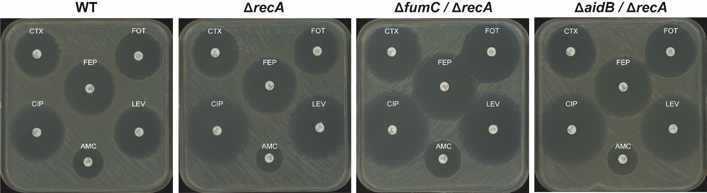

Fig S2. Enhanced antibiotic sensitisation of E. coli BW25113 by targeting the SOS response together with fumarases or the adaptive response. Representative experiment of disc diffusion assays performed on single and double mutants of BW25113. The antibiogram shows the antimicrobials that produced the largest differences in inhibition halo diameters for the double mutants, including cefotaxime (CTX), fosfomycin (FOT), cefepime (FEP), ciprofloxacin (CIP), levofloxacin (LEV) and amoxicillin-clavulanic acid (AMC).

Fig S3. Effect of single and double inactivation of fumC, aidB and recA on the growth of E. coli BW25113. OD_{595nm} values of all strains after 20 h of growth in LBB cultures without antibiotics (black columns), supplemented with ciprofloxacin (0.002 μg/mL, equivalent to 1/4 x MIC of the WT strain) (blue columns) or with cefepime (0.016 μg/mL, equivalent to 1/2 x MIC of the WT strain) (red columns). Hatched columns correspond to ΔrecA mutants. Data are the mean of ten independent measurements from at least two different experiments. Significant P values are indicated (ns, not significant; ****, P < 0.0001).

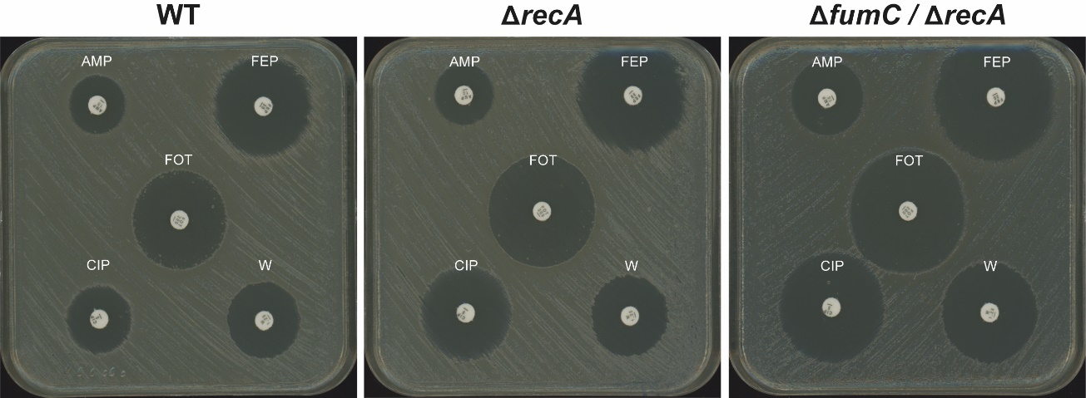

Fig S4. Enhanced antibiotic sensitisation of E. coli FI20 by targeting recA together with fumC. Representative disc diffusion assay on single- and double-inactivation mutants of F120. The antibiogram shows the antimicrobials that produced the largest differences in inhibition zone diameters against the double mutant, including ampicillin (AMP), cefepime (FEP), fosfomycin (FOT), ciprofloxacin (CIP) and trimethoprim (W).

Fig S5. Effect of fumC and/or recA inactivations on growth of FI20. OD_{595nm} values of all strains after 20 h of growth in LBB cultures: without antibiotics (black columns), supplemented with ciprofloxacin (0.25 μg/mL, equivalent to 1/3x MIC of the WT FI20 strain) (blue columns) or cefepime (0.031 μg/mL, equivalent to 1/4 x MIC of the WT FI20 strain (red columns). Hatched columns represent ΔrecA mutants. Data are the mean of ten independent measurements from at least two different experiments. Significant P values are indicated (ns, not significant; **, P < 0.01).

Supplementary material bibliography
Baba, T., Ara, T., Hasegawa, M., Takai, Y., Okumura, Y., Baba, M., et al. (2006). Construction of Escherichia coli K‐12 in‐frame, single‐gene knockout mutants: the Keio collection. Molecular Systems Biology 2, 2006.0008. doi: 10.1038/msb4100050
Chaveroche, M.-K., Ghigo, J.-M., and d’Enfert, C. (2000). A rapid method for efficient gene replacement in the filamentous fungus Aspergillus nidulans. Nucleic Acids Research 28, e97. doi: 10.1093/nar/28.22.e97
Datsenko, K. A., and Wanner, B. L. (2000). One-step inactivation of chromosomal genes in Escherichia coli K-12 using PCR products. Proceedings of the National Academy of Sciences 97, 6640–6645. doi: 10.1073/pnas.120163297
Machuca, J., Recacha, E., Gallego-Mesa, B., Diaz-Diaz, S., Rojas-Granado, G., Garciá-Duque, A., et al. (2021). Effect of RecA inactivation on quinolone susceptibility and the evolution of resistance in clinical isolates of Escherichia coli. Journal of Antimicrobial Chemotherapy 76, 338–344. doi: 10.1093/jac/dkaa448
Recacha, E., Machuca, J., Díaz de Alba, P., Ramos-Güelfo, M., Docobo-Pérez, F., Rodriguez-Beltrán, J., et al. (2017). Quinolone Resistance Reversion by Targeting the SOS Response. mBio 8, 10.1128/mbio.00971-17. doi: 10.1128/mbio.00971-17
Thomason, L. C., Costantino, N., and Court, D. L. (2007). E. coli Genome Manipulation by P1 Transduction. Current Protocols in Molecular Biology 79, 1.17.1-1.17.8. doi: 10.1002/0471142727.mb0117s79

