**Supplementary information**

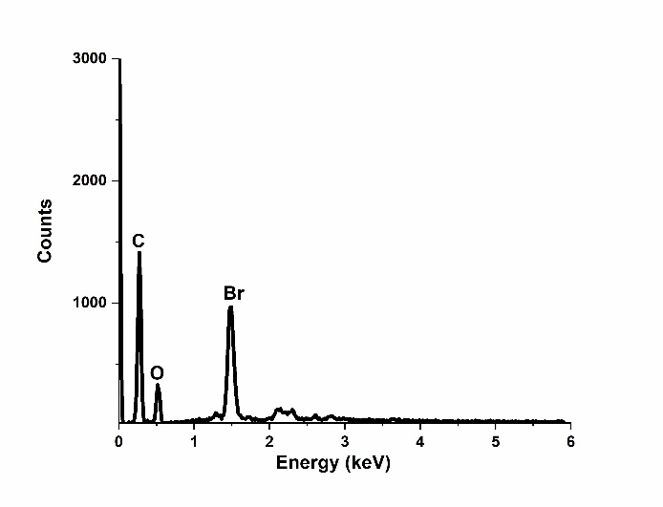

**Figure S1: EDS of GO-Br**

**C:\Users\Lenovo\Downloads\Khona NMR data supplementary.tiff**

**Figure S2: 13C CP MAS NMR spectrum**

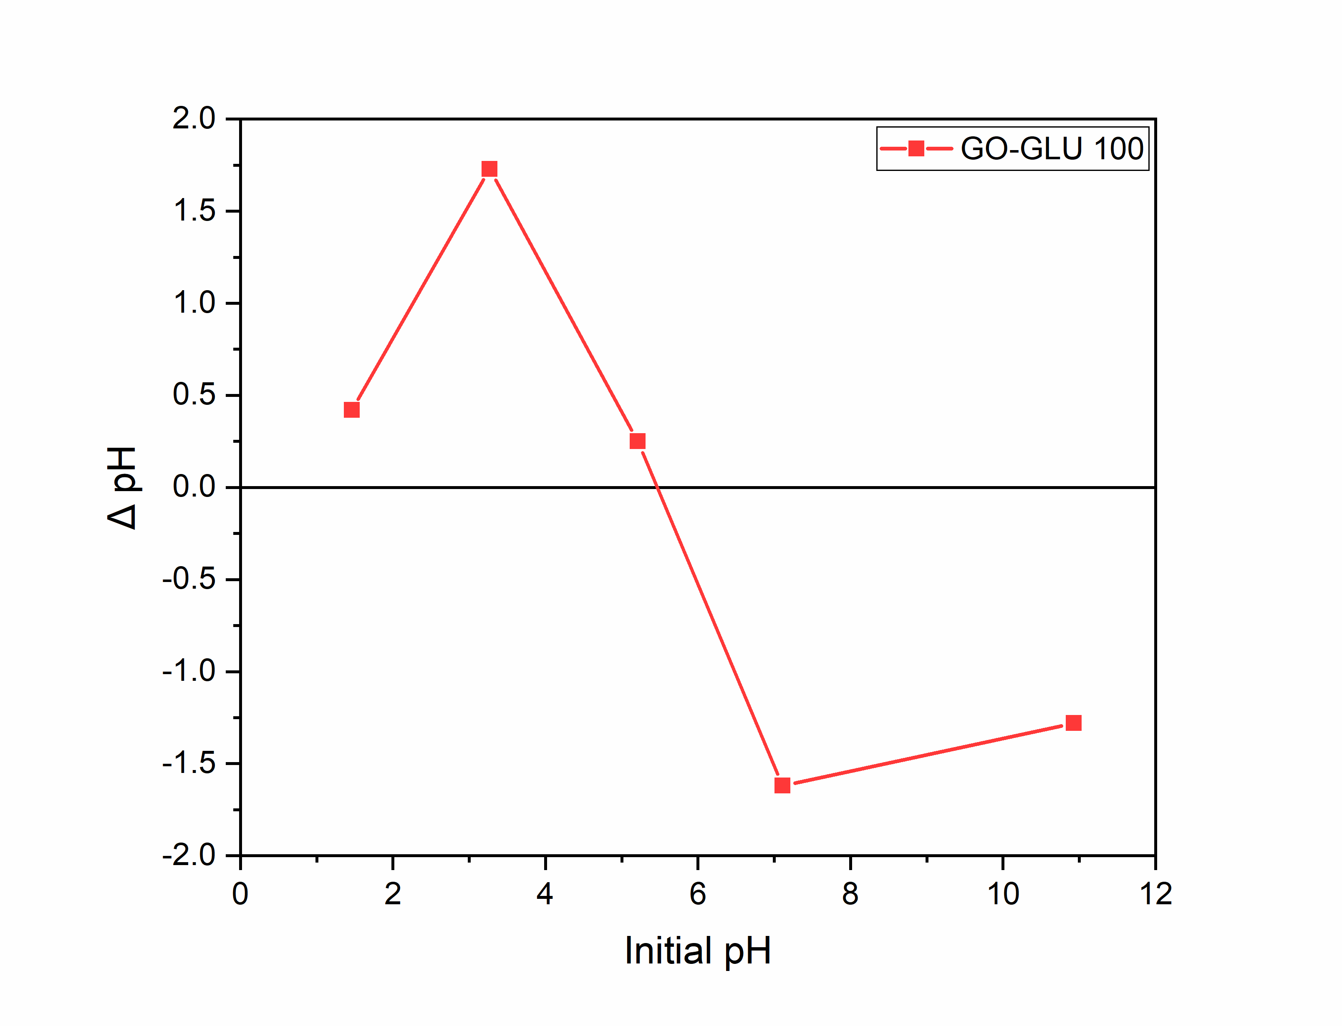

**Figure S3: Point of zero charge (pH PZC) for GO-GLU 100.**

**(a)**

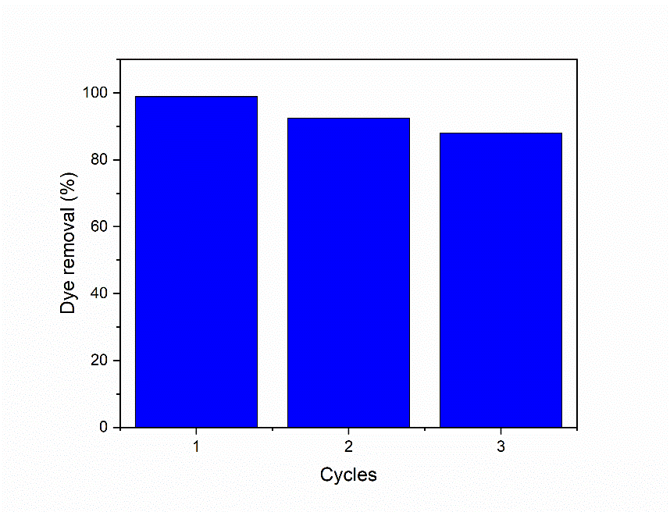 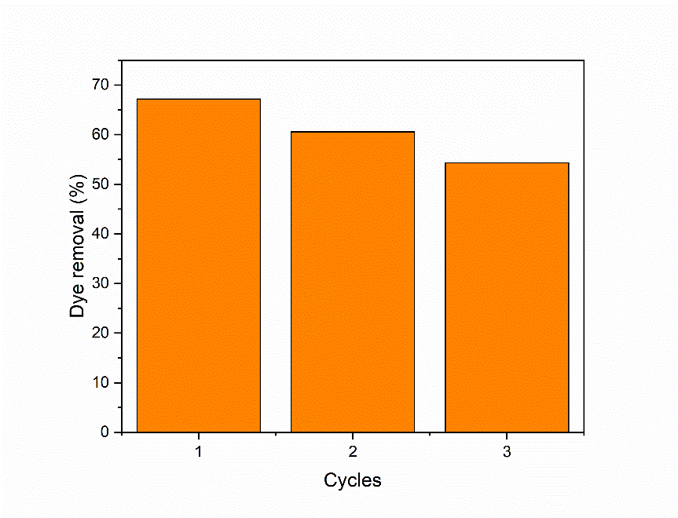

**(b)**

**Figure S4: The cycles of reusability for TFN-3; MB (a) and MO (b).**

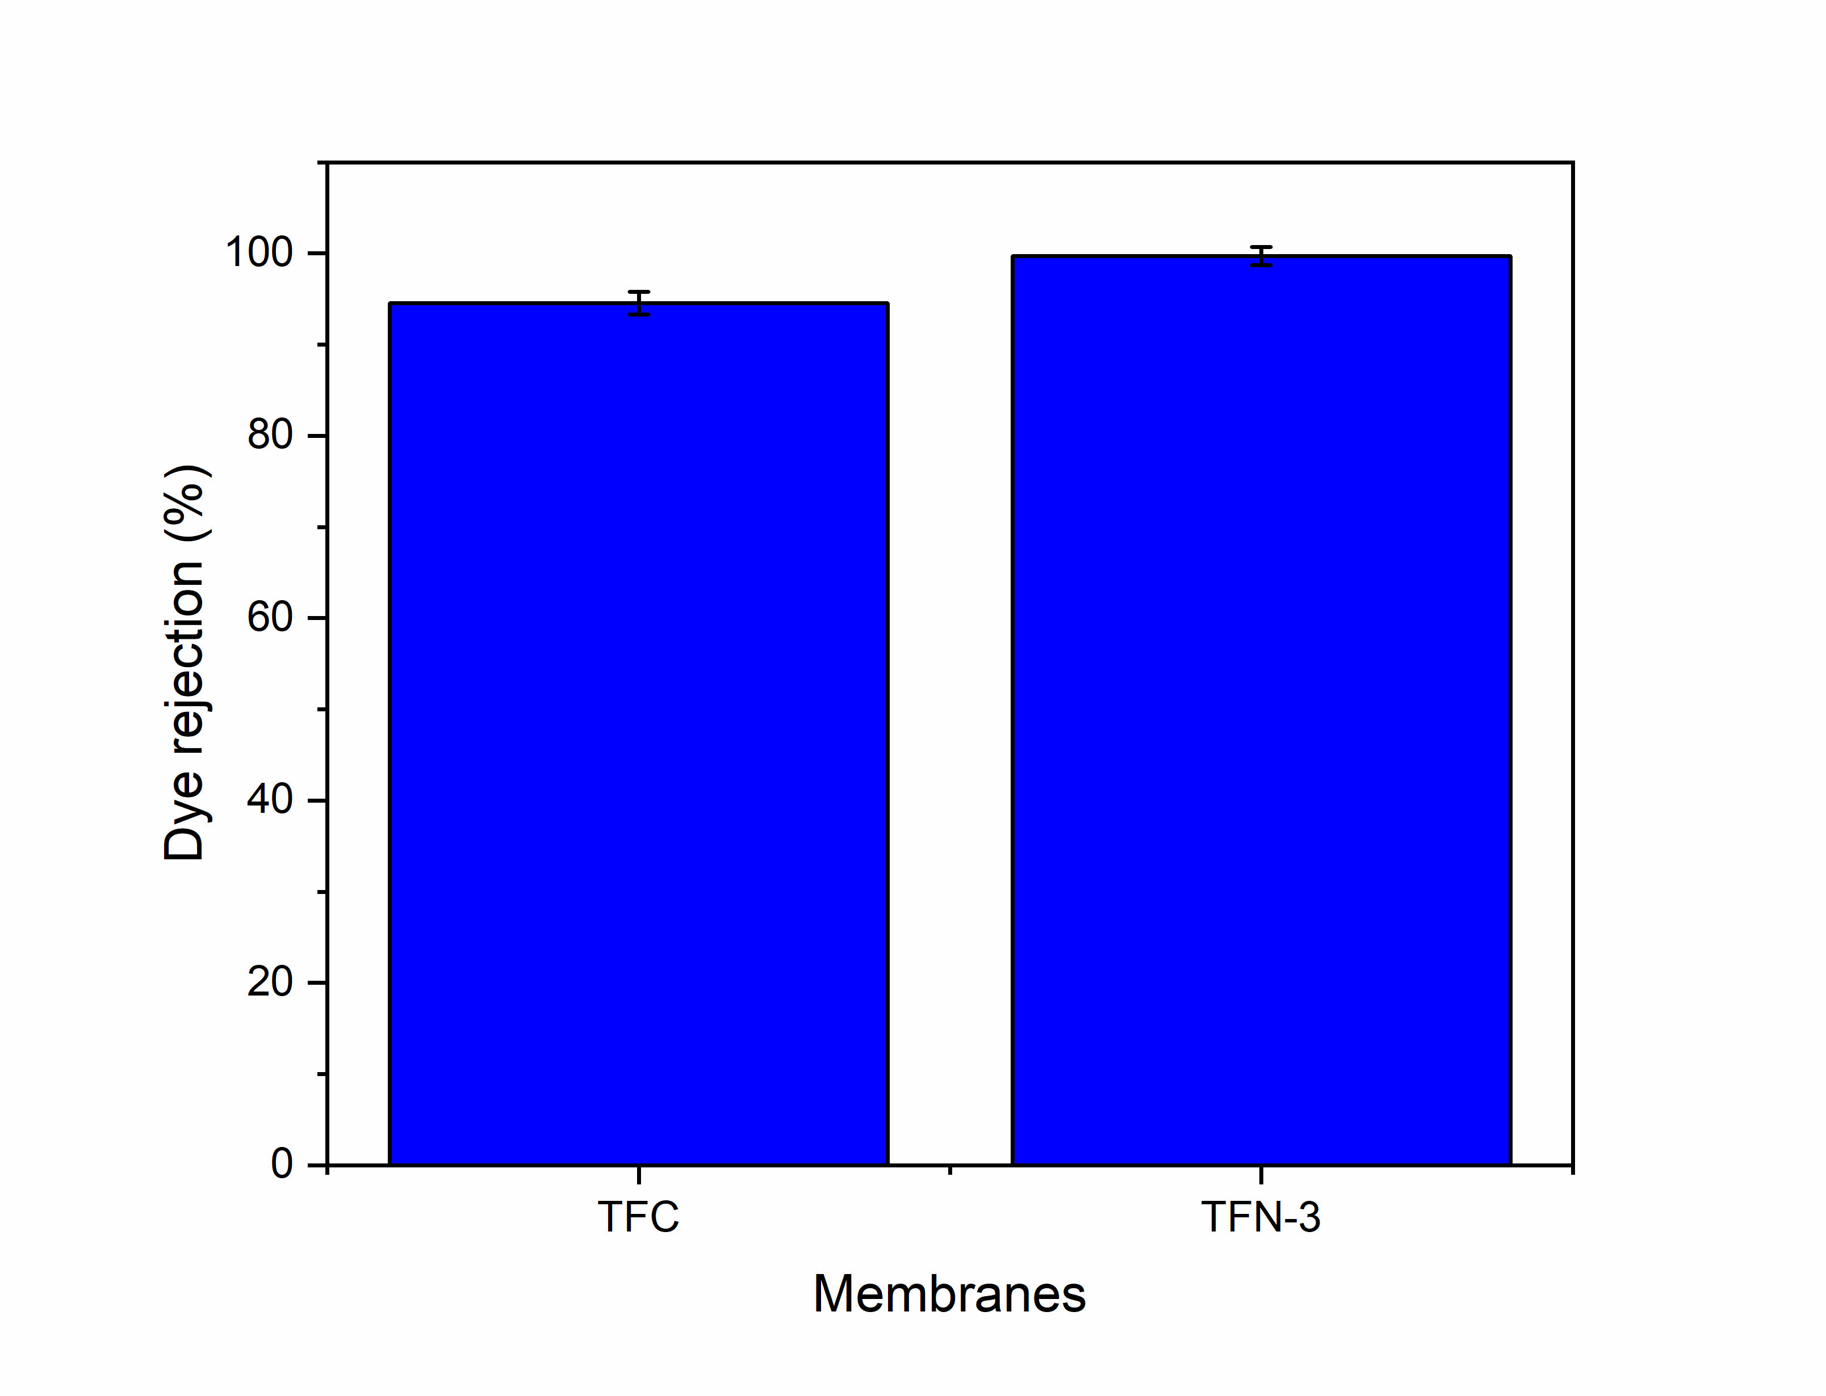  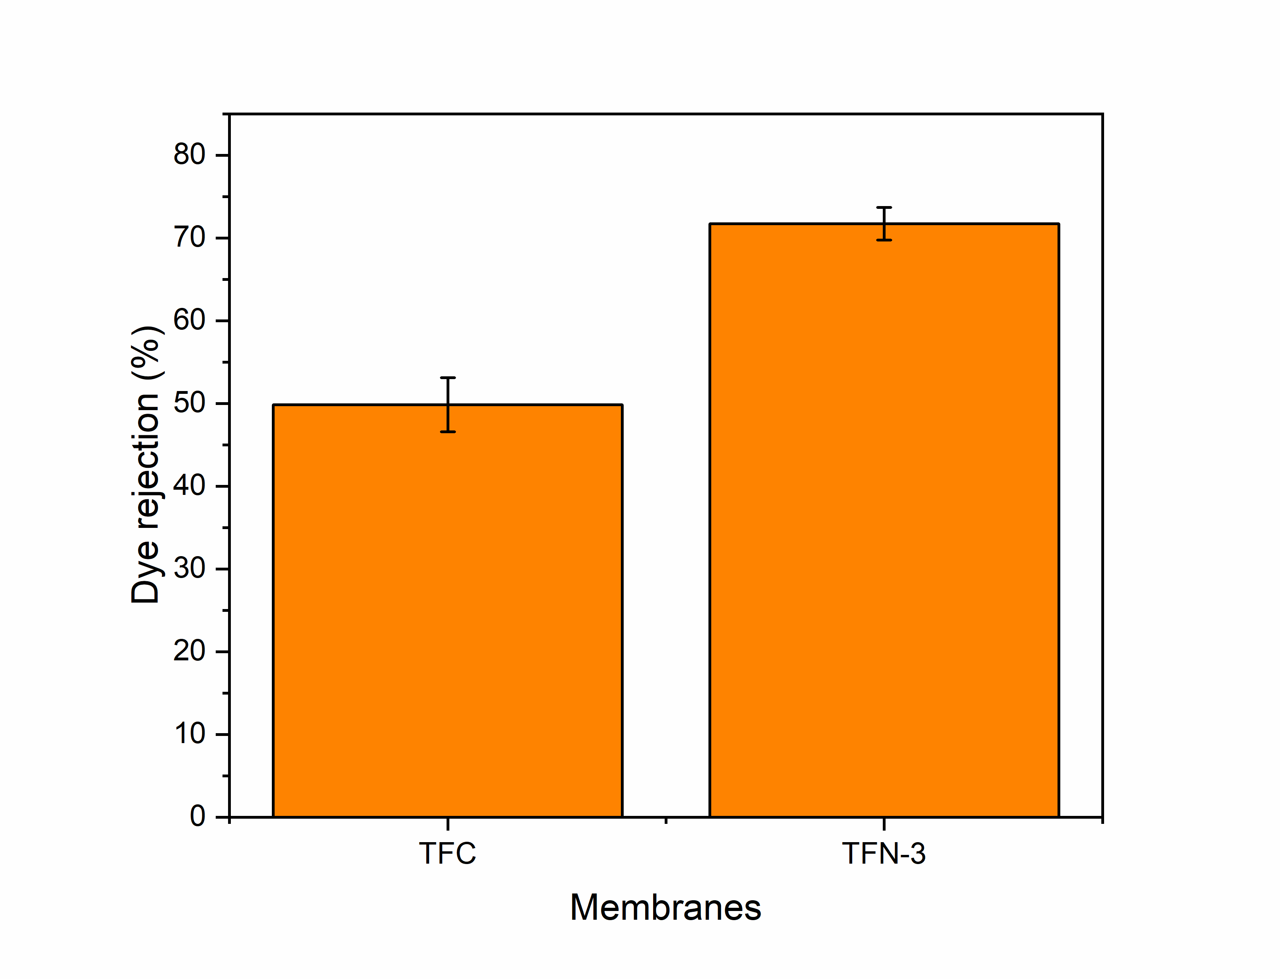

**(b)**

**(a)**

**Figure S5: TFC and TFN-3 membranes application in real water remediation for MB (a) and MO (b).**

**Table S1: Comparison of Dye Separation Performance between GO-GLU TFN with Existing Studies.**

|  |  |  |  |  |  |
| --- | --- | --- | --- | --- | --- |
| **Membrane** | **Loading concentration (wt%)** | **Dye** | **Permeability** | **Dye rejection (%)** | **Reference** |
| GO-TETA TFN | 0.03 wt%  (GO-TETA) | direct red  congo red | 73 L/m2h | 99.6 | [1] |
| f-GO PSU | 2 wt%  (GO-aminated heterocyclic compound; f-GO) | Congo red  Methylene blue | ~8 L/m2h | >99 | [2] |
| GO-TFN | 10 mL (1 ppm GO solution) | Disperse Blue 1 | 40 L/m2h.bar | 99.97 | [3] |
| MTFN | 0.2 wt%  (rGO@TiO2@Ag) | rose bengal | 52 L/m2h | 98 | [4] |
| TFN-AA/GO | 0.03 g/m2  (AA-functionalized GO) | Rhodamine B  Acid red 1  Rose bengal | 11.34 L/m2h.bar | >98 | [5] |
| PDA-rGOC3/HPAN | 0.16 wt%  (rGOC) | Reactive blue 2 | 22.8 L/m2h.bar | 99.4 | [6] |
| CSGO-PEBA/PES | * 1. wt%   1 wt%  (CSGO) | Malachite green | 17.068 L/m2h  8.58 L/m2h | 98.54  99.63 | [7] |
| PA@GO-60 | 60 mg SA  (GO/SA) | Trypan blue | 75.7 L/m2h.bar | 99.8 | [8] |
| TFN-3 | 0.10 wt%  (GO-GLU 100) | MB  MO | 14.11 L/m2h | 99.18  67.18 | This study |

**References**

[1] N. Izadmehr, Y. Mansourpanah, M. Ulbricht, A. Rahimpour, M.R. Omidkhah. TETA-anchored graphene oxide enhanced polyamide thin film nanofiltration membrane for water purification; performance and antifouling properties. *J Environ Manage*. 2020;276:111299. doi:10.1016/j.jenvman.2020.111299

**[2]** A.E. Abdelhamid, A.A. El-Sayed, A.M. Khalil. Polysulfone nanofiltration membranes enriched with functionalized graphene oxide for dye removal from wastewater. J Polym Eng. 2020;40(10):833-841. doi:10.1515/polyeng-2020-0141

[3] H.F.M. Austria, J.O. Young, O. Setiawan, T-H. Huang, A.R. Caparanga, K.R.S. Pamintuan, W-S. Hung. Thin film nanocomposite loose nanofiltration membranes with graphene oxide interlayer for textile wastewater treatment. Sep Purif Technol. 2025;354:129053. doi:10.1016/j.seppur.2024.129053

[4] H. Abadikhah, E.N. Kalali, S. Khodi, X. Xu, S. Agathopoulos. Multifunctional Thin-Film Nanofiltration Membrane Incorporated with Reduced Graphene Oxide@TiO2@Ag Nanocomposites for High Desalination Performance, Dye Retention, and Antibacterial Properties. *ACS Appl Mater Interfaces*. 2019;11(26):23535-23545. doi:10.1021/acsami.9b03557

[5] M.Q. Seah, W.J. Lau, P.S. Goh, A.F. Ismail. Greener synthesis of functionalized-GO incorporated TFN NF membrane for potential recovery of saline water from salt/dye mixed solution. *Desalination*. 2022;523:115403. doi:10.1016/j.desal.2021.115403

[6] J. Zhu, J. Wang, A.A. Uliana, M. Tian, Y. Zhang, Y. Zhang, A. Volodin, K. Simoens, S. Yuan, J. Li, J. Lin, K. Bernaerts, B. Van der Bruggen. Mussel-Inspired Architecture of High-Flux Loose Nanofiltration Membrane Functionalized with Antibacterial Reduced Graphene Oxide-Copper Nanocomposites. ACS Appl Mater Interfaces. 2017;9(34):28990-29001. doi:10.1021/acsami.7b05930

[7] S.R. Mousavi, M. Asghari, N.M. Mahmoodi, I. Salahshoori. Water decolorization and antifouling melioration of a novel PEBA1657/PES TFC membrane using chitosan-decorated graphene oxide fillers. J Environ Chem Eng. 2023;11(3):109955. doi:10.1016/j.jece.2023.109955

[8] X. Zhan, R. Ge, T. Huo, J. Lu, J. Li. Highly permeable PA@GO loose nanofiltration membranes enabled by hierarchical transport channels for efficient dye removal. Chem Eng J. 2023;476:146831. doi:10.1016/j.cej.2023.146831