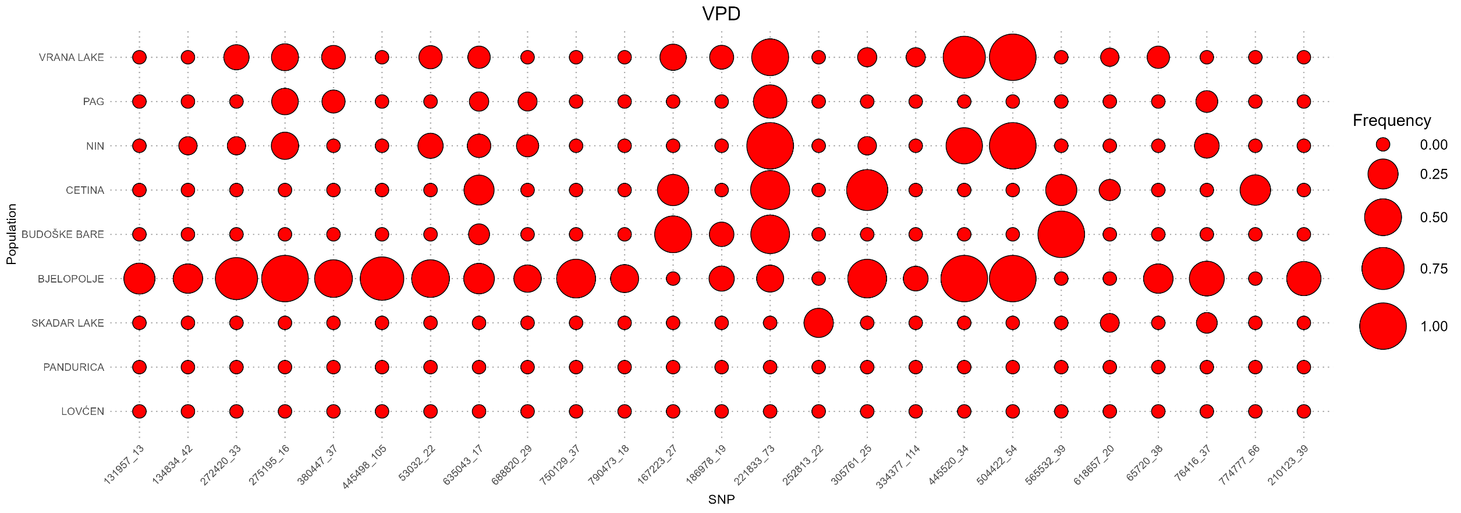
Figure 1. Frequency of effect alleles across populations for significant SNPs identified in the single-SNP LMM analysis (GEMMA and GMMAT), as well as the multi-SNP BSLMM analysis, all of which surpassed the genome-wide significance threshold (1 × 10⁻³) for the Vegetation Period Duration (VPD) trait. The analysis also includes SNPs meeting the same threshold in the multivariate GWAS. The corresponding SNPs are detailed in Table 3 and Table 5 of the manuscript.

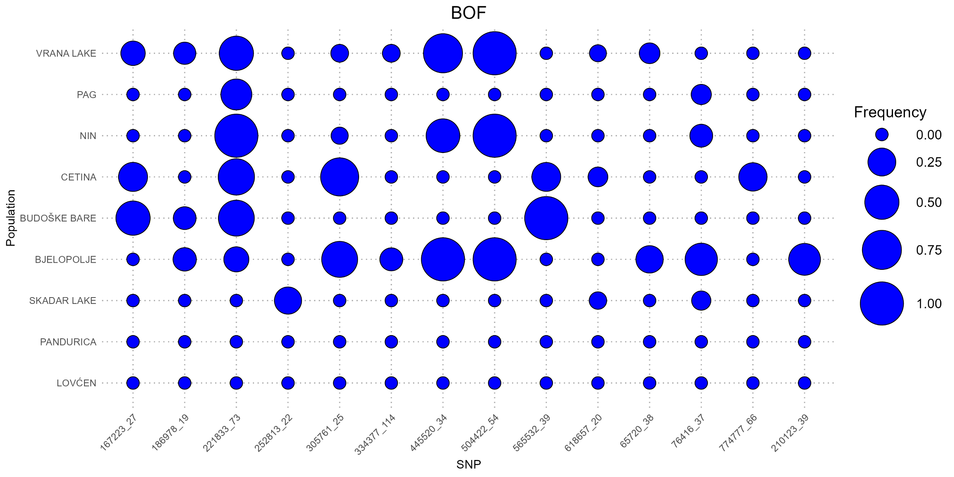
Figure 2. Frequency of effect alleles across populations for significant SNPs identified in the single-SNP LMM analysis (GEMMA and GMMAT), as well as the multi-SNP BSLMM analysis, all of which surpassed the genome-wide significance threshold (1 × 10⁻³) for the Beginning of Flowering (BOF) trait. The analysis also includes SNPs meeting the same threshold in the multivariate GWAS. The corresponding SNPs are detailed in Table 3 and Table 5 of the manuscript.
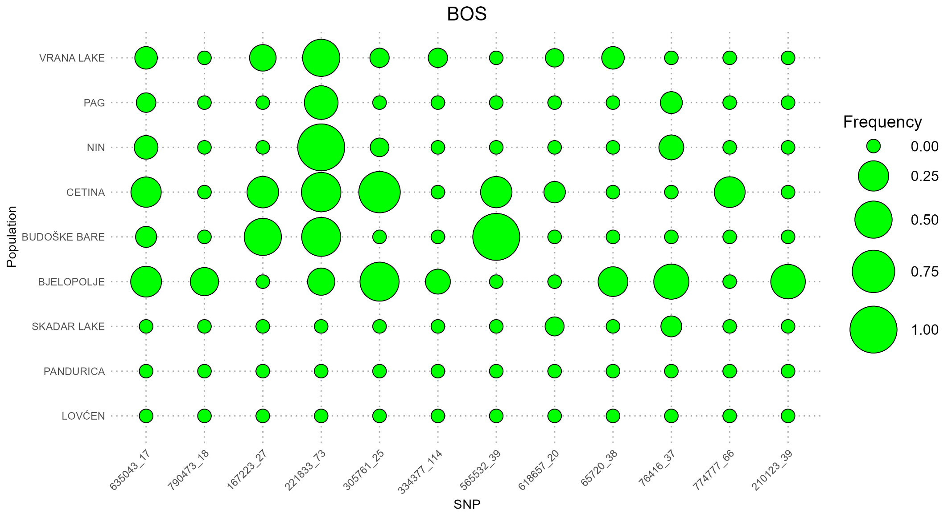
Figure 3. Frequency of effect alleles across populations for significant SNPs identified in the single-SNP LMM analysis (GEMMA and GMMAT), as well as the multi-SNP BSLMM analysis, all of which surpassed the genome-wide significance threshold (1 × 10⁻³) for the Beginning of Sprouting (BOS) trait. The analysis also includes SNPs meeting the same threshold in the multivariate GWAS. The corresponding SNPs are detailed in Table 3 and Table 5 of the manuscript.
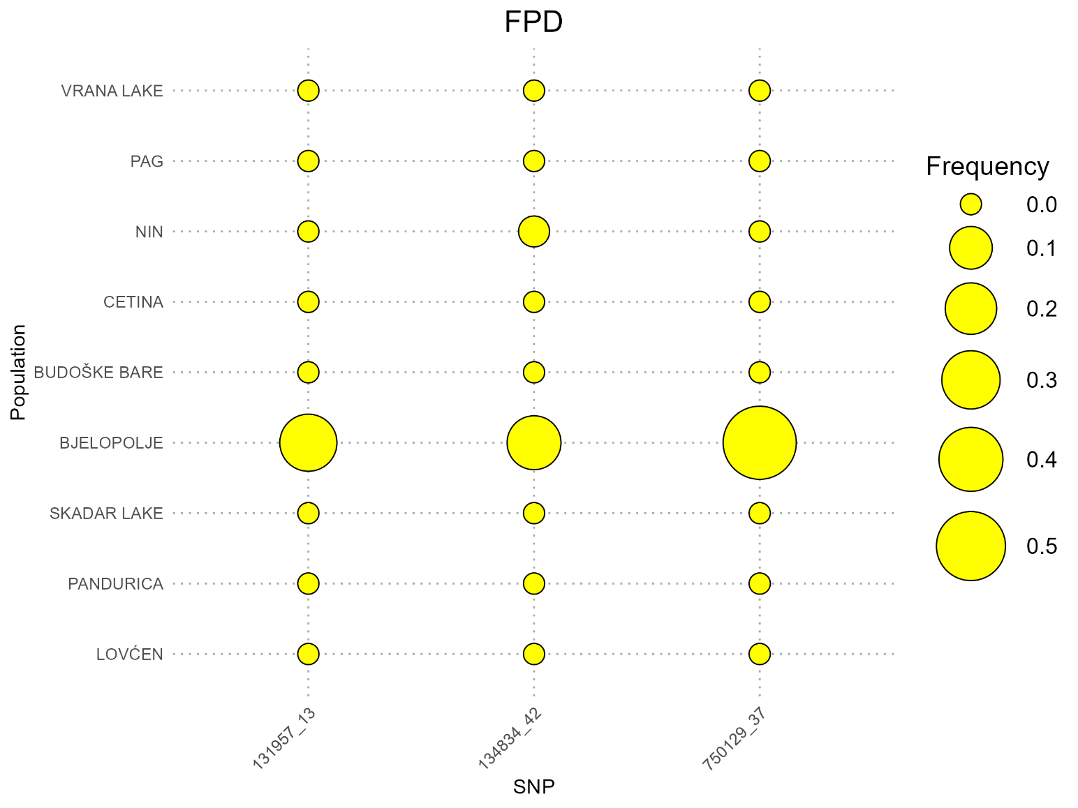

Figure 4. Frequency of effect alleles across populations for significant SNPs identified in the single-SNP LMM analysis (GEMMA and GMMAT), as well as the multi-SNP BSLMM analysis, all of which surpassed the genome-wide significance threshold (1 × 10⁻³) for the Flowering Period Duration (FPD) trait. The analysis also includes SNPs meeting the same threshold in the multivariate GWAS. The corresponding SNPs are detailed in Table 3 of the manuscript.

