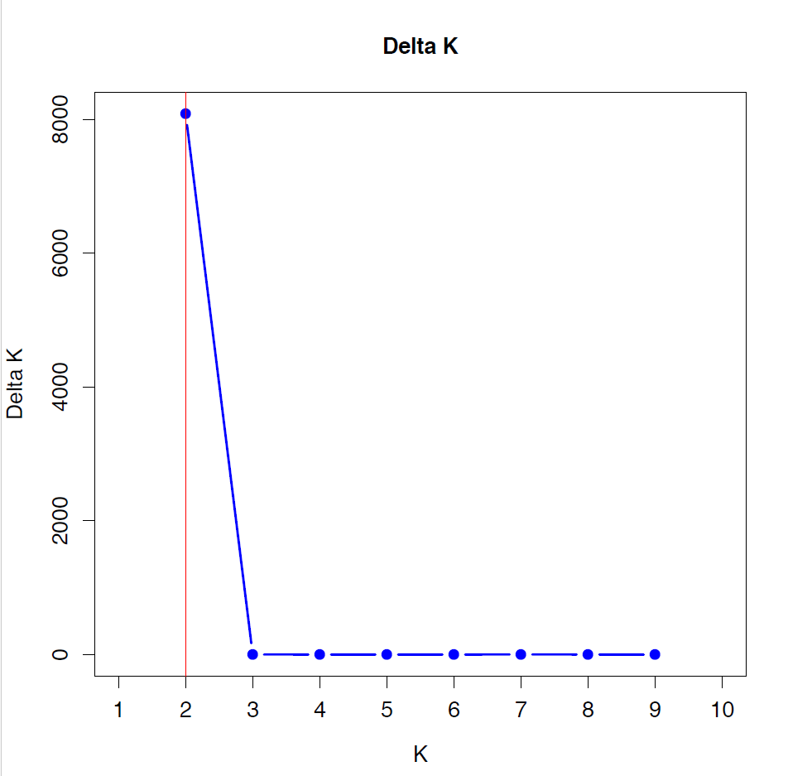
Figure 1. Delta K values as obtained by the STRUCTURE software.

