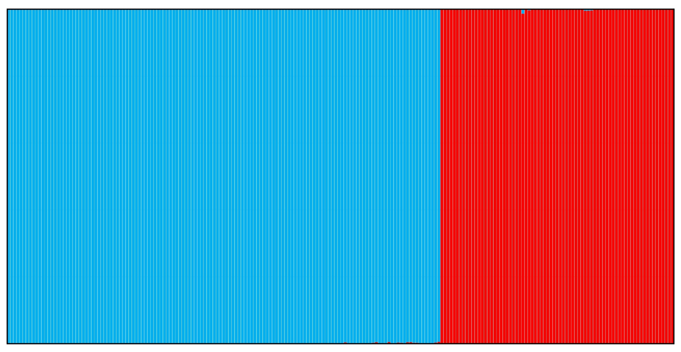**Figure 1.** Population-genetic structure of studied *Chouardia* *litardierei* populations as revealed by the STRUCTURE software. Each stacked column represents a single individual. Individuals belonging to the meadow and the seashore groups of populations are marked with blue, and individuals from the dolomite habitat populations are marked with red.