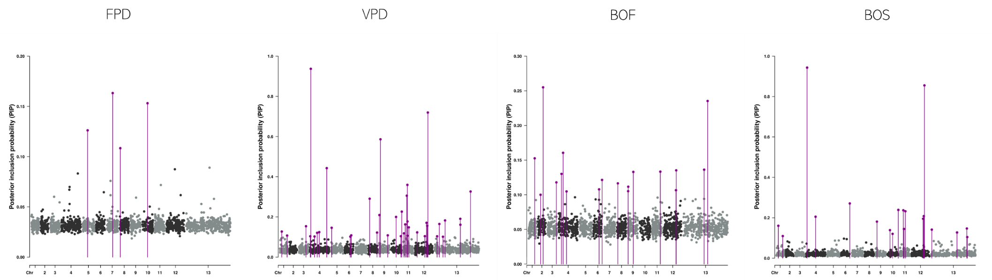
Figure 1. Manhattan plots of the BSLMM analysis for the FPD, VPD, BOF, and BOS traits of the Chouardia litardierei. The x-axis represents the chromosomal position of SNPs, and the y-axis represents their posterior inclusion probabilities (PIPs).

BSLMM; Bayesian Sparse Linear Mixed Model, BOF, Beginning of Flowering; BOS, Beginning of Sprouting; FPD, Flowering Period Duration; VPD, Vegetation Period Duration.

