SUPPLEMENTARY MATERIAL

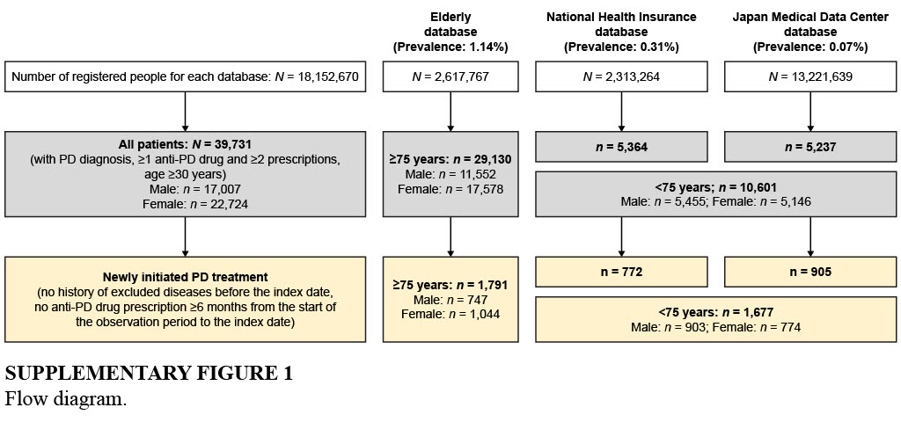

SUPPLEMENTARY Table 1 Classification of drugs prescribed for PD

Drug | Receipt code from computerized processing system | ATC code
Levodopa  Levodopa  Levodopa carbidopa hydrate  Levodopa benserazide hydrochloride  Levodopa carbidopa hydrate entacapone | 620006042, 620006043, 620008660, 620008661, 620008662, 620008889, 620008890 | N04BA01
 | 620123601, 620123701, 620123801, 620123901, 620124001, 620124101, 620124201, 620124301, 620124401, 620124501, 620124601, 621865201, 622050801, 622051301, 622067101, 622080201, 622509401, 622711600, 622711800 | N04BA02
 | 620008030, 620008659, 622325500, 622711700 | N04BA02
 | 622375701, 622375801 | N04BA03
Dopamine agonist – ergot  Bromocriptine mesilate  Pergolide mesilate  Cabergoline | 610422106, 620005063, 620005096, 620006069, 620006743, 620008579, 620008688, 620009237, 620120902, 620121001, 620121101, 620121102, 620121401, 620121701, 620121802, 620121902, 620121904, 620122001 | N04BC01
 | 620121801 | NA
 | 610406392, 610406393, 620002124, 620002125, 620002823, 620002857, 620002858, 620004067, 620004068, 621642002, 621642103, 621690101 | N04BC02
 | 620006684, 620006685, 622711100, 622711200 | NA
 | 610432023, 610432024, 620005369, 620005370, 620005371, 620005372, 620005375, 620005376, 620005377, 620005378, 620005379, 620008002, 622711400, 622711500 | N04BC06
 | 620005373, 620006667, 620006668, 620008001 | NA
Dopamine agonist – non-ergot  Talipexole hydrochloride  Ropinirole  Pramipexole hydrochloride hydrate  Apomorphine hydrochloride hydrate  Rotigotine | 610409337 | N04BC
 | 620004415, 620004416, 620004417, 622183601, 622183701, 622492301, 622492401, 622492501, 622500001, 622500101, 622500201, 622582201, 622582301, 622583401, 622583501, 622656201, 622656301, 622687201, 622687301, 622687401, 622687501, 622687601 | N04BC04
 | 620000435, 620000436, 622069601, 622069701, 622226701, 622226801, 622228701, 622228801, 622229801  622229901, 622231601, 622231701, 622233901, 622234001, 622235901, 622236001, 622238001, 622238101, 622239601, 622239701, 622245201, 622245301, 622247301, 622247401, 622249201, 622249301, 622253101, 622253201, 622253501, 622253601, 622254501, 622254601, 622256401, 622256501, 622257401, 622257501, 622272601, 622272701, 622511201, 622511301, 622513801, 622513901, 622520201, 622520301, 622524801, 622524901, 622528201, 622528301, 622530001, 622530101, 622691900 | N04BC05
 | 622263001, 622263101, 622263201, 622263301, 622692000 | NA
 | 622149301 | N04BC07
 | 622163501, 622163601, 622163701, 622163801, 622478301 | N04BC09
Monoamine oxidase type B inhibitor  Selegiline hydrochloride  Rasagiline mesilate  Safinamide mesilate | 610421338, 620003975, 620005364, 620005511, 620008494, 622711300 | N04BD01
 | 622624401, 622624501 | N04BD02
 | 622696101 | N04BD03
Catechol-O-methyltransferase inhibitor  Entacapone  Opicapone | 620004853, 622478401, 622490101, 622498501, 622503001 | N04BX02
 | 622845500, 622878901 | NA
 | 622821701 | N04BX04
Anticholinergic agent  Trihexyphenidyl hydrochloride  Biperiden hydrochloride  Biperiden lactate  Profenamine hydrochloride  Profenamine hibenzate | 610454002, 611240304, 611240415, 611240423, 611240425, 620003078, 620004382, 620004384, 620004548, 620006589, 620008311, 620008663, 620119903, 620119906, 620119907, 620119919, 620119923, 620119927, 620120303 | N04AA01
 | 620004556, 620005847, 622319200 | NA
 | 610444006, 610444007, 620000066, 620000067, 620000243, 620004893, 620004894, 620005147, 620117802, 620118102, 620118203, 620118402, 621218501, 621392101 | N04AA02
 | 620006075 | NA
 | 611240172, 611240173 | N04AA05
 | 610463153
Zonisamide | 611130087, 620001972, 620009098, 621390801, 621390901, 622400401, 622589801, 622673201, 622709200, 622709300 | N03AX15
Istradefylline | 622245801 | N04CX01
Amantadine | 610461044, 610461047, 611240079, 611240080, 620002335, 620004505, 620008286, 620116802, 620116809, 620117101, 620117103, 620117110, 620117112, 620117114, 620117401, 620117402, 620117404, 620117412, 620117413, 620117414, 622710800 | N04BB01
 | 610461046, 611240122, 611240123, 620003077, 620003267, 620003268, 620005903, 620006587, 620008280, 620116701, 620117107, 620117410, 620116702, 622309500, 620116805 | NA
Droxidopa | 620004007, 620004008, 620004009, 620004010, 620005044, 620005045, 620005046, 620006676, 620006677, 620006678, 622061101, 622061201 | C01CA27
 | 622710900, 622711000
ATC, Anatomical Therapeutic Chemical; NA, not applicable; PD, Parkinson’s disease.
This table was previously reported in Seki M, Kawata Y, Hayashi A, Arai M, Fujimoto S. Prescribing patterns and determinants for elderly patients with Parkinson's disease in Japan: a retrospective observational study using insurance claims databases. Front Neurol (2023) 14:1162016. doi: 10.3389/fneur.2023.1162016.

