Supplementary Material



**Fig. S1. Effect of LCD on cell viability in differentiated SH-SY5Y cells.** SH-SY5Y cells were differentiated for five days and treated with LCD for 24 h. Cell viability was assessed via CCK-8 assay.

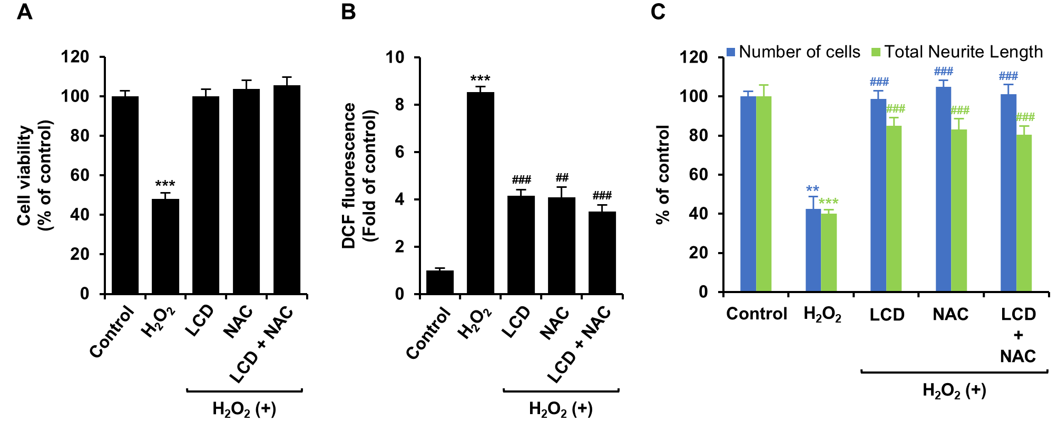

**Fig. S2. Effects of LCD and NAC co-treatment on H2O2-induced neurotoxicity in SH-SY5Y cells.** Differentiated SH-SY5Y cells were pre-treated with LCD (2 μM) and NAC (2 mM) for 3 h, followed by exposure to H2O2 (25 μM). (a) Cell viability was assessed by CCK-8 assay after 24 h of exposure. (b) Intracellular ROS levels were measured using DCFDA fluorescence after 3 h of pre-treatment and 1 h of H2O2 exposure. (c) For neurite outgrowth analysis, pre-treated cells were exposed to H2O2 for 24 h and were fixed and immunostained with β-III tubulin antibody, then with Alexa Flour 488-conjugated secondary antibody. Neurite outgrowth and nuclei were quantified using high-content screening analysis. The results are presented as mean ± SEM (*n* = 6). \*\**p* < 0.01, and \*\*\**p* < 0.001 vs the control group; ##*p* < 0.01, and ###*p* < 0.001 vs the H2O2-treated group.