Antibodies Details

|  |  |  |  |  |  |
| --- | --- | --- | --- | --- | --- |
| Antibodies | Company | Country | Catalog number | Clone | Fluorochrome |
| TNF-α | Biolegend | USA | 502913 | MAb11 | APC |
| IFN-γ | Biolegend | USA | 502511 | 4S.B3 | APC |
| Granzyme B | Biolegend | USA | 396408 | QA18A28 | APC |
| Perforin | Biolegend | USA | 353311 | B-D48 | APC |
| CD152 (CTLA-4) | Biolegend | USA | 349907 | L3D10 | APC |
| TIGIT | Biolegend | USA | 372705 | A15153G | APC |
| TIM-3 | Biolegend | USA | 364803 | A18087E | APC |
| CD8 | eBioscience | USA | 17-0088-42 | RPA-T8 | APC |
| CD28 | eBioscience | USA | 12-0289-42 | CD28.2 | PE |
| PD1 | eBioscience | USA | 11-9969-42 | MIH4 | FITC |

Microbeads Details

|  |  |  |  |
| --- | --- | --- | --- |
| Names | Company | Country | Catalog number |
| CD3 MicroBeadKit | Miltenyi | Germany | 30-097-043 |
| CD8 MicroBeadKit | Miltenyi | Germany | 130-045-201 |

Gene primer sequences

|  |  |  |
| --- | --- | --- |
| Gene | Forward primer | Reverse primer |
| GAPDH | GTCTCCTCTGACTTCAACAGCG | ACCACCCTGTTGCTGTAGCCAA |
| TIGIT | TGGTGGTCATCTGCACAGCAGT | TTTCTCCTGAGGTCACCTTCCAC |
| TIM-3 | GACTCTAGCAGACAGTGGGATC | GGTGGTAAGCATCCTTGGAAAGG |
| CTLA4 | ACGGGACTCTACATCTGCAAGG | GGAGGAAGTCAGAATCTGGGCA |

GAPDH was used as an internal control gene.

Elisa Kit Details

|  |  |  |  |
| --- | --- | --- | --- |
| Names | Company | Country | Catalog number |
| Human Granzyme B Elisa Kit | WEIAOBIO | China | EH10206S |
| Human IFN-γ Elisa Kit | WEIAOBIO | China | EH10230S |
| Human Perforin ELISA kit | WEIAOBIO | China | EH10391S |
| Human TNF-α Elisa Kit | WEIAOBIO | China | EH10497S |

Gating strategies for HCC

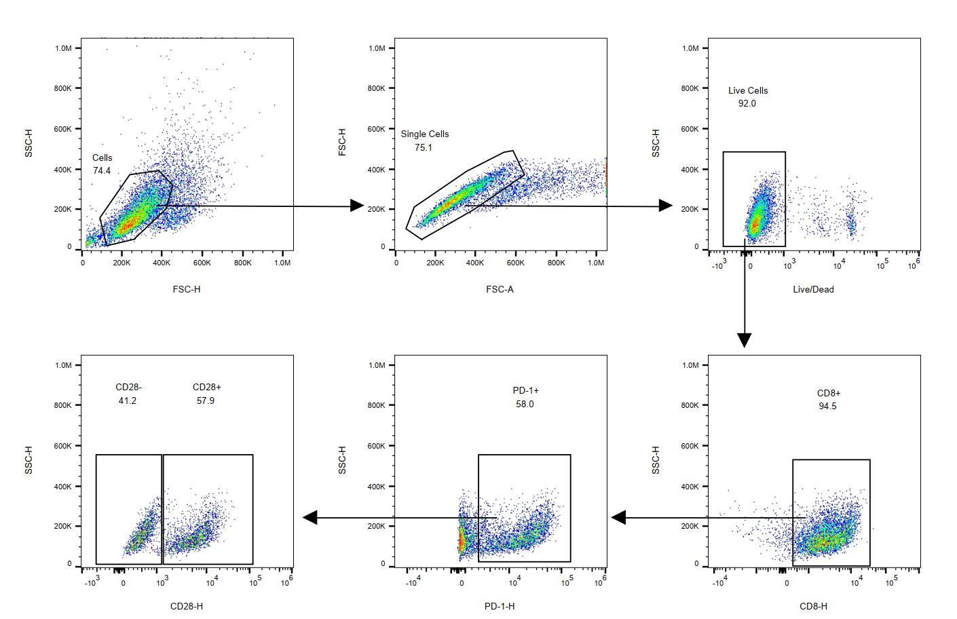

Gating strategies for Normal tissues

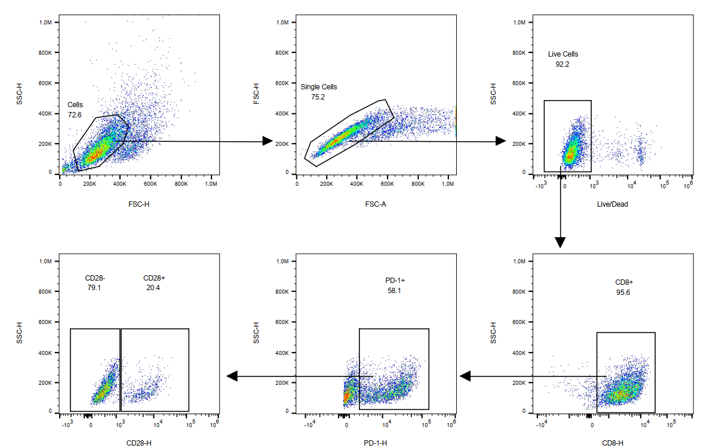

Gating strategies for HCC and Normal tissues