Supplementary Material

# Supplementary Figures

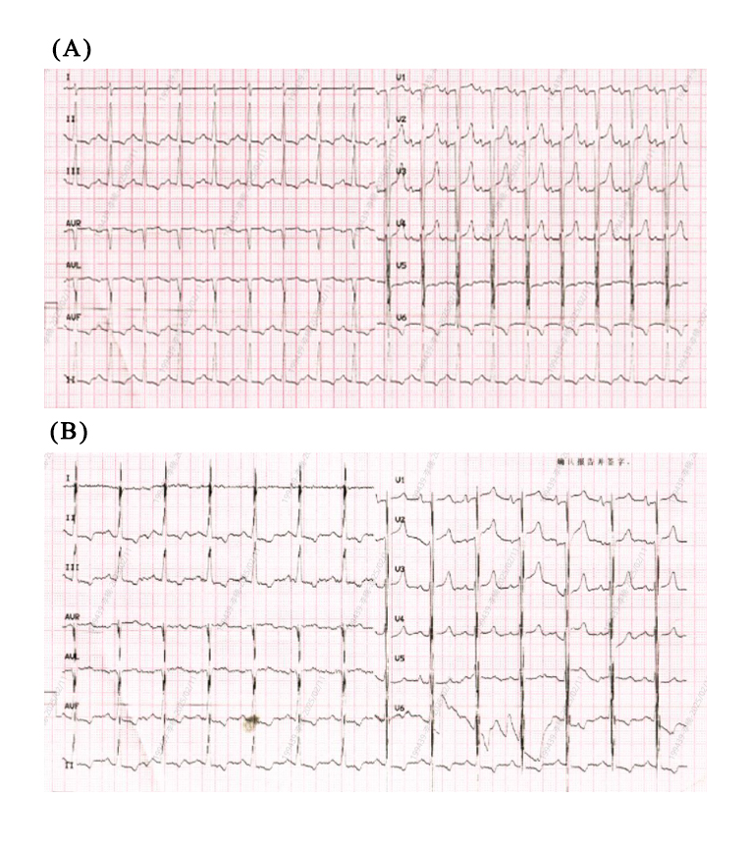

**Supplementary Figure 1.** Preoperative (A) and postoperative (B) ECGs of CCM therapy.

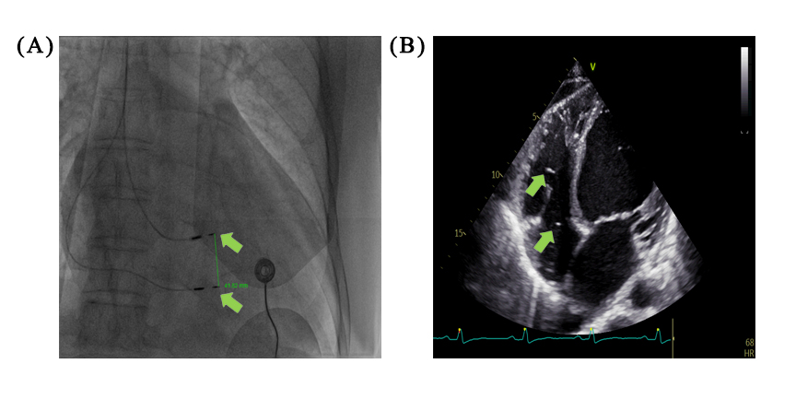

**Supplementary Figure 2.** Postoperative chest X-ray (A) and echocardiography (B) showed that the positions of the two CCM electrodes were optimal.