Supplementary Table 1: Concepts used in the regression model
Concepts – Original Structured Model | New Akrivia NLP Terms and Concepts
Baseline diagnosis | From structures data and NLP derived diagnoses mapped to ICD codes outlined below
Sex | (from structured data)
Age | (from structured data)
Ethnicity | (from structured data)
Concepts – Original Model NLP variables
emotion – tearfulness | Crying
appetite – loss | Loss of appetite, decrease of appetite, finding of appetite, Altered appetite, Appetite normal
appearance – weight loss | Overweight, Underweight, Weight gain, Weight loss, Weight steady
thoughts – guilt | Feeling guilt
emotion – irritability | Feeling irritable
thoughts – delusion | Delusion of persecution, Delusions, Paranoid delusions
thoughts – hopelessness | Feeling hopeless
Poor insight | Impaired insight, Lack of insight
agitation | Feeling agitated, Hyperactive behaviour, Feeling excited
thoughts – paranoia | Paranoid symptoms
Disturbed sleep | Disturbed Sleep
Insomnia | Insomnia
Cocaine use | Substance use type- cocaine
Cannabis use | Substance use type- cannabis
Concept – Outcome to be predicted
Psychosis diagnosis/psychotic episode. | From Structured data and NLP derived diagnoses mapped to ICD codes outlined below

Supplementary Table 2: ICD Codes used to define primary index diagnosis (taken from Irving et al., 2021 [12])

Primary index diagnosis | ICD-10 code | ICD-10 diagnosis name
Acute and transient psychotic disorders | F23.x | Acute and transient psychotic disorders
Substance use disorders | F10 (excluding *.5, *.4, *.7) | Nonpsychotic mental and behavioural disorders due to use of alcohol
 | F11 (excluding *.5, *.4, *.7) | Nonpsychotic mental and behavioural disorders due to use of opioids
 | F12 (excluding *.5, *.4, *.7) | Nonpsychotic mental and behavioural disorders due to use of cannabinoids
 | F13 (excluding *.5, *.4, *.7) | Nonpsychotic mental and behavioural disorders due to use of sedatives or hypnotics
 | F14 (excluding *.5, *.4, *.7) | Nonpsychotic mental and behavioural disorders due to use of cocaine
 | F15 (excluding *.5, *.4, *.7) | Nonpsychotic mental and behavioural disorders due to use of other stimulants, including caffeine
 | F16 (excluding *.5, *.4, *.7) | Nonpsychotic mental and behavioural disorders due to use of hallucinogens
 | F17 (excluding *.5, *.4, *.7) | Nonpsychotic mental and behavioural disorders due to use of tobacco
 | F18 (excluding *.5, *.4, *.7) | Nonpsychotic mental and behavioural disorders due to use of volatile solvents
 | F19 (excluding *.5, *.4, *.7) | Nonpsychotic mental and behavioural disorders due to multiple drug use and use of other psychoactive substances
Bipolar mood disorders | F31.x (excluding F31.2 and F31.5) | Nonpsychotic bipolar disorder
 | F34.0 | Cyclothymia
 | F30.x (excluding *.2) | Nonpsychotic mania or hypomania
Non bipolar mood disorders | [F32-F33].x (excluding F32.3 and F33.3) | Nonpsychotic depressive disorder
 | F34.1 | Dysthymia
 | F34.8, F34.9, F38.x, F39 | Unspecified mood disorders
Anxiety disorders | F40.x | Phobic anxiety disorders
 | F41.0 | Panic disorder
 | F41.1 | Generalized anxiety disorder
 | F41.2-F41.9 | Other anxiety disorders
 | F42.x | Obsessive compulsive disorders
 | F43.x | Reaction to severe stress, and adjustment disorders
 | F44.x | Dissociative [conversion] disorders
 | F45.x | Somatoform disorders
 | F48.x | Other neurotic disorders
Personality disorders | F60.0 | Paranoid personality disorder
 | F60.1 | Schizoid personality disorder
 | F60.2 | Dissocial personality disorder
 | F60.3 | Emotionally unstable personality disorder
 | F60.4 | Histrionic personality disorder
 | F60.5 | Anankastic personality disorder
 | F60.6 | Anxious [avoidant] personality disorder
 | F60.7 | Dependent personality disorder
 | F60.8-F60.9, F61, F62.x, F68.x, F69 | Other personality disorders
 | F21 | Schizotypal Disorder
 | F63.x | Habit and impulse disorders
 | F64.x, F65.x, F66.x | Sexual disorders
Developmental disorders | F80.x | Specific developmental disorders of speech and language
 | F81.x, F82, F83 | Other specific developmental disorders
 | F84.x | Pervasive developmental disorders
 | F88, F89 | Other and unspecified disorders of psychological development
Childhood/adolescence onset disorders | F90.x | Hyperkinetic disorders
 | F91.x | Conduct disorders
 | F92.x, F93.x, F94.x, F98.x | Other emotional and behavioural disorders with childhood or adolescence onset
 | F95.x | Tic disorders
Physiological syndromes | F50.x | Eating disorders
 | F51.x | Nonorganic sleep disorders
 | F52.x | Sexual dysfunction, not caused by organic disorder or disease
 | F53.x (excluding F53.1) | Non psychotic Mental and behavioural disorders associated with the puerperium, not elsewhere classified
 | F54.x, F55, F59 | Other physiological syndromes
Intellectual disabilities | F70.x | Mild Intellectual disabilities
 | F71.x | Moderate Intellectual disabilities
 | F72.x | Severe Intellectual disabilities
 | F73.x | Profound Intellectual disabilities
 | F78.x | Other Intellectual disabilities
 | F79.x | Unspecified Intellectual disabilities
F00-F09 organic mental disorders and all psychotic disorders other than F23.x were excluded

Supplementary Table 3 Regression weights applied to each predictor (taken from Irving et al., 2021 [12])

Concept | Beta Coefficient
Sex (Male – relative to Female) | +0.251607368
Age | +0.006559315
Age*Sex(Male – relative to Female) | -0.007533502
Ethnicity(Black – relative to White) | +0.768361197
Ethnicity(Asian – relative to White) | +0.453691672
Ethnicity(Mixed – relative to White) | +0.183875520
Ethnicity(Other – relative to White) | +0.166521852
Diagnosis(Acute and Transient Psychotic Disorders – relative to At Risk Mental State) | +0.231372239
Diagnosis(Substance Use Disorders – relative to At Risk Mental State) | -1.907241596
Diagnosis(Bipolar Mood Disorders – relative to At Risk Mental State) | -0.955396094
Diagnosis(Non-Bipolar Mood Disorders – relative to At Risk Mental State) | -1.510699038
Diagnosis(Anxiety Disorders – relative to At Risk Mental State) | -1.858113696
Diagnosis(Personality Disorders – relative to At Risk Mental State) | -1.790252996
Diagnosis(Developmental Disorders – relative to At Risk Mental State) | -2.705788876
Diagnosis(Childhood-onset Disorders – relative to At Risk Mental State) | -2.836895336
Diagnosis(Physiological Syndromes – relative to At Risk Mental State) | -2.240243726
Diagnosis(Intellectual disabilities – relative to At Risk Mental State) | -2.657111217
Cocaine Use mentioned in notes up to 6 months prior to index diagnosis | - 0.142318877
Poor Insight mentioned in notes up to 6 months prior to index diagnosis | + 0.015966856
Paranoia mentioned in notes up to 6 months prior to index diagnosis | + 0.961959253
Tearfulness mentioned in notes up to 6 months prior to index diagnosis | -0.075196253
Appetite loss mentioned in notes up to 6 months prior to index diagnosis | + 0.053663525
Weight loss mentioned in notes up to 6 months prior to index diagnosis | + 0.129322246
Insomnia mentioned in notes up to 6 months prior to index diagnosis | + 0.047588084
Guilt mentioned in notes up to 6 months prior to index diagnosis | -0.070702784
Irritability mentioned in notes up to 6 months prior to index diagnosis | + 0.051768711
Delusions mentioned in notes up to 6 months prior to index diagnosis | + 0.739865889
Feeling hopeless mentioned in notes up to 6 months prior to index diagnosis | -0.350144379
Disturbed sleep mentioned in notes up to 6 months prior to index diagnosis | + 0.114071043
Agitation mentioned in notes up to 6 months prior to index diagnosis | + 0.493122906

Supplementary Table 4: PI values and cut offs
Prognostic Index: Estimated Values
PI - range | -3.17 to 3.1
Mean | -1.834
Median | -1.85
SD | 0.814
Cut offs for whole dataset:
Top 10% | identify 649 with 227 transitions
Top 20% | 1264, 395
Top 30% | 1915, 516
Top 40% | 2558, 628

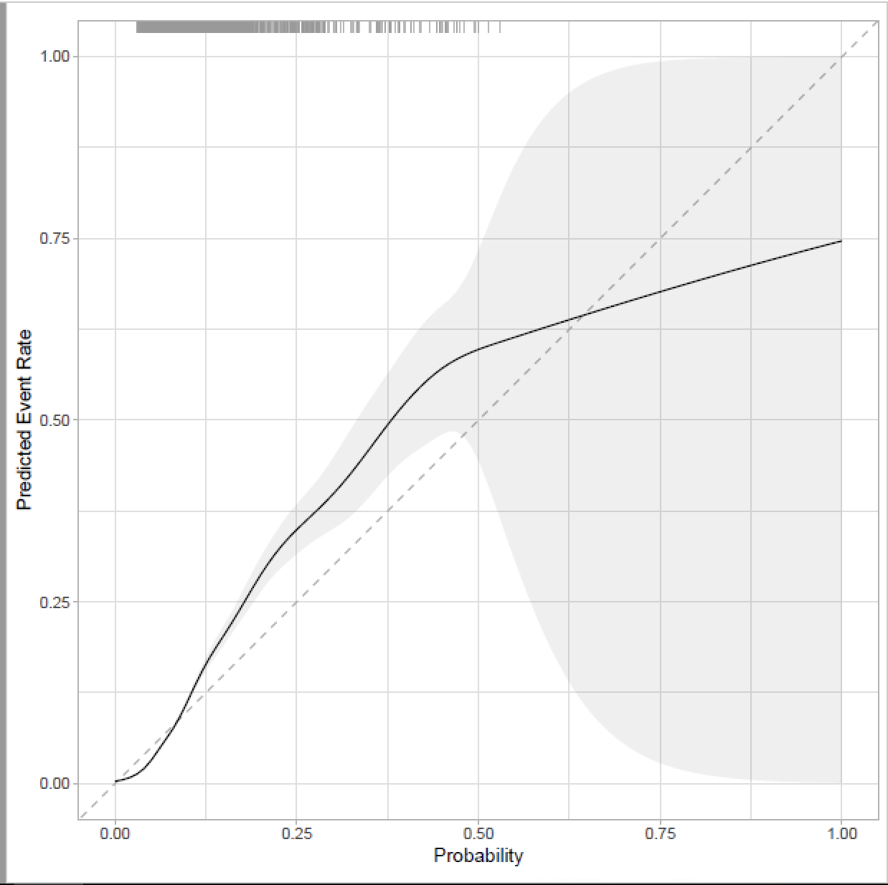
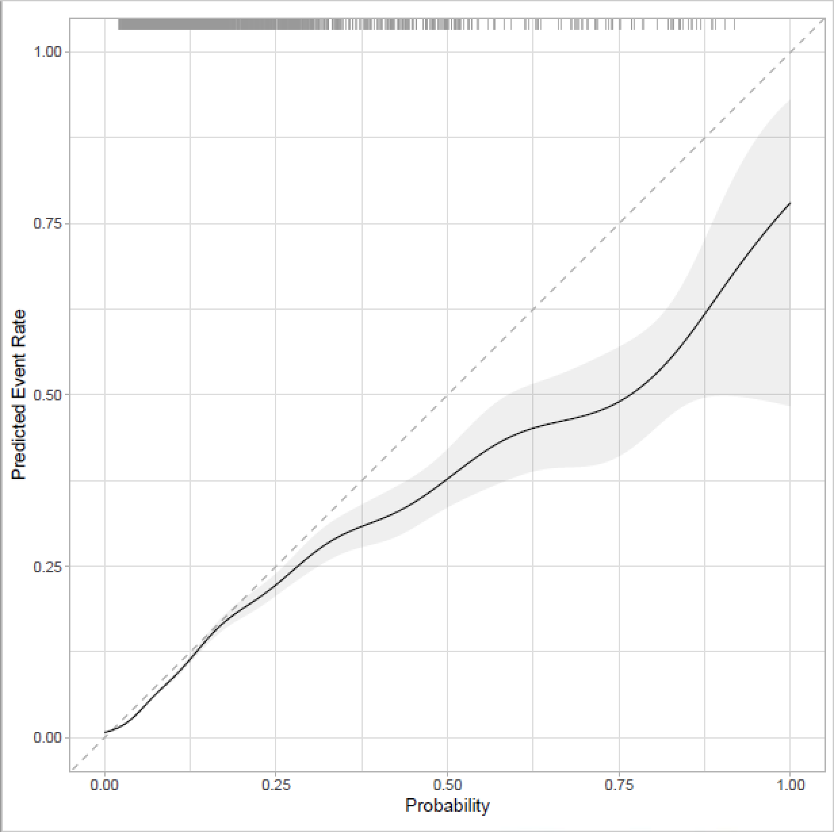
Supplementary Figure 1 Calibration plots for original (A) and NLP-refined (B) transdiagnostic risk calculator for psychosis
A
B

Supplementary Table 5 Comparison of Regression weights derived Irving et al. [12] and by LASSO from the Southeast England data

Concept | Irving et al.  Beta Coefficient | Southeast England  Lamda 1SE
Sex (Male – relative to Female) | +0.251607368 | -0.0629
Age | +0.006559315 | +0.0109
Age*Sex(Male – relative to Female) | -0.007533502 | Exc*
Ethnicity(Black – relative to White) | +0.768361197 | Exc
Ethnicity(Asian – relative to White) | +0.453691672 | Exc
Ethnicity(Mixed – relative to White) | +0.183875520 | Exc
Ethnicity(Other – relative to White) | +0.166521852 | Exc
Diagnosis(Acute and Transient Psychotic Disorders – relative to At Risk Mental State) | +0.231372239 | 1.4937
Diagnosis(Substance Use Disorders – relative to At Risk Mental State) | -1.907241596 | Exc
Diagnosis(Bipolar Mood Disorders – relative to At Risk Mental State) | -0.955396094 | +0.6035
Diagnosis(Non-Bipolar Mood Disorders – relative to At Risk Mental State) | -1.510699038 | Reference factor
Diagnosis(Anxiety Disorders – relative to At Risk Mental State) | -1.858113696 | Exc
Diagnosis(Personality Disorders – relative to At Risk Mental State) | -1.790252996 | +0.0709
Diagnosis(Developmental Disorders – relative to At Risk Mental State) | -2.705788876 | Exc
Diagnosis(Childhood-onset Disorders – relative to At Risk Mental State) | -2.836895336 | -0.3052
Diagnosis(Physiological Syndromes – relative to At Risk Mental State) | -2.240243726 | Exc
Diagnosis(Intellectual disabilities – relative to At Risk Mental State) | -2.657111217 | Exc
Cocaine Use mentioned in notes up to 6 months prior to index diagnosis | - 0.142318877 | Exc
Poor Insight mentioned in notes up to 6 months prior to index diagnosis | + 0.015966856 | Exc
Paranoia mentioned in notes up to 6 months prior to index diagnosis | + 0.961959253 | +0.8696
Tearfulness mentioned in notes up to 6 months prior to index diagnosis | -0.075196253 | +0.0311
Appetite loss mentioned in notes up to 6 months prior to index diagnosis | + 0.053663525 | Exc
Weight loss mentioned in notes up to 6 months prior to index diagnosis | + 0.129322246 | Exc
Insomnia mentioned in notes up to 6 months prior to index diagnosis | + 0.047588084 | Exc
Guilt mentioned in notes up to 6 months prior to index diagnosis | -0.070702784 | Exc
Irritability mentioned in notes up to 6 months prior to index diagnosis | + 0.051768711 | Exc
Delusions mentioned in notes up to 6 months prior to index diagnosis | + 0.739865889 | +0.4393
Feeling hopeless mentioned in notes up to 6 months prior to index diagnosis | -0.350144379 | Exc
Disturbed sleep mentioned in notes up to 6 months prior to index diagnosis | + 0.114071043 | Exc
Agitation mentioned in notes up to 6 months prior to index diagnosis | + 0.493122906 | +0.1433
Cannabis use mentioned in notes up to 6 months prior to index diagnosis | + 0.124130379 | +0.1003
*Exc: Predictors excluded by LASSO penalization.

Supplementary File 1: RECORD checklist (attached)
Supplementary File 2: TRIPOD+AI checklist (attached)

