Supplementary Material

# Supplementary Tables

Table S1. Factors influencing cultivation of improved forage grasses (probit model)

|  |  |  |
| --- | --- | --- |
| Variables | Coefficients | Marginal effects |
|  |  |  |
| Household head is male (1=yes) | 0.503** | 0.117 |
|  | (0.200) |  |
| Age of household head (years) | 0.005 | 0.001 |
|  | (0.004) |  |
| Highest level of education of household head | 0.071* | 0.017 |
|  | (0.042) |  |
| Household size (#) | -0.010 | -0.002 |
|  | (0.026) |  |
| Improved wall materials of house (1=yes) | 0.269** | 0.063 |
|  | (0.125) |  |
| Ihs of arable land owned (acres)a | -0.106 | -0.025 |
|  | (0.070) |  |
| Female HH member solely manages dairy animals (1=yes) | 0.361* | 0.084 |
|  | (0.203) |  |
| Grew any forage grass (1=yes) | 0.204 | 0.048 |
|  | (0.131) |  |
| Zero-grazing practiced for dairy animals (1=yes) | 0.487*** | 0.113 |
|  | (0.120) |  |
| Milk sold in dry season (1=yes) | -0.387*** | -0.090 |
|  | (0.126) |  |
| Main breed owned is local (1=yes) | -0.562*** | -0.131 |
|  | (0.118) |  |
| Access to credit in the past 12 months before baseline (1=yes) | 0.417*** | 0.097 |
|  | (0.132) |  |
| Be able to get any livestock extension service if wanted to (1=yes) | -0.313*** | -0.073 |
|  | (0.118) |  |
| Member of a farmer or producer organization (1=yes) | 0.496*** | 0.115 |
|  | (0.133) |  |
| Cash2grass or ISDAP project Districts (1=yes) | 2.197*** | 0.511 |
|  | (0.218) |  |
| Constant | -2.658*** |  |
|  | (0.433) |  |
|  |  |  |
| Observations | 820 |  |
| Pseudo R2 | 0.392 |  |
| F test | 0.000 |  |

Notes: Standard errors in parentheses; *** p<0.01, ** p<0.05, * p<0.1; Ihs=inverse hyperbolic sine transformation

Table S2. Covariates used for treatment model estimating whether cow was *fed* with IFGs (IPWRA first stage regression - RQ 3)

|  |  |
| --- | --- |
| Covariates | Selected |
| Gender of head of household (Hoh) | X |
| Hoh age | X |
| Hoh level of education | X |
| Household (HH) size | X |
| Improved housing wall materials (dummy) | X |
| Female HH member solely manages dairy farming (dummy) | X |
| Crossbreed/exotic breed (dummy) | X |
| Engaged in milk sales (dummy) | X |
| Experience cultivating forage grasses | X |
| Season in which CIAT improved forages were fed (rainy vs dry) | X |
| Access to livestock extension (dummy) | X |

Table S3. Covariates used for treatment model estimating whether household *fed* IFGs to cows (IPWRA first stage regression RQ 4 and 5)

|  |  |  |
| --- | --- | --- |
| Covariates | Original probit model | Reduced probit model |
| Gender of head of household (Hoh) | X | X |
| Hoh age | X | X |
| Hoh level of education | X | X |
| Household (HH) size | X | X |
| Improved housing wall materials (dummy) | X | X |
| Female HH member solely manages dairy farming (dummy) | X | X |
| Zero-grazing practiced for dairy animals (dummy) | X | X |
| Engaged in milk sales (dummy) | X | X |
| Local is the main breed of the herd (dummy) | X |  |
| Number of lactating cows | X |  |
| Arable land owned (acres) (IHS-transformed) | X | X |
| Area under IFG cultivation (sqm2) | X |  |
| Access to credit (dummy) | X | X |
| Farmer group (dummy) | X |  |
| Access to livestock extension (dummy) | X | X |
| Resides in Grass2cash or ISDAP Project District (dummy) | X | X |

Table S4. Covariates used for treatment model estimating whether household *cultivated* IFGs (IPWRA first stage regression RQ 6)

|  |  |  |
| --- | --- | --- |
| Covariates | Original probit model | Reduced probit model |
| Gender of head of household (Hoh) | X | X |
| Hoh age | X | X |
| Hoh level of education | X | X |
| Household (HH) size | X | X |
| Improved housing wall materials (dummy) | X | X |
| Female HH member solely owns dairy cows (dummy) | X |  |
| Female HH member solely manages dairy farming (dummy) | X |  |
| Zero-grazing practiced for dairy animals (dummy) | X | X |
| Engaged in milk sales (dummy) | X | X |
| Local is the main breed of the herd (dummy) | X | X |
| Arable land owned (acres) (IHS-transformed) | X | X |
| Experience cultivating forage grasses | X |  |
| Access to credit (dummy) | X | X |
| Farmer group (dummy) | X | X |
| Access to livestock extension (dummy) | X | X |
| Resides in Grass2cash or ISDAP Project District (dummy) | X |  |

Table S5.Covariates used for outcome models in IPWRA second stage regression

|  |  |  |  |  |  |  |  |
| --- | --- | --- | --- | --- | --- | --- | --- |
| Independent variables | Milk yields (RQ 3) | Dairy income (RQ 4) | Crop incomes (RQ 4) | Livestock incomes  (RQ 4) | Household income  (RQ 4) | Food security (RQ 5) | Land management (RQ 6) |
| Household variables | | | | | | | |
| Gender of head of household (Hoh) |  |  |  |  |  |  |  |
| Hoh age |  |  |  |  |  |  |  |
| Hoh level of education |  |  |  |  |  |  |  |
| Household (HH) size |  |  |  |  |  |  |  |
| Improved housing wall materials (dummy) |  |  |  |  |  |  |  |
| Female HH member solely decides if milk produced is consumed or sold (dummy) |  |  |  |  |  |  |  |
| Female HH member solely has control over revenues from dairy sales (dummy) |  |  |  |  |  |  |  |
| Female HH member solely owns dairy cows (dummy) |  |  |  |  |  |  |  |
| Female HH member solely manages dairy farming (dummy) |  |  |  |  |  |  |  |
| Dairy farming characteristics | | | | | | | |
| Zero-grazing practiced for dairy animals (dummy) |  |  |  |  |  |  |  |
| Engaged in milk sales (dummy) |  |  |  |  |  |  |  |
| Agricultural or livestock training past two years (dummy) |  |  |  |  |  |  |  |
| Local is the main breed of the herd (dummy) |  |  |  |  |  |  |  |
| Number of lactating cows |  |  |  |  |  |  |  |
| Herd size (number) (IHS-transformed) |  |  |  |  |  |  |  |
| Cow characteristics | | | | | | | |
| CIAT improved forages fed (dummy) |  |  |  |  |  |  |  |
| Season in which CIAT improved forages were fed (rainy vs dry) |  |  |  |  |  |  |  |
| Other forages or pasture fed (dummy) |  |  |  |  |  |  |  |
| Crossbreed/exotic breed (dummy) |  |  |  |  |  |  |  |
| Crop residues fed (dummy) |  |  |  |  |  |  |  |
| Maize bran or legumes fed (dummy) |  |  |  |  |  |  |  |
| Crop farming characteristics | | | | | | | |
| Arable land owned (acres) (IHS-transformed) |  |  |  |  |  |  |  |
| Access to credit (dummy) |  |  |  |  |  |  |  |
| Farmer group (dummy) |  |  |  |  |  |  |  |
| Access to livestock extension (dummy) |  |  |  |  |  |  |  |
| Geographic variables | | | | | | | |
| Resides in Grass2cash or ISDAP Project District (dummy) |  |  |  |  |  |  |  |

Table S6.Two-stage least square (2SLS) regression for the impacts of feeding IFG on DMY

|  |  |
| --- | --- |
| Variables |  |
|  |  |
| Cow fed with improved forages (1=yes) | 0.516*** |
|  | (0.146) |
| Crossbreed or exotic (1=yes) | 0.342*** |
|  | (0.049) |
| Season (1=rainy, 0=dry season) | 0.497*** |
|  | (0.015) |
| Other forages or pasture feeding (1=yes) | 0.111** |
|  | (0.049) |
| Other crop residues fed (1=yes) | 0.153*** |
|  | (0.054) |
| Maize or legumes fed (1=yes) | 0.131** |
|  | (0.062) |
| Household head is male (1=yes) | 0.030 |
|  | (0.059) |
| Age of household head at baseline (years) | -0.001 |
|  | (0.001) |
| Highest level of education of household head at baseline | 0.045*** |
|  | (0.016) |
| Household size (#) at baseline | -0.001 |
|  | (0.009) |
| Female HH member solely manages dairy animals (1=yes) | 0.040 |
|  | (0.069) |
| Milk sold in dry season at baseline (1=yes) | 0.130*** |
|  | (0.044) |
| Be able to get any livestock extension service if you wanted to at baseline (1=y | 0.221*** |
|  | (0.047) |
| IHS of arable land owned at baseline (acres) | -0.005 |
|  | (0.019) |
| Member of a farmer or producer organization at baseline (1=yes) | -0.162*** |
|  | (0.059) |
| Access to credit in the past 12 months before baseline (1=yes) | -0.019 |
|  | (0.049) |
| Constant | 0.939*** |
|  | (0.125) |
|  |  |
| Observations | 2,186 |
| R-squared | 0.337 |
| F test | 0.000 |

Notes: cluster-adjusted standard errors used for households; *** p<0.01, ** p<0.05, * p<0.1; dependent variable is the inverse

hyperbolic sine (IHS) transformation of DMY. Instrumental variable is whether household resides in sub county of demonstration

plot for IFGs.

Table S7. Relevance of instrumental variable “Forage grass demo plot in Subcounty (1=yes)”

|  |  |
| --- | --- |
|  | Probit model |
|  |
|  |  |
| Household head is male (1=yes) | 0.377* |
|  | (0.203) |
| Age of household head (years) | 0.009* |
|  | (0.005) |
| Highest level of education of household head | 0.082* |
|  | (0.047) |
| Improved wall materials of house (1=yes) | 0.335** |
|  | (0.143) |
| Household size (#) | -0.054* |
|  | (0.029) |
| Female HH member solely manages dairy animals (1=yes) | 0.066 |
|  | (0.233) |
| Milk sold in dry season (1=yes) | -0.195 |
|  | (0.156) |
| Be able to get any livestock extension service if you wanted to (1=yes) | -0.502*** |
|  | (0.133) |
| Rainy season (1=yes) | -0.009 |
|  | (0.040) |
| Grew any forage grass (1=yes) | 0.161 |
|  | (0.156) |
| Crossbreed/exotic cow (1=yes) | 0.507*** |
|  | (0.130) |
| Member of a farmer or producer organization (1=yes) | 0.881*** |
|  | (0.146) |
| Grass2cash or ISDAP project Districts (1=yes) | 1.861*** |
|  | (0.235) |
| IHS of arable land owned (acres) | -0.031 |
|  | (0.073) |
| Forage grass demo plot in Subcounty (1=yes) | 0.915*** |
|  | (0.184) |
| Constant | -3.189*** |
|  | (0.512) |
|  |  |
| Observations | 2,186 |
| F test | 0 |

Notes: *** p<0.01, ** p<0.05, * p<0.1; dependent variable is the inverse hyperbolic sine (IHS) transformation of DMY

Table S8. Falsification test of for instrument on dairy productivity among non IFG-feeding farmers

|  |  |
| --- | --- |
|  | OLS regression |
|  |
|  |  |
| Crossbreed or exotic (1=yes) | 0.376*** |
|  | (0.043) |
| Rainy season (1=yes) | 0.509*** |
|  | (0.017) |
| Other forages or pasture feeding (1=yes) | 0.245*** |
|  | (0.057) |
| Other crop residues fed (1=yes) | 0.286*** |
|  | (0.056) |
| Maize or legumes fed (1=yes) | 0.190*** |
|  | (0.063) |
| Household head is male (1=yes) | 0.063 |
|  | (0.057) |
| Age of household head at baseline (years) | 0.001 |
|  | (0.002) |
| Highest level of education of household head at baseline | 0.053*** |
|  | (0.016) |
| Household size (#) at baseline | -0.006 |
|  | (0.009) |
| Female HH member solely manages dairy animals (1=yes) | 0.078 |
|  | (0.074) |
| Milk sold in dry season at baseline (1=yes) | 0.108** |
|  | (0.049) |
| Be able to get any livestock extension service if wanted to (1=yes) | 0.088** |
|  | (0.045) |
| IHS of arable land owned at baseline (acres) | 0.014 |
|  | (0.018) |
| Member of a farmer or producer organization at baseline (1=yes) | -0.137** |
|  | (0.058) |
| Access to credit in the past 12 months before baseline (1=yes) | 0.022 |
|  | (0.060) |
| Attended any forage grass field day or training organized by SNV (1=yes) | 0.245*** |
|  | (0.086) |
| Forage grass demo plot in Subcounty (1=yes) | 0.099 |
|  | (0.104) |
| Constant | 0.709*** |
|  | (0.131) |
|  |  |
| Observations | 1,583 |
| R-squared | 0.414 |
| F test | 0 |

Notes: *** p<0.01, ** p<0.05, * p<0.1; dependent variable is the inverse hyperbolic sine (IHS) transformation of DMY

Table S9. Test for endogeneity and weak instrument test

Tests of endogeneity (Durbin-Wu-Hausmann Test)

H0: Variables are exogenous

Robust regression F(1,570) = 9.0326 (p = 0.0028) (Adjusted for 571 clusters in hhid)

* We reject the null hypothesis that variables are exogenous and must use instrumental variable approach
* Simple OLS will lead to biased estimates

Weak instrument test

|  |  |  |  |  |  |
| --- | --- | --- | --- | --- | --- |
| Endogenous variable | R-squared | Adj. R-squared | Partial R-squared | Robust F (1,570) | Prob > F |
| Feeding IFGs | 0.3535 | 0.3487 | 0.1012 | 65.5044 | 0.0000 |

* H0: instrument is weak
* F-Statistic > 10 (as the threshold value)
* We can reject H0 that the instrument “Household resides in demo plot sub county” is weak

# Supplementary Figures

Figure S1. Kernel density distribution for treatment model for dairy farmers feeding IFGs (research question 3 with impacts on milk productivity)

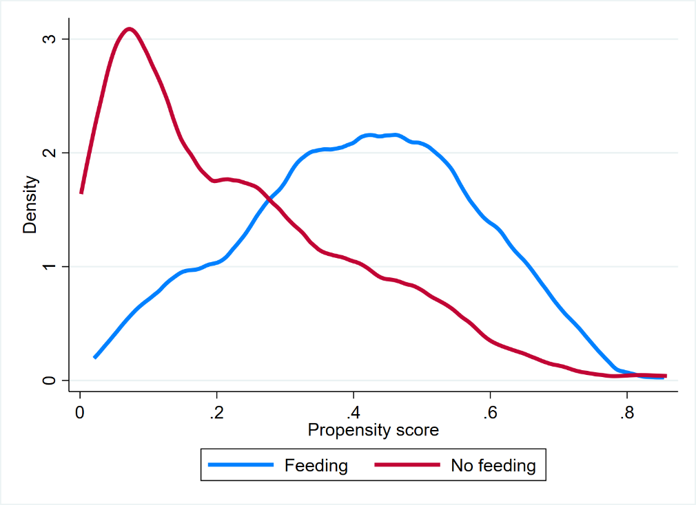

Figure S2. Kernel density distribution for treatment model for dairy farmers feeding IFGs (research question 4 and 5 with impacts on incomes and food security)

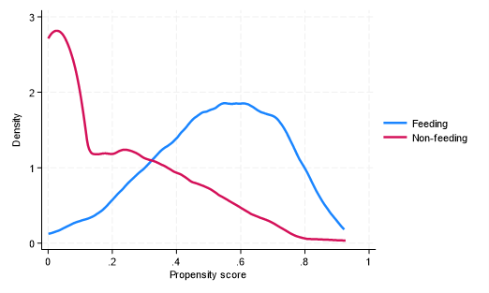

Figure S3. Kernel density distribution for treatment model for dairy farmers feeding IFGs (research question 4 and 5 with impacts on incomes and food security) – reduced treatment model



Figure S4. Kernel density distribution for treatment model for farmers cultivating IFGs (research question 6 with impacts on sustainable land management practices)

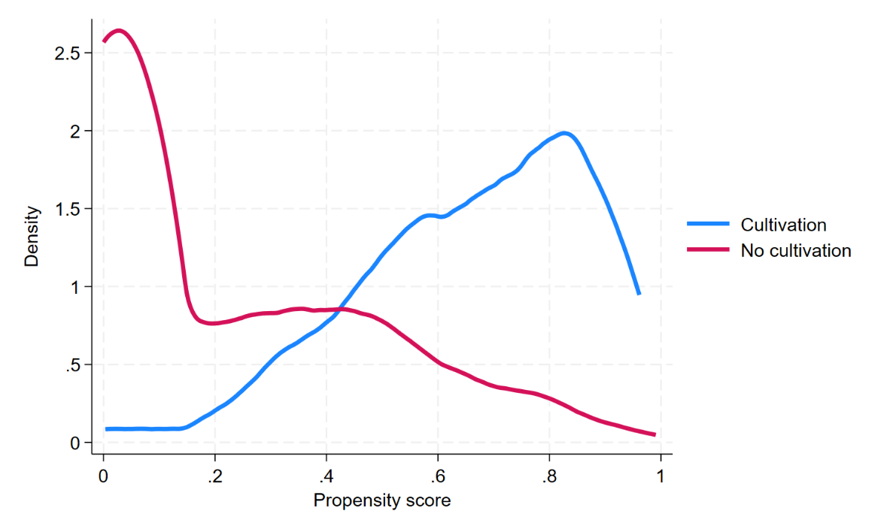

Figure S5. Kernel density distribution for treatment model for farmers cultivating IFGs (research question 6 with impacts on sustainable land management practices) – reduced treatment model

