Appendix
Figure A.1: Sequence index plot of educational trajectories across cohort groups
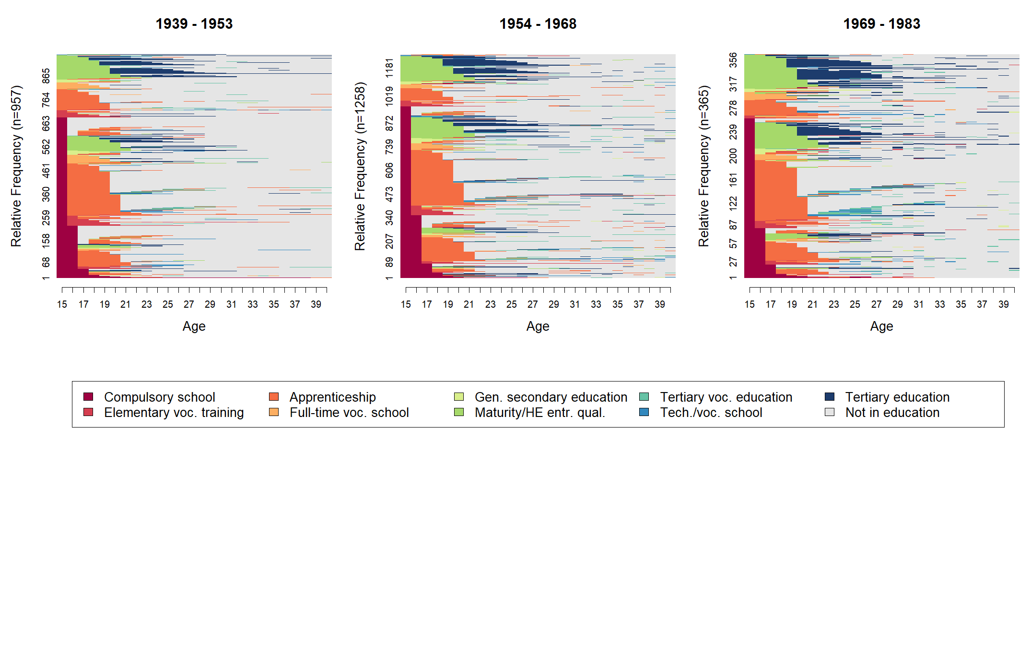
Source: Swiss Household Panel data, 1999–2023

Figure A.2: Mean time plot of the different educational states across cohorts
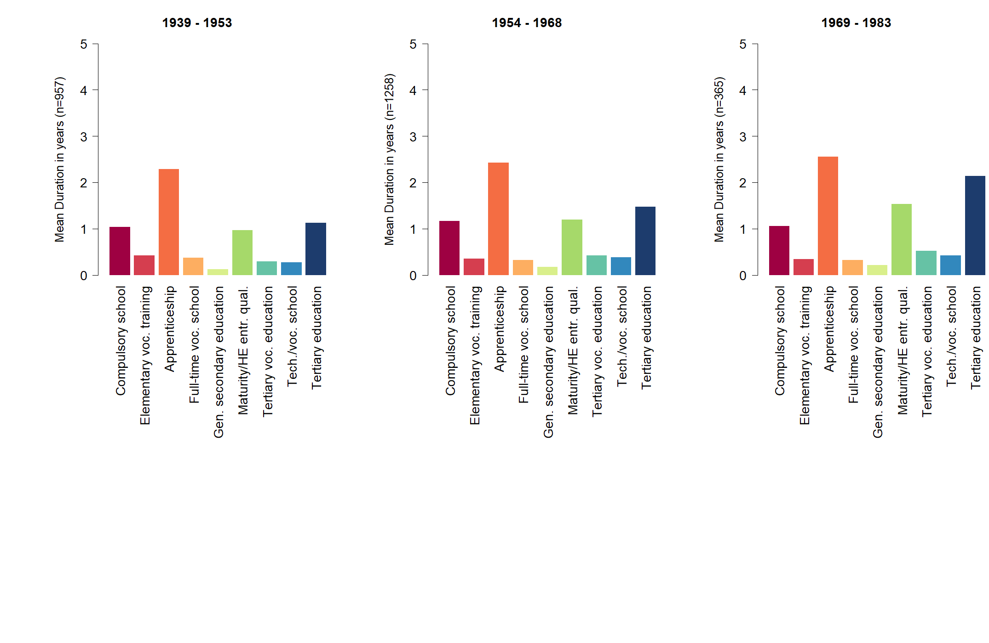
Source: Swiss Household Panel data, 1999–2023

Figure A.3: Cluster performance plots
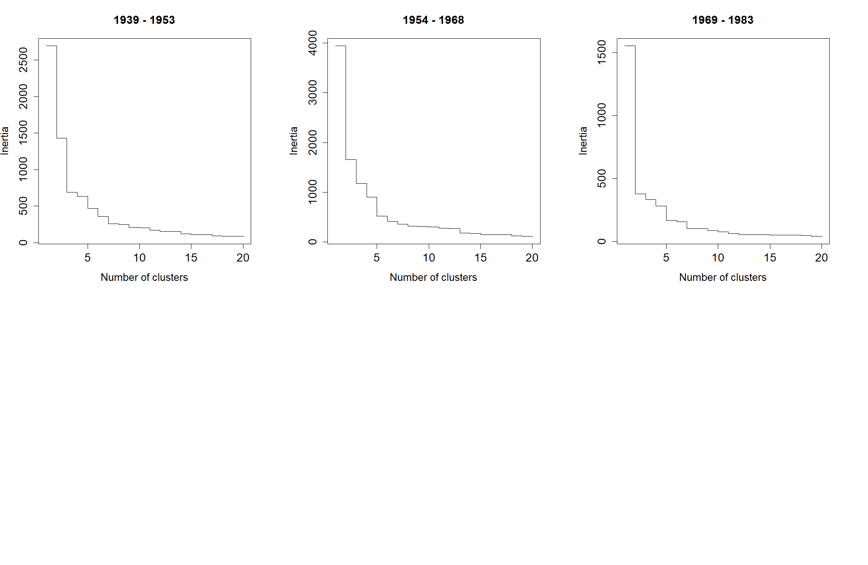
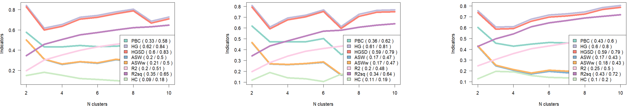

Figure A.4: Educational trajectory clusters - state distribution plots across cohort groups
2-Class Solution
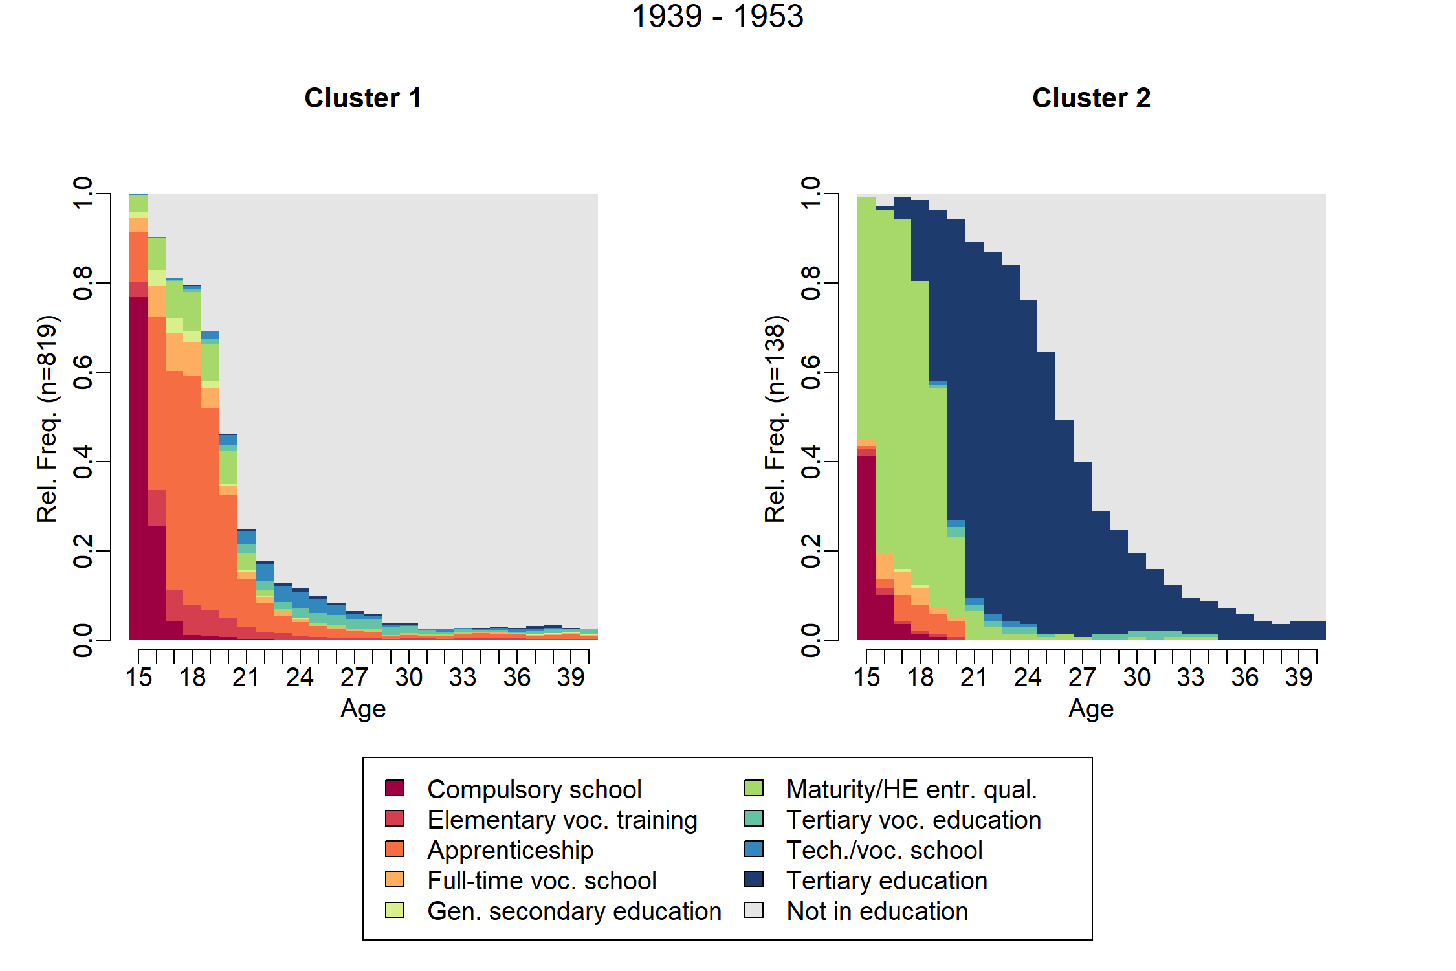
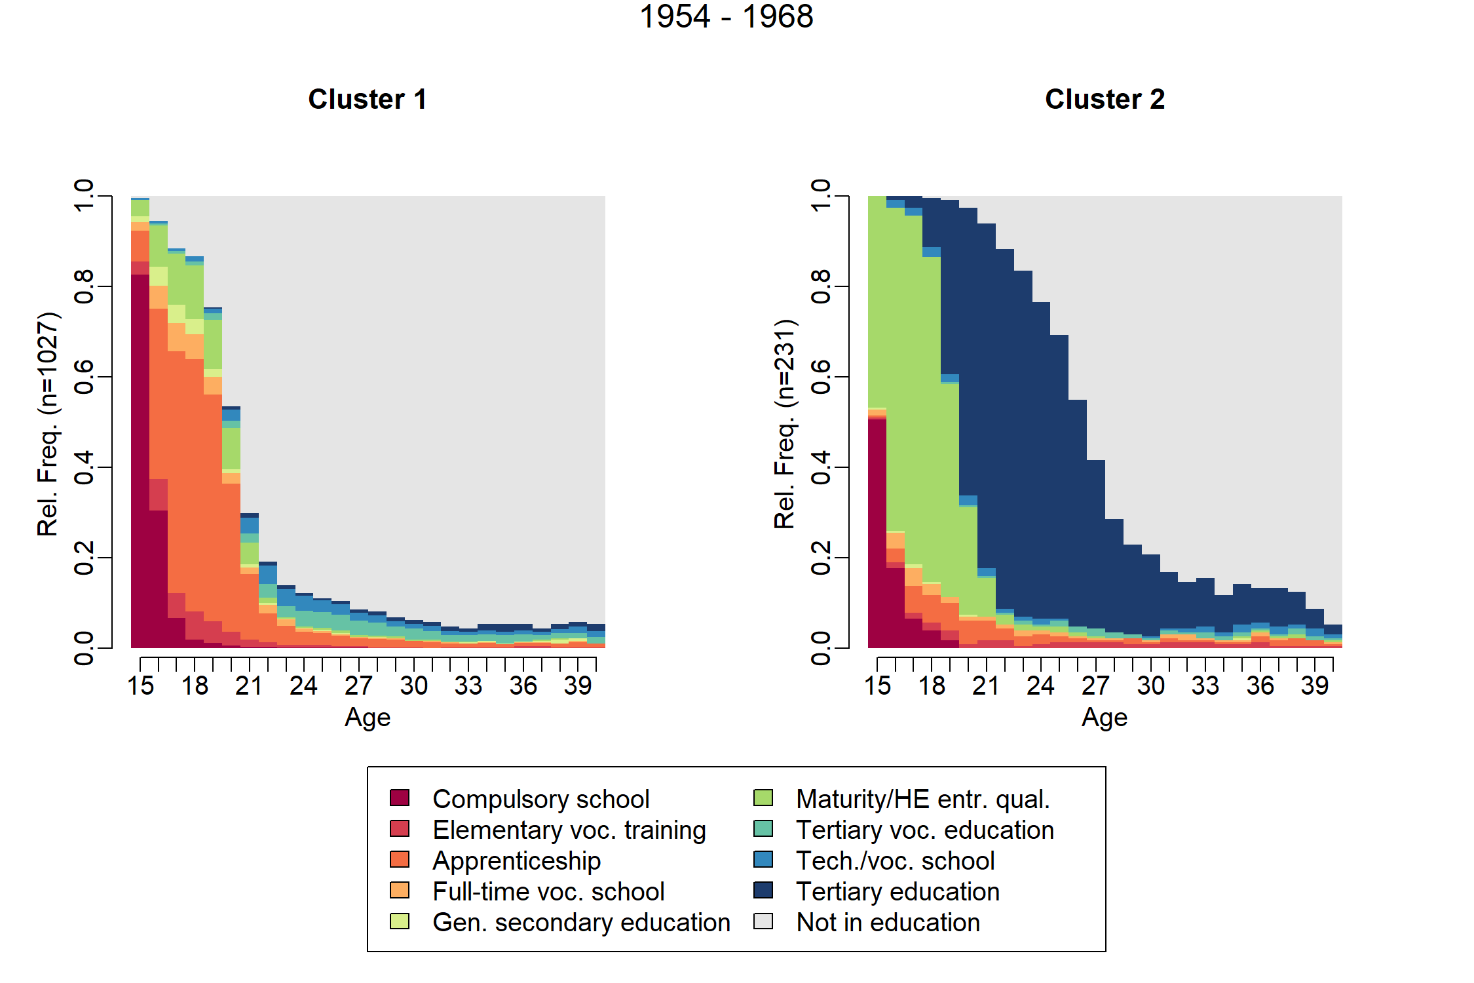
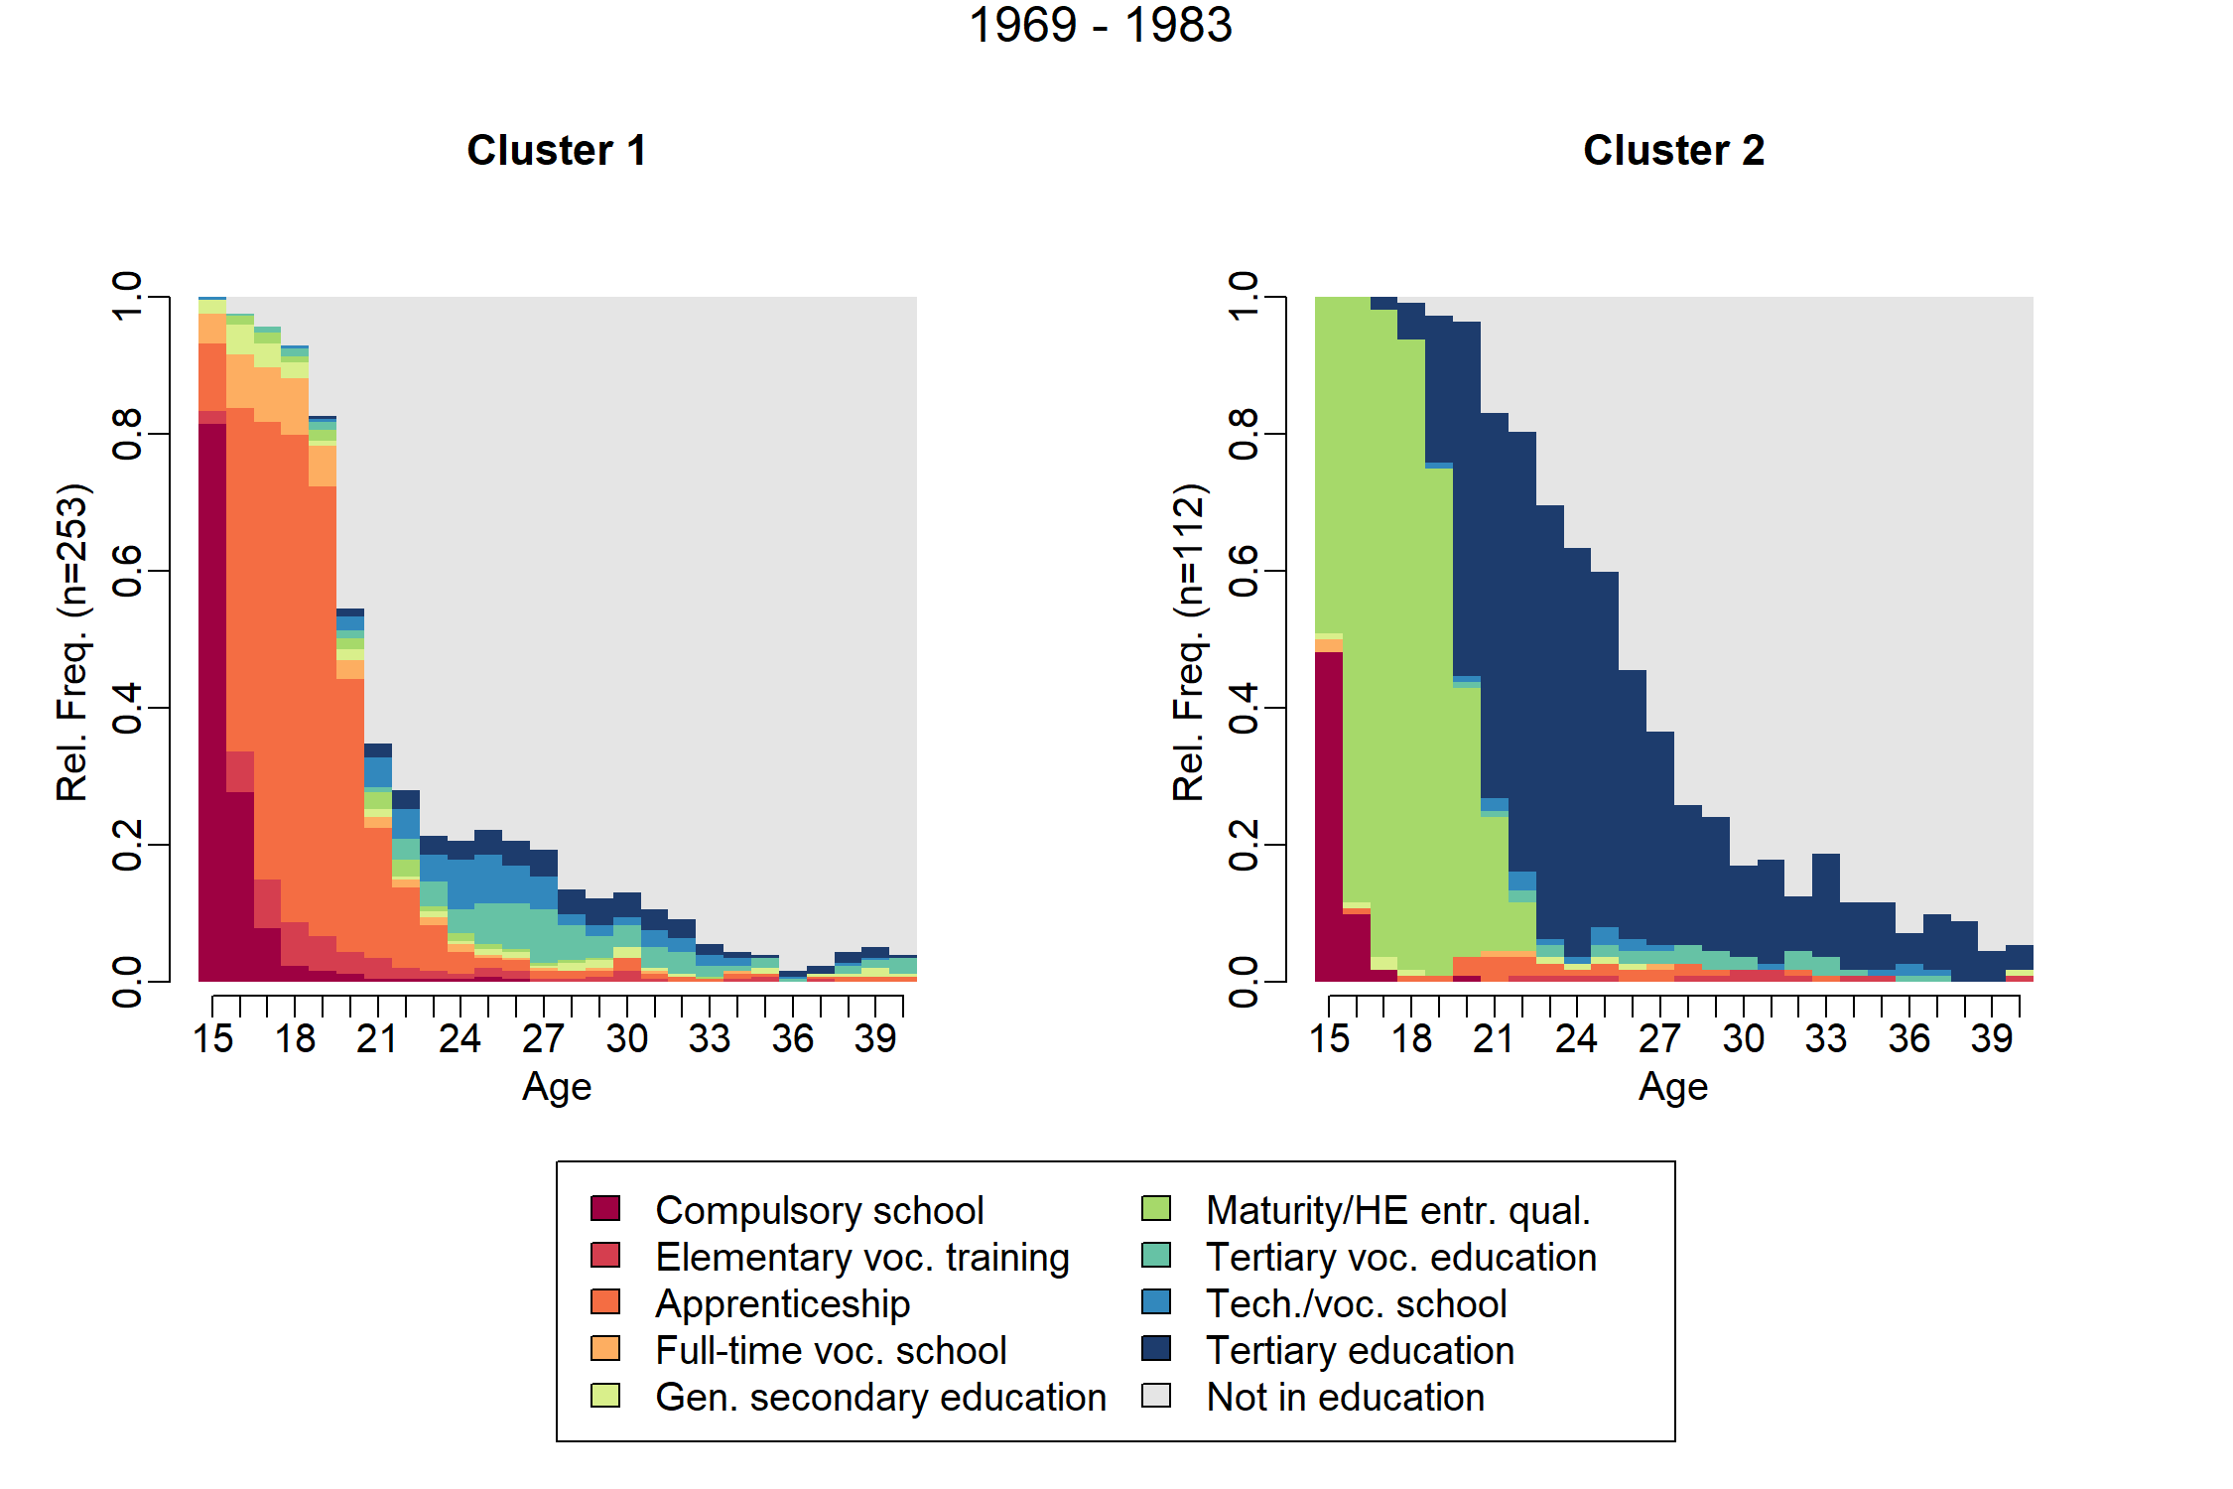
Source: Swiss Household Panel data, 1999–2023

Figure A.5: Educational trajectory clusters - state distribution plots across cohort groups
4 to 7 Class Solution
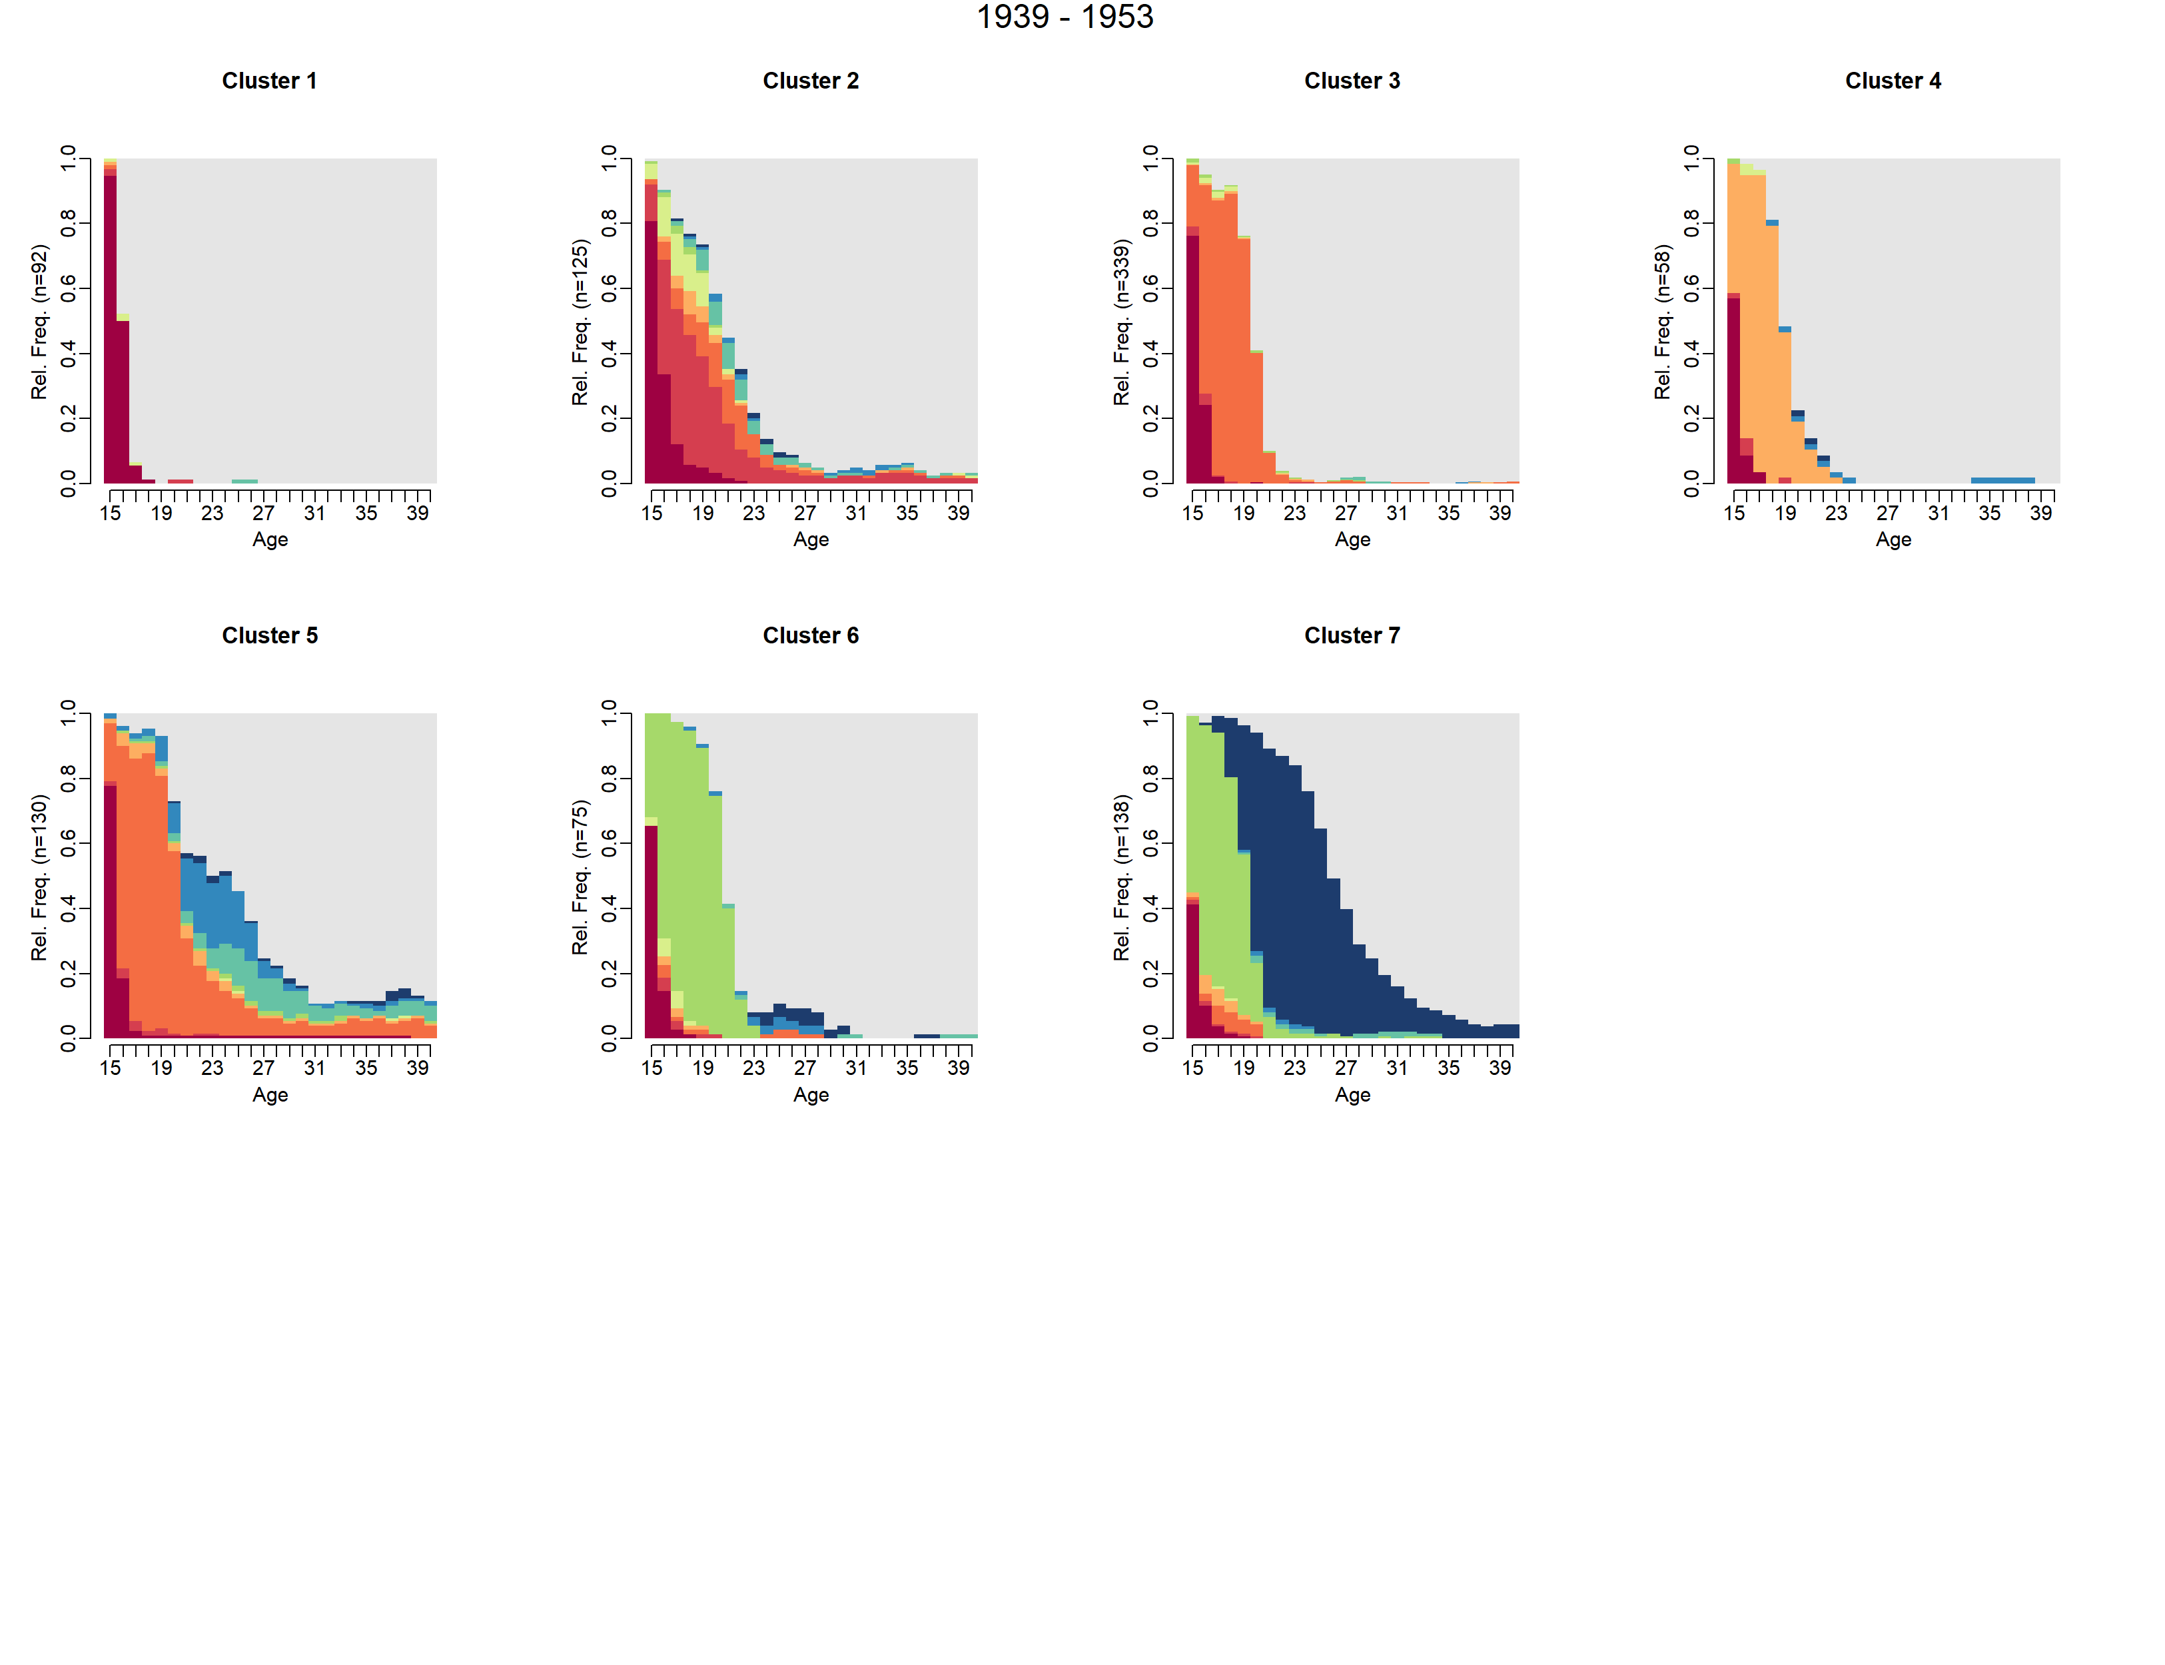
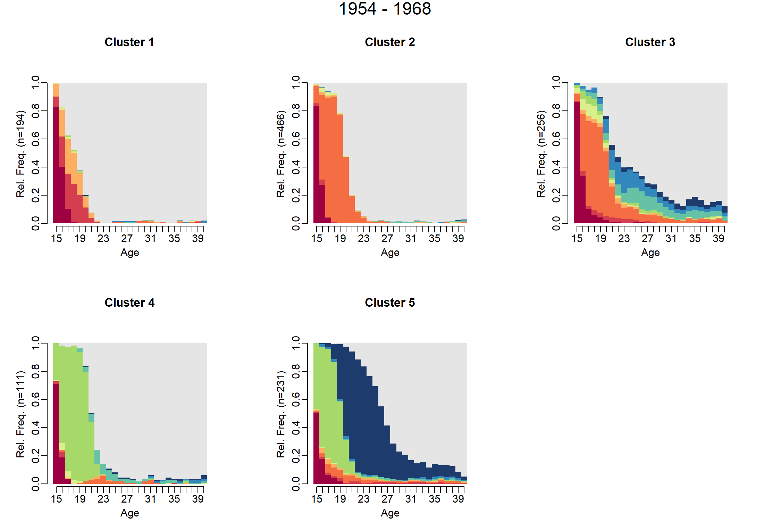
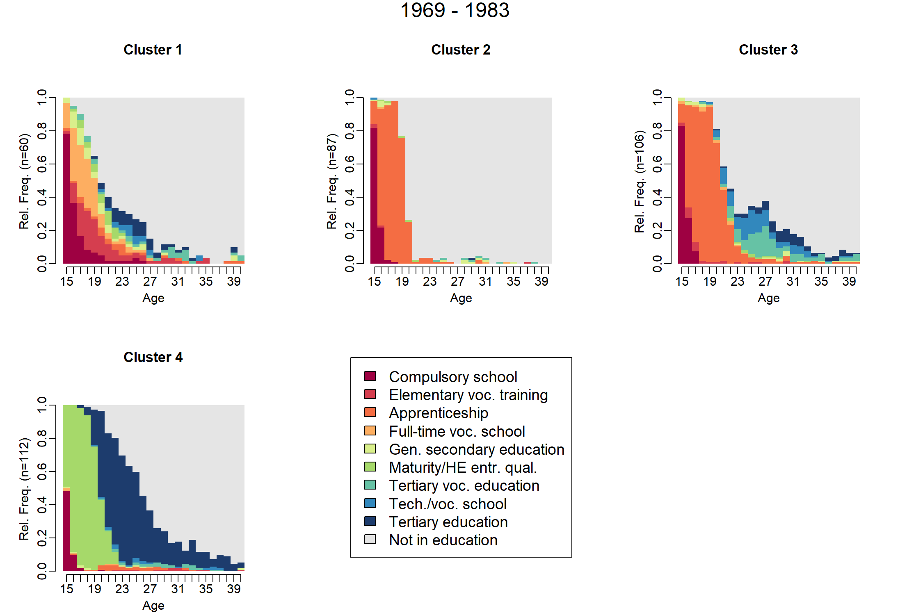
Source: Swiss Household Panel data, 1999–2023

Table A.1: Quality indices for the four best solutions
 |  | N groups | Index | N groups | Index | N groups | Index | N groups | Index
1939 - 1953 | PBC | 2 | 0.577 | 8 | 0.448 | 5 | 0.446 | 7 | 0.440
 | HG | 2 | 0.842 | 8 | 0.805 | 7 | 0.777 | 6 | 0.743
 | HGSD | 2 | 0.829 | 8 | 0.788 | 7 | 0.760 | 6 | 0.726
 | ASW | 2 | 0.501 | 3 | 0.310 | 7 | 0.306 | 8 | 0.295
 | ASWw | 2 | 0.502 | 3 | 0.312 | 7 | 0.310 | 8 | 0.300
 | CH | 2 | 234.425 | 3 | 206.169 | 4 | 172.597 | 5 | 157.529
 | R2 | 10 | 0.511 | 9 | 0.496 | 8 | 0.477 | 7 | 0.459
 | CHsq | 2 | 505.698 | 3 | 402.452 | 4 | 325.042 | 5 | 292.795
 | R2sq | 10 | 0.648 | 9 | 0.630 | 8 | 0.623 | 7 | 0.599
 | HC | 8 | 0.089 | 7 | 0.099 | 6 | 0.111 | 5 | 0.119
 |  | N groups | Index | N groups | Index | N groups | Index | N groups | Index
1954 - 1968 | PBC | 2 | 0.618 | 6 | 0.503 | 3 | 0.473 | 4 | 0.472
 | HG | 2 | 0.808 | 10 | 0.768 | 6 | 0.768 | 9 | 0.764
 | HGSD | 2 | 0.793 | 6 | 0.752 | 10 | 0.750 | 9 | 0.745
 | ASW | 2 | 0.465 | 6 | 0.284 | 5 | 0.271 | 3 | 0.269
 | ASWw | 2 | 0.466 | 6 | 0.287 | 5 | 0.273 | 3 | 0.271
 | CH | 2 | 309.708 | 3 | 245.236 | 4 | 215.309 | 5 | 196.293
 | R2 | 10 | 0.482 | 9 | 0.466 | 8 | 0.450 | 7 | 0.432
 | CHsq | 2 | 652.838 | 3 | 482.087 | 4 | 387.285 | 5 | 348.754
 | R2sq | 10 | 0.639 | 9 | 0.627 | 8 | 0.606 | 7 | 0.580
 | HC | 6 | 0.106 | 10 | 0.113 | 9 | 0.116 | 2 | 0.120
 |  | N groups | Index | N groups | Index | N groups | Index | N groups | Index
1969 - 1983 | PBC | 2 | 0.601 | 8 | 0.464 | 6 | 0.464 | 7 | 0.459
 | HG | 10 | 0.805 | 9 | 0.785 | 2 | 0.756 | 8 | 0.744
 | HGSD | 10 | 0.787 | 9 | 0.768 | 2 | 0.738 | 8 | 0.726
 | ASW | 2 | 0.427 | 3 | 0.248 | 4 | 0.206 | 6 | 0.196
 | ASWw | 2 | 0.431 | 3 | 0.254 | 4 | 0.213 | 10 | 0.208
 | CH | 2 | 119.125 | 3 | 80.207 | 4 | 67.627 | 5 | 61.198
 | R2 | 10 | 0.502 | 9 | 0.489 | 8 | 0.473 | 7 | 0.456
 | CHsq | 2 | 269.578 | 3 | 179.520 | 4 | 141.874 | 5 | 139.167
 | R2sq | 10 | 0.720 | 9 | 0.704 | 8 | 0.689 | 7 | 0.666
 | HC | 10 | 0.102 | 9 | 0.111 | 2 | 0.127 | 8 | 0.131

Source: Swiss Household Panel data, 1999–2023

Table A.2: Multinomial logistic regression for the 1939-1953 cohorts across the three clusters by gender, migration background, and social class. Reference cluster: 1.
Cohorts 1939-1953 | Cluster 2 | Cluster 3
Constant | 0.112 (0.134) | -2.714*** (0.289)
Man | 1.132*** (0.160) | 2.022*** (0.246)
Migration background | -0.842*** (0.255) | 0.887*** (0.280)
Erikson-Goldthorpe-Portocarero (EGP) class scheme
(Ref.: V Working class (skilled and unskilled))
IV Petite bourgeoisie (self-employed) | -0.343* (0.184) | -0.044 (0.332)
III Routine non-manual employees | -0.198 (0.286) | 0.649 (0.435)
II Lower service class | -0.196 (0.263) | 1.143*** (0.358)
I Upper service class | -0.639** (0.281) | 1.781*** (0.332)
Note: * p < 0.1, ** p < 0.05, *** p < 0.01, standard errors in parentheses, data: Swiss Household Panel data, 1999–2023, McFadden's Pseudo-R² = 0.116
Table A.3: Multinomial logistic regression for the 1939-1953 cohorts across the six clusters by gender, migration background, and social class. Reference cluster: 1.
Cohorts 1954-1968 | Cluster 2 | Cluster 3 | Cluster 4 | Cluster 5 | Cluster 6
Constant | 0.783*** (0.150) | -0.639*** (0.193) | -1.184*** (0.250) | -3.557*** (0.461) | -1.570*** (0.243)
Man | 0.933*** (0.201) | 1.849*** (0.223) | -0.051 (0.300) | 2.207*** (0.369) | 1.400*** (0.243)
Migration background | -1.302*** (0.264) | -0.644** (0.280) | -0.162 (0.329) | 0.740* (0.387) | 0.386 (0.274)
Erikson-Goldthorpe-Portocarero (EGP) class scheme
(Ref.: V Working class (skilled and unskilled))
IV Petite bourgeoisie (self-employed) | -0.127 (0.219) | -0.041 (0.259) | 0.420 (0.344) | -0.287 (0.629) | -0.108 (0.347)
III Routine non-manual employees | -0.190 (0.291) | 0.214 (0.332) | 0.795** (0.403) | 1.923*** (0.504) | 1.242*** (0.353)
II Lower service class | -0.001 (0.345) | 0.953*** (0.359) | 1.671*** (0.412) | 1.698*** (0.588) | 1.757*** (0.388)
I Upper service class | 0.190 (0.350) | 0.862** (0.379) | 1.696*** (0.421) | 2.668*** (0.532) | 2.654*** (0.374)
Note: * p < 0.1, ** p < 0.05, *** p < 0.01, standard errors in parentheses, data: Swiss Household Panel data, 1999–2023, McFadden's Pseudo-R² = 0.089
Table A.4: Multinomial logistic regression for the 1939-1953 cohorts across the three clusters by gender, migration background, and social class. Reference cluster: 1.
Cohorts 1969-1983 | Cluster 2 | Cluster 3
Constant | -0.976*** (0.255) | -1.321** (0.290)
Man | 1.232*** (0.293) | -0.025 (0.300)
Migration background | -0.877 (0.604) | 0.356 (0.469)
Erikson-Goldthorpe-Portocarero (EGP) class scheme
(Ref.: V Working class (skilled and unskilled))
IV Petite bourgeoisie (self-employed) | -0.430 (0.474) | 0.851* (0.461)
III Routine non-manual employees | 0.090 (0.381) | 0.806* (0.418)
II Lower service class | 0.669 (0.445) | 1.827*** (0.461)
I Upper service class | -0.197 (0.513) | 1.868*** (0.444)
Note: * p < 0.1, ** p < 0.05, *** p < 0.01, standard errors in parentheses, data: Swiss Household Panel data, 1999–2023, McFadden's Pseudo-R² = 0.087

Table A.5: Multinomial logistic regression for the 1939-1953 cohorts across the three clusters by gender, migration background, and parents’ education. Reference cluster: 1.
Cohorts 1939-1953 | Cluster 2 | Cluster 3
Constant | -0.321*  (0.181) | -3.305*** (0.392)
Man | 1.188*** (0.159) | 2.067*** (0.252)
Migration background | -0.582** (0.246) | 0.892*** (0.287)
Parents education
(Ref.: Compulsory school)
Vocational education and training | 0.374* (0.195) | 0.631 (0.384)
General secondary education | 0.227 (0.306) | 2.150*** (0.442)
Higher vocational education  (tertiary VET, tech./voc. schools) | 0.233 (0.268) | 1.332*** (0.431)
Tertiary education | -1.107** (0.446) | 2.604*** (0.435)
Note: * p < 0.1, ** p < 0.05, *** p < 0.01, standard errors in parentheses, data: Swiss Household Panel data, 1999–2023, McFadden's Pseudo-R² = 0.140
Table A.6: Multinomial logistic regression for the 1939-1953 cohorts across the six clusters by gender, migration background, and parents’ education. Reference cluster: 1.
Cohorts 1954-1968 | Cluster 2 | Cluster 3 | Cluster 4 | Cluster 5 | Cluster 6
Constant | -0.531** (0.208) | -1.104*** (0.271) | -1.491*** (0.364) | -3.987*** (0.621) | -2.794*** (0.445)
Man | 0.88*** (0.199) | 1.799*** (0.222) | -0.105 (0.295) | 2.055*** (0.369) | 1.349*** (0.245)
Migration background | -1.255*** (0.270) | -0.524* (0.286) | -0.085 (0.335) | 0.701* (0.393) | 0.432 (0.290)
Parents education
(Ref.: Compulsory school)
Vocational education and training | 0.245 (0.224) | 0.551** (0.277) | 0.774** (0.386) | 1.094* (0.601) | 1.679*** (0.448)
General secondary education | 0.789* (0.418) | 1.473*** (0.459) | 2.227*** (0.53) | 2.583*** (0.744) | 3.334*** (0.566)
Higher vocational education  (tertiary VET, tech./voc. schools) | 0.712* (0.366) | 1.555*** (0.407) | 1.792*** (0.503) | 2.359*** (0.723) | 2.916*** (0.542)
Tertiary education | -0.975 (0.675) | 1.763*** (0.537) | 2.366*** (0.596) | 3.765*** (0.754) | 4.571*** (0.605)
Note: * p < 0.1, ** p < 0.05, *** p < 0.01, standard errors in parentheses, data: Swiss Household Panel data, 1999–2023, McFadden's Pseudo-R² = 0.101

Table A.7: Multinomial logistic regression for the 1939-1953 cohorts across the three clusters by gender, migration background, and parents’ education. Reference cluster: 1.
Cohorts 1969-1983 | Cluster 2 | Cluster 3
Constant | -1.654*** (0.500) | -1.367*** (0.482)
Man | 1.1494*** (0.286) | 0.000 (0.307)
Migration background | -1.282* (0.661) | 0.316 (0.462)
Parents education
(Ref.: Compulsory school)
Vocational education and training | 0.812 (0.508) | 0.271 (0.509)
General secondary education | 0.783 (0.690) | 1.258** (0.641)
Higher vocational education  (tertiary VET, tech./voc. schools) | 1.096* (0.636) | 1.500** (0.612)
Tertiary education | 0.965 (0.698) | 2.818*** (0.613)
Note: * p < 0.1, ** p < 0.05, *** p < 0.01, standard errors in parentheses, data: Swiss Household Panel data, 1999–2023, McFadden's Pseudo-R² = 0.120

