**Supplementary materials for**

**Per- and polyfluoroalkyl substances in plain urban water network: shifting focus to sediments**

Miao-Miao Wang, Zhiqiang Xia*, Jianming Jiang, Haigang Wu, Hurong Huang, Xilong Zhang, Wen-Jun Hong, Minjie Li, Liang-Hong Guo*

Miao-Miao Wang, Hurong Huang:

School of Life Science, China Jiliang University, Hangzhou, Zhejiang 310018, China.

Zhiqiang Xia, Xilong Zhang, Wen-Jun Hong:

College of Energy Environment and Safety Engineering, China Jiliang University, Hangzhou, Zhejiang 310018, China.

Jianming Jiang:

College of Energy Environment and Safety Engineering, China Jiliang University, Hangzhou, Zhejiang 310018, China.

China Coal Zhejiang Testing Technology Co., Ltd., Hangzhou, Zhejiang 311115, China

Haigang Wu:

Zhejiang Jiaoke Environment Technology Co, Ltd, Hangzhou, Zhejiang 311305, China

Minjie Li:

College of Energy Environment and Safety Engineering, China Jiliang University, Hangzhou, Zhejiang 310018, China.

Hangzhou Institute of Medicine, Chinese Academy of Sciences, Hangzhou, Zhejiang 310018, China

Liang-Hong Guo:

College of Energy Environment and Safety Engineering, China Jiliang University, Hangzhou, Zhejiang 310018, China.

School of Environment, Hangzhou Institute for Advanced Study, University of the Chinese Academy of Sciences, Hangzhou 310024, China*\**Correspondence

Zhiqiang Xia: [*xiazhiqiang@hotmail.com*](mailto:xiazhiqiang@hotmail.com)

Liang-Hong Guo:[*lhguo@ucas.ac.cn*](mailto:lhguo@ucas.ac.cn)

Mailing address: College of Energy Environment and Safety Engineering, China Jiliang University, 168 Xueyuan Street, Qiantang District, Hangzhou, Zhejiang 310018.

**Test S1 Solid phase extraction (SPE).**

To clarify, 400 mL of water was passed through a 0.45 μm cellulose acetate membrane filter, and 10 ng of perfluorinated internal standard was added to each sample. The WAX column was activated by sequentially adding 4 mL of 1% ammonia-modified methanol, 4 mL of methanol, and 4 mL of pure water. After activation, the column was used to enrich perfluorinated compounds in the water samples. Then, 4 mL of ammonium acetate solution (25 mmol/L, pH = 4) was used to rinse the WAX column. The water was then pumped out, taking approximately 15 minutes. The enriched compounds were eluted with 4 mL of methanol and 4 mL of 1% ammonia-modified methanol. The eluate was concentrated to 1 mL by nitrogen evaporation, filtered through a 0.22 μm filter, and transferred to an injection vial for analysis.

**Text S2 Pre-treatment methods for sediments.**

Nine mL of acetonitrile and one mL of water were added to the above sediment sample, followed by a 2 min vortex at 2000 rpm and further subjected to ultrasonic extraction for 15 minutes. After centrifuging for 10 minutes (8000 rpm, 25°C), the supernatant was transferred to a new 50 mL centrifuge tube. We repeated the above procedure twice to maximize the yield and the supernatants were combined. A 2g of anhydrous magnesium sulfate was added to the resulting supernatant, followed by ultrasonication for 10 minutes. It was then centrifuged for 10 minutes (8000 rpm, 25°C), and the supernatant was collected. After rinsing the tube wall with 2 mL of acetonitrile, the solution was concentrated to 1 mL by nitrogen evaporation and reconstituted with 10 mL of pure water. The resulting sample was then subjected to the same SPE procedure as the water samples.

**Table S1** Basic information of PFASs and MPFASs.

|  |  |  |  |  |  |
| --- | --- | --- | --- | --- | --- |
| Type | Perfluoroalkyl substances | CAS NO | Abbreviation | Molecular formula | Internal standards |
| Perfluoroalkyicarboxylic acids (PFCAs) | Heptafluorobutyric acid | 375-22-4 | PFBA | C4HF7O2 | 13C4-PFBA |
| perfluoropentanoic acid | 2706-90-3 | PFPeA | C5HF9O2 | 13C4-PFBA |
| Perfluorohexanoic acid | 307-24-4 | PFHxA | C6HF11CO2 | 13C2-PFHxA |
| Perfluoroheptanoic acid | 375-85-9 | PFHpA | C7HF13O2 | 13C2-PFHxA |
| Perfluorooctanoic acid | 335-67-1 | PFOA | C8HF15O2 | 13C4-PFOA |
| Perfluorononanoic acid | 375-95-1 | PFNA | C9HF17O2 | 13C5-PFNA |
| Perfluorodecanoic acid | 335-76-2 | PFDA | C10HF19O2 | 13C2- PFDA |
| Perfluoroundecanoic acid | 2058-94-8 | PFUdA | C11HF21O2 | 13C2-PFUndA |
| Perfluorododecanoic acid | 307-55-1 | PFDoA | C12HF23O2 | 13C2-PFDoDA |
| Perfluorotridecanoate acid | 72629-94-8 | PFTrDA | C13HF25O2 | 13C2-PFDoDA |
| Perfluorotetradecanoic acid | 376-06-7 | PFTeDA | C14HF27O2 | 13C2-PFDoDA |
| Perfluorohexadecanoic acid | 67905-19-5 | PFHxDA | C16HF31O2 | 13C2-PFDoDA |
| Perfluorooctadecanoic acid | 16517-11-6 | PFoDA | C18HF35O2 | 13C2-PFDoDA |
| Perfluoroalkylsulfonates (PFSAs) | perfluorobutane sulfonate | 375-73-5 | PFBS | C4HF9SO3 | 18O2PFHxS |
| Perfluoropentane sulfonate | 2706-91-4 | PFPeS | C5HF11O3S | 18O2PFHxS |
| Perfluorohexane sulfonate | 355-46-4 | PFHxS | C6HF13SO3 | 18O2PFHxS |
| Perfluoroheptane sulfonate | 375-92-8 | PFHpS | C7HF15O3S | 18O2PFHxS |
| Perfluorooctane sulfonate | 1763-23-1 | PFOS | C8HF17SO3 | 13C4-PFOS |
| Perfluorononane sulfonate | 474511-07-4 | PFNS | C9F19O3S | 13C4-PFOS |
| Perfluordecane sulfonate | 335-77-3 | PFDS | C10HF21SO3 | 13C4-PFOS |
| Perfluoroundecane sulfonate | 79780-39-5 | PFDoS | C12HF25O3S | 13C4-PFOS |

**Table S2** Sampling Point Information in Songjiang District, Shanghai.

|  |  |
| --- | --- |
| Site | Zone |
| 1 | Living |
| 2 | Living |
| 3 | Mixed-use (Agr-liv) |
| 4 | Living |
| 5 | Industry |
| 6 | Mixed-use (Agr-liv) |
| 7 | Agriculture |
| 8 | Mixed-use (Agr-liv) |
| 9 | Mixed-use (Agr-ind) |
| 10 | Mixed-use (Agr-ind) |
| 11 | Mixed-use (Agr-liv) |
| 12 | Mixed-use (Agr-liv) |
| 13 | Mixed-use (Agr-liv) |
| 14 | Agriculture |
| 15 | Living |
| 16 | Mixed-use (Agr-liv) |
| 17 | Living |
| 18 | Living |
| 19 | Living |
| 20 | Living |
| 21 | Industry |
| 22 | Forest |
| 23 | Living |
| 24 | Living |
| 25 | Living |
| 26 | Mixed-use (Agr-liv) |
| 27 | Mixed-use (Liv-ind) |
| 28 | Forest |

**Table S3** Fragmentation voltage and collision energy for the target PFASs

|  |  |  |
| --- | --- | --- |
| PFASs | Fragmentation voltage (V) | Collision energy (eV) |
| PFBA | 55 | 5 |
| PFPeA | 55 | 5 |
| PFHxA | 55 | 13/5 |
| PFHpA | 55 | 15/5 |
| PFOA | 64/55 | 17/5 |
| PFNA | 82/73 | 13/5 |
| PFDA | 82/73 | 17/5 |
| PFUnDA | 82/73 | 17/9 |
| PFDoA | 100/118 | 29/9 |
| PFTrDA | 100/118 | 29/9 |
| PFTeDA | 100/118 | 29/13 |
| PFHxDA | 100/118 | 37/13 |
| PFODA | 100/118 | 29/13 |
| PFBS | 118 | 35/33 |
| PFPeS | 100/118 | 37 |
| PFHxS | 100/118 | 41 |
| PFHpS | 100/118 | 37/45 |
| PFOS | 100/118 | 41/45 |
| PFNS | 118 | 49 |
| PFDS | 100/118 | 57 |
| PFDoS | 118/100 | 61/65 |
| MPFBA | 56 | 5 |
| MPFHxA | 66 | 5 |
| MPFOA | 66 | 5 |
| MPFNA | 66 | 9 |
| MPFDA | 91 | 9 |
| MPFUdA | 81 | 9 |
| MPFDoA | 86 | 9 |
| MPFHxS | 75 | 41 |
| MPFOS | 75 | 50 |

**Table S4** HPLC-MS/MS Operating Parameters.

|  |  |  |
| --- | --- | --- |
| HPLC Conditions | | |
| Analytical Column | ZORBAX Eclipse XDB-C18 (3.0*150mm 1.8-Micron) | |
| Guard Column | Agilent 1290 Infinity In-Standard Flow G7116-60015 | |
| Column Temperature | 40 ℃ | |
| Injection Volume | 2 μL | |
| Mobile Phase | A：10 mmol/L Ammonium Acetate Aqueous Solution | |
|  | B：Methanol | |
| Run Time | 18 min | |
| Flow Rate | 0.3 mL/min | |
| Gradient Time | Time (min) | Mobile Phase B (%) |
|  | 0 | 50 |
| 3 | 75 |
| 7 | 75 |
| 10 | 100 |
| 12.5 | 100 |
| 12.51 | 50 |
| MS Parameter | | |
| Operating Parameter | ESI Mode；MRM | |
| Source Temperature | 230 ℃ | |
| Source Flow Rate | 12 L/min | |
| Spray Pressure | 15 psi | |
| Capillary Voltage | 2500 V negative | |
| Delta EMV (-) | 300 | |

**Table S5.** Correlation analysis between total PFASs concentrations and water quality indicators in surface water.

|  |  |
| --- | --- |
| Water quality | *P* value |
| Longitude | 0.299 |
| Latitude | 0.299 |
| Water temperature | 0.547 |
| pH | 0.891 |
| Chlorophyll-a (Chla) | 0.939 |
| Transparency (SD) | 0.159 |
| Chemical oxygen demand (COD) | 0.591 |
| Total nitrogen (TN) | 0.555 |
| Total phosphorus (TP) | 0.980 |
| ammonia nitrogen (NH3N) | 0.535 |
| DO | 0.790 |
| ORP | 0.986 |
| CODMn | 0.515 |
| TLI | 0.25 |

**Table S6** Simplified summary of the generalized linear model (GLM) indicates the correlation between perfluorinated compounds in water and water quality indicators. Bold values denote significance at the p ≤ 0.05 level.

|  |  |  |  |  |  |  |  |  |  |
| --- | --- | --- | --- | --- | --- | --- | --- | --- | --- |
|  | Model | | Estimate | Standard error | t-Value | P-value | Standard coefficient | AIC | Deviance explained |
| PFBA | | Intercept | 3.81 | 0.48 | 79.34 | **2.0×10-6** | 0.26 | 171.47 | 3.31% |
|  | | TN | 0.090 | 0.054 | 1.67 | 0.097 |  |  |  |
|  | | NH3N | -0.086 | 0.054 | -1.60 | 0.11 |  |  |  |
| PFHxA | | Intercept | 1.54×10-16 | 4.98×10-2 | 0 | 1.0 | 0.28 | 183.06 | 73.75% |
|  | | WT | -0.547 | 7.79×10-2 | -7.03 | **2.21×10-10** |  |  |  |
|  | | ORP | -8.67×10-2 | 5.52×10-2 | -1.57 | 0.12 |  |  |  |
|  | | Cond | 0.27 | 5.68×10-2 | 4.72 | **7.11×10-6** |  |  |  |
|  | | TN | -0.47 | 7.29×10-2 | -6.53 | **2.41×10-9** |  |  |  |
|  | | TP | -0.15 | 7.13×10-2 | -2.18 | **0.032** |  |  |  |
|  | | CODMn | -0.13 | 5.18×10-2 | -2.50 | **0.014** |  |  |  |
| PFPeA | | Intercept | 3.03 | 0.052 | 57.65 | **2×10-6** | 0.31 | 191.1 | 3.62% |
|  | | Chla | 0.079 | 0.052 | 1.50 | 0.14 |  |  |  |
|  | | TN | 0.079 | 0.052 | 1.49 | 0.14 |  |  |  |
| PFOA | | Intercept | -3.56×10-17 | 9.28×10-2 | 0 | 1.0 | 0.96 | 320.57 | 3.60% |
|  | | DO | -0.24 | 9.90×10-2 | -2.40 | **0.018** |  |  |  |
|  | | Cond | -0.18 | 0.11 | -1.61 | 0.11 |  |  |  |
|  | | TP | -0.23 | 0.13 | -1.8 | 0.070 |  |  |  |
|  | | NH3N | 0.23 | 0.12 | 1.94 | **0.056** |  |  |  |

**Table S7.** Spearman correlation coefficients for individual PFASs concentrations in surface water of Songjiang District (n=28). * *P* <0.05, \*\**P* < 0.01, \*\*\**P* < 0.001.

|  |  |  |  |  |  |  |  |  |  |  |  |  |  |  |  |  |  |
| --- | --- | --- | --- | --- | --- | --- | --- | --- | --- | --- | --- | --- | --- | --- | --- | --- | --- |
|  | PFBA | PFPeA | PFHxA | PFHpA | PFOA | PFNA | PFDA | PFUdA | PFTeDA | PFHxDA | PFODA | PFBS | PFPeS | PFHxS | PFHpS | PFOS | PFDS |
| PFPeA | 0.410*** |  |  |  |  |  |  |  |  |  |  |  |  |  |  |  |  |
| PFHxA | 0.160* | 0.120 |  |  |  |  |  |  |  |  |  |  |  |  |  |  |  |
| PFHpA | -0.203* | -0.101 | -0.250 |  |  |  |  |  |  |  |  |  |  |  |  |  |  |
| PFOA | 0.120 | 0.040 | 0.402*** | -0.150 |  |  |  |  |  |  |  |  |  |  |  |  |  |
| PFNA | 0.004 | -0.077 | 0.340*** | 0.480*** | 0.230* |  |  |  |  |  |  |  |  |  |  |  |  |
| PFDA | -0.180* | -0.23* | -0.012 | 0.660*** | 0.016 | 0.580* |  |  |  |  |  |  |  |  |  |  |  |
| PFUdA | 0.048 | -0.065 | 0.570*** | -0.104 | 0.180* | 0.290** | 0.046 |  |  |  |  |  |  |  |  |  |  |
| PFTeDA | 0.078 | 0.130 | -0.022 | -0.069 | -0.084 | -0.140 | -0.090 | -0.110 |  |  |  |  |  |  |  |  |  |
| PFHxDA | -0.180* | 0.019 | 0.640*** | 0.190* | 0.250** | 0.550*** | 0.430*** | 0.440*** | -0.050 |  |  |  |  |  |  |  |  |
| PFODA | -0.069 | 0.047 | 0.405*** | 0.019 | 0.046 | 0.130 | 0.077 | 0.292** | 0.202** | 0.370*** |  |  |  |  |  |  |  |
| PFBS | 0.130 | -0.008 | 0.540*** | -0.330*** | 0.310** | -0.091 | -0.270** | 0.401*** | 0.110 | 0.220* | 0.320*** |  |  |  |  |  |  |
| PFPeS | 0.030 | -0.110 | -0.680*** | 0.470*** | -0.38*** | -0.110 | 0.140 | -0.390*** | 0.055 | -0.580*** | -0.270** | -0.250** |  |  |  |  |  |
| PFHxS | -0.160* | 0.040 | -0.310*** | 0.410*** | 0.102 | 0.140 | 0.330*** | -0.170 | -0.031 | 0.005 | -0.150 | -0.130 | 0.410*** |  |  |  |  |
| PFHpS | 0.061 | 0.210* | 0.540*** | 0.038 | 0.240* | 0.340*** | 0.140 | 0.360*** | -0.071 | 0.610*** | 0.410*** | 0.180 | -0.470*** | -0.023 |  |  |  |
| PFOS | 0.089 | 0.120 | -0.180* | 0.208* | 0.130 | 0.190* | 0.260** | -0.320*** | -0.130 | -0.052 | -0.330*** | -0.470*** | 0.077 | 0.330*** | -0.043 |  |  |
| PFDS | -0.002 | 0.078 | -0.120 | 0.096 | -0.075 | -0.013 | 0.084 | -0.002 | -0.009 | -0.050 | -0.060 | -0.120 | 0.110 | -0.160 | -0.073 | 0.019 |  |
| PFDoS | -0.074 | 0.150 | -0.016 | -0.011 | 0.063 | -0.130 | -0.130 | -0.150 | -0.013 | -0.072 | -0.085 | -0.050 | -0.120 | 0.025 | -0.108 | 0.091 | -0.013 |

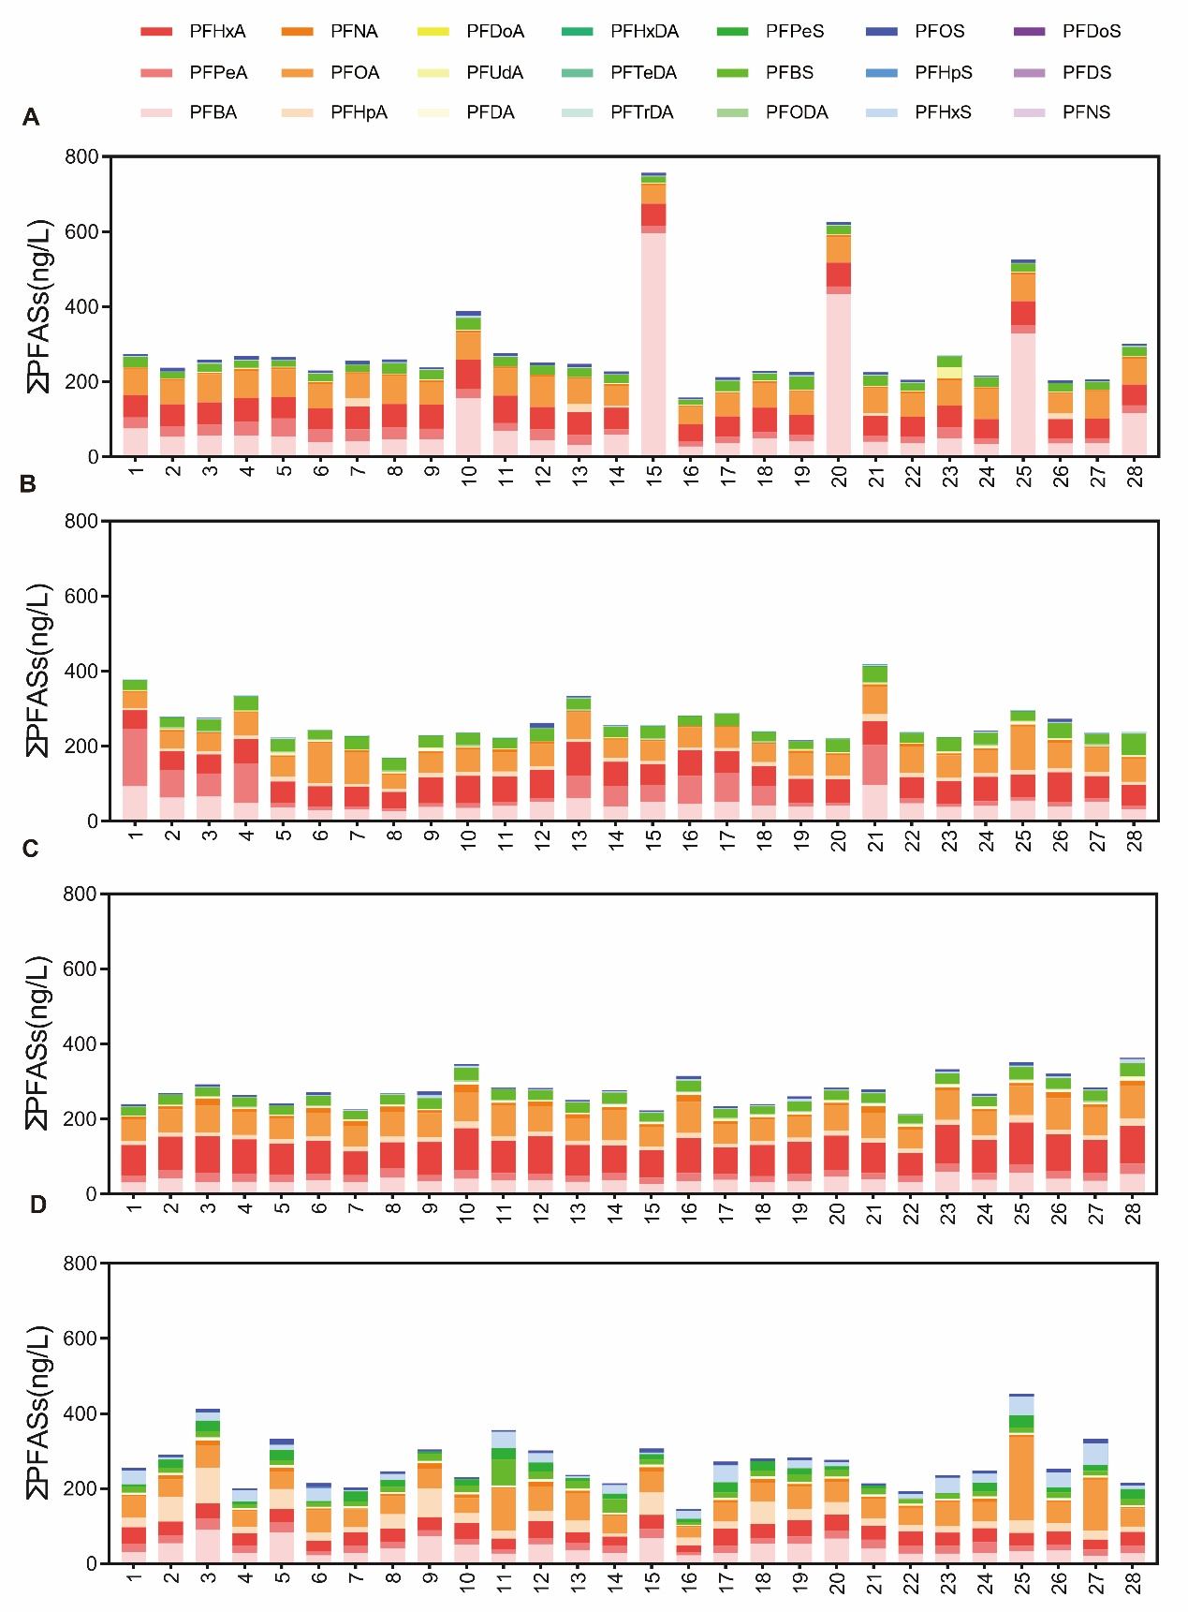

**Fig S1** Total PFASs concentrations in surface water in Songjiang District, Shanghai (A autumn, B winter, C spring, D summer).

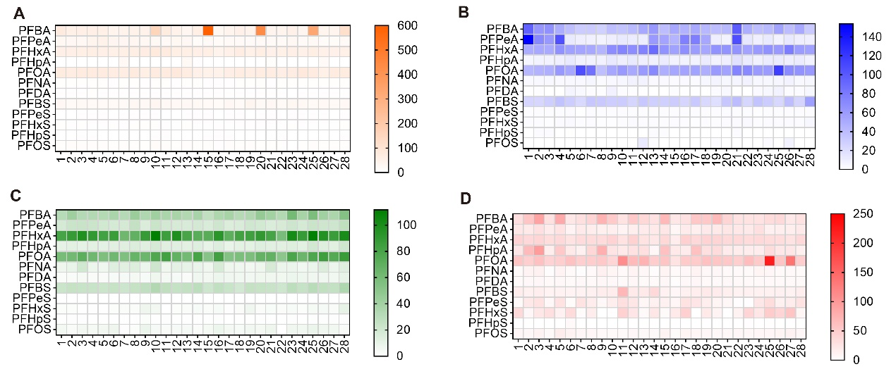

**Fig S2** Total PFASs concentrations in surface water in Songjiang District, Shanghai (A autumn, B winter, C spring, D summer).

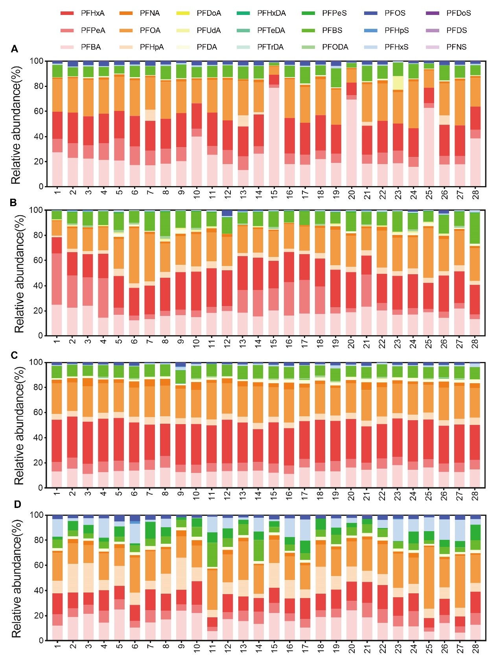

**Fig S3.** The proportions of PFASs composition in surface water in Songjiang District, Shanghai (A autumn, B winter, C spring, D summer)

**Table S8** Simplified summary of the generalized linear model (GLM) indicates the correlation between perfluorinated compounds in sediment and water quality indicators. Bold values denote significance at the P ≤ 0.05 level**.**

|  |  |  |  |  |  |  |  |  |  |
| --- | --- | --- | --- | --- | --- | --- | --- | --- | --- |
|  | Model | | Estimate | Standard error | t-Value | P-value | Standard coefficient | AIC | Deviance explained |
| PFBS | | Intercept | 0.23 | 1.13 | 0.20 | 0.84 | 0.083 | 16.29 | 44.28% |
|  | | SD | 4.23 | 1.49 | 2.84 | **0.01** |  |  |  |
|  | | Cond | -0.004 | 0.0019 | -2.07 | 0.052 |  |  |  |
|  | | TN | 0.22 | 0.13 | 1.63 | 0.12 |  |  |  |
|  | | TP | 2.70 | 1.56 | 1.73 | 0.098 |  |  |  |
|  | | Site width | -0.0049 | 0.0025 | -1.95 | 0.065 |  |  |  |
| PFOS | | Intercept | 3.22 | 10.77 | 0.30 | 0.77 | 4.40 | 120.16 | 39.33% |
|  | | WT | 1.01 | 0.56 | 1.81 | 0.086 |  |  |  |
|  | | ORP | -0.029 | 0.013 | -2.21 | **0.04** |  |  |  |
|  | | SD | -17.57 | 10.65 | -1.65 | 0.12 |  |  |  |
|  | | TP | -12.14 | 11.62 | -1.05 | 0.31 |  |  |  |
|  | | TN | -0.74 | 0.74 | -1.00 | 0.33 |  |  |  |
|  | | Site width | -0.04 | 0.019 | -2.15 | **0.045** |  |  |  |
| PFASs | | Intercept | -18.22 | 24.60 | -0.74 | 0.47 | 25.35 | 165.01 | 49.04% |
|  | | WT | 3.02 | 1.33 | 2.28 | **0.034** |  |  |  |
|  | | ORP | -0.077 | 0.032 | -2.38 | **0.028** |  |  |  |
|  | | TN | -2.51 | 1.49 | -1.69 | 0.11 |  |  |  |
|  | | CODMn | 1.67 | 1.05 | 1.59 | 0.13 |  |  |  |
|  | | Site width | -0.13 | 0.047 | -2.81 | **0.01** |  |  |  |

**Table S9** Non-carcinogenic risk values HQ for each age group.

|  |  |  |  |  |
| --- | --- | --- | --- | --- |
| PFASs | Infants | Children | Adolescents | Adults |
| PFBA | 1.19×10-4 | 1.32×10-4 | 8.44×10-5 | 7.98×10-5 |
| PFPeA | 7.91×10-5 | 8.75×10-5 | 5.61×10-5 | 5.30×10-5 |
| PFBS | 5.09×10-5 | 5.63×10-4 | 3.61×10-5 | 3.41×10-5 |
| PFHxA | 2.21×10-4 | 2.45×10-4 | 1.56×10-4 | 1.48×10-4 |
| PFHpA | 5.50×10-5 | 6.08×10-5 | 3.89×10-5 | 3.68×10-5 |
| PFHxS | 3.60×10-5 | 3.98×10-5 | 2.55×10-5 | 2.41×10-5 |
| PFOA | 1.51×10-1 | 1.67×10-1 | 1.07×10-1 | 1.01×10-1 |
| PFNA | 3.10×10-5 | 3.43×10-5 | 2.2×10-5 | 2.08×10-5 |
| PFOS | 1.18×10-2 | 1.30×10-2 | 8.34×10-3 | 7.88×10-3 |
| PFDA | 1.58×10-5 | 1.75×10-5 | 1.12×10-5 | 1.06×10-5 |
| PFUdA | 3.62×10-6 | 4.01×10-6 | 2.57×10-6 | 2.42×10-6 |
| PFDS | 3.10×10-8 | 3.43×10-8 | 2.20×10-8 | 2.08×10-8 |
| PFDoA | 1.61×10-7 | 1.78×10-7 | 1.14×10-7 | 1.08×10-7 |
| PFTrDA | 2.69×10-8 | 2.98×10-8 | 1.91×10-8 | 1.80×10-8 |
| PFTeDA | 0 | 0 | 0 | 0 |
| PFHxDA | 3.08×10-7 | 3.41×10-7 | 2.18×10-7 | 2.06×10-7 |
| PFODA | 2.8796×10-6 | 3.1851×10-6 | 2.0400×10-6 | 1.9288×10-6 |

**Table S10** Carcinogenic risk values CR for each age group.

|  |  |  |  |  |
| --- | --- | --- | --- | --- |
| PFASs | Infants | Children | Adolescents | Adults |
| PFBA | 2.07×10-8 | 4.57×10-8 | 8.79×10-8 | 4.22×10-7 |
| PFPeA | 3.67×10-9 | 8.12×10-9 | 1.56×10-8 | 7.50×10-8 |
| PFBS | 8.83×10-9 | 1.95×10-8 | 3.76×10-8 | 1.80×10-7 |
| PFHxA | 7.90×10-9 | 1.75×10-8 | 3.36×10-8 | 1.61×10-7 |
| PFHpA | 1.41×10-9 | 3.13×10-9 | 6.01×10-9 | 2.89×10-8 |
| PFHxS | 7.30×10-10 | 1.62×10-9 | 3.11×10-9 | 1.49×10-8 |
| PFOA | 5.65×10-9 | 1.25×10-8 | 2.40×10-8 | 1.15×10-7 |
| PFNA | 6.50×10-10 | 1.44×10-9 | 2.76×10-9 | 1.33×10-8 |
| PFOS | 5.26×10-10 | 1.16×10-9 | 2.24×10-9 | 1.08×10-8 |
| PFDA | 4.49×10-10 | 9.93×10-10 | 1.91×10-9 | 9.18×10-9 |
| PFUdA | 1.09×10-10 | 2.42×10-10 | 4.65×10-10 | 2.23×10-9 |
| PFDS | 1.50×10-12 | 3.33×10-12 | 6.39×10-12 | 3.07×10-11 |
| PFDoA | 5.02×10-12 | 1.11×10-11 | 2.13×10-11 | 1.02×10-10 |
| PFTrDA | 1.16×10-12 | 2.57×10-12 | 4.94×10-12 | 2.37×10-11 |
| PFTeDA | 0 | 0 | 0 | 0 |
| PFHxDA | 3.45×10-11 | 7.64×10-11 | 1.47×10-10 | 7.06×10-10 |
| PFODA | 3.17×10-10 | 7.02×10-10 | 1.35×10-9 | 6.48×10-9 |

**Note:** The average lifespan of people in Shanghai is 83 years.