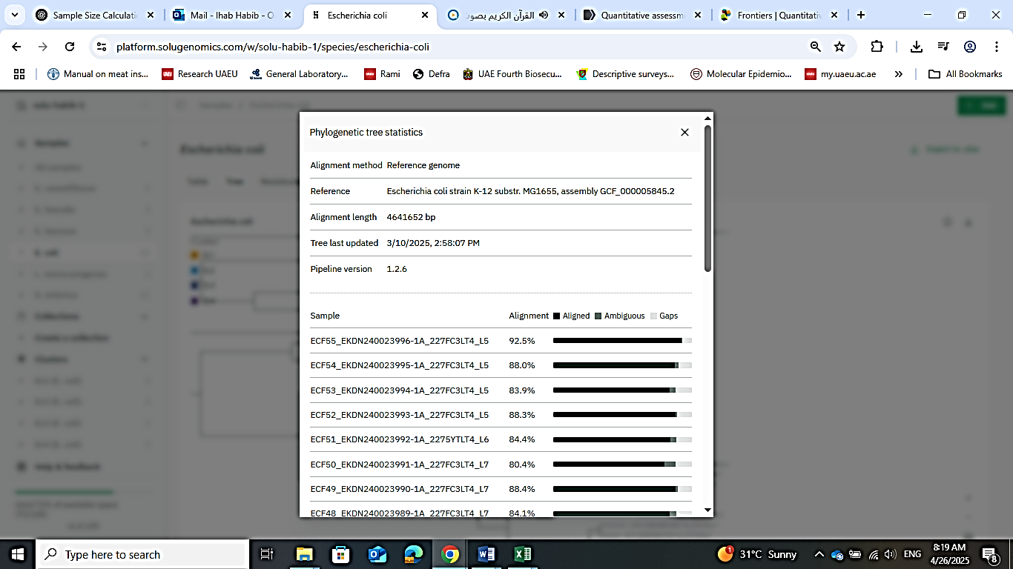**Supplementary Figure 1:**

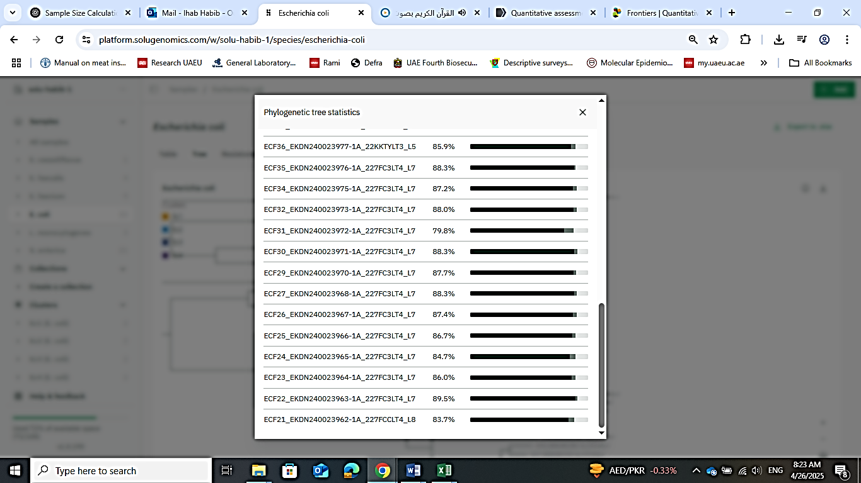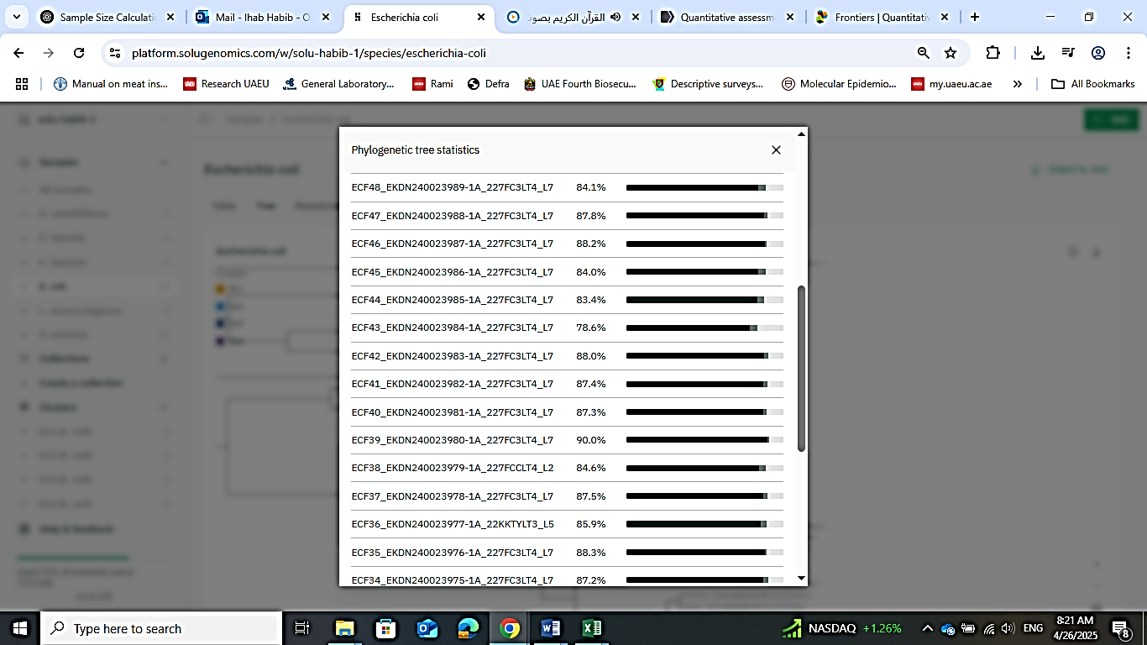SF.1. **Phylogenetic tree statistics** for the alignment of 33 whole-genome sequenced *E. coli* isolates from imported frozen carcasses sampled from UAE retails. The tree is midpoint-rooted with reference genome: *Escherichia coli* strain K-12 substr. MG1655, assembly GCF_000005845.2. Alignment length: 4641652 bp. The output in the figure below is a screenshot from output analysis by the online platform SOLU (Solu Healthcare, Inc., Finland, https://platform.solu.bio/