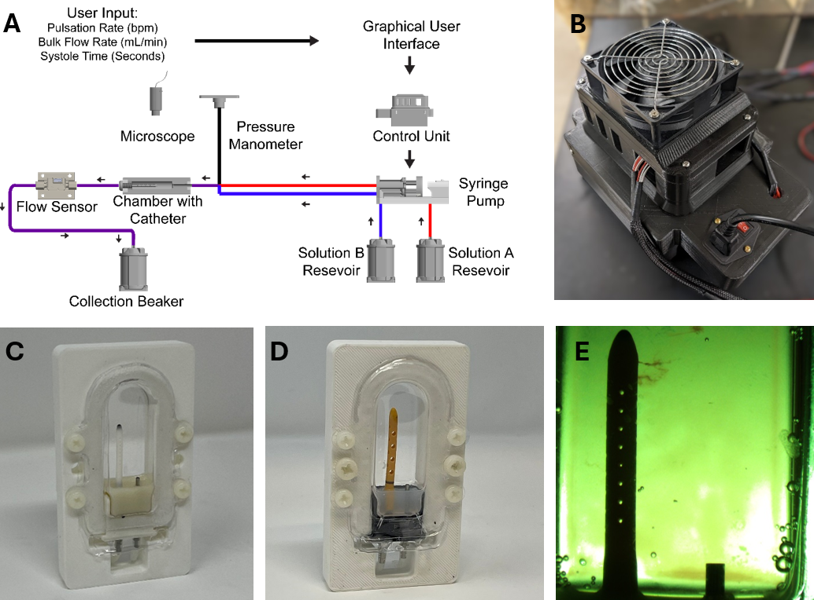
Fig. 1. The experimental setup. A. The schematic of the experimental setup. B. Top view of AIMS control unit. C. An example of a ventricular catheter in a PETG bioreactor chamber. D. An example of an EVD in a PETG bioreactor chamber. E. A top view of a ventricular catheter from the overhead microscope. Note that small clots are visible near the tip of the catheter.

Table 1. The summary of the groups included in the study. The list of groups and variables investigated.
Conditions | Sample Size (N) | Group Name | Concentration Blood (%) | Flow (mL/min) | Catheter Type
Control | 4 | Saline | 0 | 0.3 | Antibiotic
 | 4 | Heparinized Blood | 0.5 | 0.3 | Antibiotic
Blood  Concentration | 4 | Low Concentration | 0.05 | 0.3 | Antibiotic
 | 4 | High Concentration | 0.5 | 0.3 | Antibiotic
Bulk Flow Rate | 4 | High Flow Rate | 0.5 | 0.7 | Antibiotic
 | 4 | High Flow Rate- Low Blood Concentration | 0.05 | 0.7 | Antibiotic
Catheter Type | 4 | Barium-Impregnated | 0.5 | 0.3 | Barium
 | 4 | EVD-0.5% | 0.5 | 0.3 | EVD-antibiotic
 | 4 | EVD-5% | 5 | 0.3 | EVD-antibiotic-Clear

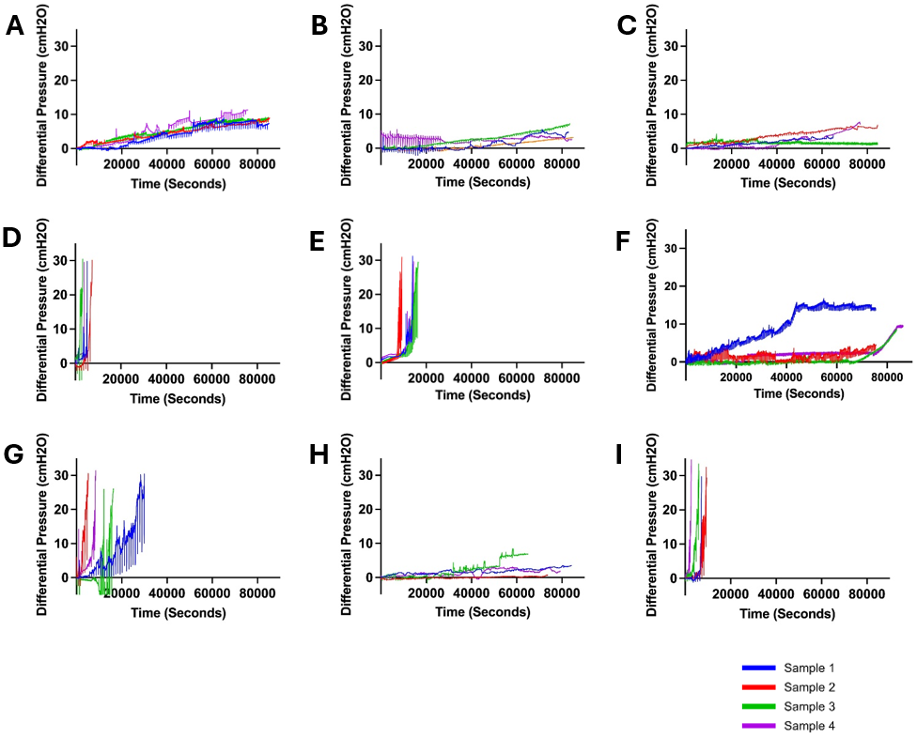
Fig. 2. Visualization of changes in differential pressure (cmH2O) for all ventricular catheter and EVD groups (N=4 per group). A. Saline Group. Antibiotic ventricular catheters exposed to saline solution at 0.3 mL/min bulk flow rate did not reach the 30 cmH2O threshold within 24 hours. B. Heparinized Blood. Antibiotic ventricular catheters exposed to 0.5% concentration of heparinized blood at 0.3 mL/min bulk flow rate did not reach the 30 cmH2O threshold within 24 hours. C. Low Concentration (0.05%) Blood Solution. Antibiotic ventricular catheters exposed to a 0.05% concentration of blood and thrombin solution at 0.3 mL/min bulk flow rate did not reach the 30 cmH2O threshold within 24 hours. D. High Concentration (0.5%) Blood Solution. All the antibiotic ventricular catheters exposed to a 0.5% concentration of blood and thrombin solution at 0.3 mL/min reached the 30 cmH2O threshold within 6,372±1152 seconds. E. High Flow Rate (0.7 mL/min). All the antibiotic ventricular catheters exposed to a 0.5% concentration of blood and thrombin solution at 0.7 mL/min bulk flow rate reached the 30 cmH2O threshold within 109,620±1,908 seconds. F. High Flow Rate- Low Blood Concentration. Antibiotic ventricular catheters exposed to a 0.05% concentration of blood and thrombin solution at 0.7 mL/min bulk flow rate did not reach the 30 cmH2O threshold within 24 hours. G. Barium-Impregnated. All barium-impregnated ventricular catheters exposed to a 0.5% concentration of blood and thrombin solution at 0.3 mL/min reached the 30 cmH2O threshold within 16,380±8,532 seconds. H. EVD-0.5%. The antibiotic EVDs exposed to a 0.5% concentration of blood and thrombin solution at 0.3 mL/min did not reach the 30 cmH2O threshold within 24 hours. I. EVD-5%. All the antibiotic EVDs exposed to a 5% concentration of blood and thrombin solution at 0.3 mL/min reached the 30 cmH2O threshold within 6,588± 2,916 seconds.

Table 2. The summary of the results. The list of groups and variables investigated, the number of failed catheters, mean of maximum pressure achieved, average survival time and mean pressurization rate.
Group Name | Number of Failed Catheters | Mean of Maximum Pressure ± SD (cmH2O) | Average Survival Time± SD (Hrs.) | Mean of Pressurization Rate± SD (cmH2O/Hrs.)
Saline | 0 | 9.72±0.74 | 24±0 | 0.47±0.06
Heparinized Blood | 0 | 2.35±1.81 | 24±0 | 0.1±0.08
Low Concentration (0.05%) Blood | 0 | 4.77±2.7 | 24±0 | 0.29±0.16
High Concentration (0.5%) Blood | 4 | 31.3±1.54 | 1.77±0.32 | 18.08±3.47
High Flow Rate (0.7 mL/min) | 4 | 30.45±0.53 | 4.2±1.46 | 8.04±3.13
High Flow Rate- Low Blood Concentration | 0 | 9.57±2.71 | 24±0 | 0.45±0.13
Barium-Impregnated | 4 | 31.5±1.93 | 4.55±2.37 | 8.49±4.08
EVD-0.5% | 0 | 2.05±0.70 | 24±0 | 0.1±0.03
EVD-5% | 4 | 30.72±0.52 | 1.83±0.81 | 21.65±14.55

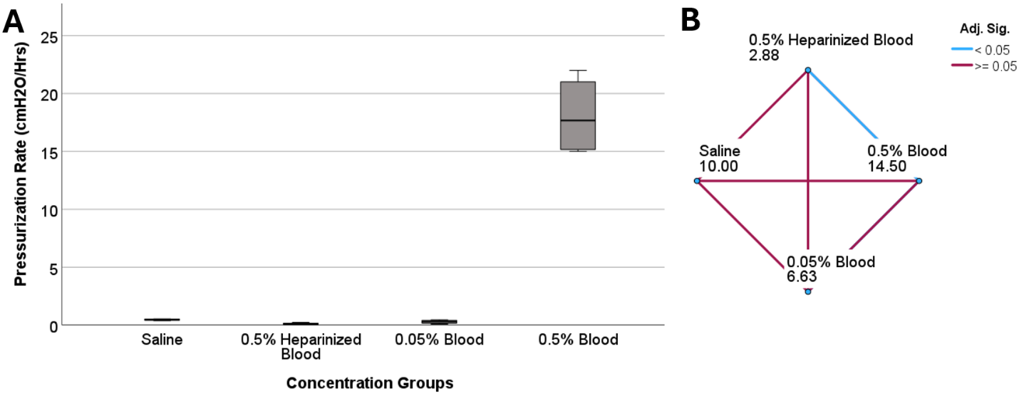Fig. 3. The investigation of differences in pressurization rate across blood concentration groups in ventricular catheters. A. The boxplot illustrates the difference in pressurization rate across the groups. A statistically significant difference in pressurization rate was observed (P=0.005) B. Pairwise comparison of concentration groups. Note that each node shows the sample average rank of the group. A statistically significant difference was observed between 0.5% heparinized blood and 0.5% blood groups (Adj. Sig.=0.003).

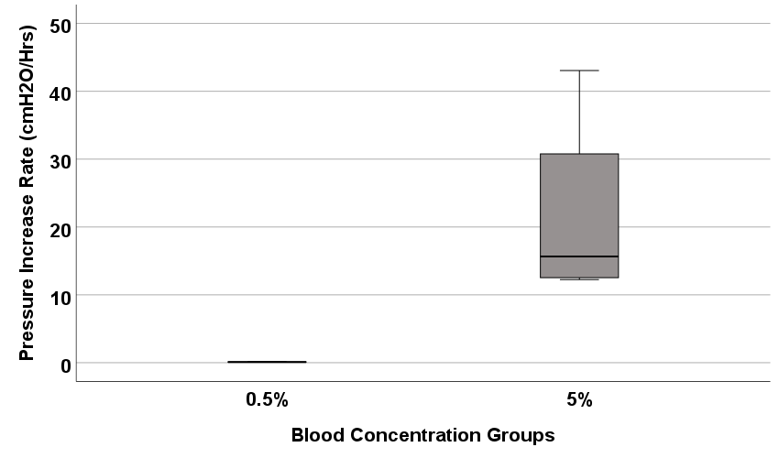
S. Fig. 1. The investigation of differences in pressurization rate of EVDs in 0.5% and 5% blood concentration groups.

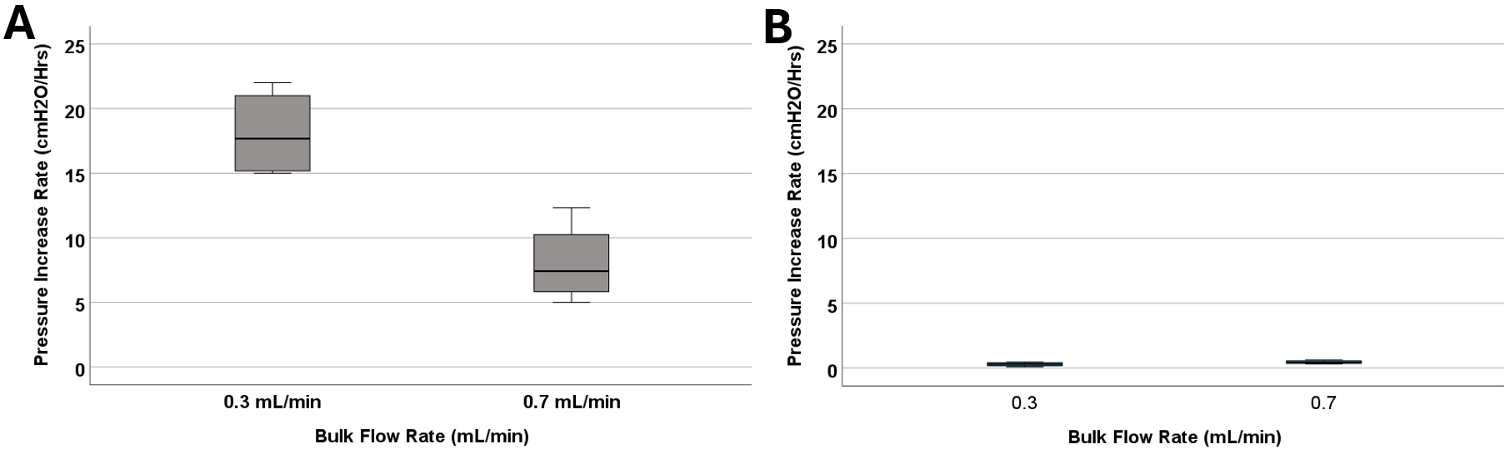
Fig. 4. The investigation of differences in pressurization rate across bulk flow rate groups. A. The boxplot illustrates the difference in pressurization rate across the 0.1 mL/min, 0.3 mL/min, and 0.7 mL/min groups. Note that blood concentration remained constant across the groups at 0.5%. A statistically significant difference in pressurization rate was observed (P=0.029) B. The boxplot illustrates the difference in pressurization rate across the 0.3 mL/min, and 0.7 mL/min groups. Note that blood concentration remained constant across the groups at 0.05%. No statistically significant difference in pressurization rate was observed (P=0.2).

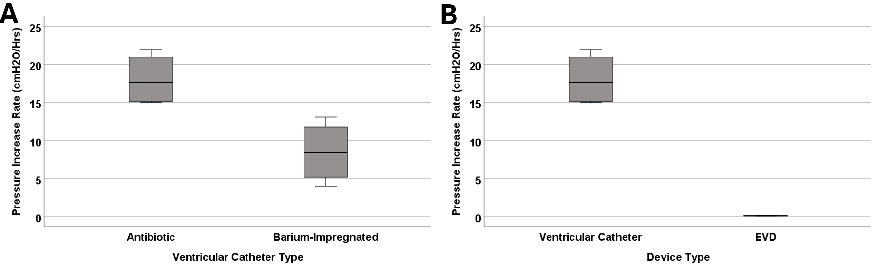
Fig. 5. The investigation of differences in pressurization rate in catheter types. A. The boxplot illustrates the difference in pressurization rate between antibiotic and barium-impregnated catheters. A statistically significant difference was observed between antibiotic and barium-impregnated ventricular catheters (P=0.029). B. The boxplot illustrates the difference in pressurization rate between antibiotic ventricular catheters and EVDs. A statistically significant difference was observed between ventricular catheters and EVDs (P=0.029). Note that blood concentration remained constant across the groups at 0.5% for all the groups represented in this figure.

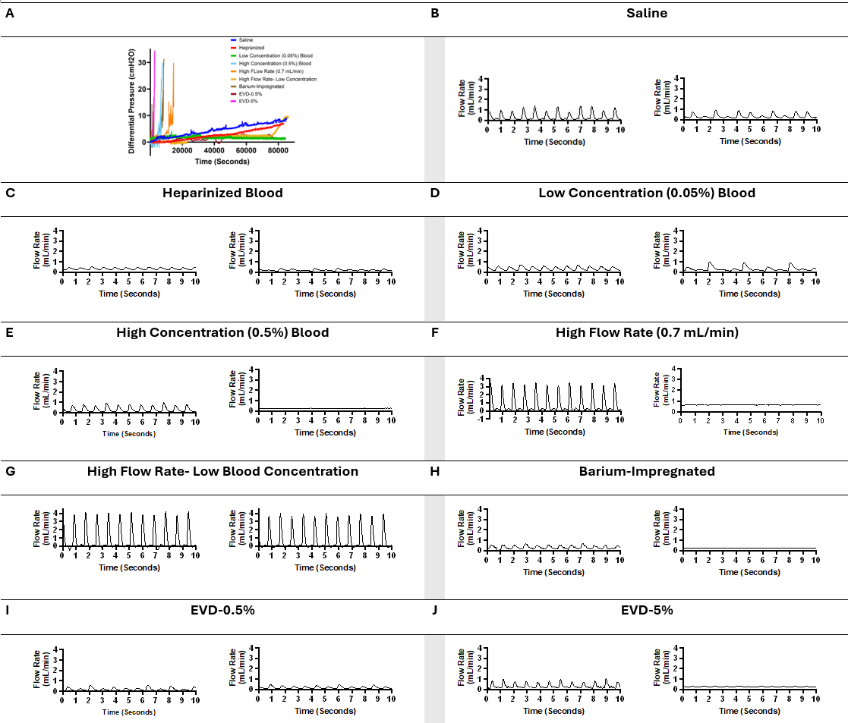
Fig. 6. Visual representation of changes in pressure and flow over time across all the groups in representative samples. B. a ten-second segment of flow measurement in a sample in the saline group shortly after the initiation of flow and a ten-second segment of flow measurement in the same sample in the saline group shortly before termination of the experiment after 24 hours of exposure to pulsatile flow. C. a ten-second segment of flow measurement in a sample in the heparinized blood group shortly after the initiation of flow and a ten-second segment of flow measurement in the same sample in the heparinized blood group shortly before termination of the experiment after 24 hours of exposure to pulsatile flow. D. a ten-second segment of flow measurement in a sample in the Low Concentration (0.05%) Blood group shortly after the initiation of flow and a ten-second segment of flow measurement in the same sample in the Low Concentration (0.05%) group shortly before termination of the experiment after 24 hours of exposure to pulsatile flow. E. a ten-second segment of flow measurement in a sample in the High Concentration (0.5%) Blood group shortly after the initiation of flow and a ten-second segment of flow measurement in the same sample in the High Concentration (0.5%) group shortly before termination of the experiment because the 30 cmH2O threshold was reached. F. a ten-second segment of flow measurement in a sample in the High Flow Rate (0.7 mL/min) Blood group shortly after the initiation of flow and a ten-second segment of flow measurement in the same sample in the High Flow Rate (0.7 mL/min) group shortly before termination of the experiment because the 30 cmH2O threshold was reached. G. a ten-second segment of flow measurement in a sample in the High Flow Rate- Low Blood Concentration group shortly after the initiation of flow and a ten-second segment of flow measurement in the same sample in the High Flow Rate- Low Blood Concentration shortly before termination of the experiment after 24 hours of exposure to pulsatile flow. H. A ten-second segment of flow measurement in a sample in the Barium-Impregnated group shortly after the initiation of flow and a ten-second segment of flow measurement in the same sample in the Barium-Impregnated group shortly before termination of the experiment because the 30 cmH2O threshold was reached. I. A ten-second segment of flow measurement in a sample in the EVD-0.5% group shortly after the initiation of flow and a ten-second segment of flow measurement in the same sample in the EVD-0.5% group shortly before termination of the experiment after 24 hours of exposure to pulsatile flow. J. a ten-second segment of flow measurement in a sample in the EVD-0.5% group shortly after the initiation of flow and a ten-second segment of flow measurement in the same sample in the EVD-5% group shortly before termination of the experiment because the 30 cmH2O threshold was reached.

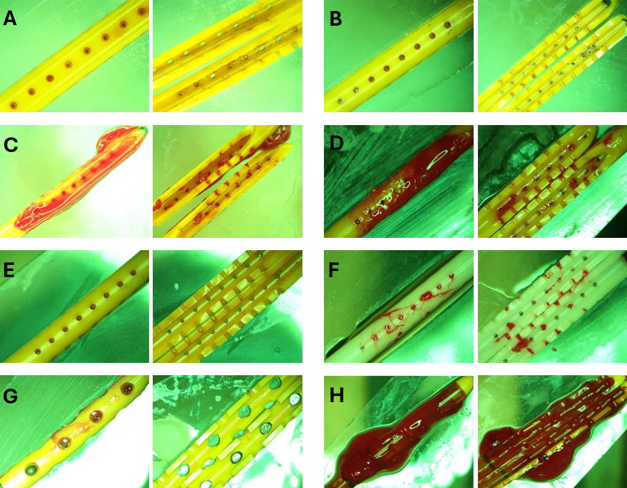Fig. 7. Representative End point view of catheters external surfaces and lumen. A. Heparinized Blood. No blood clots were visible inside or outside the catheter. B. Low Concentration (0.05%) Blood Solution. Small blood clots were visible in the cross-section of the lateral holes. Small clots were also observed on the outer surface of the catheters similar to the blood clot visible in Fig. 1E. C. High Concentration (0.5%) Blood Solution. Extensive clot formation was observed inside and outside of the catheter with blood clots expanding through the lateral holes. D. High Flow Rate (0.7 mL/min). Extensive clot formation was observed inside and outside the catheter. E. High Flow Rate- Low Blood Concentration. No blood clots were visible inside or outside the catheter F. Barium-Impregnated. Relatively large blood clots were observed inside the lumen of the catheter. Clots were also observed expanding through the lateral holes of the catheter. G. EVD-0.5%. Loosely associated blood clots were observed on the surface of the EVDs. H. EVD-5%. The EVD was engulfed in a large continuous blood clot expanding through the lumen and outer surface of the EVD.

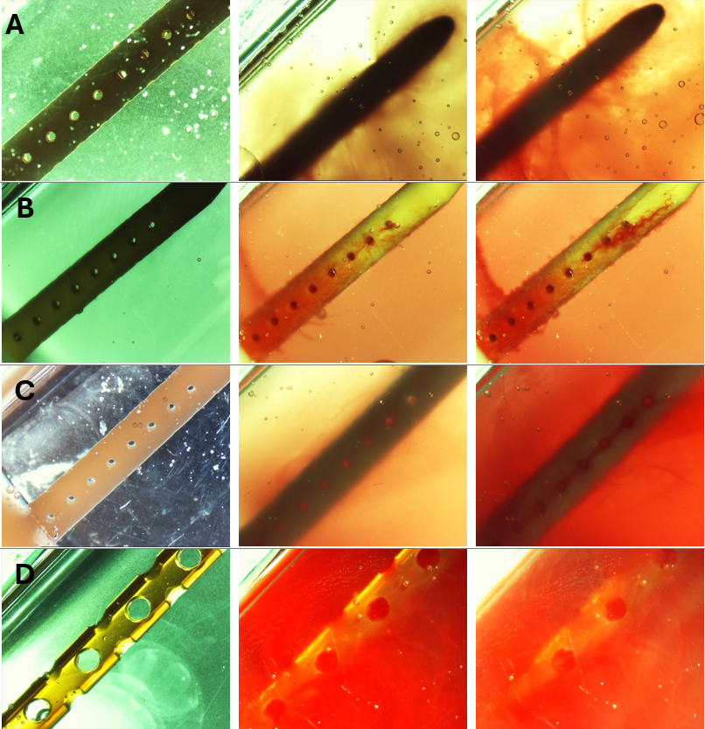
Fig. 8. Timelapse view of ventricular catheters and EVDs in samples that reached the 30 cmH2O threshold. A. High Concentration (0.5%) Blood Solution. The antibiotic ventricular catheters exposed to a 0.5% concentration of blood and thrombin solution at 0.3 mL/min showed extensive web-like clot formation throughout the catheter. B. High Flow Rate (0.7 mL/min). Extensive clot formation was observed in the vicinity of lateral holes furthest from the catheter in the antibiotic ventricular catheter exposed to a 0.5% concentration of blood and thrombin solution at 0.7 mL/min bulk flow rate. Note that fine strands were observed expanding between lateral holes. C. Barium-Impregnated. A fine web-like blood clot was observed around the Barium-impregnated ventricular catheter that was exposed to a 0.5% concentration of blood and thrombin solution at 0.3 mL/min. D. EVD-5%. The EVD exposed to a 5% at 0.3 mL/min bulk flow rate was rapidly engulfed in a continuous blood clot. The 5% blood solution significantly reduced the visibility of the EVD in the PETG chamber.

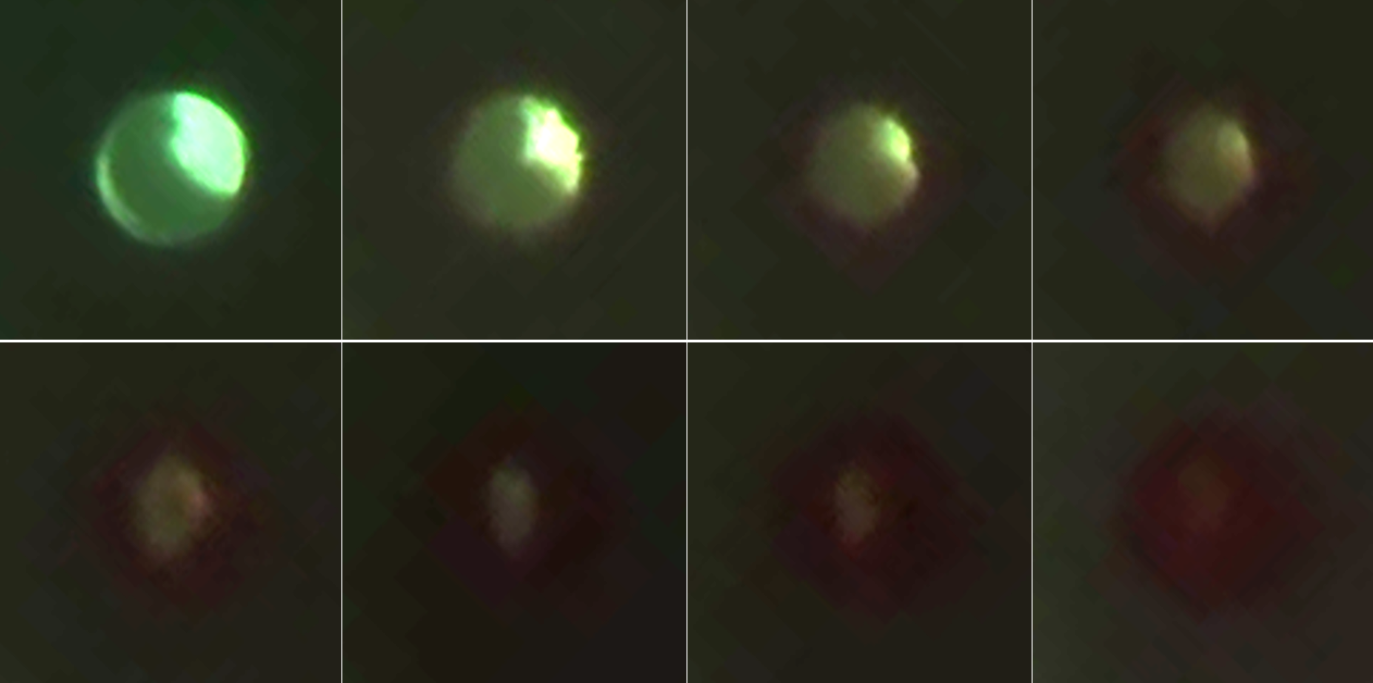
Fig. 9. Timelapse of lateral hole obstruction in a barium-impregnated ventricular catheter. Zoomed in frames from S. Vid 3 illustrating the process of obstruction formation on the lateral holes of the barium-impregnated ventricular catheter. The white dotted line shows the rough outline of the lateral hole. The round unobstructed lateral hole gradually became obstructed with blood in an outside-in process. The obstruction process began with the coating of the walls of the lateral hole. Building on the initial layer, the clot formation expanded inwards towards the center of the hole and gradually reduced the effective diameter of the lateral hole until complete obstruction was achieved. Note that the brightness was increased in post-processing to improve the visibility of the clot formation.

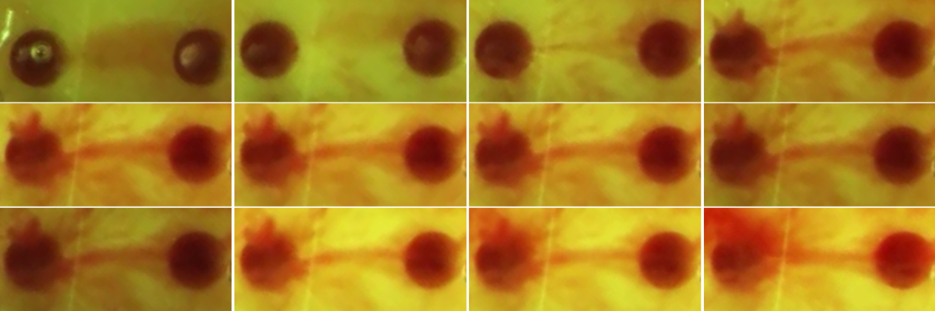
S. Fig. 2. Zoomed in frames from S. Vid 2 illustrating the formation of a fibrotic bridge across the lateral holes of the catheters. The frames demonstrate the expansion of a fibrotic bridge between the second (left) and the third (right) holes from the tip of the antibiotic ventricular catheter. It appeared that the fibrotic bridge expanded from the third lateral hole towards the second lateral hole.

Discussion
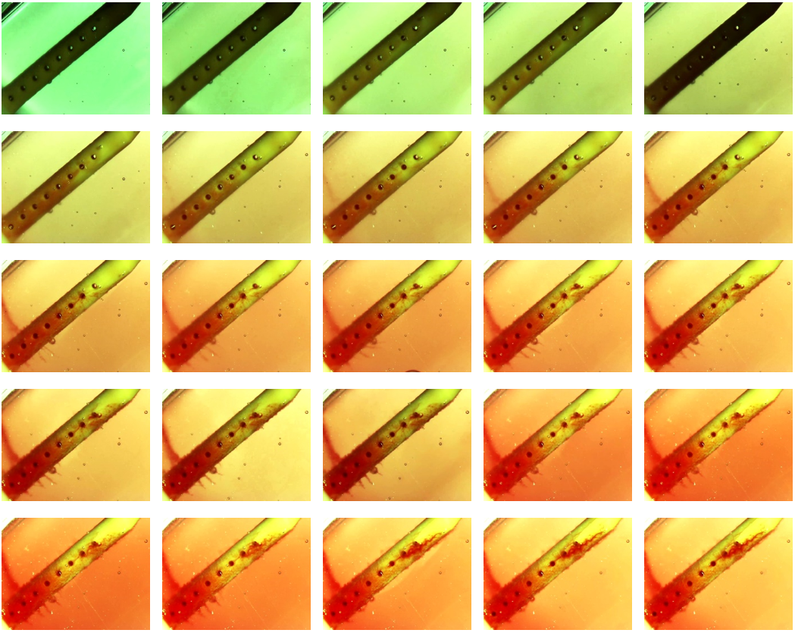Fig. 10. Detailed timelapse of clot formation. antibiotic ventricular catheter was exposed to a 0.5% concentration of blood and thrombin solution at 0.7 mL/min bulk flow rate. Clot formation was more apparent near the lateral holes furthest from the catheter tip.

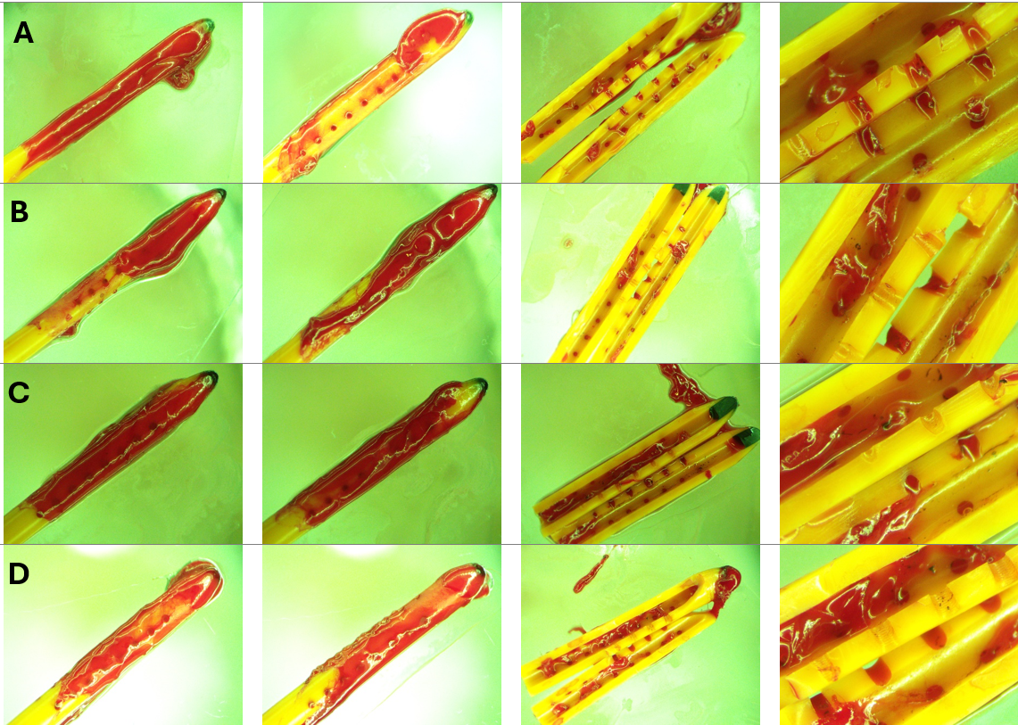
Fig. 11. Endpoint view of external surfaces and the lumen of catheters in High Concentration (0.5%) Blood solution group. A. Left to right: Front view, back view, lumen and zoomed in view of sample 1 after 30 cmH2O threshold was reached. B. Left to right: Front view, back view, lumen and zoomed in view of sample 2 after 30 cmH2O threshold was reached. C. Left to right: Front view, back view, lumen and zoomed in view of sample 3 after 30 cmH2O threshold was reached. D. Left to right: Front view, back view, lumen and zoomed in view of sample 4 after 30 cmH2O threshold was reached. Note that a large bulbous blood clot was observed near the tip of all four catheters. Nevertheless, blood coagulation is observed everywhere across the length of the catheters. While extensive luminal obstruction was observed in Fig. 10C and Fig. 10 D, only a few blood clots were observed near the middle of the catheter in Fig. 10B and Fig. 10C.

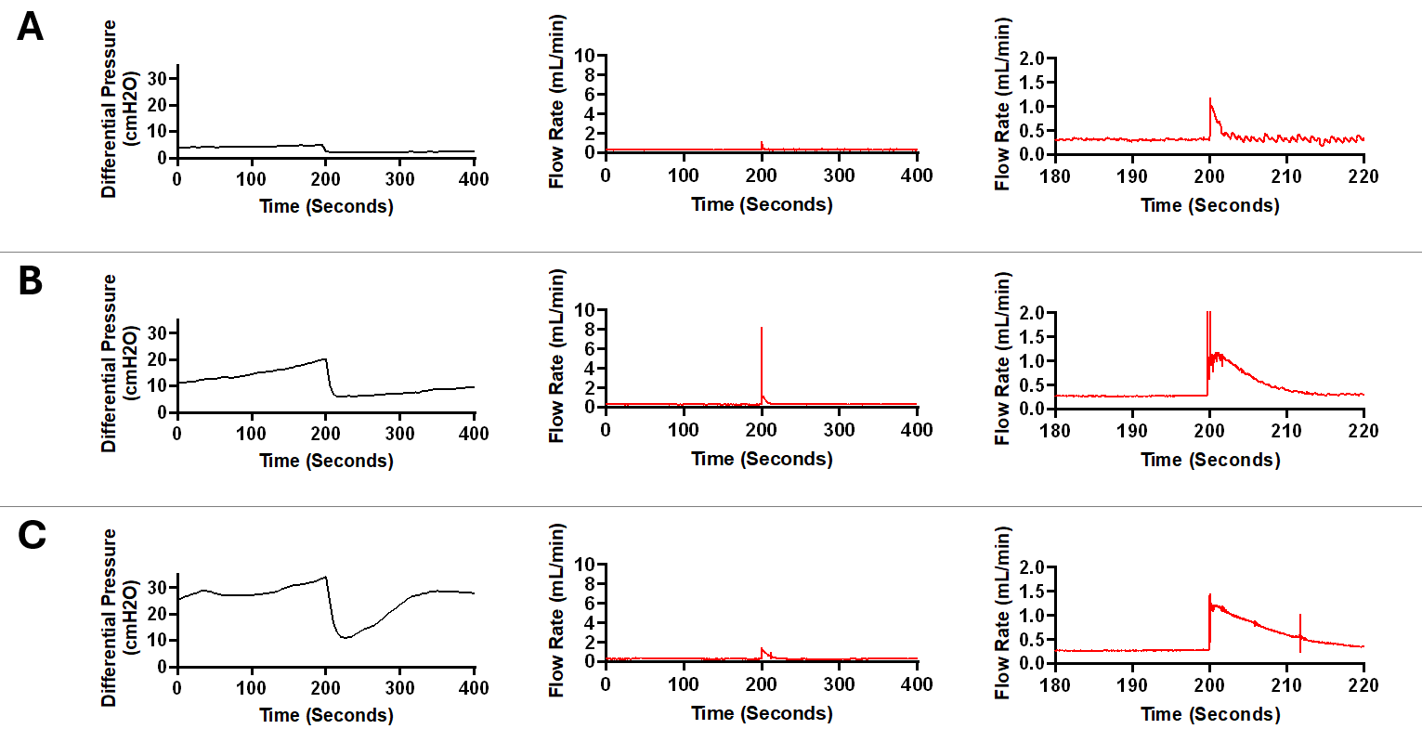
Fig. 12. Sudden fluctuations in pressure and bulk flow rate in a sample from High Concentration (0.5%) Blood group. A. In this figure, a 400-second segment of pressure and flow measurement recorded after around 5200 seconds of pulsatile flow initiation is illustrated. A 2.448 cmH2O decrease in differential pressure was recorded within 5 seconds (Left). A sudden increase in flow was recorded with a peak amplitude of 1.19 mL/min (Middle). Note that in the zoomed in graph (Right), the flow appears more pulsatile after the peak recorded around the 200 second timepoint. This observation is consistent with the waveforms in Fig. 6. The average flow rate between 0-100 seconds was 0.316 mL/min and the average flow rate between 300-400 seconds was 0.313 mL/min B. A 400-second segment of pressure and flow measurement recorded after around 7200 seconds of pulsatile flow initiation is illustrated. A 14.144 cmH2O decrease in differential pressure was recorded within 15 seconds (Left). A precipitous increase in flow was recorded with a peak amplitude of 8.214 mL/min (Middle). The smooth transition of the waveform after the surge in flow rate is illustrated in the figure on the right. A slight difference in baseline flow rate was noted before and after the surge in flow such that that the average flow rate between 0-100 seconds was 0.287 mL/min while the average flow rate between 300-400 seconds was 0.299 mL/min. C. A 400-second segment of pressure and flow measurement recorded after around 8700 seconds of pulsatile flow initiation is illustrated. A 22.712 cmH2O decrease in differential pressure was recorded within 15 seconds (Left). Compared to Fig. 12A and 12B, differential pressure recovered at a higher rate. An increase in flow was recorded with a peak amplitude of 1.456 mL/min (Middle). The gradual transition of the waveform after the surge in flow rate is illustrated (Right). The average flow rate between 0-100 seconds was 0.299 mL/min and the average flow rate between 300-400 seconds was 0.289 mL/min.

