Supplementary Material

S1.1. Sensitivity analysis for intramuscular fat fraction (FF) threshold and search radius
Table S1.1.1. Sensitivity analysis of intramuscular FF median threshold with ± 5 % variation (sd). Total number of extracted FF voxels for the threshold set to median, median+5% and median-5% were compared. For each group, three participants were randomly selected for analysis. Since the baseline vs +5% does not show differences for the total number of fat voxels, we only include the variations of -5% compared to baseline.
 | -5% | Baseline | +5% | Percentage difference  (-5% vs baseline)
Young Male
MG | 4813 (42) | 3786 (33) | 3781 (44) | 21%
LG | 2372 (55) | 1956 (46) | 1956 (40) | 18%
SOL | 16504 (113) | 12766 (120) | 12741 (108) | 22%
Young Female
MG | 3779 (35) | 3076 (37) | 3056 (30) | 22%
LG | 2048 (60) | 1679 (72) | 1678 (66) | 22%
SOL | 4259 (88) | 3470 (70) | 3469 (69) | 22%
Older Male
MG | 14091 (108) | 12736 (122) | 12736 (101) | 9.6%
LG | 7561 (88) | 6798 (72) | 6798 (63) | 10%
SOL | 31493 (212) | 28605 (187) | 28600 (199) | 9.1%
Older Female
MG | 4496 (40) | 4154 (38) | 4152 (33) | 7.6%
LG | 3360 (36) | 3014 (28) | 3012 (29) | 10%
SOL | 15090 (144) | 13265 (122) | 13264 (109) | 12%

Table S1.1.2 Spatial distribution comparisons for tested intramuscular FF thresholds
YM | -5% variation | Baseline | +5% variation
Medial Gastrocnemius | 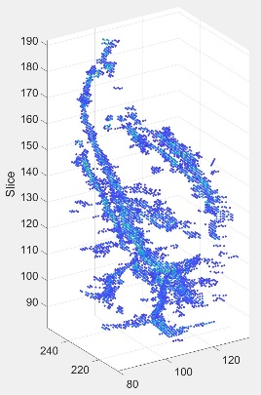 | 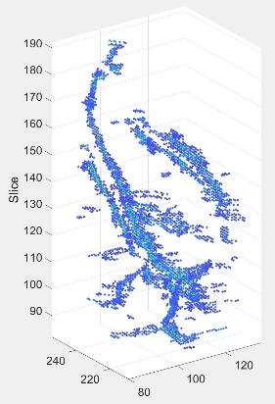 | 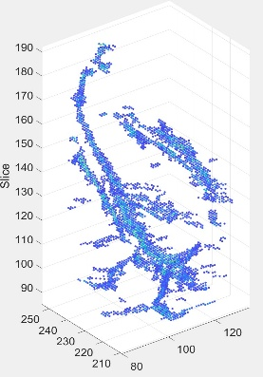
Lateral Gastrocnemius | 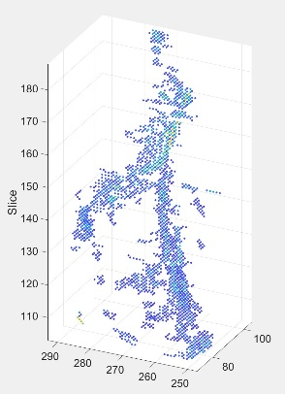 | 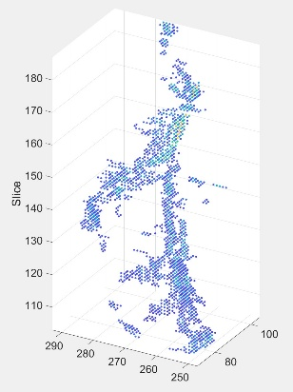 | 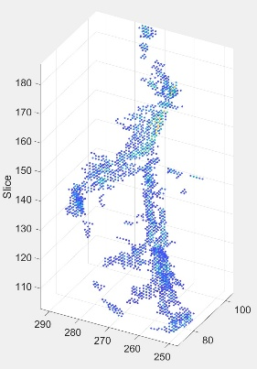
Soleus | 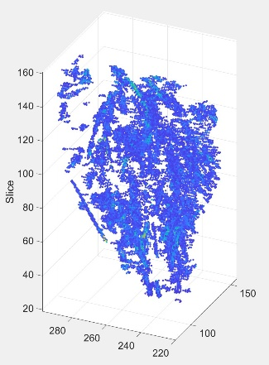 | 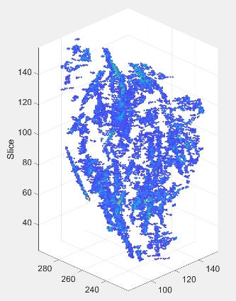 | 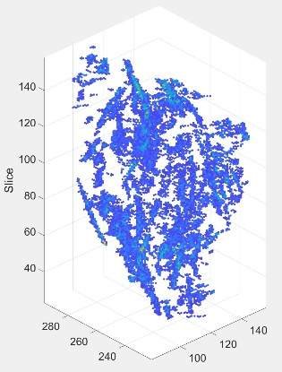

YF | -5% variation | Baseline | +5% variation
Medial Gastrocnemius | 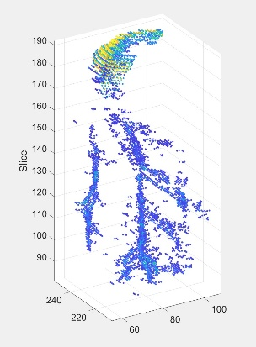 | 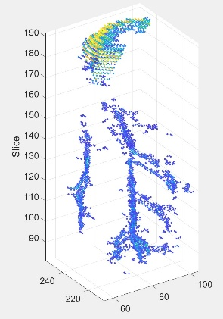 | 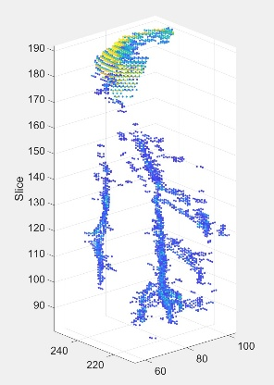
Lateral Gastrocnemius | 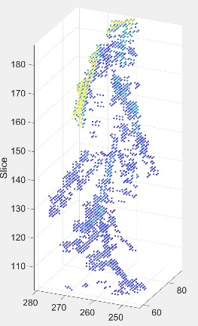 | 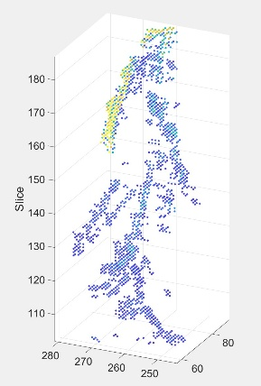 | 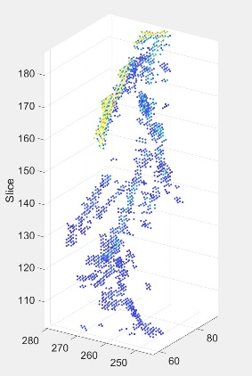
Soleus | 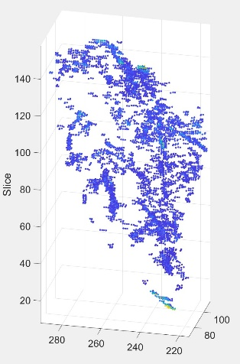 | 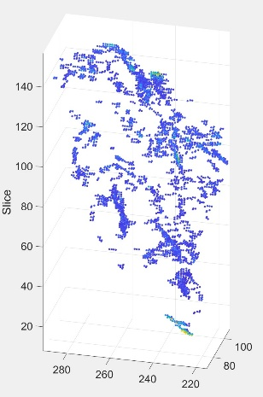 | 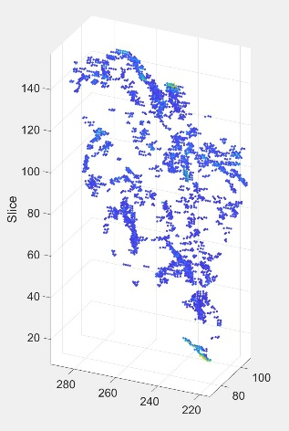

OM | -5% variation | Baseline | +5% variation
Medial Gastrocnemius | 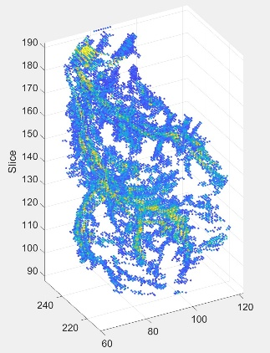 | 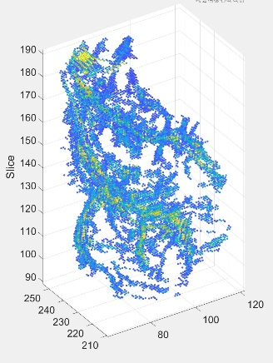 | 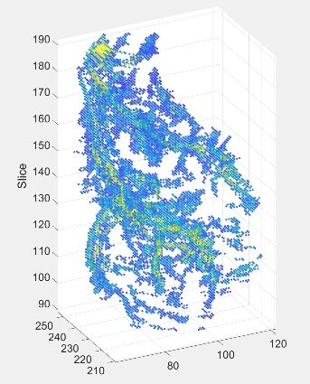
Lateral Gastrocnemius | 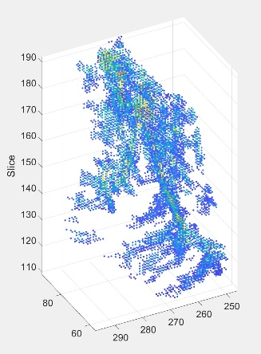 | 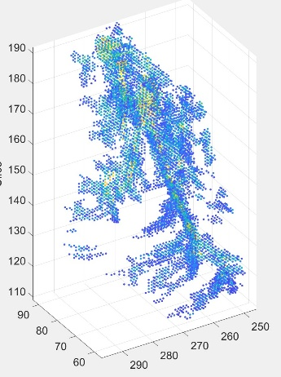 | 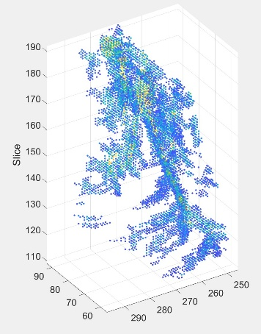
Soleus | 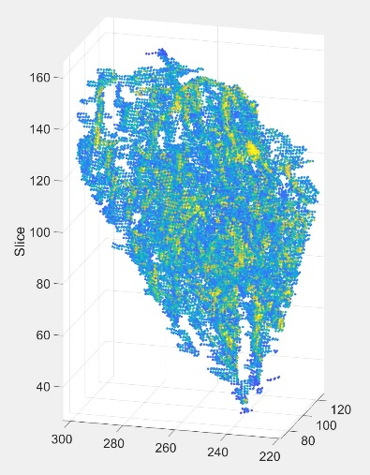 | 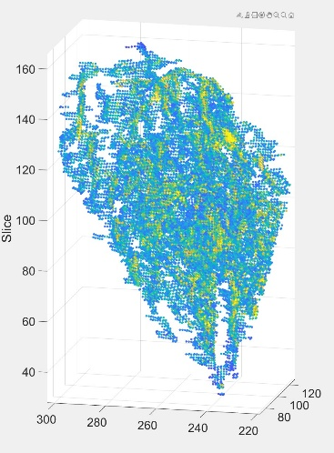 | 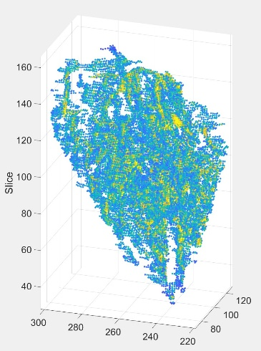

OF | -5% variation | Baseline | +5% variation
Medial Gastrocnemius | 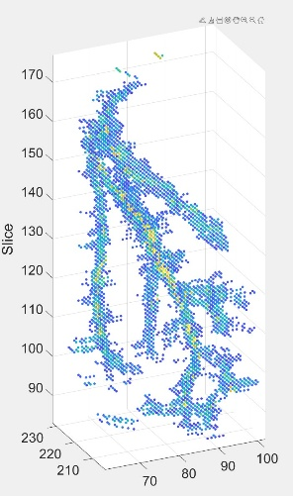 | 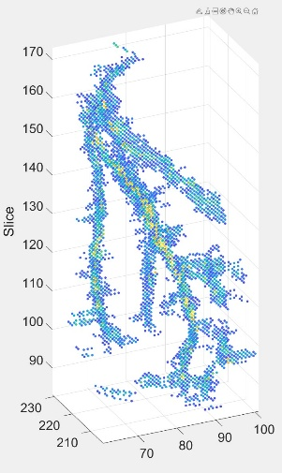 | 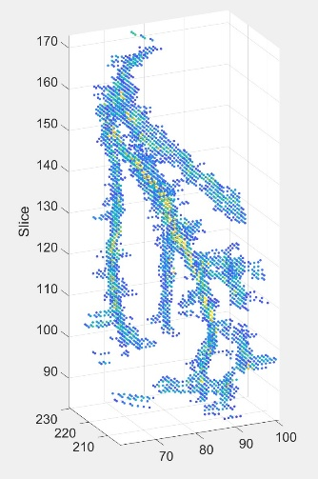
Lateral Gastrocnemius | 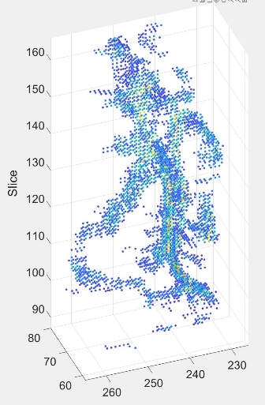 | 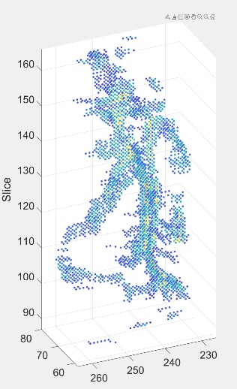 | 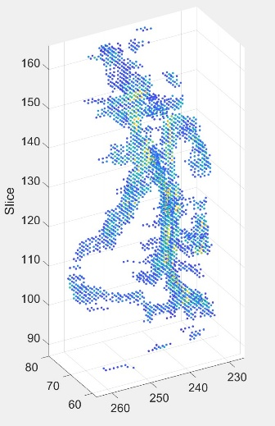
Soleus | 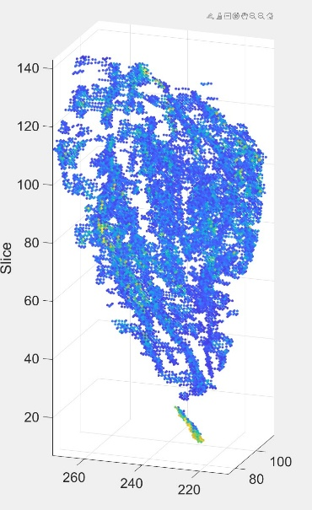 | 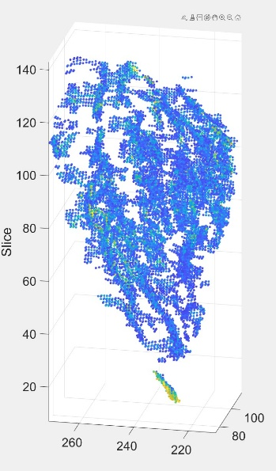 | 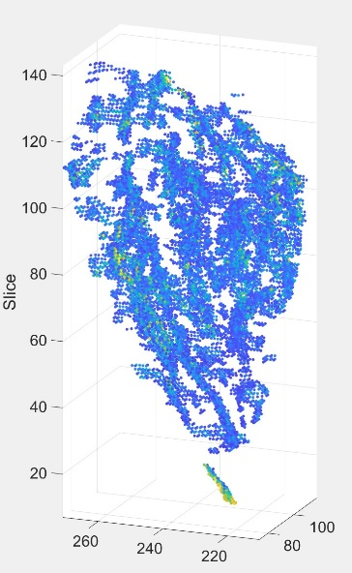

Table S1.1.3. Sensitivity analysis of searching radius. The searching radius used in the manuscript was 20 voxels. We tested 5, 10, 15, 20, 25, and 30 voxels with the same 12 participants test for threshold sensitivity (above) and compared the total number of intramuscular FF voxels identified.
Radius (voxels) | 5 | 10 | 15 | 20 | 25 | 30
YM
MG | 3786 (33) | 3786 (33) | 3786 (33) | 3786 (33) | 3786 (33) | 3786 (33)
LG | 1956 (46) | 1956 (46) | 1956 (46) | 1956 (46) | 1956 (46) | 1956 (46)
SOL | 12766 (120) | 12766 (120) | 12766 (120) | 12766 (120) | 12766 (120) | 12766 (120)
YF
MG | 3076 (37) | 3076 (37) | 3076 (37) | 3076 (37) | 3076 (37) | 3076 (37)
LG | 1679 (72) | 1679 (72) | 1679 (72) | 1679 (72) | 1679 (72) | 1679 (72)
SOL | 3470 (70) | 3470 (70) | 3470 (70) | 3470 (70) | 3470 (70) | 3470 (70)
OM
MG | 12736 (122) | 12736 (122) | 12736 (122) | 12736 (122) | 12736 (122) | 12736 (122)
LG | 6798 (72) | 6798 (72) | 6798 (72) | 6798 (72) | 6798 (72) | 6798 (72)
SOL | 28605 (187) | 28605 (187) | 28605 (187) | 28605 (187) | 28605 (187) | 28605 (187)
OF
MG | 4154 (38) | 4154 (38) | 4154 (38) | 4154 (38) | 4154 (38) | 4154 (38)
LG | 3014 (28) | 3014 (28) | 3014 (28) | 3014 (28) | 3014 (28) | 3014 (28)
SOL | 13265 (122) | 13265 (122) | 13265 (122) | 13265 (122) | 13265 (122) | 13265 (122)
Generative AI Disclosure
We confirm that no written or visual content was generated with aI

