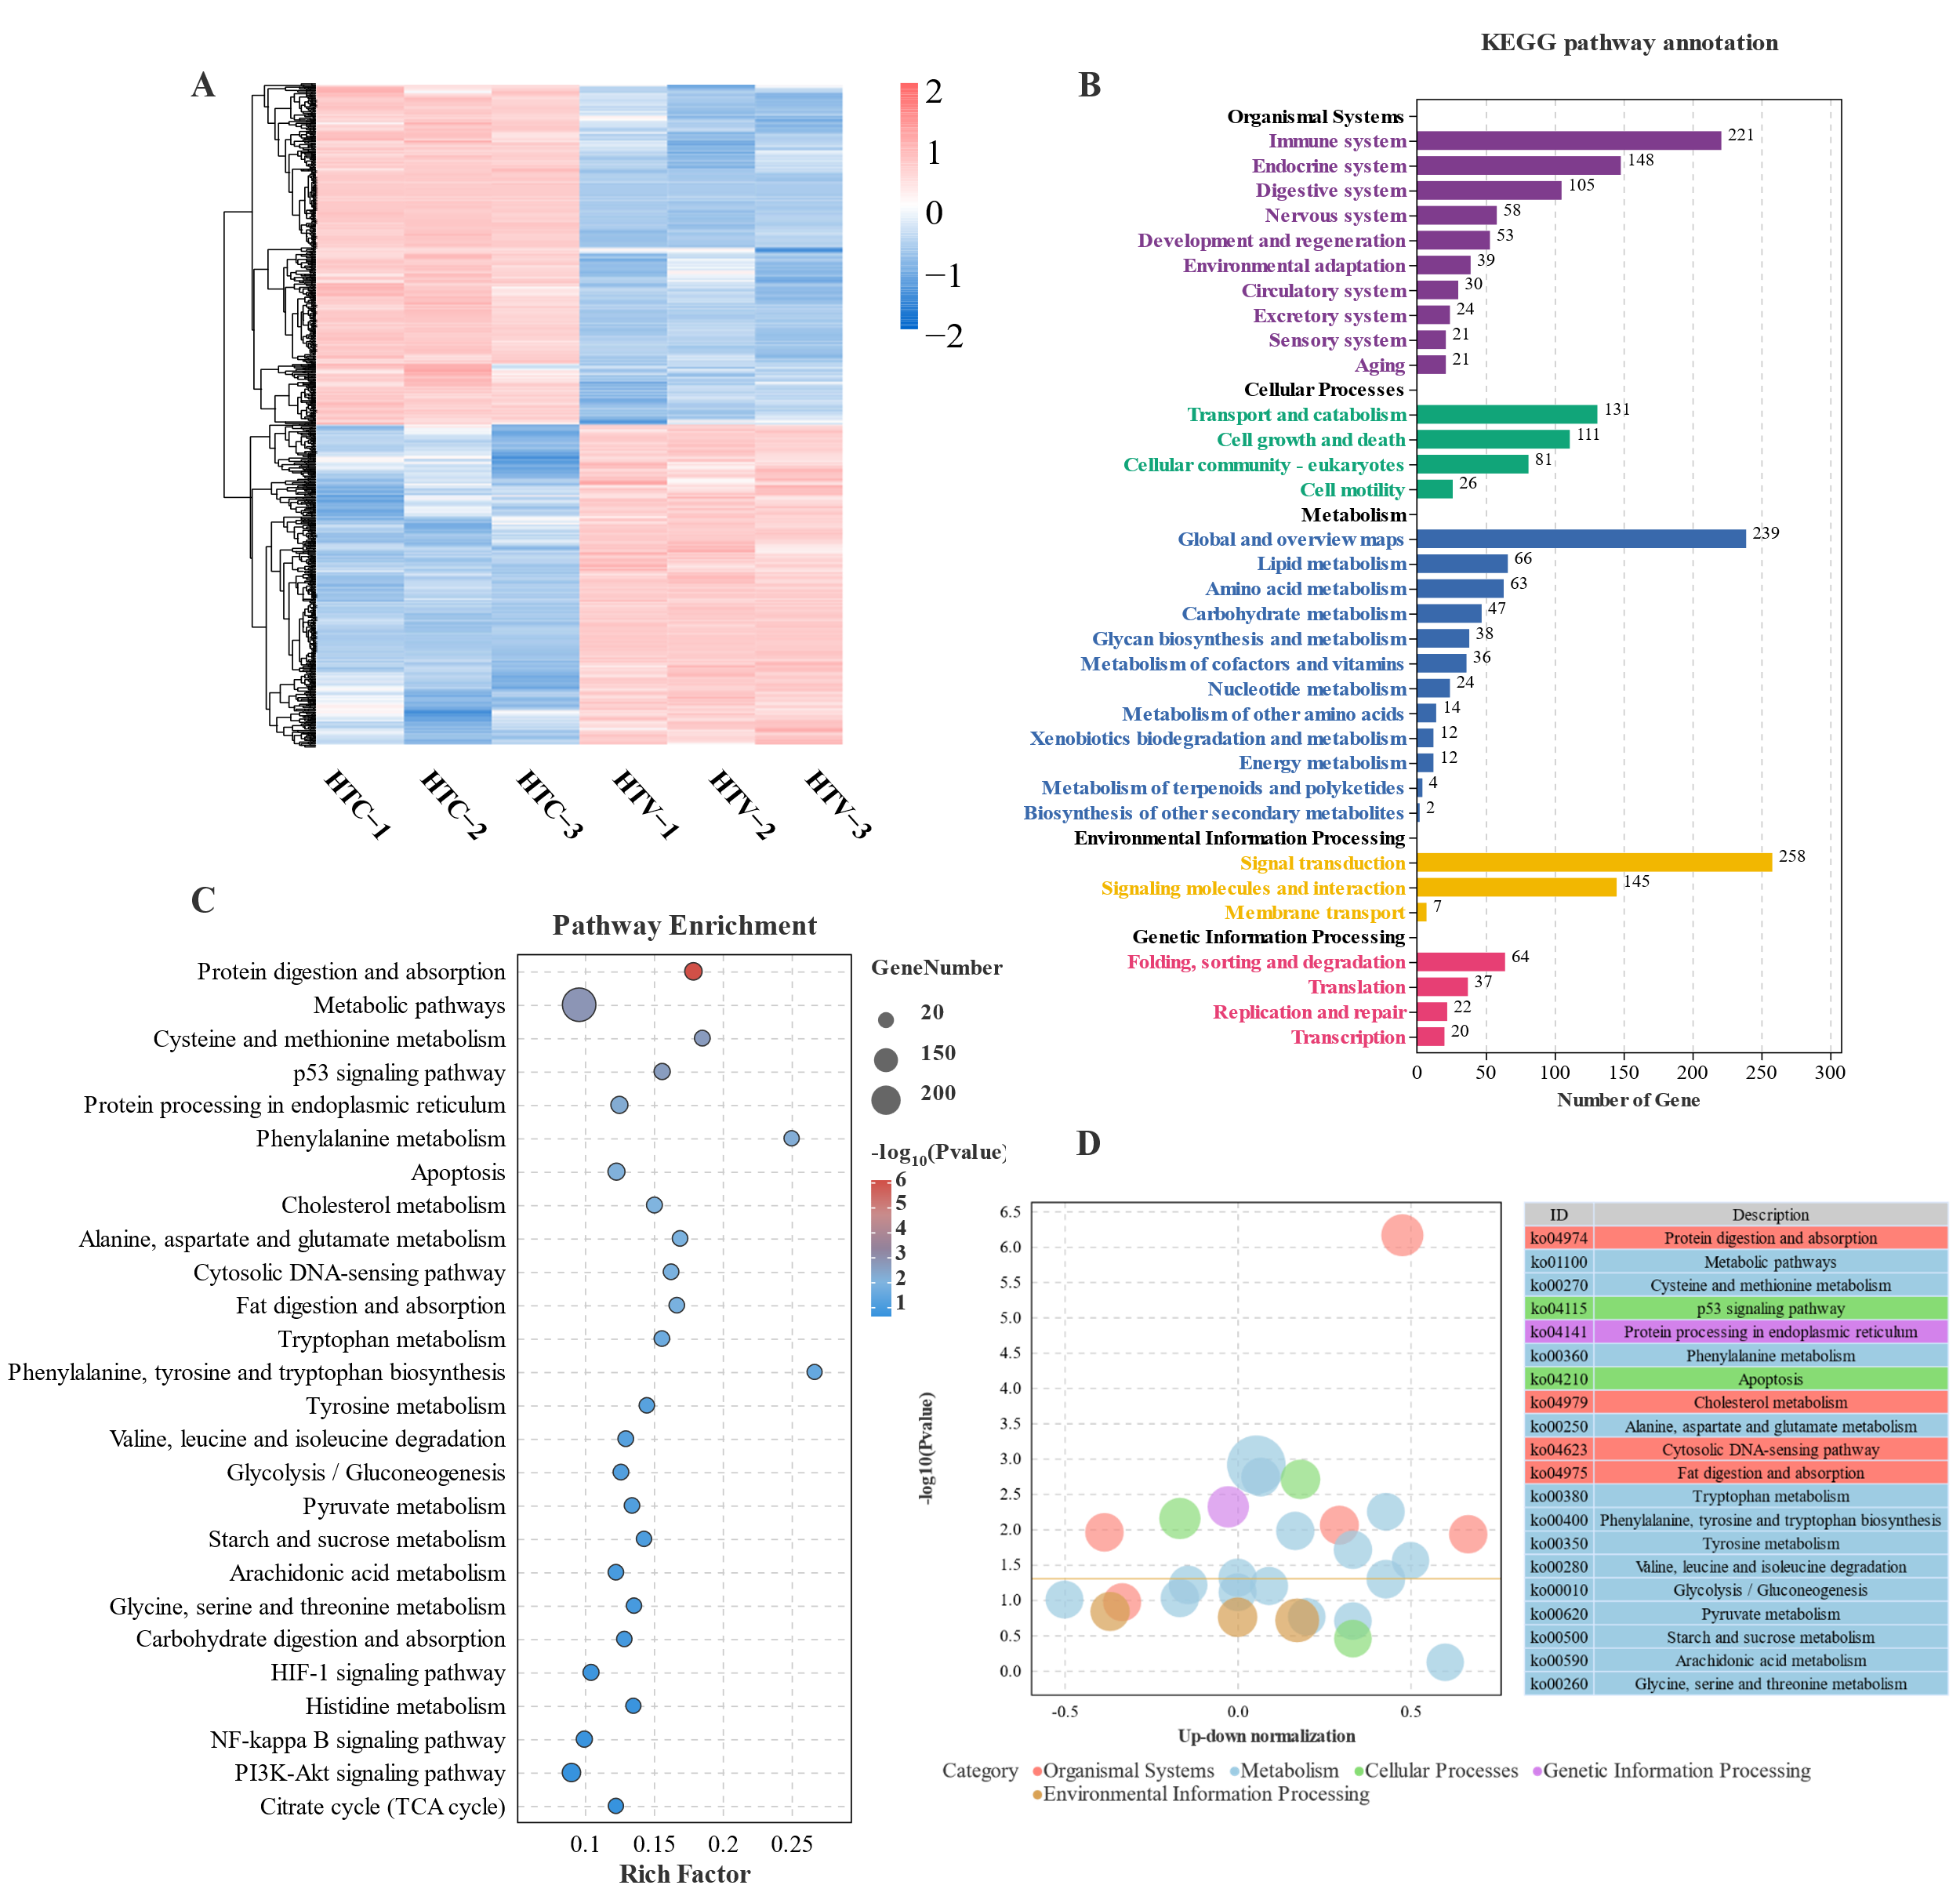

Fig. S1. Transcriptomic analysis of expression pattern of DEGs and KEGG enrichment in the liver of largemouth bass (HTC vs HTV; n = 3). (A): Heatmap; (B): The Kyoto Encyclopedia of Genes and Genomes (KEGG) classification of all the DEGs. (C): Rich factor refers to the ratio of the number of DEGs located in the pathway with the total number of genes located in this pathway among all genes. (D): Difference bubble plot of significantly enriching pathway.

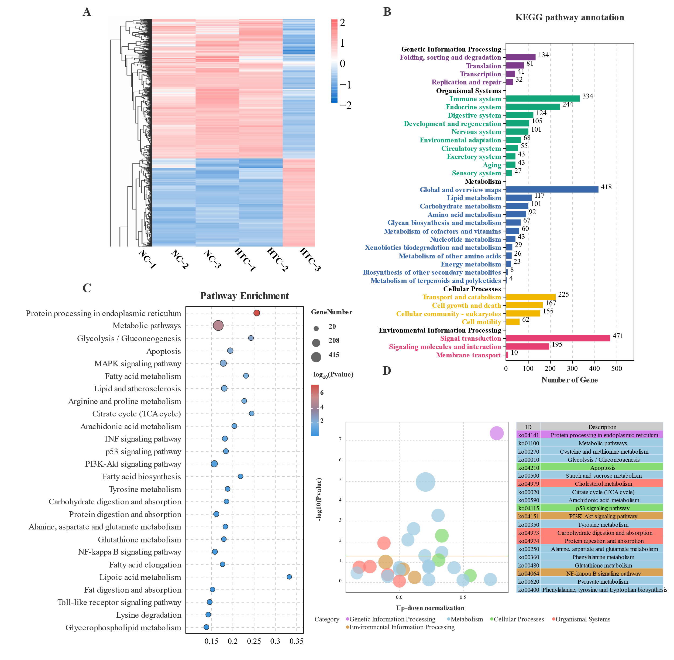

Fig. S2. Transcriptomic analysis of expression pattern of DEGs and KEGG enrichment in the liver of largemouth bass (NC vs HTC; n = 3). (A): Heatmap; (B): The Kyoto Encyclopedia of Genes and Genomes (KEGG) classification of all the DEGs. (C): Rich factor refers to the ratio of the number of DEGs located in the pathway with the total number of genes located in this pathway among all genes. (D): Difference bubble plot of significantly enriching pathway.

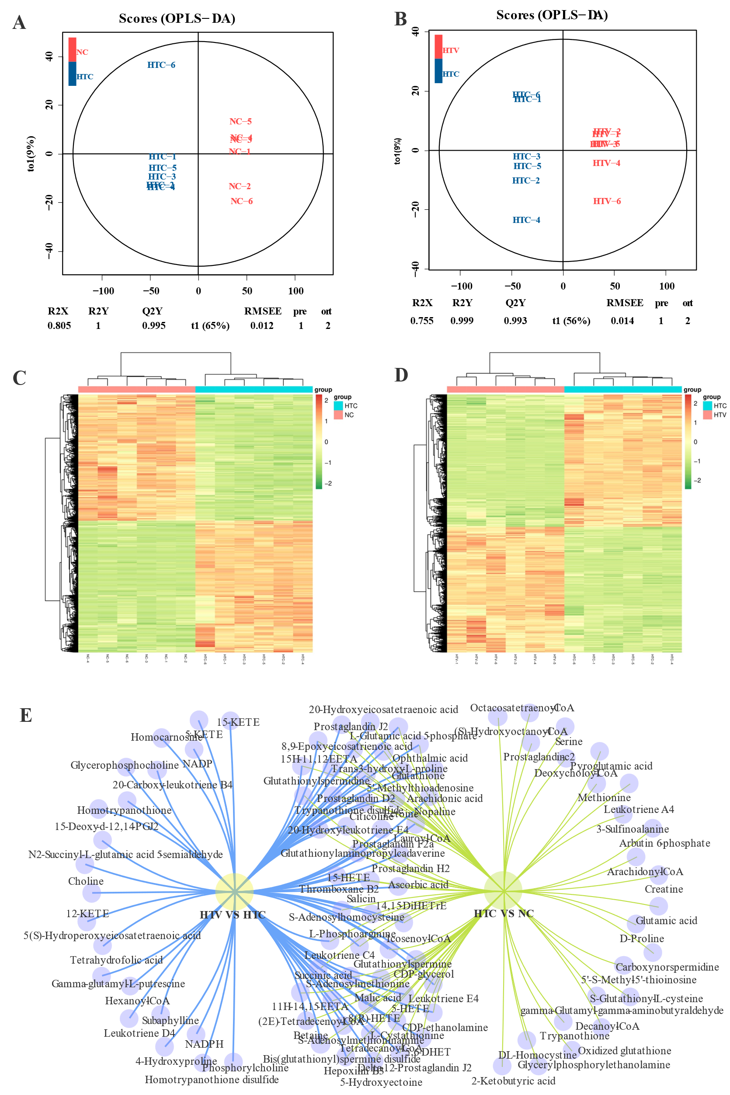

Fig. S3 OPLS-DA analysis and reliability evaluation of NC_vs_HTC (A) and HTC_vs_HTV (B) comparison group. Heat map of metabolites in NC_vs_HTC (C) and HTC_vs_HTV (D) comparison group. The vene plot of the co-DEMs among each comparison group.

Table S1. Primer sequences used in this study

|  |  |  |
| --- | --- | --- |
| Genes | Forward sequence (5′–3′) | Reverse sequence (5′–3′) |
| *β-actin* | CTGTGGTGGTGAATGAGTAGCC | CATCCTCCGTTTGGACTTGG |
| *hsp70* | GTCCTACGCCTTCAACACGA | GCTGATGGTCTCGTCACACT |
| *nrf2* | CCACACGTGACTCTGATTTCTC | TCCTCCATGACCTTGAAGCAT |
| *caspase 3* | GCTTCATTCGTCTGTGTTC | CGAAAAAGTGATGTGAGGTA |
| *caspase 9* | ATCCACGAGGGAGACAAAGAG | GCAACCGAGCACAAATAAGAG |
| *hsp90* | AGACAAGGGAGAAGGAAATGGAC | CGGAGCCCACATCCTCAATC |

Table S2. The co-DEMs in NC vs HTC and HTC vs HTV comparison group

|  |  |  |  |
| --- | --- | --- | --- |
| KEGG_ID | Name | Log2(NC_vs_HTC) | Log2(HTC_vs_HTV) |
| C00149 | Malic acid | 0.22 | 1.83 |
| C05730 | Glutathionylspermidine | 1.23 | 1.19 |
| C03287 | L-Glutamic acid 5-phosphate | 3.10 | -1.48 |
| C00513 | CDP-glycerol | 1.11 | -0.41 |
| C01137 | S-Adenosylmethioninamine | -1.66 | -1.25 |
| C16530 | Icosenoyl-CoA | 1.59 | 1.50 |
| C01451 | Salicin | -0.57 | -1.33 |
| C00042 | Succinic acid | 1.04 | -0.88 |
| C16566 | Glutathionylaminopropylcadaverine | -3.33 | 4.88 |
| C16432 | 5-Hydroxyectoine | 1.29 | -2.74 |
| C00570 | CDP-ethanolamine | 0.67 | -0.52 |
| C21016 | Ophthalmic acid | 2.90 | -1.59 |
| C01832 | Lauroyl-CoA | 0.99 | 0.97 |
| C02166 | Leukotriene C4 | 4.87 | 1.79 |
| C06231 | Ectoine | -0.59 | -0.60 |
| C00019 | S-Adenosylmethionine | 2.34 | -2.65 |
| C05273 | (2E)-Tetradecenoyl-CoA | 3.29 | -0.16 |
| C00427 | Prostaglandin H2 | 0.24 | 2.32 |
| C00719 | Betaine | -0.42 | -0.42 |
| C00051 | Glutathione | 0.51 | 4.22 |
| C05952 | Leukotriene E4 | 3.36 | -1.24 |
| C03170 | Trypanothione disulfide | -2.15 | 1.09 |
| C00307 | Citicoline | 0.07 | -0.71 |
| C00021 | S-Adenosylhomocysteine | -0.88 | 1.23 |
| C02593 | Tetradecanoyl-CoA | 0.89 | 0.21 |
| C00639 | Prostaglandin F2a | -1.86 | 1.72 |
| C00072 | Ascorbic acid | 0.28 | -1.20 |
|  |  |  |  |
| KEGG_ID | Name | Log2(NC_vs_HTC) | Log2(HTC_vs_HTV) |
| C02291 | L-Cystathionine | -0.81 | -0.84 |
| C05945 | L-Phosphoarginine | 1.76 | -0.88 |
| C03577 | 20-Hydroxy-leukotriene E4 | -0.70 | 0.76 |
| C00170 | 5'-Methylthioadenosine | 3.56 | -0.57 |
| C14813 | 11H-14,15-EETA | 0.43 | 0.92 |
| C05147 | Trans-3-hydroxy-L-proline | -0.41 | 1.51 |
| C14772 | 5,6-DHET | 0.31 | 1.21 |
| C16562 | Glutathionylspermine | -0.26 | 1.59 |
| C01682 | Nopaline | 0.72 | -0.75 |
| C14748 | 20-Hydroxyeicosatetraenoic acid | 0.78 | -0.62 |
| C16564 | Bis(glutathionyl)spermine disulfide | 2.37 | 0.66 |
| C05963 | Thromboxane B2 | -5.21 | 3.67 |
| C14781 | 15H-11,12-EETA | 1.27 | -2.80 |
| C05958 | Delta-12-Prostaglandin J2 | -0.13 | 1.41 |
| C00696 | Prostaglandin D2 | -0.16 | -0.19 |
| C04805 | 5-HETE | -0.40 | 1.32 |
| C14795 | 9S,11R,15S-trihydroxy-2,3-dinor-13E-prostaenoic acid-cyclo | -0.67 | -1.62 |
| C14775 | 14,15-DiHETrE | -0.70 | -2.33 |
| C00219 | Arachidonic acid | 0.19 | 5.56 |
| C14810 | Hepoxilin B3 | -1.29 | -1.28 |
| C14769 | 8,9-Epoxyeicosatrienoic acid | -0.36 | -0.97 |
| C14824 | 8(R)-HETE | -1.56 | -24.54 |
| C04742 | 15-HETE | -1.02 | -1.18 |
| C05957 | Prostaglandin J2 | 0.31 | 3.00 |