Supporting Information

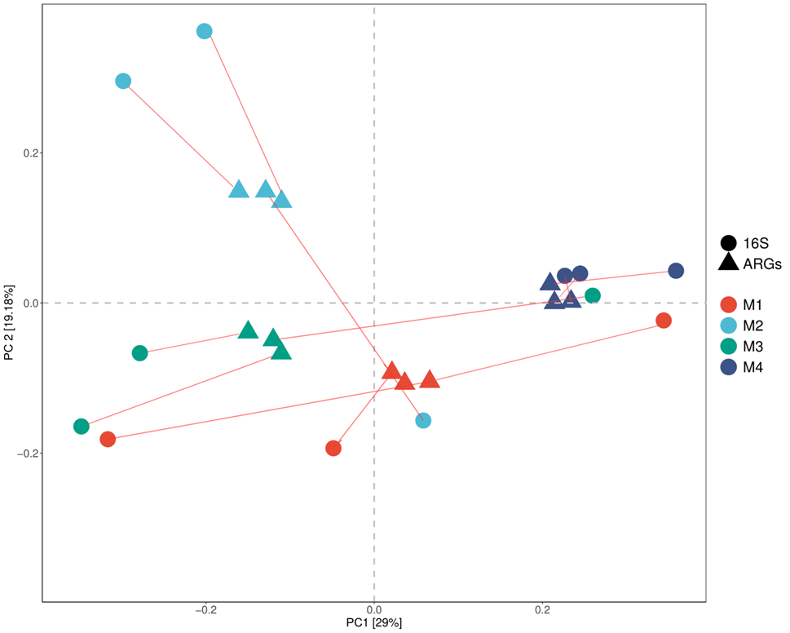

Fig. S1. Procrustes analysis diagram.