Supplementary Material

# Supplementary Figures.

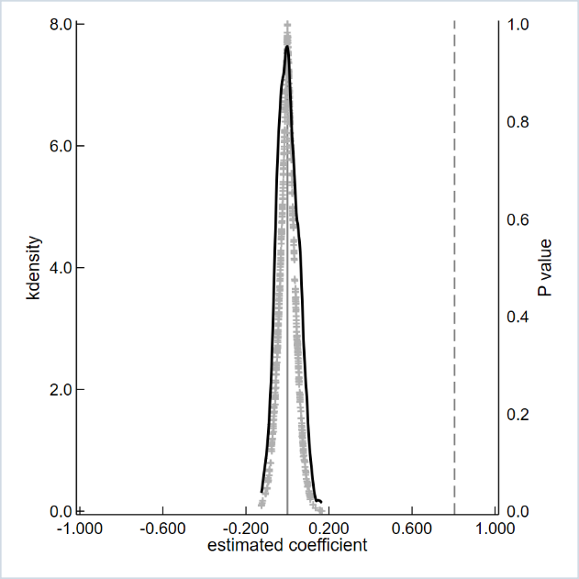

Fig.S1. The placebo test with 500 random samplings.

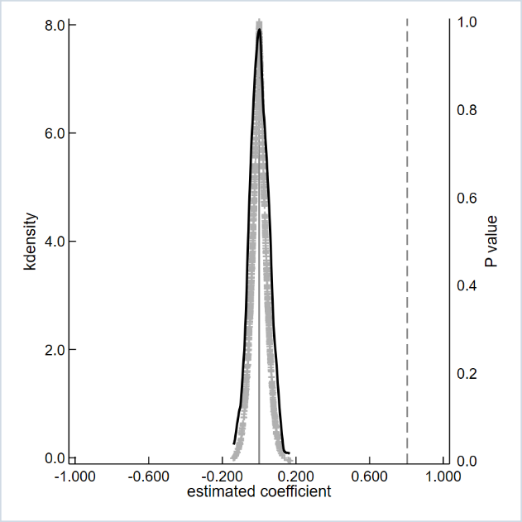

Fig.S2. The placebo test with 1000 random samplings.

# Supplementary Tables.

Table S1. Robustness check by using digital adoption intensity.

|  |  |  |  |  |
| --- | --- | --- | --- | --- |
|  | (1) | (2) | (3) | (4) |
|  | OLS | 2SLS | OLS | 2SLS |
| Usagedepth | 0.3558*** | 0.8342*** |  |  |
|  | (0.0274) | (0.1016) |  |  |
| Eshopping |  |  | 0.1826*** | 0.6493*** |
|  |  |  | (0.0219) | (0.0909) |
| EGS |  | 0.5487*** |  | 0.7050*** |
|  |  | (0.0604) |  | (0.0899) |
| First-stage F statistic  (p-value) |  | 82.64  (0.0000) |  | 61.47  (0.0000) |
| Kleibergen-Paap rk LM  (p-value) |  | 72.392  (0.0000) |  | 57.415  (0.0000) |
| Cragg-Donald Wald F statistic |  | 84.501  [16.38] |  | 66.782  16.38] |
| Controls | Yes | Yes | Yes | Yes |
| Village FE | Yes | Yes | Yes | Yes |
| N | 774 | 774 | 774 | 774 |
| Adj.R2 | 0.4908 |  | 0.4404 |  |

*Notes*: ***, **, and *represent 1%, 5%, and 10% significance levels, respectively. Unless otherwise specified, values in parentheses are standard errors. Values in square brackets are critical values for the Stock-Yogo weak instrumental variable identification F-test at the 10% significance level.

Table S2. Robustness check by replacing sample data.

|  |  |  |
| --- | --- | --- |
|  | (1) | (2) |
|  | OLS | 2SLS |
| Digitaluse | 0.2025*** | 0.3246*** |
|  | (0.0513) | (0.0904) |
| IV |  | 1.1045*** |
|  |  | (0.0908) |
| First-stage F statistic (p-value) |  | 147.91 (0.0000) |
| Kleibergen-Paap rk LM (p-value) |  | 94.011 (0.0000) |
| Cragg-Donald Wald F statistic |  | 136.939 [16.38] |
| Controls | Yes | Yes |
| Village FE | Yes | Yes |
| N | 393 | 393 |
| Adj.R2 | 0.0894 |  |

*Notes*: ***, **, and *represent 1%, 5%, and 10% significance levels, respectively. Unless otherwise specified, values in parentheses are standard errors. Values in square brackets are critical values for the Stock-Yogo weak instrumental variable identification F-test at the 10% significance level. Control variables are consistent with those specified in the baseline Model (1). Here, an instrumental variable (IV) is constructed based on whether rural households have participated in public welfare training on computer or mobile phone internet use (1 = yes, 0 = no).