Supplementary Material

Signals Connection
In a BLDC motor, the stator windings are arranged in a specific pattern, typically 3-phase, and are energized in a sequence to create a rotating magnetic field. This rotating magnetic field interacts with the permanent magnets in the rotor to produce mechanical rotation.
The developed logic circuit integrates PWM's control signals with switching signals and creates switching patterns. The switching patterns are represented in terms of Boolean equations.
The logic circuit needs to support operating the BLDC motor in energy regenerative mode and motoring mode. This dual-mode operation needs to have a two-way clockwise (CW) and counterclockwise (CCW) rotation.
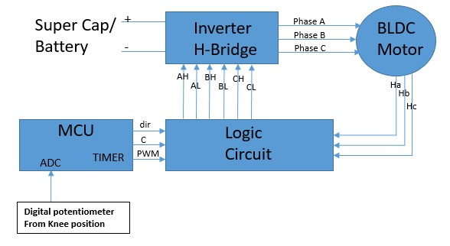
Supplementary Figure 1. Signals Connection Between the Sub-Units on the Electronic Board

Motoring Mode Commutation
The states of switching control signals for implementing the logic necessary to operate the BLDC in dual mode: Motoring mode (Supplementary Table 2.1) and Regenerating mode (Supplementary Table 2.2).

Motoring Mode Commutation
The motoring mode in a two-way (CW and CCW) rotation state
Interval | Direction  (D) | Hall sensors |  |  | AH | AL | BH | BL | CH | CL
 |  | HA | HB | HC
I | 1 | 1 | 0 | 1 | 0 | 0 | 0 | 1 | 1 | 0
II |  | 1 | 0 | 0 | 1 | 0 | 0 | 1 | 0 | 0
III |  | 1 | 1 | 0 | 1 | 0 | 0 | 0 | 0 | 1
IV |  | 0 | 1 | 0 | 0 | 0 | 1 | 0 | 0 | 1
V |  | 0 | 1 | 1 | 0 | 1 | 1 | 0 | 0 | 0
VI |  | 0 | 0 | 1 | 0 | 1 | 0 | 0 | 1 | 0
I | 0 | 1 | 0 | 1 | 0 | 0 | 1 | 0 | 0 | 1
II |  | 1 | 0 | 0 | 0 | 1 | 1 | 0 | 0 | 0
III |  | 1 | 1 | 0 | 0 | 1 | 0 | 0 | 1 | 0
IV |  | 0 | 1 | 0 | 0 | 0 | 0 | 1 | 1 | 0
V |  | 0 | 1 | 1 | 1 | 0 | 0 | 1 | 0 | 0
VI |  | 0 | 0 | 1 | 1 | 0 | 0 | 0 | 0 | 1
Supplementary Table 2. 1 Boolean table for Motoring mode
From Supplementary Table 2.1, we create these six Boolean equations (1)-(6)
$A_{H}={(D∙H}_{A}∙ \overline{H_{C}}+\overline{D}∙ \overline{H_{A}}∙H_{C})∙{PWM}_{m}$ (1)
$A_{L}=\left(D∙\overline{H_{A}}∙ H_{C}+\overline{D}∙H_{A}∙\overline{H_{C}}\right)$ (2)
$B_{H}=(D∙\overline{H_{A}}∙ H_{B}+\overline{D}∙H_{A}∙\overline{H_{B}})∙{PWM}_{m}$ (3)
$B_{L}=(D∙H_{A}∙\overline{H_{B}}+\overline{D}∙\overline{H_{A}}∙H_{B})$ (4)
$C_{H}=(D∙\overline{H_{B}}∙H_{C}+\overline{D}∙H_{B}∙\overline{H_{C}})∙{PWM}_{m}$ (5)
$C_{L}=(D∙H_{B}∙\overline{H_{C}}+\overline{D}∙\overline{H_{B}}∙H_{C})$ (6)
where ${PWM}_{m}$ is the pulse width modulation signal for motoring mode and D is the indicate direction rotation signal.

Regenerating Mode Commutation
The regenerating mode in two-way (CW and CCW) rotation State

Interval | Direction  (D) | Hall sensors |  |  | AH | AL | BH | BL | CH | CL
 |  | HA | HB | HC
I | 1 | 1 | 0 | 1 | 0 | 0 | 1 | 0 | 0 | 1
II |  | 1 | 0 | 0 | 0 | 1 | 1 | 0 | 0 | 0
III |  | 1 | 1 | 0 | 0 | 1 | 0 | 0 | 1 | 0
IV |  | 0 | 1 | 0 | 0 | 0 | 0 | 1 | 1 | 0
V |  | 0 | 1 | 1 | 1 | 0 | 0 | 1 | 0 | 0
VI |  | 0 | 0 | 1 | 1 | 0 | 0 | 0 | 0 | 1
I | 0 | 1 | 0 | 1 | 0 | 0 | 0 | 1 | 1 | 0
II |  | 1 | 0 | 0 | 1 | 0 | 0 | 1 | 0 | 0
III |  | 1 | 1 | 0 | 1 | 0 | 0 | 0 | 0 | 1
IV |  | 0 | 1 | 0 | 0 | 0 | 1 | 0 | 0 | 1
V |  | 0 | 1 | 1 | 0 | 1 | 1 | 0 | 0 | 0
VI |  | 0 | 0 | 1 | 0 | 1 | 0 | 0 | 1 | 0
Supplementary Table S2. 2 Boolean table for Motoring mode
From Supplementary Table 2.2, we create these six Boolean equations (7)-(12)
$A_{H}={(D∙\overline{H_{A}} ∙ H}_{C}+\overline{D}∙ H_{A}∙\overline{H_{C}})∙{PWM}_{r}$ (7)
$A_{L}=\left(D∙H_{A}∙\overline{H_{C}}+\overline{D}∙\overline{H_{A}}∙ H_{C}\right)∙{PWM}_{r}$ (8)
$B_{H}=(D∙H_{A}∙\overline{H_{B}}+\overline{D}∙\overline{H_{A}}∙ H_{B})∙{PWM}_{r}$ (9)
$B_{L}=(D∙\overline{H_{A}}∙H_{B}+\overline{D}∙H_{A}∙\overline{H_{B}})∙{PWM}_{r}$ (10)
$C_{H}=(D∙H_{B}∙\overline{H_{C}}+\overline{D}∙\overline{H_{B}}∙H_{C})∙{PWM}_{r}$ (11)
$C_{L}=(D∙\overline{H_{B}}∙H_{C}+\overline{D}∙H_{B}∙\overline{H_{C}})∙{PWM}_{r}$ (12)
where ${PWM}_{r}$ is the pulse width modulation signal for regenerative braking modes.

Dual Mode Operation
The equations are developed for separate cases. Equations (1)–(6) represent the motoring mode of operation, and equations (7)–(12) represent the regenerative mode of operation. These operation modes can be combined using one control signal.
C (Control Signal) | BLDC Operation Mode
"1" | Motoring
"0" | Regenerative braking
Supplementary Table 2. 3 Control signal state
Table IV introduces a control signal to combine both analyses. The motoring mode takes place when C is high state “1”, and regenerative braking takes place when C is low state “0”. Now, (1)–(6) and (7)–(12) can be combined by adding the control signal.
Finally, the combined Boolean equations based on (1)–(6) and (7)–(12) that include direction and control signals can be formed using the OR operator.
$A_{H}={{C∙(D∙H}_{A}∙ \overline{H_{C}}+\overline{D}∙ \overline{H_{A}}∙H_{C})∙{PWM}_{m}+\overline{C}∙(D∙\overline{H_{A}} ∙ H}_{C}+\overline{D}∙ H_{A}∙\overline{H_{C}})∙{PWM}_{r}$ (13)
$A_{L}=C∙\left(D∙\overline{H_{A}}∙ H_{C}+\overline{D}∙H_{A}∙\overline{H_{C}}\right)+\overline{C}∙\left(D∙H_{A}∙\overline{H_{C}}+\overline{D}∙\overline{H_{A}}∙ H_{C}\right)∙{PWM}_{r}$ (14)
$B_{H}=C∙\left(D∙\overline{H_{A}}∙ H_{B}+\overline{D}∙H_{A}∙\overline{H_{B}}\right)∙{PWM}_{m}+\overline{C}∙(D∙H_{A}∙\overline{H_{B}}+\overline{D}∙\overline{H_{A}}∙ H_{B})∙{PWM}_{r}$ (15)
$B_{L}=C∙\left(D∙H_{A}∙\overline{H_{B}}+\overline{D}∙\overline{H_{A}}∙H_{B}\right)+\overline{C}∙(D∙\overline{H_{A}}∙H_{B}+\overline{D}∙H_{A}∙\overline{H_{B}})∙{PWM}_{r}$ (16)
$C_{H}=C∙\left(D∙\overline{H_{B}}∙H_{C}+\overline{D}∙H_{B}∙\overline{H_{C}}\right)∙{PWM}_{m}+\overline{C}∙(D∙H_{B}∙\overline{H_{C}}+\overline{D}∙\overline{H_{B}}∙H_{C})∙{PWM}_{r}$ (17)
$C_{L}=C∙\left(D∙H_{B}∙\overline{H_{C}}+\overline{D}∙\overline{H_{B}}∙H_{C}\right)+\overline{C}(D∙\overline{H_{B}}∙H_{C}+\overline{D}∙H_{B}∙\overline{H_{C}})∙{PWM}_{r}$ (18)

To minimize the hardware of the six Boolean equations, we can see common Boolean expressions in (13) and (14), (15) and (16), and (17) and (18). First, the common Boolean expressions need to be created and then reused in the other equation.

Appendix

Appendix I: Comparison of the capabilities of different Exoskeleton devices
Article | Return Energy | One/Two Direction | Single/Dual Source
Pozzi et al. (Pozzi et al. 2012) |  | One | --
Donelan et al. (Donelan et al. 2008) |  | One | --
Chen et al. (Chen, Chau, and Liao 2017) |  | Two | --
Shepertcky et al. (Shepertycky et al. 2021) |  | One | --
Fan et al. (Fan et al. 2019) |  | One | --
Martin et al. (Martin and Li 2019) |  | Two | --
Cervara et al. (Cervera et al. 2016), Gad et al. (Gad et al. 2022) |  | Two | --
Shi et al. (Shi et al. 2022) |  | One | Dual
Our study |  | Two | Single
Description of the columns:
- Return Energy indicates whether the exoskeletons can return energy by operating in motoring mode and giving assistance to the users.
- One/Two Directions indicate whether the exoskeleton can harvest or return energy clockwise (cw) and counterclockwise (ccw) of the knee motion.
- Single/Dual Source indicates whether the exoskeleton performs energy return from the same energy source or from a separate energy source.

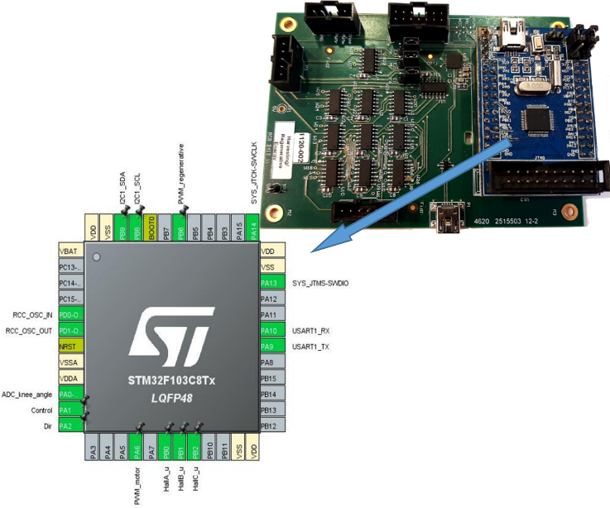
Appendix II: Developed Electronic Board on Microcontroller STM32F103C8T6
Fig. 13. Electronic board and microcontroller pinout.

TABLE Ⅰ: Microcontroller Pin Configuration

Pin Number | - Pin Name (function) | - Alternate Function(s) | - Label
5, 6 | PD0-OSC_IN/OUT |  | System clock
10 | PA0 | ADC1_IN0 | ADC_knee_angle
11 | PA1 | GPIO_Output | Control
12 | PA2 | GPIO_Output | Dir
16 | PA6 | TIM3_CH1 | PWMm_motoring
18 | PB0 | GPIO_EXTI0 | HallA_u
19 | PB1 | GPIO_EXTI1 | HallB_u
20 | PB2 | GPIO_EXTI2 | HallC_u
30 | PA9 | USART1_TX | Communication _Tx
31 | PA10 | USART1_RX | Communication _Rx
34 | PA13 | SYS_JTMS-SWDIO | Debug uses
42 | PB6 | TIM4_CH1 | PWMr_regenerative

Appendix III: BLDC EC-4POLE 22 323218 Coefficients
Motor Data | Coefficients
Max. efficiency | 89 (%)
Terminal resistance phase to phase | 0.527 (Ω)
Torque constant | 14 (mNm/A)
Speed constant | 680 (rpm/V)
Rotor inertia | 5.54 (gcm²)

