**Table 1. The** Global Environmental Protection Laws in Different Regions

|  |  |  |  |
| --- | --- | --- | --- |
| **Period** | **Domain** | **Origin** | **Indications** |
| 2005 | International Environmental Law Organization (IELCO) – 1973 Convention on the Law of Seafood and Seafood Products, and the Law Against the Depletion of Resources. | IELCO  (1973) | WorldResourcesInstitute, InternationalEnvironmentalLawOrganization |
| 2014 | United States  Clean Air Act, § 85,  The National Environmental Policy Act. | Department of Justice  U.S.-CleanAirAct 2014 | https://www.law.cornell.edu/uscode/text/42/chapter-85 |
| 2009 | India  Environmental Protection Act (EPA), Part III, Section 3. | Indian Government  Rules 1986 | IndiaEnvironmentalProtection_Act  https://cpcb.nic.in/7thEditionPollutionControlLawSeries2021.pdf |
| 2007 | Australia  2008–2009 Water Pollution Act. | Australian Government | AustraliaWater_Pollution_Act  https://www.dcceew.gov.au/water/policy/policy/water-laws |
| 2015 | United States  Clean Water and Pollution Act 43 | The U.S.  Department of Health and Human Services | U.S.-CleanWaterAct  [EPA Clean Water Act Overview](https://www.epa.gov/laws-regulations/summary-clean-water-act)  https://www.epa.gov/laws-regulations/summary-clean-water-act |
| 2016 | India  Environmental Protection Law (EPL), Chapter 2. | Indian Government Environment (Protection) Act, 1986 | IndiaEnvironmentalProtection_Laws  https://www.indiacode.nic.in/bitstream/123456789/4316/1/ep_act_1986.pdf |
| 2018 | United Kingdom  Climate and Sustainability Strategy, Part 4.  The National Green Deal. | British government  2018 to 2019 | UnitedKingdomClimateStrategy  https://www.ukri.org/wp-content/uploads/2020/10/UKRI-050920-SustainabilityStrategy.pdf |
| 2020 | India  Environmental Protection Act (EPA), Chapter 7. | Indian Government | IndiaEnvironmentalProtection_Act  https://blog.ipleaders.in/environment-protection-act-1986-2/ |
| 2021 | China  Eighteen key areas of environmental protection law are in Chapter 7. | The Chinese National Council | ChinaEnvironmental_Protection_Laws  <http://www.mee.gov.cn/>  https://www.chinalawtranslate.com/ |
| **Source: The table includes all the data created by the different country's official databases as the original, making it easy to access.** | | | |

**Table 2. Implement of Agreement**

|  |  |  |  |
| --- | --- | --- | --- |
| **Periods** | **Covenant** | **Description** | **Indications** |
| **2001** | **Stockholm Convention on Persistent Organic Pollutants (POPs)** | A global treaty to protect human health and the environment from chemicals that remain intact in the environment for extended periods (POPs). | [Stockholm Convention](https://www.pops.int/) |
| **2002** | **Johannesburg Declaration on Sustainable Development** | Adopted at the World Summit on Sustainable Development, it reaffirmed global commitment to sustainable development and environmental protection. | [UN Johannesburg Summit](https://www.un.org/) |
| **2005** | **Kyoto Protocol (Entered into Force)** | An international treaty extending the 1992 UNFCCC, committing industrialized countries to reduce greenhouse gas emissions. | [Kyoto Protocol](https://unfccc.int/kyoto_protocol) |
| **2010** | **Nagoya Protocol on Access and Benefit-Sharing** | A supplementary agreement to the Convention on Biological Diversity (CBD) focusing on fair and equitable sharing of benefits from genetic resources. | [Nagoya Protocol](https://www.cbd.int/abs/) |
| **2015** | **Paris Agreement** | A landmark agreement under the UNFCCC to limit global warming to well below 2°C, aiming for 1.5°C above pre-industrial levels. | [Paris Agreement](https://unfccc.int/paris-agreement) |
| **2017** | **Minamata Convention on Mercury** | A global treaty to protect human health and the environment from anthropogenic emissions and releases of mercury. | [Minamata Convention](https://www.mercuryconvention.org/) |
| **2018** | **Regional Agreement on Access to Information, Public Participation, and Justice in Environmental Matters in Latin America and the Caribbean (Escazú Agreement)** | The first regional environmental treaty in Latin America and the Caribbean, promoting environmental democracy. | [Escazú Agreement](https://www.cepal.org/en/escazu-agreement) |
| **2019** | **UN Climate Action Summit** | A global summit was held to accelerate action to implement the Paris Agreement and address climate change. | [UN Climate Action Summit](https://www.un.org/en/climatechange/) |
| **2021** | **Kunming Declaration** | Adopted at the UN Biodiversity Conference (COP15), it sets the stage for a post-2020 global biodiversity framework. | [Kunming Declaration](https://www.cbd.int/article/kunming-declaration)  adopted at COP15.  Source: Xinhua |
| **2022** | **Global Biodiversity Framework (GBF) - Adopted at COP15** | A framework to halt and reverse biodiversity loss by 2030, adopted in Montreal, Canada. | [GBF COP15](https://www.cbd.int/gbf/) |
| **2023** | **High Seas Treaty (Biodiversity Beyond National Jurisdiction - BBNJ)** | A legally binding treaty to protect marine biodiversity in areas beyond national jurisdiction. | [BBNJ Treaty](https://www.un.org/bbnj/) |
| **Source: The data from the UN and some countries' official databases have been added link to the table of availabilities** | | | |

**Table 3.** Laws Related to Maritime Affairs in China

|  |  |  |  |
| --- | --- | --- | --- |
| **No** | **Name Of Laws** | **Legislative Time** | **Revised Time** |
| 1 | Maritime Traffic Safety Law | 1983-09-02 | 2021-04-29 |
| 2 | Maritime Law | 1992.11.07 | Not Yet |
| 3 | Marine Environmental Protection Law | 1982-08-23 | 2023-10-24 |
| 4 | Water Pollution Prevention and Control Law | 1984-05-11 | 2017-06-27 |
| 5 | Port Law | 2003-06-28 | 2018-12-29 |
| 6 | Navigational Law | 2014-12-28 | 2016-07-02 |
| 7 | Coast Guard Law | 2021-01-22 | Not Yet |
| 8 | Maritime Procedure Law | 1999-12-25 | Not Yet |
| 9 | Sea Area Use Management Law | 2001-10-27 | Not Yet |
| 10 | Fisheries Law | 2013-12-28 | Not Yet |
| 11 | Water Law | 1988-01-21 | 2016-07-02 |
| **Source:** PKULAW Legal and Regulatory Database (PKULAW, n.d.) | | | |

**Table 4.** Regulations Related to Maritime Affairs in China

|  |  |  |  |
| --- | --- | --- | --- |
| **NO** | **Name of Regulations** | **Legislative** | **Revised** |
| 1 | Regulations on the Management of Inland River Traffic Safety | 1986-12-16 | 2019-03-02 |
| 2 | Regulations on Waterway Management | 1987-08-22 | 2008-12-27 |
| 3 | Implementation Rules for the Regulations on Waterway Management | 1991-08-29 | 2009-06-23 |
| 4 | Regulations on the Management of Foreign Nationality Ships | 1979-09-18 | Not Yet |
| 5 | Regulations on Ship Registration | 1994-06-02 | 2014-07-29 |
| 6 | Measures for the Inspection of International Vessels Calling at or Leaving Ports of the People's Republic of China | 1961-09-08 | 2019-03-02 |
| 7 | Regulations on International Cruise Ships Docking and Supplying at Ports in the People's Republic of China | 2024-04-22 | Not Yet |
| 8 | Crew Regulations | 2007-04-14 | 2023-07-20 |
| 9 | Regulations on the Prevention and Control of Marine Environmental Pollution from Ships | 1983-12-29 | 2018-03-19 |
| 10 | Regulations on Environmental Management for Preventing Ship Dismantling Pollution | 1988-05-18 | 2017-03-01 |
| 11 | Regulations on the Management of Marine Waste Disposal | 1985-03-06 | 2017-03-01 |
| 12 | Regulations on the Prevention and Control of Pollution Damage to the Marine Environment by Land-based Pollutants | 1990-06-22 | Not Yet |
| 13 | Regulations on the Management of Marine Environment Damage Caused by Pollution from Coastal Engineering Construction Projects | 1990-06-25 | 2018-03-19 |
| 14 | Regulations on the Prevention and Control of Pollution Damage to the Marine Environment from Marine Engineering Construction Projects | 2006-09-19 | 2018-03-19 |
| 15 | Regulations on Investigation and Handling of Maritime Traffic Accidents | 1990-01-11 | Not Yet |
| 16 | International Maritime Regulations | 2001-12-11 | 2023-07-20 |
| 17 | Regulations on Domestic Waterway Transportation Management | 2012-10-13 | 2023-07-20 |
| **Source:** PKULAW Legal and Regulatory Database (PKULAW, n.d.). | | | |

# Table 5. Between 1947 to 2024, Pakistan Established the Following Marine Laws and Regulations

|  |  |  |  |  |
| --- | --- | --- | --- | --- |
| **Year** | **Law/Regulation** | **Purpose** | **Significance** | **Orientations** |
| 1947 | N/A | N/A | N/A | N/A |
| 1976 | Territorial Waters and Maritime Zones Act | Defines territorial waters and exclusive economic zone (EEZ) | Establishes jurisdiction over marine resources | Government of Pakistan.  (1976). The Territorial Waters and Maritime Zones Act, 1976. |
| 1980 | Sindh Fisheries Ordinance | Regulates fisheries in the Sindh province | Promotes sustainable fishing practices in the region | Government of Pakistan.  (1983).Pakistan Marine Fisheries Ordinance. |
| 1983 | Pakistan Marine Fisheries Ordinance | Regulates fishing activities, licensing, and conservation of fish stocks | It aims to prevent overfishing | Khan, M. A. (2010).  Marine Resource Management in Pakistan: Challenges and Opportunities. |
| 1994 | Pakistan Maritime Security Agency Act | Establishes PMSA for maritime law enforcement | Enhances security in maritime zones | Pakistan Maritime Security Agency.  (2020). Annual Report on Maritime Security and Fisheries Management*.*  https://dgps.gov.pk/SiteImage/Misc/files/Year%20Book%202020-21.pdf |
| 1997 | Pakistan Environmental Protection Act | Provides a framework for environmental protection, including marine ecosystems | Ensures sustainable development and conservation | Government of Pakistan.  (1997). Pakistan Environmental Protection Act. |
| 2001 | Merchant Shipping Ordinance | Regulates shipping, navigation, and maritime safety | Aligns with international maritime conventions | Ali, S.  (2015). The Legal Framework for Marine Fisheries Management in Pakistan.  Journal of Marine Policy.  https://shippingoffice.gov.pk/pdfs/MSO-2001-UPDATED.pdf |
| 2012 | National Climate Change Policy | Addresses impacts of climate change on marine and coastal environments | Enhances resilience and adaptive capacity | National Climate Change Policy  (2021). Government of Pakistan of Climate Change Islamabad, Pakistan |
| 2019 | Marine Pollution (Prevention and Control) Act | Addresses marine pollution from ships and land-based sources | Implements measures to protect marine ecosystems | World Bank.  (2019). Pakistan: Marine Fisheries and Coastal Management. |
| 2020-2024 | Ongoing developments (e.g., alignment with UNCLOS) | Continuous efforts for sustainable fisheries management and marine biodiversity conservation | Reflects commitment to international maritime laws | United Nations.  (1982). United Nations Convention on the Law of the Sea (UNCLOS). |
| **Source: Table of materials collected by the Government of Pakistan, ministries, official UNCLOS documents, and the World Bank.** | | | | |

**Table 6. The Global Governance of the United Nations**

|  |  |  |  |
| --- | --- | --- | --- |
| **Year** | **Framework/Document** | **Description** | **Orientation** |
| 2000 | **Millennium Declaration** | Established global commitments to sustainable development. | [UN](https://www.un.org/millennium/declaration/ares552e.htm) |
| 2002 | **World Summit on Sustainable Development** | Resulted in the Johannesburg Plan of Implementation, emphasizing sustainable development. | [UN](https://www.un.org/esa/sustdev/documents/WSSD_POI_PD/English/POI.pdf) |
| 2004 | **UN Convention on Biological Diversity** | Focused on conservation and sustainable use of biological diversity. | [CBD](https://www.cbd.int/) |
| 2010 | **Aichi Biodiversity Targets** | Set global biodiversity targets for 2020 to enhance ecosystem protection. | [CBD](https://www.cbd.int/sp/targets/) |
| 2015 | **Paris Agreement** | International treaty to combat climate change and limit global warming to below 2°C. | [UNFCCC](https://unfccc.int/process-and-meetings/the-paris-agreement/the-paris-agreement) |
| 2015 | **2030 Agenda for Sustainable Development** | A global framework to end poverty while protecting the planet, including 17 Sustainable Development Goals (SDGs). | [UN](https://sdgs.un.org/2030agenda) |
| 2016 | **United Nations Environment Assembly (UNEA)** | Promotes global environmental governance and sustainable development. | [UNA](https://www.unep.org/environmentassembly) |
| 2018 | **Global Pact for the Environment** | It aims to strengthen international environmental law and promote sustainable development. | [UN](https://www.un.org/en/ga/search/view_doc.asp?symbol=A/73/419) |
| 2021 | **UN Climate Change Conference (COP26)** | Focused on global climate action, reinforcing commitments from the Paris Agreement. | [UNFCCC](https://ukcop26.org/) |
| **Source: All datasets by the UN can be accessed through the official link https://www.un.org/en/observances/biological-diversity-day/convention** | | | |

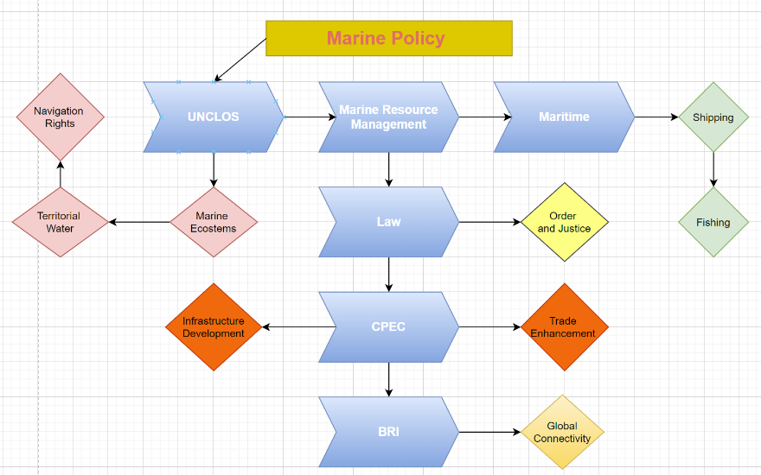**Figure 1: Describes the Main Research Tasks and Knowledge**

**Figure 2. The study emphasizes the research approach and highlights the principal elements of the investigation**

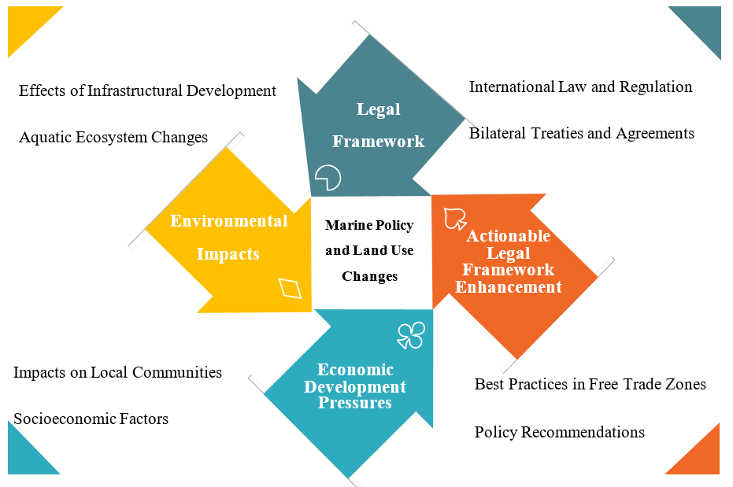

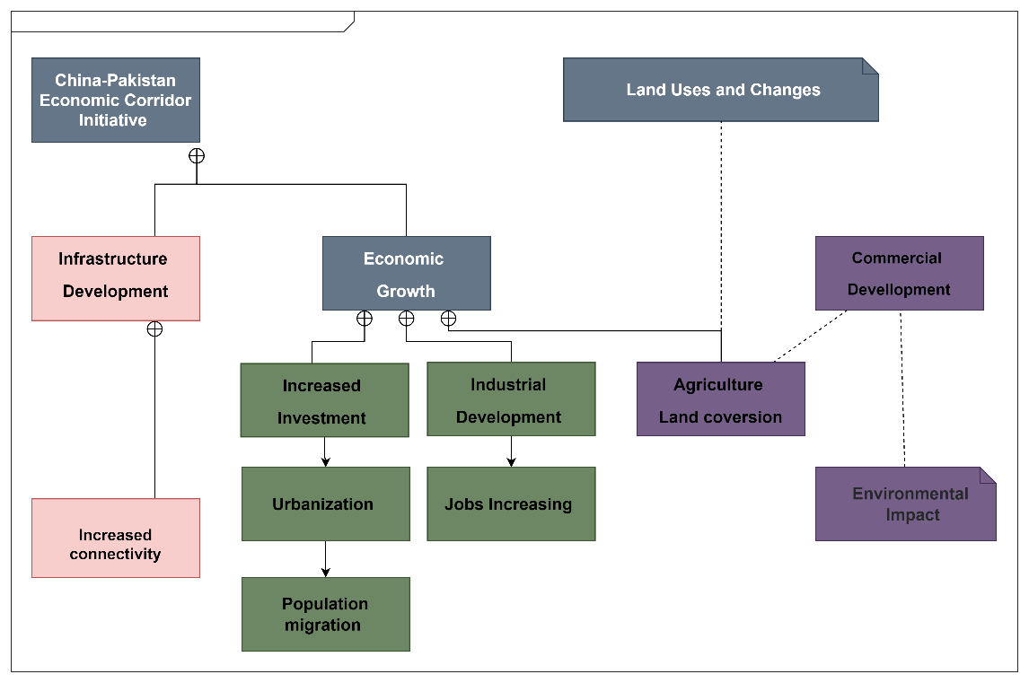**Figure 3. Transformations in Land Use and Agricultural Development**