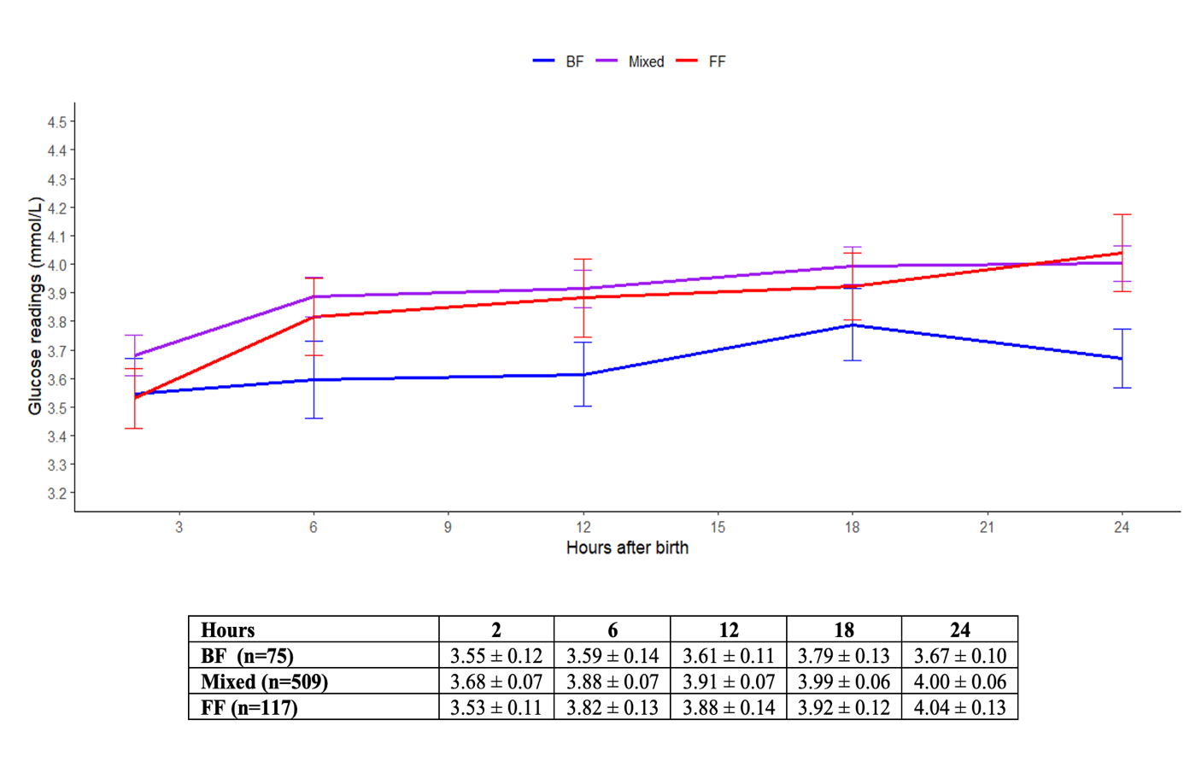
Supplementary Figure 1. Overall mean glucose profiles of at-risk babies stratified by feeding type throughout 24 hours of life.
Results are reported in mean ± 95% confidence intervals. Abbreviations: BF, breastfed; FF, formula-fed.

