Supplementary Material 1

# Supplementary Material (Figure 1)

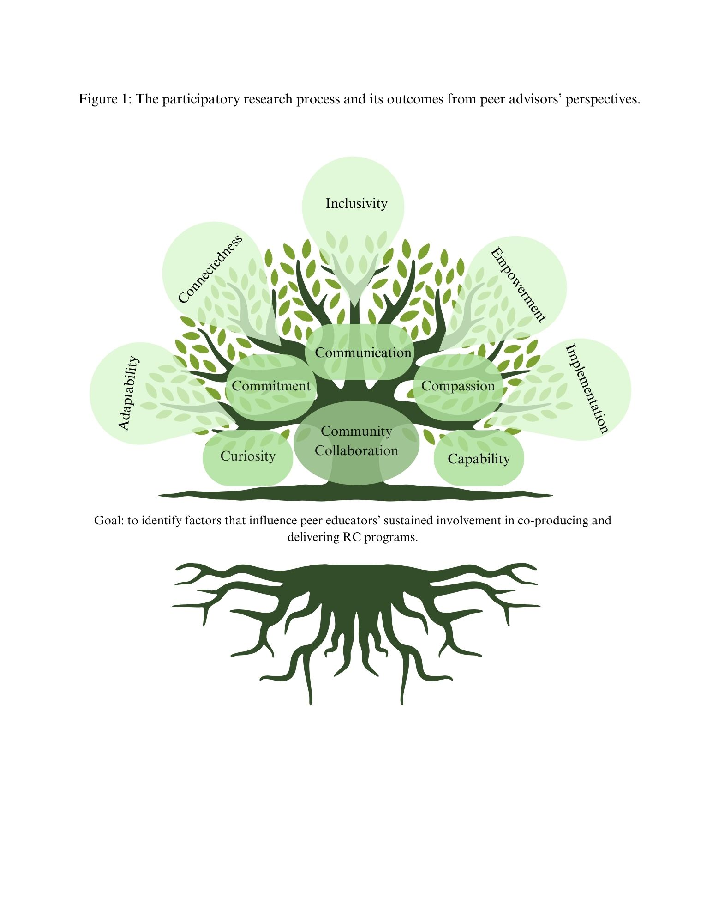Figure 1: The participatory research process and its outcomes from peer advisors’ perspectives.

The image used in this manuscript was created using Canva Pro, following Canva’s Content License Agreement. As per Canva’s licensing terms, Pro users are granted the right to use and publish content generated within the platform, including for academic and commercial purposes, provided that elements used comply with the license type (Free, Pro, or Extended). The image does not violate any intellectual property rights and adheres to Canva’s guidelines for permissible use. For further reference, Canva’s full licensing agreement can be found at: https://www.canva.com/policies/content-license-agreement/.