# **Supplementary Materials**

**Household characteristics associated with environmentally persistent free radicals in house dust in two Australian locations**

Wen Ray Lee1, Prakash Dangal2, Gaurav Langan1, Nina Lazarevic3, Zhiwei Xu4, Stephania A. Cormier2, Slawo Lomnicki2, Peter D Sly1, Dwan Vilcins1

1The University of Queensland, Child Health Research Centre, Children’s Health and Environment Program, South Brisbane, QLD 4101, Australia.

2Superfund Research Centre, Louisiana State University, Baton Rouge, United States.

3 National Centre for Epidemiology and Population Health, Australian National University, Canberra, ACT 2601, Australia.

4School of Medicine and Dentistry, Griffith University, Gold Coast, QLD 4215, Australia.

**Corresponding author**: Dwan Vilcins | Email: [d.vilcins@uq.edu.au](mailto:d.vilcins@uq.edu.au)

Figure S1 Directed Acyclic Graph of household characteristics and presence of EPFR in dust.

Table S1 Frequency of important variables in the 100 cross-validation LASSO models for ELLF cohort (Indoor PM2.5).

|  |  |  |
| --- | --- | --- |
| **Household characteristics** | **EPFR** | **O-EPFR** |
| Season – Winter (vs. summer)  24-hour average indoor PM2.5 (per doubling) | 100  0 | 99  0 |
| Major house renovation – Yes (vs. no)  Living room – Carpet/rug (vs. no carpet/rug)  Heating in living room – Dirty (vs. clean)  Heating in child’s room – Clean (vs. no heating)  Cooling in living room – Dirty (vs. clean)  Cooling in child’s room – Dirty (vs. clean)  Use of candles/incense (days/year) | 96  100  61  1  0  1  0 | 85  65  -  55  85  3  4 |
| Use of mosquito coil – Yes (vs. no)  Type of cooktop – Gas (vs. electric)  Use of extractor fan – Always (vs. never)  Use of extractor fan – Occasionally (vs. never)  Housing material – Weatherboard (vs. brick) | 0  0  100  0  0 | 82  0  71  0  55 |
| Enclosed garage – Yes (vs. no)  Age of house (years)  Household size (total number of family members)  Frequency of windows/doors opened (days/week)  Method of cleaning – Sweep (vs. mop/vacuum) | 6  6  50  83  0 | 82  0  95  36  0 |
| Method of cleaning surface – Dry cloth/dusting wand (vs. wet cloth)  Pets – Yes (vs. no)  Open plan kitchen – Yes (vs. no)  Fireplace – Yes (vs. no)  Neighbourhood traffic – Low (vs. high)  Frequency of cleaning floors (times/week)  Frequency of cleaning surfaces (times/week)  24-hour average indoor CO (per doubling)  24-hour average indoor NO2 (per doubling) | 96  0  61  0  3  100  0  0  49 | 85  13  0  0  36  81  85  0  85 |

Table S2 Frequency of important variables in the 100 cross-validation LASSO models for BIS cohort (Ambient PM2.5).

|  |  |  |
| --- | --- | --- |
| **Household characteristics** | **EPFR** | **O-EPFR** |
| Annual ambient NO2 (per doubling)  Annual ambient PM2.5 (per doubling) | 67  87 | 0  26 |
| House age (years)  Enclosed garage – Yes (vs. no)  Other areas – Carpet/rug (vs. no carpet/rug)  Frequency of windows opened (hours/day)  Use of candles/incense (days/year)  Method of cleaning floors – Sweep (vs. mop/vacuum)  Frequency of cleaning living room (days/year) | 100  95  90  1  87  57  54 | 0  0  0  0  0  0  0 |
| Frequency of cleaning child’s room (days/year)  Neighbourhood traffic – High (vs. low)  Neighbourhood traffic – Some (vs. low)  Housing material – Weatherboard (vs. brick)  Type of cooktop – Gas (vs. electric)  Use of extractor fan – Always (vs. never)  Use of extractor fan – Occasionally (vs. never) | 100  99  87  95  1  90  57 | 3  51  4  1  1  1  1 |
| Type of oven – Gas (vs. electric)  Heating in living room – Dirty (vs. clean)  Cooling in living room – Dirty (vs. clean)  Cooling in child’s room – Dirty (vs. clean)  Smoking/vaping – Yes (vs. no)  Total number of smokes (per day)  Fireplace – Yes (vs. no) | 100  1  3  29  57  1  97 | 3  0  3  0  2  0  2 |
| Season – Autumn (vs. summer)  Season – Spring (vs. summer)  Season – Winter (vs. summer)  Living room or kitchen – Carpet/rug (vs. no carpet/rug)  Bedrooms – Carpet/rug (vs. no carpet/rug) | 44  95  22  100  100 | 0  0  0  3  13 |

Table S3 Important household characteristics identified in the LASSO regression model in the ELLF cohort for O-EPFR Concentration (24-hour ambient).

|  |  |  |  |  |
| --- | --- | --- | --- | --- |
| **Household characteristics** | **Exponential change in mean EPFR concentration** | | **95% CI (Post-selection inference)** | **95% CI (GEE)** |
| Season – Winter (vs. summer) | 3.21 | (-0.50, 6.09) | | (1.71, 4.72) |
| Major house renovation – Yes (vs. no)  Cooling in living room – Dirty (vs. clean) | 1.92  0.77 | (-9.36, 12.52)  (-16.03, 11.63) | | (0.67, 3.18)  (0.16, 1.37) |
| Use of mosquito coil – Yes (vs. no) | 0.38 | (-19.29, 4.96) | | (-0.30, 1.07) |
| Enclosed garage – Yes (vs. no)  Household size (total number of family members) | 1.17  1.06 | (-17.84, 8.17)  (-1.74, 4.49) | | (0.05, 2.28)  (0.30, 1.82) |
| Method of cleaning surfaces – Dry cloth/dusting wand (vs. wet cloth)  Frequency of cleaning floors (times/week)  Frequency of cleaning surfaces (times/week)  24-hour ambient NO2 (per doubling) | -0.04  -0.48  -0.04  -0.02 | (-13.83, 5.99)  (-2.29, 4.24)  (-2.48, 3.96)  (-10.49, 21.33) | | (-1.03, 0.94)  (-0.85, -0.10)  (-0.34, 0.26)  (-2.64, 2.60) |

Table S4 Frequency of important variables in the 100 cross-validation LASSO models for ELLF cohort (24-hour ambient).

|  |  |  |  |  |
| --- | --- | --- | --- | --- |
| **Household characteristics** | | | **EPFR** | **O-EPFR** |
| Season – Winter (vs. summer)  24-hour average ambient PM2.5 (per doubling) | 100  0 | | | 99  0 |
| Major house renovation – Yes (vs. no)_  Living room – Carpet/rug (vs. no carpet/rug)  Heating in living room – Dirty (vs. clean)  Heating in child’s room – Clean (vs. no heating)  Cooling in living room – Dirty (vs. clean)  Cooling in child’s room – Dirty (vs. clean)  Use of candles/incense (days per year) | | | 97  100  61  1  0  1  0 | 84  64  0  54  84  0  1 |
| Use of mosquito coil – Yes (vs. no)  Type of cooktop – Gas (vs. electric)  Use of extractor fan – Always (vs. never)  Use of extractor fan – Occasionally (vs. never)  Housing material – Weatherboard (vs. brick) | | 0  0  100  0  0 | | 81  0  69  0  54 |
| Enclosed garage – Yes (vs. no)  Age of house (years)  Household size (total number of family members)  Frequency of windows/doors opened (days/week)  Method of cleaning floors – Sweep (vs. mop/vacuum) | | 6  6  51  86  0 | | 81  0  94  32  0 |
| Method of cleaning surface – Dry cloth/dusting wand (vs. wet cloth)  Pets – Yes (vs. no)  Open plan kitchen – Yes (vs. no)  Fireplace – Yes (vs. no)  Neighbourhood traffic – Low (vs. high)  Frequency of cleaning floors (times/week)  Frequency of cleaning surfaces (times/week)  24-hour average ambient CO (per doubling)  24-hour average ambient NO2 (per doubling) | | 97  0  61  0  3  100  0  0  51 | | 84  12  0  0  32  83  84  0  84 |

Table S5 Important household characteristics identified in the LASSO regression model in the ELLF cohort for O-EPFR concentration (annual ambient).

|  |  |  |  |
| --- | --- | --- | --- |
| **Household characteristics** | **Exponential change in mean O-EPFR concentration** | **95% CI (Post-selection inference)** | **95% CI (Generalized Estimating Equations)** |
| Season – Winter (vs. summer) | 2.00 | (-9.23, 21.51) | (-0.09, 4.10) |
| Major house renovation – Yes (vs. no)  Heating in child’s room – Clean (vs. no heating) | 2.91  -1.47 | (-7.34, 15.17)  (-11.40, 13.38) | (1.00, 4.82)  (-3.34, 0.41) |
| Cooling in living area – Dirty (vs. clean) | 1.79 | (-16.36, 16.30) | (-0.31, 3.89) |
| Use of mosquito coil – Yes (vs. no) | 1.17 | (-4.48, 3.32) | (-0.09, 2.43) |
| Use of extractor fan – Always (vs. never)  Household size (total number of family members)  Frequency of opening windows/doors (days/week)  Pets – Yes (vs. no) | 0.15  1.38  -0.04  1.18 | (-13.03, 6.96)  (-1.55, 7.76)  (-1.91, 4.05)  (-6.25, 5.49) | (-1.57, 1.87)  (0.37, 2.39)  (-0.42, 0.34)  (-0.20, 2.56) |
| 24-hour average ambient CO (per doubling) | -0.004 | (-3.74, 13.02) | (-0.95, 0.94) |

Table S6 Frequency of important variables in the 100 cross-validation LASSO models for ELLF cohort (annual ambient).

|  |  |  |
| --- | --- | --- |
| **Household characteristics** | **EPFR** | **O-EPFR** |
| Season – Winter (vs. summer)  Annual ambient PM2.5 | 7  0 | 99  0 |
| Major house renovation – Yes (vs. no)_  Living room – Carpet/rug (vs. no carpet/rug)  Heating in living room – Dirty (vs. clean)  Heating in child’s room – Clean (vs. no heating)  Cooling in living room – Dirty (vs. clean)  Cooling in child’s room – Dirty (vs. clean)  Use of candles/incense (days per year) | 0  0  -  0  0  0  0 | 84  1  -  78  77  62  9 |
| Use of mosquito coil – Yes (vs. no)  Type of cooktop – Gas (vs. electric)  Use of extractor fan – Always (vs. never)  Use of extractor fan – Occasionally (vs. never)  Housing material – Weatherboard (vs. brick) | 0  0  0  0  0 | 79  4  82  1  14 |
| Enclosed garage – Yes (vs. no)  Age of house (years)  Household size (total number of family members)  Frequency of windows/doors opened (days/week)  Method of cleaning floors – Sweep (vs. mop/vacuum) | 0  0  0  0  0 | 16  1  100  79  7 |
| Method of cleaning surfaces – Dry cloth/dusting wand (vs. wet cloth)  Pets – Yes (vs. no)  Open plan kitchen – Yes (vs. no)  Fireplace – Yes (vs. no)  Neighbourhood traffic – Low (vs. high)  Frequency of cleaning floors (times/week)  Frequency of cleaning surfaces (times/week)  24-hour average ambient CO (per doubling)  Annual ambient NO2 (per doubling) | 0  0  0  0  -  7  0  7  0 | 0  78  0  -  -  19  6  83  1 |

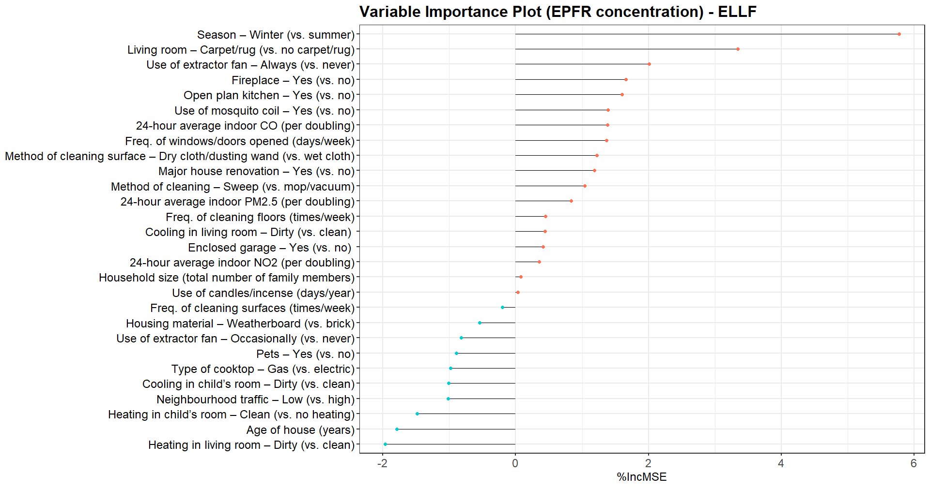

Figure S2 Random Forest Variable Importance Plot – from most important (red point) to least important (blue point) household characteristic of EPFR concentration in the ELLF cohort (included 24-hour average indoor PM2.5, NO2 and CO).

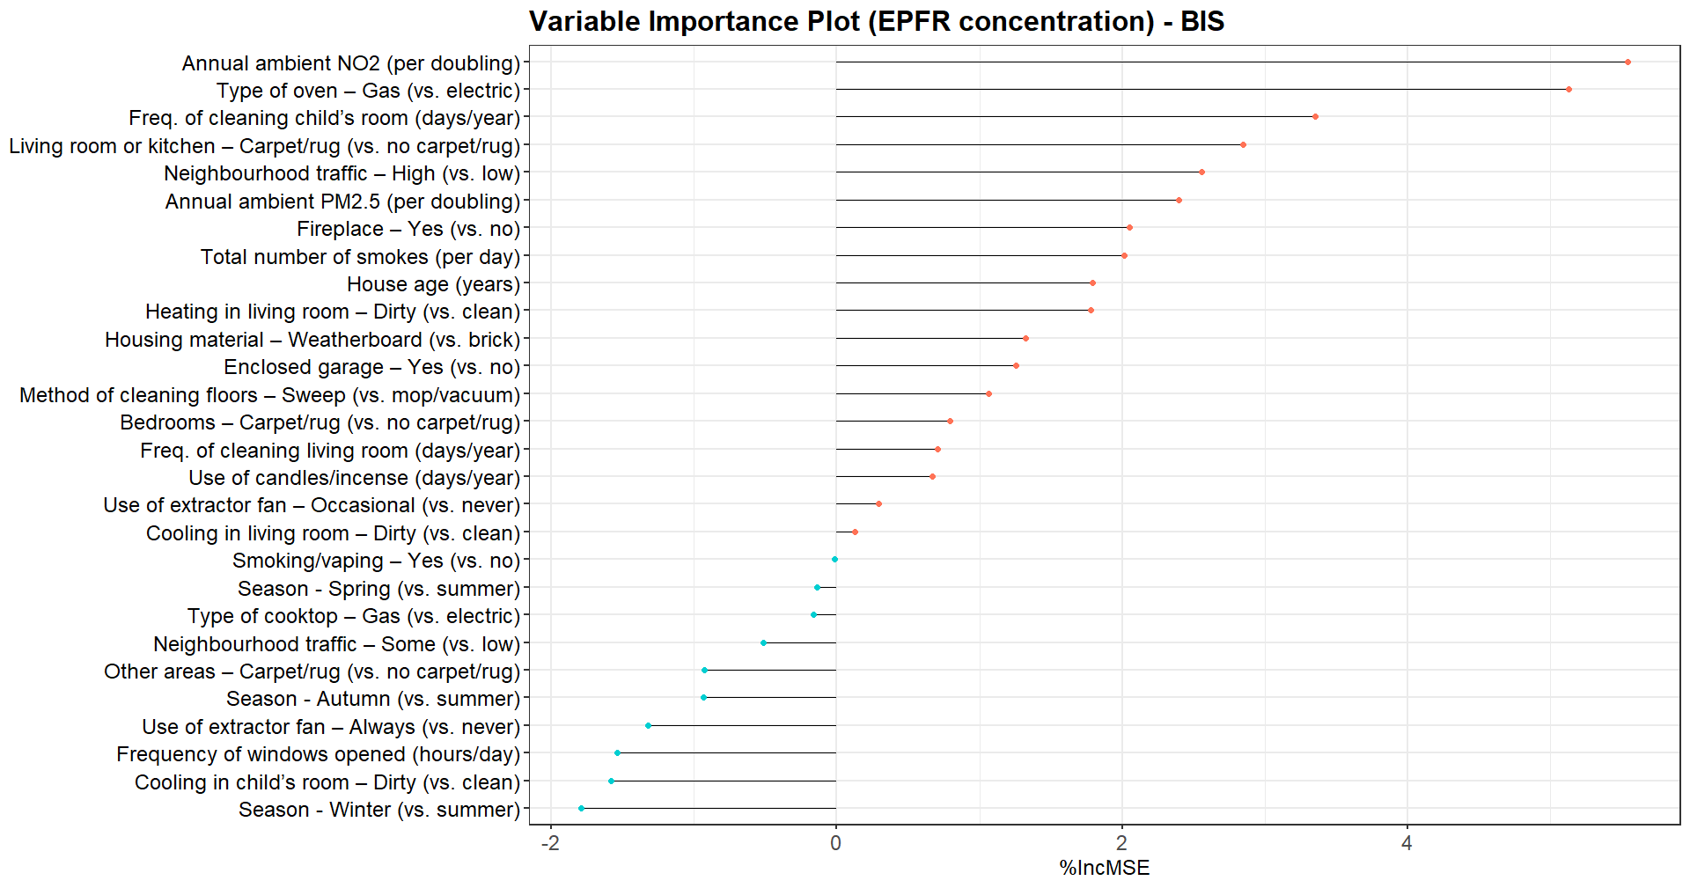

Figure S3 Random Forest Variable Importance Plot – from most important (red point) to least important (blue point) household characteristic of EPFR concentration in the BIS cohort (included ambient PM2.5 and NO2).

Table S7 Household characteristics associated with EPFR concentrations in the ELLF cohort (based on 1000 Bootstrap samples).

|  |  |  |
| --- | --- | --- |
| **Household characteristics** | **Difference in mean**  **log-EPFR concentration,**  **β (log(spins/g))** | **95% CI (Bootstrap)** |
| Season – Winter (vs. summer) | 3.64 | (1.23, 6.12) |
| Major house renovation – Yes (vs. no) | 2.69 | (-0.37, 6.00) |
| Living room – Carpet/rug (vs. no carpet/rug) | -2.06 | (-4.20, 0.16) |
| Use of extractor fan – Always (vs. never) | -3.89 | (-6.42, -1.31) |
| Method to clean surfaces – Dry cloth/dusting wand (vs. wet cloth) | 1.13 | (-0.98, 0.25) |
| Frequency of opening windows/doors (days/week) | -0.39 | (-1.01, 3.32) |
| Frequency of cleaning floors (times/per week) | -0.35 | (-0.68, 0.21) |

Table S8 Household characteristics associated with EPFR concentrations in the BIS cohort (based on 1000 Bootstrap samples)

|  |  |  |
| --- | --- | --- |
| **Household characteristics** | **Difference in mean**  **log-EPFR concentration,**  **β (log(spins/g))** | **95% CI (Bootstrap)** |
| Annual ambient PM2.5 (per doubling) | 1.95 | (-1.09, 5.21) |
| House age (years) | 0.01 | (-0.003, 0.03) |
| Enclosed garage – Yes (vs. no) | -0.74 | (-1.54, 0.04) |
| Candles/Incense usage (days/year) | 0.003 | (-0.0006, 0.006) |
| Frequency of cleaning in child’s room (days/year) | 0.01 | (0.004, 0.014) |
| Neighbourhood traffic – High (vs. low) | 0.54 | (-0.31, 1.36) |
| Neighbourhood traffic – Some (vs. low) | 0.70 | (0.02, 1.41) |
| Housing material – Weatherboard (vs. brick) | 0.49 | (-0.29, 1.28) |
| Use of extractor fan – Always (vs. never) | -0.24 | (-0.86, 0.42) |
| Type of oven – Gas (vs. electric) | -1.38 | (-2.15, -0.62) |
| Fireplace – Yes (vs. no) | 0.67 | (-0.21, 1.54) |
| Season – Spring (vs. summer) | -0.57 | (-1.41, 0.22) |
| Living room or kitchen – Carpet/rug (vs. no carpet/rug) | 0.79 | (-0.04, 1.60) |
| Bedrooms – Carpet/rug (vs. no carpet/rug) | 1.64 | (0.41, 2.94) |
| Other areas – Carpet/rug (vs. no carpet/rug) | 0.34 | (-0.35, 1.03) |