Appendix A. Scientific Content Coding Rubrics

Supplemental Table 1. Plants Rubric
Supplemental Table 2. Animals – General Rubric
Supplemental Table 3. Animals – Fossils Rubric
Supplemental Table 4. Matter Rubric

Supplemental Table 1. Plants Rubric
PLANTS DEPICTED:
Content | Primary Text | Auxiliary Text | Graphics | Graphic Text
Type of plant
Plants need sunlight to survive
Plants need air to survive
Plants need water to survive
Plants need nutrients/soil/dirt to survive
Plants have stems
Plants have leaves
Plants have petals
Plants have roots
Plants have seeds
Plants come from seeds
Plants can grow
Plants can die
Plants can be different colons
Plants can grow in grass
Plants respond to environmental changes (i.e. trees’ leaves shed in the fall, flowers’ petals bloom in the spring, etc.)
Plants reproduce through pollen, seed distribution, etc. (2nd)
Water cycles among land and atmosphere, including precipitation through clouds (2nd)
Incidental content
Personal language
Incorrect information
Accurate adjective doesn’t fit elsewhere:

ANIMALS DEPICTED:
Content: Animals | Primary Text | Auxiliary Text | Graphics | Graphic Text
Animal name ⇄ class
Scientific name
Animals need air/oxygen to survive
Animals need water to survive
Animals need food to survive
Animals eat plants, fruits, nuts, seeds, and other nonliving things
Animals eat/feed off other animals
Animals can be predators and/or prey and are part of the food chain
Animals have distinguishing features:
Mammals – warm-blooded; have fur/hair, live births, mammary glands; nurse
Amphibians – cold-blooded; have moist skin, have both gills and lungs; have webbed feet; lay many eggs; are born in water
Reptiles – cold-blooded; have dry, scaly skin, either four legs or no legs; lay leathery eggs; are born on land
Fish – cold-blooded; have scales, gills; lay many eggs
Birds – warm-blooded; have feathers, wings, beaks, 2 legs; hatch from eggs
Arthropods – have exoskeletons, segmented bodies, more than four jointed limbs, no backbones
Compare/contrast of characteristics of species to other species
Compare/contrast of characteristic variety within species
Animals have internal structural support
Animals have body parts that perform specific functions: see; hear; grasp objects; transport; protect from danger; consume food, air, water
Body part exemplar
Animals make sounds
Animals have innate behaviors that they inherit because of evolution and adaptation (i.e. bears hibernating, birds migrating, etc.)
Animals have learned behaviors that are not inherited that they use to respond to their environment (i.e. deer leaving a forest because of a fire, dogs trained to follow commands, etc.)
Animals are unique to geographical ecosystems/landscapes/habitats
Parents engage in behaviors to help offspring survive (i.e. protect, defend, teach life skills, etc.)
Family structure/community
Life cycle: birth, maturation, reproduction, death
Animal species can become endangered
Animal species can go extinct
Some animals can be domesticated
Incidental content
Personal language
Incorrect information
Accurate adjective doesn’t fit elsewhere:
Supplemental Table 2. Animals – Rubric

Supplemental Table 3. Animals - Fossils Rubric
ANIMALS DEPICTED:
Content: Fossils | Primary Text | Auxiliary Text | Graphics | Graphic Text
Fossils defined: prints, indents of a previously living animal/plant
How fossils created – general: pressed into rock (this goes further than saying it is a print or an indent…needs a general verb)
How fossils created – specific: one for each aspect of cycle (Animal dies, dirt or something covers it, time passes, becomes stone)
Bones defined: internal structure, inside a body, under the skin, white, hard
Fossil examples: animal, person, dinosaur, shells, bones, leaves, stones, food leftovers, sticks/trees, plates, teeth, water life
Mentioned/defined extinction (must use specific word)
Fossils specifically named (e.g., name of dinosaur)
Why fossils useful? Look at things, put bones in the right place, scientists understand them, place in museum, let regular people see them, determine what something was, compare today vs. back then
Knowledge of fossil when alive: herbivore, carnivore, plant eater, meat eater, size, specific body parts (e.g., plates), function of specific body parts
When were fossils alive? Timeframe, ancient, long time ago
Where fossils are found: specific geographic location
Where fossils are found: materials found in like sand, stone, clay, dirt
Who studies fossils – general: scientist (only score once even if mentioned multiple)
Who studies fossils – specific: naming paleontologist (only score once even if mentioned multiple)
What scientist/paleontologist does? Digs for them, compares them, puts them together, finds them, cleans them, polishes them (must make specific connection between scientists/paleo and their behaviors…vs. why fossils are useful
Incidental content
Personal language
Incorrect information
Accurate adjective doesn’t fit elsewhere:

Supplemental Table 4. Matter Rubric
SOLIDS DEPICTED:
LIQUIDS DEPICTED:
GASES DEPICTED:
Content | Primary Text | Auxiliary Text | Graphics | Graphic Text
Solid ⇄ matter
Liquid ⇄ matter
Gas ⇄ matter
Solid exemplar
Liquid exemplar
Gas exemplar
Texture of material
Temperature of material
Color of material
Properties of solids: hold their shape, don’t flow; can be broken; have specific structure/arrangement of particles
Properties of liquids: don’t have their own shape; flow; fill the container they’re in; particles are close together and move around
Properties of gases: some are visible, some aren’t; expand to fill shape of the container they’re in; particles are well separated and move freely
Other observable properties
Purpose of the matter/how material interacts with the environment (i.e. gas form of water creates clouds and causes rain)
Processes cause changes in states of matter
Changes of state doesn't = loss of mass
Other states of material: solid/liquid; liquid/gas; solid/gas
Conductivity of the material (ability to transfer energy)
Incidental content
Personal language
Incorrect Information
Accurate adjective doesn’t fit elsewhere:

Appendix B. Summary Writing Samples

- Supplemental Figure 1. Fossil content generated by a 2nd grade student coded as Complex Complementary Multimodal Text
- Supplemental Figure 2. Animal content generated by a 1st grade student coded as Complex Redundant Multimodal Text
- Supplemental Figure 3. Matter content generated by a 2nd grade student coded as Foundational Multimodal Text
- Supplemental Figure 4. Plant content generated by kindergarten student coded as Unlabeled Visual Text
- Supplemental Figure 5. Animal content constructed by a 2nd grade student coded as Text-Centric Narrative Text
- Supplemental Figure 6. Plant content generated by kindergarten student coded as Labeled Visual Text

Supplemental Figure 1. Fossil content generated by a 2nd grade student coded as Complementary Complex Multimodal Text

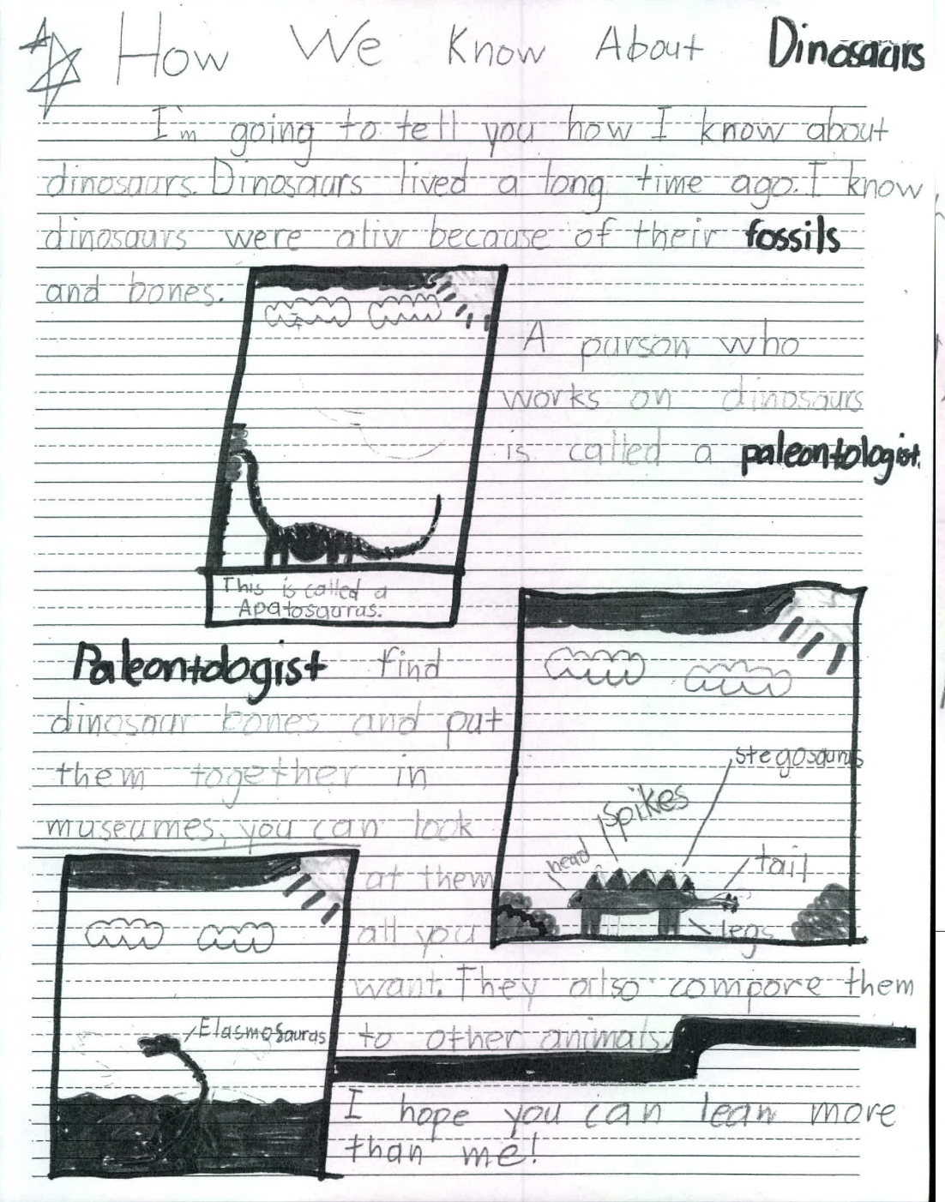

Supplemental Figure 2. Animal content generated by a 1st grade student coded as Redundant Complementary Complex Multimodal Text

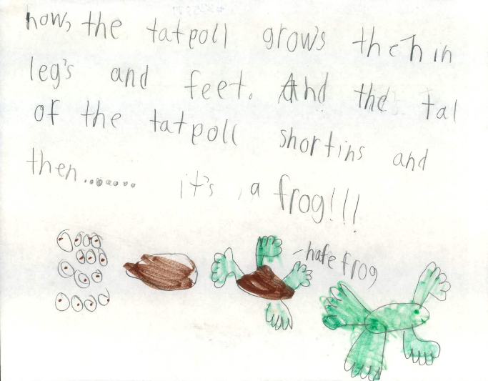
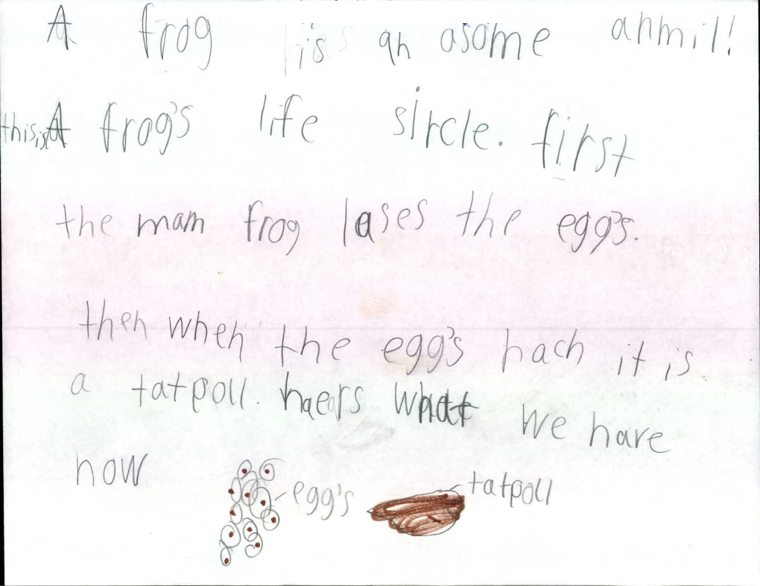
Supplemental Figure 3. Matter content generated by a 2nd grade student coded as Foundational Multimodal Text

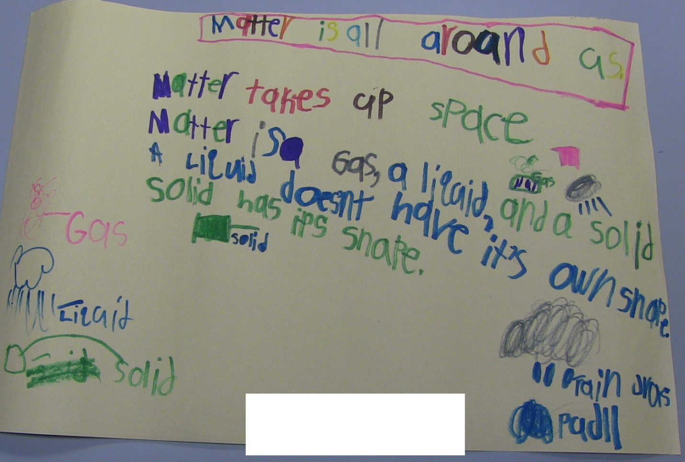
Supplemental Figure 4. Plant content generated by kindergarten student coded as Unlabeled Visual Text
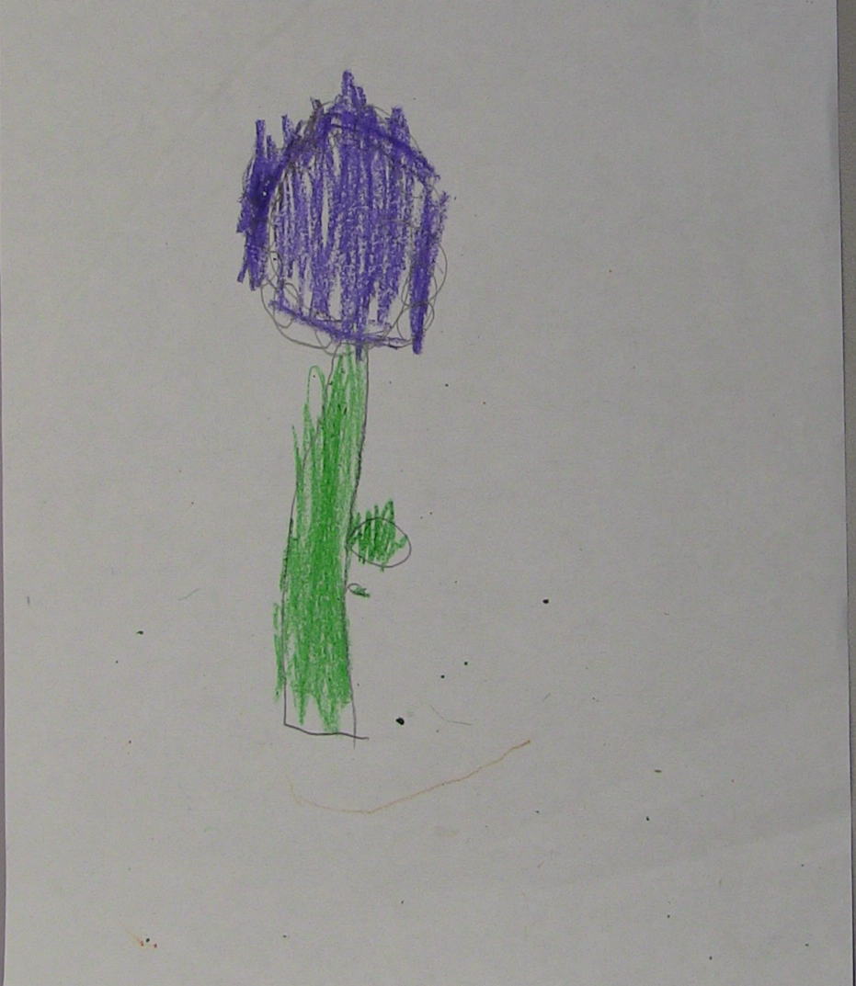
Supplemental Figure 5. Animal content constructed by a 2nd grade student coded as Text-Centric Narrative Text
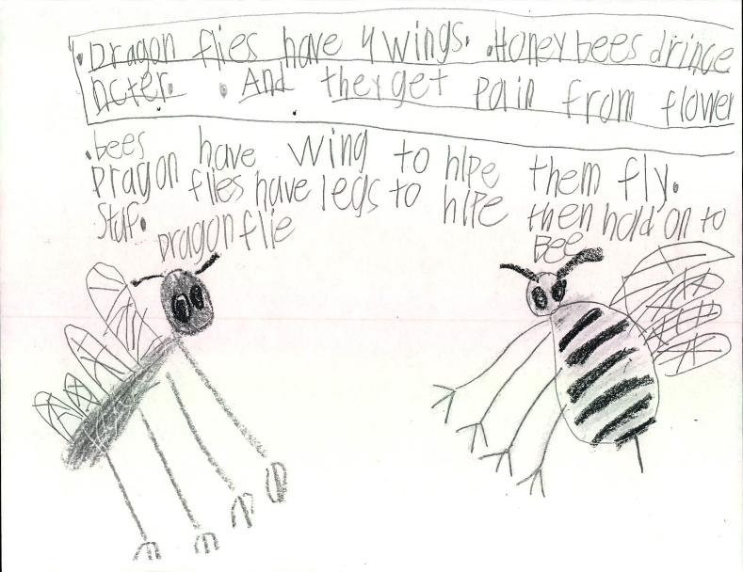
Supplemental Figure 6. Plant content generated by kindergarten student coded as Labeled Visual Text

