**Supplementary data**

**Figure legends:**

Figure S1 Photo of straw and biochar co-application experiment site

Figure S2 Soil samples of pepper after 2 years of continuous cropping under straw and biochar application

Figure S3 Effects of straw and biochar application on single pepper leaf area after two years of continuous cropping

Figure S4 Effects of straw and biochar application on leaf MDA and osmoregulatory substance content after two years of continuous cropping.

Figure S5 PCA was analyzed for relationship between the pepper leaf antioxidant enzyme activities and plant morphological under straw and biochar application after two years of continuous cropping.

Figure S6 Analysis of Rank-abundance curves of the rhizosphere soil bacteria (A) and fungi (B) under straw and its carbonization addition after two years of pepper continuous cropping.

Figure S7 Similarity analysis of the rhizosphere soil bacteria (A) and fungi (B) under straw and its carbonization addition after two years of pepper continuous cropping.

Figure S8 Relative abundance of the rhizosphere soil bacteria (A) and fungi (B) groups at the genus level under straw and its carbonization addition after two years of pepper continuous cropping

Figure S9 Pearson correlation analysis of the rhizosphere soil microbial community diversity and soil enzyme activity. (A) rhizosphere bacteria; (B) rhizosphere fungi

**Table legends:**

Table S1 16S method: PCR amplification conditions.

Table S2 ITS method: PCR amplification conditions.

Table S3 Effects of straw and biochar application on Growth characteristics of pepper plants in facility continuous cropping

Table S4 Effects of straw and biochar application on leaf chlorophyll content of pepper after two years of pepper continuous cropping

Table S5 Effects of straw and biochar application on the soil enzyme activity of pepper in facility continuous cropping

Table S6 Alpha rarefaction of the rhizosphere soil under straw and biochar application after two years of pepper continuous cropping

Table S7 Effective sequence numbers for bacteria and fungi in the rhizosphere soil under straw and biochar application after two years of pepper continuous cropping

Table S8 Quantities of bacterial and fungal communities in the rhizosphere soil at different levels under straw and biochar application after two years of pepper continuous cropping

Table S9 OTU taxonomy of the rhizosphere soil bacteria under straw and biochar application after two years of pepper continuous cropping.

Table S10 OTU taxonomy of the rhizosphere soil fungi under straw and biochar application after two years of pepper continuous cropping.

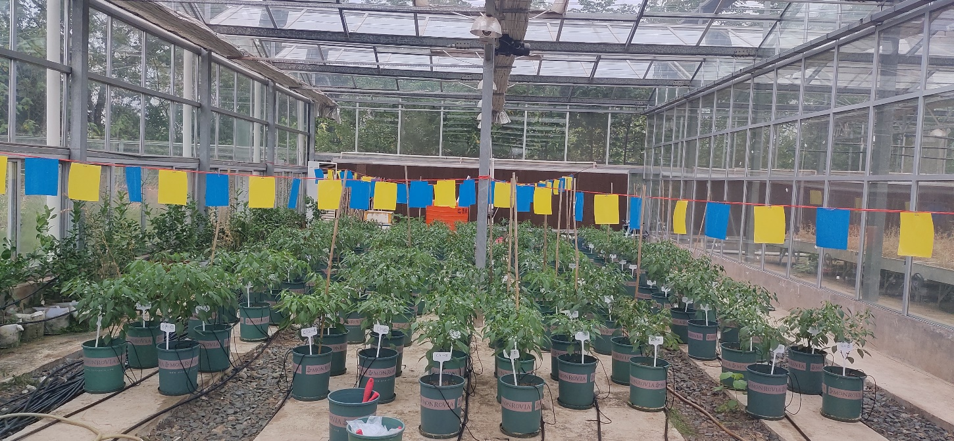

**Figure S1** Photo of straw and biochar co-application experiment site

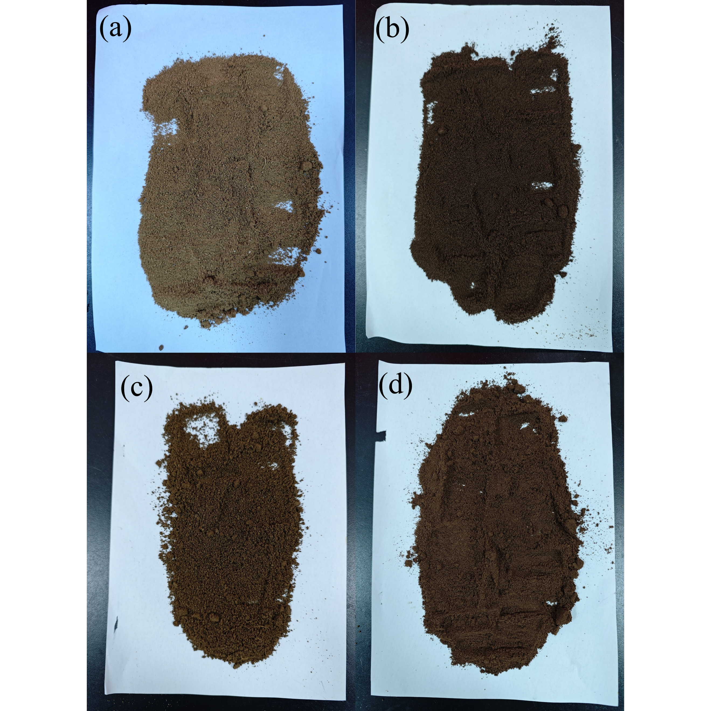

**Figure S2** Soil samples of pepper after two years of continuous cropping under straw and biochar application. (a) CK (no material added). (b) B (1% soil mass of biochar added). (c) (equal amount of straw added, and 2.4% soil mass of straw added at a carbonization rate of 42.00%). (d) BS (cumulative application of biochar and straw).

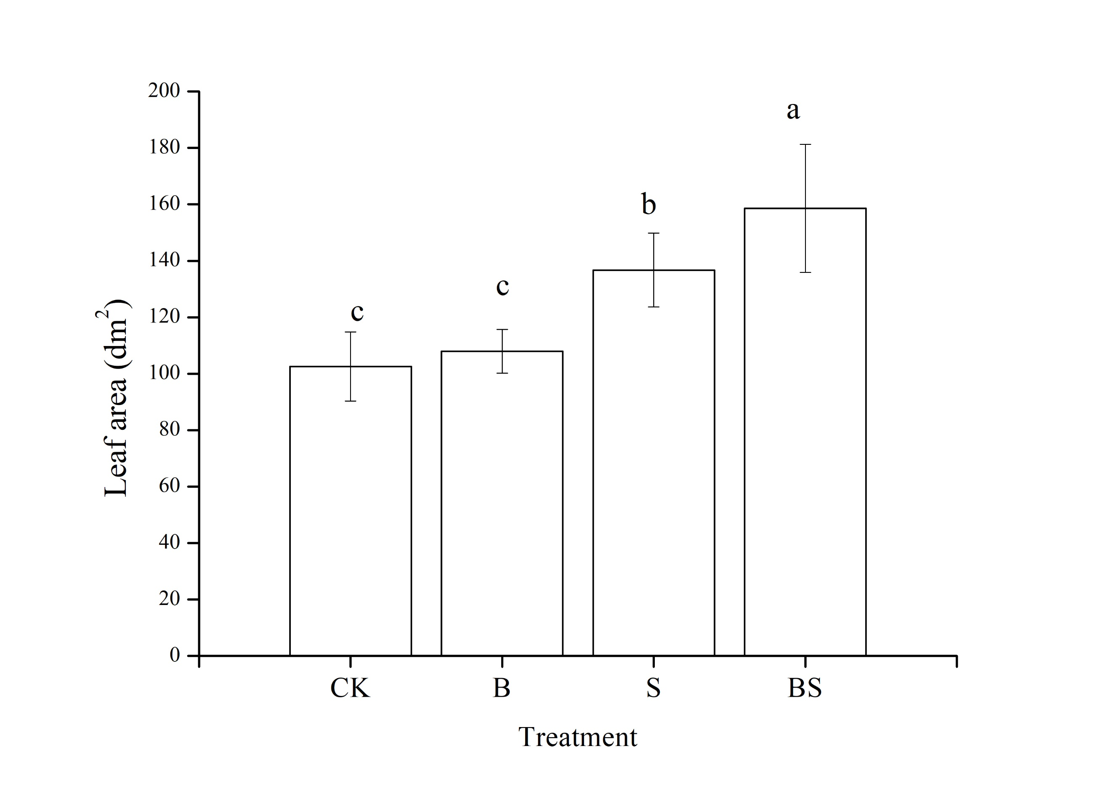

**Figure S3** Effects of straw and biochar application on single pepper leaf area after two years of continuous cropping

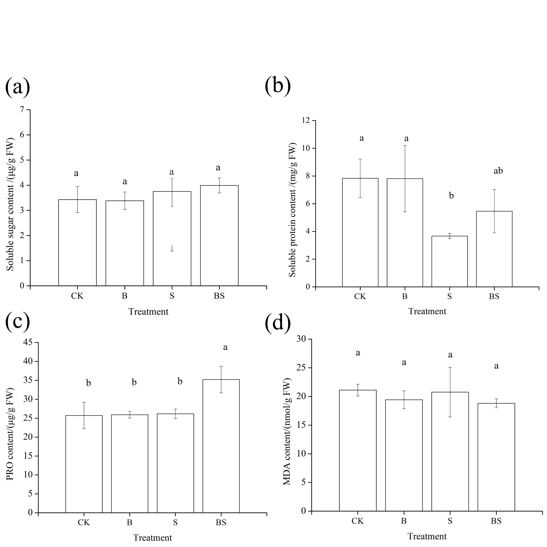

**Figure S4** Effects of straw and biochar application on leaf MDA and osmoregulatory substance content after two years of continuous cropping.

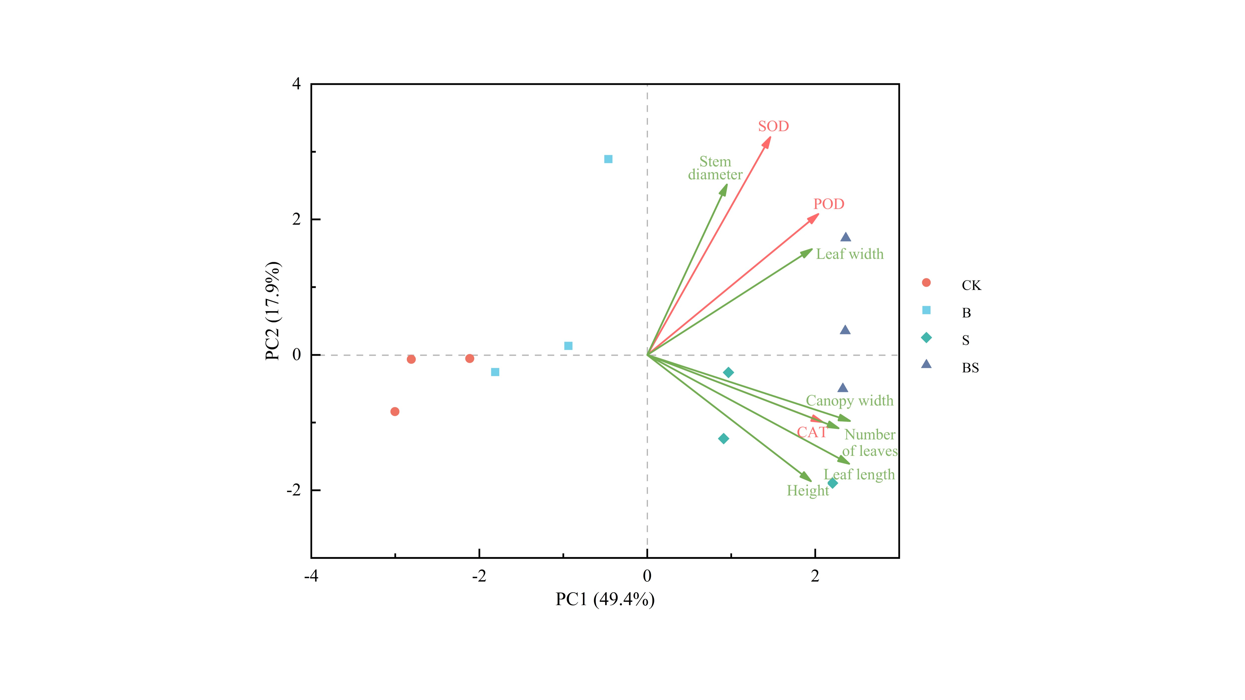

**Figure S5** PCA was analyzed for relationship between the pepper leaf antioxidant enzyme activities and plant morphological under straw and biochar application after two years of continuous cropping. SOD: Superoxide dismutase; POD: Peroxidase; CAT: Catalase.

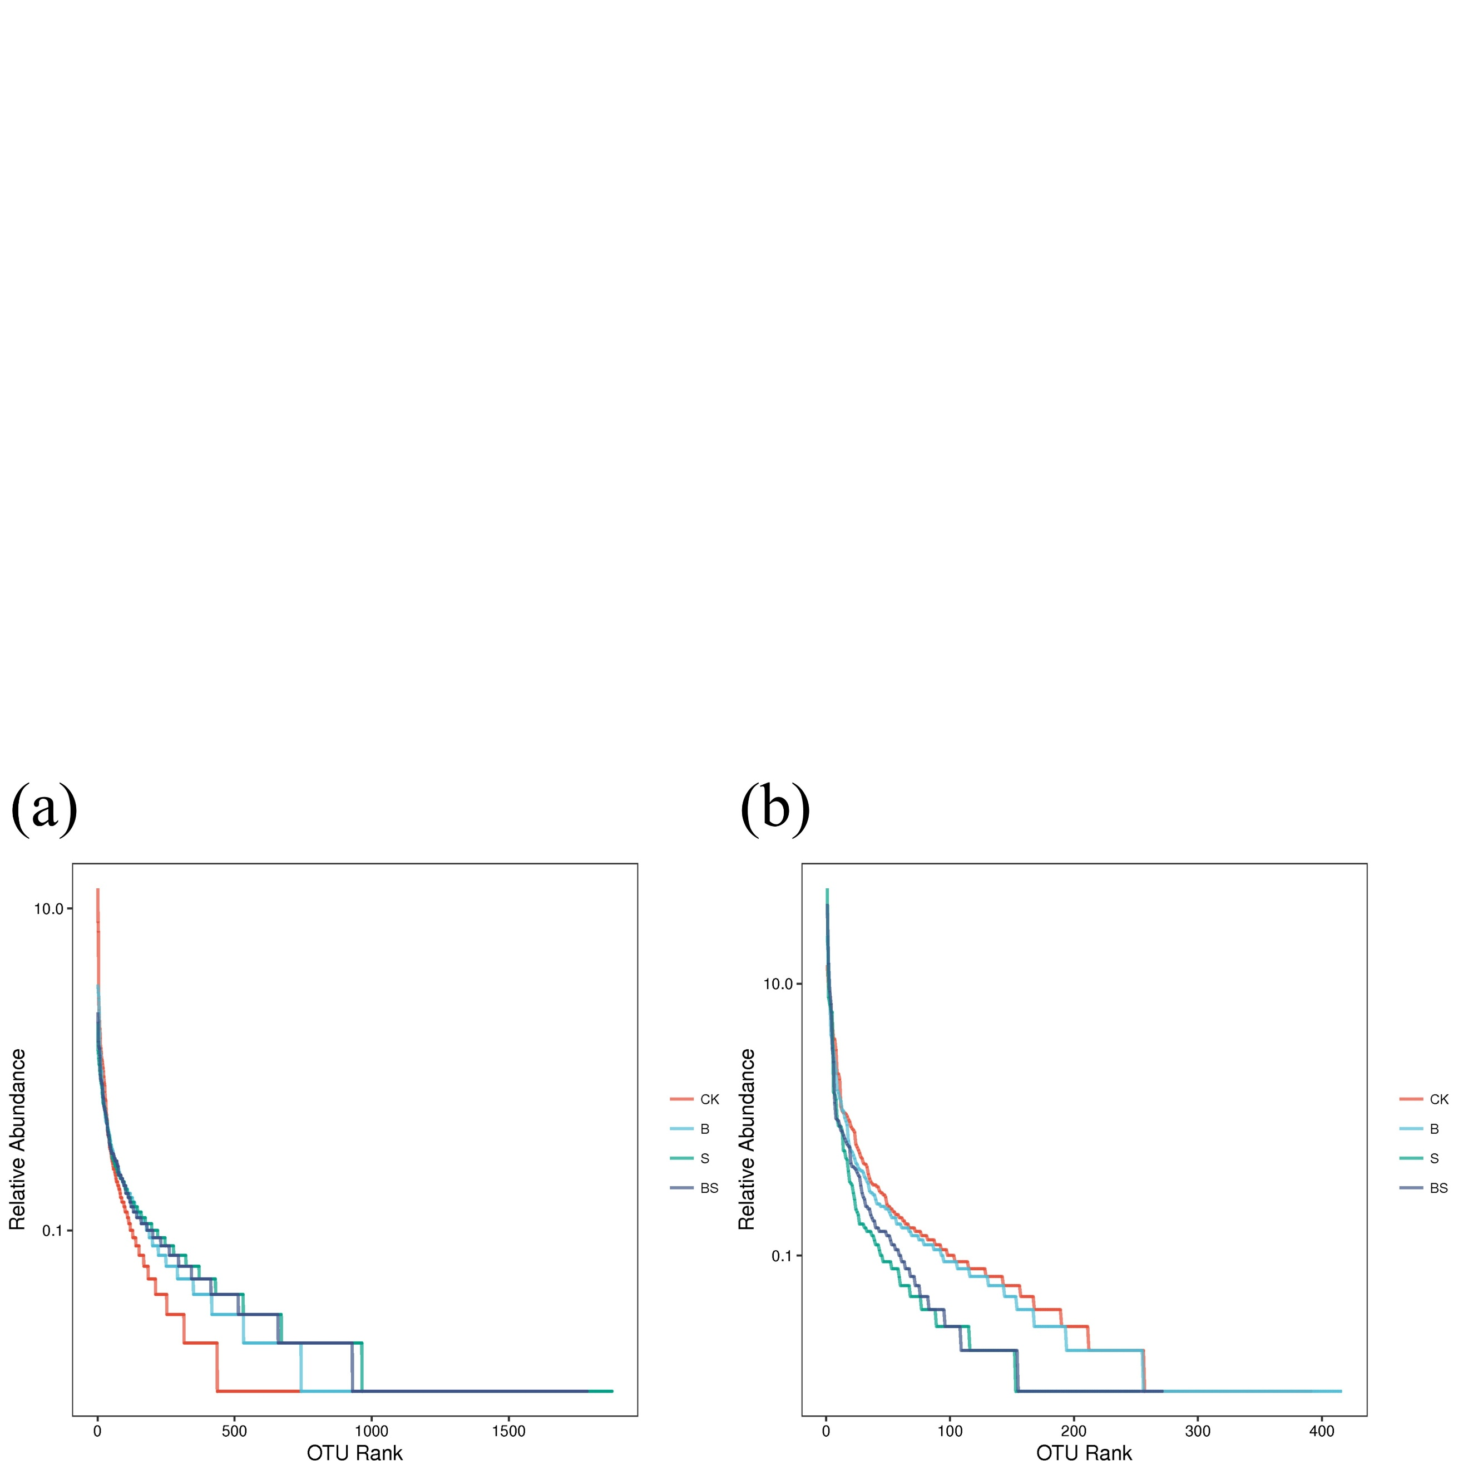

**Figure S6** Analysis of Rank-abundance curves of the rhizosphere soil bacteria (a) and fungi (b) under straw and its carbonization addition after two years of pepper continuous cropping.

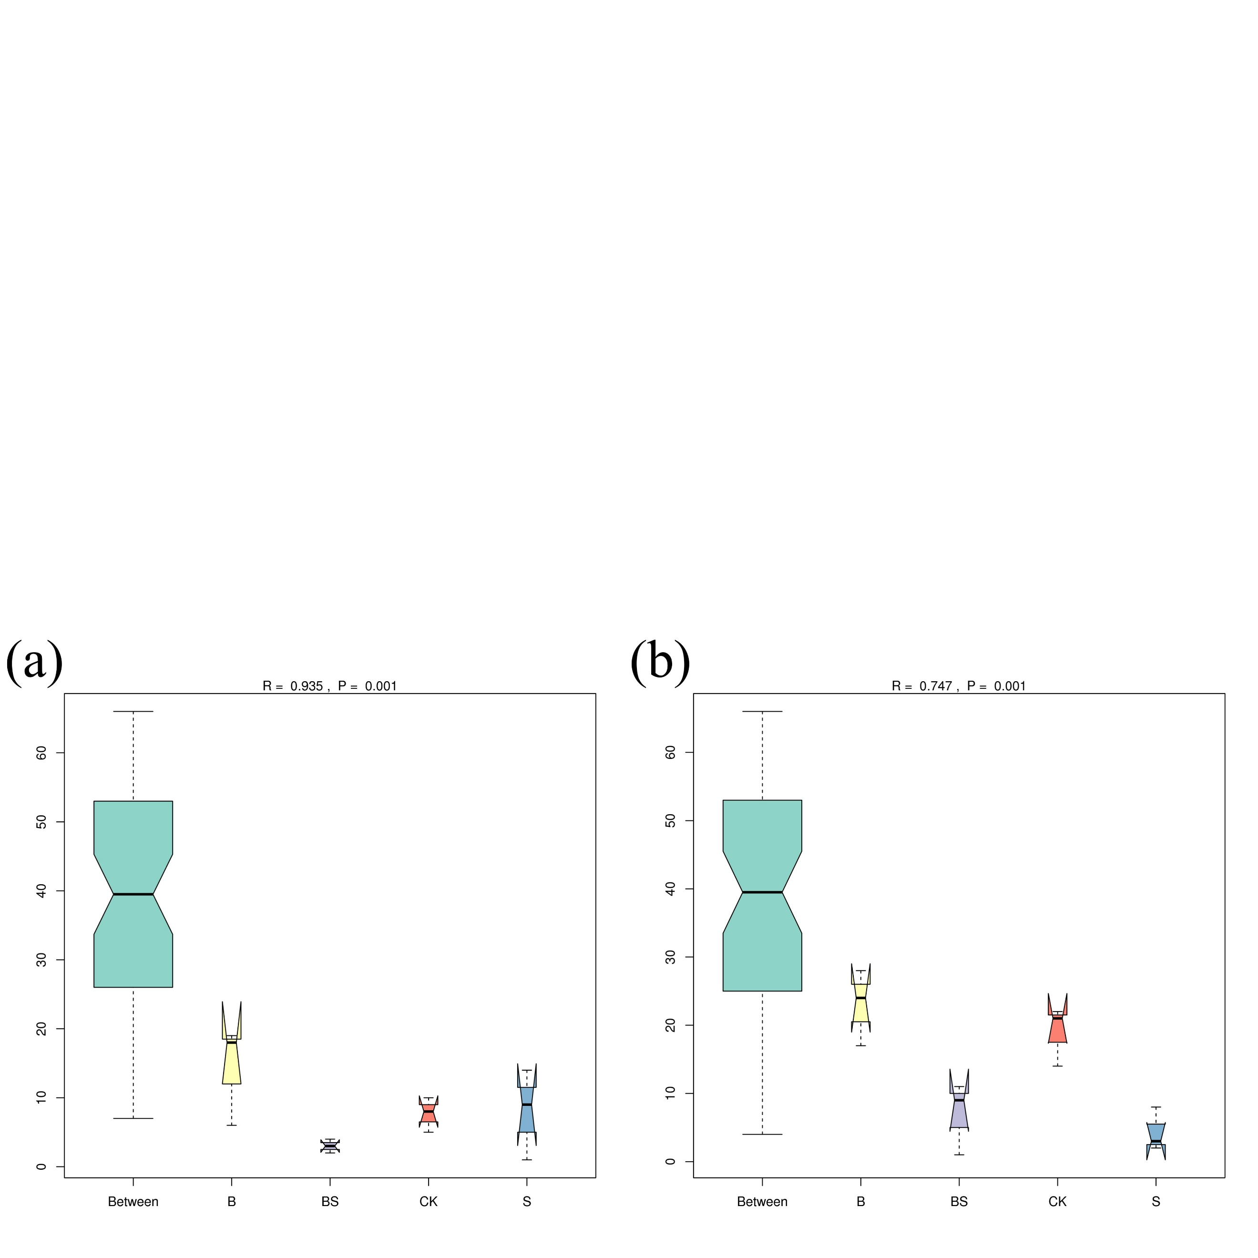

**Figure S7** Similarity analysis of the rhizosphere soil bacteria (a) and fungi (b) under straw and its carbonization addition after two years of pepper continuous cropping.

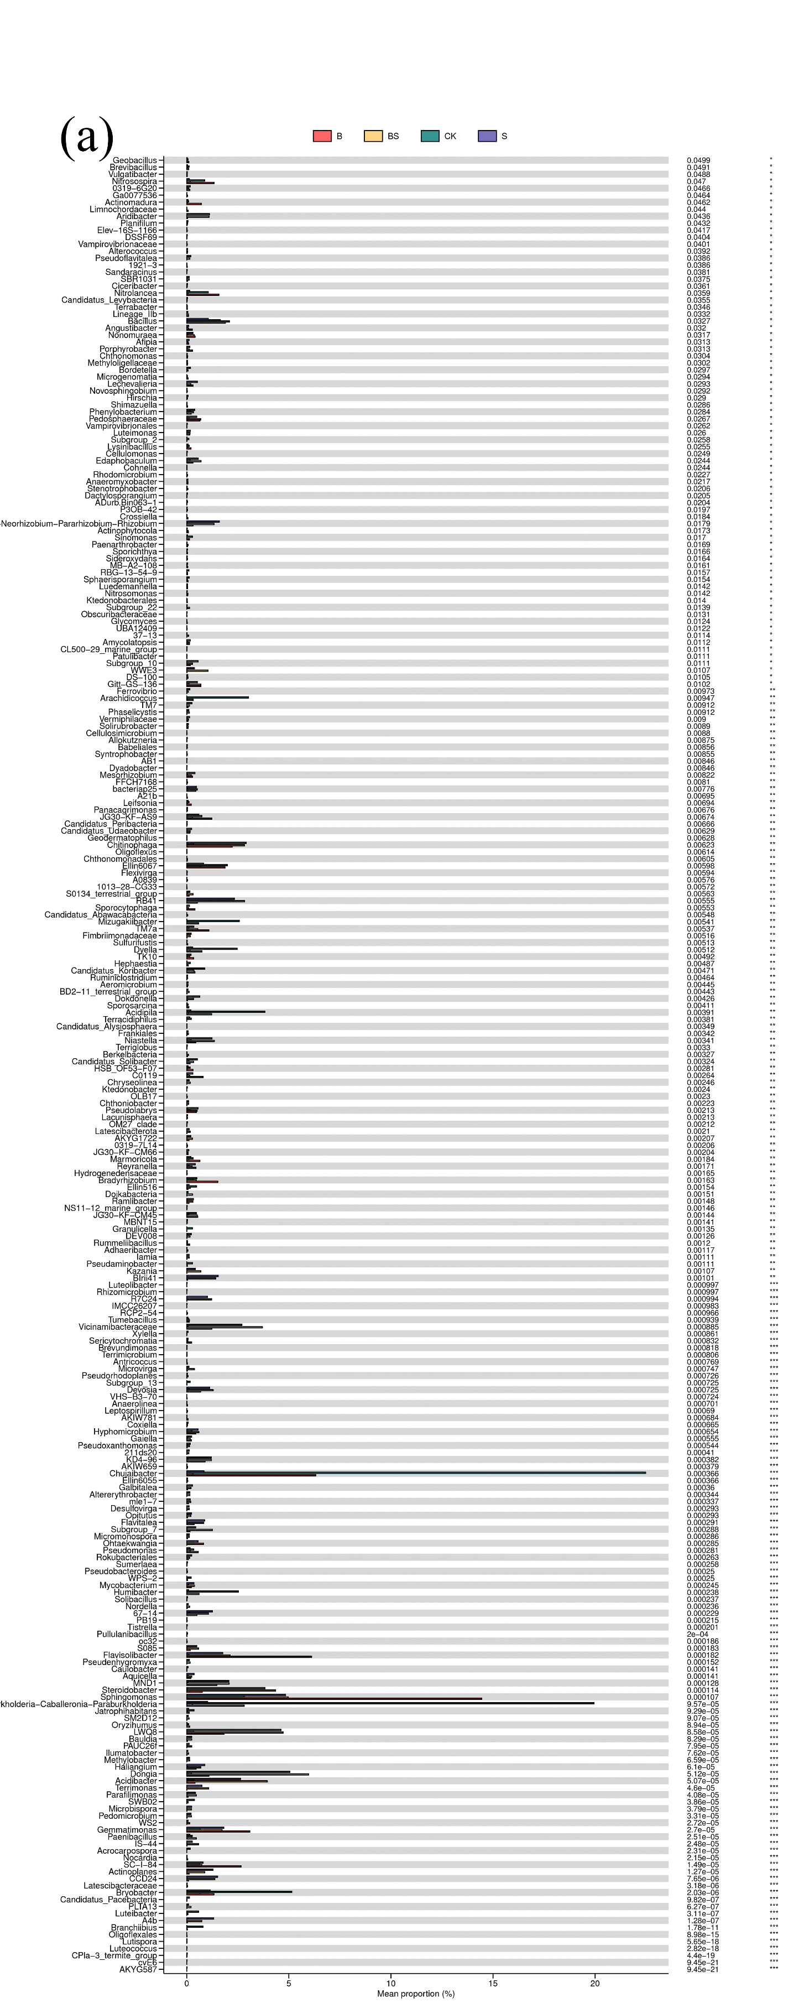

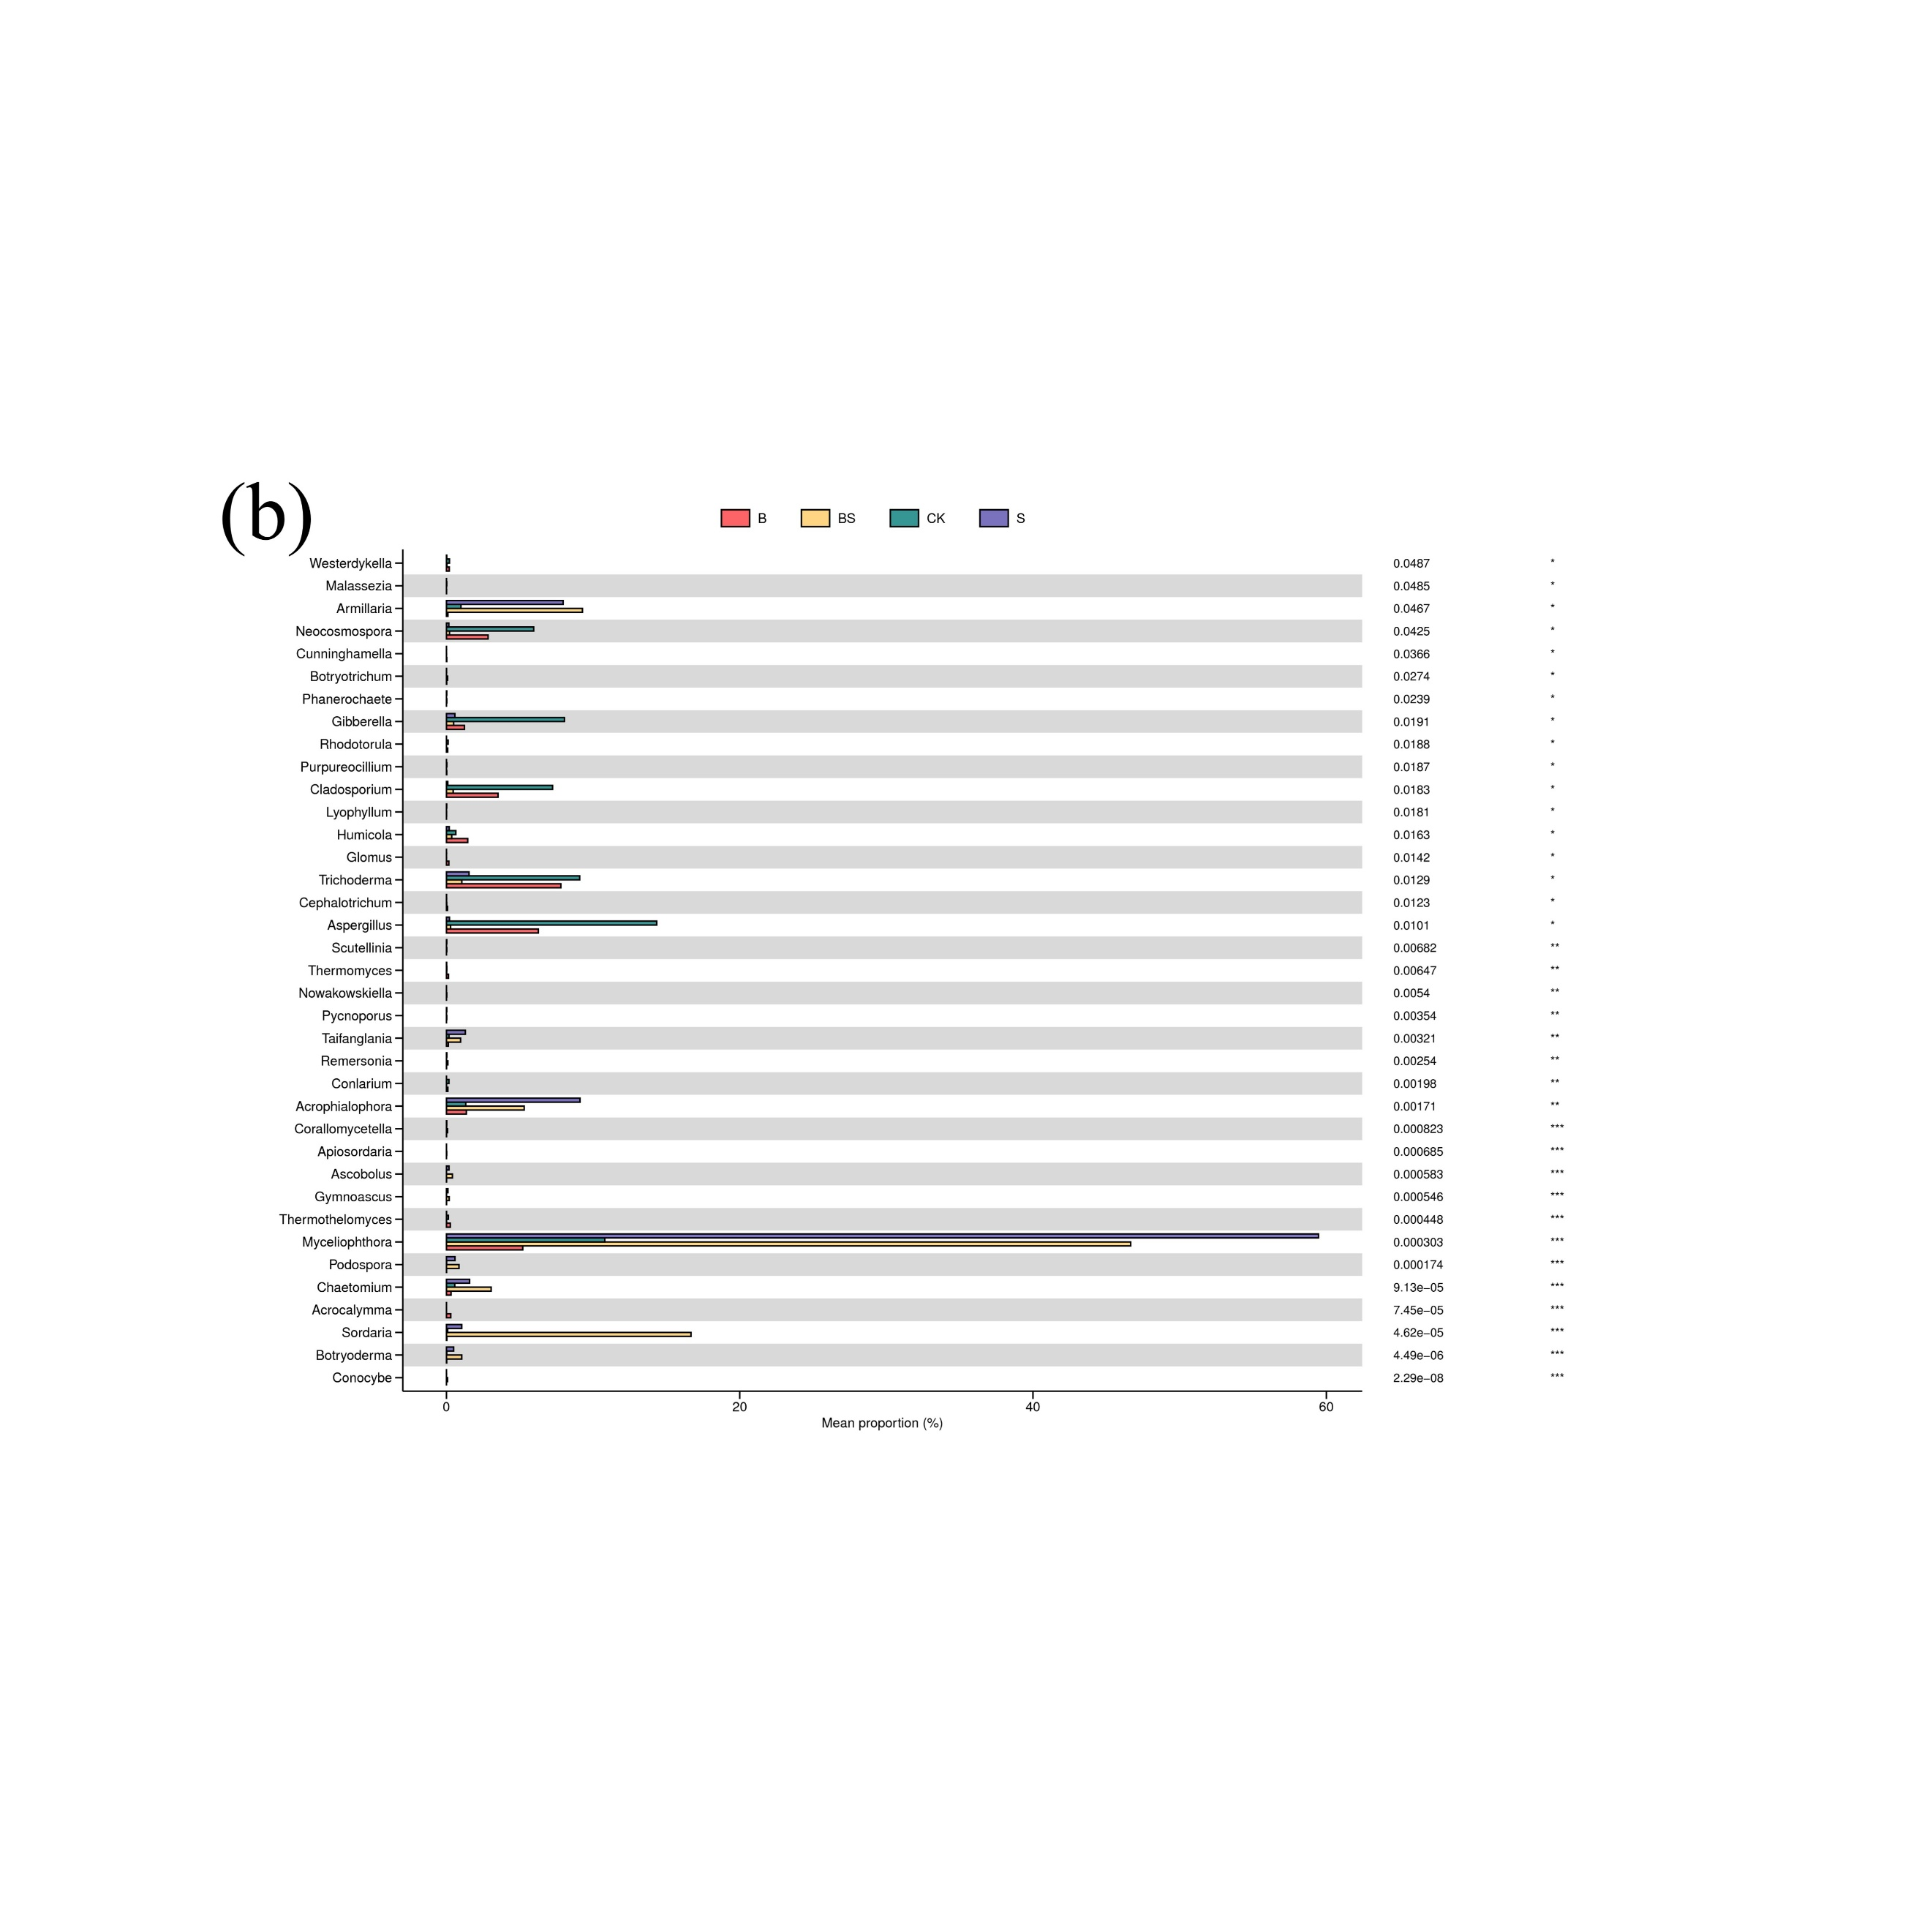

**Figure S8** Relative abundance of the rhizosphere soil bacteria (a) and fungi (b) groups at the genus level under straw and its carbonization addition after two years of pepper continuous cropping. The x axis represents the average relative abundance in different groups of species, and the columns of different colors represent different groups. Different lowercase letters indicate significant differences (ANOVA, Tukey’s HSD test; *p* < 0.05) among the three salinity gradients. On the far right is the P value: *, *p* < 0.05; **, *p* < 0.01; ***, *p* <0.001. NA, not available, indicates that the taxa cannot be detected in some groups.

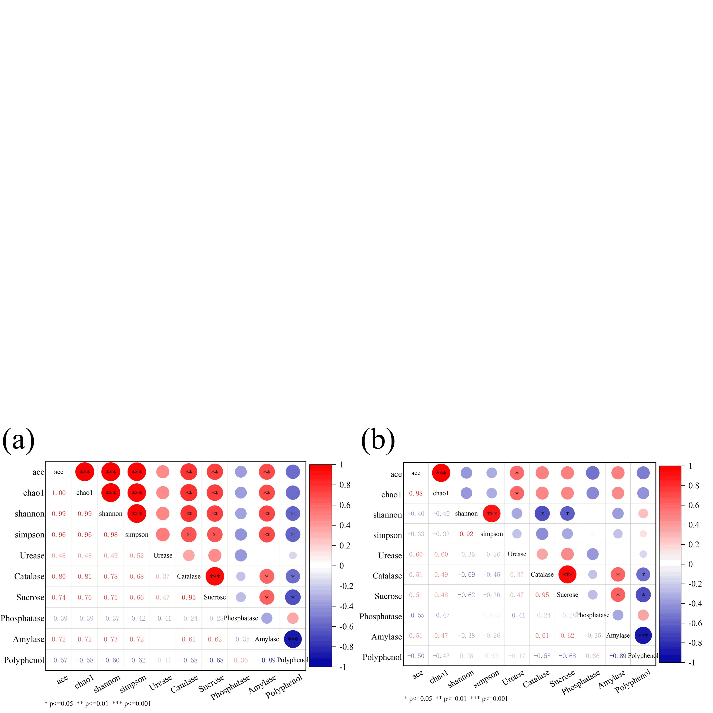

**Figure S9** Pearson correlation analysis of the rhizosphere soil microbial community diversity and soil enzyme activity. (a) rhizosphere bacteria; (b) rhizosphere fungi. Significance test *P* values less than 0.001 are labeled ***, *P* values between 0.01 and 0.001 are labeled **, and *P* values between 0.01 and 0.05 are labeled *.

**Table S1** 16S method: PCR amplification conditions

|  |  |  |  |  |  |  |
| --- | --- | --- | --- | --- | --- | --- |
| Reagent | Volume（μl） | First round  PCRprocedure | Cycle step | Temperature | Time | Cycles |
| gDNA | 17.5-X | Initial denaturation | 94℃ | 3 min | 1 |
| 10×TransStart Buffer | 2.5 | Denaturation | 94℃ | 10 sec | 14-16 cycles |
| dNTPs （2.5mM each） | 2 | Annealing | 57℃ | 90 sec |
| primer F | 2.5 | Extension | 72℃ | 15 sec |
| primer R | Final  Extension | 72℃ | 5 min | 1 |
| 2.5U/μL TransStart Taq | 0.5 | Hold | 4℃ | Forever | 1 |
| Reagent | Volume（μl） | Second round  PCRprocedure | Cycle step | Temperature | Time | Cycles |
| First round PCR roducts | 25 | Initial denaturation | 94℃ | 3 min | 1 |
| 10×Taq buffer | 2.5 | Denaturation | 94℃ | 10 sec | 10-12 cycles |
| dNTPs （2.5mM each） | 2 | Annealing | 60℃ | 30 sec |
| INDEX primer N | 3 | Extension | 72℃ | 15 sec |
| INDEX primer S | 3 | Final Extension | 72℃ | 5 min | 1 |
| 1xcocktail | 4 | Hold | 4℃ | Forever | 1 |
| 2.5U/μL TransStart Taq | 0.5 |  |  |  |  |
| To ddH2O | 50 |  |  |  |  |
| Library purification, QC | 27 |  |  |  |  |

**Table S2** ITS method: PCR amplification conditions

|  |  |  |  |  |  |  |
| --- | --- | --- | --- | --- | --- | --- |
| Reagent | Volume（μl） | first round  PCRprocedure | Cycle step | Temperature | Time | Cycles |
| gDNA | 36.5-X | Initial  Denaturation | 94℃ | 3 min | 1 |
| 10×TransStart Buffer | 5 | Denaturation | 94℃ | 30 sec | 10 cycles |
| dNTPs （2.5mM each） | 4 | Annealing | 51℃ | 30 sec |
| ITS2-F/Fn primer | 1/1 | Extension | 72℃ | 30 sec |
| ITS2-R/Rn primer | 1/1 | Denaturation | 94℃ | 30 sec | 14-18 cycles |
| 2.5U/μL TransStart Taq | 0.5 | Annealing | 53℃ | 30 sec |
| Reagent | Volume（μl） | Extension | 72℃ | 30 sec |
| first round PCR roducts | 50 | Final Extension | 72℃ | 5 min | 1 |
| 10XTaq buffer | 2.5 | Hold | 4℃ |  | 1 |
| dNTP | 2 | second round  PCRprocedure | Cycle step | Temperature | Time | Cycles |
| primerF | 3 | Initial Denaturation | 94℃ | 3 min | 1 |
| primerR | 3 | Denaturation | 94℃ | 10 sec | 10-12 cycles |
| 1xcocktail | 4 | Annealing | 60℃ | 30 sec |
| Taq enzyme | 0.5 | Extension | 72℃ | 15 sec |
| Total volume | 75 | Final Extension | 72℃ | 5 min | 1 |
| Library purification, QC | 40 | Hold | 4℃ |  | 1 |

**Table S3** Effects of straw and biochar application on Growth characteristics of pepper plants in facility continuous cropping

|  |  |  |  |  |  |  |  |  |  |
| --- | --- | --- | --- | --- | --- | --- | --- | --- | --- |
| Year | Rotations | Treatment | Height/(cm) | Stem diameter/(mm) | Leaf length/(mm) | Leaf width/(mm) | Number of leaves/(piece) | Canopy width/(cm) | SPAD |
| 2021 | Winter-spring stubble | CK | 42.84±8.42c | 5.37±1.58c | 50.36±8.58b | 23.78±8.24b | 38.06±6.92b | 32.39±24.71c | 50.54±6.83a |
| B | 48.53±6.51ab | 6.09±1.00b | 52.00±12.29ab | 25.02±9.10ab | 38.94±8.64ab | 34.66±26.42bc | 53.76±7.41a |
| S | 45.93±14.59bc | 6.53±1.43ab | 56.66±13.99a | 26.26±2.24ab | 39.50±8.95ab | 38.73±31.16ab | 52.77±7.01a |
| BS | 47.28±17.92a | 6.70±1.52a | 53.20±17.92ab | 28.36±2.17a | 40.89±9.91a | 40.97±33.43a | 55.61±7.85a |
| Autumn-winter stubble | CK | 46.38±9.85b | 7.02±1.22b | 85.09±5.62a | 36.78±2.16a | 49.60±5.76b | 42.68±10.27a | 56.00±5.76a |
| B | 54.26±9.39a | 8.69±2.10a | 88.23±5.27a | 38.15±2.16a | 47.16±5.27b | 44.04±12.32a | 56.29±5.04a |
| S | 47.57±12.91b | 7.15±1.64b | 83.55±8.20a | 37.51±2.87a | 54.76±6.67ab | 42.19±11.80a | 57.01±5.57a |
| BS | 47.57±12.04b | 7.24±1.62b | 83.55±3.02a | 38.20±1.04a | 70.83±10.40a | 44.18±12.53a | 56.32±7.12a |
| 2022 | Winter-spring stubble | CK | 61.49±23.22b | 8.45±3.28b | 91.29±12.89b | 41.97±3.83a | 79.54±10.66b | 51.80±24.98c | 57.31±3.76a |
| B | 62.33±24.08b | 8.51±3.69b | 92.59±14.17b | 42.40±5.90a | 79.63±17.50b | 53.13±28.23bc | 57.92±3.04a |
| S | 68.13±23.38a | 9.83±3.92a | 102.15±12.65a | 44.01±2.76a | 89.63±16.87ab | 59.20±24.61ab | 58.87±5.82a |
| BS | 66.81±25.34a | 10.10±4.19a | 101.08±13.95a | 43.02±3.61a | 98.51±19.68a | 62.37±29.85a | 59.23±4.39a |
| Autumn-winter stubble | CK | 48.77±6.84b | 8.13±1.19a | 86.24±12.44b | 34.51±4.25a | 63.47±17.46b | 31.93±9.30b | 50.45±3.48a |
| B | 43.13±6.24c | 8.31±2.18a | 88.22±10.33b | 38.14±3.41a | 65.14±14.44b | 34.70±11.17b | 54.46±6.66a |
| S | 55.47±8.38a | 9.08±0.55a | 94.53±9.78a | 40.00±2.45a | 74.54±17.48a | 44.40±14.34a | 53.94±7.48a |
| BS | 53.67±7.39a | 9.02±1.57a | 94.18±6.54a | 41.87±4.01a | 78.22±18.48a | 44.23±16.70a | 55.14±5.47a |

**Table S4** Effects of straw and biochar application on leaf chlorophyll content of pepper after two years of pepper continuous cropping

|  |  |  |  |  |  |  |
| --- | --- | --- | --- | --- | --- | --- |
| Samples | Chla/(mg·g-1FW) | Chlb/(mg·g-1FW) | Carotenoid/(mg·g-1FW) | Chla/Chlb | Total chlorophyll  /(mg·g-1FW) | Car/Chl(a+b)  /(mg·g-1FW) |
| CK | 2.80±0.05a | 1.31±0.10a | 0.41±0.06a | 2.15±0.11a | 4.12±0.15a | 0.10±0.01a |
| B | 3.27±0.25a | 1.51±0.44a | 0.56±0.08a | 2.30±0.73a | 4.79±0.20a | 0.12±0.02a |
| S | 2.56±0.98a | 0.91±0.31a | 0.48±0.22a | 2.78±0.23a | 3.46±1.29a | 0.13±0.02a |
| BS | 2.64±0.44a | 1.06±0.17a | 0.50±0.13a | 2.53±0.51a | 3.69±0.49a | 0.13±0.02a |

**Table S5** Effects of straw and biochar application on the soil enzyme activity of pepper in facility continuous cropping

|  |  |  |  |  |  |  |  |  |
| --- | --- | --- | --- | --- | --- | --- | --- | --- |
| Year | Rotations | Samples | Urease /[mg/ (g·d)-1] | Catalase  /(U) | Sucrose  /[mg/ (g·d)-1] | Acid phosphatase  /[mg/ (g·d)-1] | Amylase  /[mg/ (g·d)-1] | Polyphenol oxidase/[mg/ (g·d)-1] |
| 2021 | Winter-spring stubble | CK | 0.29±0.09c | 1.25±0.26b | 0.64±0.22b | 0.80±0.11c | 2.97±0.11a | 8.91±1.25a |
| B | 0.36±0.04c | 1.49±0.10b | 0.89±0.09ab | 1.45±0.05a | 3.17±0.06a | 8.29±1.67a |
| S | 0.53±0.05b | 2.03±0.06a | 1.03±0.08a | 0.76±0.13c | 3.39±0.19a | 3.20±0.46b |
| BS | 1.19±0.07a | 2.10±0.21a | 1.33±0.48a | 1.13±0.15b | 3.73±0.87a | 2.42±1.56b |
| Autumn-winter stubble | CK | 0.74±0.25c | 1.05±0.07b | 0.57±0.24b | 0.74±0.12c | 3.43±0.28b | 9.14±1.34a |
| B | 1.56±0.24b | 1.29±0.08b | 0.96±0.07b | 1.08±0.15a | 4.57±0.16b | 8.07±1.03a |
| S | 1.75±0.34b | 2.09±0.11b | 1.34±0.15ab | 0.94±0.25b | 5.18±0.25a | 4.51±1.42b |
| BS | 2.65±0.16a | 2.75±0.41a | 1.56±0.17a | 0.85±0.10ab | 6.17±0.65a | 3.04±2.01b |
| 2022 | Winter-spring stubble | CK | 1.83±0.42a | 0.76±0.07c | 0.43±0.07c | 2.15±0.50b | 3.68±1.23b | 9.42±1.04a |
| B | 2.44±0.35a | 0.82±0.04c | 0.72±0.14c | 2.75±0.45a | 5.65±0.88b | 6.41±2.14ab |
| S | 2.58±0.28a | 2.15±0.10b | 1.37±0.07b | 2.47±0.21ab | 7.22±1.45a | 6.08±1.07ab |
| BS | 3.15±0.48a | 2.64±0.05a | 2.14±0.04a | 1.96±0.24c | 8.24±1.27a | 3.41±0.09b |
| Autumn-winter stubble | CK | 2.64±0.61a | 0.53±0.06c | 0.40±0.18c | 3.41±0.82a | 3.86±2.16b | 9.50±2.00a |
| B | 3.32±0.52a | 0.56±0.21c | 0.58±0.17c | 2.36±0.57b | 7.88±2.12a | 5.90±2.17ab |
| S | 2.92±0.68a | 2.07±0.03b | 1.49±0.16b | 3.26±0.40a | 8.87±2.07a | 6.30±1.31ab |
| BS | 3.86±0.72a | 2.55±0.03a | 2.31±0.06a | 2.22±0.58b | 9.16±1.44a | 3.66±2.31b |

**Table S6** Alpha rarefaction of the rhizosphere soil under straw and biochar application after two years of pepper continuous cropping

|  |  |  |  |  |
| --- | --- | --- | --- | --- |
| Microorganism | Samples | Ace | Simpson | Goods_coverage |
| Bacteria | CK | 1668.82±157.75c | 0.96±0.01b | 0.99±0.01a |
| B | 2656.52±357.72b | 0.99±0.01a | 0.99±0.01b |
| S | 3246.46±52.91a | 1.00±0.01a | 0.99±0.01b |
| BS | 3180.78±0.85a | 1.00±0.01a | 0.99±0.01b |
| Fungi | CK | 467.91±86.03b | 0.92±0.04a | 1.00±0.01a |
| B | 573.48±29.35ab | 0.83±0.17a | 1.00±0.01b |
| S | 560.86±34.28ab | 0.72±0.09a | 1.00±0.01b |
| BS | 600.81±27.71a | 0.80±0.08a | 1.00±0.01b |

**Table S7** Effective sequence numbers for bacteria and fungi in the rhizosphere soil under straw and biochar application after two years of pepper continuous cropping

|  |  |  |  |  |  |
| --- | --- | --- | --- | --- | --- |
| Microorganism | Samples | #PE_reads | #Nochimera | AvgLen(bp) | GC(%) |
| Bacteria | CK | 65467±4382.58a | 54810±4034.21a | 455.07±0.80a | 55.54±0.12a |
| B | 80598±18329.94a | 67965±13290.61a | 450.29±0.81b | 55.42±0.45a |
| S | 74315±4971.90a | 63999±3924.51a | 450.46±0.48b | 55.17±0.13a |
| BS | 72626±2427.59a | 62389±2114.10a | 451.08±0.16b | 55.01±0.05a |
| Fungi | CK | 97432±2848.2b | 65838±13630.31b | 321.79±15.84b | 56.73±1.02a |
| B | 102921±1790.37a | 75281±10127.26ab | 338.49±11.46a | 54.6±5.74a |
| S | 101593±382.87a | 93487±3710.19a | 308.97±5.3b | 55±1.67a |
| BS | 101391±629.87a | 87156±2056.57a | 307.22±6.71b | 53.12±2.23a |

#PE_ Reads: The number of original PEreads; #Nochimera: number of effective sequences after removing chimeras; AvgLen (bp): The average length of the effective sequence; GC (%): The percentage content of GC in valid data.

**Table S8** Quantities of bacterial and fungal communities in the rhizosphere soil at different levels under straw and biochar application after two years of pepper continuous cropping

|  |  |  |  |  |  |  |  |  |
| --- | --- | --- | --- | --- | --- | --- | --- | --- |
| Microbial Community | Samples | Kingdom | Phylum | Classes | Orders | Families | Genera | Species |
| bacteria | CK | 2 | 24 | 60 | 136 | 193 | 324 | 337 |
| B | 2 | 29 | 79 | 172 | 246 | 423 | 457 |
| S | 3 | 32 | 88 | 200 | 302 | 511 | 534 |
| BS | 2 | 34 | 96 | 210 | 307 | 508 | 526 |
| fungi | CK | 2 | 9 | 24 | 39 | 69 | 90 | 137 |
| B | 2 | 9 | 26 | 42 | 76 | 103 | 155 |
| S | 2 | 9 | 23 | 37 | 63 | 85 | 134 |
| BS | 2 | 11 | 27 | 39 | 65 | 94 | 152 |

**Table S9** OTU taxonomy of the rhizosphere soil bacteria under straw and biochar application after two years of pepper continuous cropping

|  |  |
| --- | --- |
| OTU_ID | taxonomy |
| OTU21 | Bacteria, Actinobacteriota, Actinobacteria, Micrococcales, Microbacteriaceae, Humibacter |
| OTU16 | Bacteria, Proteobacteria, Gammaproteobacteria, Burkholderiales, Burkholderiaceae, Burkholderia-Caballeronia-Paraburkholderia |
| OTU1 | Bacteria, Proteobacteria, Gammaproteobacteria, Xanthomonadales, Rhodanobacteraceae, Chujaibacter, uncultured_bacterium |
| OTU25 | Bacteria, Acidobacteriota, Acidobacteriae, Acidobacteriales, Acidobacteriaceae_(Subgroup_1), Acidipila |
| OTU23 | Bacteria, Acidobacteriota, Acidobacteriae, Bryobacterales, Bryobacteraceae, Bryobacter |
| OTU2192 | Bacteria, Proteobacteria, Gammaproteobacteria, Xanthomonadales, Rhodanobacteraceae, Chujaibacter |
| OTU2 | Bacteria, Proteobacteria, Gammaproteobacteria, Burkholderiales, Burkholderiaceae, Burkholderia-Caballeronia-Paraburkholderia |
| OTU8 | Bacteria, Proteobacteria, Gammaproteobacteria, Burkholderiales, TRA3-20, TRA3-20, uncultured_bacterium |
| OTU38 | Bacteria, Acidobacteriota, Acidobacteriae, Bryobacterales, Bryobacteraceae, Bryobacter |
| OTU39 | Bacteria, Proteobacteria, Gammaproteobacteria, Xanthomonadales, Rhodanobacteraceae, Frateuria, Frateuria_terrea |
| OTU20 | Bacteria, Bacteroidota, Bacteroidia, Chitinophagales, Chitinophagaceae, Arachidicoccus, uncultured_bacterium |
| OTU15 | Bacteria, Actinobacteriota, Actinobacteria, Streptomycetales, Streptomycetaceae, Streptomyces |
| OTU34 | Bacteria, Bacteroidota, Bacteroidia, Chitinophagales, Chitinophagaceae, uncultured, uncultured_Sphingobacteriales |
| OTU4 | Bacteria, Proteobacteria, Alphaproteobacteria, Sphingomonadales, Sphingomonadaceae, Sphingomonas, uncultured_Sphingomonadaceae |
| OTU2424 | Bacteria, Proteobacteria, Alphaproteobacteria, Sphingomonadales, Sphingomonadaceae, Sphingomonas, uncultured_Sphingomonadaceae |
| OTU27 | Bacteria, Proteobacteria, Gammaproteobacteria, Steroidobacterales, Steroidobacteraceae, Steroidobacter, uncultured_bacterium |
| OTU13 | Bacteria, Patescibacteria, Saccharimonadia, Saccharimonadales, LWQ8, LWQ8 |
| OTU10 | Bacteria, Proteobacteria, Gammaproteobacteria, Steroidobacterales, Steroidobacteraceae, Steroidobacter |
| OTU12 | Bacteria, Chloroflexi, Ktedonobacteria, Ktedonobacterales, Ktedonobacteraceae, 1959-1, uncultured_bacterium |
| OTU5 | Bacteria, Proteobacteria, Alphaproteobacteria, Dongiales, Dongiaceae, Dongia, uncultured_Rhodospirillales |
| OTU14 | Bacteria, Bacteroidota, Bacteroidia, Cytophagales, Microscillaceae, uncultured |
| OTU59 | Bacteria, Acidobacteriota, Blastocatellia, Pyrinomonadales, Pyrinomonadaceae, RB41, uncultured_Acidobacteriaceae |
| OTU32 | Bacteria, Proteobacteria, Alphaproteobacteria, Dongiales, Dongiaceae, Dongia, uncultured_bacterium |
| OTU18 | Bacteria, Proteobacteria, Alphaproteobacteria, Dongiales, Dongiaceae, Dongia |
| OTU11 | Bacteria, Bacteroidota, Bacteroidia, Chitinophagales, Chitinophagaceae, Flavisolibacter |
| OTU494 | Bacteria, Proteobacteria, Alphaproteobacteria, Sphingomonadales, Sphingomonadaceae, Sphingomonas, uncultured_Sphingomonadaceae |
| OTU9 | Bacteria, Proteobacteria, Alphaproteobacteria, Sphingomonadales, Sphingomonadaceae, Sphingomonas |
| OTU29 | Bacteria, Bacteroidota, Bacteroidia, Cytophagales, Microscillaceae, uncultured, uncultured_Cytophagia |
| OTU3 | Bacteria, Gemmatimonadota, Gemmatimonadetes, Gemmatimonadales, Gemmatimonadaceae, uncultured |
| OTU7 | Bacteria, Bacteroidota, Bacteroidia, Chitinophagales, Chitinophagaceae, Chitinophaga |

**Table S10** OTU taxonomy of the rhizosphere soil fungi under straw and biochar application after two years of pepper continuous cropping.

|  |  |
| --- | --- |
| OTU_ID | taxonomy |
| OTU5 | Fungi, Chytridiomycota, Spizellomycetes, Spizellomycetales, Spizellomycetaceae, Spizellomyces, Spizellomyces_dolichospermus |
| OTU38 | Fungi, Ascomycota, Sordariomycetes, Sordariales, Sordariaceae, Neurospora, Neurospora_sp |
| OTU18 | Fungi, unidentified, unidentified, unidentified, unidentified, unidentified, Fungi_sp |
| OTU6 | Fungi, Basidiomycota, Agaricomycetes, Agaricales, Physalacriaceae, Armillaria, Armillaria_mellea |
| OTU3 | Fungi, unidentified, unidentified, unidentified, unidentified, unidentified, Fungi_sp |
| OTU139 | Fungi, Basidiomycota, Agaricomycetes, Polyporales, Irpicaceae, Gloeoporus, Gloeoporus_sp |
| OTU4 | Fungi, Ascomycota, Sordariomycetes, Sordariales, Sordariaceae, Sordaria, Sordaria_conoidea |
| OTU23 | Fungi, Ascomycota, Sordariomycetes, Sordariales, Chaetomiaceae, Chaetomium, Chaetomium_globosum |
| OTU24 | Fungi, Ascomycota, Sordariomycetes, Sordariales, Chaetomiaceae, Myceliophthora, Myceliophthora_verrucosa |
| OTU115 | Fungi, Ascomycota, Sordariomycetes, Sordariales, Chaetomiaceae, unidentified, Chaetomiaceae_sp |
| OTU9 | Fungi, Ascomycota, Sordariomycetes, Sordariales, Chaetomiaceae, Acrophialophora, Acrophialophora_major |
| OTU1049 | Fungi, Ascomycota, Sordariomycetes, Sordariales, Chaetomiaceae, Acrophialophora, Acrophialophora_sp |
| OTU1 | Fungi, Ascomycota, Sordariomycetes, Sordariales, Chaetomiaceae, Myceliophthora, Myceliophthora_verrucosa |
| OTU44 | Fungi, Ascomycota, Sordariomycetes, Sordariales, unidentified, unidentified, Sordariales_sp |
| OTU7 | Fungi, Ascomycota, unidentified, unidentified, unidentified, unidentified, Ascomycota_sp |
| OTU20 | Fungi, Chytridiomycota, Spizellomycetes, Spizellomycetales, Spizellomycetaceae, Spizellomyces, Spizellomyces_dolichospermus |
| OTU37 | Fungi, Chytridiomycota, Spizellomycetes, Spizellomycetales, Spizellomycetaceae, Spizellomyces, Spizellomyces_dolichospermus |
| OTU10 | Fungi, Ascomycota, Eurotiomycetes, Eurotiales, Aspergillaceae, Aspergillus, Aspergillus_fumigatus |
| OTU13 | Fungi, Ascomycota, Sordariomycetes, Hypocreales, Nectriaceae, Neocosmospora, Neocosmospora_sp |
| OTU16 | Fungi, Ascomycota, Dothideomycetes, Capnodiales, Cladosporiaceae, Cladosporium, Cladosporium_tenuissimum |
| OTU15 | Fungi, Ascomycota, Sordariomycetes, Hypocreales, Nectriaceae, Gibberella, Gibberella_fujikuroi |
| OTU21 | Fungi, Ascomycota, Dothideomycetes, Venturiales, Venturiaceae, Venturia, Venturia_sp |
| OTU8 | Fungi, Ascomycota, Eurotiomycetes, Eurotiales, Aspergillaceae, Aspergillus, Aspergillus_niger |
| OTU14 | Fungi, Ascomycota, Dothideomycetes, Capnodiales, Cladosporiaceae, Cladosporium, Cladosporium_sphaerospermum |
| OTU19 | Fungi, Ascomycota, Sordariomycetes, Sordariales, Chaetomiaceae, Humicola, Humicola_fuscoatra |
| OTU12 | Fungi, Ascomycota, Sordariomycetes, Hypocreales, Nectriaceae, Fusarium, Fusarium_oxysporum |
| OTU11 | Fungi, Ascomycota, Eurotiomycetes, Onygenales, Onygenales_fam_Incertae_sedis, Chrysosporium, Chrysosporium_sp |
| OTU17 | Fungi, Ascomycota, Sordariomycetes, Hypocreales, Nectriaceae, Gibberella, Gibberella_fujikuroi |
| OTU2 | Fungi, Ascomycota, Sordariomycetes, Xylariales, Hyponectriaceae, Monographella, Monographella_nivalis |
| OTU22 | Fungi, unidentified, unidentified, unidentified, unidentified, unidentified, Fungi_sp |