Supplementary materials

Table S1. Quality assessment of included studies
Figure S1. Funnel plot of pooled prevalence of poor sleep quality in Parkinson’s disease patients
Figure S2. Sensitivity analysis of pooled prevalence of poor sleep quality in Parkinson’s disease patients

Table S1. Quality assessment of included studies
Authors and citation No. | Target population is clearly defined? | probability sampling OR entire population surveyed | Is the response rate ≥80% | Are non-responders clearly described? | Do the characteristics of respondents match the target population? | Were data collection methods standardized? | Were validated criteria used to diagnose poor sleep quality？ | Are the prevalence estimates given with confidence intervals and detailed by subgroups (if applicable)? | Total scores
Ma and Ren ⁷⁶ | 1 | 0 | 0 | 0 | 1 | 1 | 1 | 1 | 5
Chen, Zhang, Zhou, Yang and Feng ⁷⁷ | 1 | 0 | 0 | 0 | 1 | 1 | 1 | 0 | 4
Chen, Hu, Han, Zhang and Zhang ⁷⁸ | 1 | 0 | 0 | 0 | 1 | 1 | 1 | 0 | 4
Chen, Hong and Chen ⁷⁹ | 1 | 0 | 0 | 0 | 1 | 1 | 1 | 0 | 4
Guo, Yu, Zuo, Liu, Li, Pu, Hu, Lian, Wang, Yu, Jin, Zhu and Zhang ⁸⁰ | 1 | 0 | 0 | 0 | 1 | 1 | 1 | 0 | 4
Guo ⁸¹ | 1 | 0 | 0 | 0 | 1 | 1 | 1 | 0 | 4
Yuan, Hu, Zhao, Wang, Zhang and Li ⁸² | 1 | 0 | 0 | 0 | 1 | 1 | 1 | 0 | 4
Xue ⁸³ | 1 | 0 | 0 | 0 | 1 | 1 | 1 | 0 | 4
Hu and Zhang ⁸⁴ | 1 | 0 | 0 | 0 | 1 | 1 | 1 | 0 | 4
Cheng, Yu and Wu ⁸⁵ | 1 | 0 | 0 | 0 | 1 | 1 | 1 | 0 | 4
Wang, Feng, Gu, Liu and Chen ⁸⁶ | 1 | 0 | 0 | 0 | 1 | 1 | 1 | 1 | 5
Wang, Feng, Gu, Liu, Zhang and Chen ⁸⁷ | 1 | 0 | 0 | 0 | 1 | 1 | 1 | 1 | 5
Wang and Wang ⁸⁸ | 1 | 0 | 0 | 0 | 1 | 1 | 1 | 1 | 5
Wang, Sun, Ma, Shi, Li, Huang, Hu and Zheng ⁸⁹ | 1 | 0 | 0 | 0 | 1 | 1 | 1 | 0 | 4
Mao and Zhang ⁹⁰ | 1 | 0 | 0 | 0 | 1 | 1 | 1 | 0 | 4
Mao, Dai and Liu ⁹¹ | 1 | 0 | 0 | 0 | 1 | 1 | 1 | 0 | 4
Mao and Saimaiti ⁹² | 1 | 0 | 0 | 0 | 1 | 0 | 1 | 0 | 3
Liang, Cui, Wu, Yu and Chen ⁹³ | 1 | 0 | 0 | 0 | 1 | 1 | 1 | 0 | 4
Zhu, Zheng and Yang ⁹⁴ | 1 | 0 | 0 | 0 | 1 | 1 | 1 | 1 | 5
Cao, Liu, Ma, Chen, Ren, Zhang and Xu ⁹⁵ | 1 | 0 | 0 | 0 | 1 | 1 | 1 | 0 | 4
Cao, Yu, Su and Guo ⁹⁶ | 1 | 0 | 0 | 0 | 1 | 1 | 1 | 0 | 4
Zhang, Gao and Wei ⁹⁷ | 1 | 0 | 0 | 0 | 1 | 1 | 1 | 0 | 4
Zhang, Zhang, Zhu, Jiang and Wu ⁹⁸ | 1 | 0 | 0 | 0 | 1 | 1 | 1 | 0 | 4
Zhang, Liu, Wang, Liu and Gu ⁹⁹ | 1 | 0 | 0 | 0 | 1 | 1 | 1 | 1 | 5

Table S1. Quality assessment of included studies. (continued)
Authors and publication year | Target population is clearly defined? | probability sampling OR entire population surveyed | Is the response rate ≥80% | Are non-responders clearly described? | Do the characteristics of respondents match the target population? | Were data collection methods standardized? | Were validated criteria used to diagnose poor sleep quality？ | Are the prevalence estimates given with confidence intervals and detailed by subgroups (if applicable)? | Total scores
Zhang, Luo and Liao ¹⁰⁰ | 1 | 0 | 0 | 0 | 1 | 1 | 1 | 0 | 4
Cui, Qing, Liu and Chen ¹⁰¹ | 1 | 0 | 0 | 0 | 1 | 1 | 1 | 1 | 5
song, Zhao, Li and Yin ¹⁰² | 1 | 0 | 0 | 0 | 1 | 1 | 1 | 0 | 4
Song, Sun, Ma, Lu, Fan, Wang, Wang and Wang ¹⁰³ | 1 | 0 | 0 | 0 | 1 | 1 | 1 | 1 | 5
Sun, Gao, Mo and Gong ¹⁰⁴ | 1 | 0 | 0 | 0 | 1 | 1 | 1 | 0 | 4
Lv, Wang, Zhu, Zhao and Guo ¹⁸ | 1 | 0 | 0 | 0 | 1 | 1 | 1 | 1 | 5
Lu ¹⁰⁵ | 1 | 0 | 0 | 0 | 1 | 1 | 1 | 0 | 4
Liu and Chen ¹⁰⁶ | 1 | 0 | 0 | 0 | 1 | 1 | 1 | 0 | 4
Liu, Li, Fang, Qin and Wei ¹⁰⁷ | 1 | 0 | 0 | 0 | 1 | 1 | 1 | 0 | 4
Liu, Chou, Ma, Zhang, Wang and Gu ¹⁰⁸ | 1 | 0 | 0 | 0 | 1 | 1 | 1 | 1 | 5
Liu, Wang, Wang, Mao and Wang ¹⁰⁹ | 1 | 0 | 0 | 0 | 1 | 1 | 1 | 0 | 4
YU, PENG, LUO, HUANG and WANG ¹¹⁰ | 1 | 0 | 0 | 0 | 1 | 1 | 1 | 0 | 4
Yi, Yu-Peng, Jiang-Ting, Jing-Yi, Qi-Xiong, Dan-Lei, Jing-Wei, Zhi-Juan, Yong-Jie, Zhe and Zheng ¹¹¹ | 1 | 0 | 0 | 1 | 1 | 1 | 1 | 0 | 5
Wang, Xiong, Chao, Zhuang, Li and Liu ¹¹² | 1 | 0 | 0 | 0 | 1 | 1 | 1 | 1 | 5
Tang, Yang, Zhu, Gong, Sun, Chen, Guan, Yu, Wang, Zhang, Li, Ma and Wang ¹¹³ | 1 | 0 | 0 | 0 | 1 | 1 | 1 | 1 | 5
Song, Gu, An and Chan ¹¹⁴ | 1 | 0 | 0 | 0 | 1 | 1 | 1 | 0 | 4
Shulman, Taback, Bean and Weiner ¹¹⁵ | 1 | 0 | 1 | 1 | 1 | 1 | 1 | 0 | 6

Authors and publication year | Target population is clearly defined? | probability sampling OR entire population surveyed | Is the response rate ≥80% | Are non-responders clearly described? | Do the characteristics of respondents match the target population? | Were data collection methods standardized? | Were validated criteria used to diagnose poor sleep quality？ | Are the prevalence estimates given with confidence intervals and detailed by subgroups (if applicable)? | Total scores
Santos García, Cabo López, Labandeira Guerra, Yáñez Baña, Cimas Hernando, Paz González, Alonso Losada, Gonzalez Palmás, Cores Bartolomé and Martínez Miró ¹⁹ | 1 | 0 | 0 | 0 | 1 | 1 | 1 | 0 | 4
Sahebzadeh, Farsi Baf and Homam ¹¹⁶ | 1 | 1 | 0 | 0 | 1 | 1 | 1 | 1 | 6
Qiu, Gu, Liu and Li ¹¹⁷ | 1 | 0 | 0 | 0 | 1 | 1 | 1 | 0 | 4
Qin, Li, Chen, Chen, Shi, Liu, Li, Xin and Gao ¹¹⁸ | 1 | 0 | 0 | 0 | 1 | 1 | 1 | 0 | 4
Pandey, Bajaj, Wadhwa and Anand ¹⁷ | 1 | 0 | 0 | 0 | 1 | 1 | 1 | 0 | 4
Mahale, Yadav and Pal ¹¹⁹ | 1 | 0 | 0 | 0 | 1 | 1 | 1 | 0 | 4
Louter, van der Marck, Pevernagie, Munneke, Bloem and Overeem ¹²⁰ | 1 | 0 | 0 | 0 | 1 | 1 | 1 | 0 | 4
Lin, Chen, Lu, Huang, Weng, Yeh, Lin and Hung ¹²¹ | 1 | 0 | 0 | 0 | 1 | 1 | 1 | 1 | 5
Havlikova, van Dijk, Nagyova, Rosenberger, Middel, Dubayova, Gdovinova and Groothoff ¹²² | 1 | 0 | 1 | 0 | 1 | 1 | 1 | 0 | 5
Gao, Huang, Cai and Li ¹²³ | 1 | 0 | 0 | 0 | 1 | 1 | 1 | 0 | 4
Duncan, Khoo, Yarnall, O'Brien, Coleman, Brooks, Barker and Burn ¹²⁴ | 1 | 0 | 0 | 0 | 1 | 1 | 1 | 0 | 4
Ding, Zhu, Lu, Shen, Dai and Zhu ¹²⁵ | 1 | 0 | 0 | 0 | 1 | 1 | 1 | 0 | 4
Shafazand, Wallace, Arheart, Vargas, Luca, Moore, Katzen, Levin and Singer ¹²⁶ | 1 | 0 | 0 | 0 | 1 | 1 | 1 | 0 | 4
Table S1. Quality assessment of included studies. (continued)

Table S1. Quality assessment of included studies. (continued)
Authors and publication year | Target population is clearly defined? | probability sampling OR entire population surveyed | Is the response rate ≥80% | Are non-responders clearly described? | Do the characteristics of respondents match the target population? | Were data collection methods standardized? | Were validated criteria used to diagnose poor sleep quality？ | Are the prevalence estimates given with confidence intervals and detailed by subgroups (if applicable)? | Total scores
Skorvanek, Nagyova, Rosenberger, Krokavcova, Saeedian, Groothoff, Gdovinova and van Dijk ¹²⁷ | 1 | 0 | 0 | 0 | 1 | 1 | 1 | 0 | 4
Shi, Guan, Gao, Huang and Wang ¹²⁸ | 1 | 0 | 0 | 0 | 1 | 1 | 1 | 0 | 4
Dong and Tan ¹²⁹ | 1 | 0 | 0 | 0 | 1 | 1 | 1 | 0 | 4
Chang, Fan, Chang and Wu ¹³⁰ | 1 | 0 | 0 | 0 | 1 | 1 | 1 | 0 | 4
Shi ¹³¹ | 1 | 0 | 0 | 0 | 1 | 1 | 1 | 0 | 4
Li, Yuan, Ye, Yuan, Gao and Hu ¹³² | 1 | 0 | 0 | 0 | 1 | 1 | 1 | 0 | 4
Gui, Wang, Wu and Sun ¹³³ | 1 | 0 | 0 | 0 | 1 | 1 | 1 | 0 | 4
Hu, Sun, Lan, Wang, Li and Zhong ¹³⁴ | 1 | 0 | 0 | 0 | 1 | 1 | 1 | 0 | 4
Niu and Gou ¹³⁵ | 1 | 0 | 0 | 0 | 1 | 1 | 1 | 0 | 4

Figure S1. Funnel plot of pooled prevalence of poor sleep quality in Parkinson’s disease patients
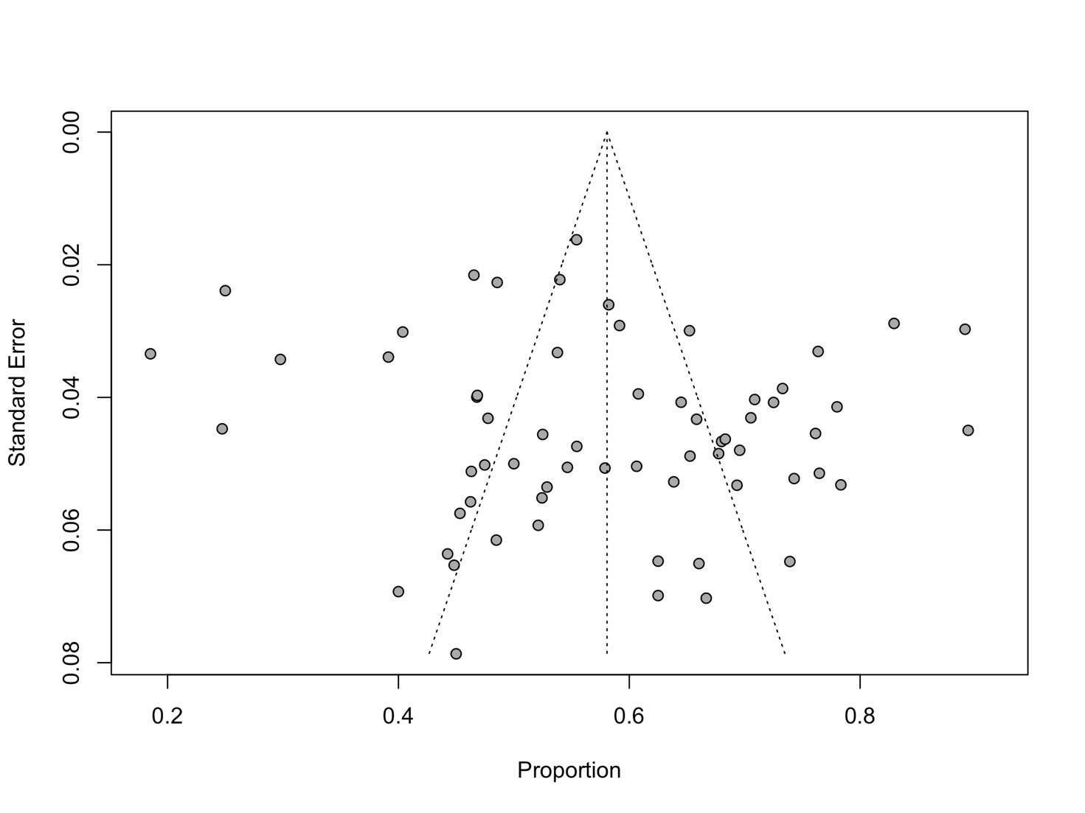
Funnel plot of pooled prevalence of poor sleep quality from 63 included studies (Egger’s test t = 1.42, P= 0.1608)

Figure S2. Sensitivity analysis of pooled prevalence of poor sleep quality in Parkinson’s disease patients
