Supplementary Material

# Supplementary Figures

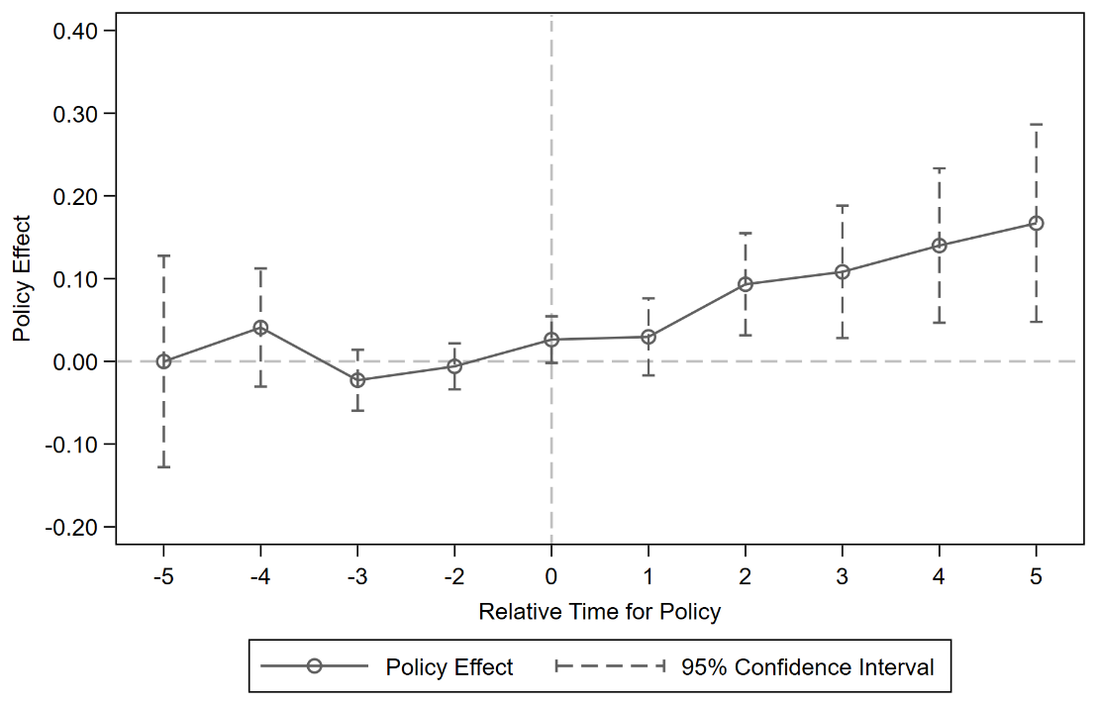

Figure 1. Parallel trend test.

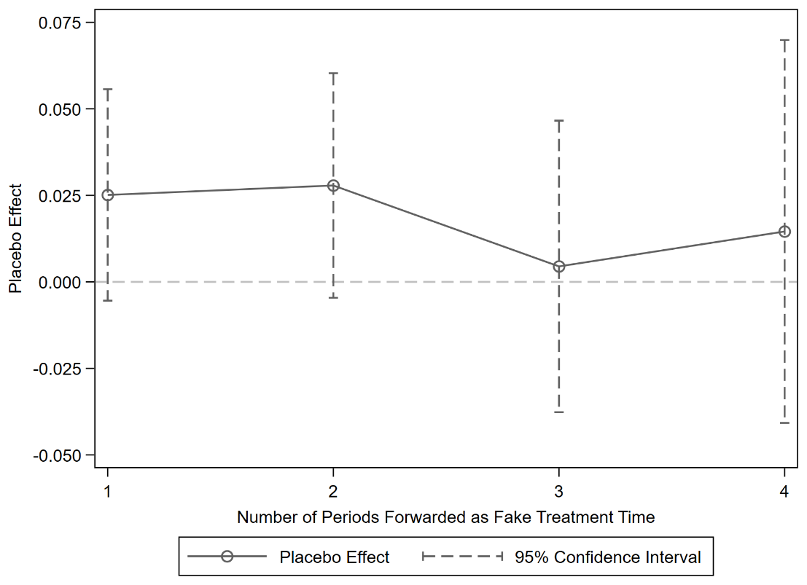

Figure 2. Time placebo test.

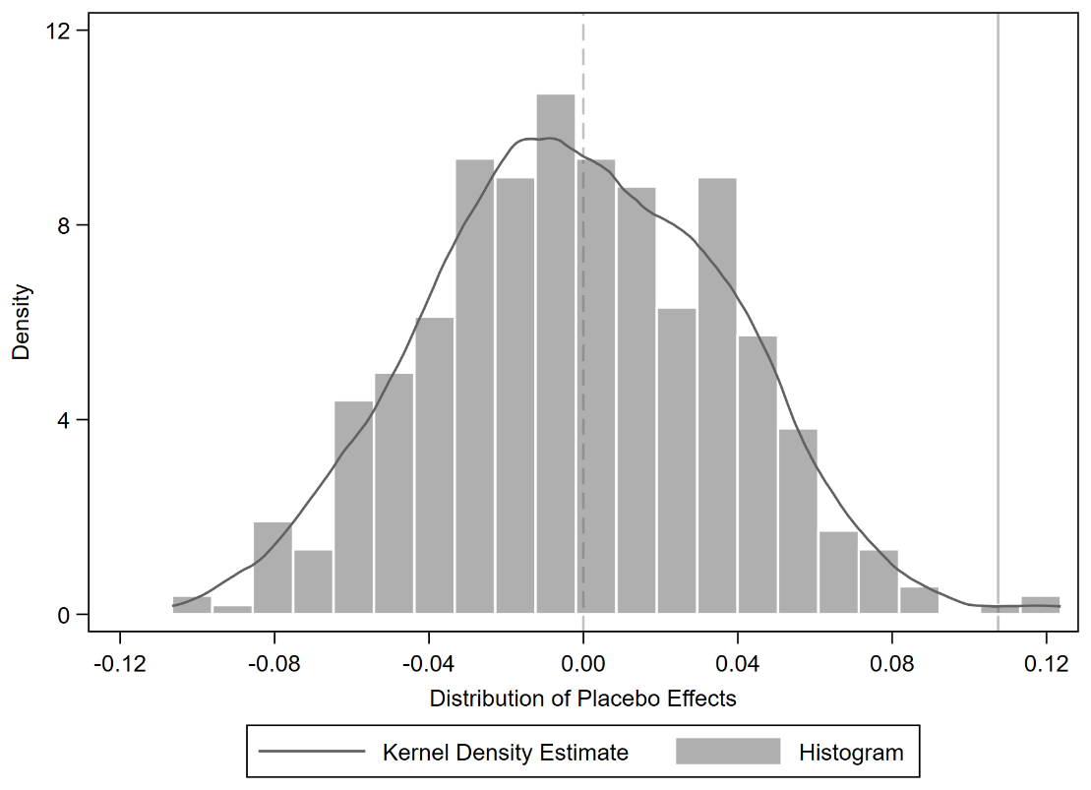

Figure 3. Spatial placebo test.

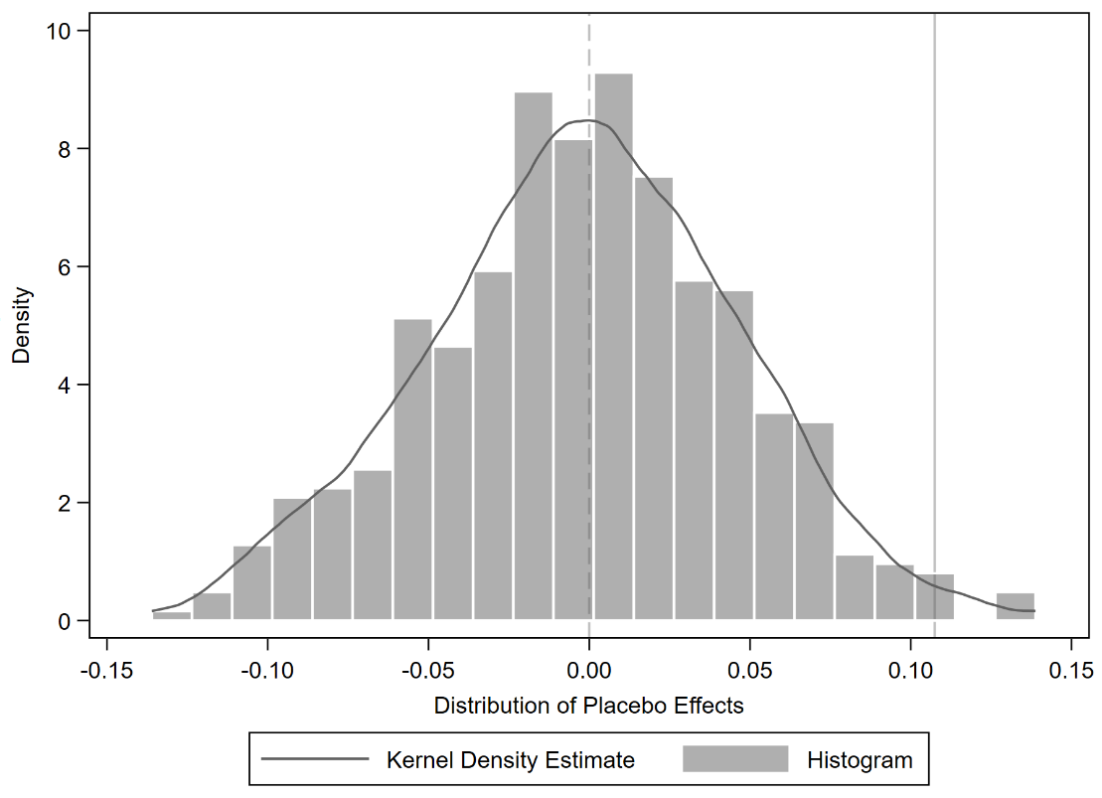

Figure 4. Mixed placebo test.

# Supplementary Tables

Table 1. Evaluation index system of AGTFP.

|  |  |  |  |
| --- | --- | --- | --- |
| **Type** | **Indicator** | **Definition** | **Unit** |
| Input indicators | Land | Total sown area of crops | 1000 hectares |
| Labor force | Number of employees in agricultural industry | 10,000 persons |
| Agricultural machinery | Total power of agricultural machinery | 10,000 kilowatts |
| Chemical fertilizer | Pure amount of agricultural chemical fertilizer application | 10,000 tons |
| Water | Effective irrigation area | 1000 hectares |
| Output indicators | Desired outputs | Agricultural economic value | 100 million CNY |
| Agricultural ecological value | 100 million CNY |
| Undesired outputs | Agricultural carbon emissions | 10,000 tons |
| Agricultural non-point source pollution | 100 million cubic meters |

Table 2. Descriptive statistics of variables.

|  |  |  |  |  |  |
| --- | --- | --- | --- | --- | --- |
| **Variables** | **Obs** | **Mean** | **Std.Dev.** | **Min** | **Max** |
| AGTFP | 3718 | 1.6462 | 0.6125 | 0.2124 | 6.8208 |
| DE | 3718 | 0.2598 | 0.4386 | 0.0000 | 1.0000 |
| GTI | 3718 | 4.6893 | 1.7418 | 0.0000 | 10.0116 |
| ER | 3718 | 0.9904 | 0.2785 | 0.3331 | 3.0866 |
| FD | 3718 | 0.2078 | 0.0550 | 0.0924 | 0.5648 |
| IND | 3718 | 0.4301 | 0.1155 | 0.1139 | 0.9771 |
| AFE | 3718 | 0.1220 | 0.0464 | 0.0125 | 0.3828 |
| FDI | 3718 | 1.4442 | 1.5726 | 0.0008 | 12.0992 |
| HCS | 3718 | 4.7754 | 0.9717 | 0.5666 | 7.1328 |
| PI | 3718 | 0.4153 | 0.2042 | 0.0125 | 1.9884 |
| LI | 3718 | 1.1242 | 0.5332 | 0.0615 | 2.8293 |

Table 3. Results of baseline model.

|  |  |  |  |  |  |  |
| --- | --- | --- | --- | --- | --- | --- |
| **Variables** | **(1)** | **(2)** | **(3)** | **(4)** | **(5)** | **(6)** |
| DE | 0.1070**  (0.0417) | 0.1075***  (0.0392) | 0.1058***  (0.0393) | 0.1074***  (0.0393) | 0.1061***  (0.0387) | 0.1043***  (0.0389) |
| IND |  | 0.2181  (0.2316) | 0.2113  (0.2339) | 0.2181  (0.2315) | 0.2084  (0.2290) | 0.2007  (0.2314) |
| AFE |  | -0.7328  (0.5493) | -0.7165  (0.5483) | -0.7360  (0.5378) | -0.7290  (0.5457) | -0.7114  (0.5329) |
| FDI |  | 0.0333***  (0.0076) | 0.0333***  (0.0076) | 0.0333***  (0.0077) | 0.0348***  (0.0076) | 0.0347***  (0.0077) |
| HCS |  | 0.0653  (0.0454) | 0.0657  (0.0454) | 0.0652  (0.0455) | 0.0676  (0.0458) | 0.0680  (0.0458) |
| PI |  | 0.2450  (0.1676) | 0.2433  (0.1674) | 0.2430  (0.1710) | 0.2470  (0.1683) | 0.2448  (0.1715) |
| LI |  | -0.2549***  (0.0908) | -0.2549***  (0.0911) | -0.2550***  (0.0908) | -0.2496***  (0.0898) | -0.2496***  (0.0901) |
| SmartCity |  |  | 0.0256  (0.0319) |  |  | 0.0285  (0.0318) |
| NBDCEZs |  |  |  | -0.0035  (0.0537) |  | -0.0006  (0.0535) |
| NASTPs |  |  |  |  | -0.0696*  (0.0360) | -0.0703*  (0.0360) |
| Constant | 1.0000***  (0.0179) | 0.7763***  (0.2648) | 0.7771***  (0.2650) | 0.7780***  (0.2638) | 0.7746***  (0.2645) | 0.7758***  (0.2634) |
| City FE | YES | YES | YES | YES | YES | YES |
| Year FE | YES | YES | YES | YES | YES | YES |
| N | 3718 | 3718 | 3718 | 3718 | 3718 | 3718 |
| R2 | 0.7319 | 0.7395 | 0.7396 | 0.7395 | 0.7406 | 0.7407 |

Notes: The robust standard errors of clustering at the city level are reported in parentheses; *, **, and *** represent significance at the 10%, 5%, and 1% levels, respectively.

Table 4. Results of Goodman-Beacon decomposition.

|  |  |  |
| --- | --- | --- |
| **DD Comparison** | **Avg DD Est** | **Weight** |
| Earlier Treatment vs. Later Comparison | 0.077 | 0.022 |
| Later Treatment vs. Earlier Comparison | -0.050 | 0.057 |
| Treatment vs. Never Treated | 0.118 | 0.920 |

Table 5. Results of instrumental variable test.

|  |  |  |
| --- | --- | --- |
| **Variables** | **（1）** | **(2)** |
| **DE** | **AGTFP** |
| DE |  | 0.6444**  (0.2596) |
| IV | 0.0026***  (0.0005) |  |
| Constant | -0.0946  (0.2137) | 0.5271*  (0.2870) |
| Control Variables | YES | YES |
| City FE | YES | YES |
| Year FE | YES | YES |
| Kleibergen-Paap rk LM statistic | 17.83***  (0.0000) |  |
| Cragg-Donald Wald F statistic | 137.85 |  |
| Kleibergen-Paap rk Wald F statistic | 22.50 |  |
| N | 3718 | 3718 |
| R2 | 0.3707 | 0.6873 |

Notes: *, **, and *** represent significance at the 10%, 5%, and 1% levels, respectively.

Table 6. Results of PSM-DID.

|  |  |  |  |
| --- | --- | --- | --- |
| **Variables** | **(1)** | **(2)** | **(3)** |
| **Nearest Neighbor Match** | **Radius Match** | **Kernel Match** |
| DE | 0.1038***  (0.0387) | 0.1075***  (0.0392) | 0.1068***  (0.0392) |
| Constant | 0.9858***  (0.3182) | 0.7763***  (0.2648) | 0.7486***  (0.2698) |
| Control Variables | YES | YES | YES |
| City FE | YES | YES | YES |
| Year FE | YES | YES | YES |
| N | 2880 | 3718 | 3704 |
| R2 | 0.7464 | 0.7395 | 0.7389 |

Notes: The robust standard errors of clustering at the city level are reported in parentheses; *** represent significance at the 1% levels.

Table 7. Results of other robustness tests.

|  |  |  |  |  |  |
| --- | --- | --- | --- | --- | --- |
| **Variables** | **(1)** | **(2)** | **(3)** | **(4)** | **(5)** |
| **Intensity DID** | **Lag Treatment of Independent Variable** | **Exclude Certain City Samples** | **1% Bilateral Winsorization** | **Controlling for Province-Year Fixed Effect** |
| DE | 0.4534***  (0.1458) |  | 0.0793*  (0.0436) | 0.1005***  (0.036) | 0.1311***  (0.0341) |
| L2.DE |  | 0.1078**  (0.0430) |  |  |  |
| Constant | 0.7293***  (0.2645) | 0.7478**  (0.3075) | 0.7127***  (0.2735) | 0.6791**  (0.3074) | 0.4645  (0.3026) |
| Control Variables | YES | YES | YES | YES | YES |
| City FE | YES | YES | YES | YES | YES |
| Year FE | YES | YES | YES | YES | YES |
| Province*Year FE | NO | NO | NO | NO | YES |
| N | 3718 | 3146 | 3263 | 3718 | 3718 |
| R2 | 0.7411 | 0.7039 | 0.7336 | 0.7796 | 0.8170 |

Notes: The robust standard errors of clustering at the city level are reported in parentheses; ** and *** represent significance at the 5% and 1% levels, respectively.

Table 8. Results of mechanism test.

|  |  |  |  |  |  |  |  |
| --- | --- | --- | --- | --- | --- | --- | --- |
| **Variables** | **(1)** | **(2)** | **(3)** | **(4)** | **(5)** | **(6)** | **(7)** |
| **AGTFP** | **GTI** | **AGTFP** | **ER** | **AGTFP** | **FD** | **AGTFP** |
| DE | 0.1075***  (0.0392) | 0.1422***  (0.0524) | 0.0989**  (0.0393) | 0.0568**  (0.0221) | 0.1038***  (0.0393) | 0.0746***  (0.0030) | 0.0516  (0.0557) |
| GTI |  |  | 0.0600***  (0.0214) |  |  |  |  |
| ER |  |  |  |  | 0.0636**  (0.0281) |  |  |
| FD |  |  |  |  |  |  | 0.7491*  (0.4269) |
| Constant | 0.7763***  (0.2648) | 2.4793***  (0.4025) | 0.6275**  (0.2696) | 0.6446***  (0.1415) | 0.7353***  (0.2669) | 0.2652***  (0.0193) | 0.5776*  (0.3076) |
| Control Variables | YES | YES | YES | YES | YES | YES | YES |
| City FE | YES | YES | YES | YES | YES | YES | YES |
| Year FE | YES | YES | YES | YES | YES | YES | YES |
| Sobel Test |  | 0.009***  (0.002) | | 0.004**  (0.002) | | 0.056***  (0.018) | |
| Bootstrap Test |  | (0.0030, 0.0141) | | (0.0003, 0.0070) | | (0.0136, 0.0981) | |
| N | 3718 | 3718 | 3718 | 3718 | 3718 | 3718 | 3718 |
| R2 | 0.7395 | 0.8222 | 0.7412 | 0.0832 | 0.7402 | 0.6819 | 0.7403 |

Notes: The robust standard errors of clustering at the city level are reported in parentheses; ** and *** represent significance at the 5% and 1% levels, respectively; Bootstrap Test reports the confidence interval at the 95% level.

Table 9. Results of heterogeneity test for natural geographical factors.

|  |  |  |  |  |  |  |  |
| --- | --- | --- | --- | --- | --- | --- | --- |
| **Variables** | **Natural Geographical Locations** | | | **Precipitation Distributions** | | **Terrain Relief Degrees** | |
| **(1)** | **(2)** | **(3)** | **(4)** | **(5)** | **(6)** | **(7)** |
| **Eastern** | **Central** | **Western** | **Humid Areas** | **Non-Humid Areas** | **High** | **Low** |
| DE | 0.1544**  (0.0606) | 0.0915*  (0.0543) | 0.0583  (0.0833) | 0.0836  (0.0510) | 0.1383**  (0.0570) | 0.1026*  (0.0572) | 0.1118**  (0.0533) |
| Constant | 0.6207  (0.5570) | 1.465***  (0.4013) | 0.7013**  (0.3505) | 0.8966**  (0.4201) | 0.6153**  (0.3094) | 0.9589***  (0.2919) | 0.7216  (0.5886) |
| Control Variables | YES | YES | YES | YES | YES | YES | YES |
| City FE | YES | YES | YES | YES | YES | YES | YES |
| Year FE | YES | YES | YES | YES | YES | YES | YES |
| N | 1313 | 1287 | 1118 | 2340 | 1378 | 1859 | 1859 |
| R2 | 0.8016 | 0.6910 | 0.7667 | 0.7194 | 0.7966 | 0.7625 | 0.7249 |

Notes: The robust standard errors of clustering at the city level are reported in parentheses; *, **, and *** represent significance at the 10%, 5%, and 1% levels, respectively.

Table 10. Results of heterogeneity test for socio-economic factors.

|  |  |  |  |  |  |  |
| --- | --- | --- | --- | --- | --- | --- |
| **Variables** | **Agricultural Functional Zones** | | **Digitalization Levels** | | **Financial Literacy Levels** | |
| **(1)** | **(2)** | **(3)** | **(4)** | **(5)** | **(6)** |
| **Main Grain-Producing Areas** | **Non-Main Grain-Producing Areas** | **High** | **Low** | **High** | **Low** |
| DE | 0.0882**  (0.0393) | 0.1995***  (0.0740) | 0.0870*  (0.0482) | 0.0837  (0.0695) | 0.1403***  (0.0465) | 0.0479  (0.0646) |
| Constant | 1.1861***  (0.3232) | 0.4384  (0.3867) | 0.8400**  (0.4039) | 0.5780  (0.3594) | 0.5201  (0.7660) | 0.5934*  (0.3331) |
| Control Variables | YES | YES | YES | YES | YES | YES |
| City FE | YES | YES | YES | YES | YES | YES |
| Year FE | YES | YES | YES | YES | YES | YES |
| N | 2210 | 1508 | 1859 | 1859 | 1859 | 1859 |
| R2 | 0.7286 | 0.7941 | 0.8035 | 0.6837 | 0.7921 | 0.6821 |

Notes: The robust standard errors of clustering at the city level are reported in parentheses; * and ** represent significance at the 10% and 5% levels, respectively.

Table 11. Results of spatial autocorrelation test.

|  |  |  |
| --- | --- | --- |
| **Year** | ***W*1** | ***W*2** |
| 2012 | 0.1008*** | 0.1608*** |
| 2013 | 0.1398*** | 0.1705*** |
| 2014 | 0.1508*** | 0.1734*** |
| 2015 | 0.1310*** | 0.1552*** |
| 2016 | 0.0827*** | 0.1138*** |
| 2017 | 0.0420*** | 0.0597* |
| 2018 | 0.1135*** | 0.1558*** |
| 2019 | 0.1209*** | 0.1688*** |
| 2020 | 0.1271*** | 0.1654*** |
| 2021 | 0.1125*** | 0.1634*** |
| 2022 | 0.1482*** | 0.1476*** |
| 2023 | 0.1458*** | 0.1477*** |

Notes: * and *** represent significance at the 10% and 1% levels, respectively.

Table 12. Results of adaptability test for spatial econometrics model.

|  |  |  |
| --- | --- | --- |
| **Test** | ***W*1** | ***W*2** |
| LM_Lag | 2411.266*** | 6880.890*** |
| Robust LM_Lag | 887.985*** | 1340.878*** |
| LM_Error | 160.337*** | 5779.219*** |
| Robust LM_Error | 117.056*** | 239.207*** |
| Hausman | 27.62*** | 31.33*** |
| Wald_Lag | 18.15*** | 23.83*** |
| Wald_Error | 17.43*** | 19.23*** |
| LR_Lag | 12.23* | 25.35*** |
| LR_Error | 17.84** | 22.94*** |
| LR_SDM_Ind | 44.38*** | 379.52*** |
| LR_SDM_Time | 2652.94*** | 2607.75*** |

Notes: *, **, and *** represent significance at the 10%, 5%, and 1% levels, respectively.

Table 13. Results of SDID model.

|  |  |  |
| --- | --- | --- |
| **Variables** | ***W*1** | ***W*2** |
| DE | 0.1110***  (0.0364) | 0.0957**  (0.0375) |
| W*DE | 0.0602*  (0.0325) | 0.0448*  (0.0242) |
| Rho | 0.6414***  (0.0637) | 0.2670***  (0.0411) |
| Direct Effect | 0.1075***  (0.0396) | 0.1005***  (0.0384) |
| Indirect Effect | 0.0988*  (0.0594) | 0.0886**  (0.0444) |
| Total Effect | 0.2063*  (0.1191) | 0.1891*  (0.1029) |
| Proportion of Indirect Effect | 0.4789 | 0.4688 |
| Control Variables | YES | YES |
| City FE | YES | YES |
| Year FE | YES | YES |
| N | 3718 | 3718 |
| R2 | 0.3906 | 0.2499 |

Notes: The robust standard errors of clustering at the city level are reported in parentheses; *, **, and *** represent significance at the 10%, 5%, and 1% levels, respectively.

Table 14. Results of robustness tests for SDID model.

|  |  |  |  |  |  |
| --- | --- | --- | --- | --- | --- |
| **Variables** | **Exclude Certain City Samples** | | **1% Bilateral Winsorization** | | **Replace the Spatial Weight Matrix** |
| **(1)** | **(2)** | **(3)** | **(4)** | **(5)** |
| ***W*1** | ***W*2** | ***W*1** | ***W*2** | ***W*3** |
| DE | 0.0877**  (0.0418) | 0.0702*  (0.0418) | 0.1034***  (0.0331) | 0.0879**  (0.0344) | 0.1163***  (0.0367) |
| W*DE | 0.0478*  (0.0284) | 0.0353**  (0.0179) | 0.0577**  (0.0285) | 0.0373*  (0.0203) | 0.0341*  (0.0192) |
| Rho | 0.6032***  (0.0720) | 0.2711***  (0.0464) | 0.6811***  (0.0612) | 0.2866***  (0.0457) | 0.3208***  (0.0613) |
| Direct Effect | 0.0794*  (0.0450) | 0.0770*  (0.0433) | 0.1012***  (0.0364) | 0.0924***  (0.0354) | 0.1154***  (0.0396) |
| Indirect Effect | 0.0519**  (0.0226) | 0.0436**  (0.0222) | 0.0934*  (0.0502) | 0.0805*  (0.0444) | 0.0848*  (0.0497) |
| Total Effect | 0.1312**  (0.0619) | 0.1205*  (0.0722) | 0.1946*  (0.1131) | 0.1729*  (0.0998) | 0.1992**  (0.0994) |
| Proportion of Indirect Effect | 0.3953 | 0.3616 | 0.4800 | 0.4655 | 0.4258 |
| Control Variables | YES | YES | YES | YES | YES |
| City FE | YES | YES | YES | YES | YES |
| Year FE | YES | YES | YES | YES | YES |
| N | 3263 | 3263 | 3718 | 3718 | 3718 |
| R2 | 0.3874 | 0.0949 | 0.0809 | 0.3910 | 0.3854 |

Notes: The robust standard errors of clustering at the city level are reported in parentheses; *, **, and *** represent significance at the 10%, 5%, and 1% levels, respectively.