**Supplementary Materials:**

**Table S1** Medical centers participating in the study.

**Table S2** Checklist of recommendations for reporting observational studies using the RECORD Guideline.

**Table S3** All 27 baseline characteristics of patients receiving or not receiving DHI before and after propensity-score matching (Model 3).

**Table S4** Detailed definitions and amount of missing data.

**Table S5** Sensitivity analysis of the associations between DHI use and the primary outcome.

**Table S6** Baseline characteristics of patients receiving or not receiving DHI after sIPTW.

**Table S7** Baseline characteristics of patients receiving or not receiving DHI before and after propensity-score matching (Model 1).

**Table S8** Baseline characteristics before and after PSM, excluding patients who received intravenous thrombolysis or endovascular therapy (Model 4).

**Table S9** Baseline characteristics before and after PSM, excluding patients with severe stroke (baseline NIHSS score ≥ 21) (Model 5).

**Figure S1** HPLC chromatogram of representative components in DHI.

**Figure S2** Post-hoc E-value analysis to assess the extent of unmeasured confounding that would be required to negate the observed results.

**Figure S3** Ethics approval document.

**Table S1** Medical centers participating in the study.

|  |  |
| --- | --- |
| No. | Centers |
| 1 | The First Affiliated Hospital of Zhejiang Chinese Medical University |
| 2 | The Second Affiliated Hospital of Zhejiang Chinese Medical University |
| 3 | Nanjing Hospital of Chinese Medicine Affiliated to Nanjing University of Chinese Medicine |
| 4 | Affliated Hospital of Shaanxi University of Chinese Medicine |
| 5 | The First Affiliated Hospital of Henan University of Chinese Medicine |
| 6 | The First Hospital of Hunan University of Chinese Medicine |
| 7 | The First Affiliated Hospital of Guizhou University of Traditional Chinese Medicine |
| 8 | Yunnan Provincial Hospital of Traditional Chinese Medicine |

**Table S2** Checklist of recommendations for reporting observational studies using the RECORD Guideline.

|  |  |  |  |
| --- | --- | --- | --- |
|  | **Item No** | **Recommendation** | **Reported** |
| **Title and abstract** | 1 | (a) Indicate the study’s design with a commonly used term in the title or the abstract | Title;  Abstract |
| (b) Provide in the abstract an informative and balanced summary of what was done and what was found | Abstract |
| **Introduction** | | | |
| Background/rationale | 2 | Explain the scientific background and rationale for the investigation being reported | Introduction |
| Objectives | 3 | State specific objectives, including any prespecified hypotheses | Introduction |
| **Methods** | | | |
| Study design | 4 | Present key elements of study design early in the paper | Methods - study design |
| Setting | 5 | Describe the setting, locations, and relevant dates, including periods of recruitment, exposure, follow-up, and data collection | Methods - study design, study participants, procedures |
| Participants | 6 | (a) Give the eligibility criteria, and the sources and methods of selection of participants. | Methods - study design, study participants, procedures |
| (b) For matched studies, give matching criteria and number of exposed and unexposed | Methods - statistical analyses; Results - patients and baseline characteristics |
| Variables | 7 | Clearly define all outcomes, exposures, predictors, potential confounders, and effect modifiers. Give diagnostic criteria, if applicable | Methods - outcomes, covariates |
| Data sources/ measurement | 8 | For each variable of interest, give sources of data and details of methods of assessment (measurement). Describe comparability of assessment methods if there is more than one group | Methods - study design |
| Bias | 9 | Describe any efforts to address potential sources of bias | Methods - statistical analyses;  Discussion |
| Study size | 10 | Explain how the study size was arrived at | Not applicable |
| Quantitative variables | 11 | Explain how quantitative variables were handled in the analyses. If applicable, describe which groupings were chosen and why | Methods - statistical analyses |
| Statistical methods | 12 | (a) Describe all statistical methods, including those used to control for confounding | Methods - statistical analyses |
| (b) Describe any methods used to examine subgroups and interactions | Methods - statistical analyses |
| (c) Explain how missing data were addressed | Methods - statistical analyses |
| (d) If applicable, explain how loss to follow-up was addressed | Not applicable |
| (e) Describe any sensitivity analyses | Methods - statistical analyses |
| **Results** | | | |
| Participants | 13 | (a) Report numbers of individuals at each stage of study—eg numbers potentially eligible, examined for eligibility, confirmed eligible, included in the study, completing follow-up, and analyzed | Result - patients and baseline characteristics; Figure 1 |
| (b) Give reasons for non-participation at each stage | Figure 1 |
| (c) Consider use of a flow diagram | Figure 1 |
| Descriptive data | 14 | (a) Give characteristics of study participants (e.g. demographic, clinical, social) and information on exposures and potential confounders | Result - patients and baseline characteristics; Table 1, Table S2 |
| (b) Indicate number of participants with missing data for each variable of interest | Methods - statistical analyses; Table S3 |
| (c) Summarize follow-up time (e.g. average and total amount) | Not applicable |
| Outcome data | 15 | Report numbers of outcome events or summary measures | Results - primary outcome, secondary outcome; Table 2, Table 4 |
| Main results | 16 | (a) Give unadjusted estimates and, if applicable, confounder-adjusted estimates and their precision (e.g. 95% confidence interval). Make clear which confounders were adjusted for and why they were included | Results - primary outcome; Table 2, Table 3 |
| (b) Report category boundaries when continuous variables were categorized | Result - patients and baseline characteristics; Table 1, Table S2 |
| (c) If relevant, consider translating estimates of relative risk into absolute risk for a meaningful time period | Not applicable |
| Other analyses | 17 | Report other analyses done—e.g. analyses of subgroups and interactions, and sensitivity analyses | Result - subgroup and sensitivity analyses; Figure 4, Table S4, Figure S3 |
| **Discussion** | | | |
| Key results | 18 | Summarize key results with reference to study objectives | Discussion |
| Limitations | 19 | Discuss limitations of the study, taking into account sources of potential bias or imprecision. Discuss both direction and magnitude of any potential bias | Discussion |
| Interpretation | 20 | Give a cautious overall interpretation of results considering objectives, limitations, multiplicity of analyses, results from similar studies, and other relevant evidence | Discussion |
| Generalizability | 21 | Discuss the generalizability (external validity) of the study results | Discussion |
| **Other information** | | | |
| Funding | 22 | Give the source of funding and the role of the funders for the present study and, if applicable, for the original study on which the present article is based | Funding |

**Table S3** All 27 baseline characteristics of patients receiving or not receiving DHI before and after propensity-score matching (Model 3).

|  |  |  |  |  |  |  |
| --- | --- | --- | --- | --- | --- | --- |
| **Characteristics** a | Unmatched patients | | | Propensity-score-matched patients | | |
| DHI group  (n = 1425) | Non-DHI group  (n = 2135) | SMD b | DHI group  (n = 1397) | Non-DHI group  (n = 1397) | SMD |
| **Sex, n(%)** |  | | | | | |
| Male | 883 (62.0) | 1334 (62.5) | 0.011 | 867 (62.1) | 855 (61.2) | 0.018 |
| Female | 542 (38.0) | 801 (37.5) | 530 (37.9) | 542 (38.8) |
| **Age, mean (SD)** | 68.37 (11.84) | 67.61 (11.55) | 0.065 | 68.17 (11.79) | 68.23 (11.34) | 0.006 |
| **District, n(%)** c |  | | | | | |
| East | 479 (33.6) | 594 (27.8) | 0.178 | 455 (32.6) | 465 (33.3) | 0.015 |
| Middle | 476 (33.4) | 660 (30.9) | 472 (33.8) | 467 (33.4) |
| West | 470 (33.0) | 881 (41.3) | 470 (33.6) | 465 (33.3) |
| **Smoking status, n(%)** |  | | | | | |
| Current smoker | 392 (27.5) | 615 (28.8) | 0.046 | 382 (27.3) | 383 (27.4) | 0.030 |
| Former smoker | 110 (7.7) | 182 (8.5) | 108 (7.7) | 97 (6.9) |
| Never smoker | 923 (64.8) | 1338 (62.7) | 907 (64.9) | 917 (65.6) |
| **Drinking, n (%)** | 345 (24.2) | 562 (26.3) | 0.049 | 340 (24.3) | 332 (23.8) | 0.013 |
| **Medical history, n(%)** d |  | | | | | |
| Stroke | 525 (36.8) | 671 (31.4) | 0.114 | 506 (36.2) | 500 (35.8) | 0.009 |
| Ischemic stroke | 504 (35.4) | 620 (29.0) | 0.136 | 485 (34.7) | 481 (34.4) | 0.006 |
| Heart disease | 332 (23.3) | 451 (21.1) | 0.052 | 322 (23.0) | 315 (22.5) | 0.012 |
| Hypertension | 1103 (77.4) | 1704 (79.8) | 0.059 | 1081 (77.4) | 1084 (77.6) | 0.005 |
| Type 2 diabetes | 508 (35.6) | 766 (35.9) | 0.005 | 496 (35.5) | 487 (34.9) | 0.013 |
| Hyperlipidemia | 341 (23.9) | 605 (28.3) | 0.100 | 337 (24.1) | 340 (24.3) | 0.005 |
| **Disease course, n(%)** |  | | | | | |
| ≤ 1d | 714 (50.1) | 1121 (52.5) | 0.048 | 698 (50.0) | 694 (49.7) | 0.006 |
| > 1d | 711 (49.9) | 1014 (47.5) | 699 (50.0) | 703 (50.3) |
| **TOAST classification, n(%)** |  | | | | | |
| LAA | 357 (25.1) | 576 (27.0) | 0.068 | 355 (25.4) | 361 (25.8) | 0.015 |
| SVO | 395 (27.7) | 622 (29.1) | 388 (27.8) | 379 (27.1) |
| Other types e | 673 (47.2) | 937 (43.9) | 654 (46.8) | 657 (47.0) |
| **Infarction size, n(%)** |  |  |  |  |  |  |
| LI | 1079 (75.7) | 1562 (73.2) | 0.059 | 1056 (75.6) | 1058 (75.7) | 0.003 |
| FLI | 346 (24.3) | 573 (26.8) | 341 (24.4) | 339 (24.3) |
| **Baseline NIHSS score, n(%)** |  |  |  |  |  |  |
| ≤ 4 | 1008 (70.7) | 1528 (71.6) | 0.019 | 993 (71.1) | 999 (71.5) | 0.018 |
| 5-20 | 402 (28.2) | 586 (27.4) | 389 (27.8) | 381 (27.3) |
| ≥ 21 | 15 (1.1) | 21 (1.0) | 15 (1.1) | 17 (1.2) |
| **Laboratory parameters, (%)** f |  |  |  |  |  |  |
| WBC | 1392 (97.7) | 2087 (97.8) | 0.005 | 1366 (97.8) | 1367 (97.9) | 0.005 |
| NC | 1393 (97.8) | 2087 (97.8) | 0.000 | 1367 (97.9) | 1368 (97.9) | 0.005 |
| HGB | 1395 (97.9) | 2096 (98.2) | 0.020 | 1372 (98.2) | 1374 (98.4) | 0.011 |
| PLT | 1394 (97.8) | 2089 (97.8) | 0.001 | 1370 (98.1) | 1371 (98.1) | 0.005 |
| HCY | 1048 (73.5) | 1657 (77.6) | 0.095 | 1035 (74.1) | 1046 (74.9) | 0.018 |
| D-D | 1184 (83.1) | 1778 (83.3) | 0.005 | 1158 (82.9) | 1168 (83.6) | 0.019 |
| ALB | 1382 (97.0) | 2083 (97.6) | 0.036 | 1357 (97.1) | 1357 (97.1) | 0.000 |
| Cr | 1310 (91.9) | 2012 (94.2) | 0.091 | 1302 (93.2) | 1298 (92.9) | 0.011 |
| UA | 1349 (94.7) | 2005 (93.9) | 0.033 | 1323 (94.7) | 1323 (94.7) | 0.000 |
| TG | 1197 (84.0) | 1685 (78.9) | 0.131 | 1172 (83.9) | 1171 (83.8) | 0.002 |
| TC | 1311 (92.0) | 1917 (89.8) | 0.077 | 1286 (92.1) | 1273 (91.1) | 0.034 |
| HbA1c | 1050 (73.7) | 1569 (73.5) | 0.004 | 1027 (73.5) | 1025 (73.4) | 0.003 |

a Values are presented as n (%) or mean (SD).  
b The SMD was used to compare characteristics between the DHI and Non-DHI groups, with an SMD < 0.1 indicating balanced and comparable covariates.  
c “District” refers to Eastern (Zhejiang, Nanjing), Central (Shaanxi, Henan, Hunan), or Western (Guizhou, Yunnan) regions.  
d “Stroke” includes ischemic stroke and hemorrhagic stroke; “Heart disease” includes coronary artery disease, myocardial infarction, atrial fibrillation, and heart failure.  
e “Other types” refers to all AIS patients other than LAA and SVO.

f Laboratory tests were defined as a binary variable (1 = normal or abnormal with no clinical significance, 0 = abnormal with clinical significance). The table displays the number and proportion of patients classified as 1.

Abbreviations: DHI, Danhong Injection; SMD, standardized mean difference; SD, standard deviation; LAA, large-artery atherosclerosis; SVO, small-vessel occlusion; LI, lacunar infarction; FLI, focal or large-area infarction; NIHSS, National Institutes of Health Stroke Scale; WBC, white blood cell count; NC, neutrophil count; HGB, hemoglobin; PLT, platelet count; HCY, homocysteine; D-D, D-dimer; ALB, albumin; Cr, creatinine; CCr, creatinine clearance rate; UA, uric acid; TG, triglycerides; TC, total cholesterol; HbA1c, glycated hemoglobin.

**Table S4** Detailed definitions and amount of missing data.

|  |  |  |  |
| --- | --- | --- | --- |
|  | Normal or abnormal with no clinical significance | Abnormal with clinical significance | Missing data (%) |
| WBC | (3.5-12.0) × 109/L | < 3.5×109/L or > 12.0×109/L | 0.08 |
| NC | (1.5-8.0) × 109/L | < 1.5×109/L or > 8.0×109/L | 0.08 |
| HGB | ≥ 90g/L | < 90g/L | 0.08 |
| PLT | ≥ 100×109/L | < 100×109/L | 0.08 |
| HCY | ≤ 20μmol/L | > 20μmol/L | 17.87 |
| D-D | ≤ 1mg/L | > 1mg/L | 15.98 |
| ALB | ≥ 30g/L | < 30g/L | 0.20 |
| Cr | Cr < 133μmol/L and CCr > 80ml/min | Cr > 133μmol/L or CCr < 80ml/min | 0.11 |
| UA | ≤ 500μmol/L | > 500μmol/L | 0.22 |
| TG | ≤ 2.3mmol/L | > 2.3mmol/L | 2.42 |
| TC | ≤ 6.19mmol/L | > 6.19mmol/L | 2.42 |
| HbA1c | ≤ 6.5% | > 6.5% | 15.11 |

Except for the laboratory tests, all variables in this study were complete. Abbreviations: WBC, white blood cell count; NC, neutrophil count; HGB, hemoglobin; PLT, platelet count; HCY, homocysteine; D-D, D-dimer; ALB, albumin; Cr, creatinine; CCr, creatinine clearance rate; UA, uric acid; TG, triglycerides; TC, total cholesterol; HbA1c, glycated hemoglobin.

**Table S5** Sensitivity analysis of the associations between DHI use and the primary outcome.

|  |  |  |  |  |  |
| --- | --- | --- | --- | --- | --- |
| Analysis | DHI group a | Non-DHI group a | RR (95% CI) | *p*-value | MD b |
| Model 1 c | 2.02 (3.10) | 2.52 (3.31) | 0.80 (0.74-0.87) | < 0.001 | 0.59 (2.95) |
| Model 3 d | 1.99 (2.93) | 2.49 (3.30) | 0.80 (0.74-0.87) | < 0.001 | 0.68 (2.62) |
| Model 4 e | 1.96 (2.89) | 2.50 (3.37) | 0.78 (0.72-0.86) | < 0.001 | 0.62 (2.36) |
| Model 5 f | 1.82 (2.32) | 2.29 (2.56) | 0.80 (0.73-0.86) | < 0.001 | 0.56 (2.42) |

a Shown is the post-treatment NIHSS score, presented as mean (SD).  
b MD is calculated as the difference in NIHSS (pre- to post-treatment) for the DHI group minus the difference in NIHSS (pre- to post-treatment) for the Non-DHI group, and is also presented as mean (SD).

c Model 1 includes sex, age, district, lifestyle, and previous medical history.  
d Model 3 includes sex, age, district, lifestyle, previous medical history, disease course, TOAST classification, infarction size, baseline NIHSS score, and laboratory parameters.  
e Model 4 excludes patients who received intravenous thrombolysis or endovascular therapy.  
f Model 5 excludes patients with severe stroke (baseline NIHSS score ≥ 21).

**Table S6** Baseline characteristics of patients receiving or not receiving DHI after sIPTW.

|  |  |  |  |
| --- | --- | --- | --- |
| **Characteristics** | DHI group  (n=1424.8) | Non-DHI group  (n=2135.1) | SMD |
| **Sex, n(%)** |  |  |  |
| Female | 888.8 (62.4) | 1330.9 (62.3) | 0.001 |
| **Age, mean (SD)** | 67.82 (11.83) | 67.87 (11.54) | 0.004 |
| **District, n(%)** |  |  |  |
| East | 427.0 (30.0) | 642.0 (30.1) | 0.002 |
| Middle | 456.3 (32.0) | 682.2 (32.0) |
| West | 541.5 (38.0) | 811.0 (38.0) |
| **Smoking status, n(%)** |  |  |  |
| Current smoker | 400.1 (28.1) | 603.0 (28.2) | 0.004 |
| Former smoker | 118.9 (8.3) | 176.2 (8.3) |
| Never smoker | 905.8 (63.6) | 1355.9 (63.5) |
| **Drinking, n (%)** | 358.6 (25.2) | 541.9 (25.4) | 0.005 |
| **Medical history, n(%)** |  |  |  |
| Stroke | 478.1 (33.6) | 717.6 (33.6) | 0.001 |
| Ischemic stroke | 449.9 (31.6) | 674.5 (31.6) | < 0.001 |
| Heart disease | 312.0 (21.9) | 468.6 (21.9) | 0.001 |
| Hypertension | 1121.6 (78.7) | 1681.6 (78.8) | 0.001 |
| Type 2 diabetes | 510.1 (35.8) | 763.9 (35.8) | < 0.001 |
| Hyperlipidemia | 377.3 (26.5) | 566.5 (26.5) | 0.001 |
| **Disease course, n(%)** |  |  |  |
| ≤ 1d | 732.1 (51.4) | 1098.9 (51.5) | 0.002 |
| **TOAST classification, n(%)** |  |  |  |
| LAA | 373.2 (26.2) | 559.4 (26.2) | 0.002 |
| SVO | 409.3 (28.7) | 611.4 (28.6) |
| Other types | 642.3 (45.1) | 964.4 (45.2) |
| **Infarction size, n(%)** |  |  |  |
| LI | 1060.0 (74.4) | 1585.5 (74.3) | 0.003 |
| **Baseline NIHSS score, n(%)** |  |  |  |
| ≤ 4 | 1015.9 (71.3) | 1521.0 (71.2) | 0.002 |
| 5-20 | 394.3 (27.7) | 592.4 (27.7) |
| ≥ 21 | 14.6 (1.0) | 21.8 (1.0) |

The weighted number of cases was calculated based on sIPTW, reflecting a statistically adjusted sample size rather than the actual count of patients. Therefore, non-integer values may arise, which is a normal characteristic of this weighting approach. Abbreviations: sIPTW, stable inverse probability of treatment weighting.

**Table S7** Baseline characteristics of patients receiving or not receiving DHI before and after propensity-score matching (Model 1).

|  |  |  |  |  |  |  |
| --- | --- | --- | --- | --- | --- | --- |
| **Characteristics** a | Unmatched patients | | | Propensity-score-matched patients | | |
| DHI Group  (n = 1425) | Non-DHI Group  (n = 2135) | SMD b | DHI Group  (n = 1420) | Non-DHI Group  (n = 1420) | SMD |
| **Sex, n(%)** |  | | | | | |
| Male | 883 (62.0) | 1334 (62.5) | 0.011 | 880 (62.0) | 887 (62.5) | 0.010 |
| Female | 542 (38.0) | 801 (37.5) | 540 (38.0) | 533 (37.5) |
| **Age, mean (SD)** | 68.37 (11.84) | 67.61 (11.55) | 0.065 | 68.35 (11.84) | 68.11 (11.44) | 0.021 |
| **District, n(%)** c |  | | | | | |
| East | 479 (33.6) | 594 (27.8) | 0.178 | 474 (33.4) | 463 (32.6) | 0.018 |
| Middle | 476 (33.4) | 660 (30.9) | 476 (33.5) | 477 (33.6) |
| West | 470 (33.0) | 881 (41.3) | 470 (33.1) | 480 (33.8) |
| **Smoking status, n(%)** |  | | | | | |
| Current smoker | 392 (27.5) | 615 (28.8) | 0.046 | 389 (27.4) | 389 (27.4) | 0.005 |
| Former smoker | 110 (7.7) | 182 (8.5) | 110 (7.7) | 112 (7.9) |
| Never smoker | 923 (64.8) | 1338 (62.7) | 921 (64.9) | 919 (64.7) |
| **Drinking, n (%)** | 345 (24.2) | 562 (26.3) | 0.049 | 341 (24.0) | 347 (24.4) | 0.010 |
| **Medical history, n(%)** d |  | | | | | |
| Stroke | 525 (36.8) | 671 (31.4) | 0.114 | 520 (36.6) | 524 (36.9) | 0.006 |
| Ischemic stroke | 504 (35.4) | 620 (29.0) | 0.136 | 499 (35.1) | 503 (35.4) | 0.006 |
| Heart disease | 332 (23.3) | 451 (21.1) | 0.052 | 330 (23.2) | 339 (23.9) | 0.015 |
| Hypertension | 1103 (77.4) | 1704 (79.8) | 0.059 | 1098 (77.3) | 1102 (77.6) | 0.007 |
| Type 2 diabetes | 508 (35.6) | 766 (35.9) | 0.005 | 507 (35.7) | 523 (36.8) | 0.023 |
| Hyperlipidemia | 341 (23.9) | 605 (28.3) | 0.100 | 341 (24.0) | 321 (22.6) | 0.033 |

a Values are presented as n (%) or mean (SD).  
b The SMD was used to compare characteristics between the DHI and Non-DHI groups, with an SMD < 0.1 indicating balanced and comparable covariates.  
c “District” refers to Eastern (Zhejiang, Nanjing), Central (Shaanxi, Henan, Hunan), or Western (Guizhou, Yunnan) regions.  
d “Stroke” includes ischemic stroke and hemorrhagic stroke; “Heart disease” includes coronary artery disease, myocardial infarction, atrial fibrillation, and heart failure.

**Table S8** Baseline characteristics before and after PSM, excluding patients who received intravenous thrombolysis or endovascular therapy (Model 4).

|  |  |  |  |  |  |  |
| --- | --- | --- | --- | --- | --- | --- |
| **Characteristics**a | Unmatched patients | | | Propensity-score-matched patients | | |
| DHI group  (n = 1362) | Non-DHI group  (n = 2034) | SMD b | DHI group  (n = 1354) | Non-DHI group  (n = 1354) | SMD |
| **Sex, n(%)** |  | | | | | |
| Male | 839 (61.6) | 1275 (62.7) | 0.022 | 834 (61.6) | 846 (62.5) | 0.018 |
| Female | 523 (38.4) | 759 (37.3) | 520 (38.4) | 508 (37.5) |
| **Age, mean (SD)** | 68.43 (11.83) | 67.69 (11.58) | 0.063 | 68.42 (11.84) | 68.14 (11.55) | 0.024 |
| **District, n(%)** c |  | | | | | |
| East | 456 (33.5) | 558 (27.4) | 0.182 | 448 (33.1) | 447 (33.0) | 0.037 |
| Middle | 453 (33.3) | 627 (30.8) | 453 (33.5) | 433 (32.0) |
| West | 453 (33.3) | 849 (41.7) | 453 (33.5) | 474 (35.0) |
| **Smoking status, n(%)** |  | | | | | |
| Current smoker | 372 (27.3) | 584 (28.7) | 0.047 | 370 (27.3) | 383 (28.3) | 0.024 |
| Former smoker | 107 (7.9) | 176 (8.7) | 107 (7.9) | 102 (7.5) |
| Never smoker | 883 (64.8) | 1274 (62.6) | 877 (64.8) | 869 (64.2) |
| **Drinking, n (%)** | 330 (24.2) | 540 (26.5) | 0.053 | 329 (24.3) | 323 (23.9) | 0.010 |
| **Medical history, n(%)** d |  | | | | | |
| Stroke | 503 (36.9) | 648 (31.9) | 0.107 | 497 (36.7) | 488 (36.0) | 0.014 |
| Ischemic stroke | 482 (35.4) | 598 (29.4) | 0.128 | 476 (35.2) | 474 (35.0) | 0.003 |
| Heart disease | 307 (22.5) | 421 (20.7) | 0.045 | 304 (22.5) | 306 (22.6) | 0.004 |
| Hypertension | 1062 (78.0) | 1625 (79.9) | 0.047 | 1057 (78.1) | 1057 (78.1) | 0.000 |
| Type 2 diabetes | 492 (36.1) | 731 (35.9) | 0.004 | 486 (35.9) | 515 (38.0) | 0.044 |
| Hyperlipidemia | 326 (23.9) | 574 (28.2) | 0.098 | 326 (24.1) | 332 (24.5) | 0.010 |
| **Disease course, n(%)** |  | | | | | |
| ≤ 1d | 653 (47.9) | 1025 (50.4) | 0.049 | 648 (47.9) | 638 (47.1) | 0.015 |
| > 1d | 709 (52.1) | 1009 (49.6) | 706 (52.1) | 716 (52.9) |
| **TOAST classification, n(%)** |  | | | | | |
| LAA | 328 (24.1) | 528 (26.0) | 0.067 | 328 (24.2) | 327 (24.2) | 0.015 |
| SVO | 387 (28.4) | 607 (29.8) | 386 (28.5) | 395 (29.2) |
| Other types e | 647 (47.5) | 899 (44.2) | 640 (47.3) | 632 (46.7) |
| **Infarction size, n(%)** |  |  |  |  |  |  |
| LI | 1059 (77.8) | 1527 (75.1) | 0.063 | 1053 (77.8) | 1054 (77.8) | 0.002 |
| FLI | 303 (22.2) | 507 (24.9) | 301 (22.2) | 300 (22.2) |
| **Baseline NIHSS score, n(%)** |  |  |  |  |  |  |
| ≤ 4 | 986 (72.4) | 1488 (73.2) | 0.024 | 983 (72.6) | 974 (71.9) | 0.019 |
| 5-20 | 362 (26.6) | 529 (26.0) | 357 (26.4) | 364 (26.9) |
| ≥ 21 | 14 (1.0) | 17 (0.8) | 14 (1.0) | 16 (1.2) |

a Values are presented as n (%) or mean (SD).  
b The SMD was used to compare characteristics between the DHI and Non-DHI groups, with an SMD < 0.1 indicating balanced and comparable covariates.  
c “District” refers to Eastern (Zhejiang, Nanjing), Central (Shaanxi, Henan, Hunan), or Western (Guizhou, Yunnan) regions.  
d “Stroke” includes ischemic stroke and hemorrhagic stroke; “Heart disease” includes coronary artery disease, myocardial infarction, atrial fibrillation, and heart failure.  
e “Other types” refers to all AIS patients other than LAA and SVO.

**Table S9** Baseline characteristics before and after PSM, excluding patients with severe stroke (baseline NIHSS score ≥ 21) (Model 5).

|  |  |  |  |  |  |  |
| --- | --- | --- | --- | --- | --- | --- |
| **Characteristics** a | Unmatched patients | | | Propensity-score-matched patients | | |
| DHI group  (n = 1410) | Non-DHI group  (n = 2114) | SMD b | DHI group  (n = 1396) | Non-DHI group  (n = 1396) | SMD |
| **Sex, n(%)** |  | | | | | |
| Male | 876 (62.1) | 1325 (62.7) | 0.011 | 865 (62.0) | 873 (62.5) | 0.012 |
| Female | 534 (37.9) | 789 (37.3) | 531 (38.0) | 523 (37.5) |
| **Age, mean (SD)** | 68.32 (11.83) | 67.57 (11.54) | 0.064 | 68.23 (11.81) | 68.09 (11.48) | 0.011 |
| **District, n(%)** c |  | | | | | |
| East | 468 (33.2) | 589 (27.9) | 0.174 | 454 (32.5) | 461 (33.0) | 0.020 |
| Middle | 474 (33.6) | 649 (30.7) | 474 (34.0) | 461 (33.0) |
| West | 468 (33.2) | 876 (41.4) | 468 (33.5) | 474 (34.0) |
| **Smoking status, n(%)** |  | | | | | |
| Current smoker | 389 (27.6) | 610 (28.9) | 0.046 | 384 (27.5) | 379 (27.1) | 0.028 |
| Former smoker | 109 (7.7) | 181 (8.6) | 108 (7.7) | 99 (7.1) |
| Never smoker | 912 (64.7) | 1323 (62.6) | 904 (64.8) | 918 (65.8) |
| **Drinking, n (%)** | 343 (24.3) | 557 (26.3) | 0.046 | 340 (24.4) | 339 (24.3) | 0.002 |
| **Medical history, n(%)** d |  | | | | | |
| Stroke | 520 (36.9) | 659 (31.2) | 0.121 | 510 (36.5) | 511 (36.6) | 0.001 |
| Ischemic stroke | 500 (35.5) | 608 (28.8) | 0.144 | 490 (35.1) | 489 (35.0) | 0.002 |
| Heart disease | 326 (23.1) | 444 (21.0) | 0.051 | 321 (23.0) | 336 (24.1) | 0.025 |
| Hypertension | 1092 (77.4) | 1689 (79.9) | 0.060 | 1083 (77.6) | 1099 (78.7) | 0.028 |
| Type 2 diabetes | 505 (35.8) | 758 (35.9) | 0.001 | 498 (35.7) | 501 (35.9) | 0.004 |
| Hyperlipidemia | 340 (24.1) | 601 (28.4) | 0.098 | 340 (24.4) | 335 (24.0) | 0.008 |
| **Disease course, n(%)** |  | | | | | |
| ≤ 1d | 703 (49.9) | 1106 (52.3) | 0.049 | 697 (49.9) | 678 (48.6) | 0.027 |
| > 1d | 707 (50.1) | 1008 (47.7) | 699 (50.1) | 718 (51.4) |
| **TOAST classification, n(%)** |  | | | | | |
| LAA | 346 (24.5) | 557 (26.3) | 0.064 | 345 (24.7) | 352 (25.2) | 0.012 |
| SVO | 395 (28.0) | 621 (29.4) | 392 (28.1) | 392 (28.1) |
| Other types e | 669 (47.4) | 936 (44.3) | 659 (47.2) | 652 (46.7) |
| **Infarction size, n(%)** |  |  |  |  |  |  |
| LI | 1079 (76.5) | 1560 (73.8) | 0.063 | 1067 (76.4) | 1066 (76.4) | 0.002 |
| FLI | 331 (23.5) | 554 (26.2) | 329 (23.6) | 330 (23.6) |
| **Baseline NIHSS score, n(%)** |  |  |  |  |  |  |
| ≤ 4 | 1008 (71.5) | 1528 (72.3) | 0.018 | 1001 (71.7) | 996 (71.3) | 0.008 |
| 5-20 | 402 (28.5) | 586 (27.7) | 395 (28.3) | 400 (28.7) |

a Values are presented as n (%) or mean (SD).  
b The SMD was used to compare characteristics between the DHI and Non-DHI groups, with an SMD < 0.1 indicating balanced and comparable covariates.  
c “District” refers to Eastern (Zhejiang, Nanjing), Central (Shaanxi, Henan, Hunan), or Western (Guizhou, Yunnan) regions.  
d “Stroke” includes ischemic stroke and hemorrhagic stroke; “Heart disease” includes coronary artery disease, myocardial infarction, atrial fibrillation, and heart failure.  
e “Other types” refers to all AIS patients other than LAA and SVO.

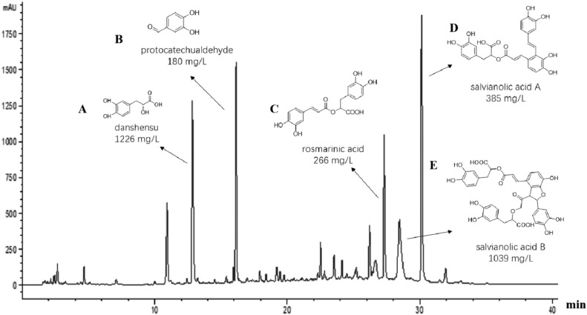

**Figure S1** HPLC chromatogram of representative components in DHI. The relative contents of five compounds and chemical structures were shown. The essential components of DHI and their relative contents detected using HPLC were danshensu (1226 mg/L), protocatechualdehyde (180 mg/L), rosmarinic acid (266 mg/L), salvianolic acid A (385 mg/L) and salvianolic acid B (1039 mg/L).

Reproduced from: Li, L., Yang, J., Li, C., Zhou, H., Yu, L., Wu, X., et al. (2023). Danhong injection improves neurological function in rats with ischemic stroke by enhancing neurogenesis and activating BDNF/AKT/CREB signaling pathway. *Biomed. Pharmacother.* 163, 114887. doi: 10.1016/j.biopha.2023.114887. License: CC BY-NC-ND 4.0. No modifications were made.

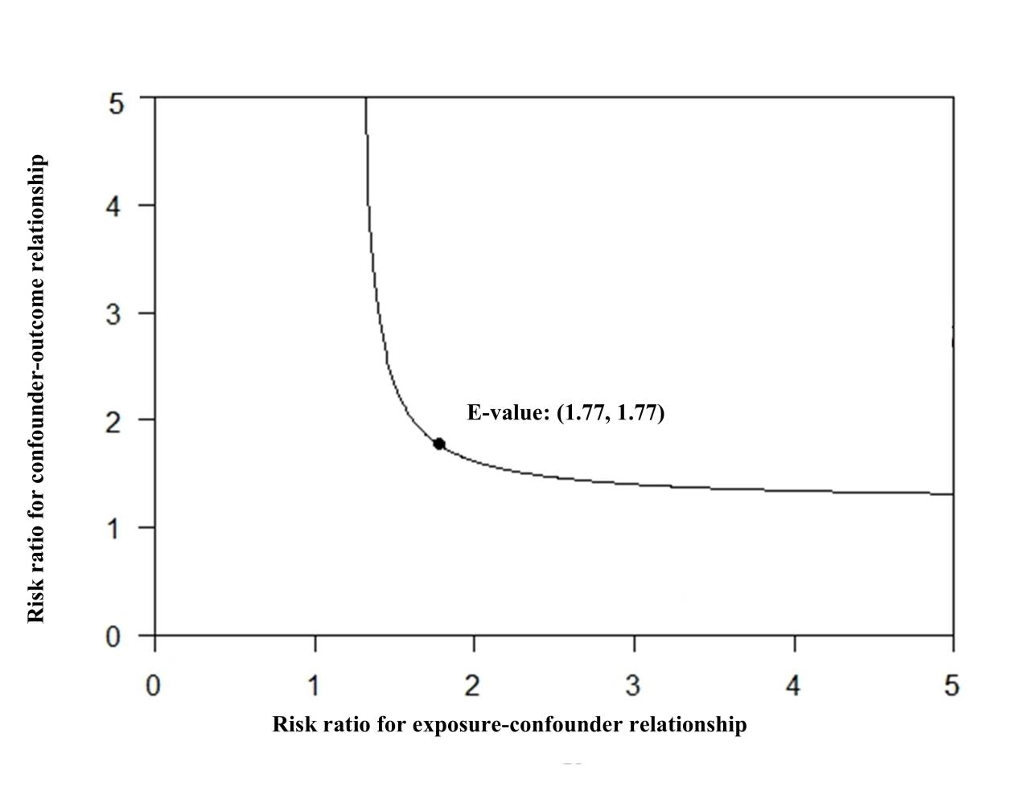

**Figure S2** Post-hoc E-value analysis to assess the extent of unmeasured confounding that would be required to negate the observed results.

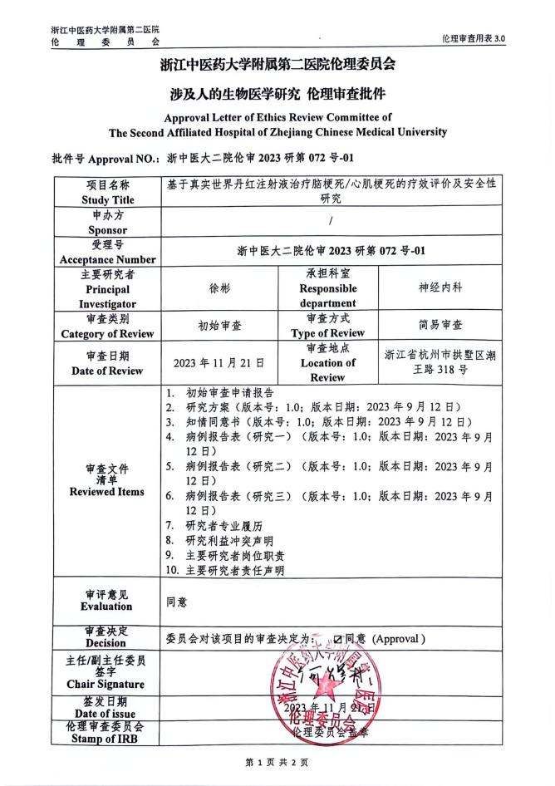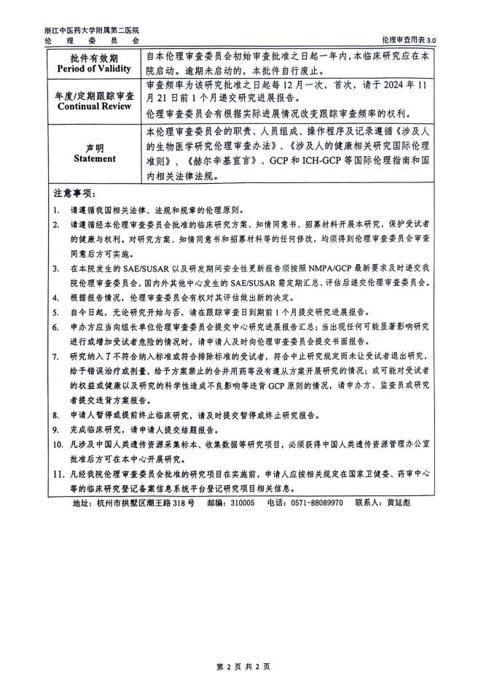

**Figure S3** Ethics approval document.