Causal Information Changes How We Reason: A Mixed Methods Analysis of Decision-Making with Causal Information
Samantha Kleinberg¹, Cristina Leone², Alice Liefgreen², David A. Lagnado²
¹Computer Science Department, Stevens Institute of Technology, Hoboken, NJ, USA
²Experimental Psychology, Division of Psychology & Language Sciences, University College London, London, United Kingdom

Supplementary Materials

Additional Results
Given the demographics of our participants, we additionally included age and sex as covariates to test whether either was associated with decision accuracy. We again used a linear mixed model with information condition, domain, and their interaction, along with gender (binary, excluding 2 individuals identifying as “other”), and age (continuous). Coefficients for age (p =.56) nor gender (.52) were not significant in the model.
Tables and Figures
Table S1. Percentage of participants mentioning each reasoning theme by question, collapsed across all information conditions.
Theme | Description | Bodyweight | Finance | BP/Prevention | Hypoglycemia/  Explanation
feasibility | Being easier or more practical | 0.31 | 0.0 | 0.36 | 0.09
logic | Using logic or deduction, process of elimination | 0.38 | 0.44 | 0.13 | 0.21
experience | Using personal experience | 0.26 | 0.15 | 0.10 | 0.18
info from question | Mention of diagram, information provided | 0.46 | 0.40 | 0.47 | 0.50
prior knowledge | Common sense/ knowledge, prior reading | 0.24 | 0.27 | 0.13 | 0.20
causal reasoning | Using causal language | 0.44 | 0.21 | 0.31 | 0.39
avoiding side effects | Mention of negative impacts of a choice | 0.32 | 0.81 | 0.14 | 0.07
benefits | Mention of positive impacts of a choice | 0.00 | 0.00 | 0.12 | 0.00

Table S2. Percentage of participants mentioning each similarity theme by question, collapsed across text and diagram information conditions.
Theme | Description | Bodyweight | Finance | BP/Prevention | Hypoglycemia/  Explanation
match | information fully consistent w/ beliefs | 0.67 | 0.50 | 0.55 | 0.37
partial match | information partly consistent w/beliefs | 0.16 | 0.03 | 0.23 | 0.07
no match | information does not match beliefs | 0.02 | 0.05 | 0.02 | 0.03
overcomplicated | information too complex | 0.01 | 0.00 | 0.00 | 0.01
oversimplified | information too simple | 0.07 | 0.00 | 0.05 | 0.00
unclear | information unclear | 0.00 | 0.12 | 0.03 | 0.15
experience | relied fully on own experience | 0.04 | 0.00 | 0.03 | 0.05
information | relied fully on provided information | 0.01 | 0.23 | 0.10 | 0.33

Table S3. Reasoning type as a predictor of decision accuracy, by condition.
 | Diagram |  | Text |  |  | No info
 | Estimate | P-value | Estimate | P-value | Estimate |  | P-value
Causal reasoning | 0.33 | .09 | 0.37 | .08 | 0.13 |  | .54
Prior knowledge | 0.09 | .74 | 0.94 | <.001*** | 0.59 |  | .01*
Logic | 1.17 | <.001*** | 0.81 | <.001*** | 0.68 |  | .003**
Feasibility | 0.37 | .21 | 0.17 | .52 | 0.60 |  | .02*
Experience | 0.44 | .19 | 0.55 | .06 | 0.64 |  | .01*
Info from question | -0.09 | .65 | -0.45 | .02* | -0.48 |  | .03*

Table S4. Accuracy as a function of match between a participant’s beliefs and information provided for diagram condition.
Diagram | Regression Coefficient | Standard Error | Z value | P value
Match | 0.17 | 0.149 | 1.146 | .25
Partial Match | -0.053 | 0.255 | -0.21 | .83
No Match | -0.49 | 0.54 | -0.918 | .36
Info | -0.933 | 0.30226 | -3.088 | .002**

Table S5. Accuracy as a function of match between a participant’s beliefs and information provided for text condition.
Text | Regression Coefficient | Standard Error | Z value | P value
Match | 0.26442 | 0.14 | 1.837 | .066
Partial Match | -0.82753 | 0.31638 | -2.616 | .009**
No Match | 2.20 | 1.04548 | 2.110 | .034*
Info | -0.02 | 0.20776 | -0.139 | .89

Table S6. Participant ratings of each item by question and information type.
 |  | Understandable | Informative | Confidence | Believable | Compatible
Bodyweight | Text | 6.1 | 5.3 | 5.4 | 5.4 | 5.5
 | Diagram | 5.7 | 5.1 | 5.0 | 5.3 | 5.3
Finance | Text | 5.1 | 4.9 | 4.7 | 4.8 | 4.6
 | Diagram | 4.8 | 4.3 | 4.3 | 4.5 | 4.2
BP/Prevention | Text | 5.9 | 5.3 | 5.3 | 5.3 | 5.3
 | Diagram | 5.0 | 4.9 | 4.9 | 5.1 | 5.0
Hypoglycemia/Explanation | Text | 5.2 | 5.2 | 4.9 | 5.0 | 4.8
 | Diagram | 4.3 | 4.4 | 4.2 | 4.5 | 4.0

Table S7. Confidence intervals and odds ratios for model of accuracy as a function of reasoning type.
Reasoning Theme | Odds ratio estimate | 95% C.I.
Info from question | 0.692 | (0.55-0.87)
Feasibility | 1.467 | (1.08-2.01)
Logic | 2.321 | (1.80-3.01)
Experience | 1.791 | (1.30-2.48)
Prior Knowledge | 1.829 | (1.37-2.45)
Causal | 1.309 | (1.04-1.66)

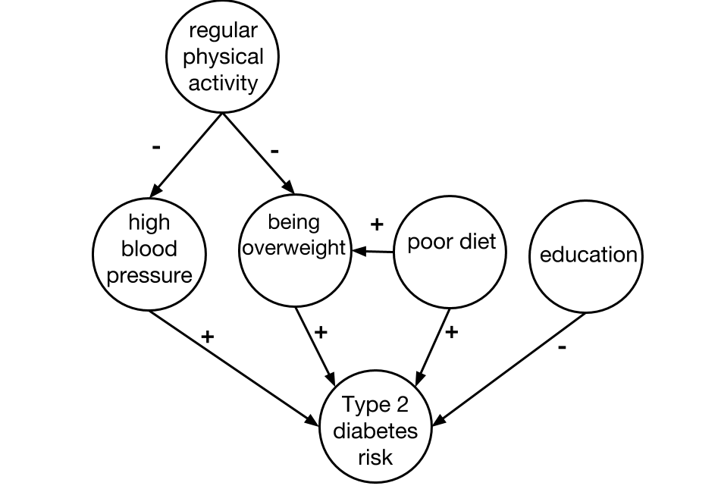
Figure S1. Example causal diagram corresponding to question about reducing T2D risk.

