Supplementary Information

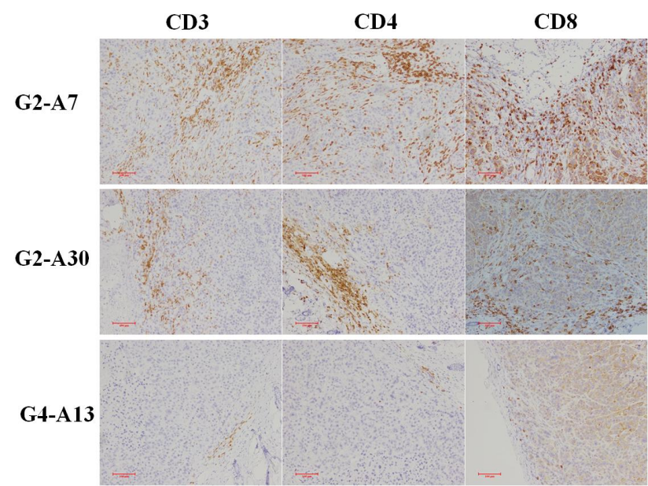

Supplementary Figure 1. Immunohistochemical analyses of T cells in tumor tissues (magnification, Í100). Marker-positive cells were stained brown or tan, while cell nuclei were counterstained with hematoxylin (blue staining).

