

Figure S1. A funnel plot assesses the risk of publication bias in the effect of music therapy on the ATEC score (A: total ATEC score, B: communication skills, C: social interaction skills, D: language ability, E: cognitive function).



Figure S2. A funnel plot assesses the risk of publication bias in the effect of music therapy on the ABC score (A: total ABC score, B: sensory, C: social and self-help).



Figure S3. A funnel plot assesses the risk of publication bias in the effect of music therapy on the ATEC score (A: body and object use, B: language skills, C: relating).

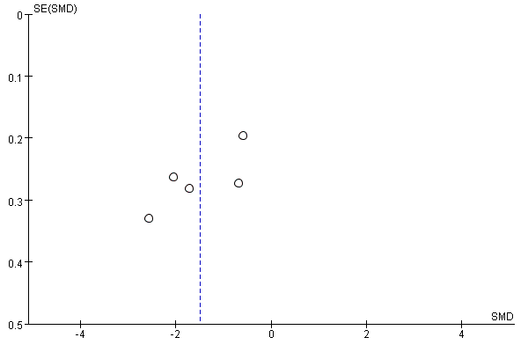

Figure S4. A funnel plot assesses the risk of publication bias in the effect of music therapy on the CARS score.