Supplementary Tables and Figures of
“Genetic predisposition to immune dysregulation and extracellular matrix remodeling in cardiac arrhythmia reveals potential mediation by SPP1+ macrophages”
Jie-Yuan Jin^{1,2#}, Shuai Guo^{2#}, Yao Deng³, Ya-Qin Chen⁴, Chen Liang⁵, Yu-Jie Jiang², Wang Zhao^{4*}, Rong Xiang²*

¹ School of Medicine, Shaoxing University, Shaoxing, 312000, China;
² School of Life Sciences, Central South University, Changsha, 410013, China;
³ Department of Cardiovascular Surgery, Xiangya Hospital, Central South University, Changsha, 410008, China;
⁴ Department of Cardiovascular Medicine, the Second Xiangya Hospital, Central South University, Changsha, 410011, China;
⁵ Center for Medical Genetics, Jiangmen Maternal & Child Health Care Hospital, Jiangmen, 529000, China.

# Jie-Yuan Jin and Shuai Guo contributed equally to this work.

* Corresponding Authors.

Supplementary Tables 1-7: https://1drv.ms/x/s!Ati0XzrZojHZgZsZdtMQd9C2cjy_7w?e=5FO8ka
Table of contents:
Table S1. Detailed clinical information
Table S2. 132 r.v. genes across patient cohort
Table S3. Catalogued pathogenic variants in cardiac disease databases
Table S4. GO results of 132 r.v. genes
Table S5. Patient demographics and clinical information (scRNA-seq cohort from GSE224959).
Table S6. Cell-type-specific GO results of DE genes between Controls and Arrhythmias
Table S7. Signature genes of SPP1+ macrophage

Supplementary Figures:
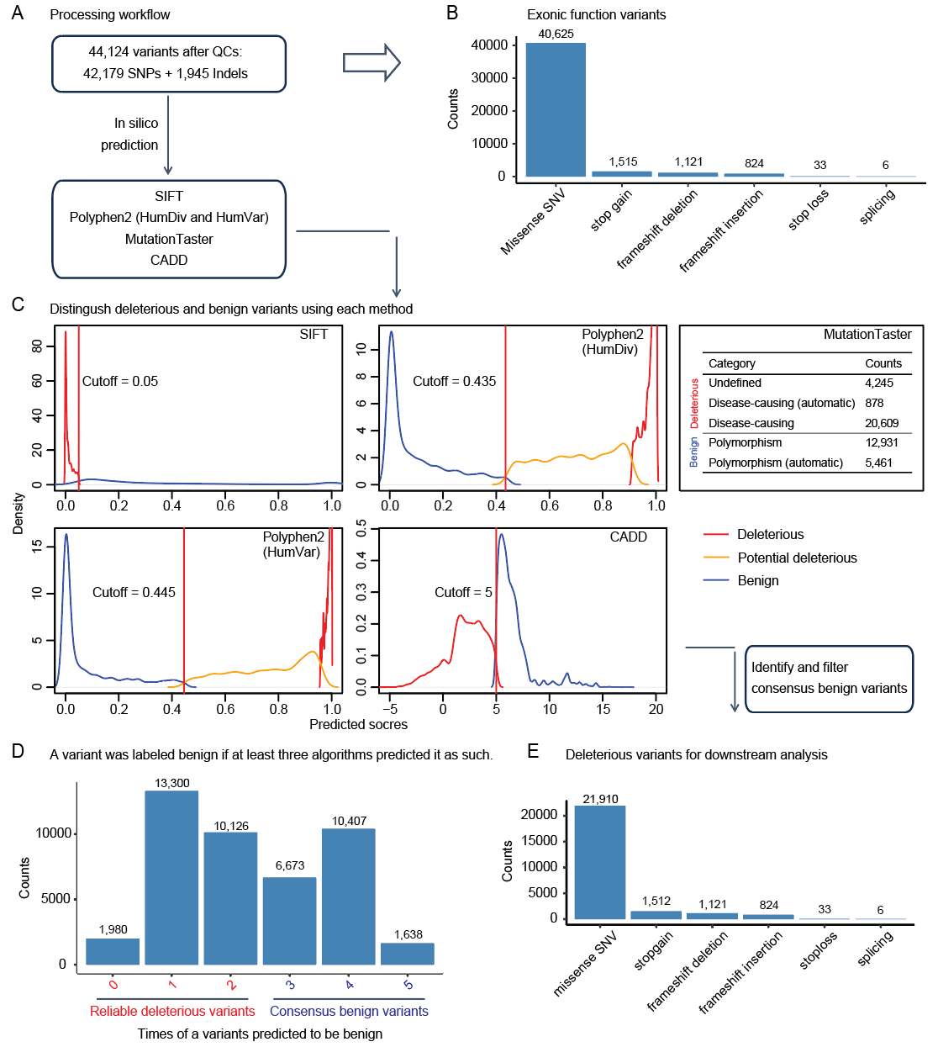
Figure S1. Variants Filtering and Classification Workflow.
(A) The processing workflow for variant analysis post-quality control screening, illustrating the initial count of variants which includes single nucleotide polymorphisms (SNPs) and insertions/deletions (Indels). Four in-silico tools (SIFT, Polyphen2 (HumDiv and HumVar), MutationTaster, and CADD) are used for a robust variant pathogenicity prediction. (B) Counts of exonic function variants are categorized into missense SNV, stop gain, frameshift deletion, frameshift insertion, stop loss, and splicing. (C) Graphs representing the distribution of predicted scores for the variants. According to the cutoff thresholds, variants are classified as deleterious, potentially deleterious, or benign. Red lines indicate the cutoff used to distinguish benign variants. (D) Bar graph showing the counts of variants classified based on the consensus of at least three algorithms predicting them as such, differentiating between reliable deleterious variants and consensus benign variants. (E) Final counts of deleterious variants that were selected for downstream analysis after the filtering process, broken down by variant type.

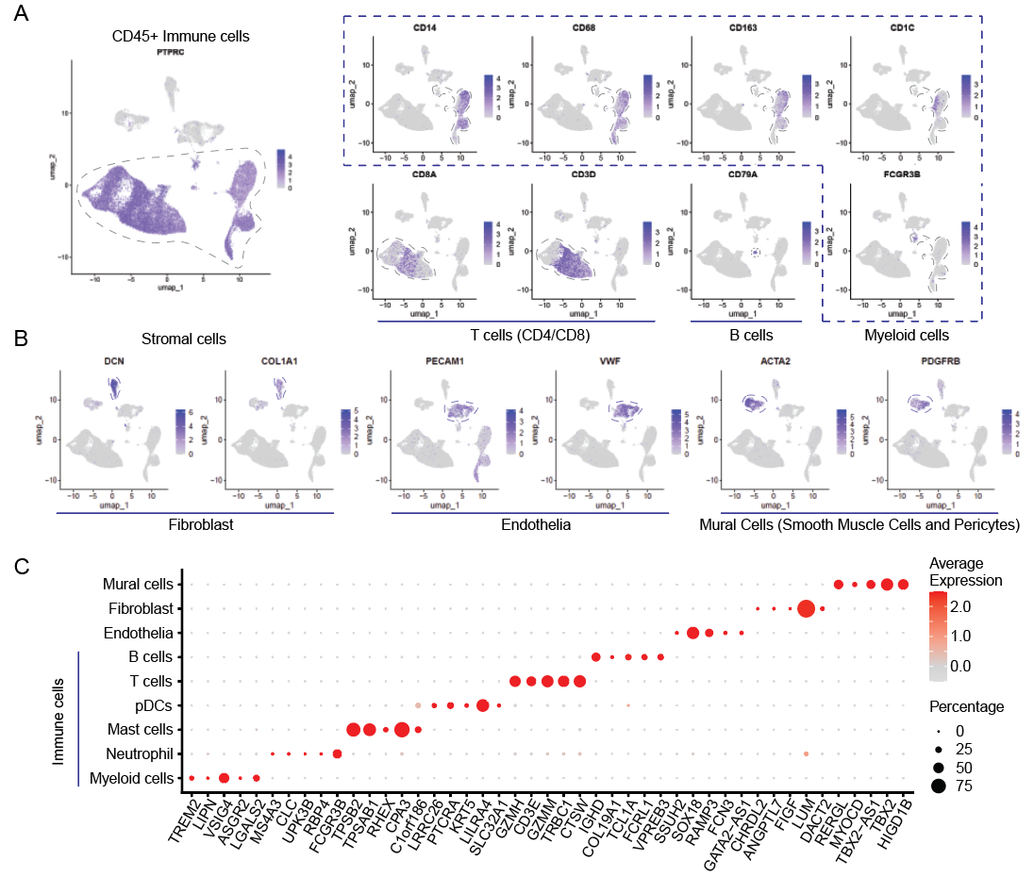
Figure S2. Annotation of the Human Cardiac Arrhythmias Single-Cell Atlas
(A) UMAP visualization of CD45+ immune cells within the scRNA-seq data, with each panel showing the density of specific cell markers (PTPRC for circulating immune cells; CD14, CD68, CD163, and CD16 for myeloid lineages; CD8A and CD3D for T cells; CD79A for B cells). (B) UMAP visualization of stromal cells, each highlighted by key cellular markers (DCN and COL1A1 for fibroblast; PECAM1 and VWF for endothelia; ACTA2 and PDGFRB for mural cells). (C) Dot plot matrix displaying the expression levels and percentages of various markers across all the annotated cell types. Dot size represents the percentage of cells expressing the marker, and color intensity indicates the average expression level.

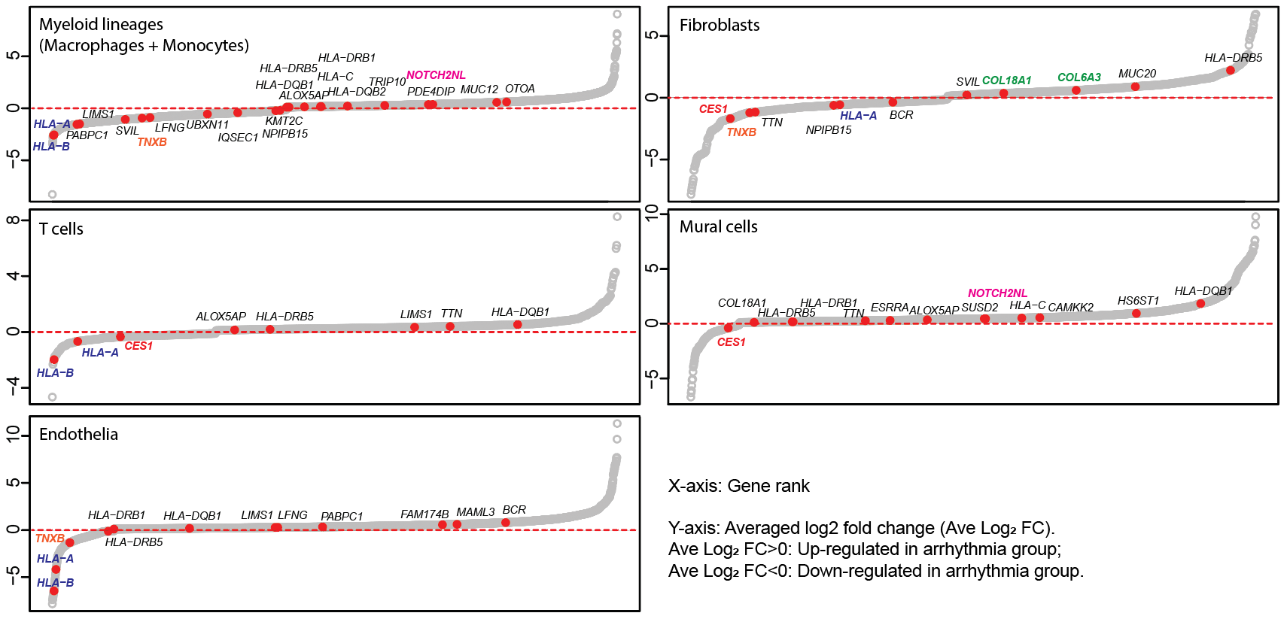
Figure S3. Recurrent Variant Genes in Cell-type-specific Differential Gene Expression
Scatter plots for each cell type (myeloid lineages, T cells, endothelia, fibroblasts, and mural cells) displaying differential gene expression between cardiac arrhythmia and healthy control groups. The x-axis represents the gene rank based on the log2 fold change, while the y-axis indicates the specific log2 fold change for each gene. Red dots represent r.v. genes that are significantly upregulated (above the dashed line) or downregulated (below the dashed line) in the arrhythmia group compared to controls.

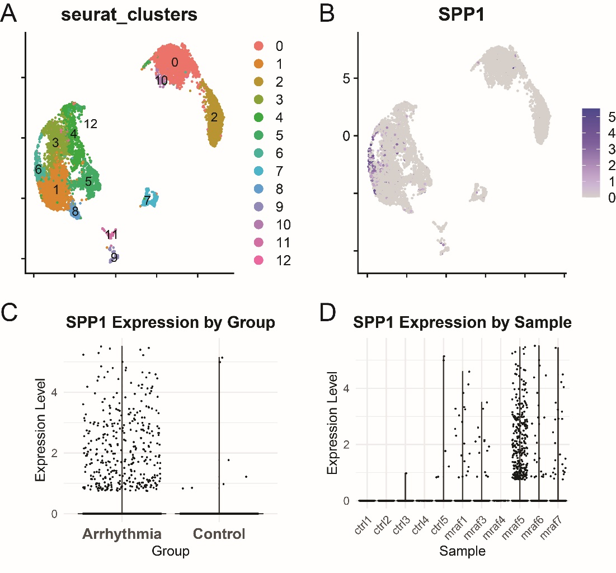
Figure S4. SPP1 expression analysis for macrophage subtype identification
(A) UMAP visualization showing Seurat clustering of myeloid lineages. (B) SPP1 gene expression on the same UMAP, with color intensity indicating expression levels. Highest SPP1 expression is observed in Cluster 6. (C) Violin plot comparing SPP1 expression levels between arrhythmic and control groups. Each dot represents a single cell. (D) Sample-wise SPP1 expression distribution.

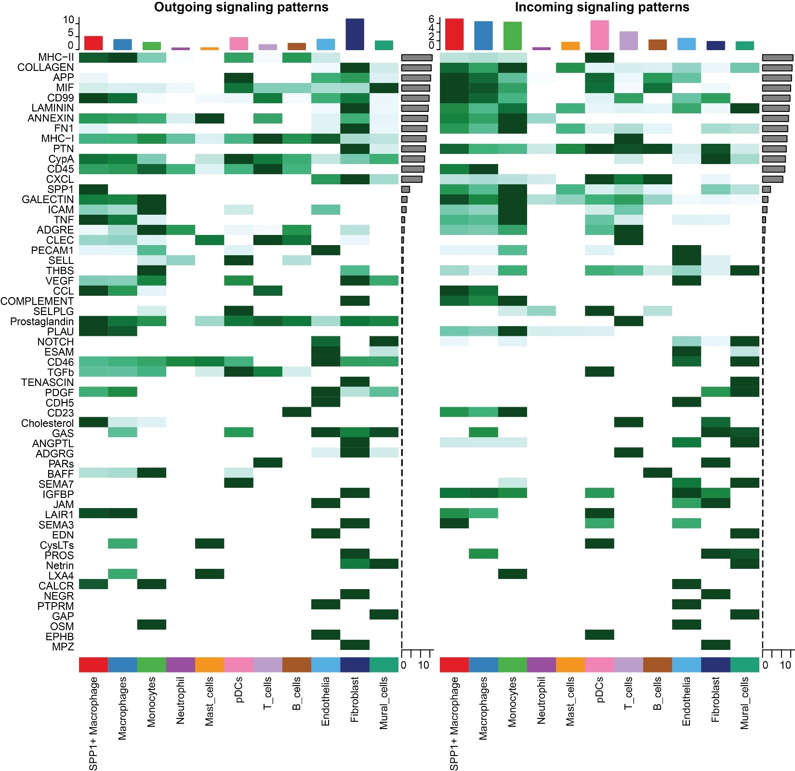
Figure S5. Cell-cell communication signaling pathways in arrhythmia

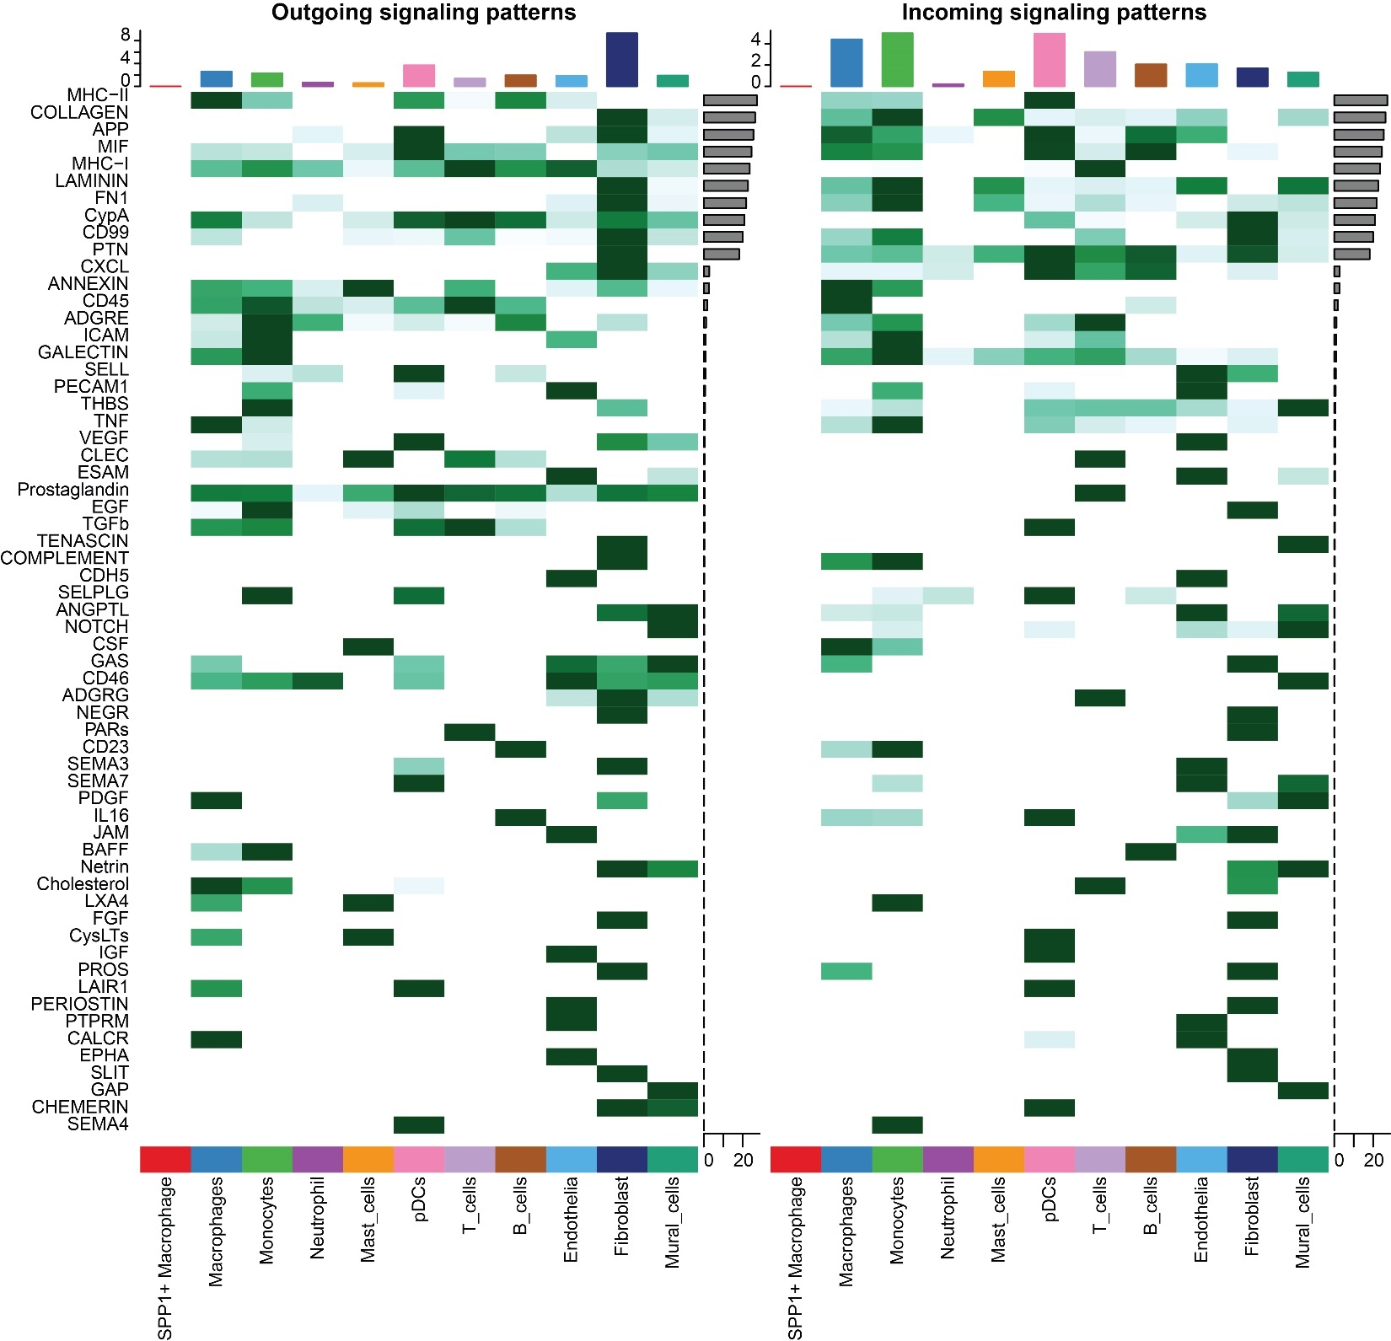
Figure S6. Cell-cell communication signaling pathways in control

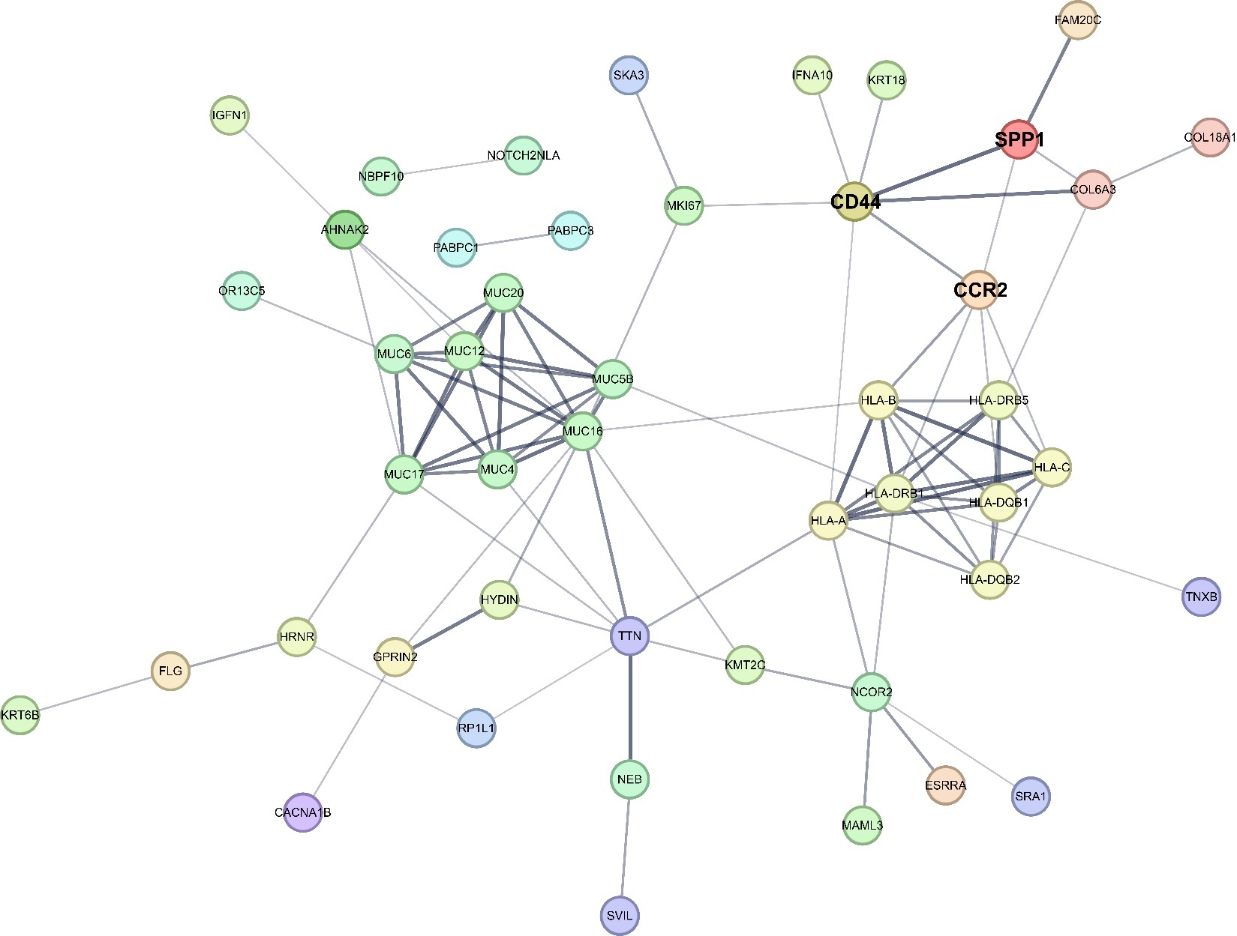
Figure S7. Protein-protein interaction network of r.m. genes with SPP1/CCR2/CD44 axis
Updated PPI network incorporating CD44 alongside SPP1 and CCR2, showing direct and indirect interactions with 132 r.m. genes. Key functional clusters include: mucin families (MUC4, MUC6, MUC12, MUC17, MUC20), HLA families (HLA-A, HLA-B, HLA-C, HLA-DRB1, HLA-DRB5, HLA-DQB1, HLA-DQB2), and structural proteins (TTN, NEB). The central SPP1/CCR2/CD44 axis connects to collagens (COL18A1, COL6A3) and transcriptional regulators (NCOR2, ESRRA), establishing molecular bridges between immune dysregulation and ECM remodeling pathways.

