Appendix
- Traditional connectedness methodology (Diebold and Yilmaz (2012))
Table A1
 | AFAHF | MIN | MFG | EHGW | CON | WRT | TSPS | A&C | ITSI | FIN | RE | LBS | SRTS | WEPFM | EDU | HSW | CSE | COM | GPR
AFAHF | 0 | 4.919 | 4.702 | 4.928 | 5.068 | 5.107 | 4.915 | 4.792 | 5.005 | 4.905 | 5.170 | 4.924 | 4.959 | 5.186 | 5.222 | 4.757 | 5.083 | 4.831 | 5.253
MIN | 5.222 | 0 | 4.655 | 4.938 | 5.054 | 5.118 | 4.801 | 4.772 | 4.908 | 4.953 | 4.990 | 5.050 | 5.152 | 4.977 | 5.365 | 4.728 | 5.015 | 4.854 | 5.200
MFG | 5.098 | 4.751 | 0 | 5.003 | 5.136 | 5.264 | 4.968 | 4.910 | 5.059 | 4.844 | 5.028 | 5.065 | 5.008 | 5.049 | 5.214 | 4.752 | 5.029 | 4.894 | 5.204
EHGW | 5.160 | 4.907 | 4.721 | 0 | 5.138 | 5.207 | 4.881 | 4.798 | 4.937 | 5.008 | 5.096 | 5.038 | 4.929 | 4.974 | 5.361 | 4.720 | 5.092 | 4.928 | 5.198
CON | 5.145 | 4.818 | 4.706 | 4.932 | 0 | 5.193 | 4.879 | 4.875 | 4.892 | 4.885 | 5.031 | 4.996 | 4.958 | 5.072 | 5.194 | 4.728 | 5.038 | 4.972 | 5.373
WRT | 5.045 | 4.904 | 4.780 | 5.020 | 5.110 | 0 | 4.971 | 4.962 | 5.027 | 4.858 | 5.040 | 5.028 | 5.012 | 4.970 | 5.230 | 4.644 | 5.019 | 4.923 | 5.205
TSPS | 5.117 | 4.746 | 4.805 | 5.037 | 5.130 | 5.094 | 0 | 4.841 | 4.980 | 4.937 | 4.894 | 4.926 | 5.100 | 5.038 | 5.403 | 4.642 | 4.964 | 4.984 | 5.155
A&C | 5.245 | 4.949 | 4.762 | 4.887 | 4.941 | 5.156 | 4.894 | 0 | 4.970 | 4.829 | 4.974 | 4.961 | 5.062 | 5.027 | 5.337 | 4.862 | 5.017 | 4.982 | 5.208
ITSI | 5.035 | 4.799 | 4.851 | 4.946 | 5.150 | 5.256 | 4.875 | 4.923 | 0 | 4.920 | 5.038 | 5.080 | 4.967 | 5.015 | 5.184 | 4.698 | 5.086 | 4.936 | 5.157
FIN | 5.143 | 4.892 | 4.813 | 4.914 | 5.228 | 5.130 | 4.784 | 4.665 | 5.002 | 0 | 5.085 | 4.995 | 5.004 | 5.051 | 5.245 | 4.632 | 5.139 | 4.939 | 5.104
RE | 5.069 | 4.714 | 4.799 | 4.872 | 5.060 | 5.150 | 4.881 | 4.840 | 5.078 | 4.937 | 0 | 5.011 | 4.962 | 5.004 | 5.233 | 4.745 | 5.039 | 5.033 | 5.231
LBS | 5.102 | 4.813 | 4.699 | 4.874 | 5.103 | 5.116 | 4.918 | 4.837 | 5.043 | 5.055 | 5.145 | 0 | 4.914 | 5.005 | 5.290 | 4.717 | 5.068 | 4.905 | 5.271
SRTS | 5.055 | 4.804 | 4.741 | 4.712 | 5.079 | 5.276 | 4.916 | 4.936 | 5.059 | 4.868 | 5.065 | 5.137 | 0 | 5.004 | 5.328 | 4.608 | 5.099 | 4.865 | 5.203
WEPFM | 5.033 | 4.738 | 4.765 | 4.952 | 5.136 | 5.206 | 4.910 | 4.828 | 4.980 | 4.996 | 5.035 | 5.110 | 4.911 | 0 | 5.208 | 4.744 | 5.148 | 4.980 | 5.138
EDU | 5.132 | 4.921 | 4.704 | 4.793 | 5.008 | 5.160 | 4.928 | 4.797 | 5.029 | 4.956 | 5.127 | 5.069 | 5.055 | 5.052 | 0 | 4.707 | 4.978 | 4.877 | 5.273
HSW | 5.119 | 4.764 | 4.729 | 4.749 | 5.119 | 5.087 | 4.808 | 4.738 | 5.070 | 5.048 | 5.092 | 4.960 | 5.024 | 5.051 | 5.159 | 0 | 5.087 | 4.860 | 5.393
CSE | 4.990 | 4.828 | 4.774 | 4.946 | 5.235 | 5.253 | 4.924 | 4.804 | 5.104 | 4.834 | 5.096 | 5.148 | 4.944 | 5.054 | 5.222 | 4.651 | 0 | 4.981 | 5.043
COM | 5.112 | 4.802 | 4.686 | 4.857 | 5.206 | 5.072 | 4.977 | 4.929 | 4.884 | 4.917 | 5.172 | 4.913 | 4.998 | 5.035 | 5.288 | 4.709 | 4.961 | 0 | 5.313
GPR | 5.110 | 4.821 | 4.646 | 4.900 | 5.196 | 5.020 | 4.994 | 4.843 | 5.067 | 4.943 | 5.156 | 5.005 | 4.866 | 5.027 | 5.300 | 4.565 | 5.007 | 4.855 | 0

- Replacing the SJC-copula function with the Clayton copula function
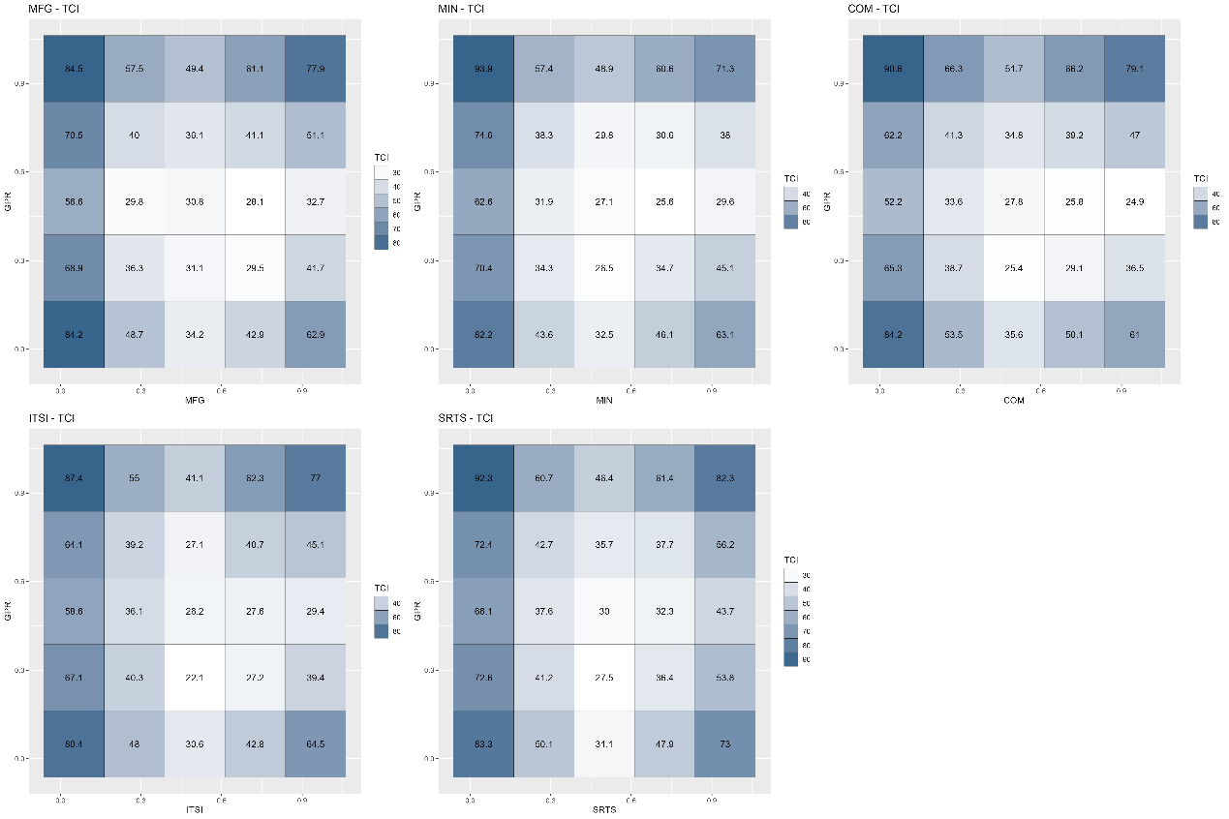
Figure A1. Average quantile-on-quantile connectedness between GPR and the tail risk of the dominant industries.
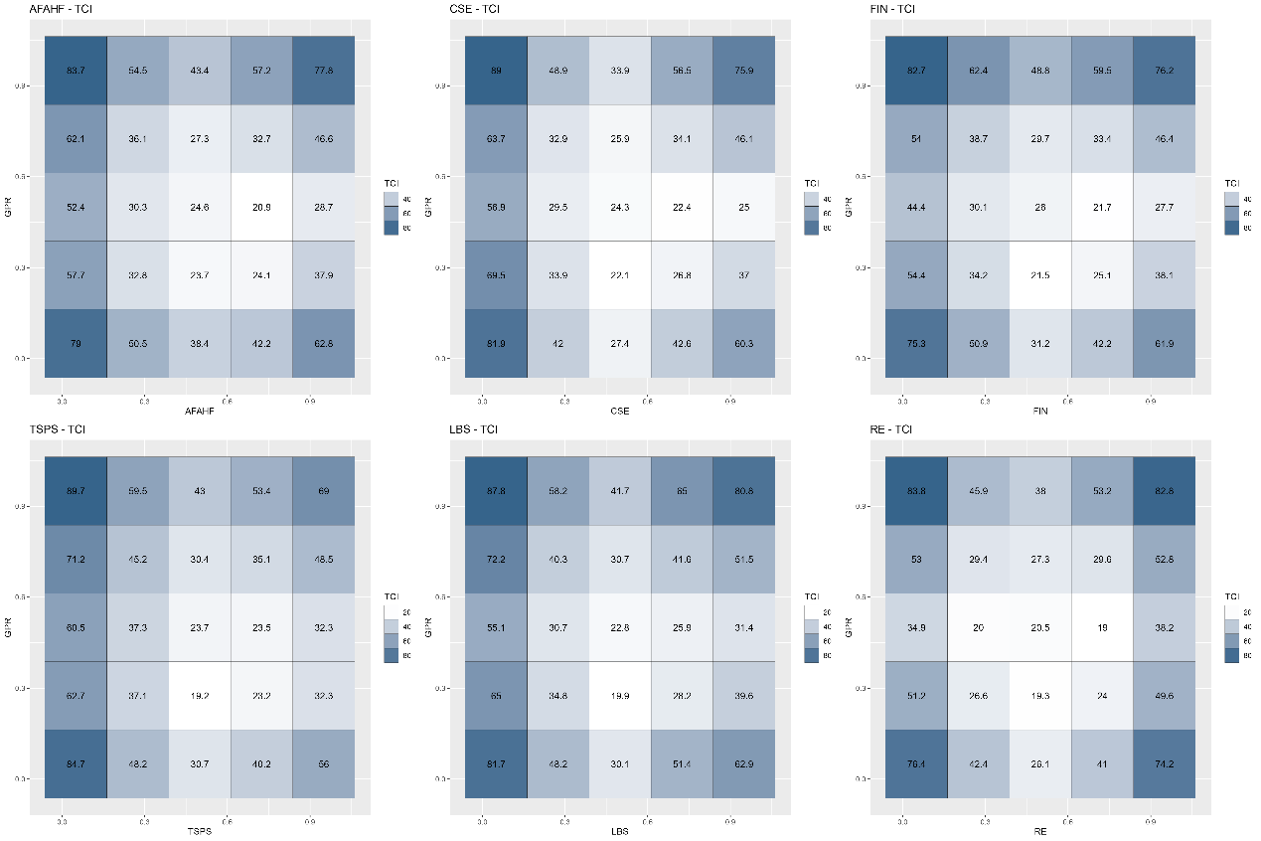
Figure A2. Average quantile-on-quantile connectedness between GPR and the tail risk of the basic support industries.
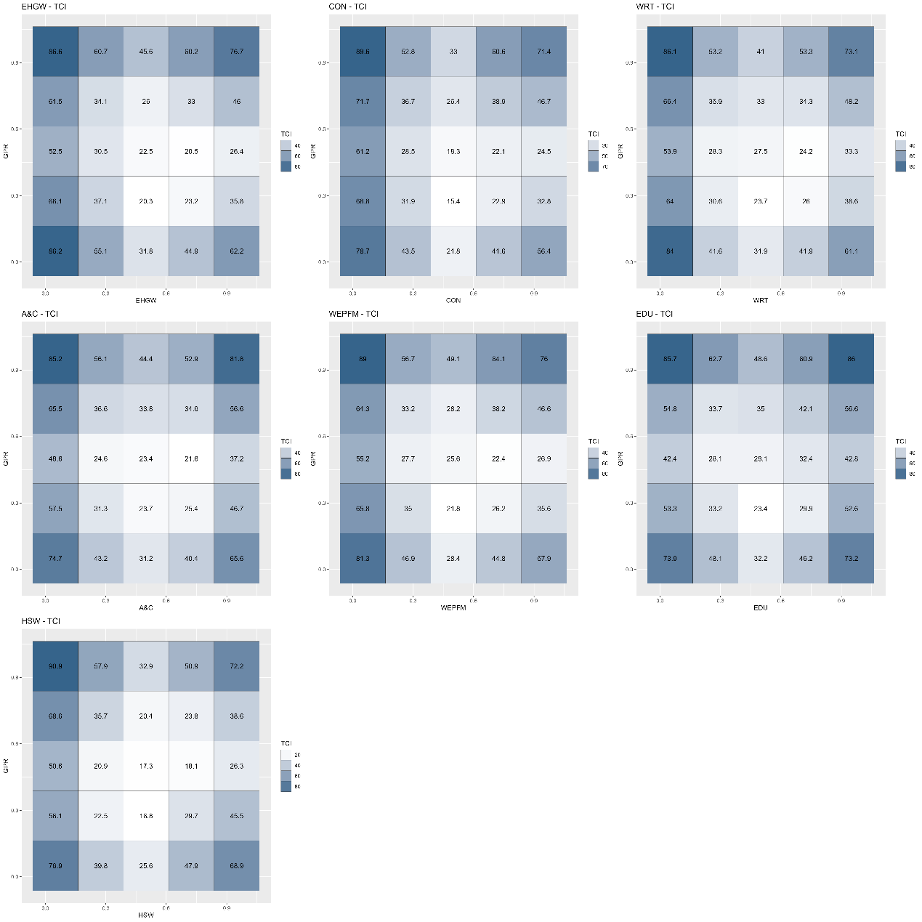
Figure A3. Average quantile-on-quantile connectedness between GPR and the tail risk of the modern service industries.
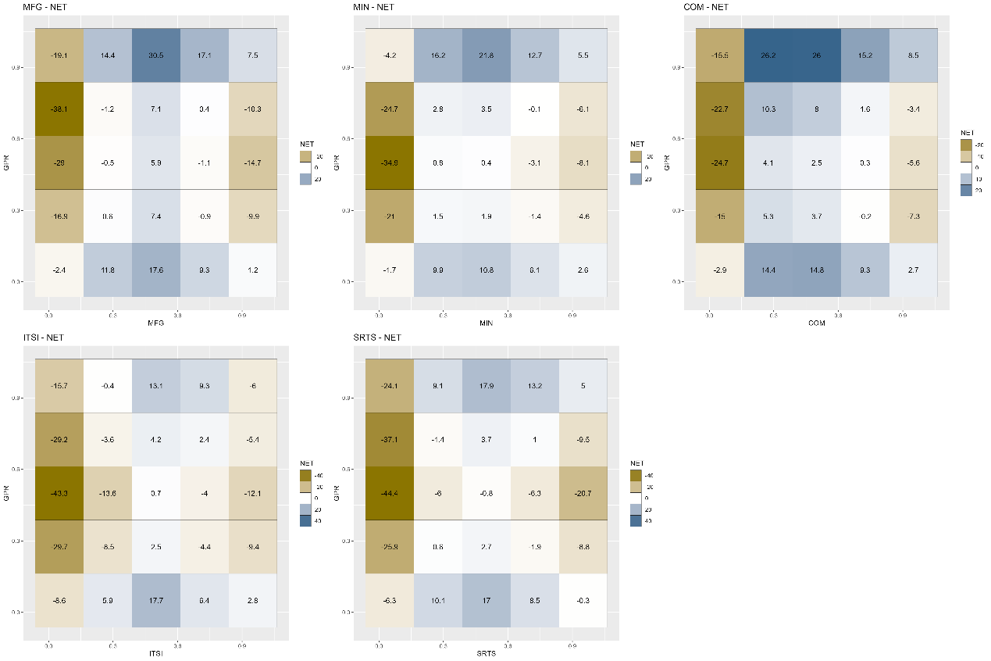
Figure A4. Net quantile-on-quantile connectedness between GPR and the tail risk of the dominant industries.
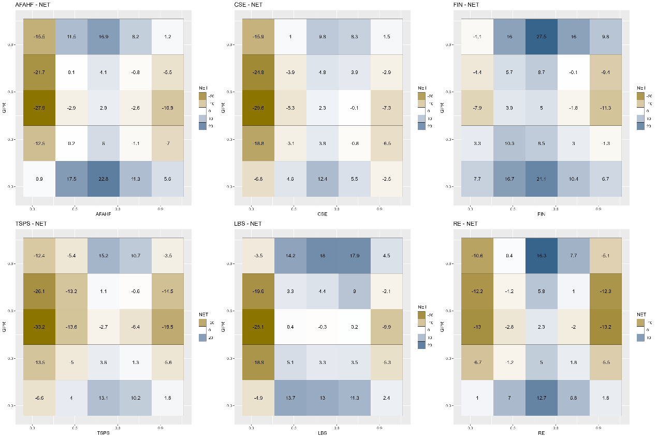
Figure A5. Net quantile-on-quantile connectedness between GPR and the tail risk of the basic support industries.
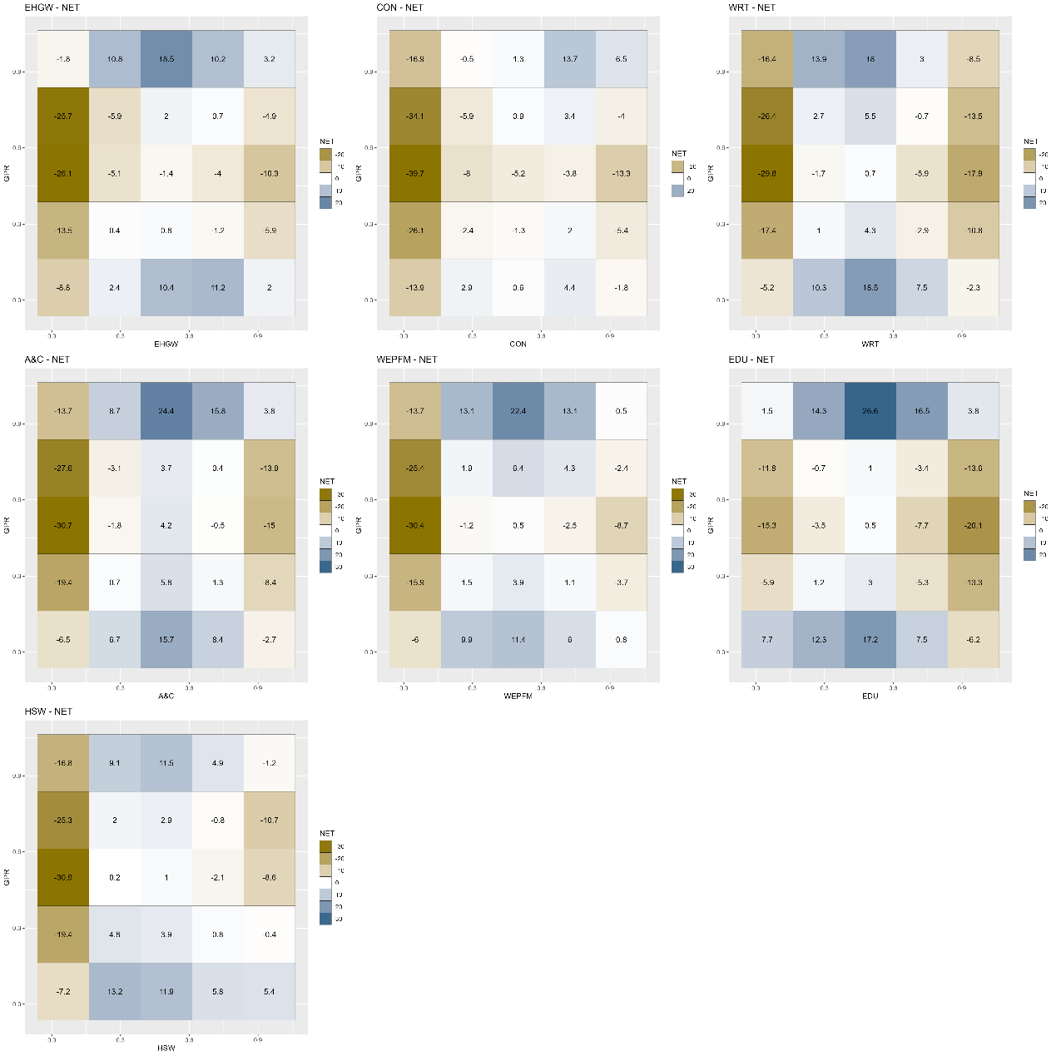
Figure A6. Net quantile-on-quantile connectedness between GPR and the tail risk of the modern service industries.
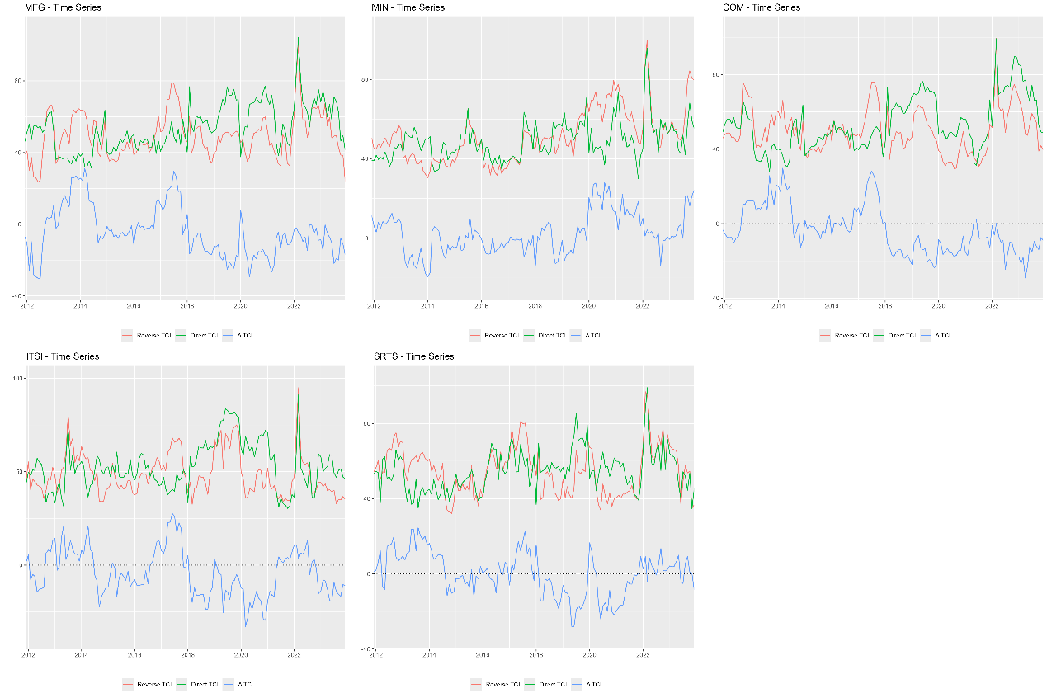
Figure A7. Dynamic quantile-on-quantile connectedness between GPR and the tail risk of the dominant industries.
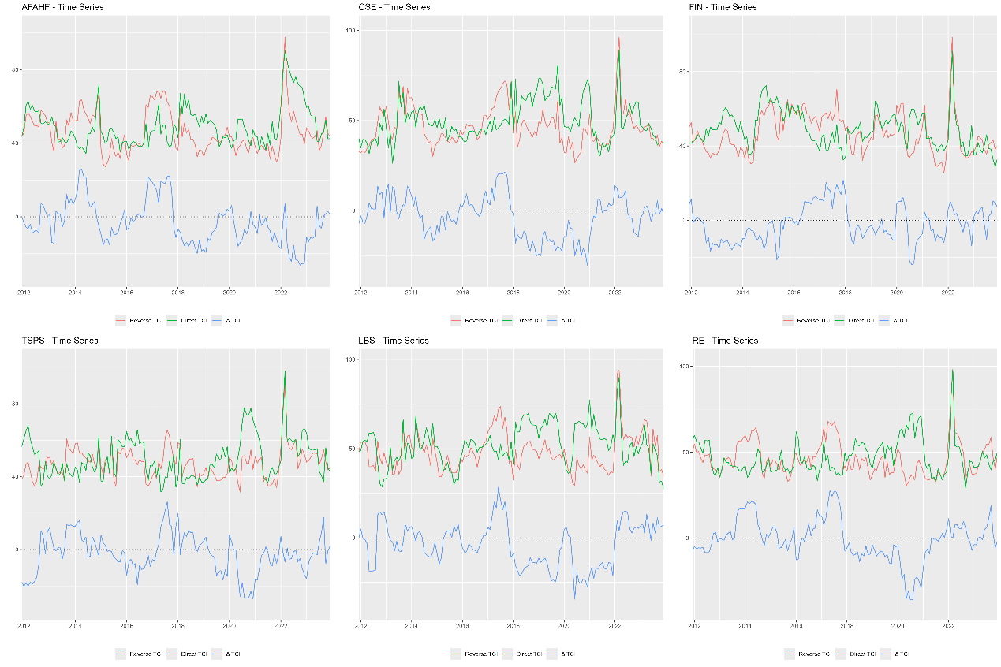
Figure A8. Dynamic quantile-on-quantile connectedness between GPR and the tail risk of the basic support industries.
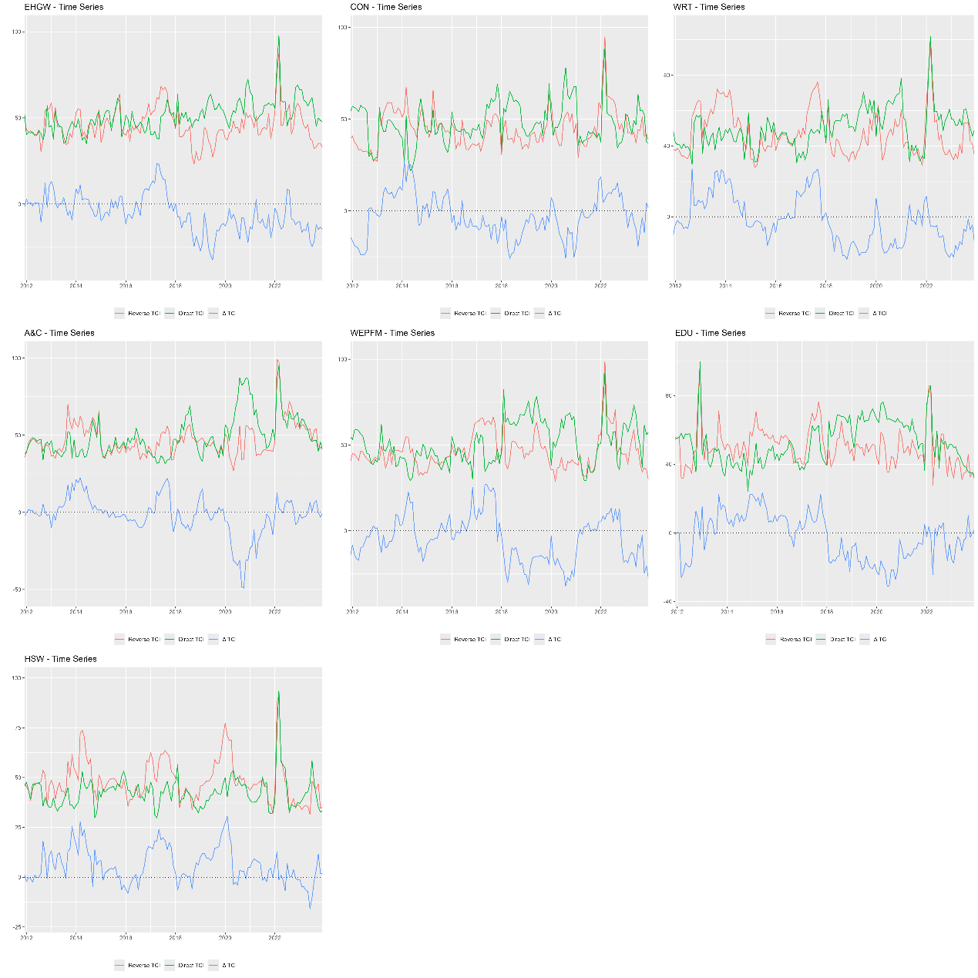
Figure A9. Dynamic quantile-on-quantile connectedness between GPR and the tail risk of the modern service industries.
- GPRC_CHN and tail risk
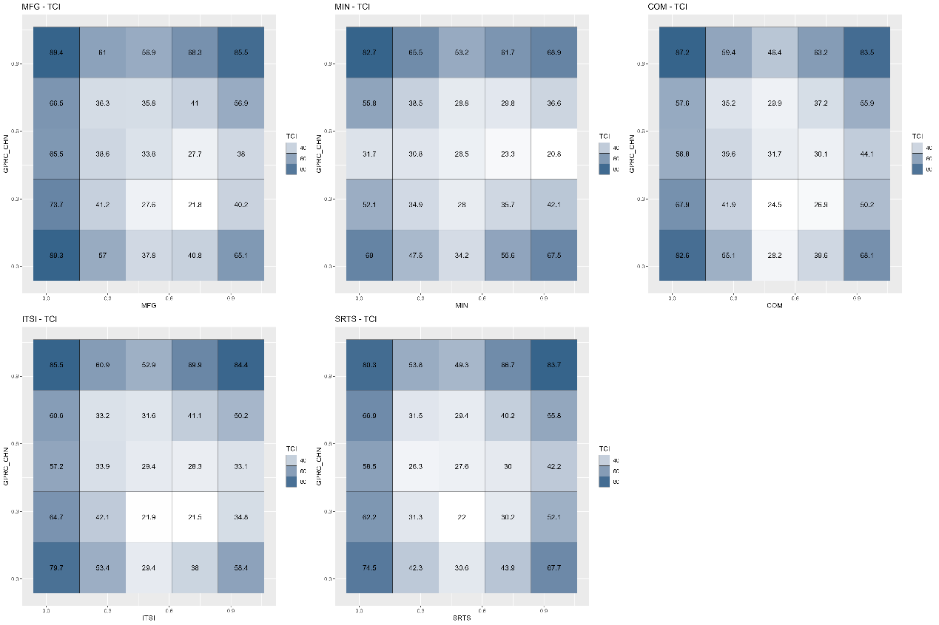
Figure A10. Average quantile-on-quantile connectedness between GPR and the tail risk of the dominant industries.
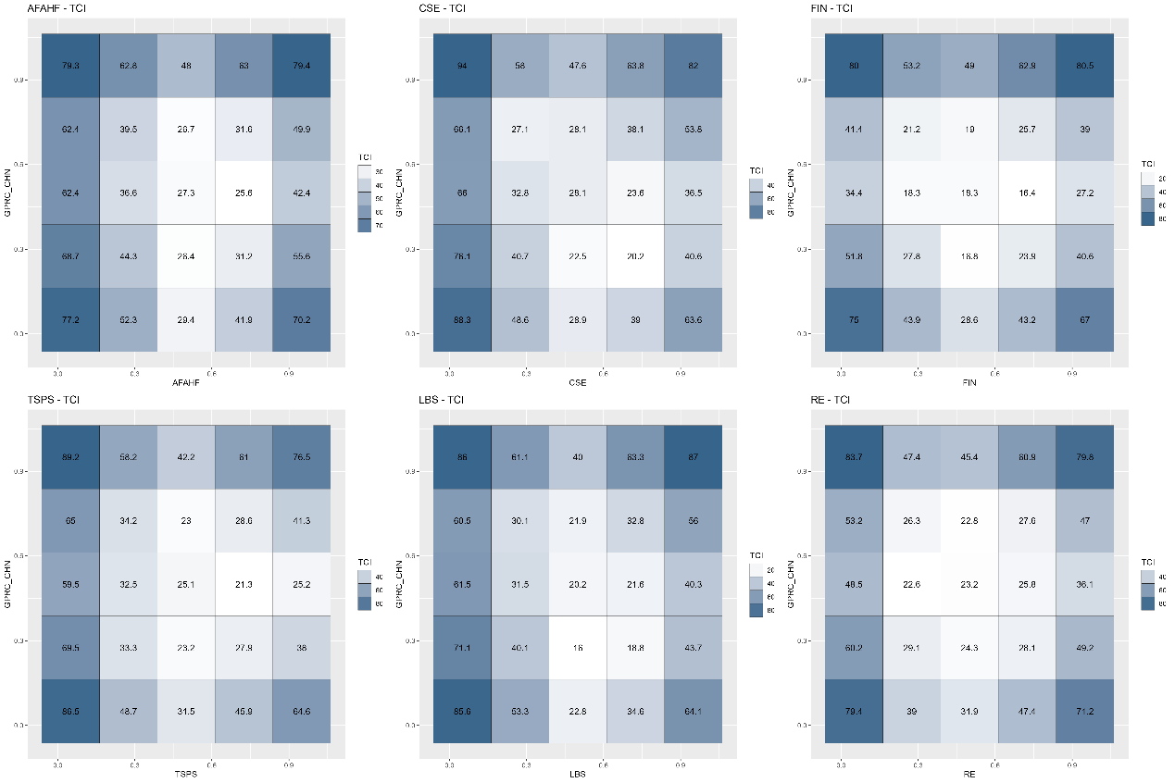
Figure A11. Average quantile-on-quantile connectedness between GPR and the tail risk of the basic support industries.
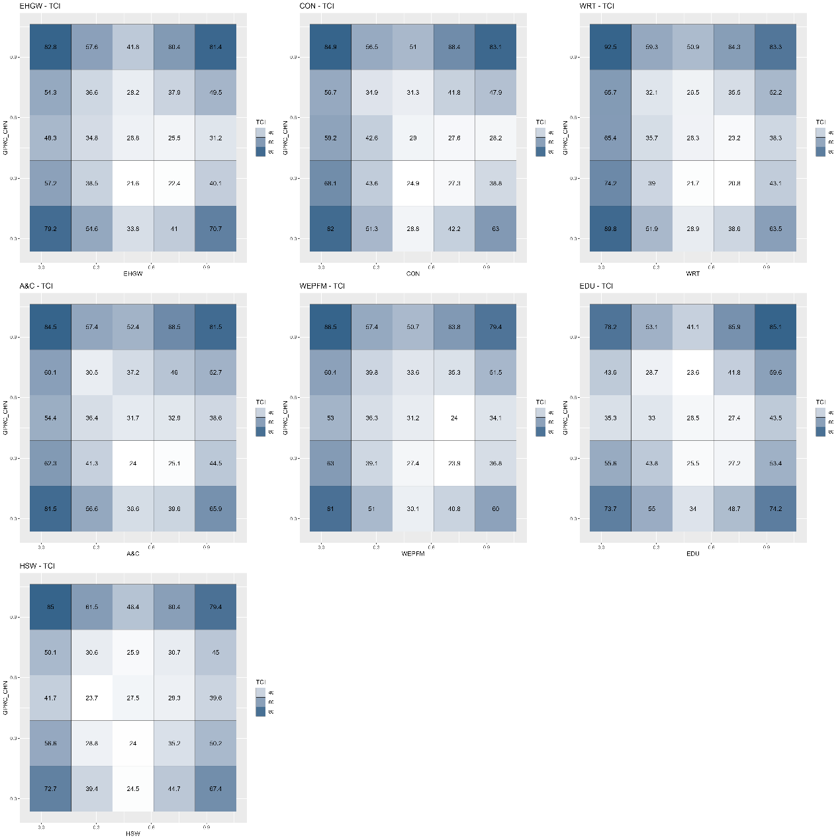
Figure A12. Average quantile-on-quantile connectedness between GPR and the tail risk of the modern service industries.
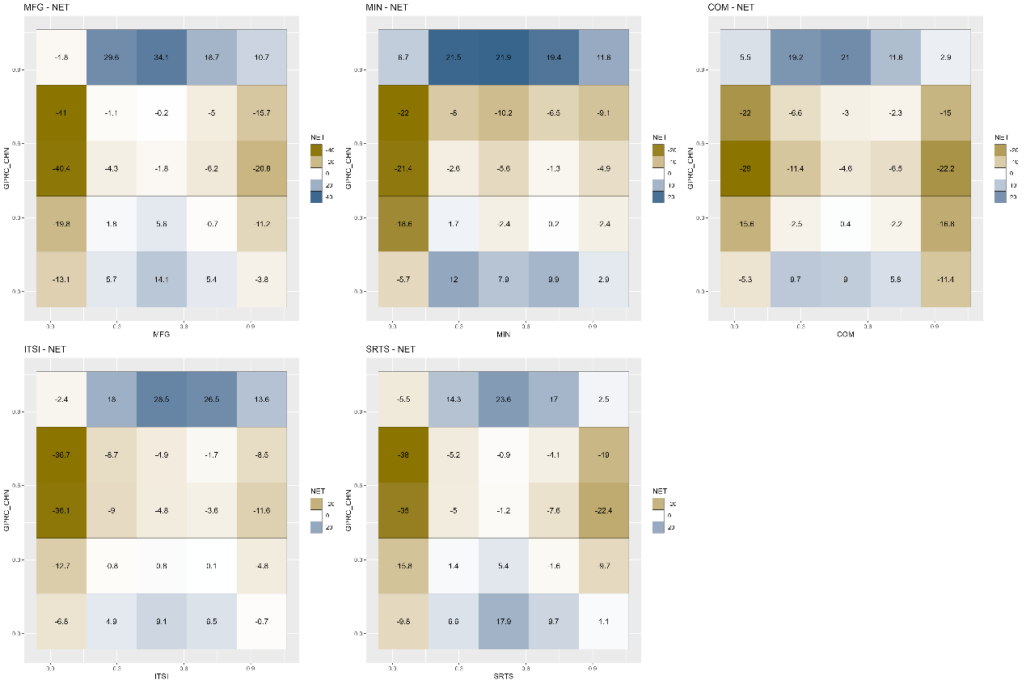
Figure A13. Net quantile-on-quantile connectedness between GPR and the tail risk of the dominant industries.
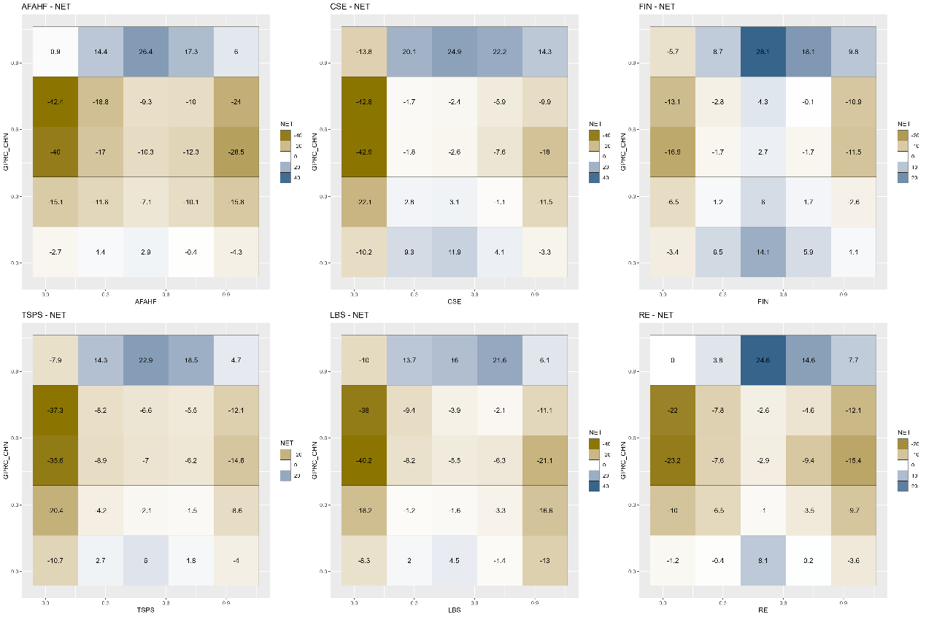
Figure A14. Net quantile-on-quantile connectedness between GPR and the tail risk of the basic support industries.
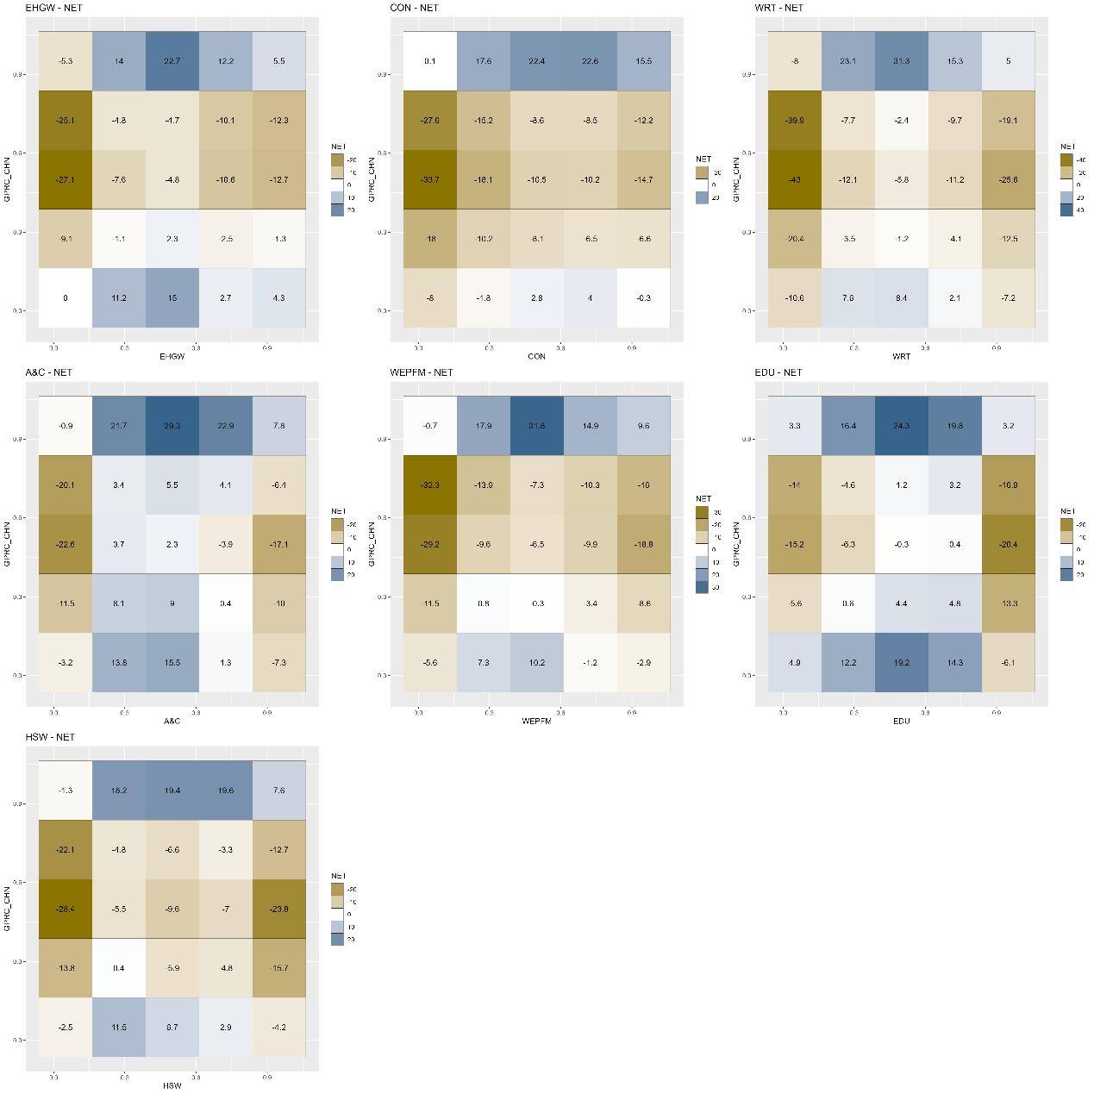
Figure A15. Net quantile-on-quantile connectedness between GPR and the tail risk of the modern service industries.
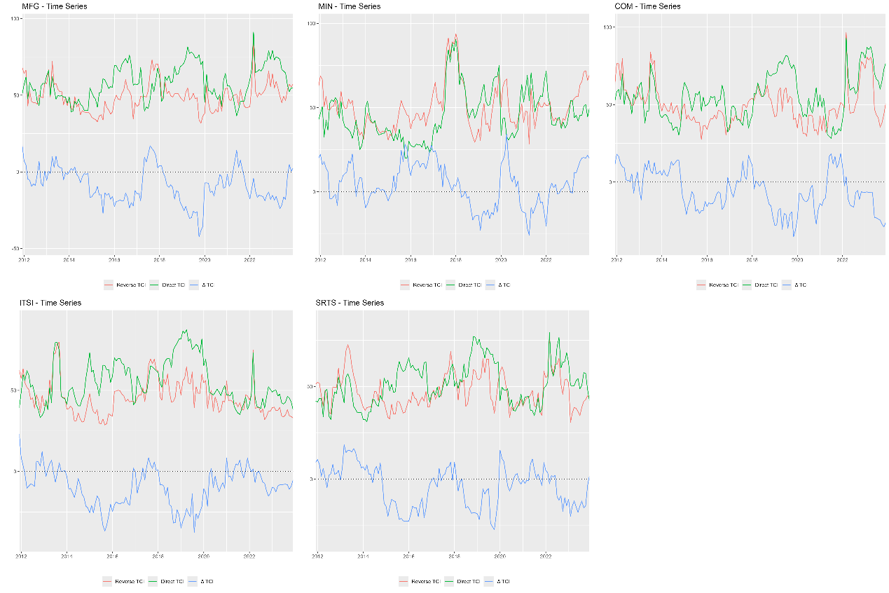
Figure A16. Dynamic quantile-on-quantile connectedness between GPR and the tail risk of the dominant industries.
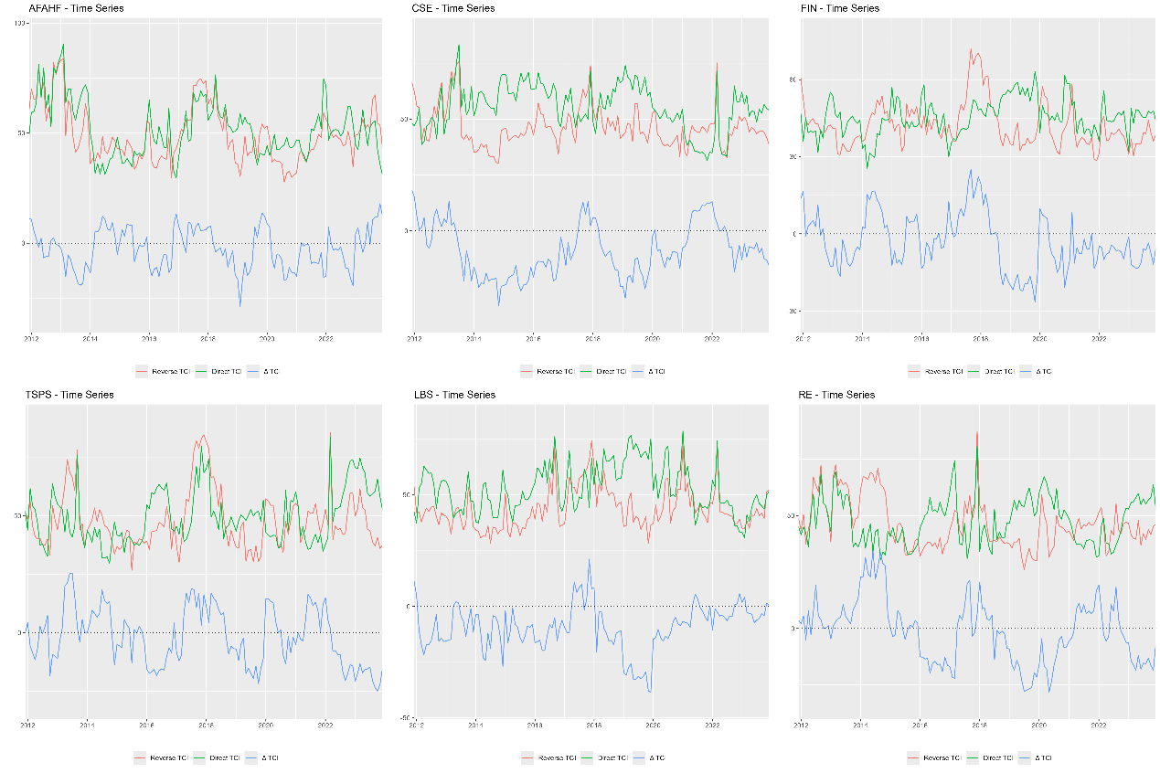
Figure A17. Dynamic quantile-on-quantile connectedness between GPR and the tail risk of the basic support industries.
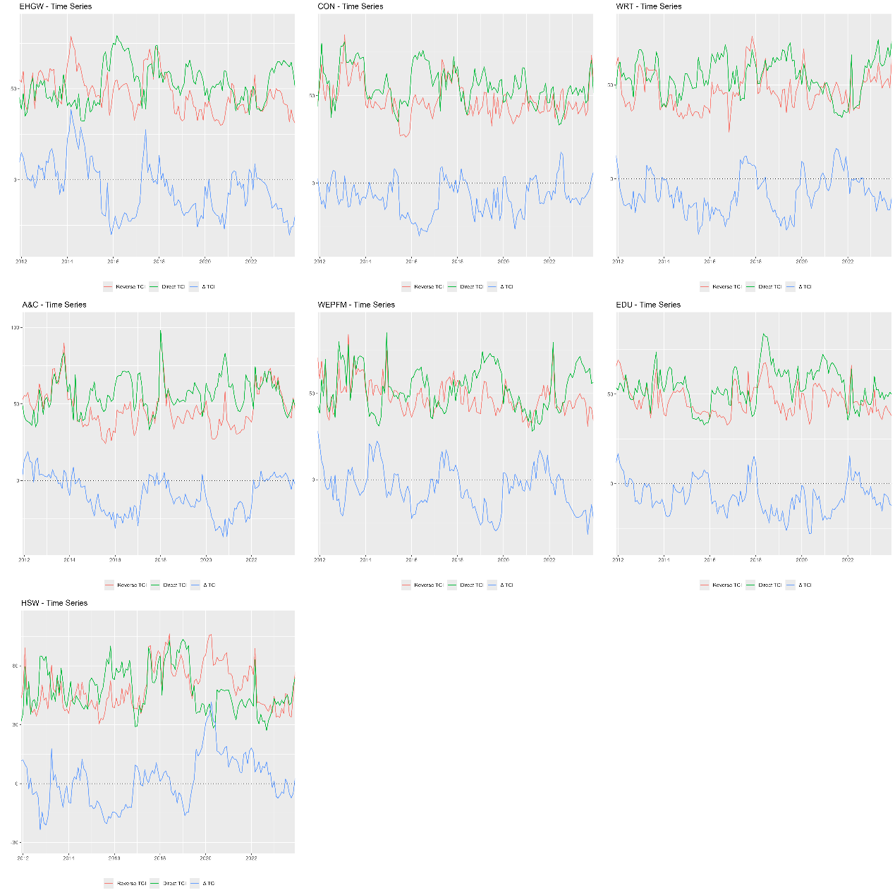
Figure A18. Dynamic quantile-on-quantile connectedness between GPR and the tail risk of the modern service industries.
- Forecast horizon (nfore)
  - nfore=10moths
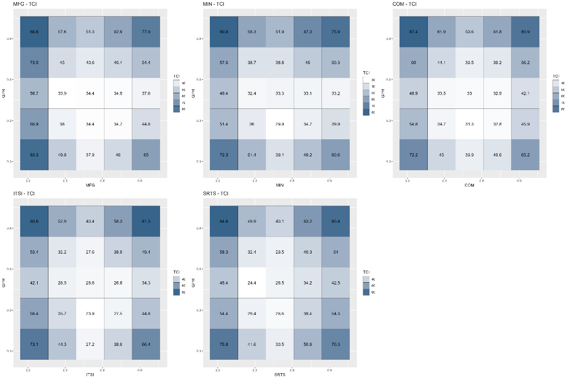
Figure A19. Average quantile-on-quantile connectedness between GPR and the tail risk of the dominant industries.
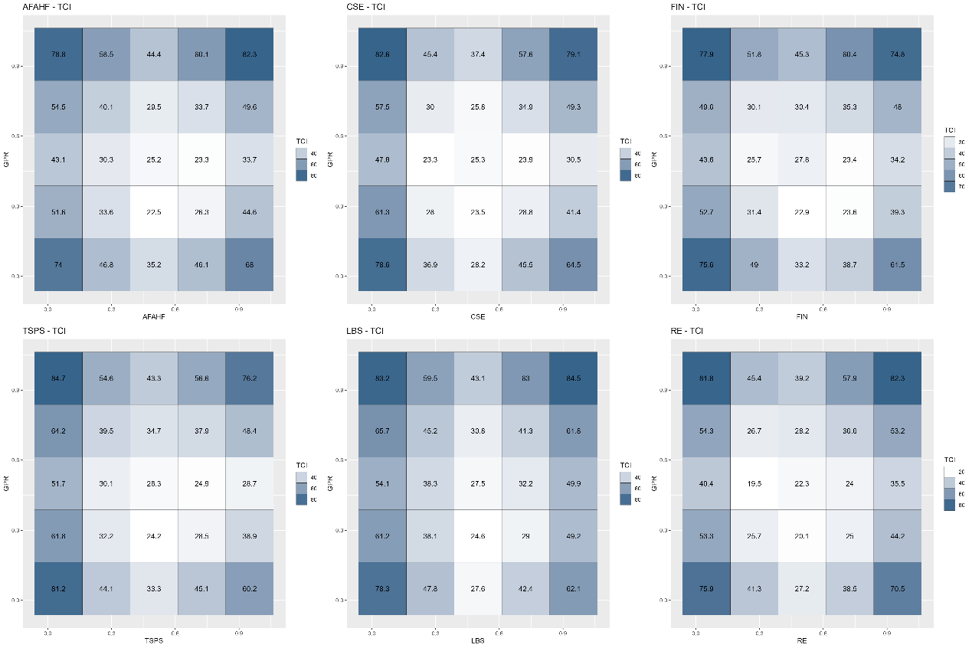
Figure A20. Average quantile-on-quantile connectedness between GPR and the tail risk of the basic support industries.
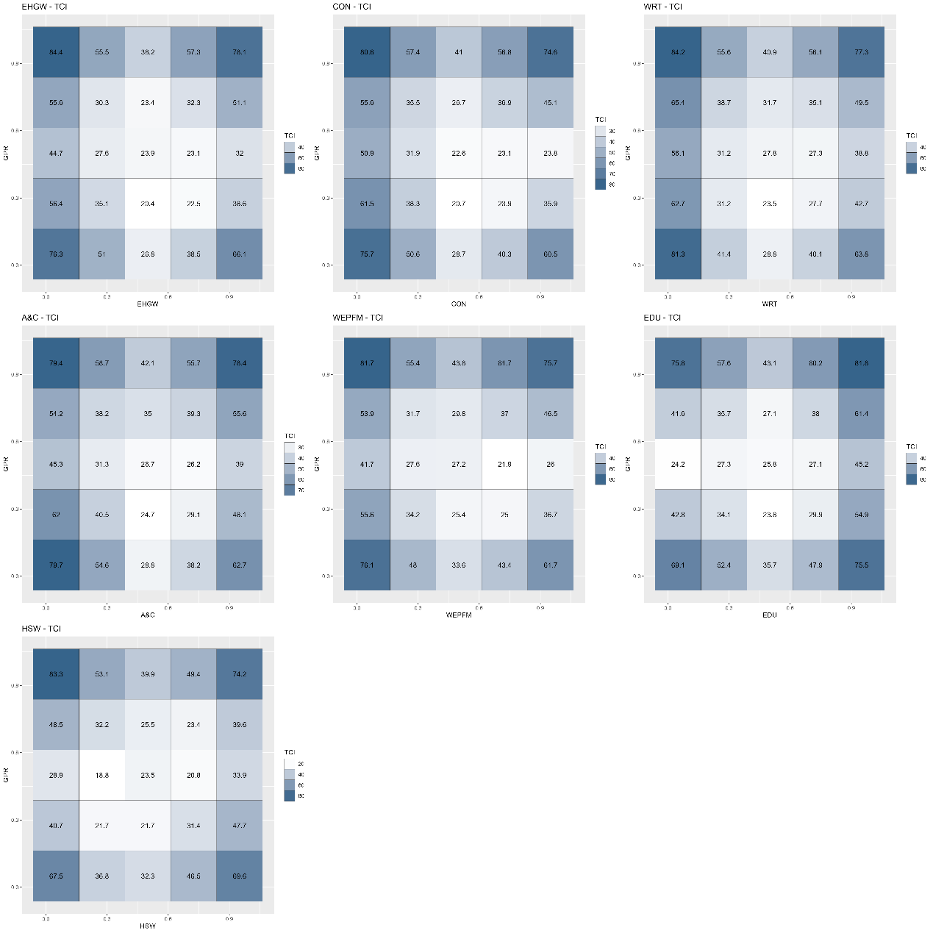
Figure A21. Average quantile-on-quantile connectedness between GPR and the tail risk of the modern service industries.
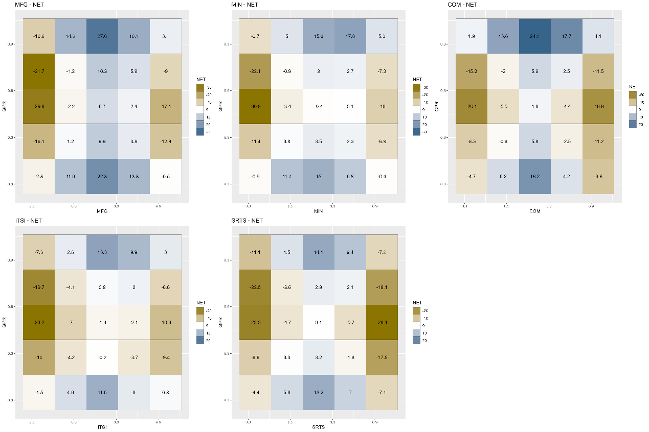
Figure A22. Net quantile-on-quantile connectedness between GPR and the tail risk of the dominant industries.
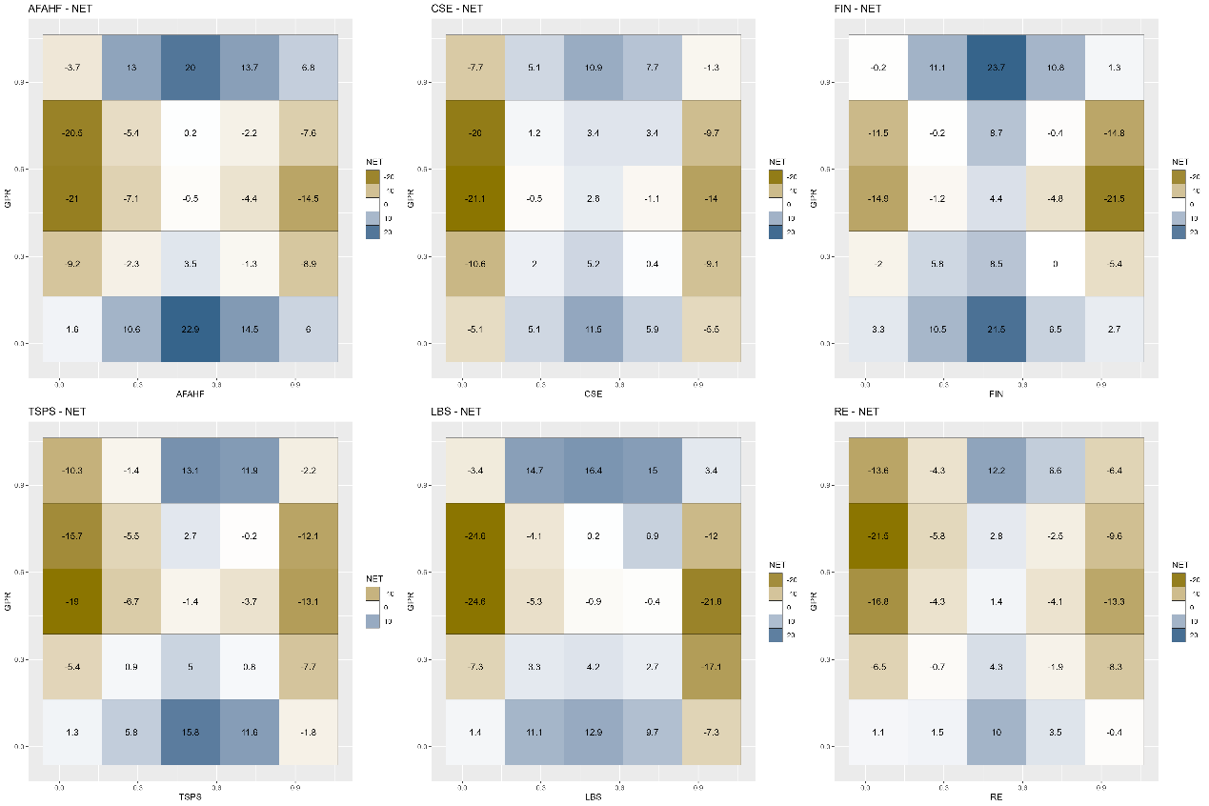
Figure A23. Net quantile-on-quantile connectedness between GPR and the tail risk of the basic support industries.
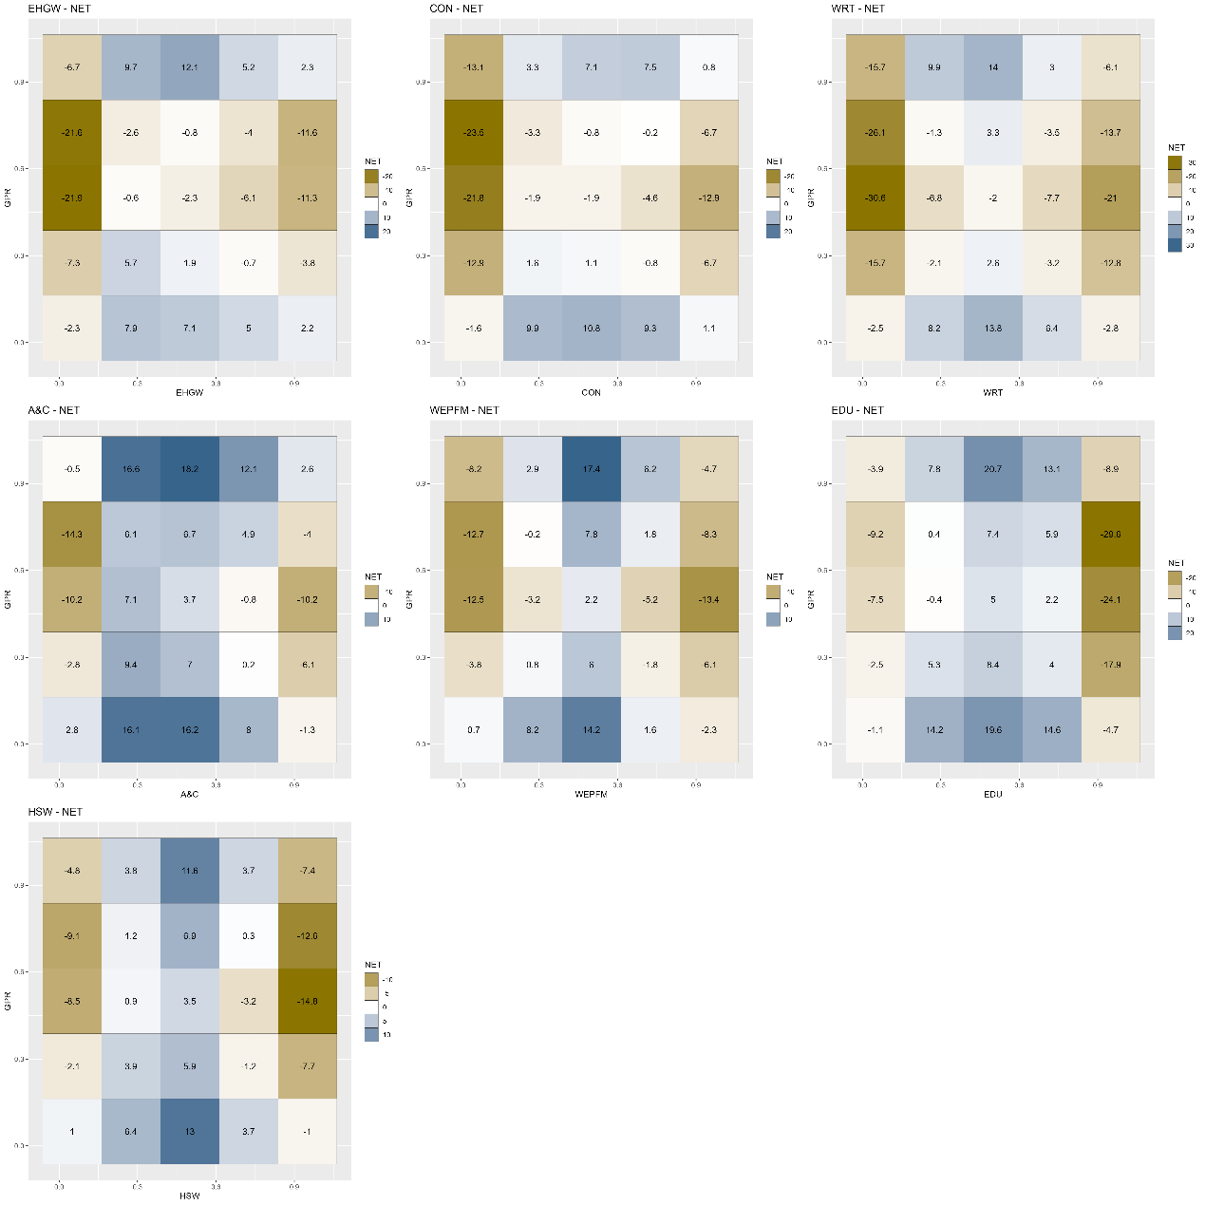
Figure A24. Net quantile-on-quantile connectedness between GPR and the tail risk of the modern service industries.
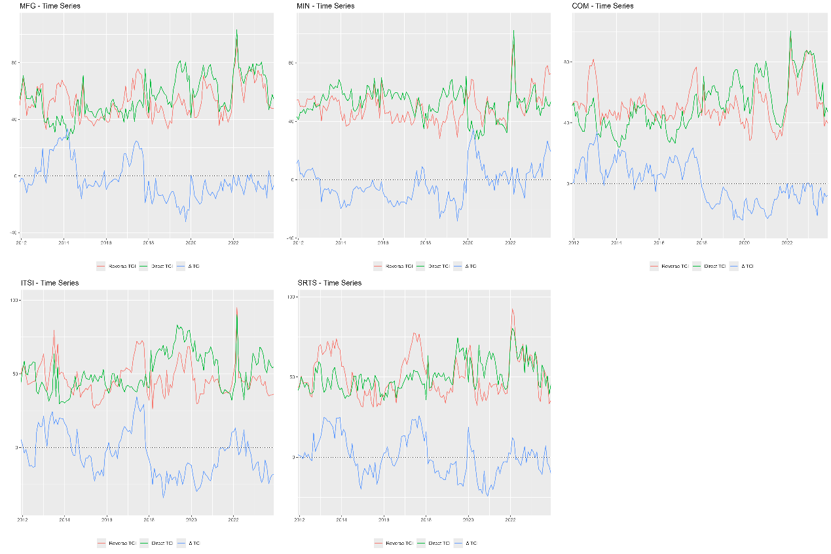
Figure A25. Dynamic quantile-on-quantile connectedness between GPR and the tail risk of the dominant industries.
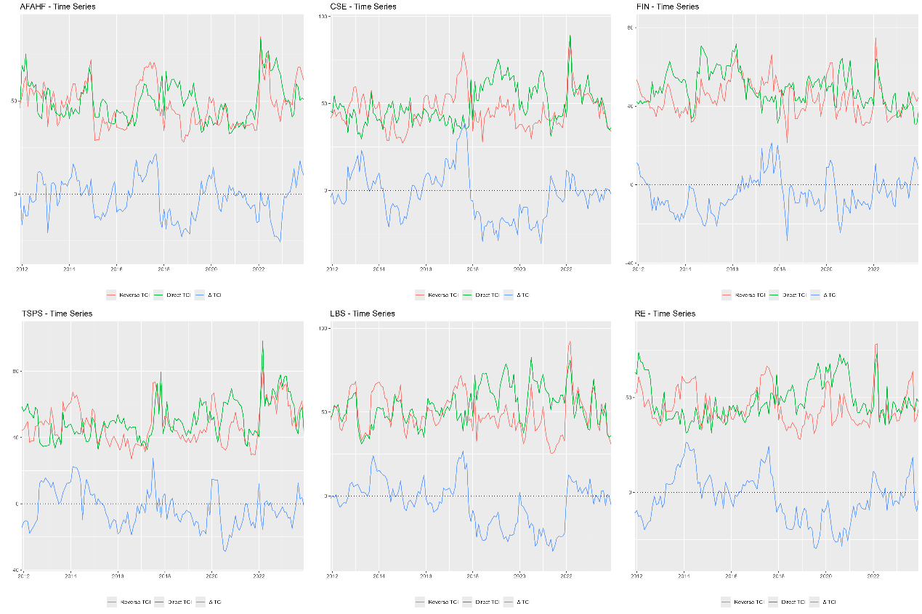
Figure A26. Dynamic quantile-on-quantile connectedness between GPR and the tail risk of the basic support industries.
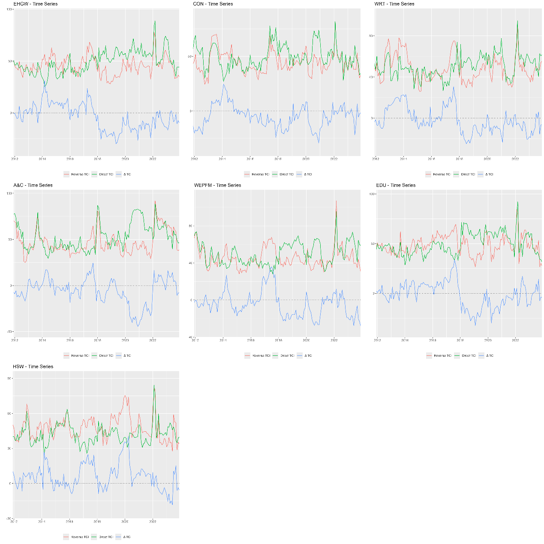
Figure A27. Dynamic quantile-on-quantile connectedness between GPR and the tail risk of the modern service industries.
  - nfore=30moths
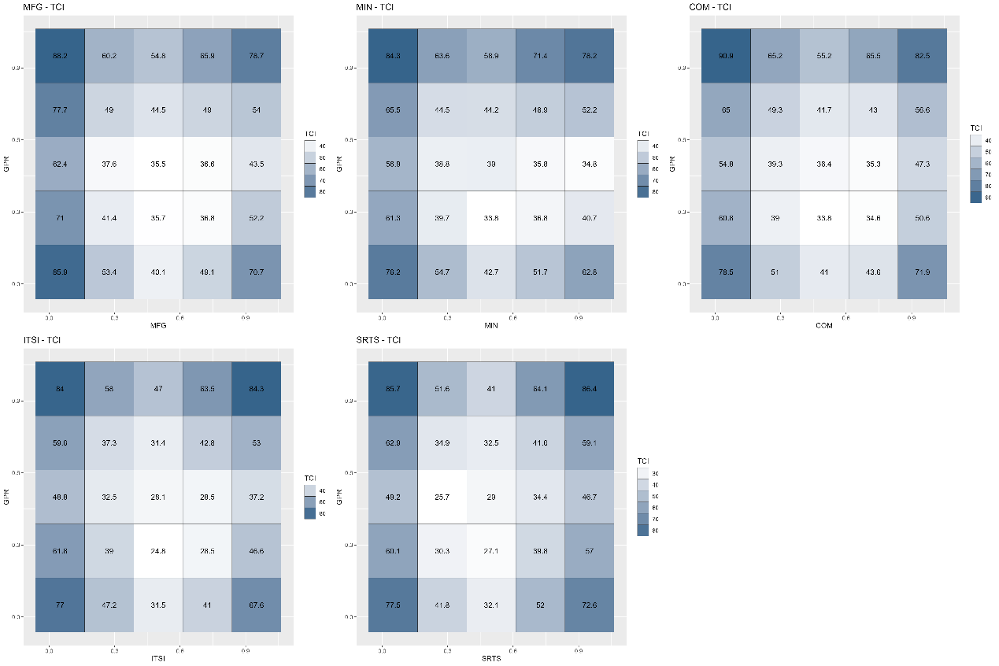
Figure A28. Average quantile-on-quantile connectedness between GPR and the tail risk of the dominant industries.
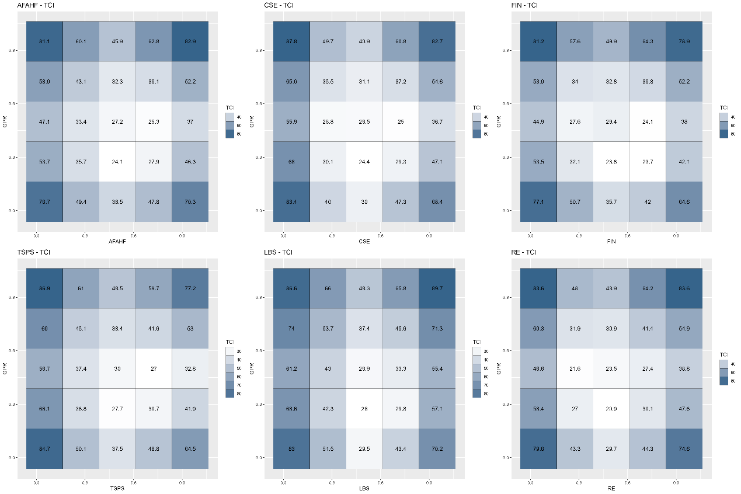
Figure A29. Average quantile-on-quantile connectedness between GPR and the tail risk of the basic support industries.
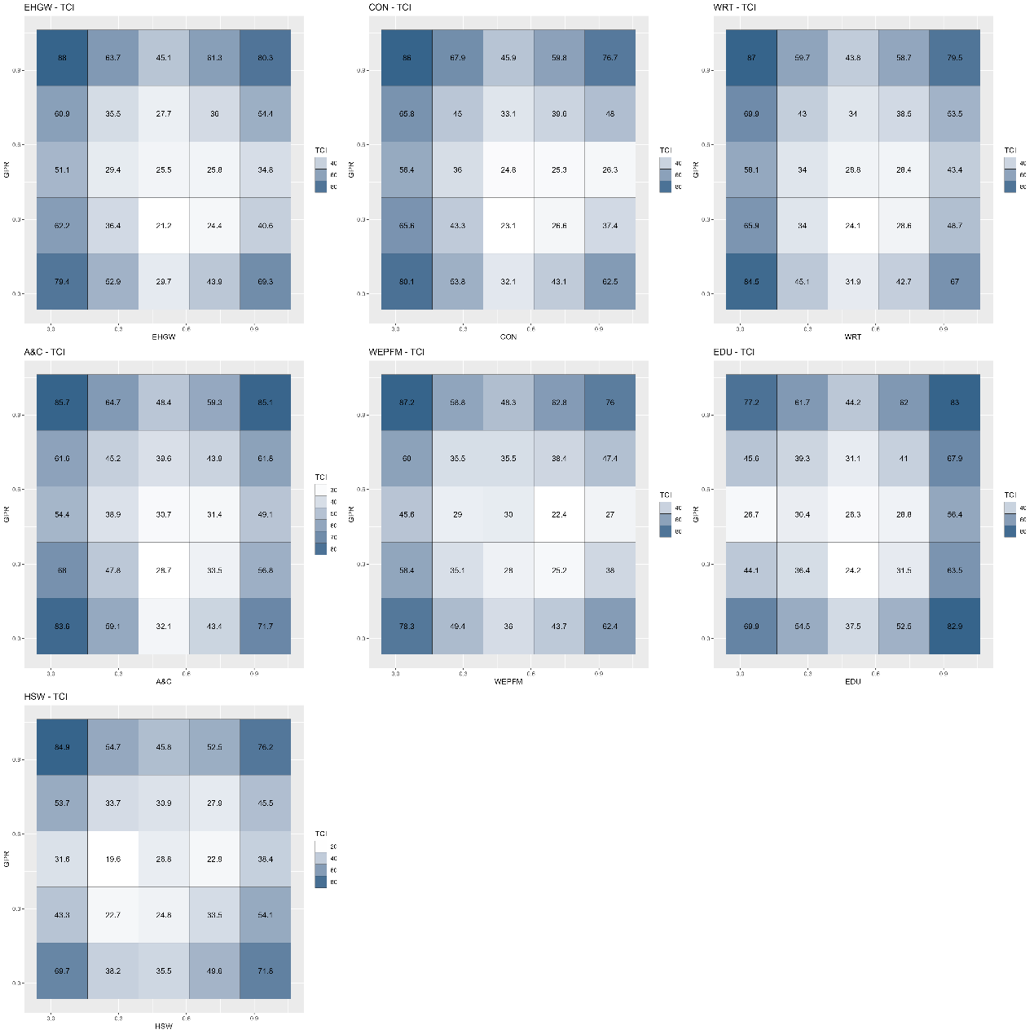
Figure A30. Average quantile-on-quantile connectedness between GPR and the tail risk of the modern service industries.
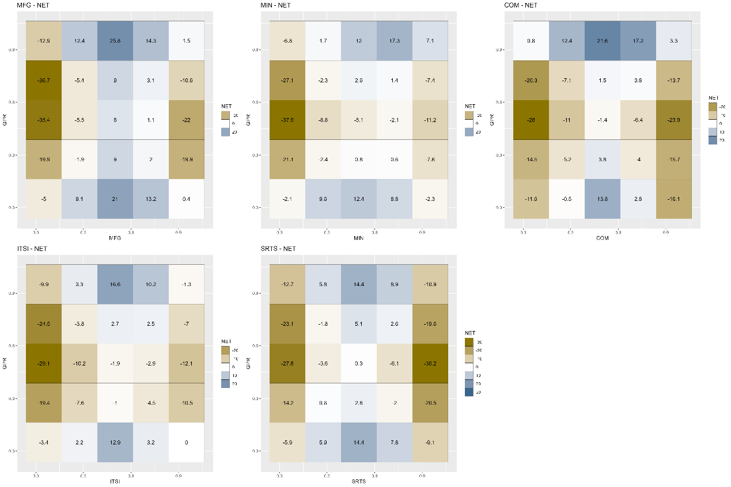
Figure A31. Net quantile-on-quantile connectedness between GPR and the tail risk of the dominant industries.
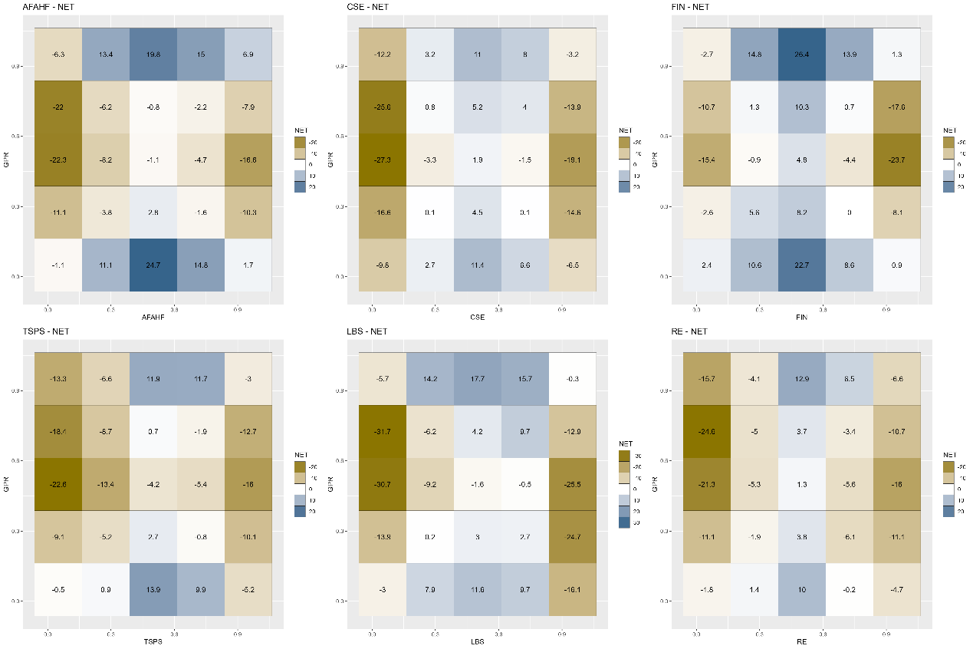
Figure A32. Net quantile-on-quantile connectedness between GPR and the tail risk of the basic support industries.
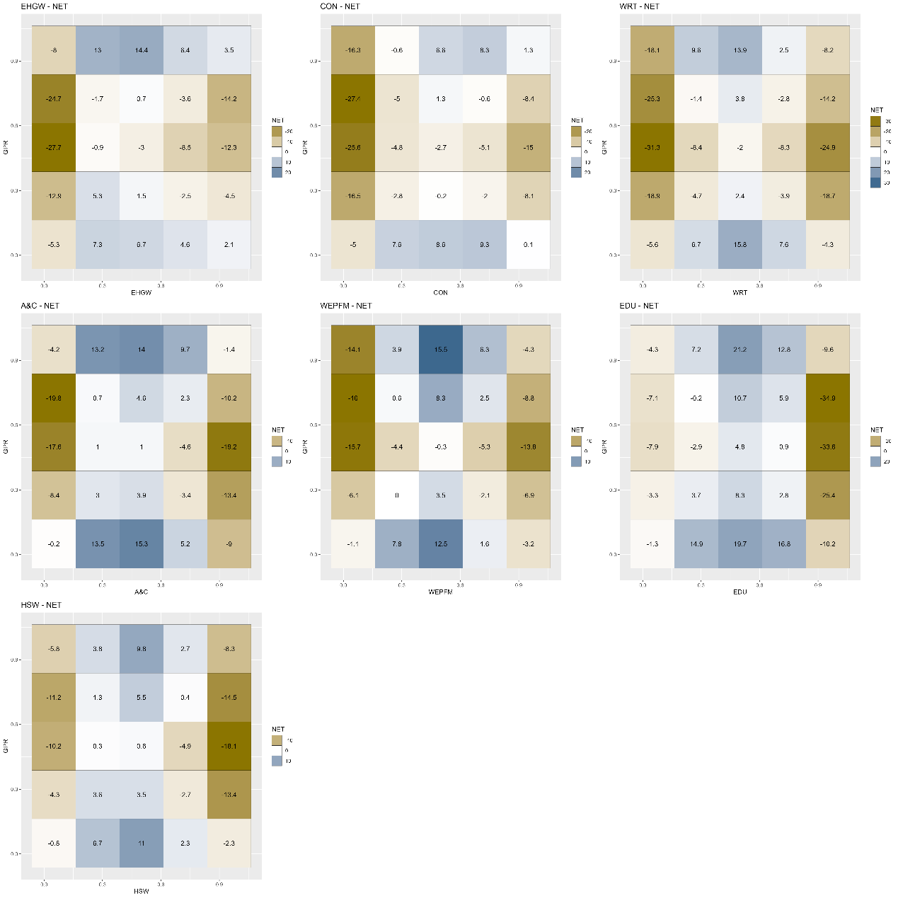
Figure A33. Net quantile-on-quantile connectedness between GPR and the tail risk of the modern service industries.
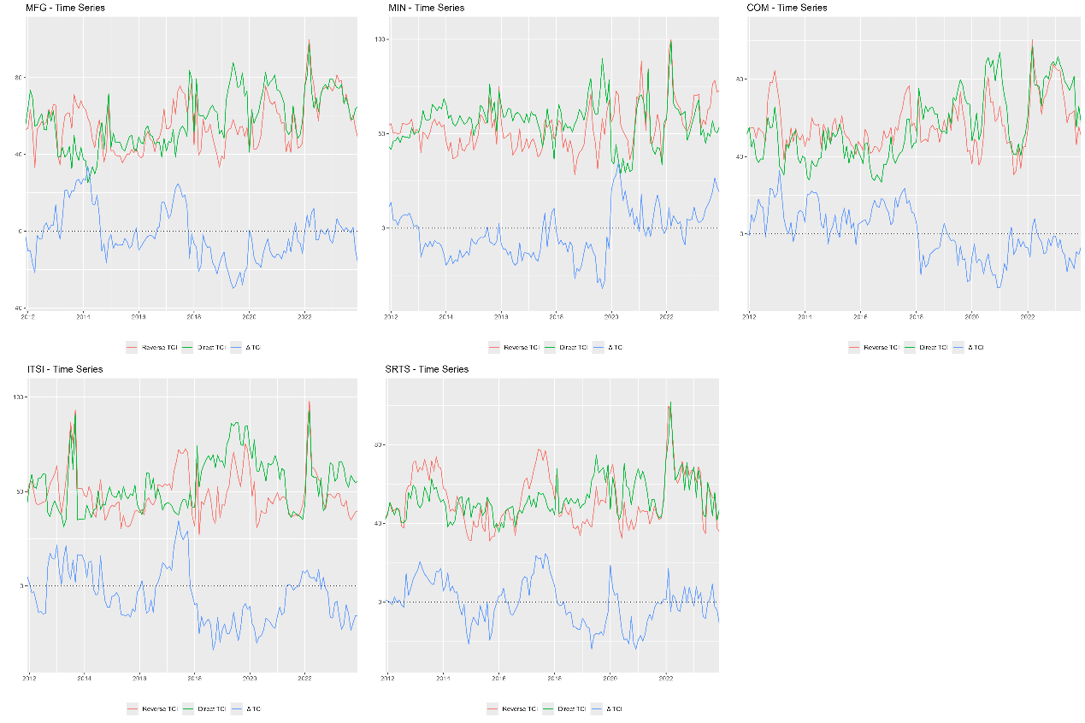
Figure A34. Dynamic quantile-on-quantile connectedness between GPR and the tail risk of the dominant industries.
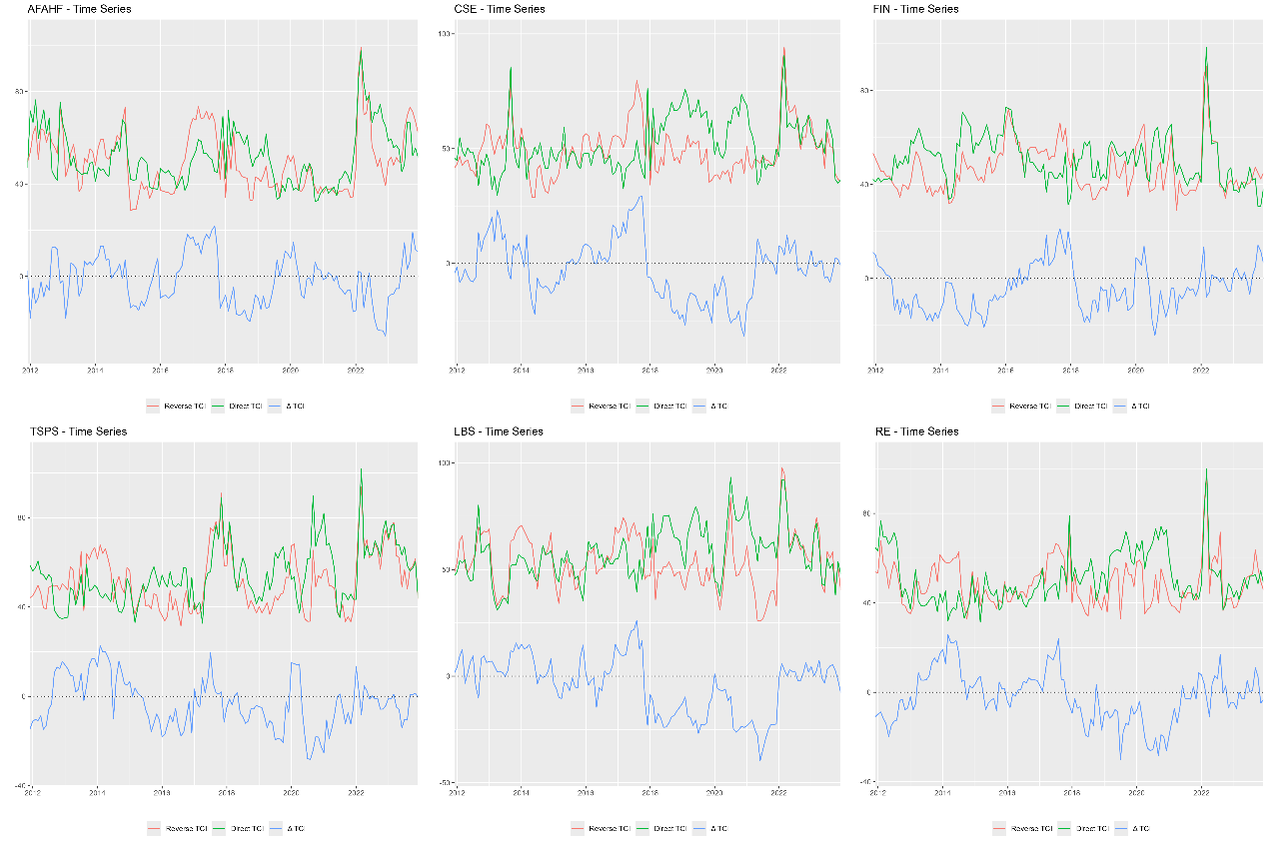
Figure A35. Dynamic quantile-on-quantile connectedness between GPR and the tail risk of the basic support industries.
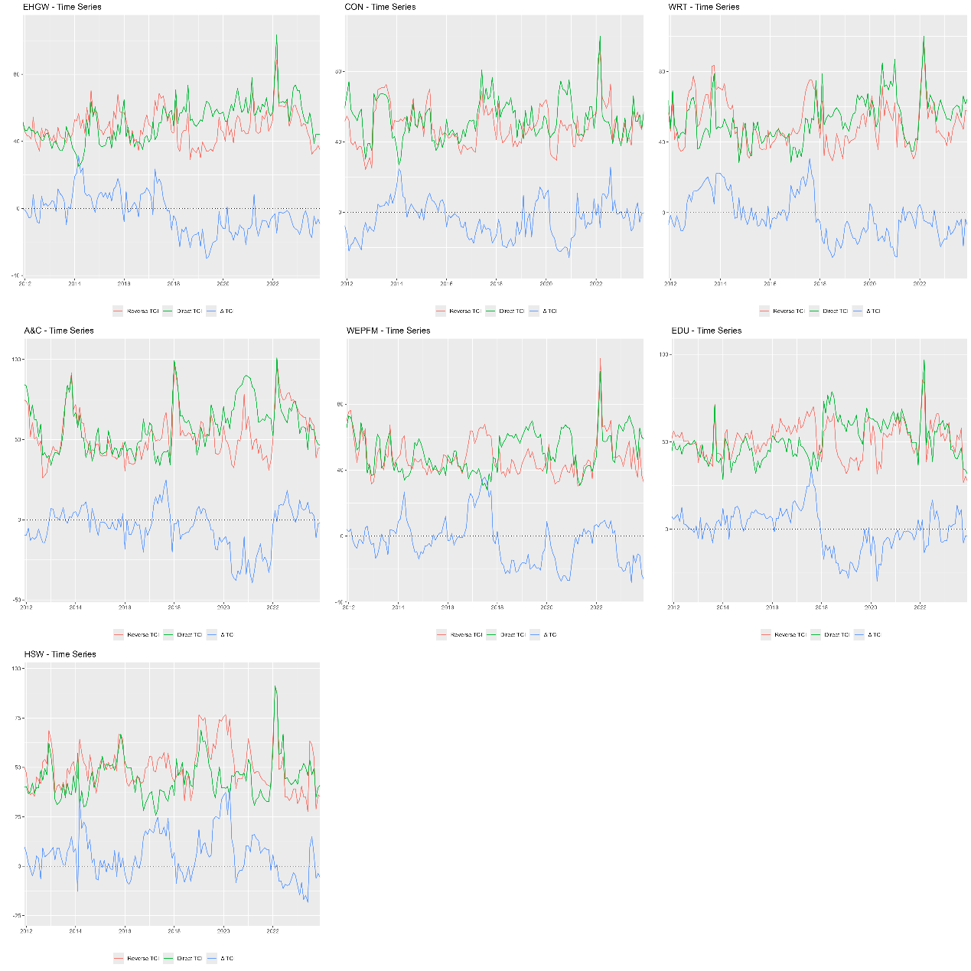
Figure A36. Dynamic quantile-on-quantile connectedness between GPR and the tail risk of the modern service industries.
- Rolling window (window.size)
  - window.size=12moths
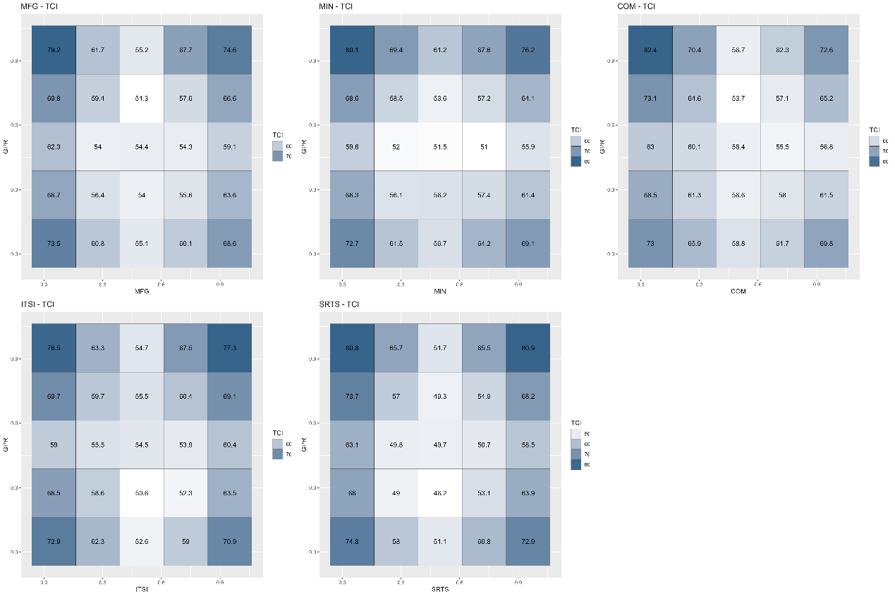
Figure A37. Average quantile-on-quantile connectedness between GPR and the tail risk of the dominant industries.
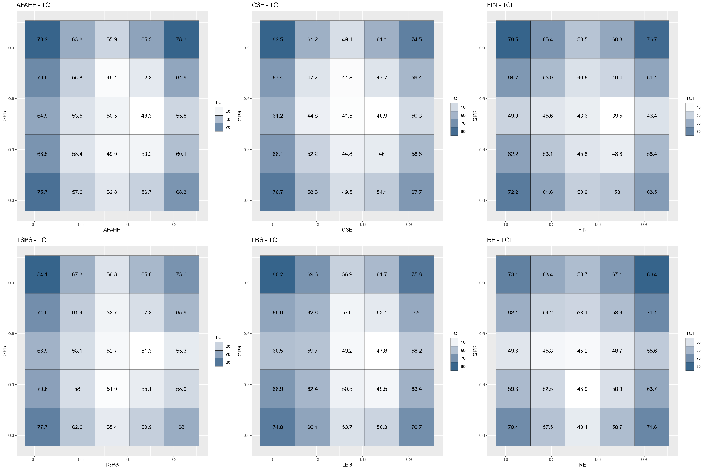
Figure A38. Average quantile-on-quantile connectedness between GPR and the tail risk of the basic support industries.
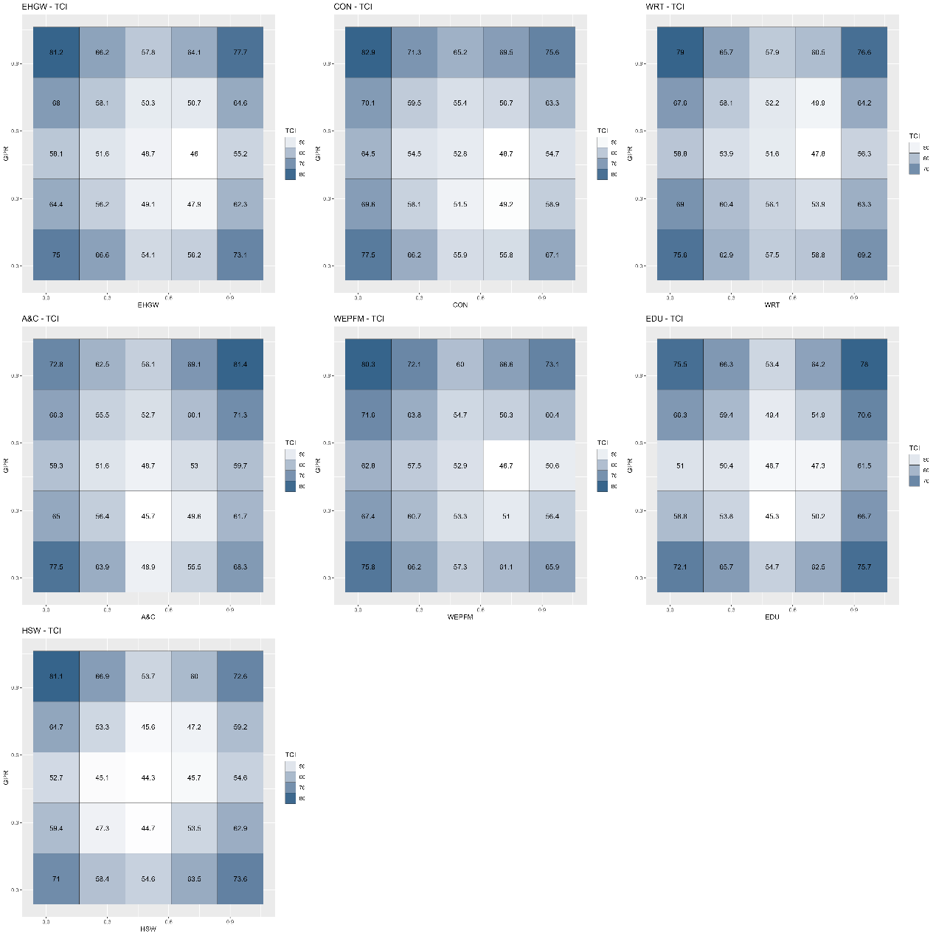
Figure A39. Average quantile-on-quantile connectedness between GPR and the tail risk of the modern service industries.
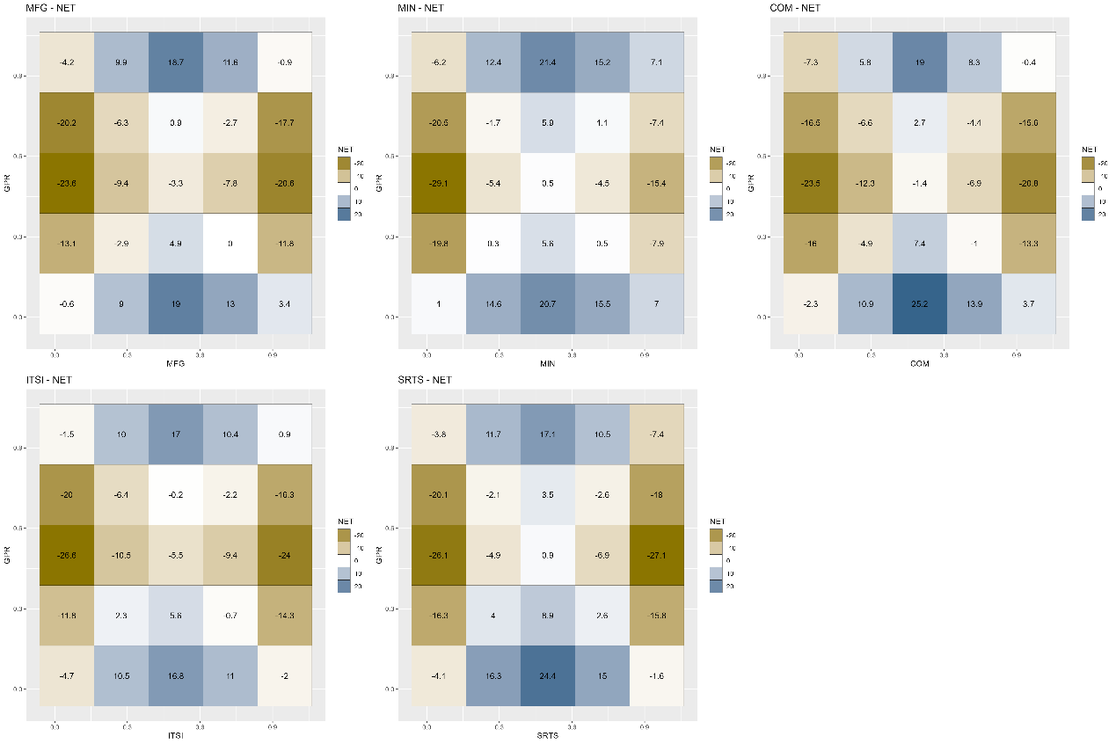
Figure A40. Net quantile-on-quantile connectedness between GPR and the tail risk of the dominant industries.
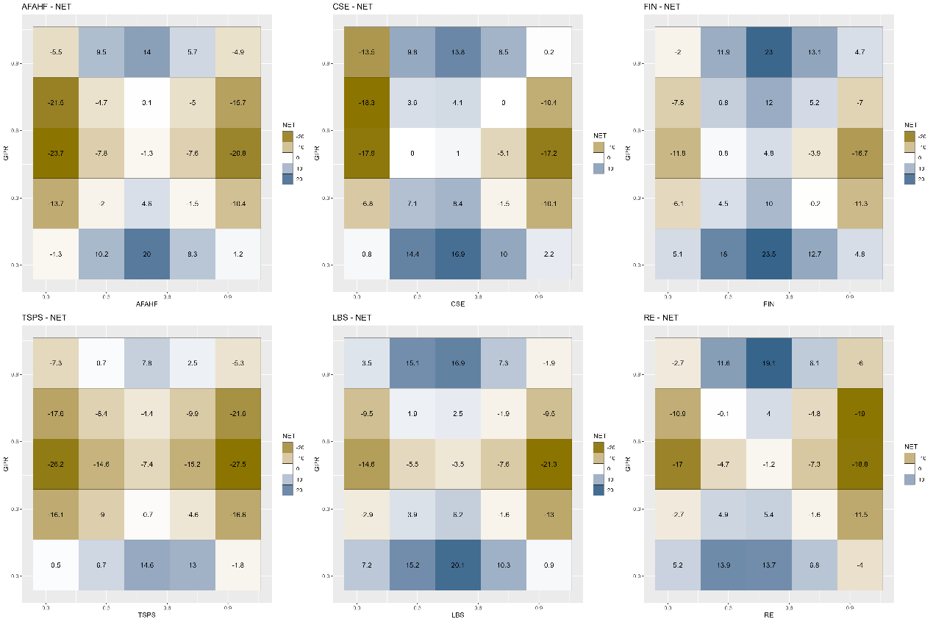
Figure A41. Net quantile-on-quantile connectedness between GPR and the tail risk of the basic support industries.
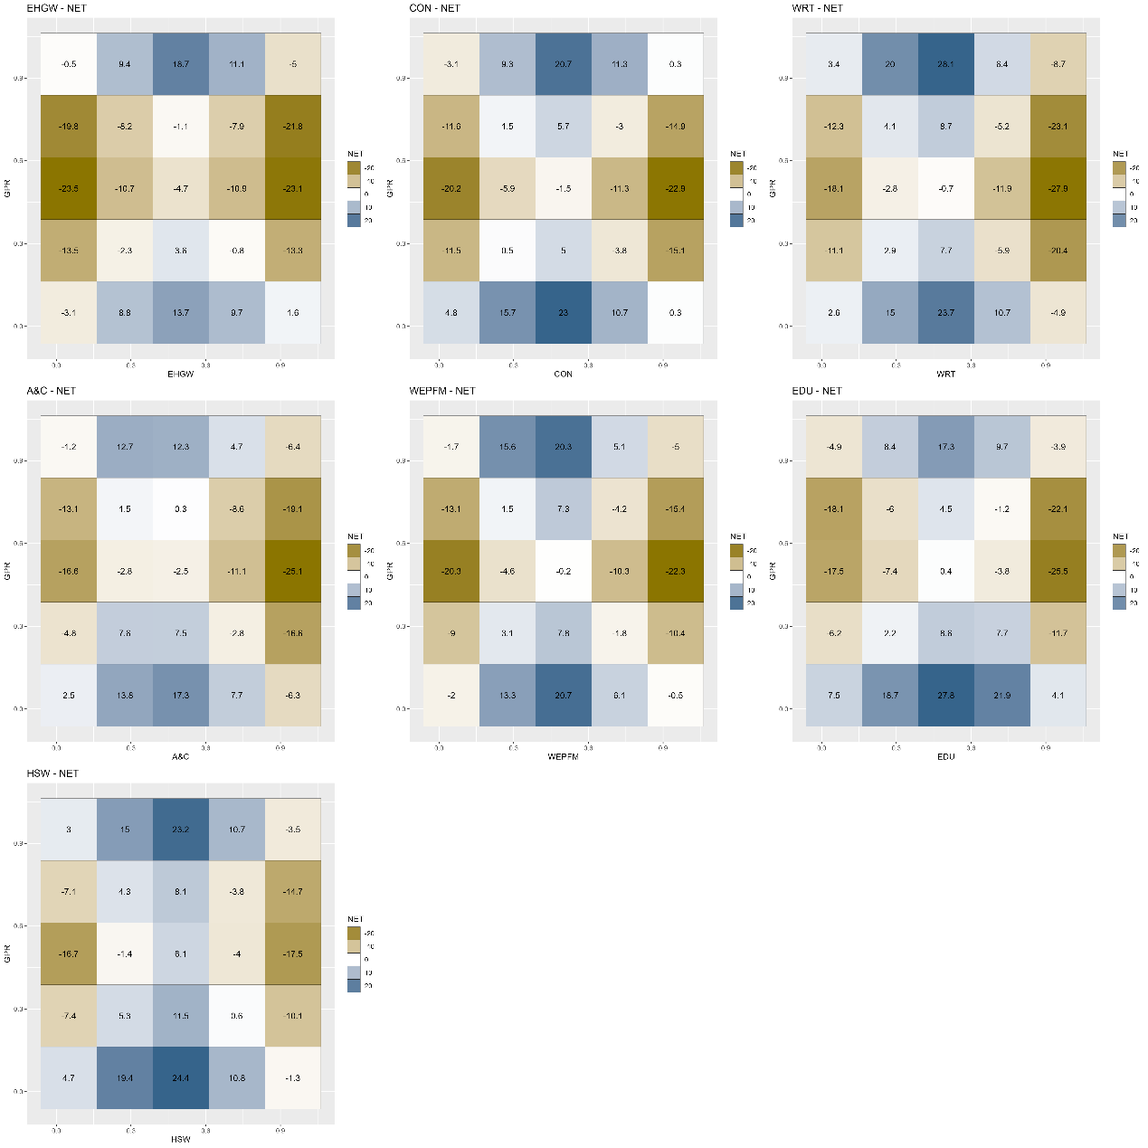
Figure A42. Net quantile-on-quantile connectedness between GPR and the tail risk of the modern service industries.
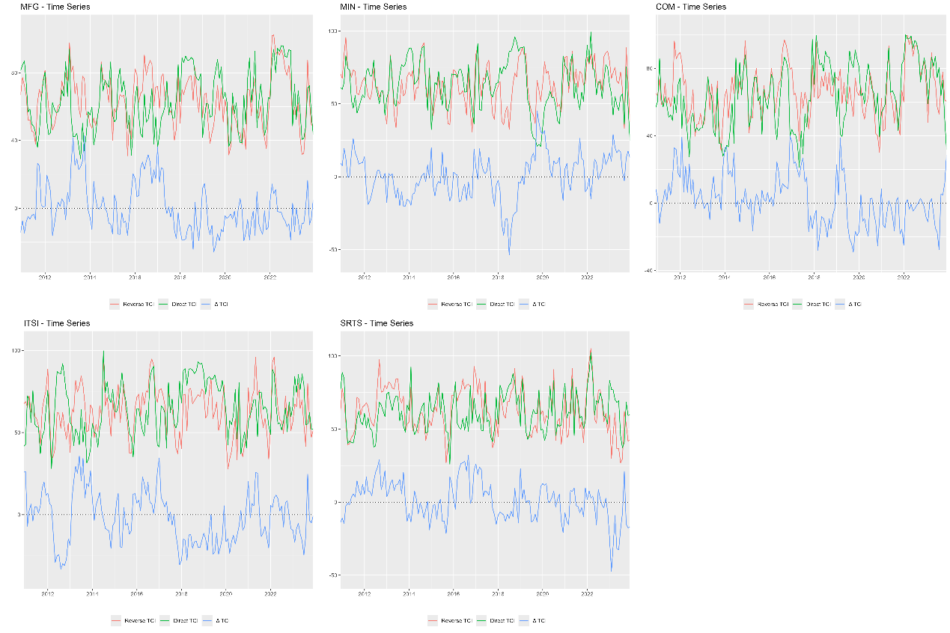
Figure A43. Dynamic quantile-on-quantile connectedness between GPR and the tail risk of the dominant industries.
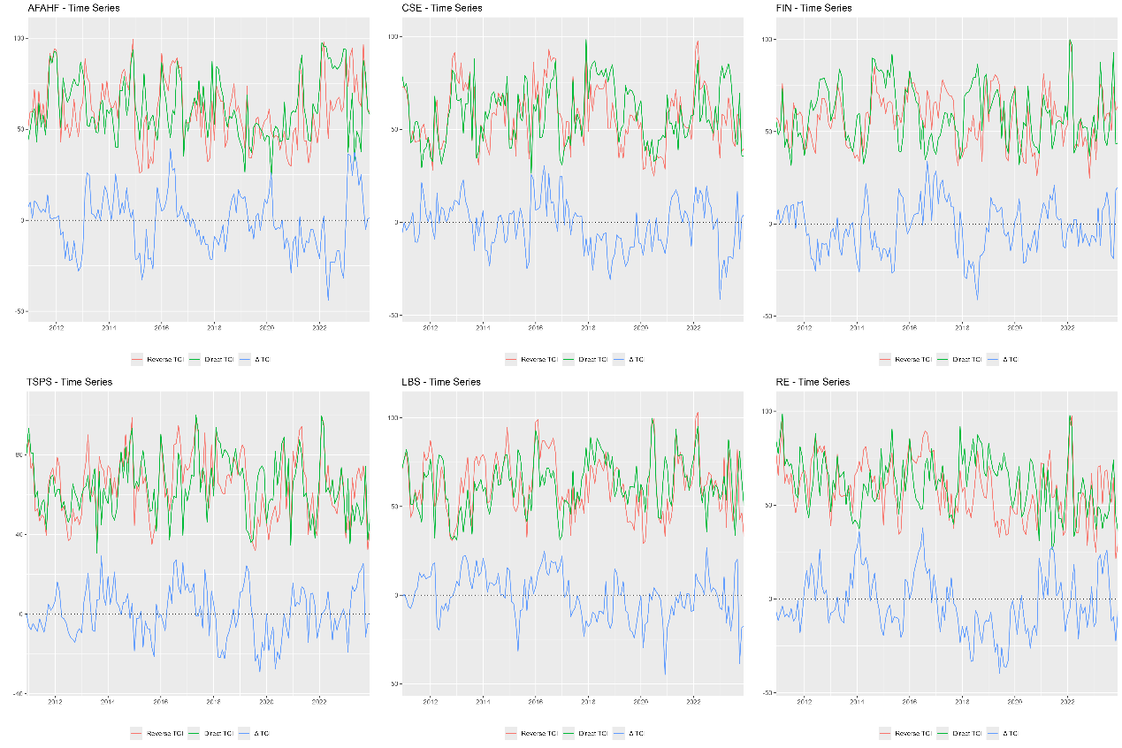
Figure A44. Dynamic quantile-on-quantile connectedness between GPR and the tail risk of the basic support industries.
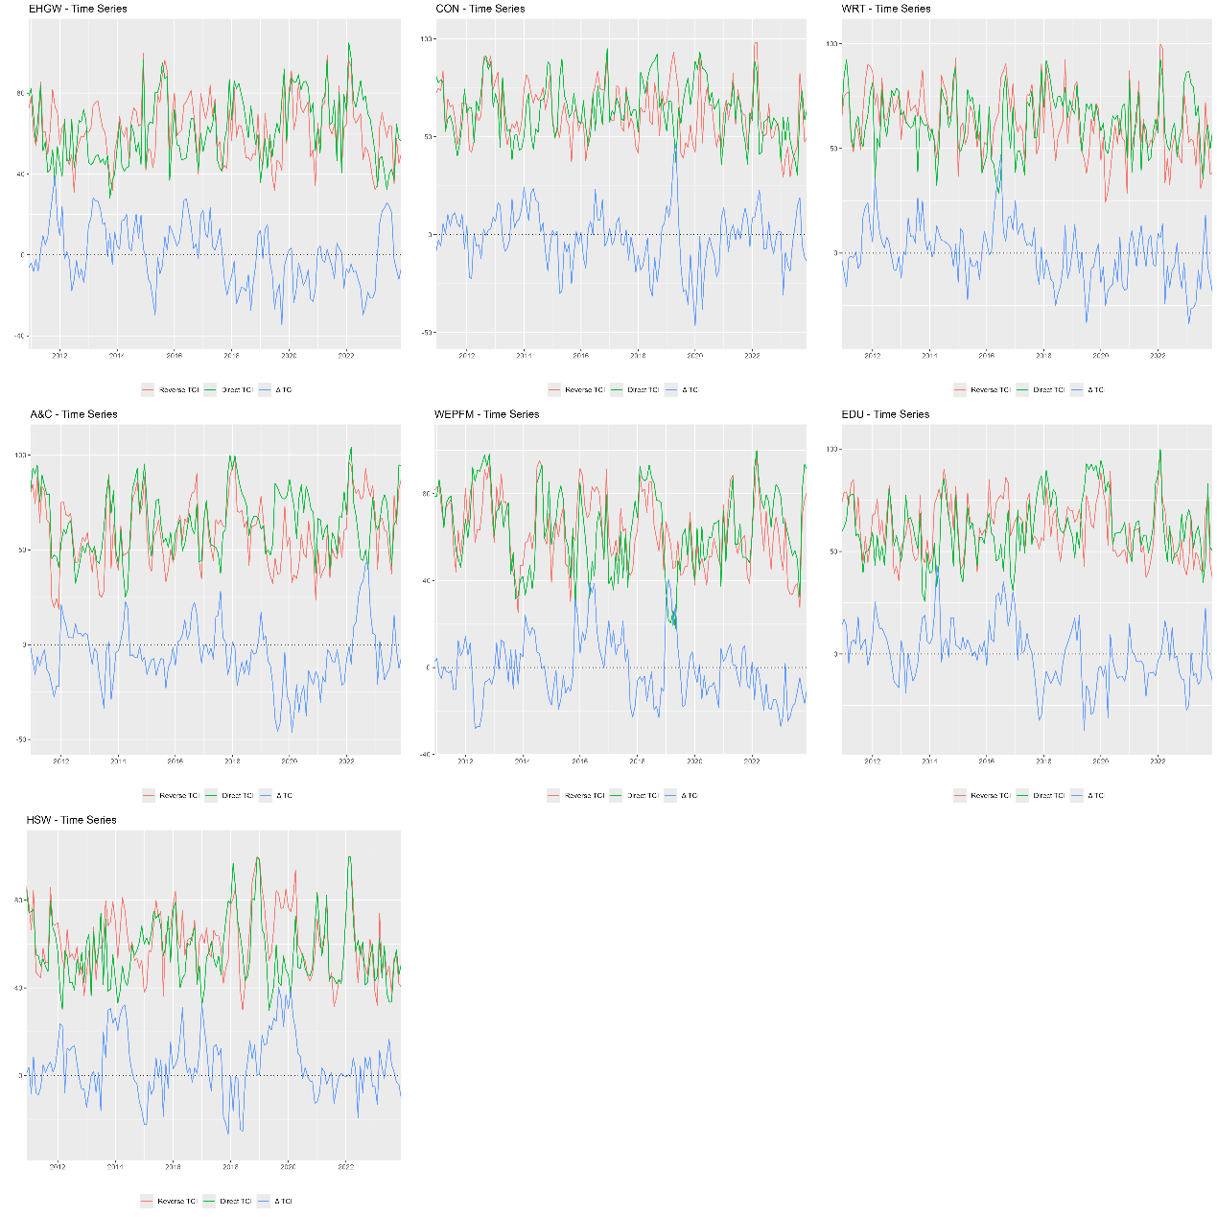
Figure A45. Dynamic quantile-on-quantile connectedness between GPR and the tail risk of the modern service industries.
  - Window.size=18moths
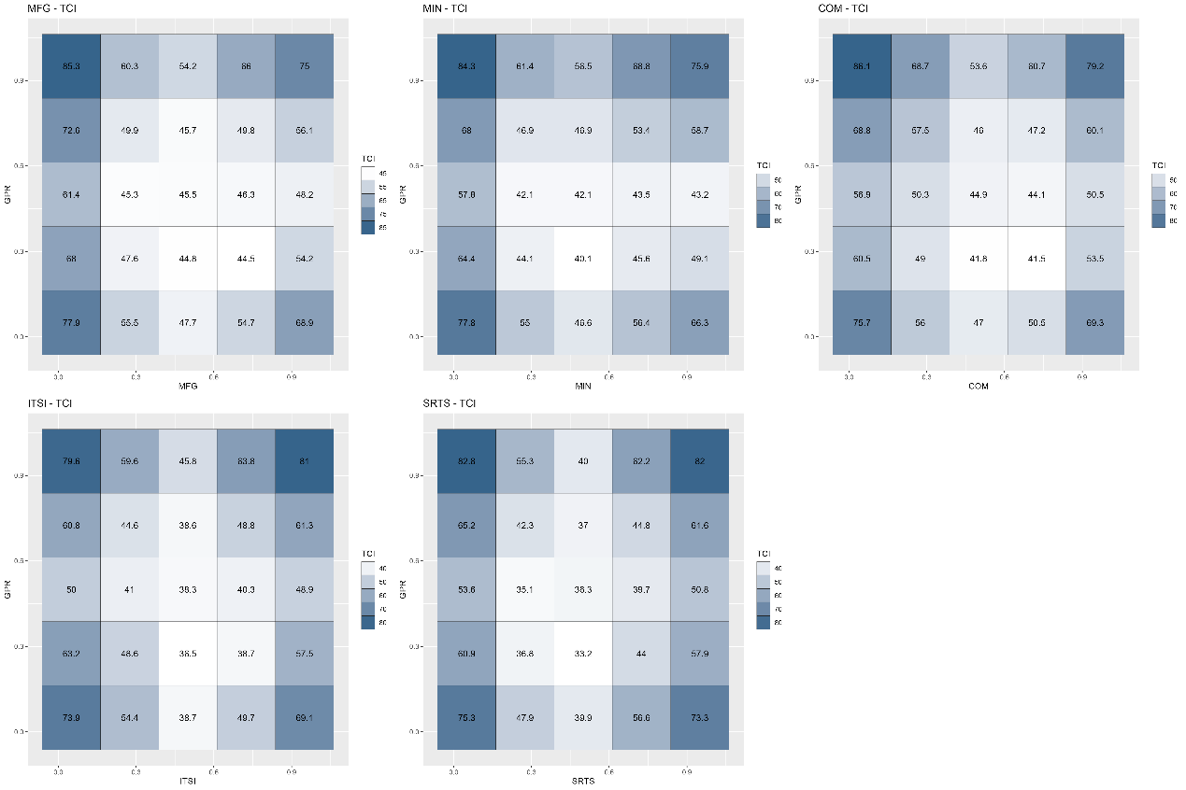
Figure A46. Average quantile-on-quantile connectedness between GPR and the tail risk of the dominant industries.
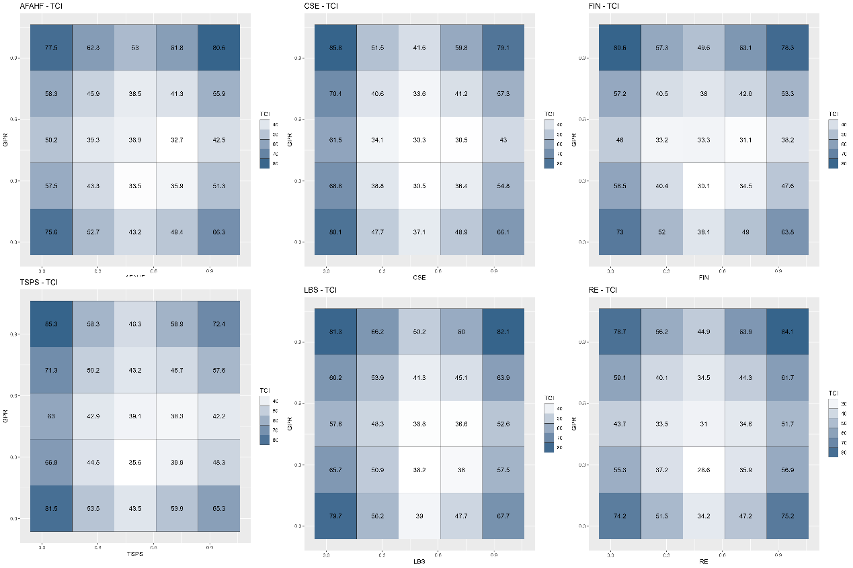
Figure A47. Average quantile-on-quantile connectedness between GPR and the tail risk of the basic support industries.
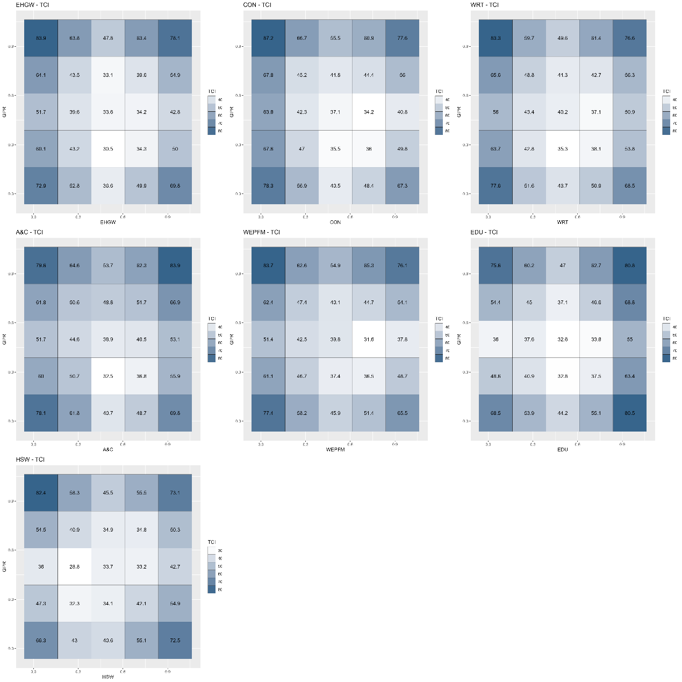
Figure A48. Average quantile-on-quantile connectedness between GPR and the tail risk of the modern service industries.
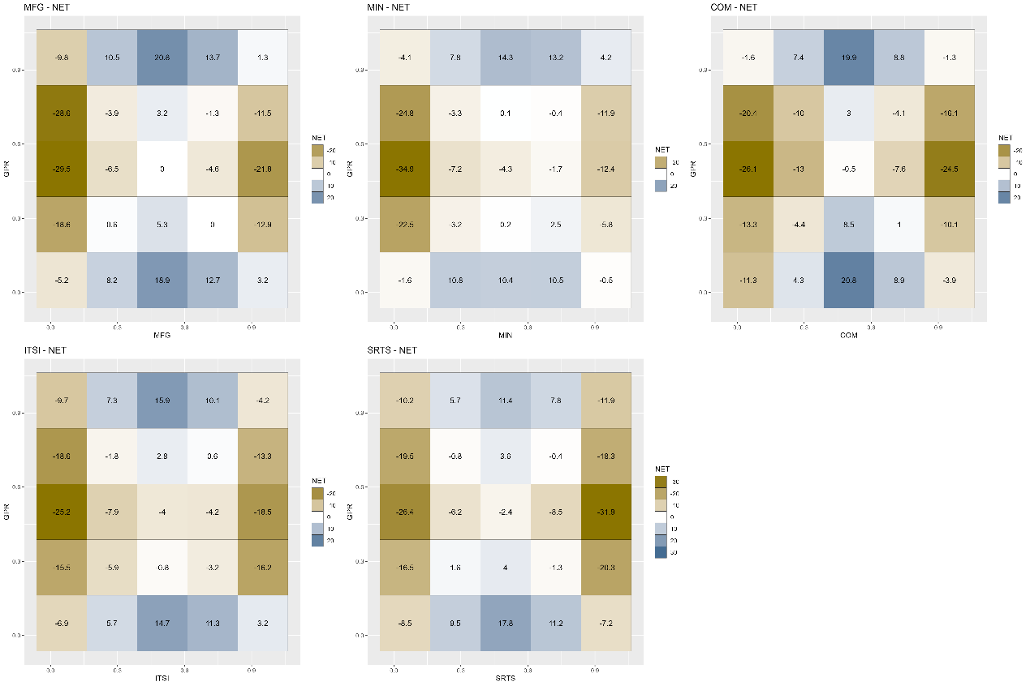
Figure A49. Net quantile-on-quantile connectedness between GPR and the tail risk of the dominant industries.
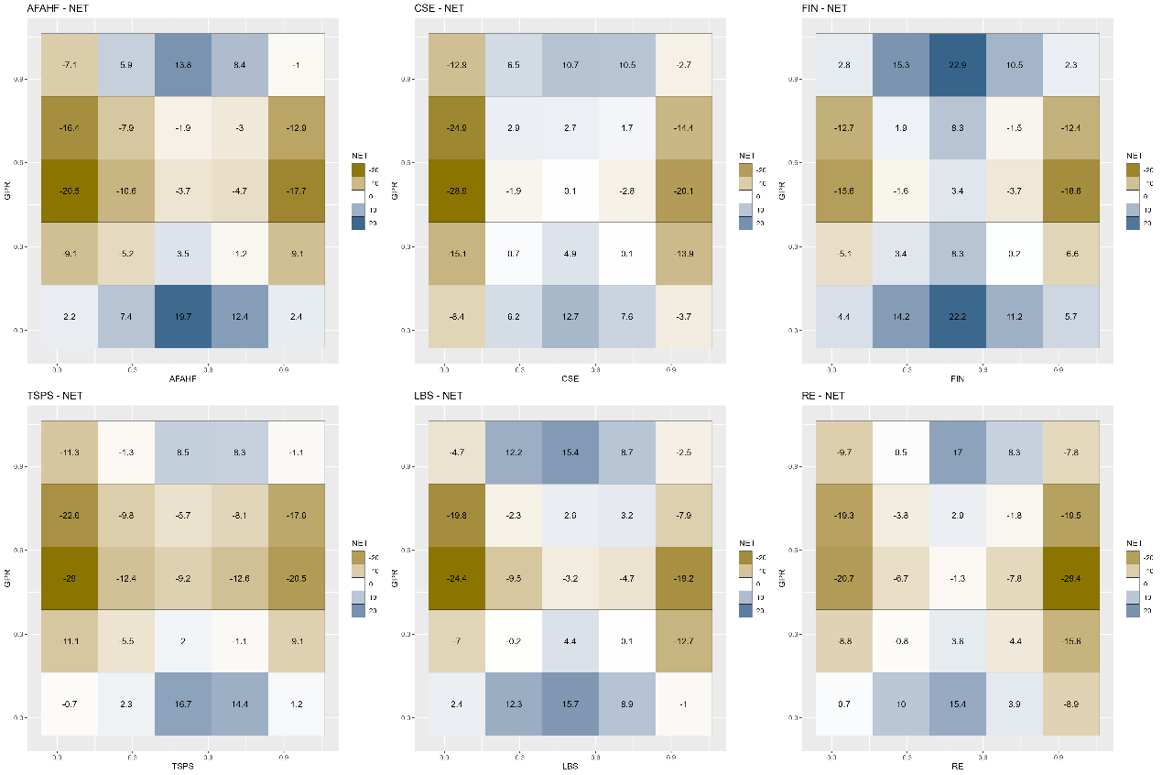
Figure A50. Net quantile-on-quantile connectedness between GPR and the tail risk of the basic support industries.
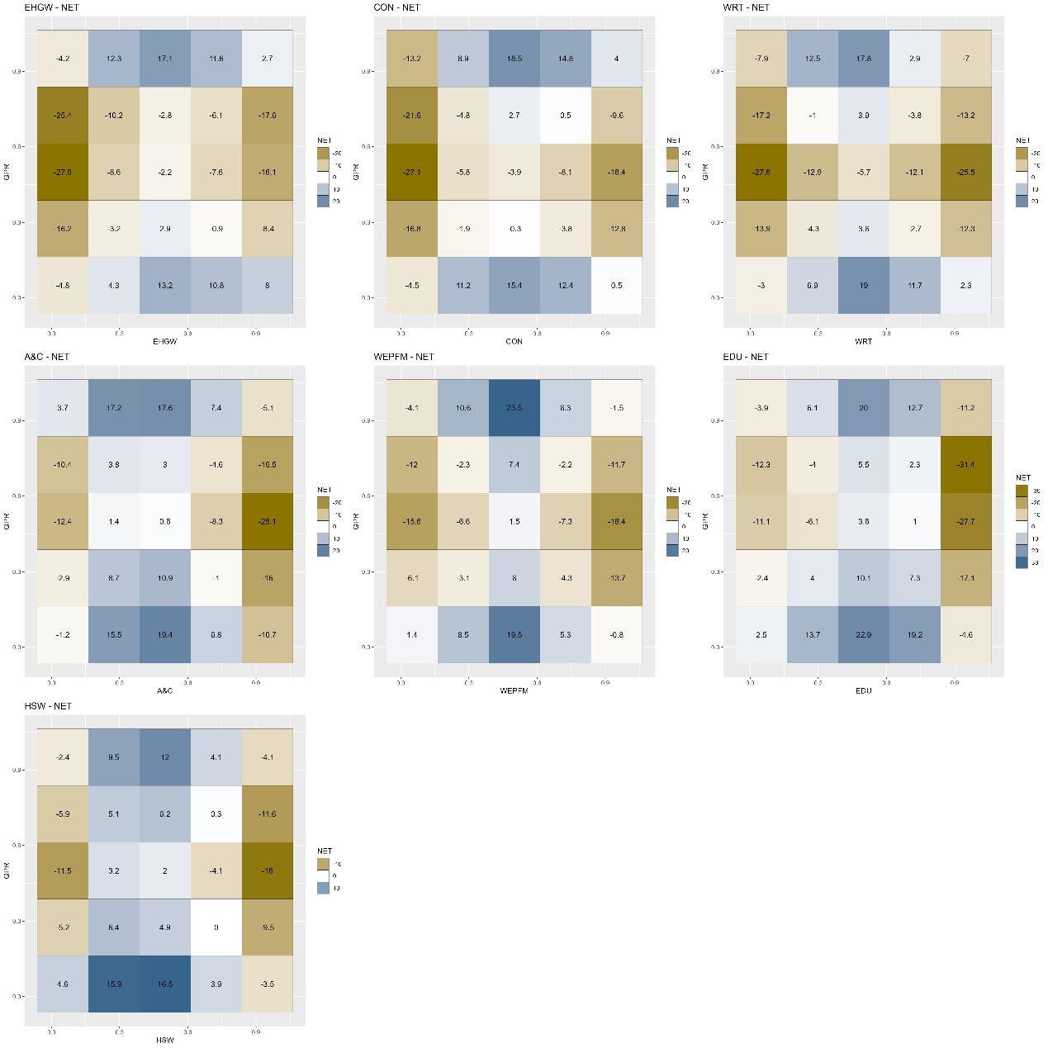
Figure A51. Net quantile-on-quantile connectedness between GPR and the tail risk of the modern service industries.
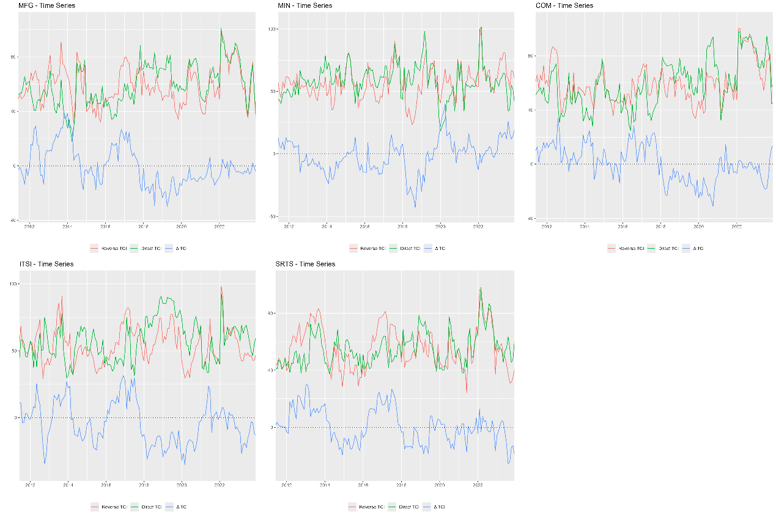
Figure A52. Dynamic quantile-on-quantile connectedness between GPR and the tail risk of the dominant industries.
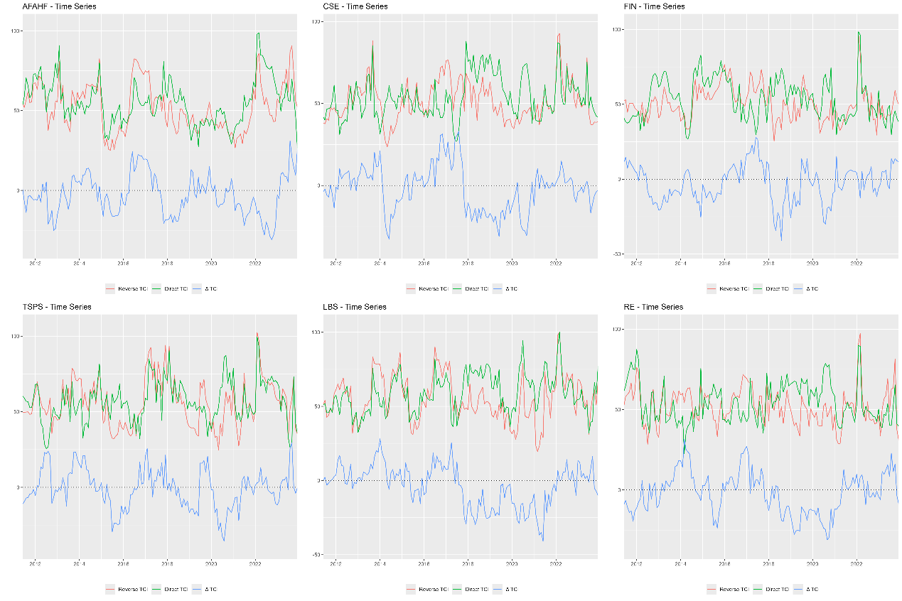
Figure A53. Dynamic quantile-on-quantile connectedness between GPR and the tail risk of the basic support industries.
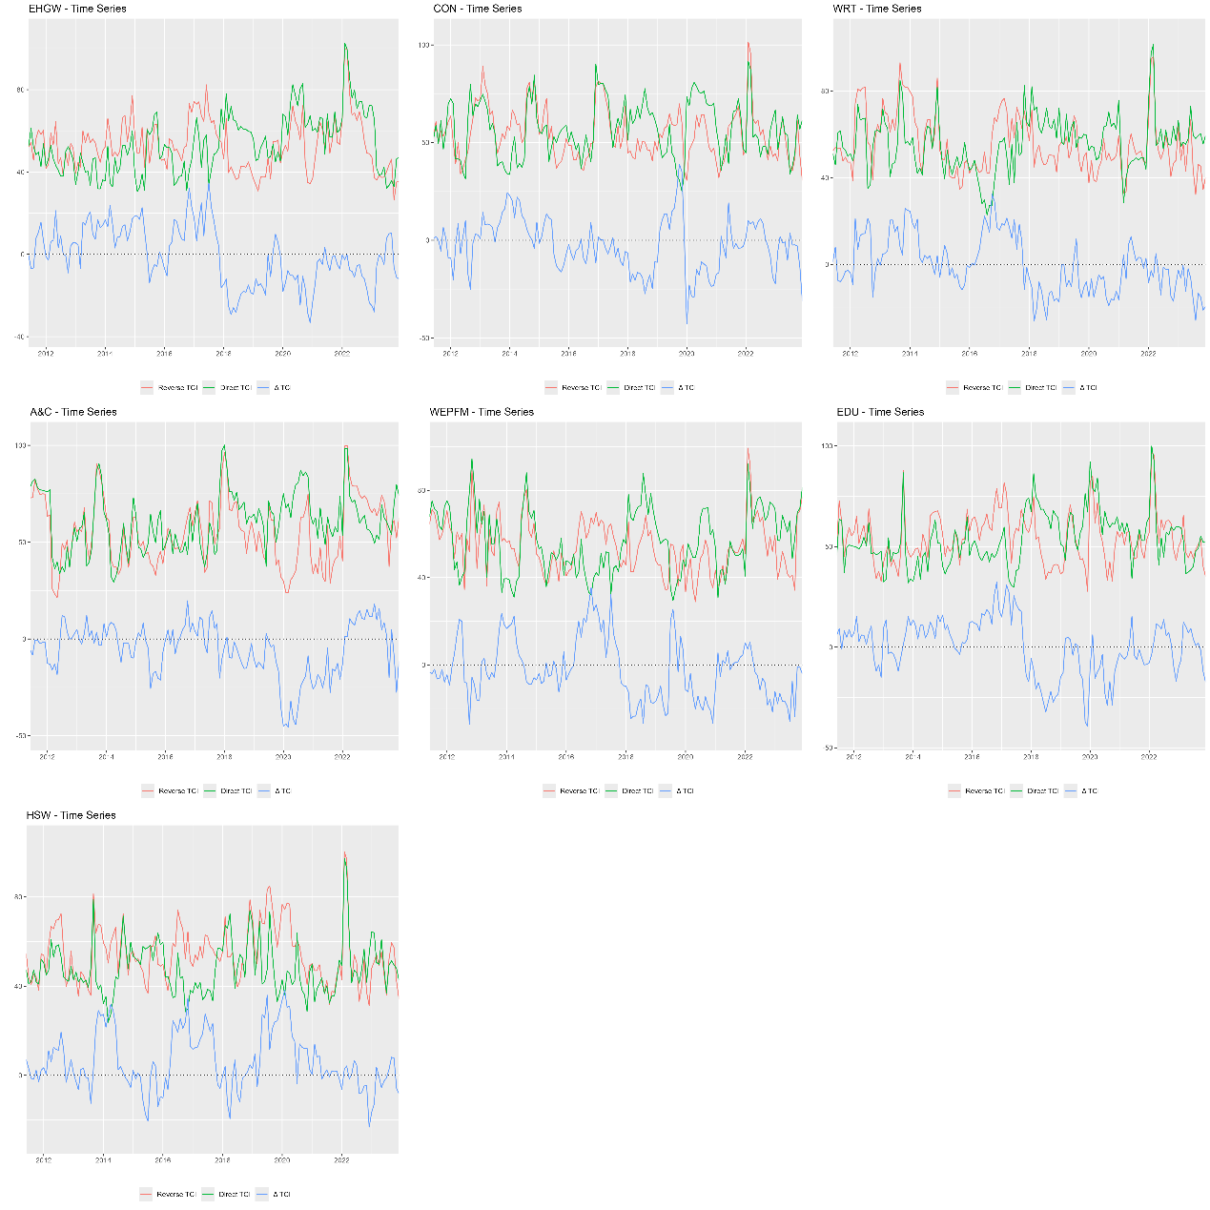
Figure A54. Dynamic quantile-on-quantile connectedness between GPR and the tail risk of the modern service industries.
  - Window.size=36moths
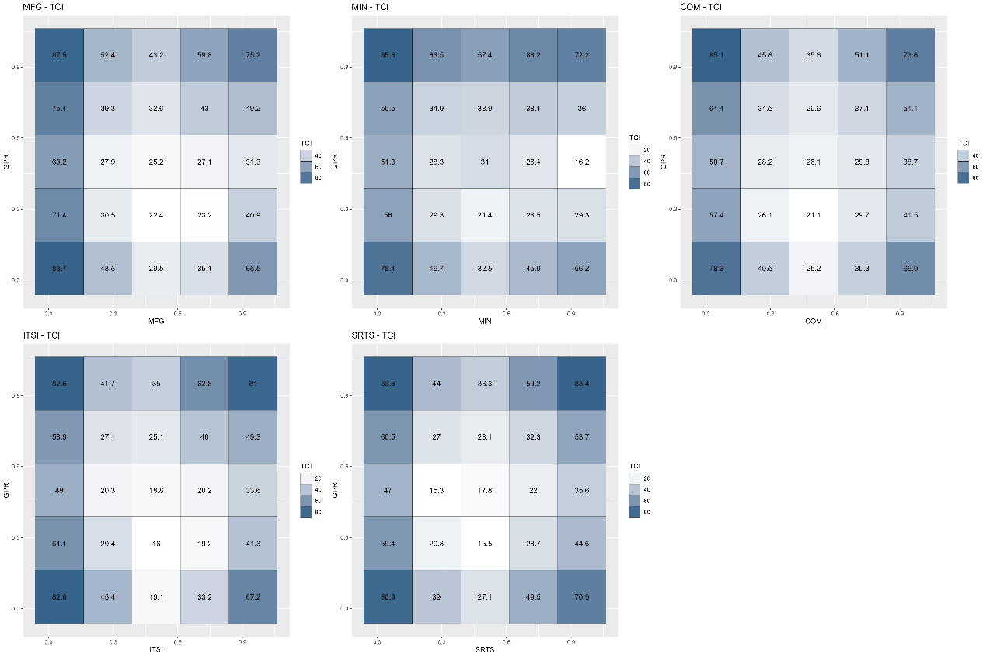
Figure A55. Average quantile-on-quantile connectedness between GPR and the tail risk of the dominant industries.
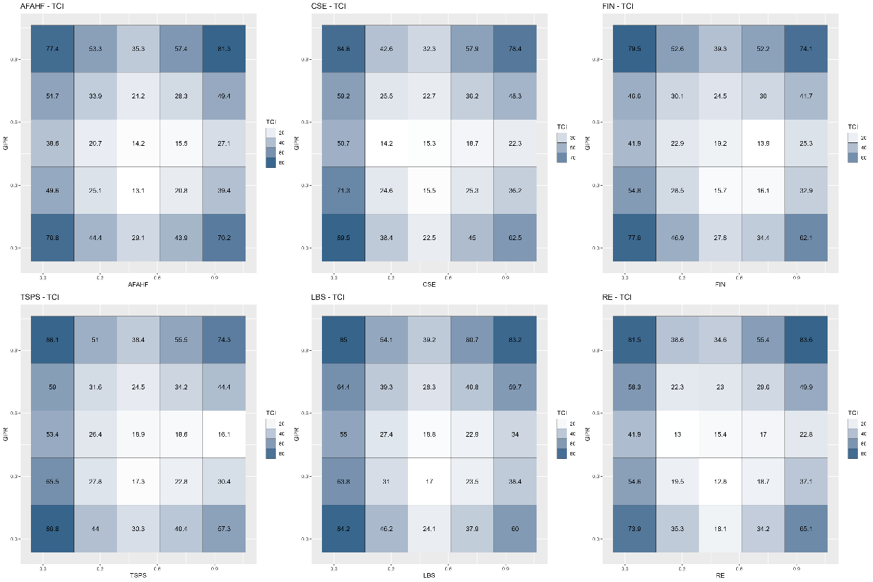
Figure A56. Average quantile-on-quantile connectedness between GPR and the tail risk of the basic support industries.
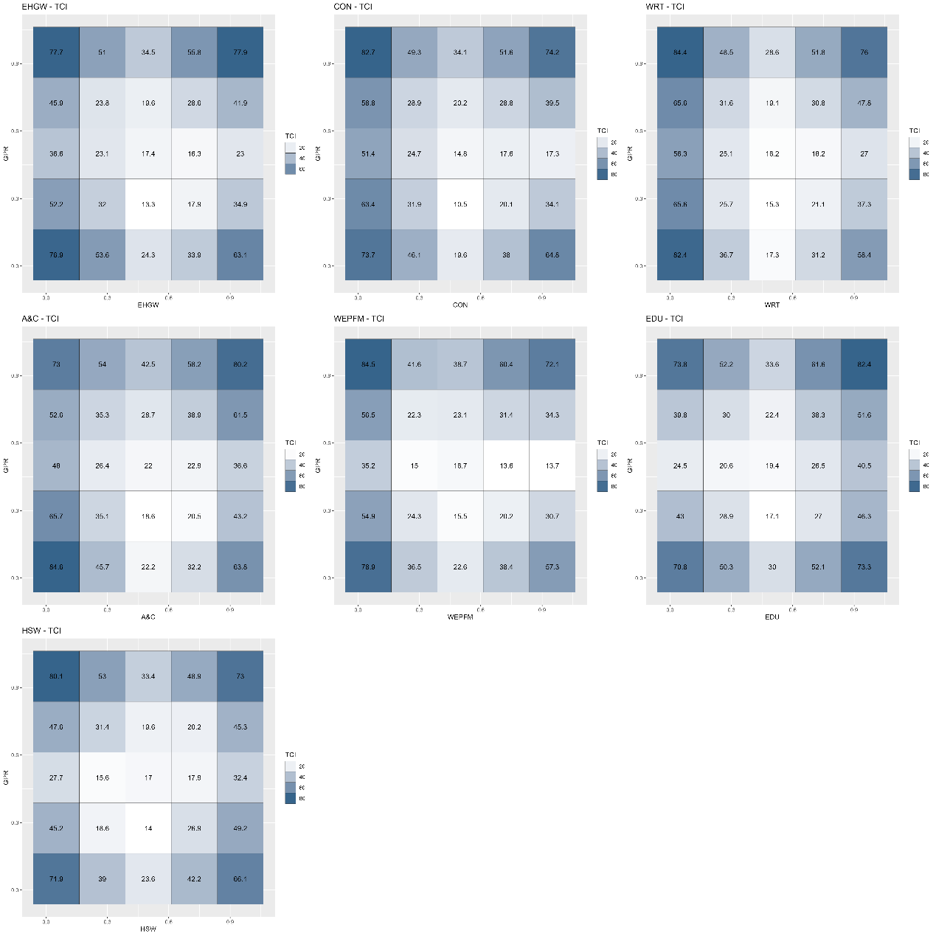
Figure A57. Average quantile-on-quantile connectedness between GPR and the tail risk of the modern service industries.
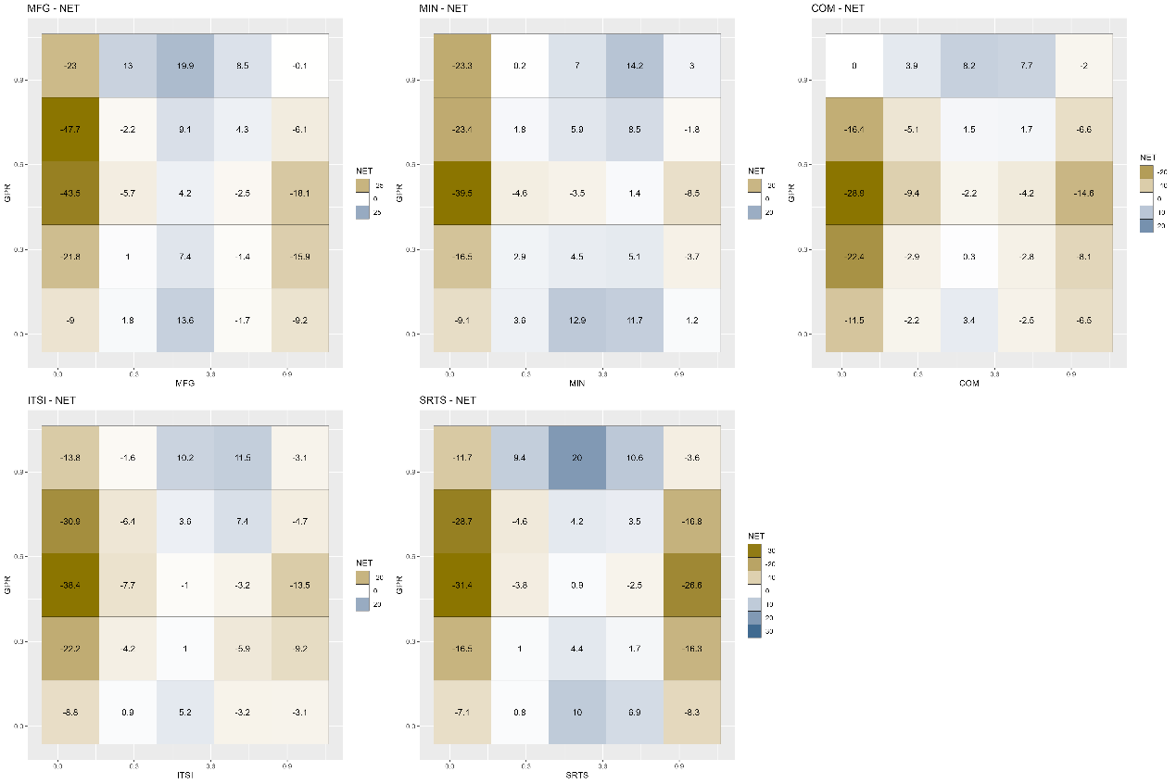
Figure A58. Net quantile-on-quantile connectedness between GPR and the tail risk of the dominant industries.
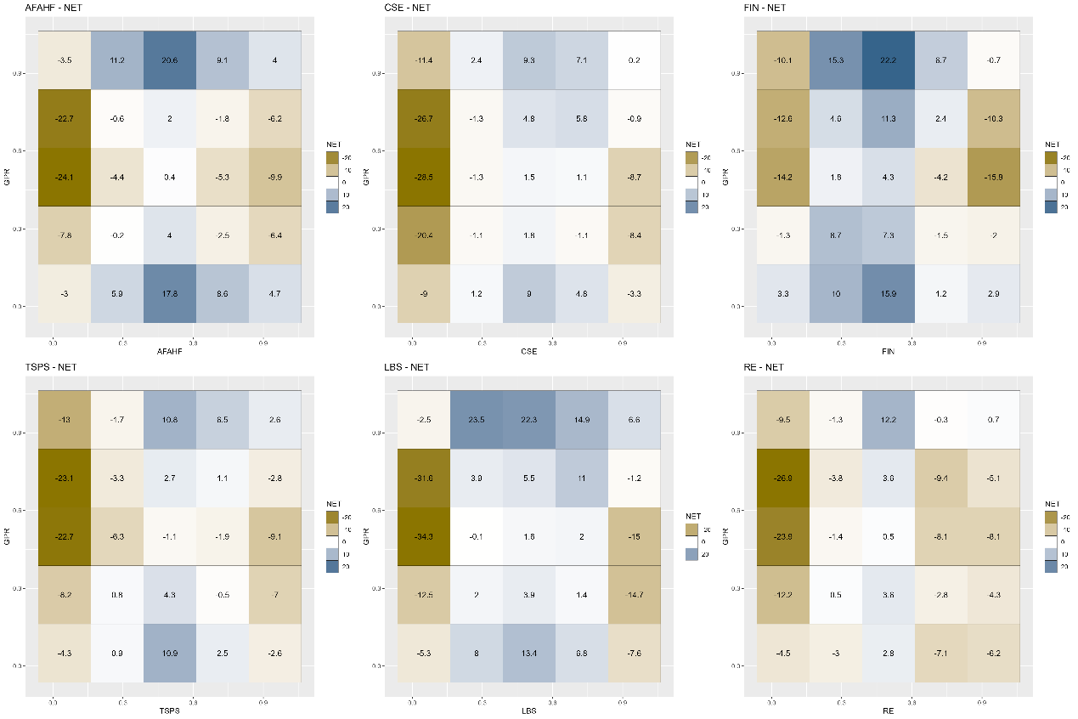
Figure A59. Net quantile-on-quantile connectedness between GPR and the tail risk of the basic support industries.
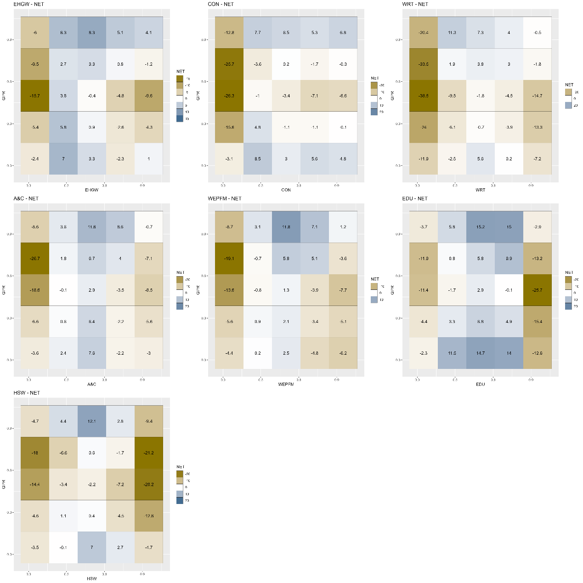
Figure A60. Net quantile-on-quantile connectedness between GPR and the tail risk of the modern service industries.
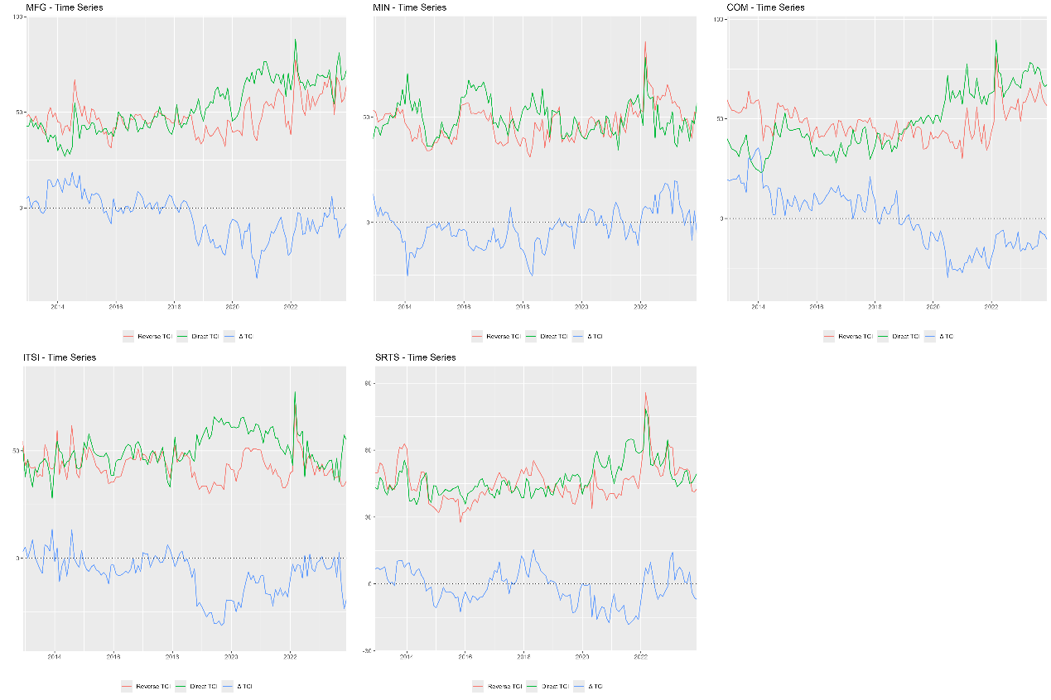
Figure A61. Dynamic quantile-on-quantile connectedness between GPR and the tail risk of the dominant industries.
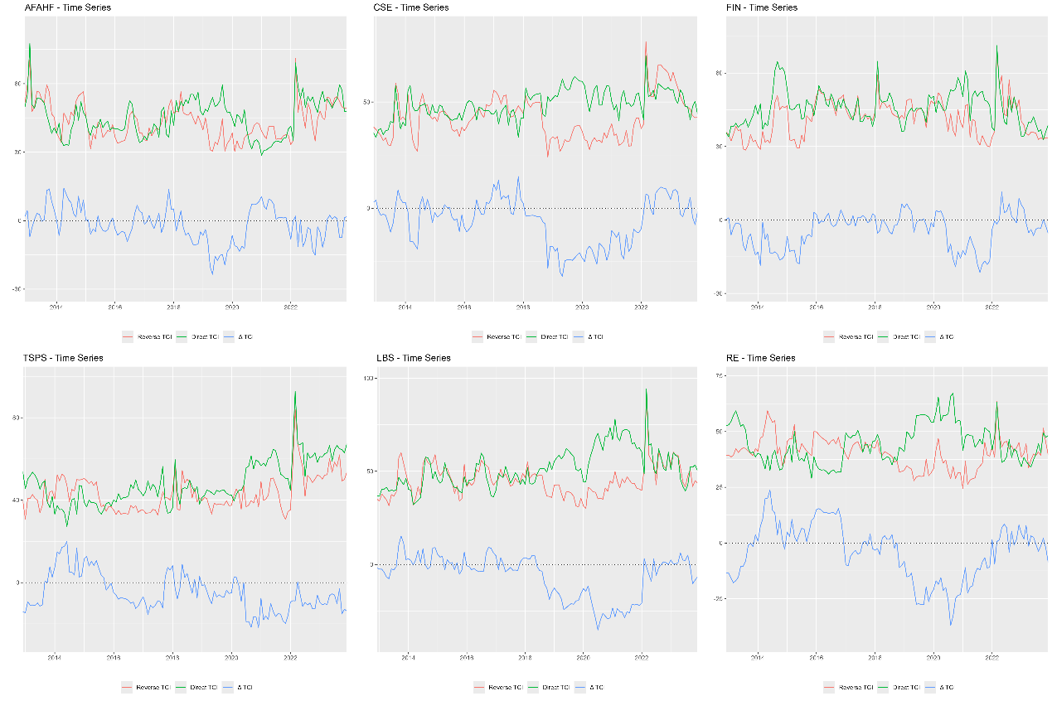
Figure A62. Dynamic quantile-on-quantile connectedness between GPR and the tail risk of the basic support industries.
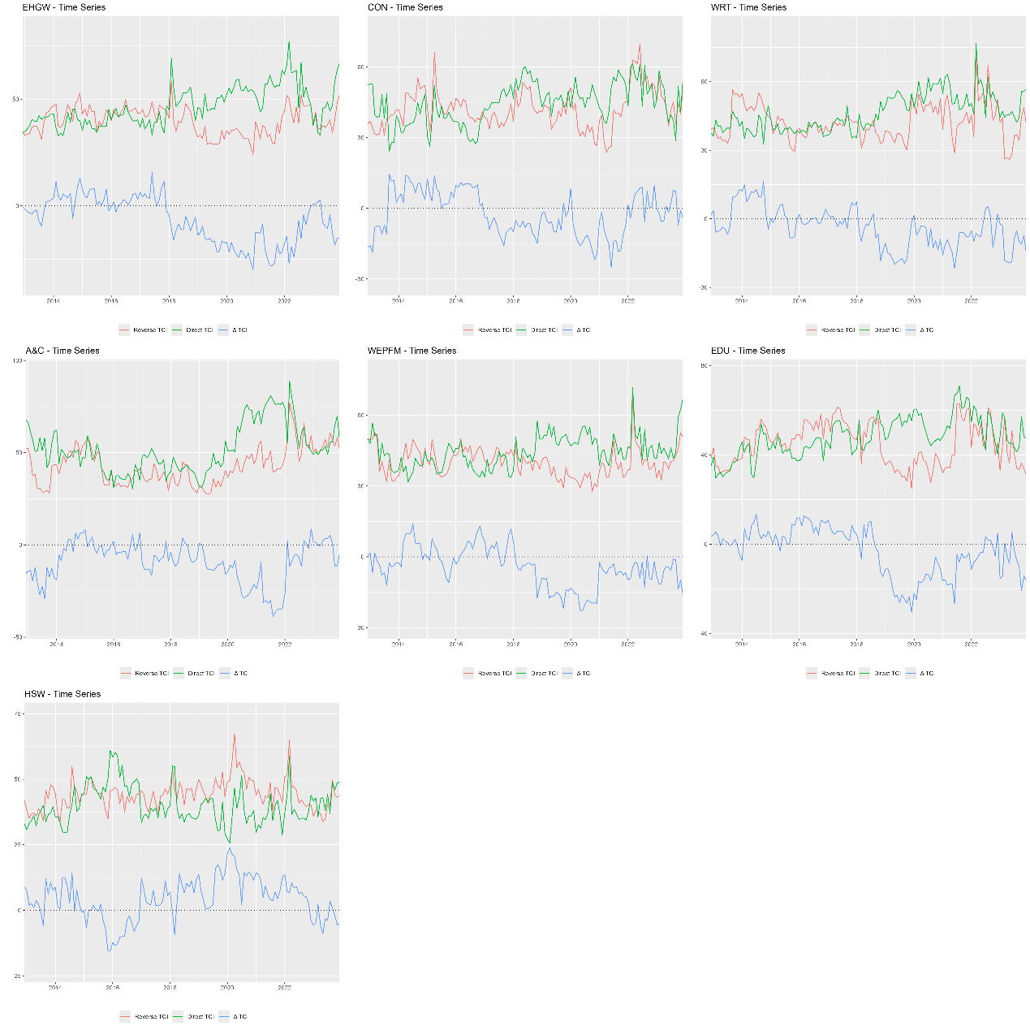
Figure A63. Dynamic quantile-on-quantile connectedness between GPR and the tail risk of the modern service industries.
- Quantiles
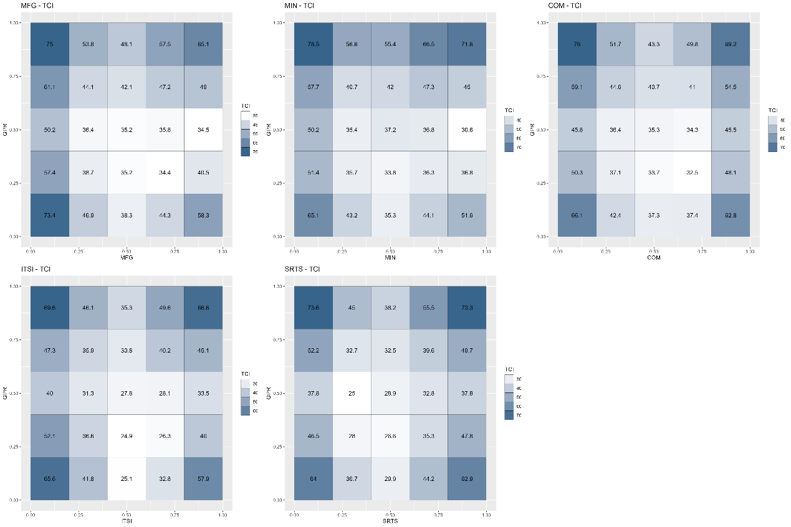
Figure A64. Average quantile-on-quantile connectedness between GPR and the tail risk of the dominant industries.
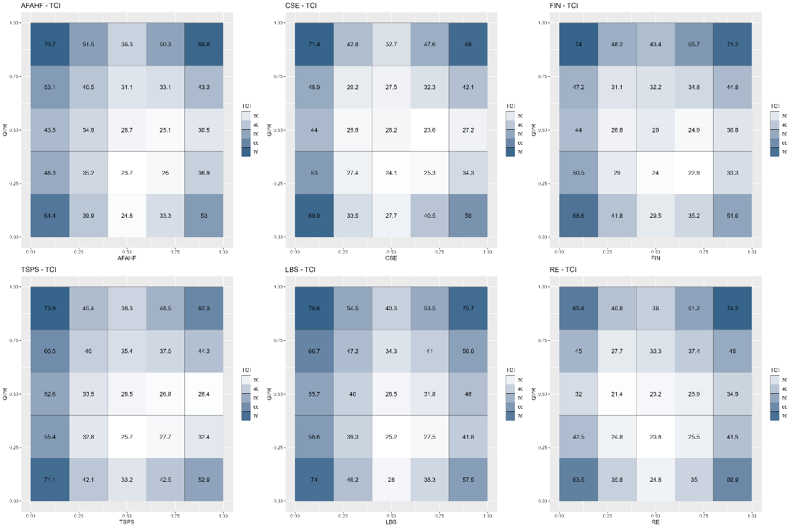
Figure A65. Average quantile-on-quantile connectedness between GPR and the tail risk of the basic support industries.
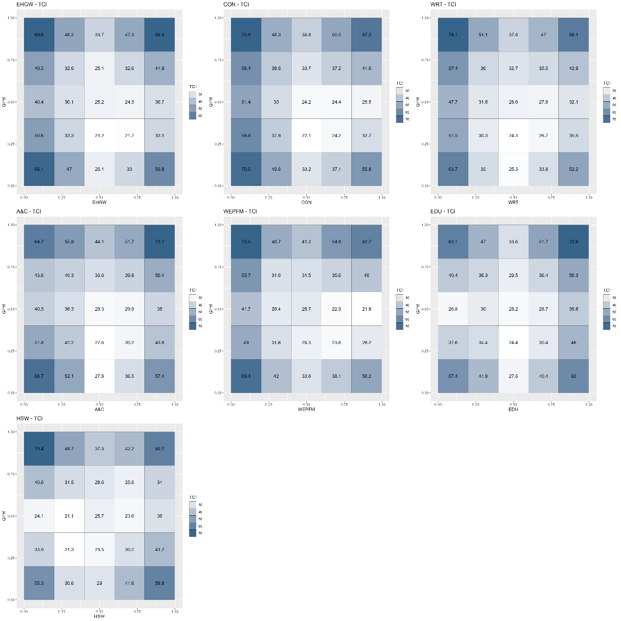
Figure A66. Average quantile-on-quantile connectedness between GPR and the tail risk of the modern service industries.
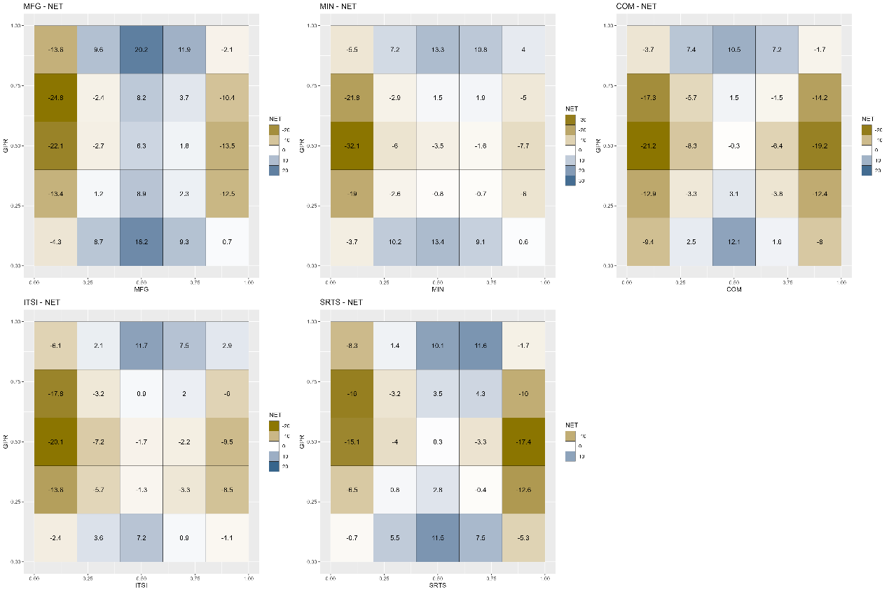
Figure A67. Net quantile-on-quantile connectedness between GPR and the tail risk of the dominant industries.
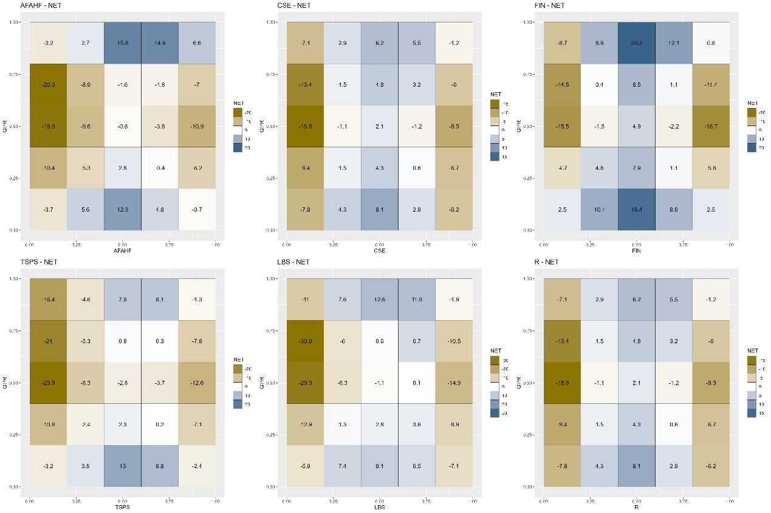
Figure A68. Net quantile-on-quantile connectedness between GPR and the tail risk of the basic support industries.
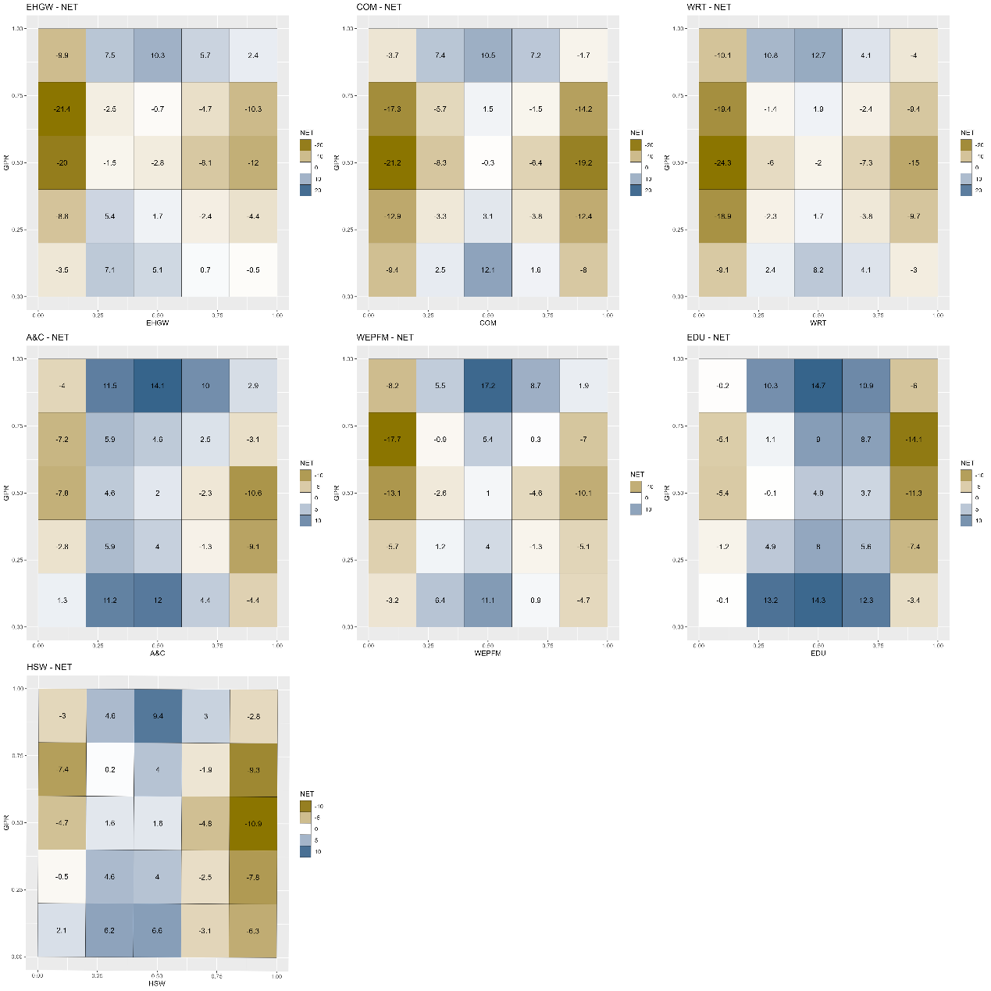
Figure A69. Net quantile-on-quantile connectedness between GPR and the tail risk of the modern service industries.
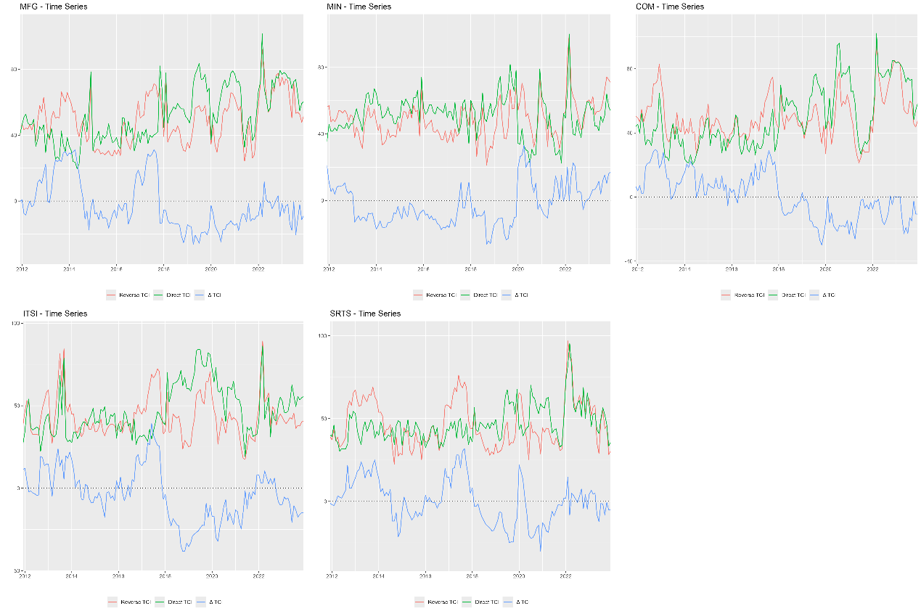
Figure A70. Dynamic quantile-on-quantile connectedness between GPR and the tail risk of the dominant industries.
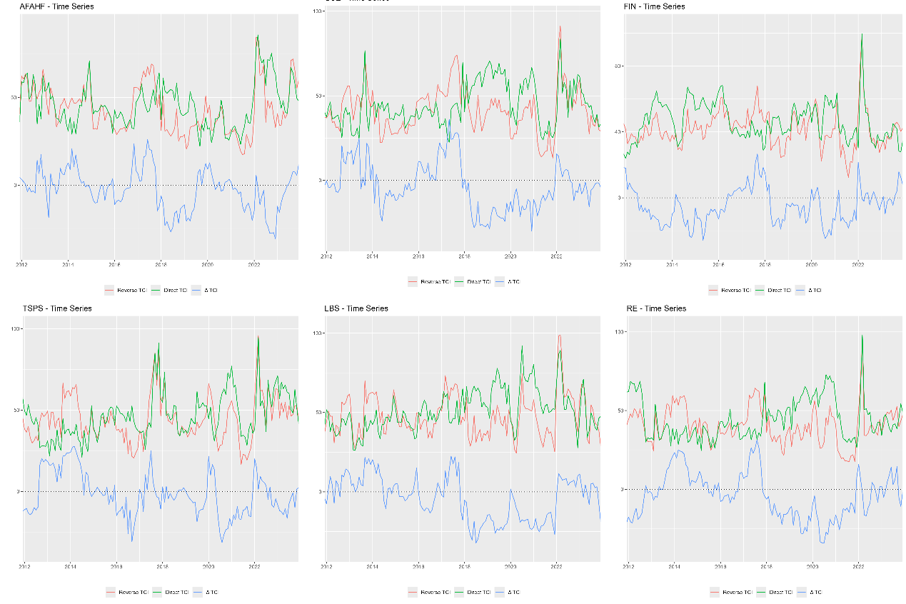
Figure A71. Dynamic quantile-on-quantile connectedness between GPR and the tail risk of the basic support industries.
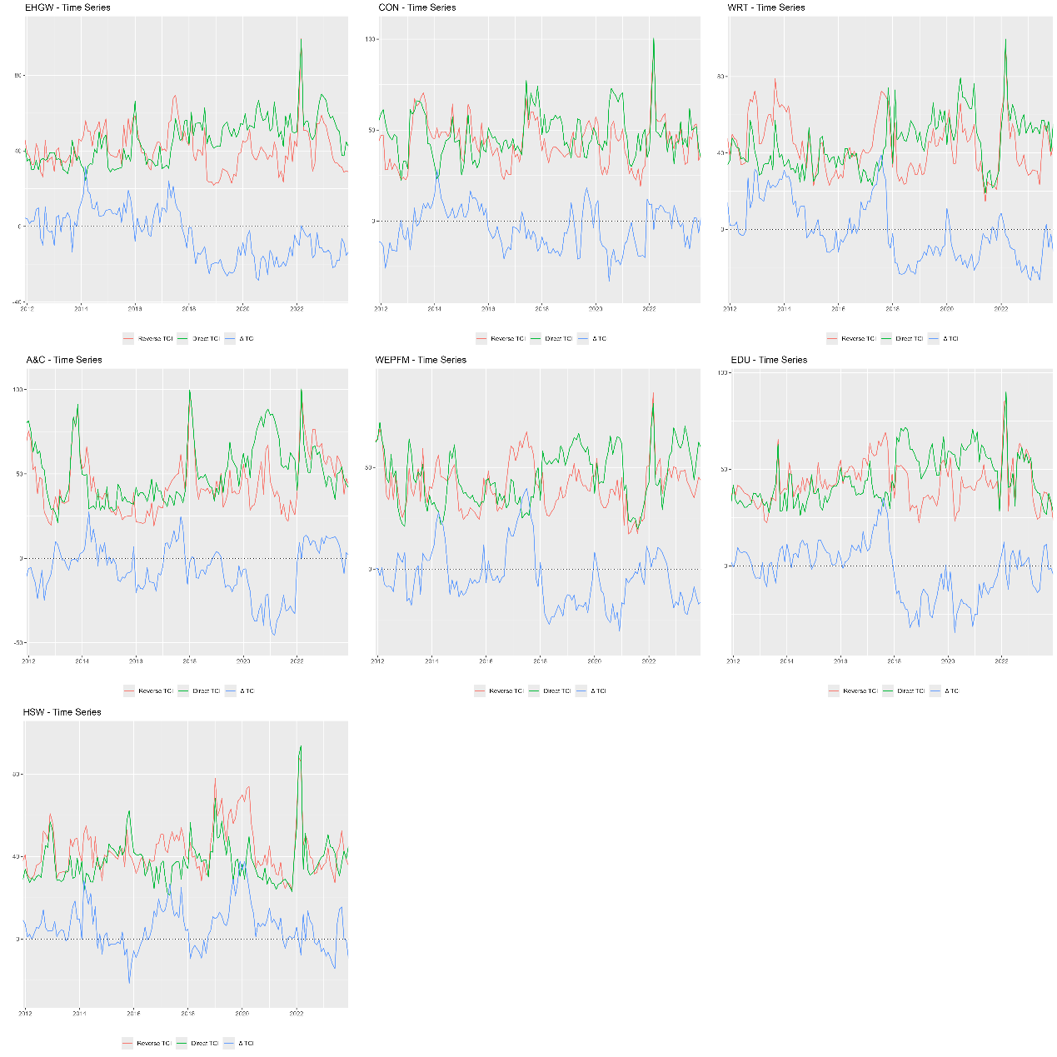
Figure A72. Dynamic quantile-on-quantile connectedness between GPR and the tail risk of the modern service industries.
- Post Covid-19
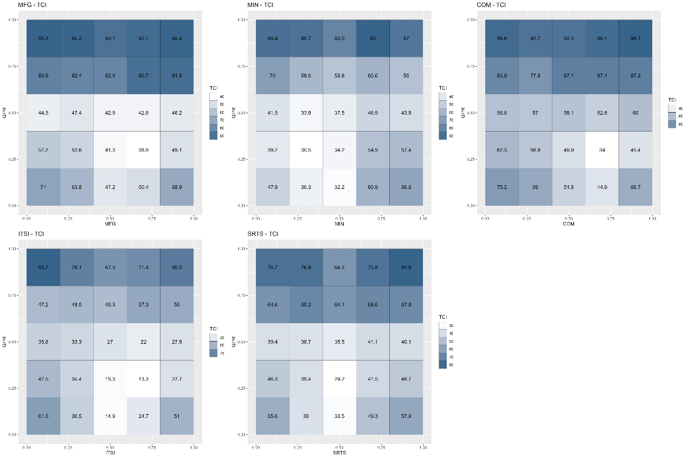
Figure A73. Average quantile-on-quantile connectedness between GPR and the tail risk of the dominant industries.
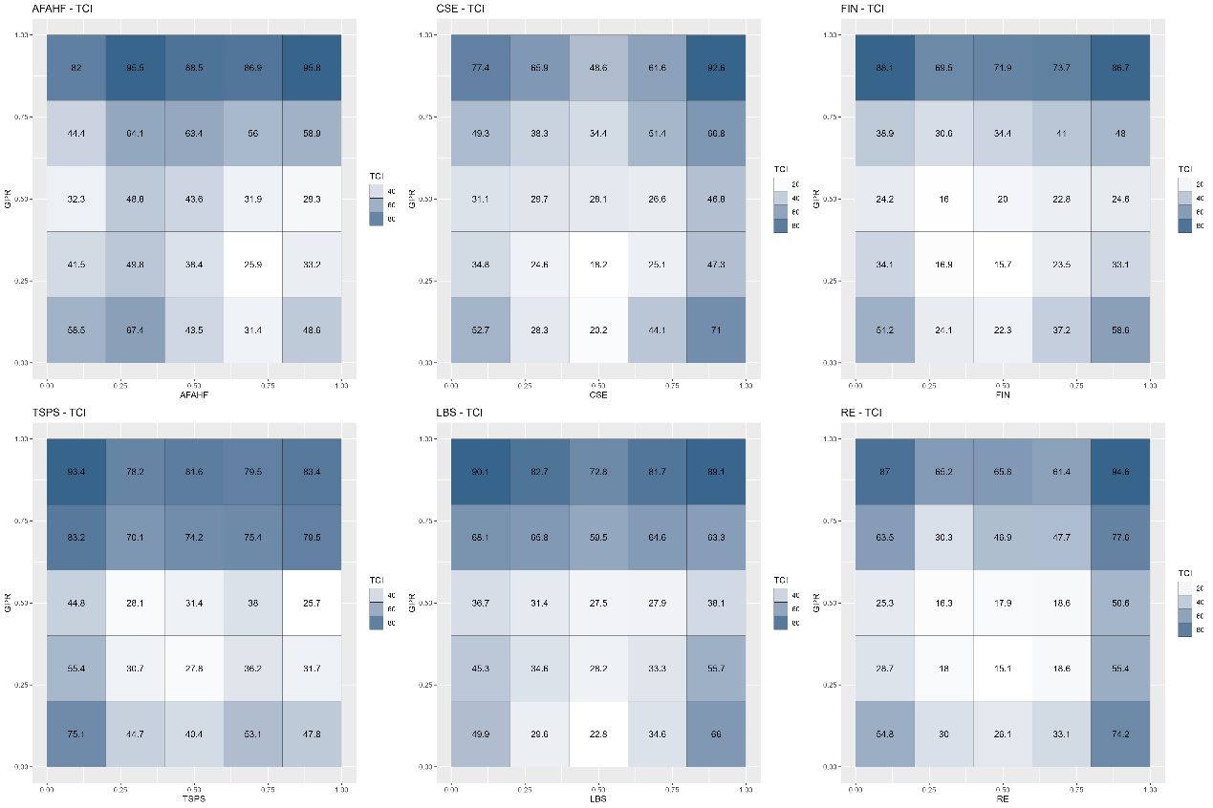
Figure A74. Average quantile-on-quantile connectedness between GPR and the tail risk of the basic support industries.
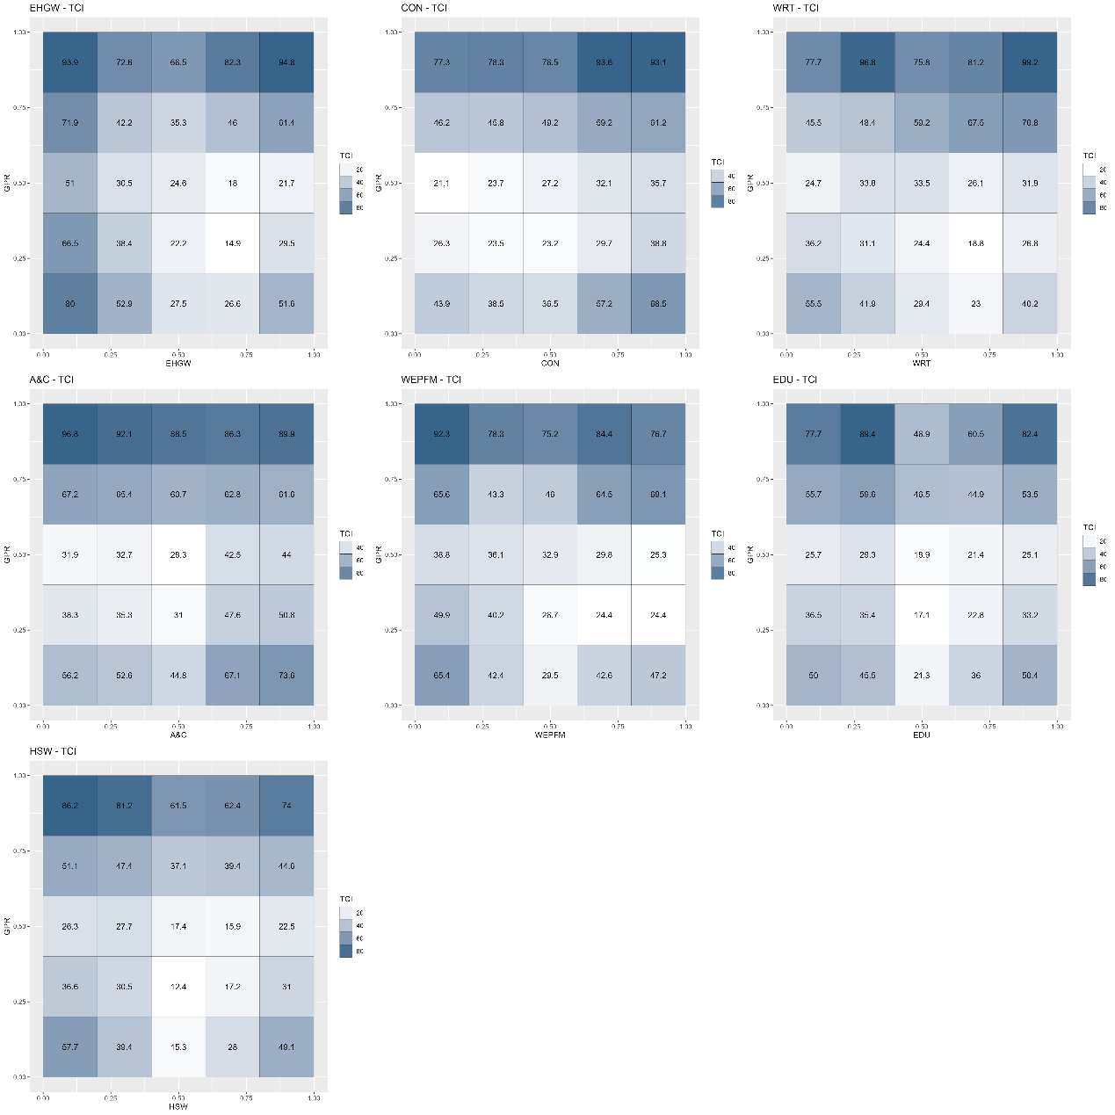
Figure A75. Average quantile-on-quantile connectedness between GPR and the tail risk of the modern service industries.
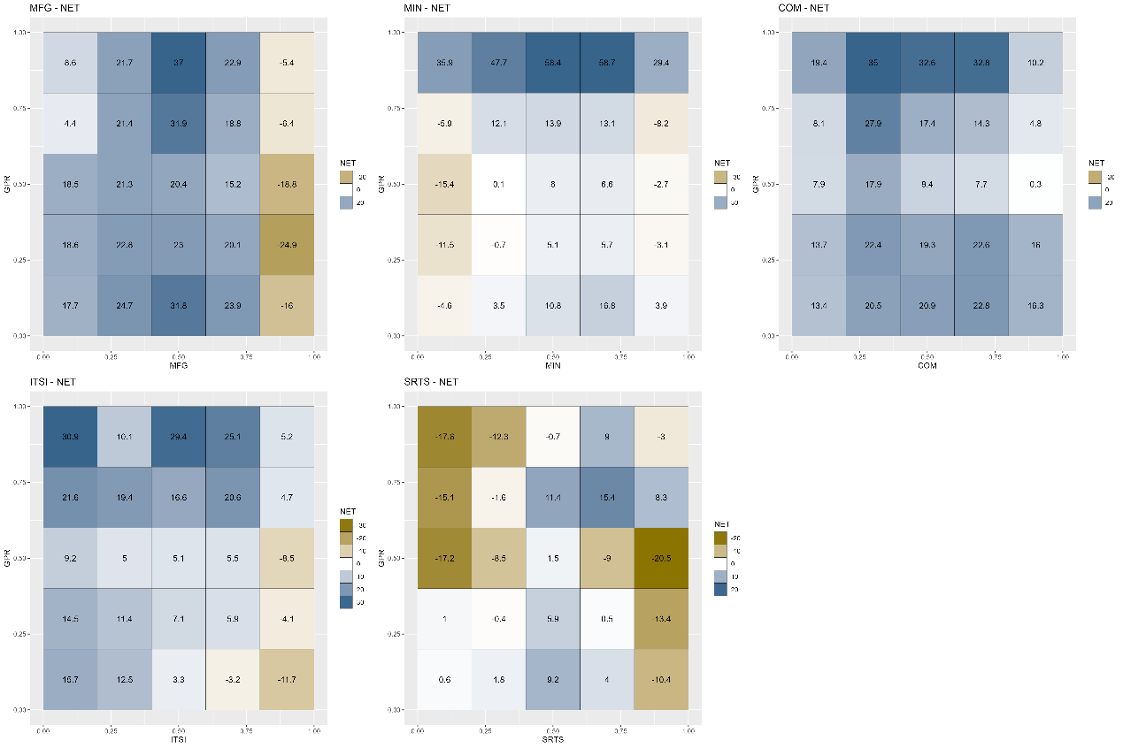
Figure A76. Net quantile-on-quantile connectedness between GPR and the tail risk of the dominant industries.
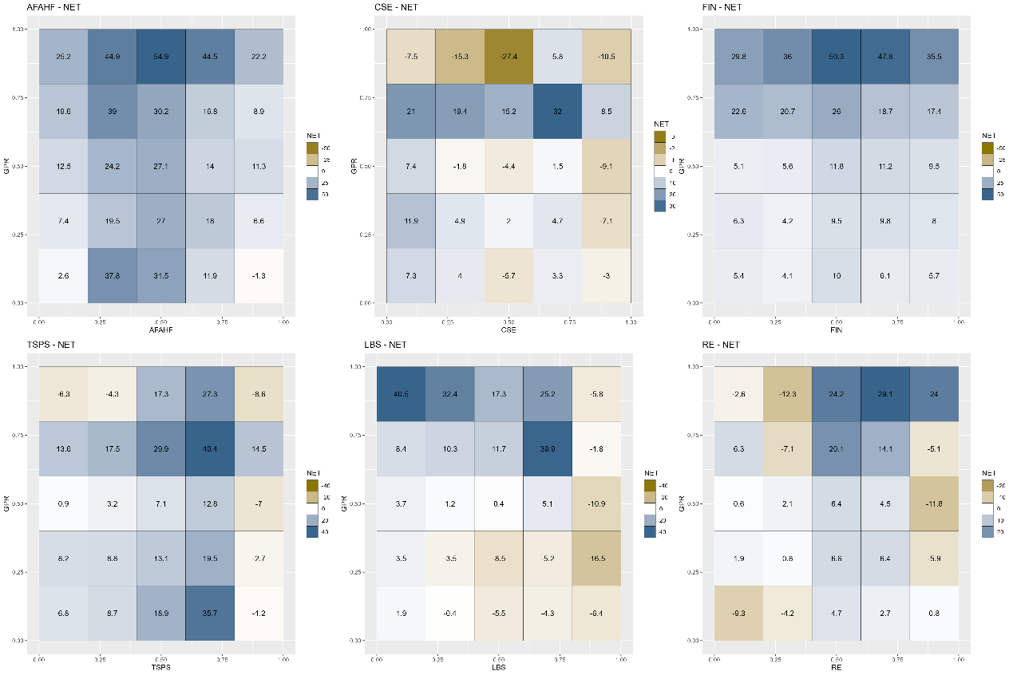
Figure A77. Net quantile-on-quantile connectedness between GPR and the tail risk of the basic support industries.
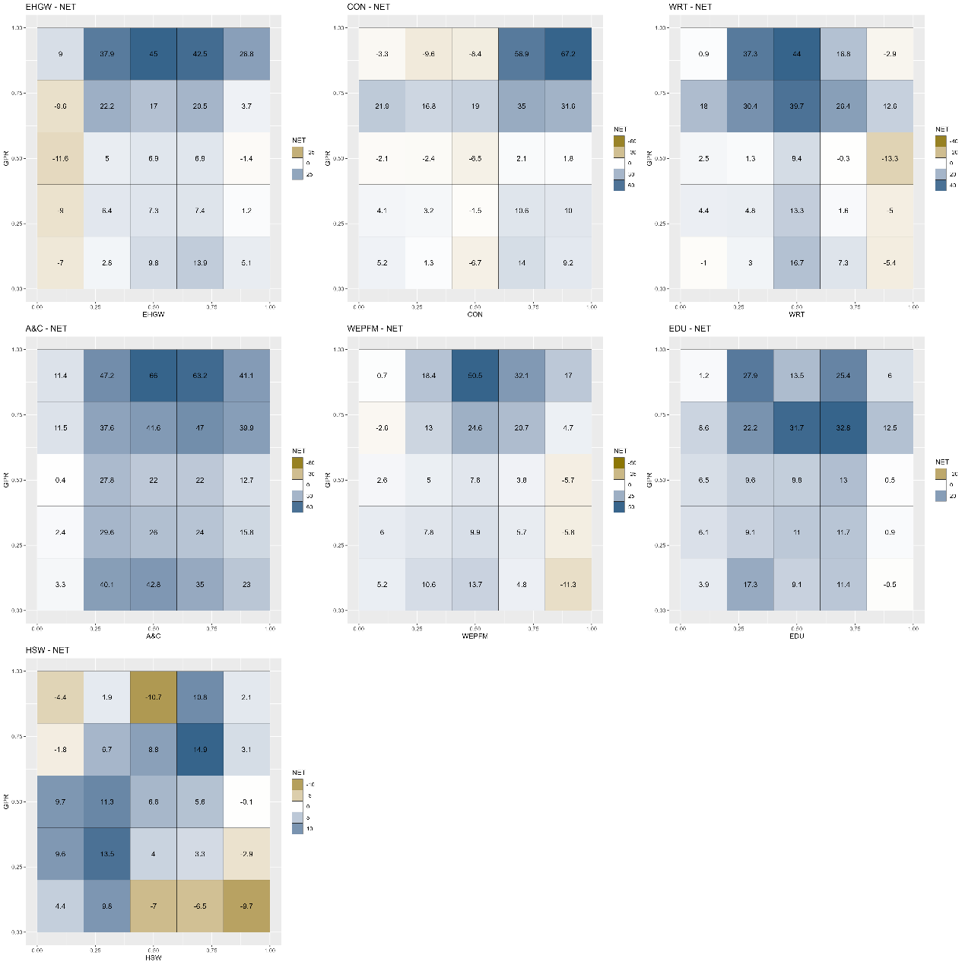
Figure A78. Net quantile-on-quantile connectedness between GPR and the tail risk of the modern service industries.
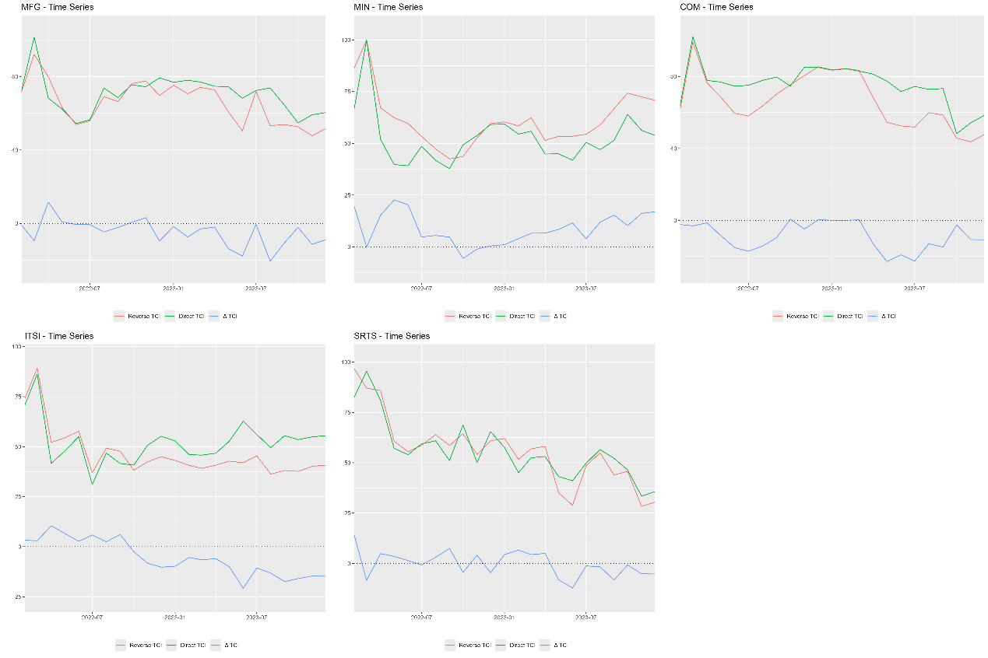
Figure A79. Dynamic quantile-on-quantile connectedness between GPR and the tail risk of the dominant industries.
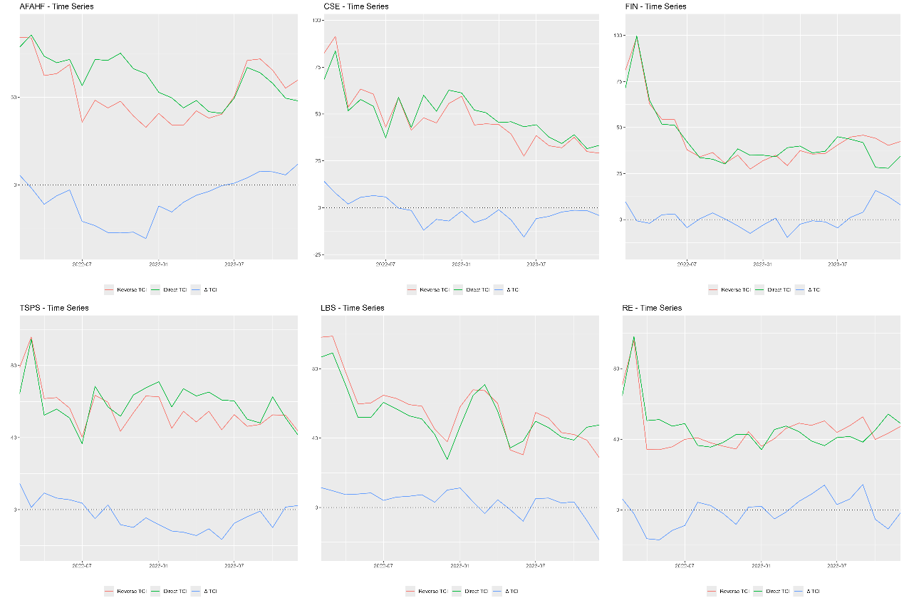
Figure A80. Dynamic quantile-on-quantile connectedness between GPR and the tail risk of the basic support industries.
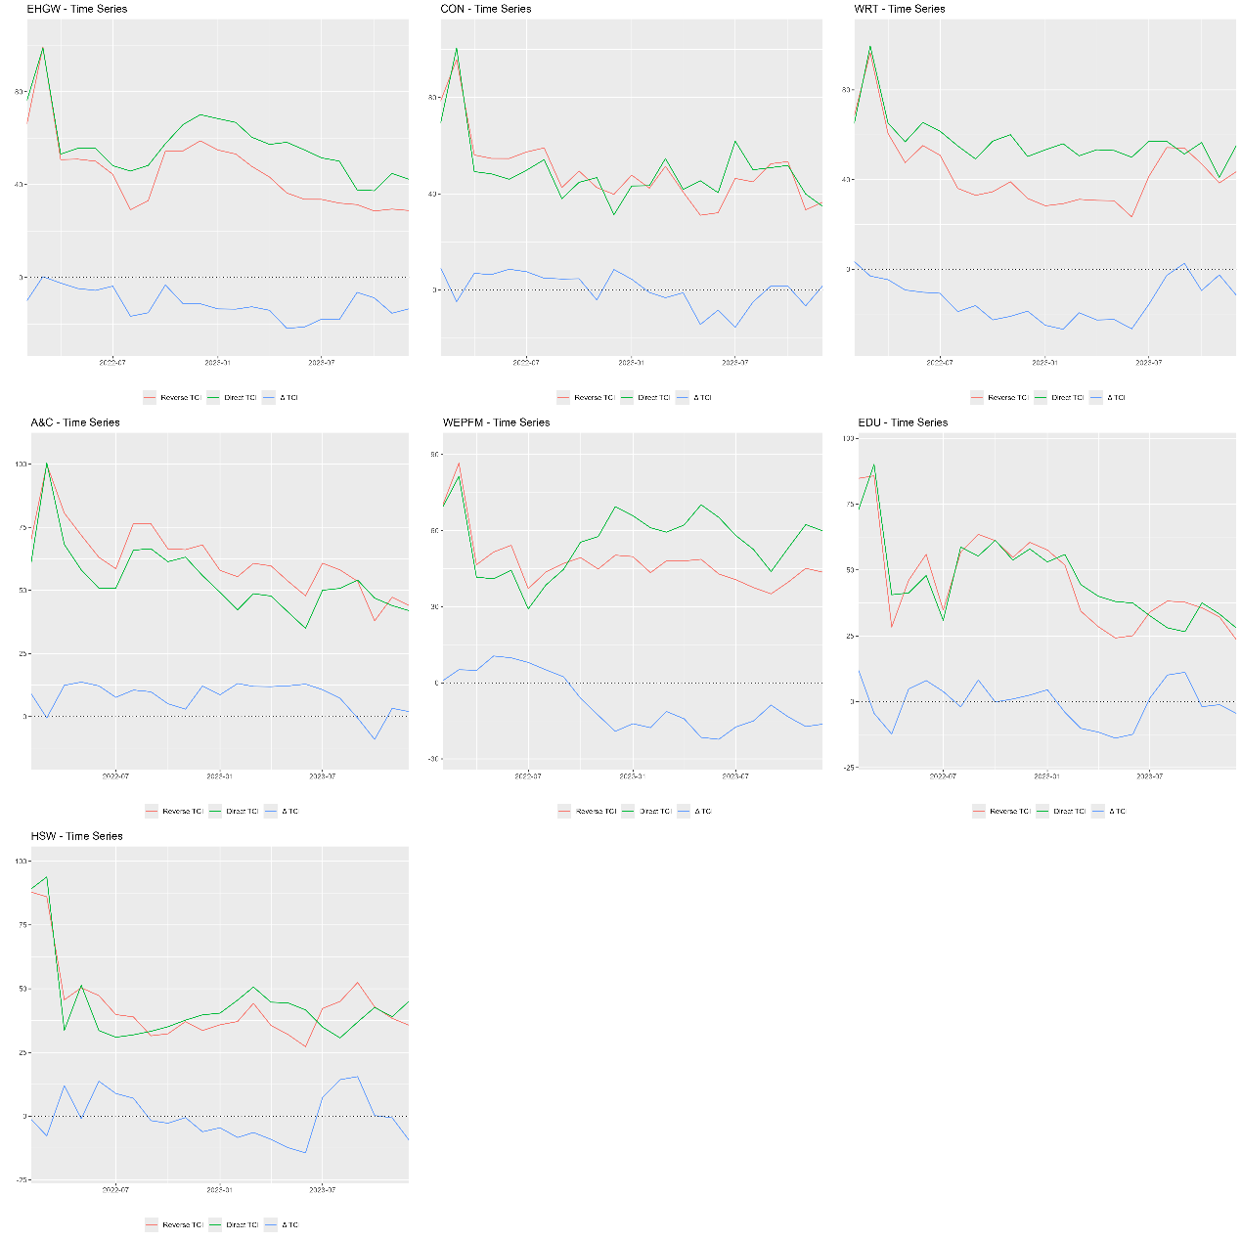
Figure A81. Dynamic quantile-on-quantile connectedness between GPR and the tail risk of the modern service industries.

