Supplementary Material

Supplementary Results in Preliminary Tests
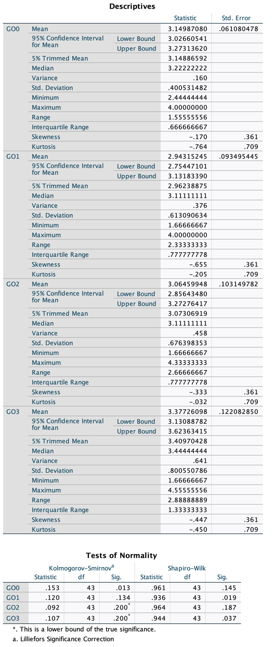
Supplementary Figure 1. Goal orientation results in normality tests

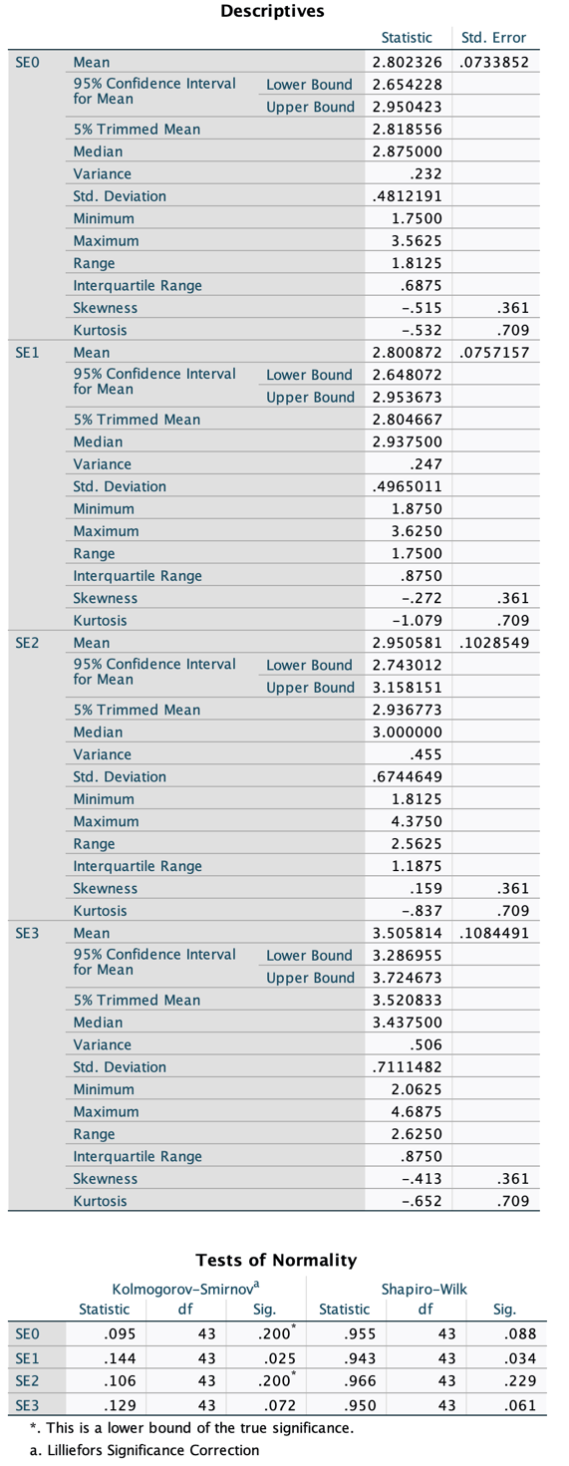
Supplementary Figure 2. Self-efficacy results in normality tests

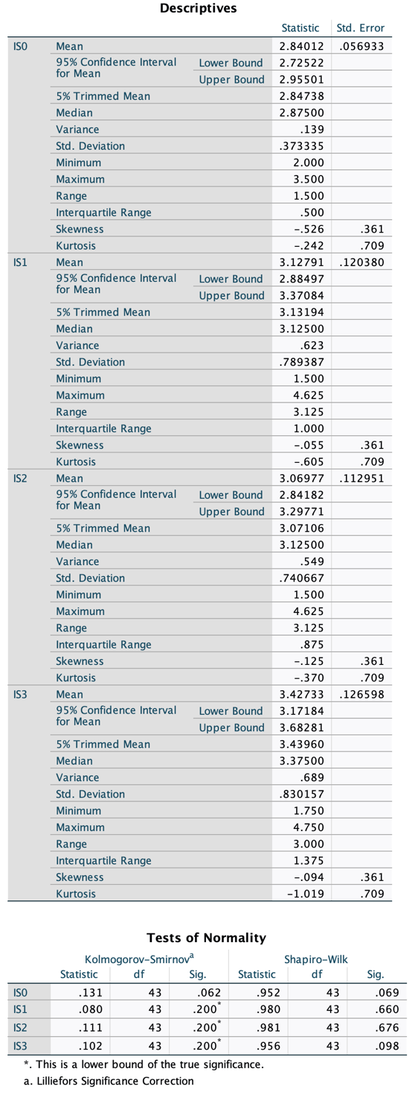
Supplementary Figure 3. Instructional support results in normality tests

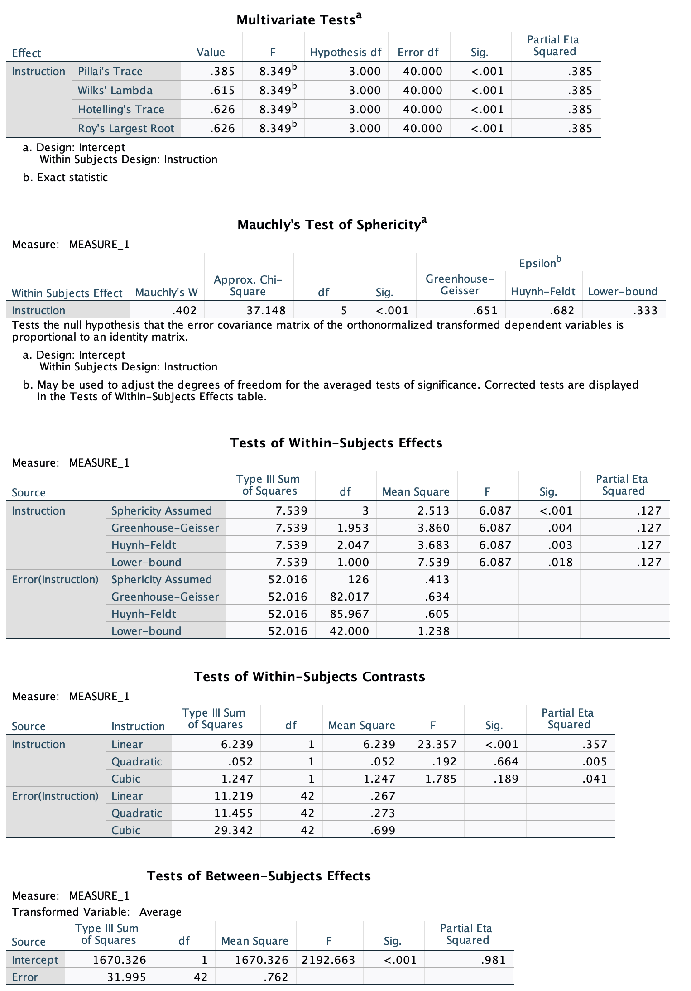
Supplementary Figure 4. Instructional support results in Mauchly's Test of Sphericity

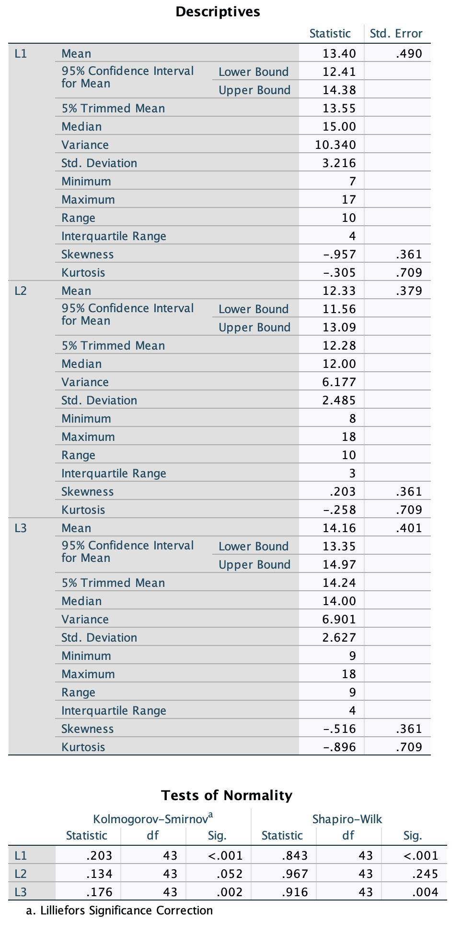
Supplementary Figure 5. Listening results in normality tests

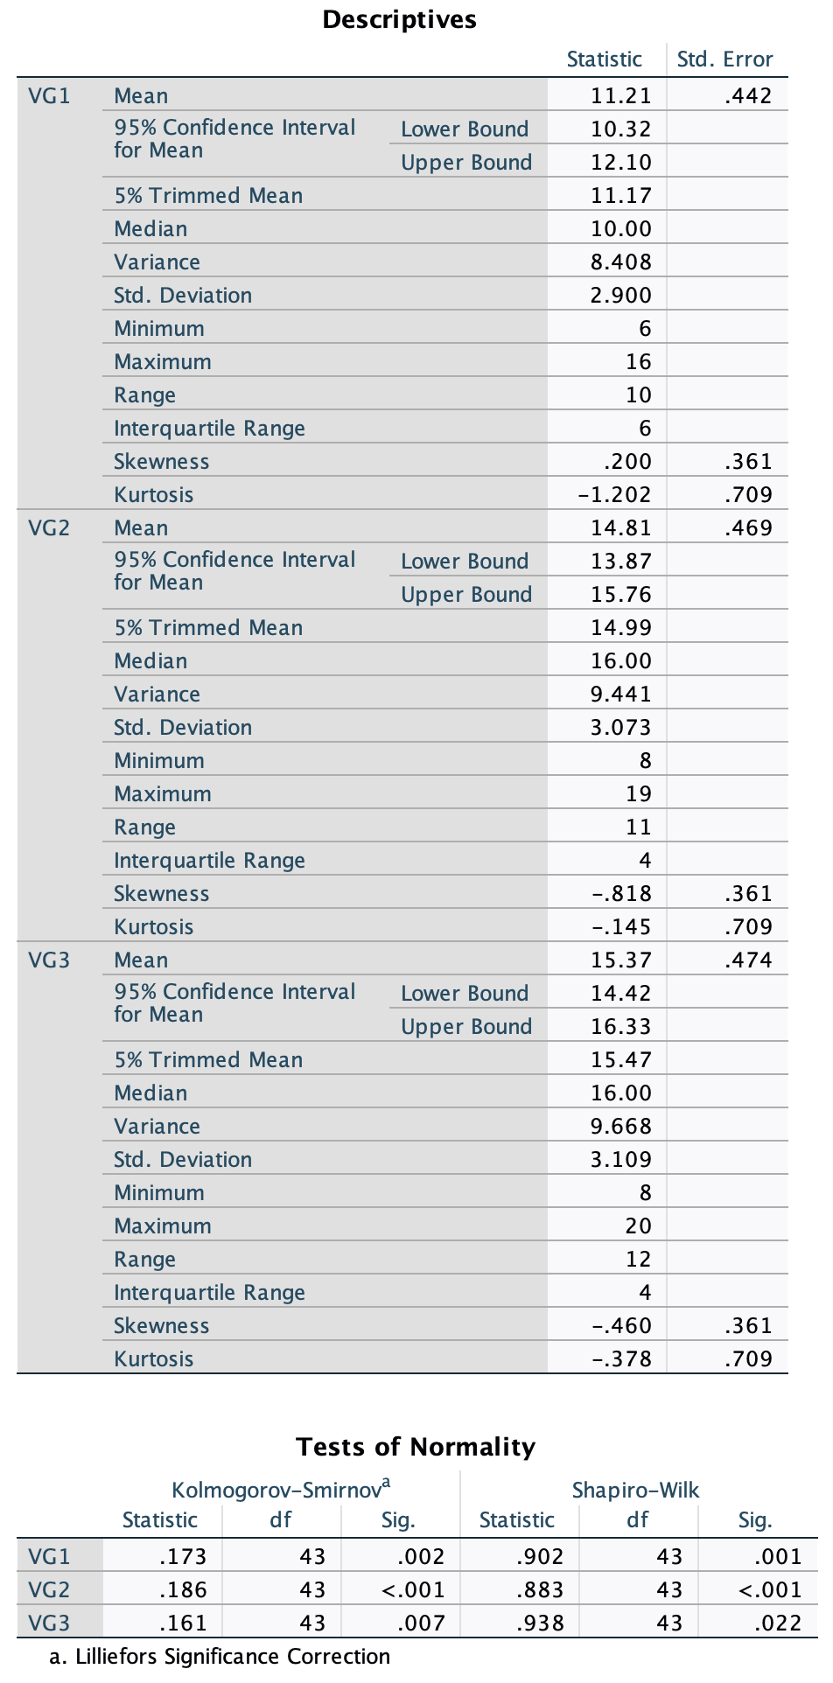
Supplementary Figure 6. Vocabulary and Grammar results in normality tests

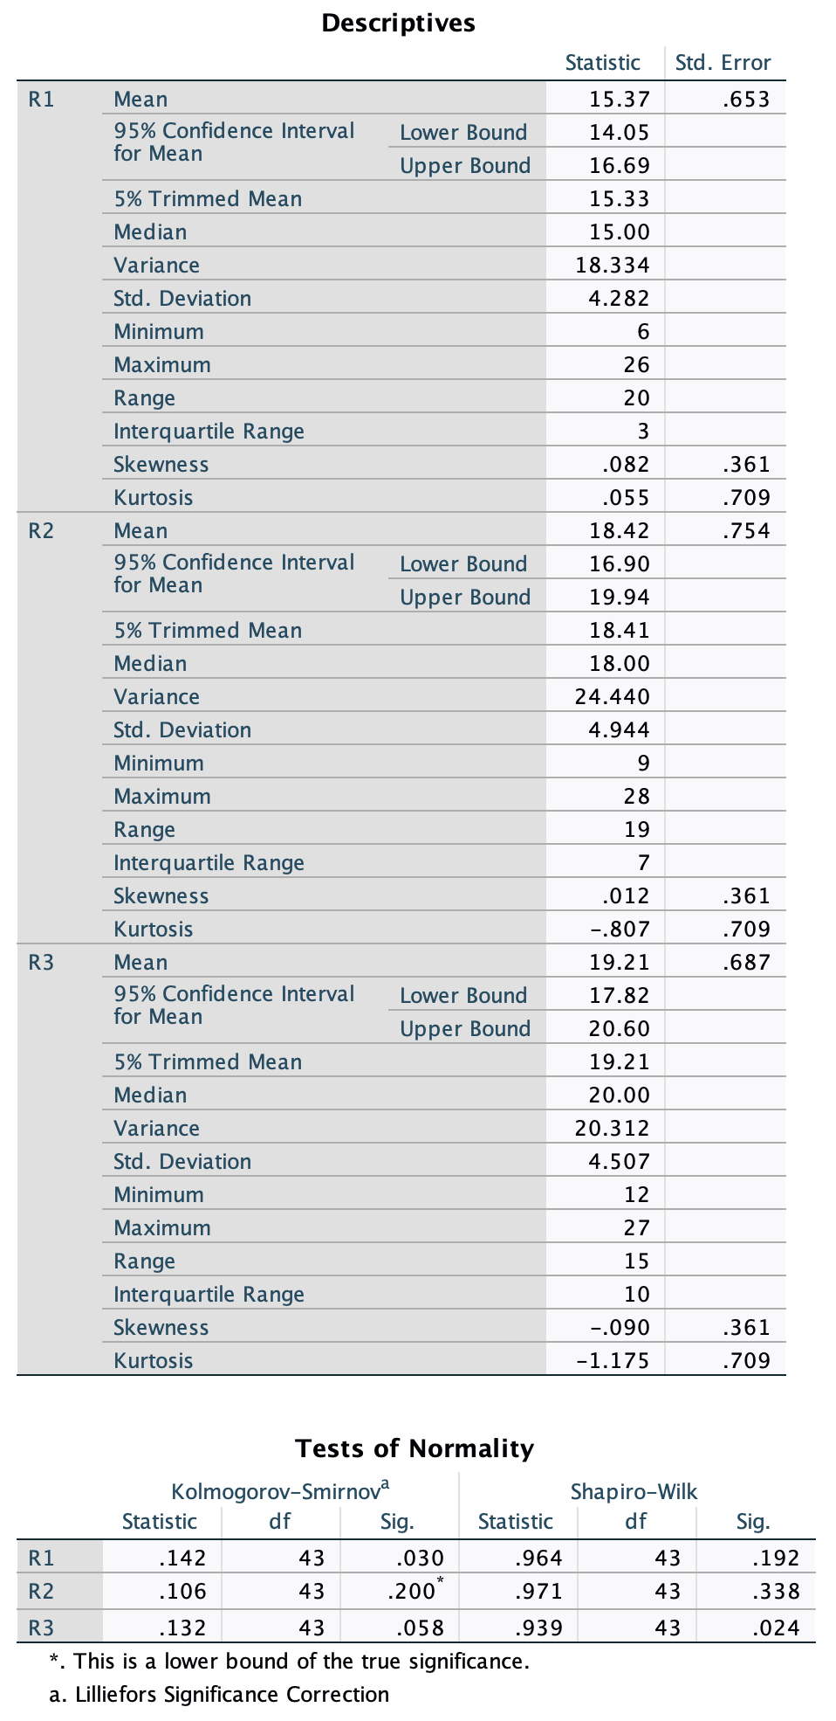
Supplementary Figure 7. Reading results in normality tests
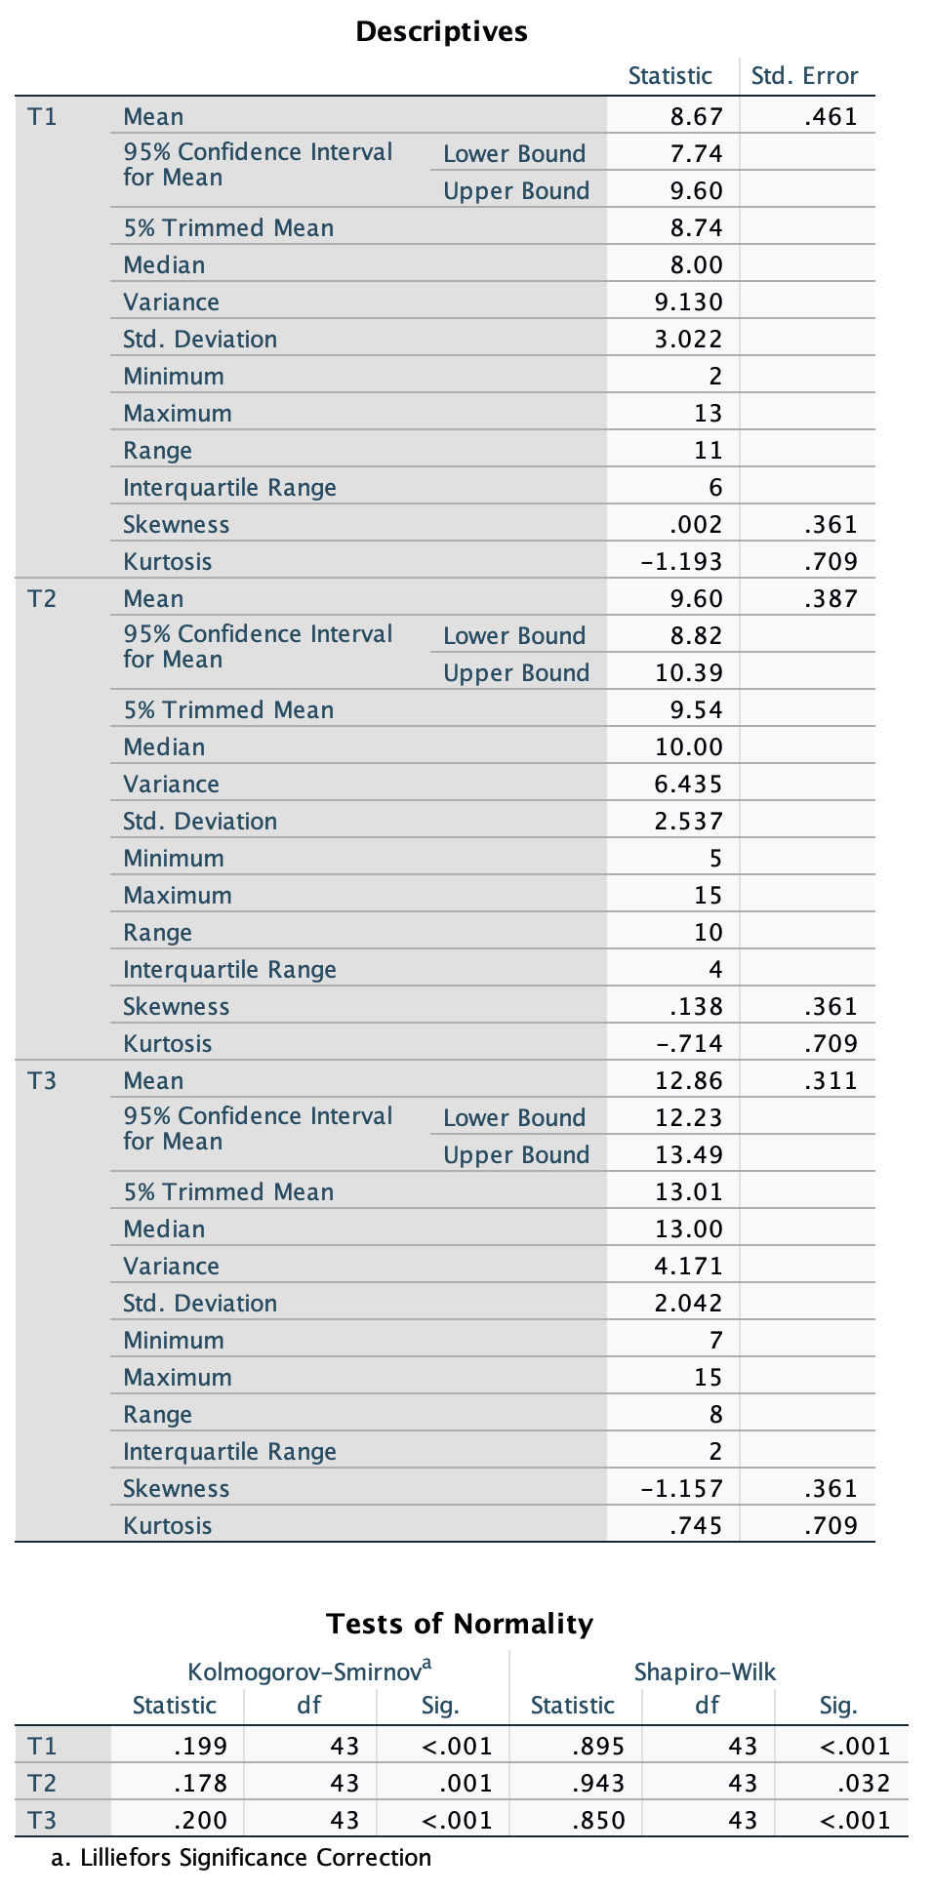
Supplementary Figure 8. Translation results in normality tests

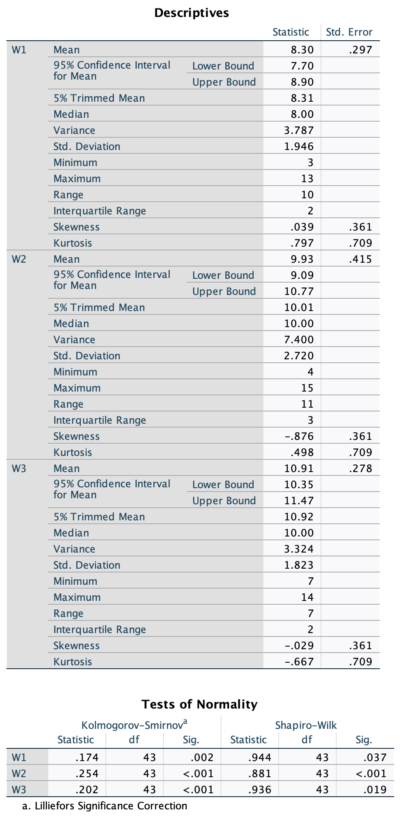
Supplementary Figure 9. Writing results in normality tests

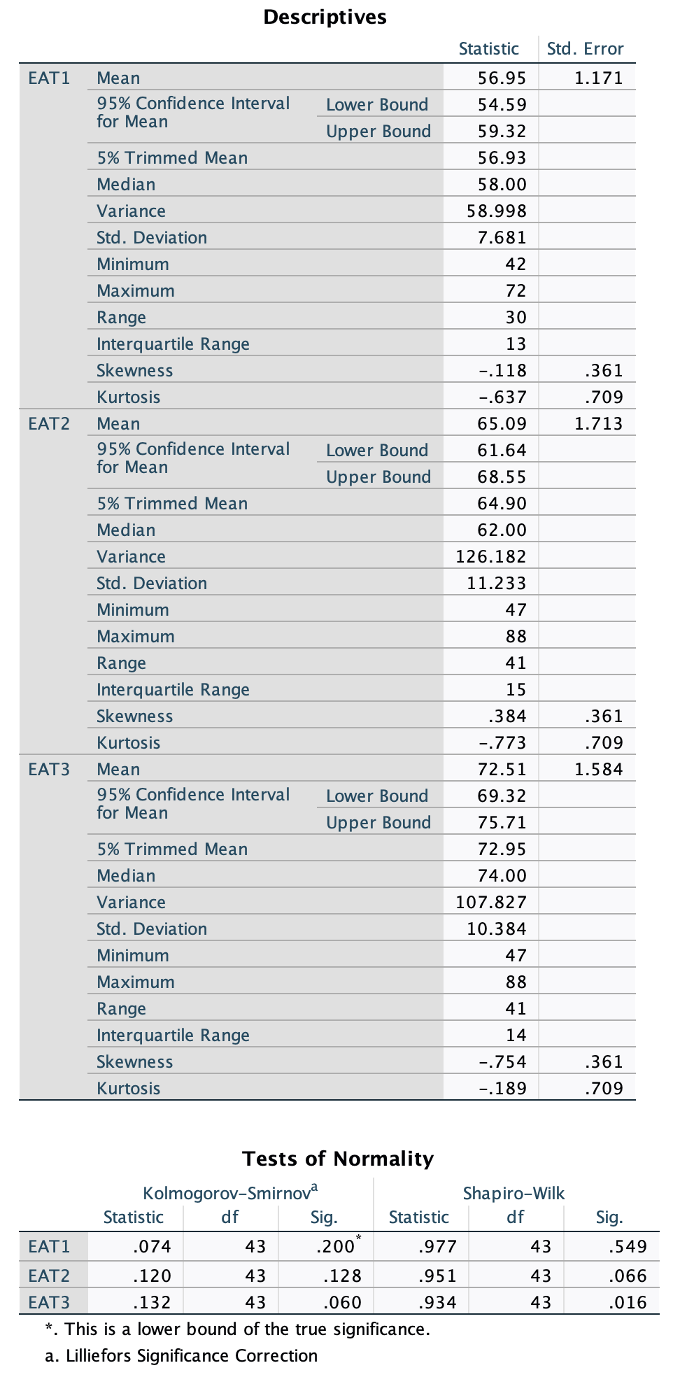
Supplementary Figure 10. English achievement test results in normality tests

