Suplemementary Material

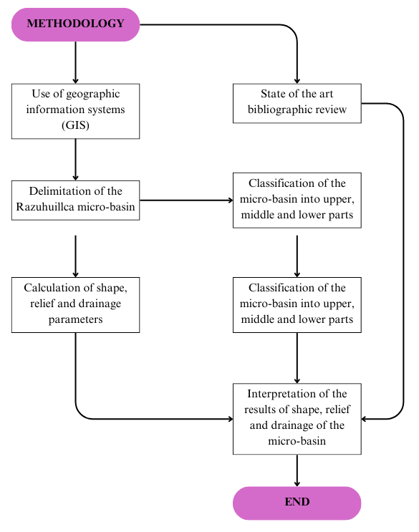

*Figure S1. General schematic of the methodology applied for the morphometric characterization of the Razuhuillca micro-watershed.*

This schematic summarizes the sequential methodological stages applied in the morphometric and hydro-environmental assessment

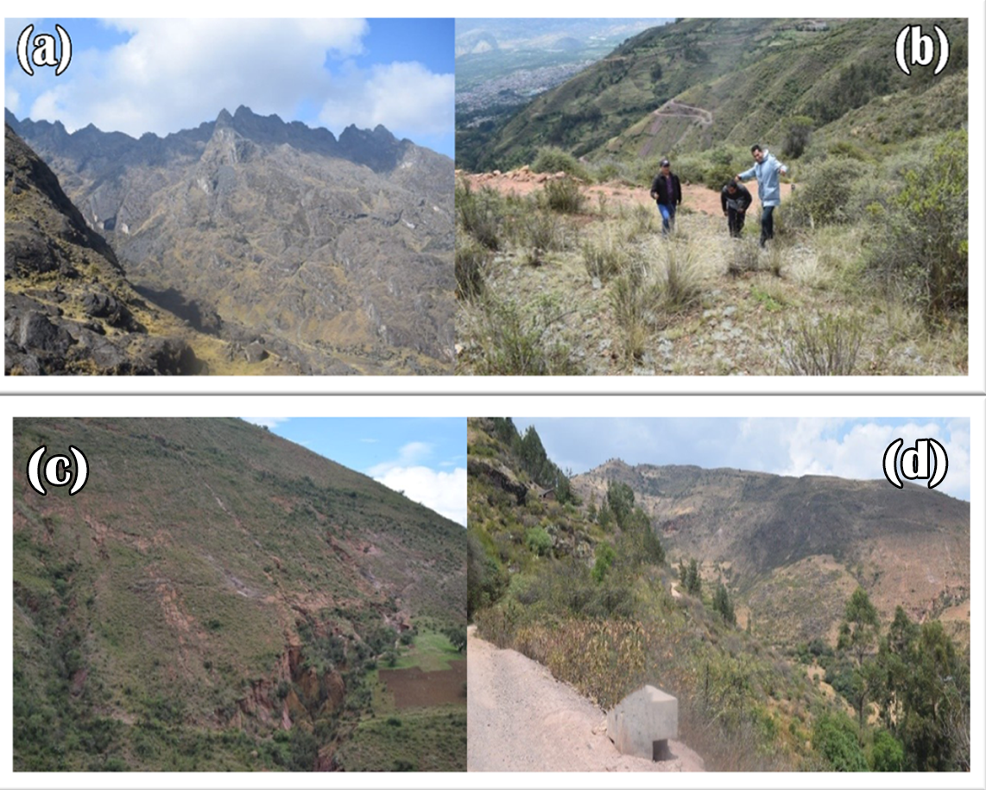

Figure S2. Field photographs from the Razuhuillca micro-watershed.

(a) Rocky terrain in the upper part; (b) Steep slope verification;

(c) Evidence of active erosion in the mid-upper section;

(d) Low vegetation cover in eroded areas.

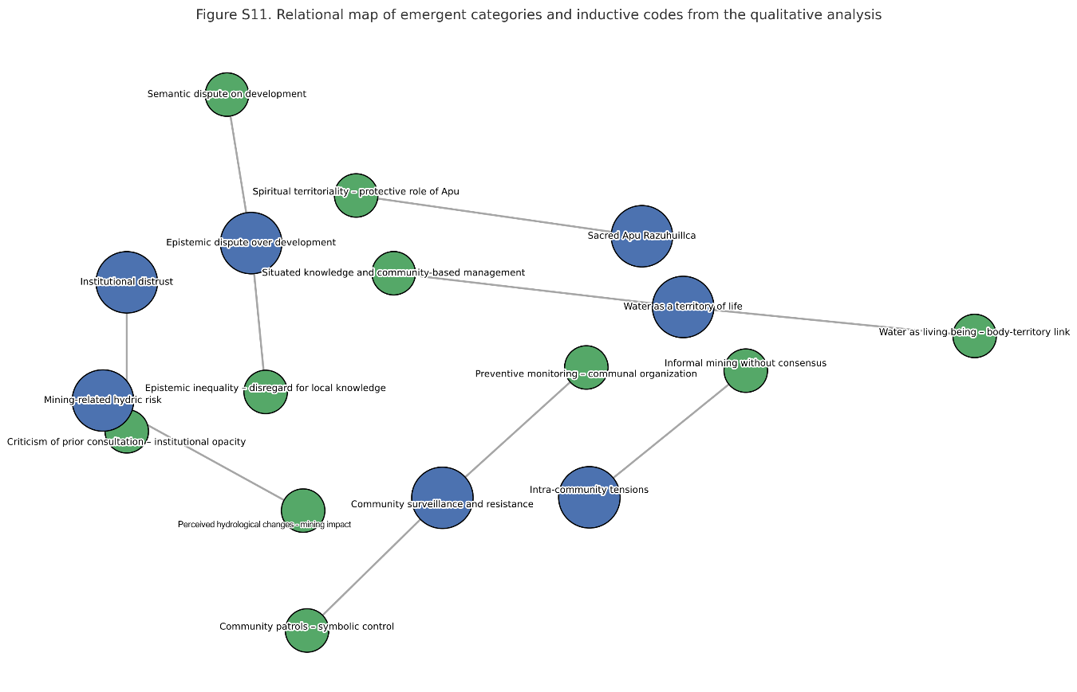

Supplementary Figure S3. Relational map of emergent categories and inductive codes generated through thematic analysis of ten semi-structured interviews. The visualization reflects the post-coding structure derived from ATLAS.ti 23, highlighting connections between hydrosocial meanings, mining-related perceptions, and local territorial resistance strategies.

**Morphometric Parameter Calculation**

After delineating the Razuhuillca micro-watershed, morphometric characterization was conducted by calculating general and specific parameters related to shape, relief, and drainage. The analysis was performed in ArcGIS 10.8, using a 30 m resolution DEM. Standard procedures were followed (Horton, 1945; Schumm, 1956; Strahler, 1957).

**General Parameters of the Micro-Watershed**

Basic dimensions such as area, perimeter, main stream length, and basin width and length were calculated. These values describe the geometric configuration of the watershed and its likely hydrological response. Procedures followed Camino et al. (2018), Gaspari et al. (2015), Ramírez (2013), Reyes et al. (2010), and Silva et al. (2022). (see Table S1).

**Table S1. General information extracted from GIS for the Razuhuillca micro-watershed.**

|  |  |  |
| --- | --- | --- |
| **Variable and Parameter** | **Unit** | **Definition** |
| Area (A) | $${Km}^{2}$$ | Orthogonal projection of the drainage area |
| Perimeter (P) | Km | Length of the watershed boundary line |
| Main Stream Length (L) | Km | Distance from the furthest source point to the outlet |
| Basin Length (Lm) | Km | Distance from the outlet to the farthest divide |
| |  |  | | --- | --- | | Basin Width (l) |  | | Km | Perpendicular distance to Lm |

**Shape Parameters**

Shape parameters include Horton’s Form Factor (Kf), Miller's Circularity Index (Ic), Gravelius Compactness Index (Kc), Elongation Ratio (Re), and Elongation Index (Ia). Classification criteria were based on Camino et al. (2018), Gaspari et al. (2015), and Ramírez (2013). (see Table S2).

Table S2. Shape parameters of the Razuhuillca micro-watershed.

|  |  |  |
| --- | --- | --- |
| **Variable and Parameter** | **Equation** | Classification |
| Kf (Form Factor) | $$K_{f}=\frac{L}{{lm}^{2}}$$ | $K_{f}=0-1,25$: Narrow $K_{f}=0,25-0,50$ : Elongated $K_{f}=0,50-0,75$ : Broad $K_{f}=0,75-1$ : Wide |
| Ic (Circularity) | $$I_{C}=\frac{4πA}{P^{2}}$$ | $K_{c}=0-1,25$: Oblong $K_{c}=0,25-0,50$ : Oval $K_{c}=0,50-0,75$ : Circular tendency $K_{c}=0,75-1$ : Circular |
| Kc (Compactness) | $$K_{c}=0.28x\frac{P}{\sqrt{A}}$$ | $K_{c}=1-1,25$: Almost round $K_{c}=1,25-1,50$ : Round-oval $K_{c}=1,50-1,75$ : Oblong-oval $K_{c}>1,75$ : Elongated |
| Re (Elongation Ratio) | $$K_{c}=1.128x\frac{\sqrt{A}}{L}$$ | $K_{c}<0.5:$ Very elongated $K_{c}=0.5-0,8:$ Elongated $K_{c}≈1:$ circular |
| Ia (Elongation Index) | $$I_{a}=\frac{L_{m}}{l}$$ | $I_{a}=0-1.4:$ Slightly elongated $I_{a}=1.5-2.8:$ Moderately elongated $I_{a}=2.9-4.2:$ Highly elongated |

**Relief Parameters**

Slope and relief influence runoff and erosion. Parameters calculated include Mean Slope (S), Main Channel Slope (Sm), Massivity Coefficient (Km), Orographic Coefficient (Co), Elevation Range (G), and Simple Mean Elevation (Hms), following standards in the literature (Camino et al., 2018; Gaspari et al., 2015; Reyes et al., 2010). (see Table S3)

**Table S3. Relief Parameters of the Razuhuillca Micro-Watershed**

|  |  |  |
| --- | --- | --- |
| **Variable and Parameter** | **Equation** | **Classification** |
| Mean Slope (S) | $$S=100\%\frac{\sum{L_{i}.E}}{A}$$ | $S=0-3\%:$ Flat $S=3-7\%:$ Gentle $S=7-12\%:$ Moderate $S=12-35\%:$ Steep $S=35-50\%:$ Strongly steep $S=50-75\%:$ Very steep $S>75\%:$ Escarped |
| Main Channel Slope (Sm) | $$S_{m}={\left[\frac{n}{\frac{1}{\sqrt{S_{1}}}+\frac{1}{\sqrt{S_{2}}}+…+\frac{1}{\sqrt{S_{n}}}}\right]}^{2}$$ | $S_{m}<10\%:$ Gentle $S_{m}=10-30\%:$ Moderate $S_{m}>30\%:$ Steep |
| Massivity Coefficient (Km) | $$K_{m}=\frac{H_{med}}{A}$$ | $K_{m}=0-35:$ Moderately mountainous; $K_{m}=35-70:$ Mountainous $K_{m}=70-105:$ Very mountainous |
| Orographic Coefficient (Co) | $$C_{O}=\frac{h^{2}}{A}$$ | $C_{O}<6:$ Slightly rugged $C_{O}>6:$ Rugged |
| Elevation Range (G) | $$G=H_{máx}-H_{mín}$$ | No classification range |
| Mean Elevation (Hms) | $$H_{ms}=\frac{H_{máx}+H_{mín}}{2}$$ | No classification range |

**Drainage Parameters**

Drainage network structure affects watershed response to rainfall. Calculated parameters include Stream Order (O), Drainage Density (Dd), Concentration Time (Tc), Drainage Frequency (Fd), Bifurcation Ratio (Rb), and Torrentiality Coefficient (Ct), using criteria from Camino et al. (2018) and Ramírez (2013). (see Table S4).

**Table S4. Drainage Parameters of the Razuhuillca Micro-Watershed**

|  |  |  |
| --- | --- | --- |
| **Parameter** | **Equation** | **Classification** |
| Stream Order (O) | Based on Strahler (GIS) | $O=1-2:$ Low $O=2.1-4:$ Medium-high $O=4.1-6:$ High |
| Drainage Density (Dd) | $$D_{d}=\frac{\sum{L}}{A}$$ | $D_{d}<1:$ Low $D_{d}=1-2:$ Moderate $D_{d}=2-3:$ High $D_{d}>3:$ Very High |
| Concentration Time (Tc) | $$T_{c}=0.9482x{\left(\frac{L^{3}}{H}\right)}^{0.385}$$ | $T_{c}<40:$ Very fast $T_{c}=40-80:$ Moderate $T_{c}>80:$ Very Slow |
| Drainage Frequency (Fd) | $$F_{d}=\frac{N_{c}}{A}$$ | $F_{d}<2:$ Low $F_{d}=2-5:$ Moderate $F_{d}=6-10:$ High $F_{d}>10:$ Very High |
| Bifurcation Ratio (Rb) | $$R_{b}=\frac{N_{n}}{N_{n+1}}$$ | $R_{b}<3:$ Low $R_{b}=3-5:$ Moderate $R_{b}>5:$ Very High |
| Torrentiality Coefficient (Ct) | $$C_{t}=\frac{n_{i}}{A}$$ | $C_{t}<0.5:$ Low $C_{t}=0.5-1:$ Moderate $C_{t}>1:$ Very High |

**Results of General Morphometric Values**

The total area of the watershed is 79.24 km², with a perimeter of 69.68 km and a main stream length of 19.31 km. The basin length is 6.74 km, and the average basin width is 15.64 km. These values reflect the elongated nature of the watershed. (see Table S5)

**Table S5. General information of the Razuhuillca micro-watershed**

|  |  |  |
| --- | --- | --- |
| **Parameter** | **Unit** | **Value** |
| Total area (A) | $${Km}^{2}$$ | 79.24 |
| Perimeter (P) | $$Km$$ | 69.68 |
| Main stream length (L) | $$Km$$ | 19.31 |
| Basin length (Lm) | $$Km$$ | 6.74 |
| Basin width (l) | $$Km$$ | 15.64 |

**Results of Shape Parameters**

The Form Factor (Kf) was 0.32, confirming an elongated configuration. The Circularity Index (Ic) was 0.21, indicating an oval shape with extended water flow distribution. The Compactness Coefficient (Kc) was 2.16, and the Elongation Ratio (Re) was 0.64, further supporting the classification of the watershed as elongated. (see Table S6).

***Table S6. Shape parameters of the Razuhuillca micro-watershed***

|  |  |  |
| --- | --- | --- |
| **Parameter** | **Value** | **Classification** |
| Horton’s Form Factor (Kf) | 0.32 | Elongated |
| Miller’s Circularity Index (Ic) | 0.21 | Oval |
| Compactness Coefficient (Kc) | 2.16 | Elongated |
| Elongation Ratio (Re) | 0.64 | Elongated |
| Elongation Index (Ia) | 2.87 | Highly elongated |

**Results of Relief Parameters**

The average slope of the watershed was 8.61%, indicating a moderately gentle terrain. In the upper part, slopes exceeded 24% and even surpassed 75% in certain sections, classifying them as steep. The Massivity Coefficient (Km) was 45.17, categorizing the terrain as mountainous. The Simple Mean Elevation was 3,579 m, suggesting that the watershed lies within a mid-mountain range. (see Table S7)

**Table S7. Relief parameters of the Razuhuillca micro-watershed**

|  |  |  |
| --- | --- | --- |
| Parameter | Resultado | Clasificación |
| Mean slope (%) | 8.61 % | Moderate  - |
| Main channel slope (%) | 7.83 % |
| Massivity coefficient (Km) | 45.17 | Mountainous |
| Orographic coefficient (Co) | 0.16 | Slightly rugged |
| Elevation range (G) | 2588.00 msnm | - |
| Simple mean elevation (Hms) | 3579.00 msnm | - |

**Results of Drainage Parameters**

The watershed's drainage density was 1.56 km/km² (moderate), and the stream order was 4 (medium). The drainage frequency was 5.7 streams/km², also moderate. The bifurcation ratio was 4.52, and the torrentiality coefficient reached 2.99, indicating high torrential behavior and significant erosion in lower-order channels. (see Table S8)

**Table S8. Drainage parameters of the Razuhuillca micro-watershed**

|  |  |  |
| --- | --- | --- |
| Parameter | Value | Classification |
| Stream order (O) | 4 | Medium |
| Drainage density (Dd) | 1.56 $Km/{km}^{2}$ | Moderate |
| Concentration time (Tc) | 70.26 min | Moderate |
| Drainage frequency (Fd) | 5.70 arroyos/ ${km}^{2}$ | Moderate |
| Bifurcation ratio (Rb) | 4.52 | Moderate |
| Torrentiality coefficient (Ct) | 2.99 | High |

**Comparative Morphometry of Upper, Middle, and Lower Watershed Zones**

The upper zone (Q1 and Q2) exhibited steeper slopes and higher fragmentation, with low infiltration and high runoff generation. The middle zone (Q3) showed a transitional morphology with increased drainage complexity. The lower zone (Q4, Q5, and Q6) had gentle slopes, higher concentration time, and a tendency for sediment deposition, contributing to more stable hydrological behavior. (see Table S9).

**Table S9. Morphometric parameters of the six sub-watersheds**

|  |  |  |  |  |  |  |  |  |  |  |  |  |  |
| --- | --- | --- | --- | --- | --- | --- | --- | --- | --- | --- | --- | --- | --- |
| Clasif. | N° | A | P | Kf | Ic | Kc | Re | S | Dd | Tc | Fd | Rb | Ct |
| High | Q1 | 15.68 | 17.46 | 0.73 | 0.64 | 1.24 | 0.96 | 17.95 | 1.14 | 29.98 | 4.30 | 4.52 | 2.82 |
| Q2 | 13.69 | 16.81 | 0.60 | 0.60 | 1.28 | 0.88 | 14.21 | 1.28 | 30.04 | 4.34 | 4.34 | 2.13 |
| Medium | Q3 | 21.42 | 21.99 | 0.98 | 0.56 | 1.33 | 1.12 | 19.19 | 1.36 | 24.21 | 5.93 | 5.00 | 3.13 |
| Low | Q4 | 10.61 | 19.86 | 0.39 | 0.34 | 1.71 | 0.70 | 15.87 | 2.01 | 32.11 | 7.54 | 5.34 | 2.83 |
| Q5 | 8.92 | 21.26 | 0.30 | 0.25 | 1.99 | 0.61 | 15.04 | 2.00 | 25.60 | 3.48 | 2.62 | 1.91 |
| Q6 | 10.17 | 18.89 | 0.77 | 0.36 | 1.66 | 0.99 | 3.74 | 1.81 | 35.56 | 6.39 | 4.52 | 4.03 |

**Hypsometric Curve Analysis**

Hypsometric curves were evaluated for all six sub-watersheds (Q1 to Q6). Q2 showed a convex curve, indicating an old geomorphic stage. Q1, Q4, Q5, and Q6 had sigmoidal curves, representing a mature stage. Q3 showed a convex upper segment, suggesting transition toward old age. Overall, the watershed appears to be in a mature geomorphic stage, except for Q2 and Q3. (related to Figure 5).

The curves were generated using a 30-meter resolution DEM processed in ArcGIS 10.5

**Mining Concessions in the Watershed**

A total of 24 mining concessions were identified within the watershed. The concessions are classified as “Titled,” “In Process,” or “Extinguished,” based on the legal registry. These concessions reflect increasing land pressure and possible environmental risks for the watershed. (see Table S10)

**Mining concessions in the Razuhuillca micro-watershed**

Table S10. Mining concessions in the Razuhuillca micro-watershed

Data extracted from INGEMMET Geocatmin platform: https://geocatmin.ingemmet.gob.pe/geocatmin_v3/?codigou=010100923

|  |  |  |  |  |  |  |
| --- | --- | --- | --- | --- | --- | --- |
| N° | CODE | DATE | CONCESSION | CONCESSION HOLDER | LEGAL CONDITION | STATUS |
| 1 | 10189724 | 19/07/2024 | TRINIDAD MORAN 2024 | VICTOR ADOLFO PEREYRA DELGADILLO | D.M. Titulado D.L. 708 | Titled |
| 2 | 10224707 | 11/04/2007 | GOLDEN FOX 2 | ROSA MARIA INES GUERRA LAPIERRE E.I.R.L. | D.M. Titulado D.L. 708 | Titled |
| 3 | 20000903 | 15/01/2003 | GOLDEN FOX | ROSA MARIA INES GUERRA LAPIERRE E.I.R.L. | D.M. Titulado D.L. 708 | Titled |
| 4 | 10321916 | 22/12/2016 | CHIMPA | GRUPO COBRE AZUL SAC | D.M. Titulado D.L. 708 | Titled |
| 5 | 10274812 | 09/07/2012 | TRINIDAD MORAN 99 | PUMA ÑAHUI EXPLORACIONES PERU S.A.C. | D.M. Titulado D.L. 708 | Titled |
| 6 | 10146223 | 26/06/2023 | TRINIDAD23 | PUMA ÑAHUI EXPLORACIONES PERU S.A.C. | D.M. Titulado D.L. 708 | Titled |
| 7 | 10146323 | 26/06/2023 | TRINIDAD2023 | PUMA ÑAHUI EXPLORACIONES PERU S.A.C. | D.M. Titulado D.L. 708 | Titled |
| 8 | 10164623 | 11/07/2023 | TRINIDAD2023A | PUMA ÑAHUI EXPLORACIONES PERU S.A.C. | D.M. Titulado D.L. 708 | Titled |
| 9 | 10164723 | 11/07/2023 | TRINIDAD2023B | PUMA ÑAHUI EXPLORACIONES PERU S.A.C. | D.M. Titulado D.L. 708 | Titled |
| 10 | 550005623 | 06/07/2023 | MENDEZ QURI SUNQU I | ANICETO HINOSTROZA MENDEZ | D.M. en Trámite D.L. 708 | Process |
| 11 | 10045620 | 01/07/2020 | EVELYN N° 02 | NEWMONT PERU S.R.L. | D.M. Ext. Pub.L.D. Aún No Petic. | Extinguished |
| 12 | 10045720 | 01/07/2020 | ESPERANZA 04 | NEWMONT PERU S.R.L. | D.M. Ext. Pub.L.D. Aún No Petic. | Extinguished |
| 13 | 10046020 | 01/07/2020 | EVELYN N° 01 | NEWMONT PERU S.R.L. | D.M. Ext. Pub.L.D. Aún No Petic. | Extinguished |
| 14 | 10046320 | 01/07/2020 | ESPERANZA 05 | NEWMONT PERU S.R.L. | D.M. Ext. Pub.L.D. Aún No Petic. | Extinguished |
| 15 | 10045820 | 01/07/2020 | ESPERANZA 03 | NEWMONT PERU S.R.L. | D.M. Ext. Pub.L.D. Aún No Petic. | Extinguished |
| 16 | 10218220 | 02/11/2020 | TRINIDAD MORAN 2020 | PUMA ÑAHUI EXPLORACIONES PERU S.A.C. | D.M. Titulado D.L. 708 | Titled |
| 17 | 10228421 | 29/10/2021 | SAN VICENTE DE PUTCA 3 | ACUBA ARESTE DE LA CRUZ | D.M. Ext. Pub.L.D. Aún No Petic. | Extinguished |
| 18 | 550004222 | 30/06/2022 | NUEVA PACCHANCA 2 | ALDO BENDEZU JUAREZ | D.M. Titulado D.L. 708 | Titled |
| 19 | 550007822 | 04/11/2022 | MINERIA ALDAHIR 7 | ANTONIO SALAZAR PRADO | D.M. en Trámite D.L. 708 | Process |
| 20 | 550008222 | 14/11/2022 | MINERIA TOTORA | MOISES ROMERO POTOSINO | D.M. en Trámite D.L. 708 | Process |
| 21 | 10034823 | 24/02/2023 | EPIM UNSCH | ROBERTO JUAN GUTIERREZ PALOMINO | D.M. Titulado D.L. 708 | Titled |
| 22 | 550001123 | 14/02/2023 | HUAYLLA PUNTA | RENAN HINOSTROZA CHOCCE | D.M. en Trámite D.L. 708 | Process |
| 23 | 550004023 | 09/05/2023 | FM LIZAR | SERGIO LIZARASO OSORIO | D.M. en Trámite D.L. 708 | Process |
| 24 | 10221824 | 07/08/2024 | TRINIDAD MORAN BIC. | VICTOR ADOLFO PEREYRA DELGADILLO | D.M. Titulado D.L. 708 | Titled |

Table S11. Examples of inductive coding from semi-structured interviews on the Razuhuillca micro-watershed (analysis conducted with ATLAS.ti 23)

|  |  |  |
| --- | --- | --- |
| **Verbatim quote from interviewee** | **Assigned code** | **Emergent category** |
| “Water is not just for irrigation, it’s the blood of our mountain. If the mountain gets sick, so do we.” (E1) | Water as living being – body–territory link | Water as a territory of life |
| “We don’t see him as a god, but as a protector. Without the Apu, there is no water; without water, there is no life.” (E7) | Spiritual territoriality – protective role of Apu | Sacred Apu Razuhuillca |
| “They want to impose progress. For them, development is money; for us, it’s water.” (E3) | Semantic dispute on development | Epistemic dispute over development |
| “They say they’ll consult us, but they never come. We just see the maps with those little boxes.” (E6) | Criticism of prior consultation – institutional opacity | Institutional distrust |
| “There are mining pits uphill, where we used to graze. Now even the water doesn’t flow like before.” (E5) | Perceived hydrological changes – mining impact | Mining-related hydric risk |
| “We go up to the Apu when there are threats. We don’t carry weapons, just our meeting minutes and staffs.” (E1) | Community patrols – symbolic territorial control | Community surveillance and resistance |
| “We meet every week to check for activity. We’re not going to wait to be surprised.” (E9) | Preventive monitoring – communal organization | Autonomous surveillance strategies |
| “Some went up to extract minerals on their own. There’s no agreement, but they’re damaging the mountain anyway.” (E4) | Informal mining without consensus – internal conflict | Intra-community tensions |
| “We’ve sent letters, requested meetings, but no one answers. It seems only papers matter.” (E10) | Epistemic inequality – disregard for local knowledge | Epistemic inequality |
| “To protect the water, you must climb, observe the spring, clean it. You can’t protect it from Lima.” (E2) | Situated knowledge and community-based management | Situated knowledge and local governance |

Supplementary Table S12. Campesino communities within the Razuhuillca micro-watershed, organized by altitudinal zone.

|  |  |
| --- | --- |
| Zone | Campesino Community |
| Low zone | Maynay |
| Low zone | San Luis |
| Low zone | Huanza |
| Low zone | Pampa Chacra |
| Low zone | Chacco |
| Low zone | Quinrapa |
| Low zone | Rosario |
| Middle zone | Callqui |
| Middle zone | Soccosccocha |
| Middle zone | Uyvirca |
| Middle zone | Espíritu Santo |
| Middle zone | Chula I |
| Middle zone | Huancayocc |
| Middle zone | Huallhuayocc |
| Middle zone | Chula II (Maraypata) |
| Middle zone | Occochaca (Tablacacha) |
| Middle zone | Runguyocc |
| Middle zone | Huamancaccac |
| Middle zone | Yacupcha |
| Middle zone | Pucahuasi |
| High zone | Rumi Urmascca |
| High zone | Corpacancha |

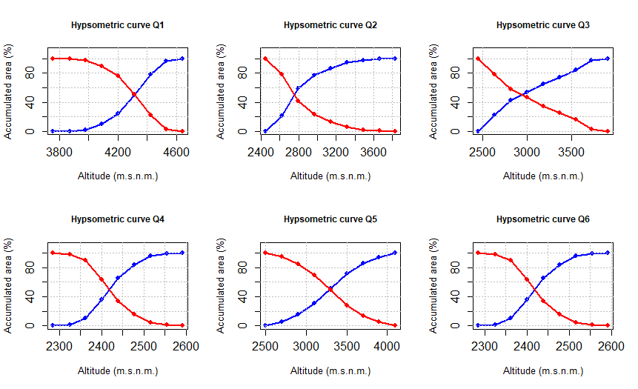

Figure S4. Hypsometric curves of the Razuhuillca micro-watershed sub-watersheds (Q1–Q6). ( SE VA MS)

Figure S5. Comparative visualization of morphometric parameters across sub-watersheds (Q1–Q6). Each parameter is represented independently to improve readability and identification of sub-watershed extremes.

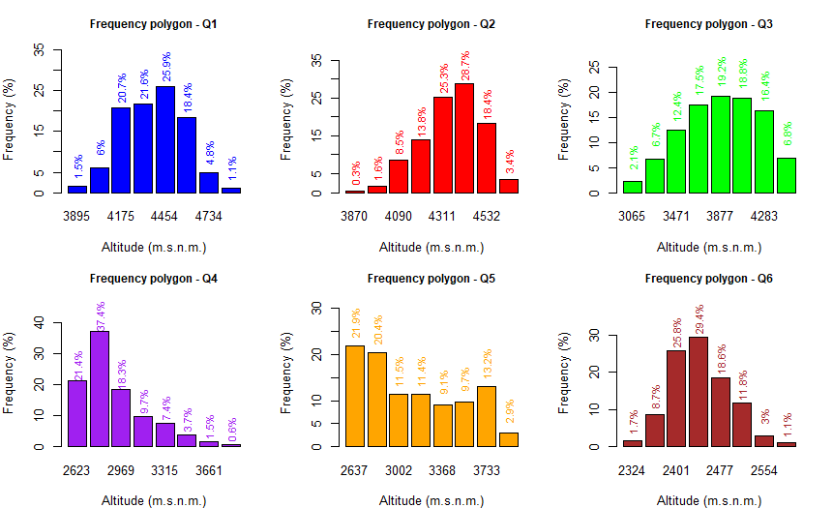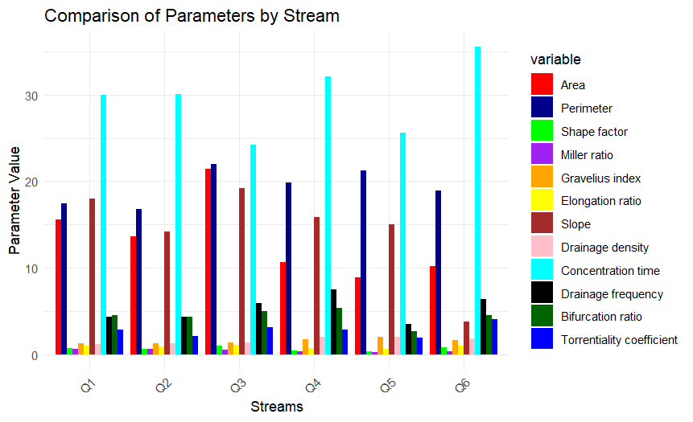Figure S6. Altitudinal frequency polygons for each stream in the Razuhuillca micro-watershed.