Supplementary Figure 1
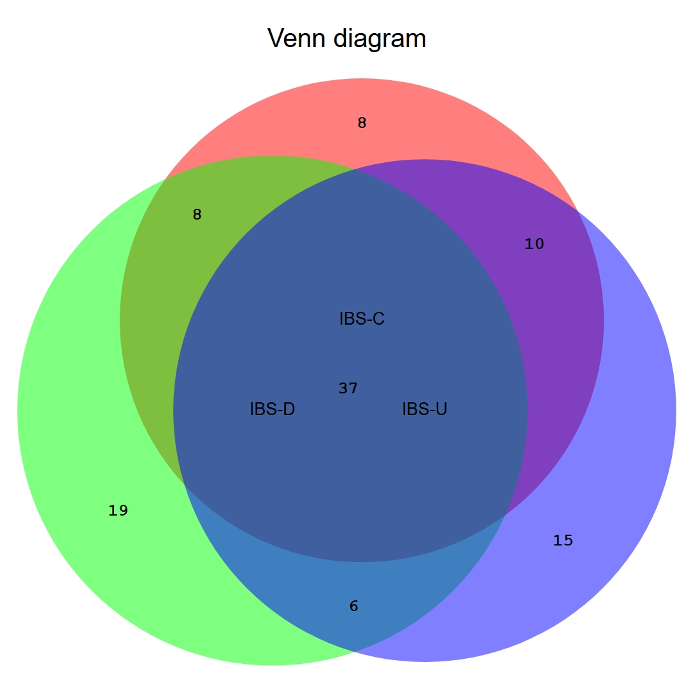
Supplementary Fig.1. All CAGs Venn diagram of the common and specific gut microbiota among the three subtypes of IBS. The red area in the Venn diagram represents the genera of bacteria present in the gut microbiota of patients with the IBS - C. The green area represents the genera of bacteria found in those with the IBS - D. The blue area represents the genera of bacteria in patients with the IBS - U. The overlapping regions indicate the genera of bacteria shared among different subtypes, while the non - overlapping parts represent the unique genera specific to each subtype.

